The Solunary Document

Introduction
Hello, I’m Lynx, and before we dive deeper into the reasons and the contents of this document, trigger warnings are as follows:

- Sexual abuse/exploitation
- Predatory Behavior
- Emotional abuse
- Self-harm
- Sexual topics/NSFW

Every person’s name that is not involved in all of this, and may be shown on the screenshots will be blurred/crossed out, as much as every NSFW material, if shown, will be censored.

Please note that Solunary's name won’t be censored, as it is already public information, because he showed it through his soundcloud profile numerous times, as well as in his servers.(some of his FLPs even have his name when you open them). Faces will be blurred.

This document will be broken into chapters, each explaining the timeline of events between late 2019 to as of today.

For the context of the entirety of this document, I need to note that Solunary claims to have BPD (Borderline personality disorder), with signs as follows:
- Fear of abandonment
- Unstable Relationships
- Unclear or shifting self-image.
- Impulsive, self-destructive behaviors
- Self-harm
- Extreme emotional swings
- Chronic feelings of emptiness
- Explosive anger

However, he has never been diagnosed, so keep that in mind.

I’d like to mention that this document has been made a year after the break up, so most screenshots shown will be from the 2020-2024 period. This is also to ensure people know this document isn’t made purely out of malice or spite, as everything has heated down.

This document wouldn’t be made if Solunary owned up to his actions, apologized, and sorted everything out privately, but so far, no remorse has been shown, as he continuously tries to put me in a bad spotlight.

This document is not made to spread hate. Please DO NOT HARASS ANYBODY mentioned in this doc.

Chapter 1: How it started
So, a legitimate question: “How did you guys even end up together?”
I met him in an Undertale au team discord server.
I was 14. He was 12 at the time. We were no more than people talking to each other.
Fast forward a few months, he asked me out. In a childish way, one would say, but as I was very young and naive, I agreed.
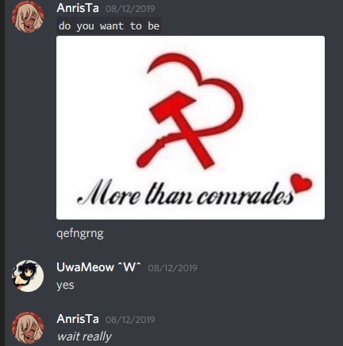
Please, do note, that the age gap between 12 and 14 is only a year and a half, as his birthday would come on November 4th. He would turn 13 shortly. For context, my birthday is January 17th.
His primary defense when this is brought up nowadays is that:
I’m 2 whole years older, but let me tell you, younger people are not always the victims.

I DO NOT CONDONE DATING AT SUCH AGE.

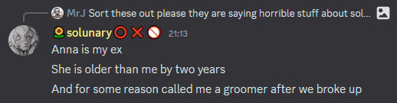

Shortly after, from what I recall, he would show suicidal tendencies, and I’d encourage him to stay safe. This was one of many early calls of his mental decline that I should’ve seen sooner.

Chapter 2: Sexual abuse
Some context for this is needed.
I have severe trust issues and mental problems with showing my face or let alone anything else of myself on the internet. This occurs due to personal life situations, that I will not mention here.
Solunary knew of those, and would always try to help me solve those issues, but the reason behind that help is obvious.

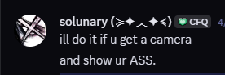
(This was put as a joke, but knowing how Solunary tends to project his sexual fantasies through his jokes, it’s problematic to know his true intentions. This will be shown down the line.
Keep in mind he will probably use this as his defense in the future.)
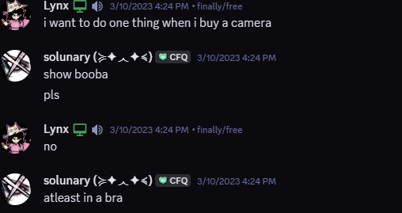
( Do note how I’m disagreeing here. It won’t be a one time occasion )
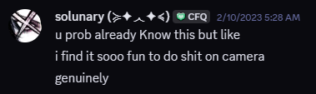
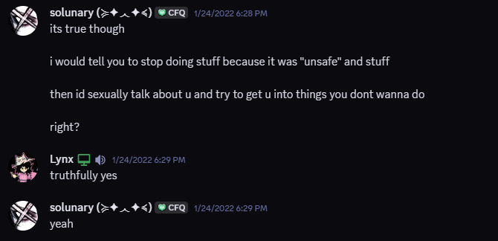
( Here’s him outright agreeing that some things were forced upon me by him. )
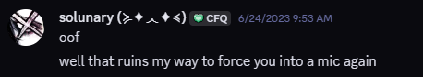
As well as constantly asking for nudes, he would ask me for permission to send his as well.
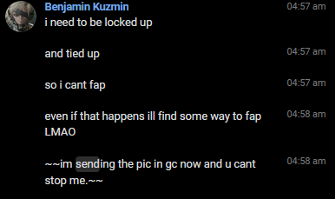
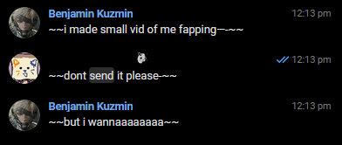
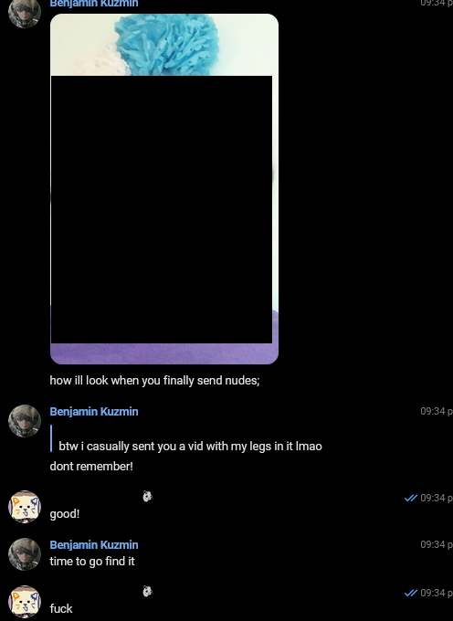
( The censored image is a picture of his face doing a smug face )

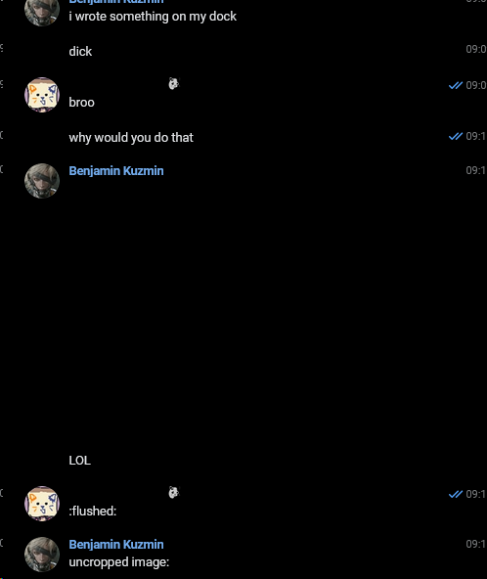
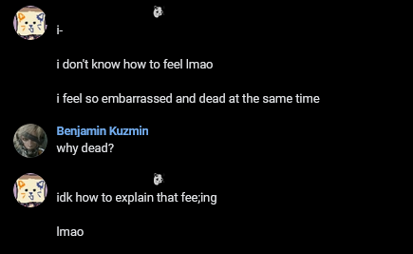
It’s very obvious what’s on the censored image given what’s above. It was his VERY PRIVATE AREA, but it had my real name on it as well, written on with a marker. Keep in mind this dates back to 2020, Ages of 14 (him) and 15 (me), you see i’m obviously surprised. I did NOT ask for this. (the 2 years older one, by the way)

Solunary would very often propose to me to send nudes/or do sexual stuff with him in exchange of something I'd ask him (be it a song, a picture that isn’t even sexual [read: A picture of him smiling, for example], or something else. Examples of this will be shown below.)

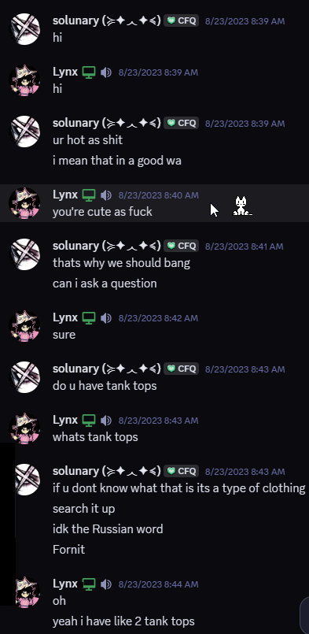
(Notice how a simple conversation starts off immediately sexual from his side 🤐)

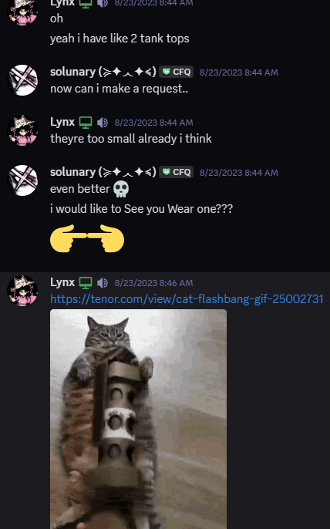
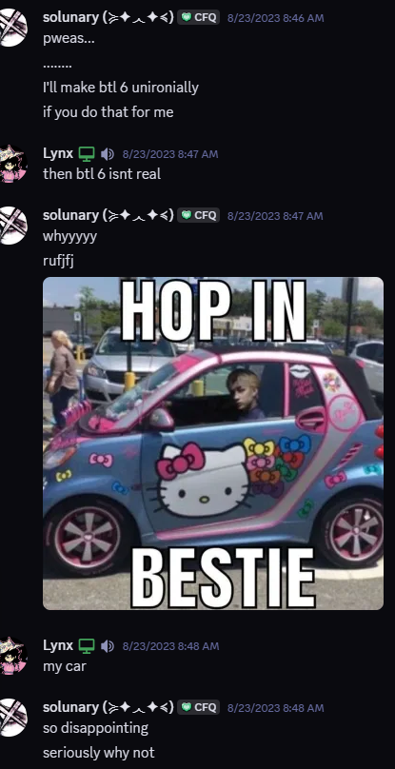
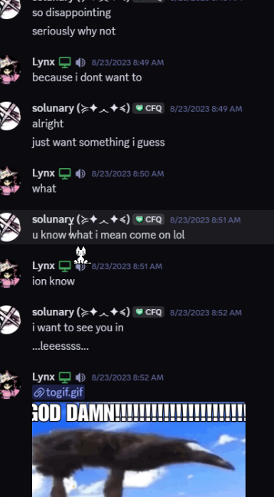

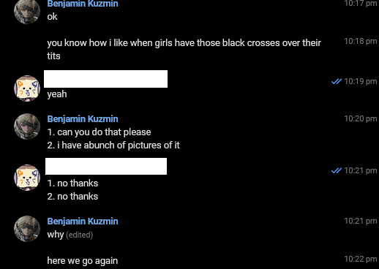

I’d like to say that mental maturity and physical maturity are two different things. He knew more about sexual topics than I did upon meeting him. Almost every single sexual interaction was initiated by him. I’m not saying there weren’t any initiated by me, but in comparison, it was very little, and way before I matured as a person to stop doing so. Past 2023 very few interactions were of my own accord, as opposed hundreds if not thousands from him. Proof of this will be found below.

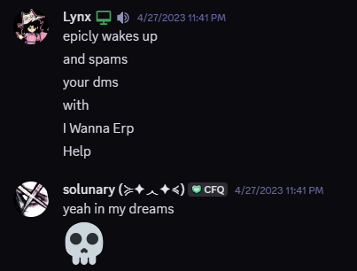
(An admission of me doing it less than him.)

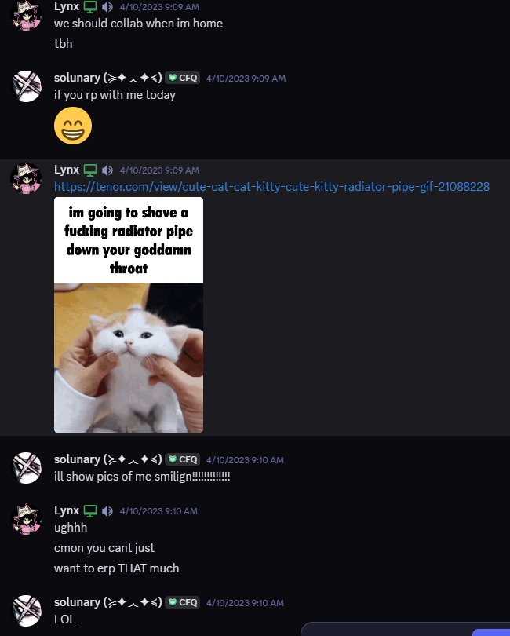
(Me expressing my unwillingness to ERP.)

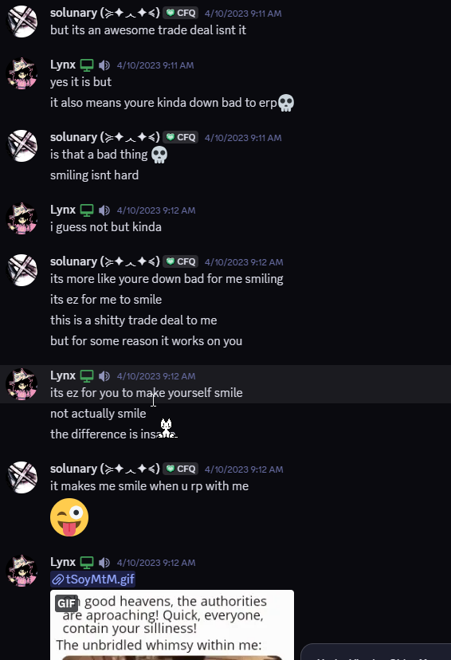

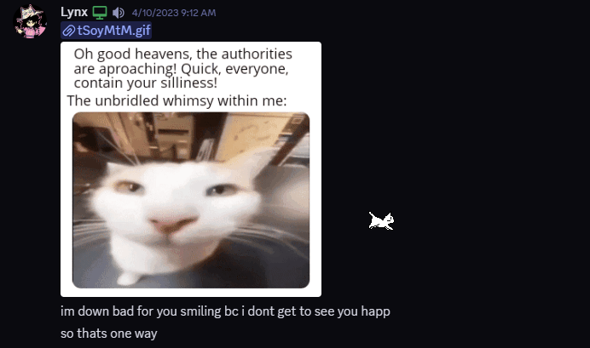
Here’s another point I wanna make. Most ERPs that we’ve had were initiated by him AND I consented mostly only because I wanted to see him happy. That might sound crazy to some of you, but I like when my partner is happy. I did not realize how bad it was until later (would be like the latter half of 2023) because his behavior started to take a toll on my mental health.
I was a kind and accepting person, I would excuse all of his behaviour. Simply because I didn’t know any better at the time. I thought everything was completely normal, and that all people do that. But that kindness got abused to a point where one couldn’t take it anymore. More on that regard will be in the “Breaking up” and “Aftermath” sections of the document, but back to the point for now.

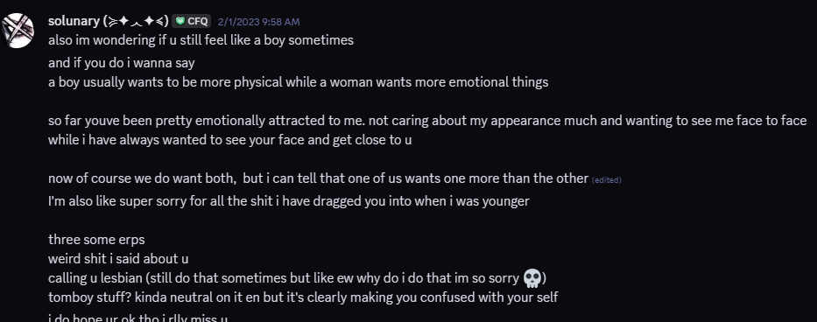
I should mention I have had some issues with my self-identity, and my sexuality at the time. As Solunary says above, he only fueled it more. As he did apologize, he only continued doing the exact same things he apologized for afterwards. Dates on messages below will speak for themselves.

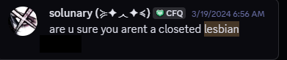
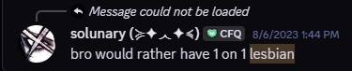
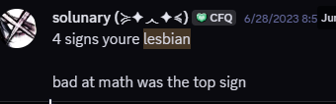
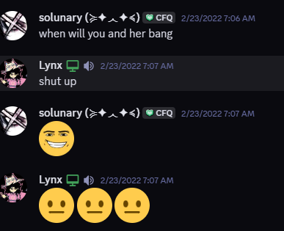
(This is referring to a person I knew irl.)

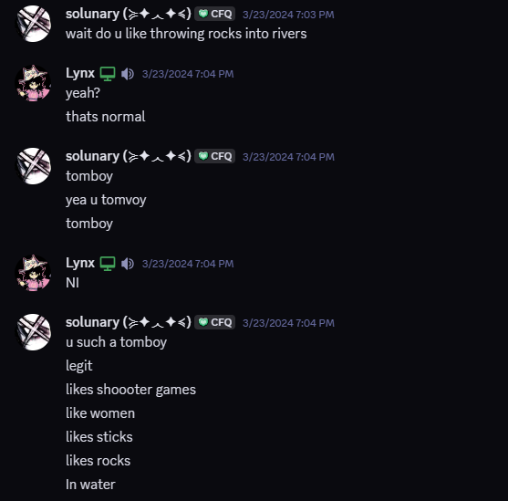
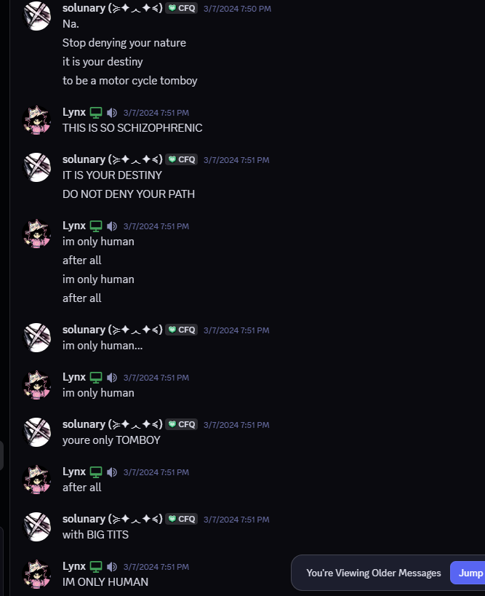
(Me obviously expressing my discomfort with this, using jokes, but more serious discomfort will also be shown. Another sexual remark, by the way, too.)

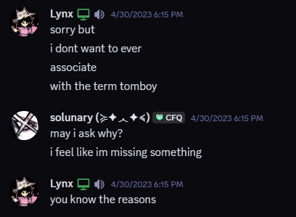

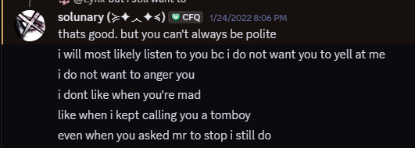
(Outright admitting some of it is done on purpose.)

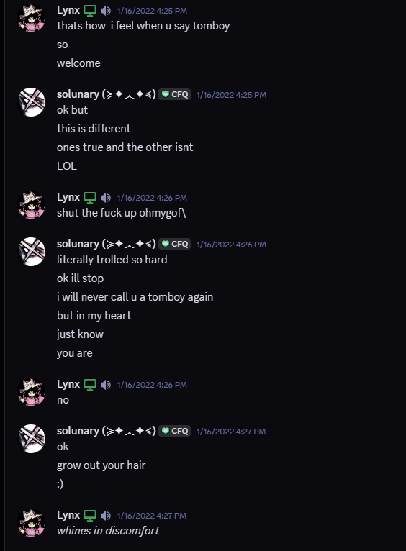
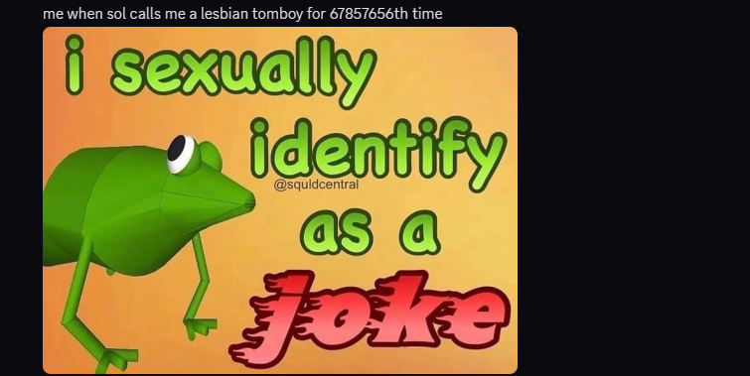

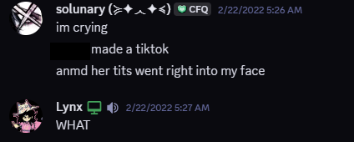

Here’s him talking about one of his former friends. I think saying that to your own partner is already diabolical by itself. Please note, that this is not the only instance of him sexualizing someone else/putting other people into his sexual fantasies and telling it to me.
For example, have those:

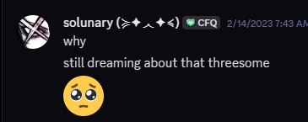

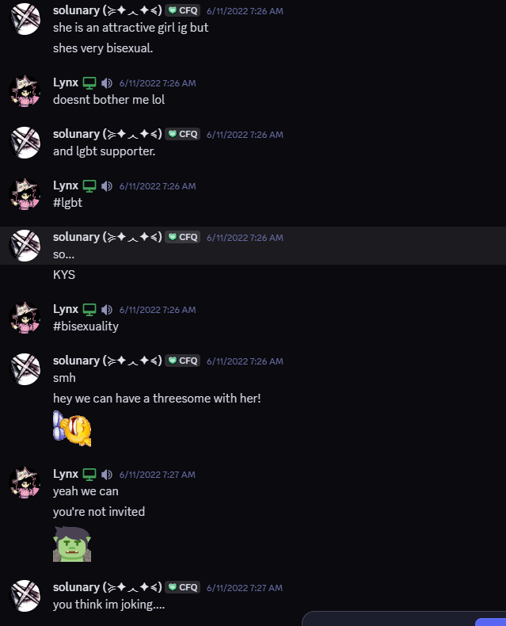
That’s how he introduced me to one of his friends. Cool, ain’t it?

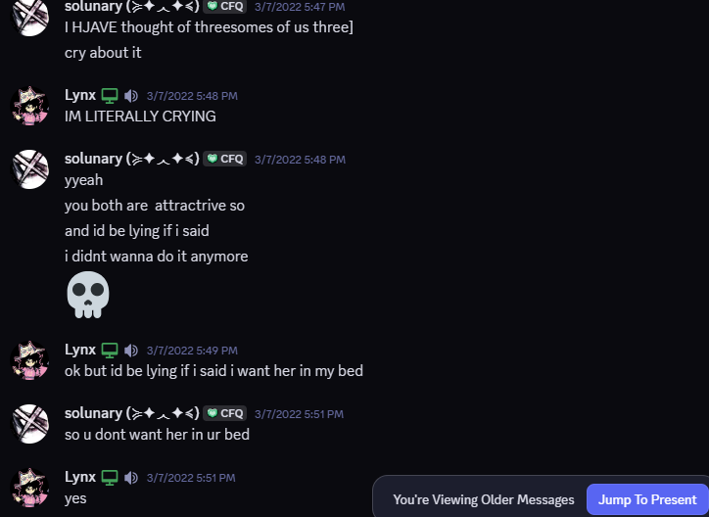
Once again, I am showing discomfort. He’s here referring to one of my irl friends.

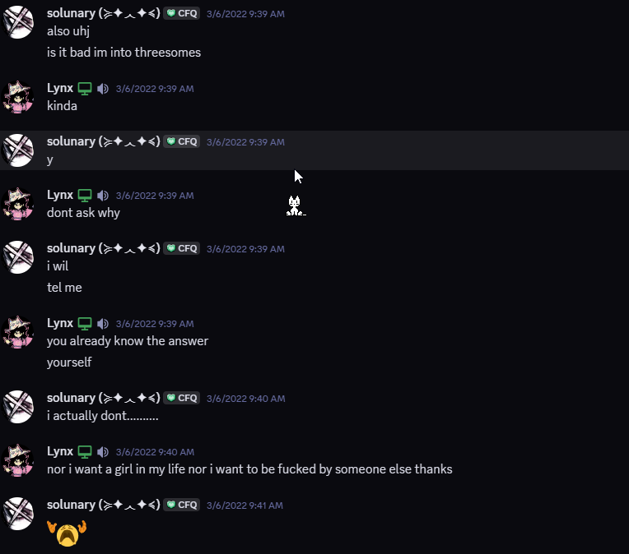
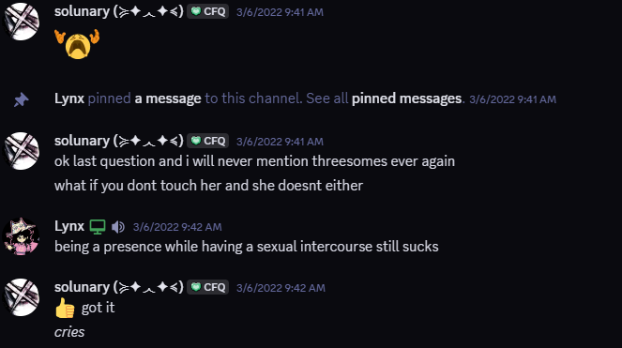
“I will never mention threesomes again”, and he did, if you look at the dates on previous messages. Ironic.

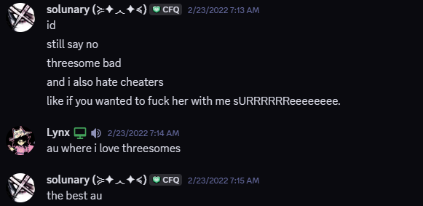
And here he yet another time contradicts his own statements.

Chapter 3: Porn addiction
This section will be very brief, as the previous already sort of established this, but this chapter is just to show how many times he’s “asked for help”, “got help in various ways”, but, inevitably, came back to his addiction. As of 2025, his current state on this is unknown to me, but my personal theory after knowing him for 5 years is that he is just ashamed of it, hiding it, as even before only I knew about this, so even if he says he “got better”, it will hard for me to believe, as he has never told anyone the full truth.

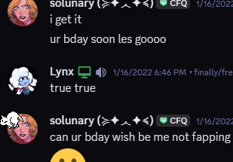
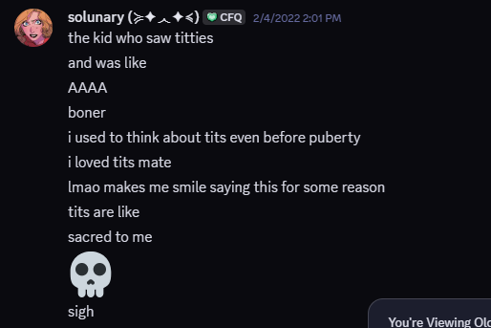
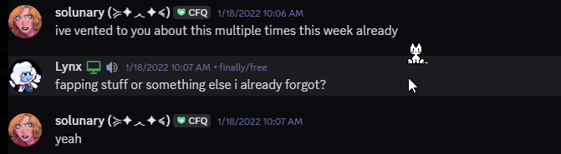
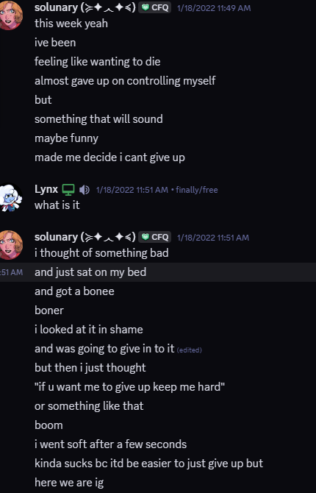
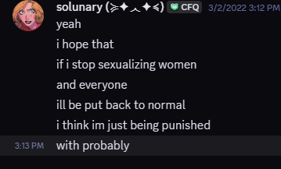
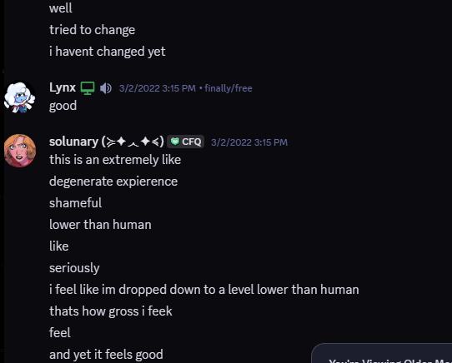
He himself agrees that sexualizing women is a “degenerate experience”, so, dear reader, riddle me this:
WHY does he keep doing that, as dates speak for themselves in the previous chapter?
Don’t worry, that’s just the tip of the iceberg of his hypocrisy. Let’s keep going.

As I’ve already mentioned in the beginning of this document, he had suicidal tendencies. I’ll show one very specific example to you, I’m sure the rest won’t be much needed, as they basically follow the same formula.
As for Solunary, I’m sorry this further section won’t be censored, as it provides further insight into the problem.
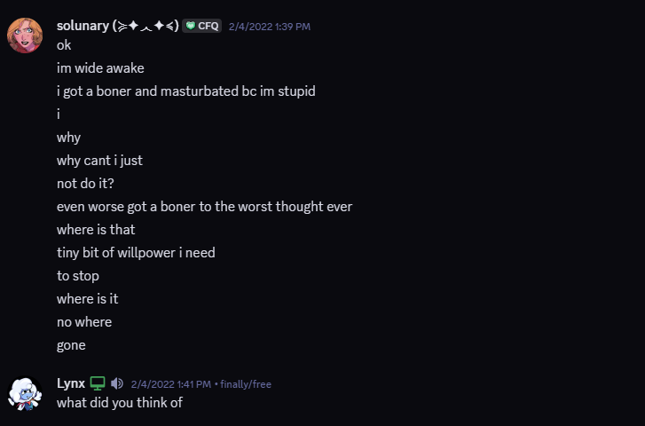
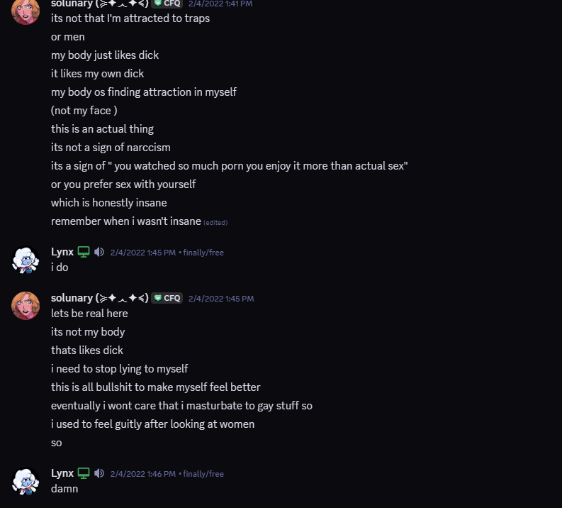
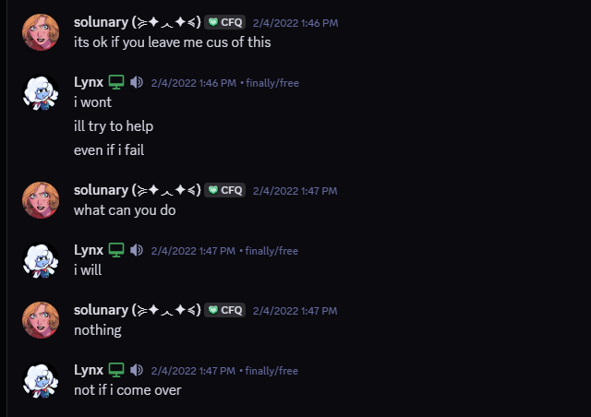
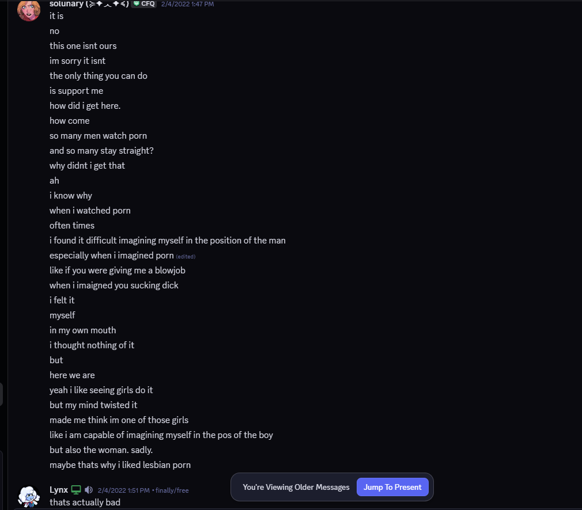
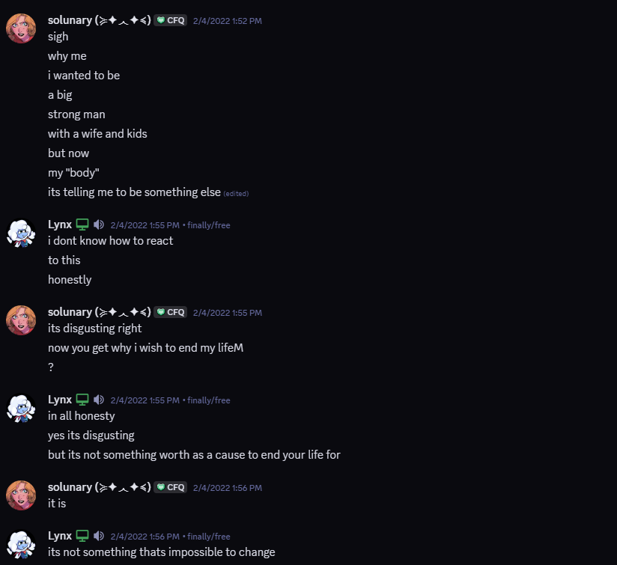
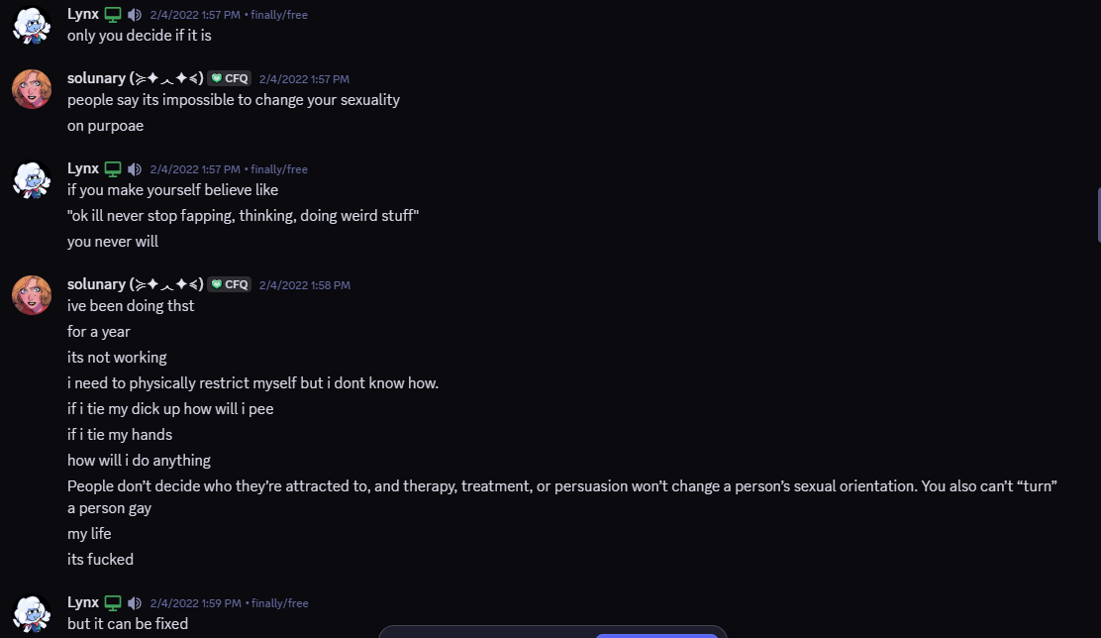
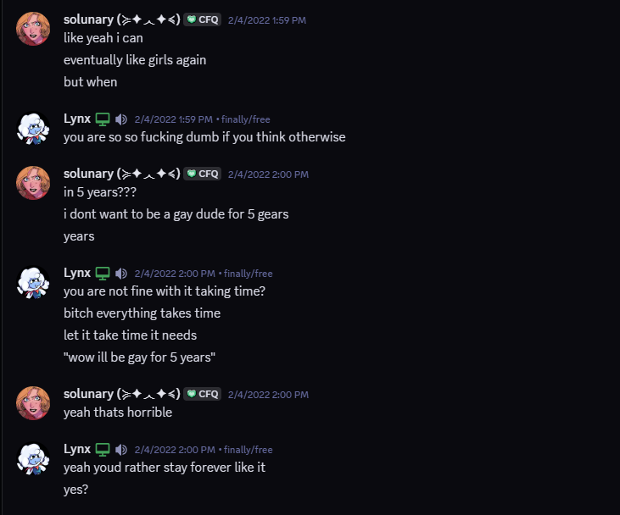
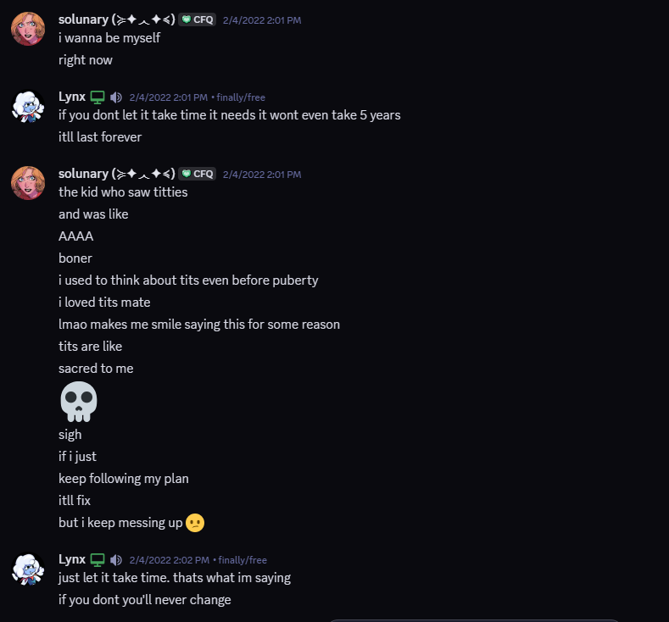
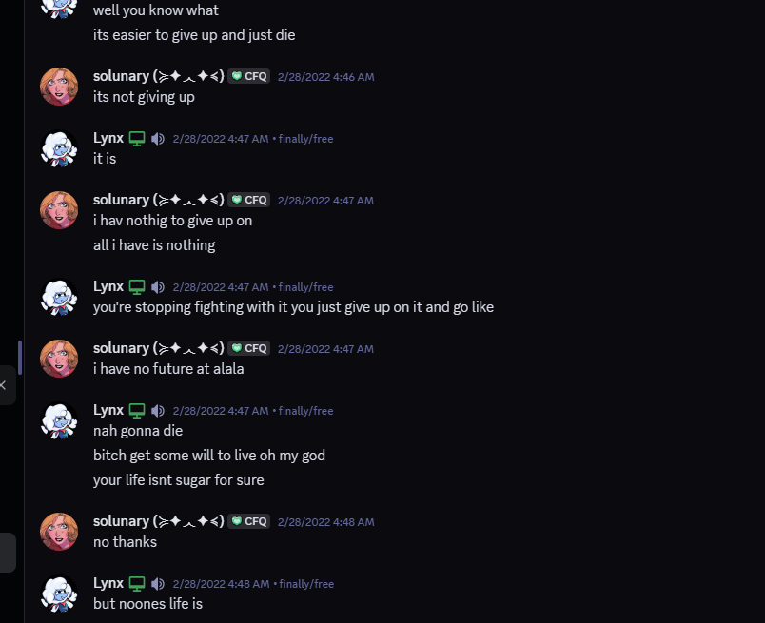
That’s another instance of the same problem reoccurring, causing suicidal thoughts.
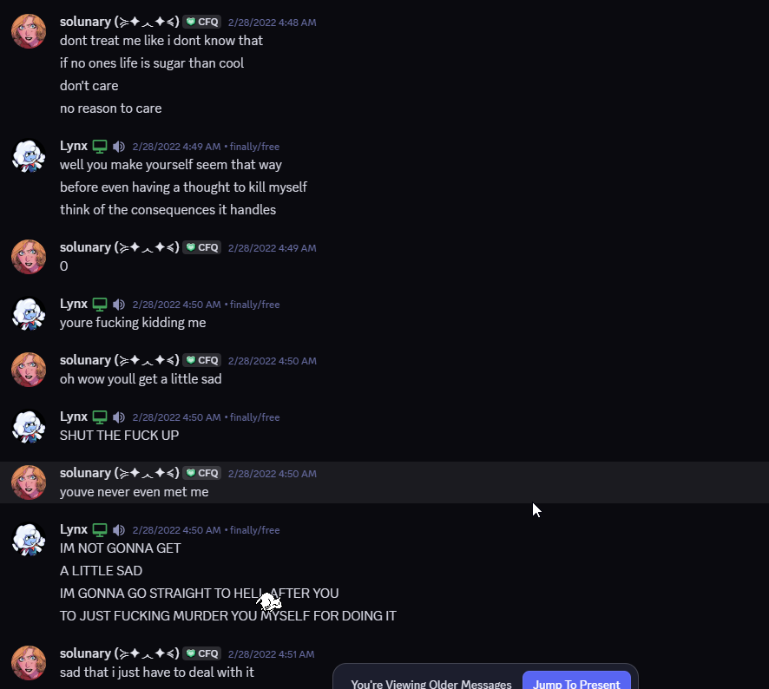
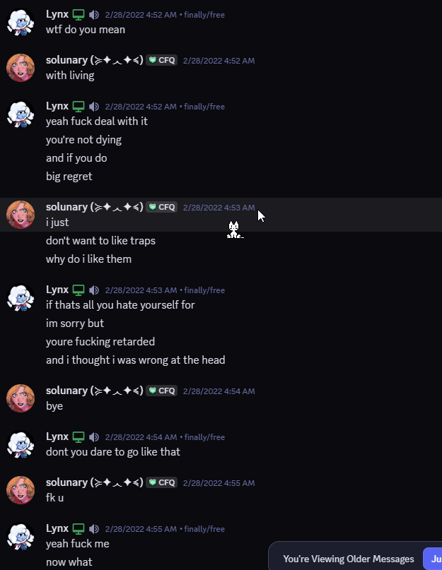
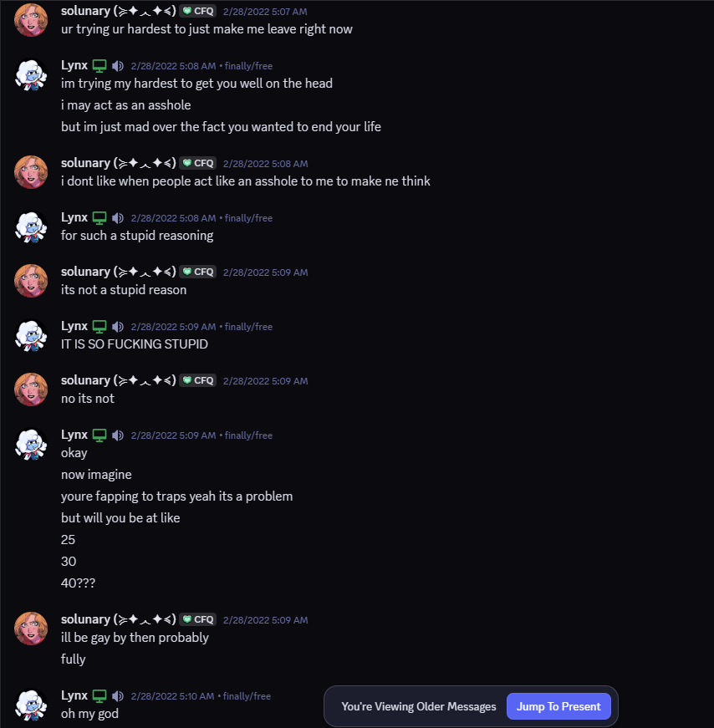

Keep in mind, I’ve been trying to support him no matter what he’s attracted to. Personally, I’ve never cared, as sex never interests me in a relationship (Most of sexual interactions of my own accord were to please him, and not myself. I rejected my own boundaries for his happiness’ sake. Sure, some of it might be my fault, and I will own up to all those parts later in the document, but it is his fault for abusing this for so long with no self-awareness of how badly it affected me.)
Tell me, when your partner says “If I kill myself because of what I’m attracted to, you will probably just shed a tear and move on”, would it not hurt? And it did hurt.I got mad at him for this, making all his future attempts at venting to me about this, or similar issues, tick me off to a point I decided for myself it’d be best if I said nothing, than causing a whole rollercoaster of emotions for myself. Is that bad of me? Sure. But I never said I’m perfect in all of this as well, but my actions can’t compare to his on a scale, and I hope you understand that. Unlike him, I’ve been working on bettering myself and growing as a person.
Could the same be applied to him? Likely not, but this will be also tackled further down. We will continue

Chapter 4: Manipulation
This section will be very brief, as there is not much i can find without exposing my face, but in short, Solunary has always requested me to change my appearance, whether it be a hair style/hair color/nail color/clothes to fit his desires, disregarding how i feel about that, and blocking me/or starting to ignore me and have a depression episode if i raised any opinion of my own, basically convincing me i have to obey no matter what his opinion is, or i will be blocked.This is basically manipulating me to fit his vision of me at all times.
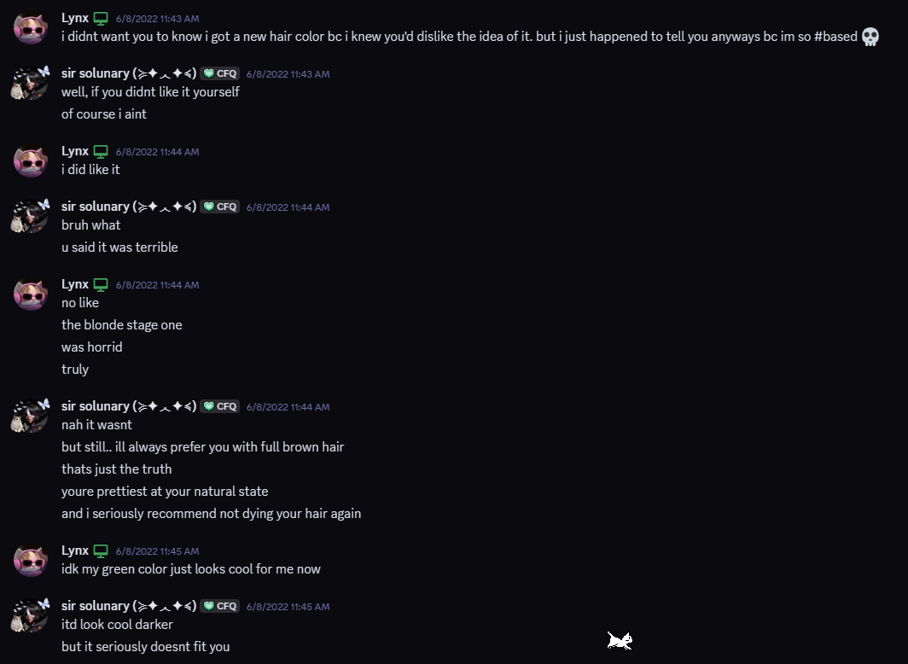
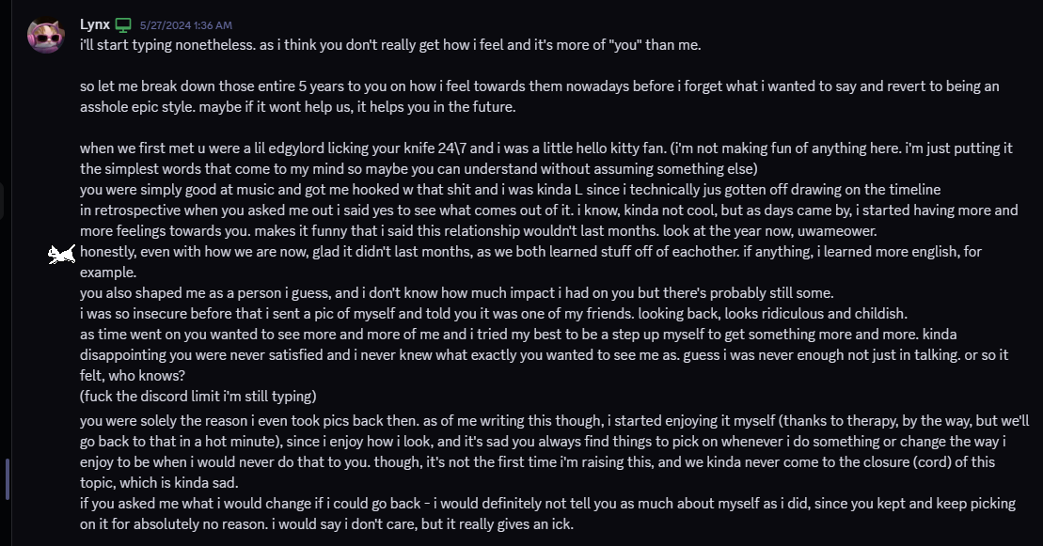
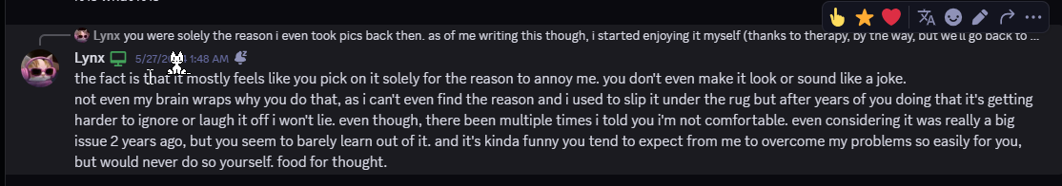
Here’s my full statement I wrote to him post-breakup. I don’t think this topic needs any further addressing, but here is his response.
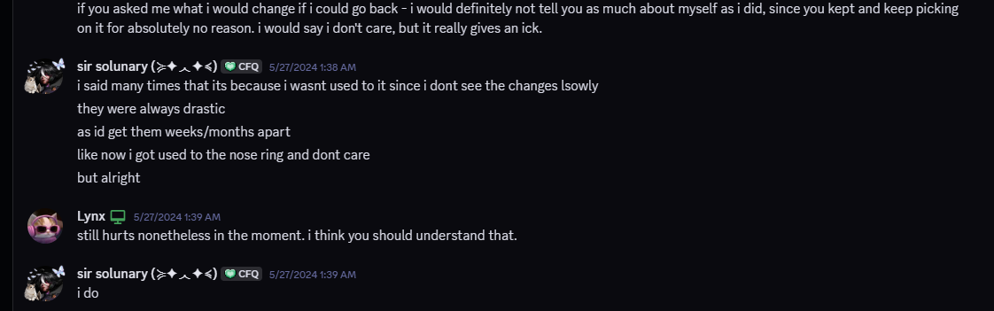
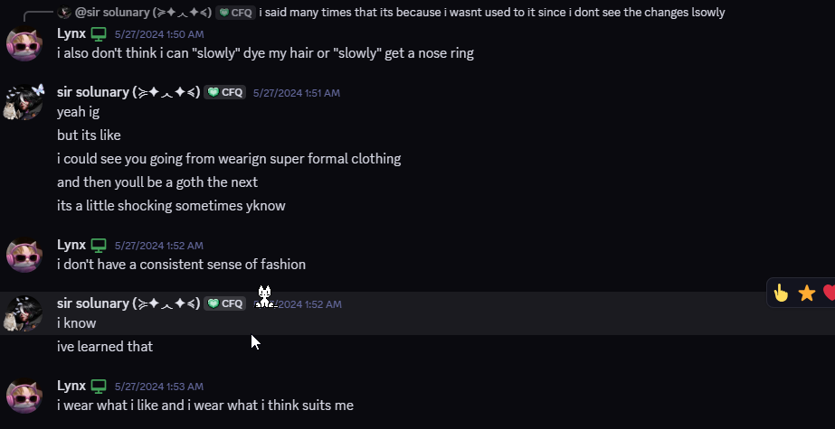
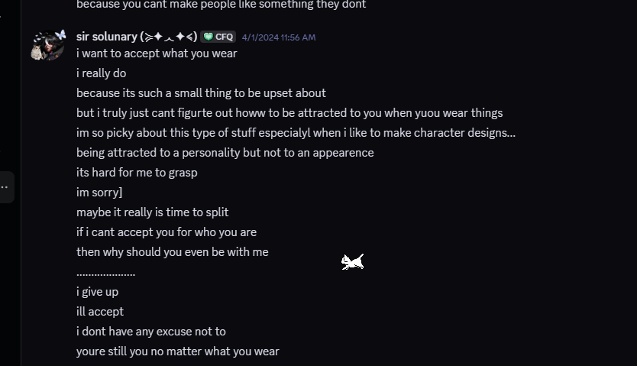
That’s the point he came to often, but then once he saw a sudden change again in my appearance, I’d get criticized.
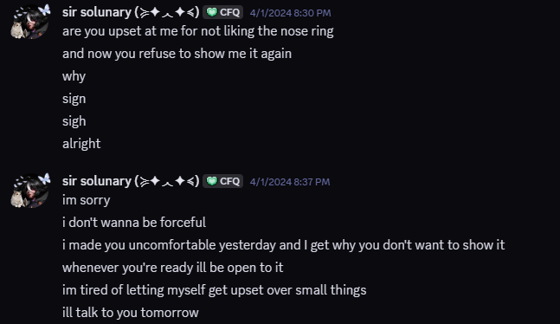
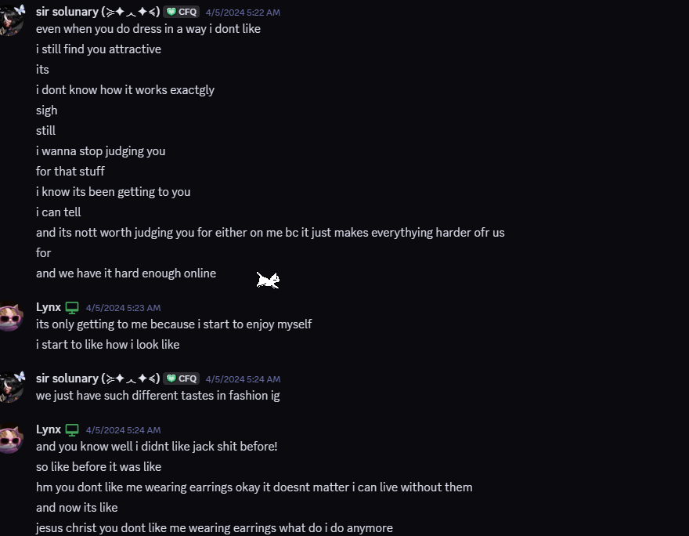
Pretty sure this makes you get the gist of the situation, and I don’t have to elaborate further.
This topic would be brought up every time I'd send a picture of myself, and there would always be something to complain about, and as Solunary himself says above, he knew it started giving me a toll, yet kept doing so.

Chapter 5: Breaking up
So, many of you are probably wondering, how did we even break up to begin with?
Well, for context, Solunary used to have random bursts of anger, due to his BPD (however, keep it mind, it is undiagnosed, and it can’t really excuse ALL of this behavior.), and he would just randomly block me, or start ignoring me.
So one day he DMed me about coming down to my city, and my reaction was lacking, as I’ve been dealing with other things on my end.
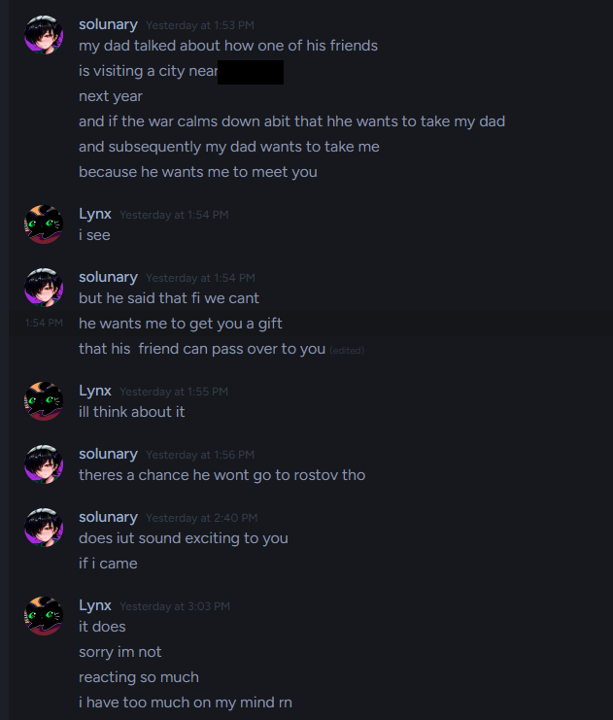
Next day we’re having a casual conversation, joke-y and stuff, but here’s how it goes.
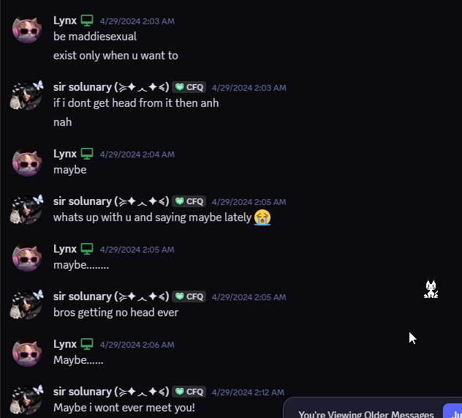
Which even as a joke shouldn’t really be said to your partner.
So I get angry and just stop responding. Here’s what happens.
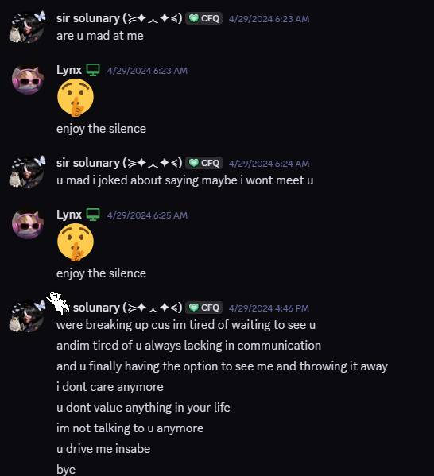
And he blocked me afterwards as I was sleeping.
A few hours later, I woke up and saw this. Keep in mind this wouldn’t be the only time something like this would happen, but it hurt even more than usual, as earlier i mentioned i was dealing with my own personal issues.

I DMed HKtuber and announced I was gonna take a break, due to the fact this is a strong hit to take and I was already dealing with a lot, asking if he could pass a message along.
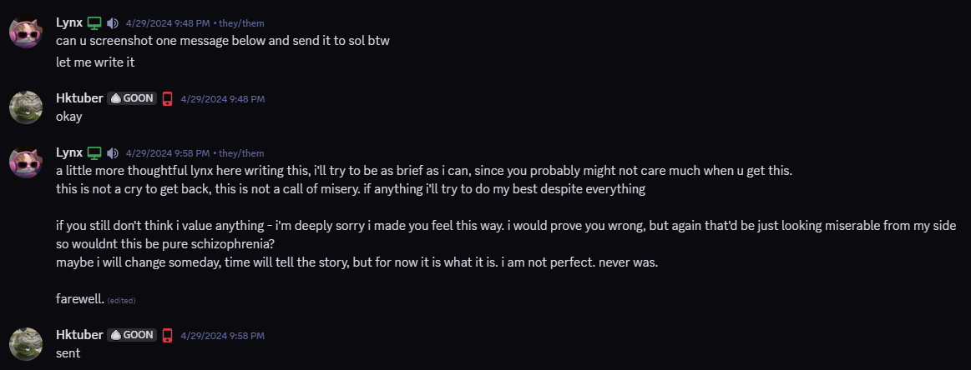
To this he gave no response.

Chapter 6: Aftermath

Keep in mind the timeline of events here might be out of order, as I no longer have some of the accounts the DMs were on, but I'll try my best to restore the original chronological order.

After receiving no response, and calming down, realizing I haven't done anything wrong in this situation. I got angry over the fact I poured my heart out and got nothing from it and decided to DM him myself.

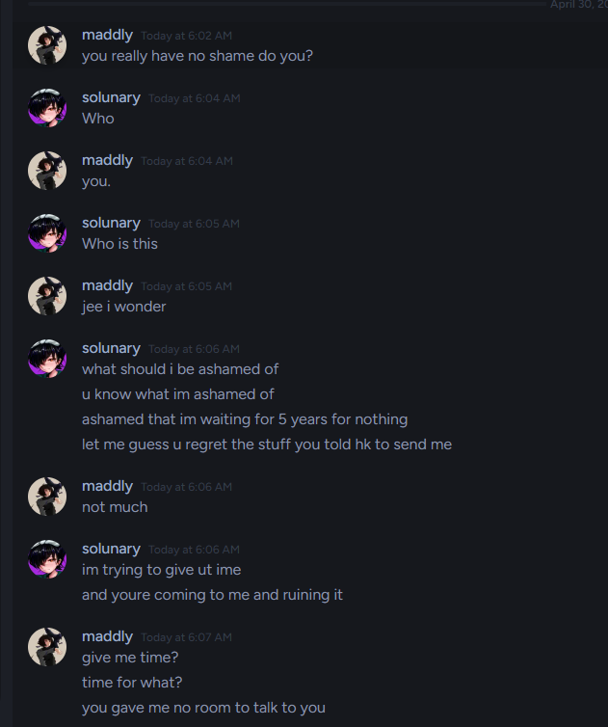
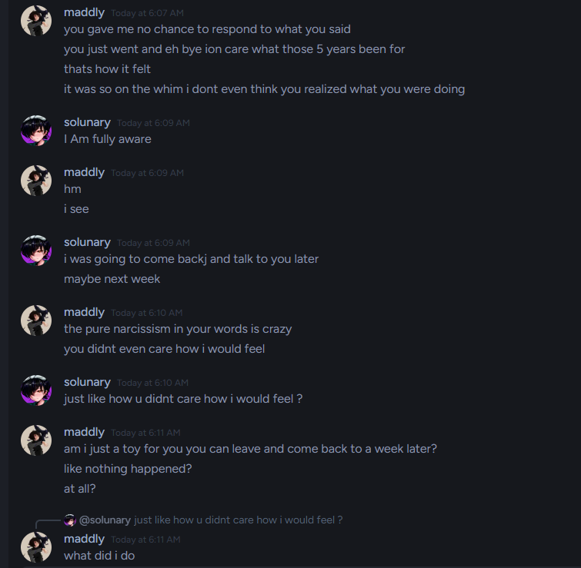
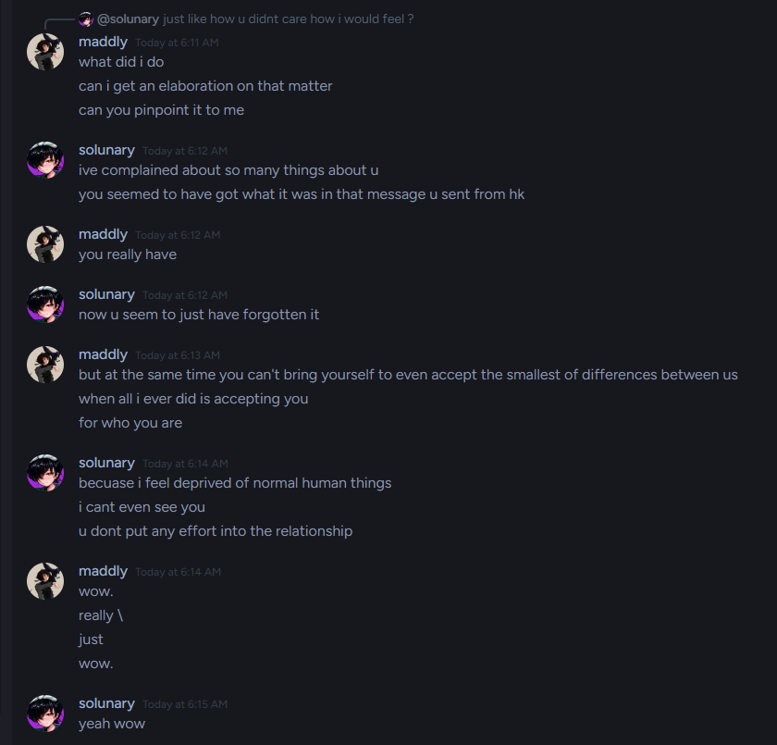
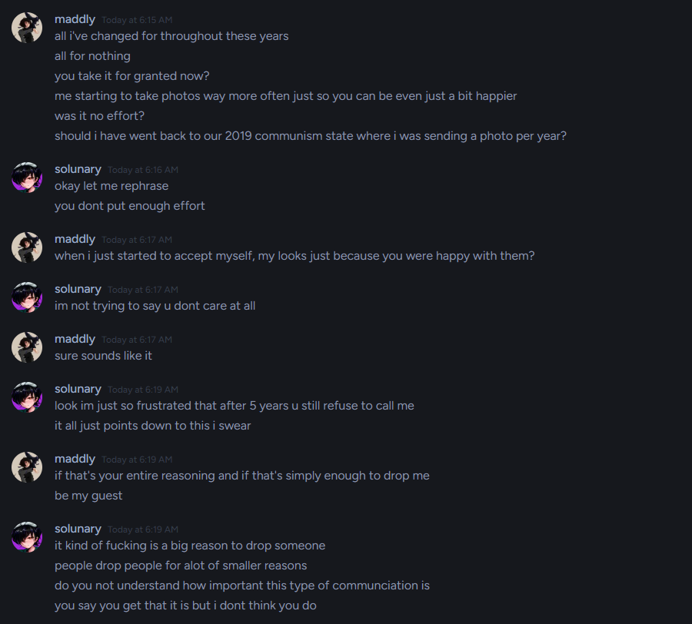
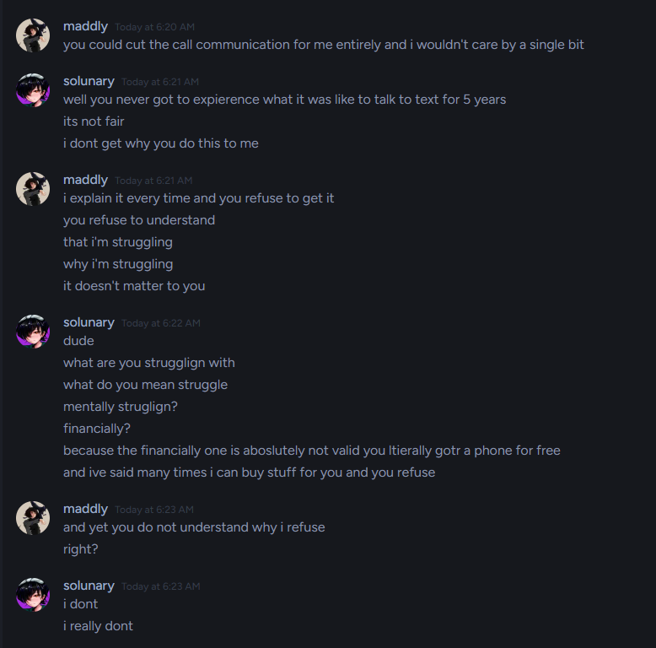
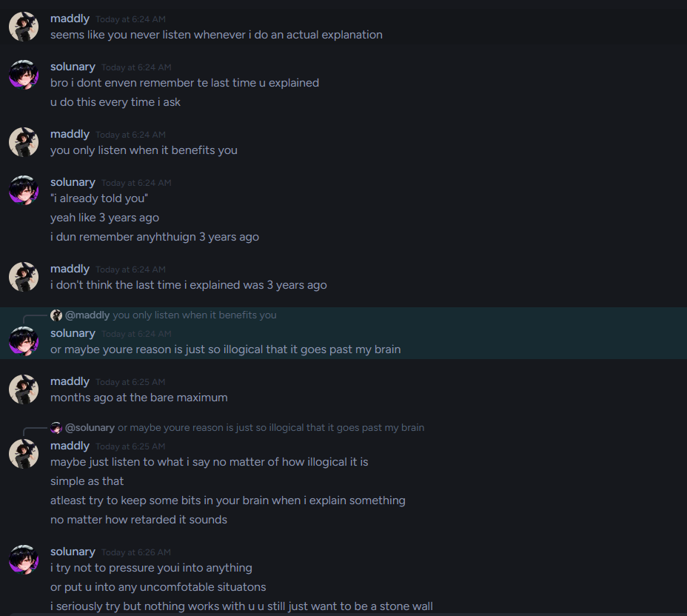
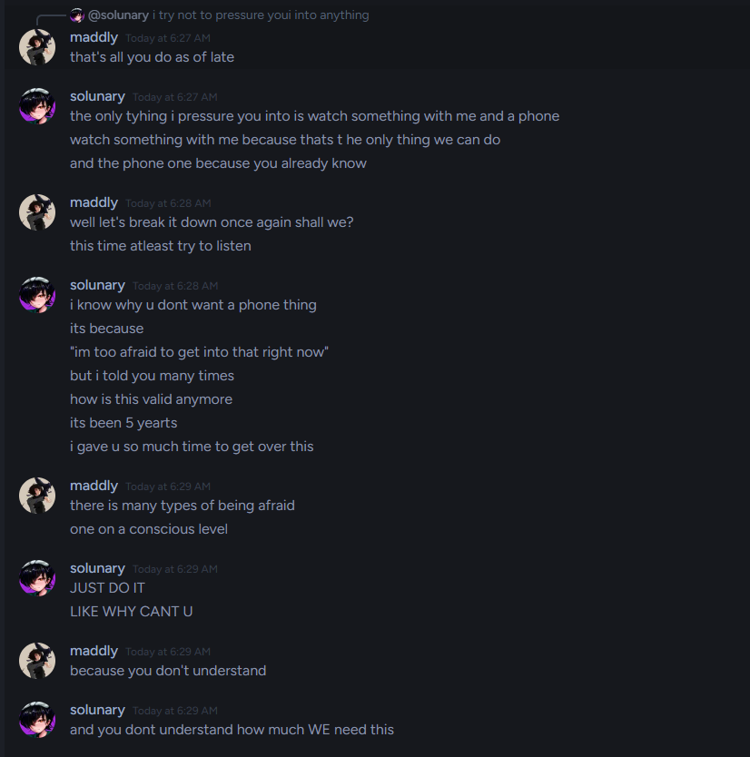
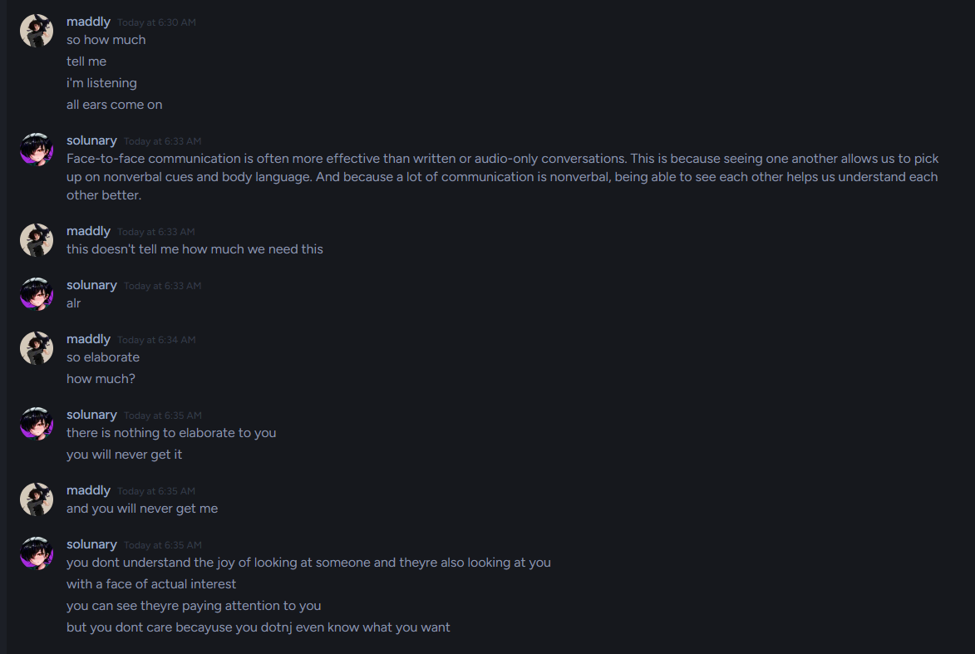
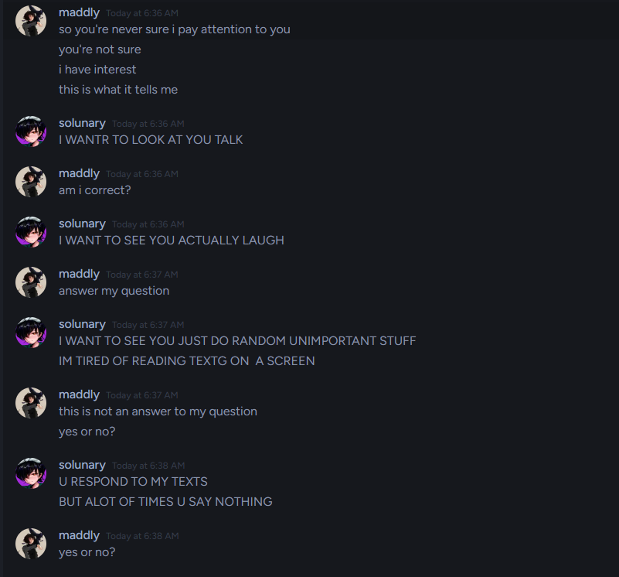
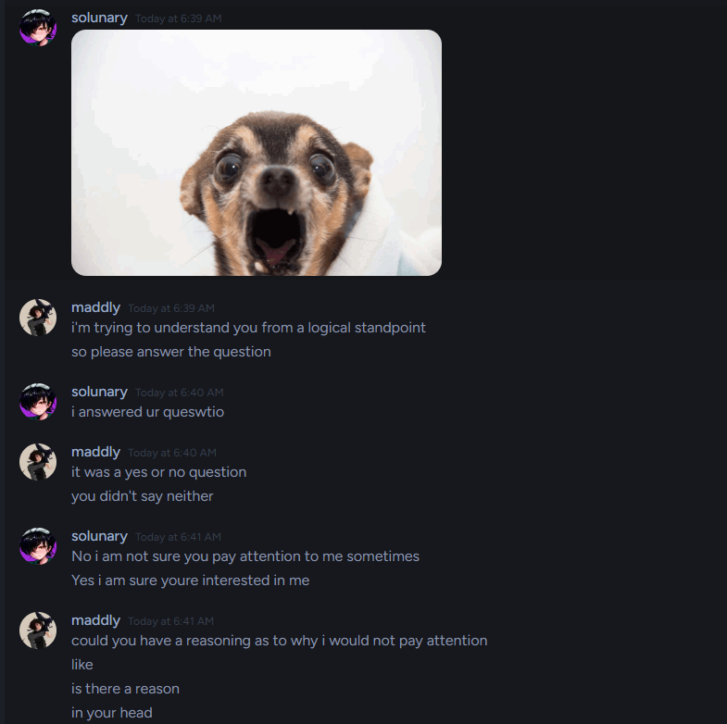
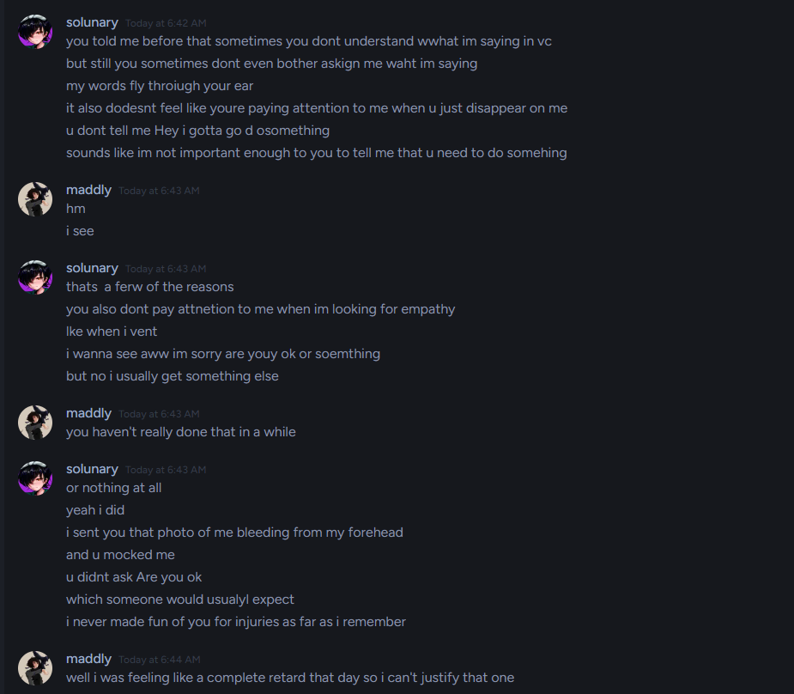
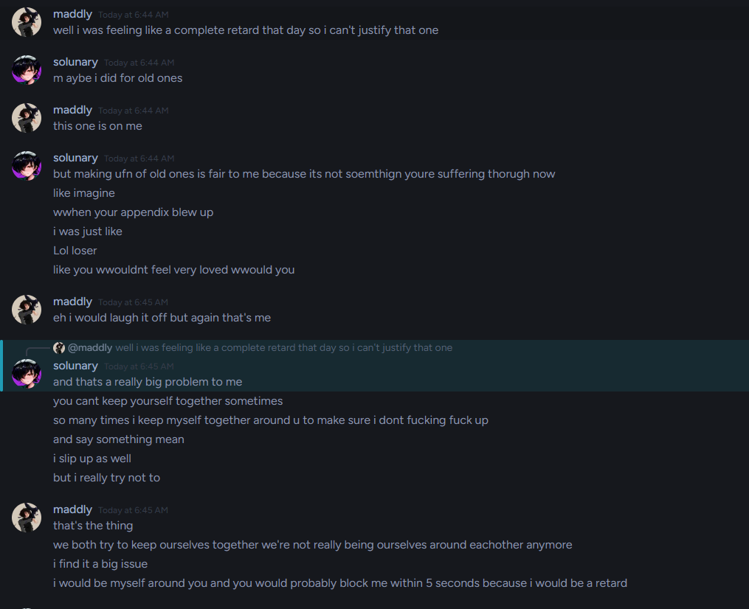
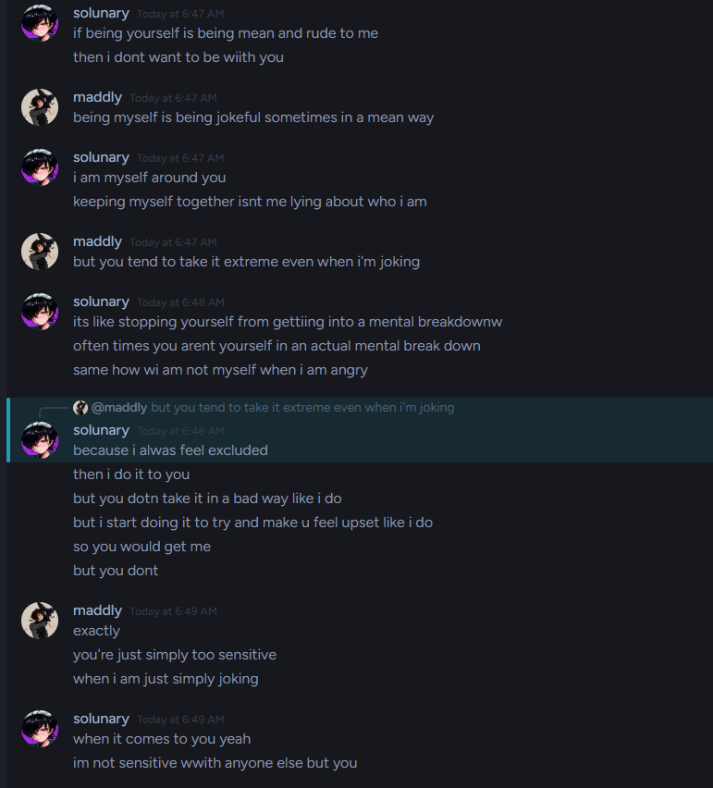
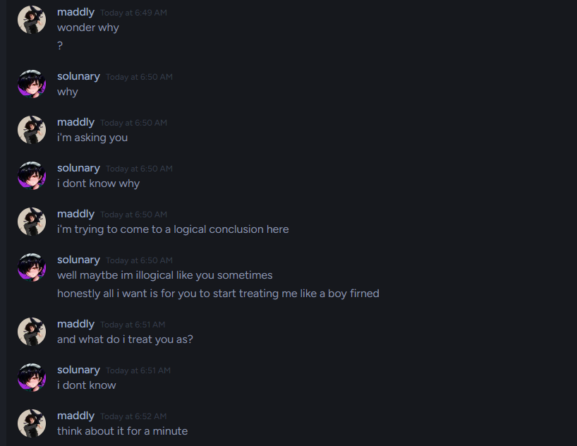
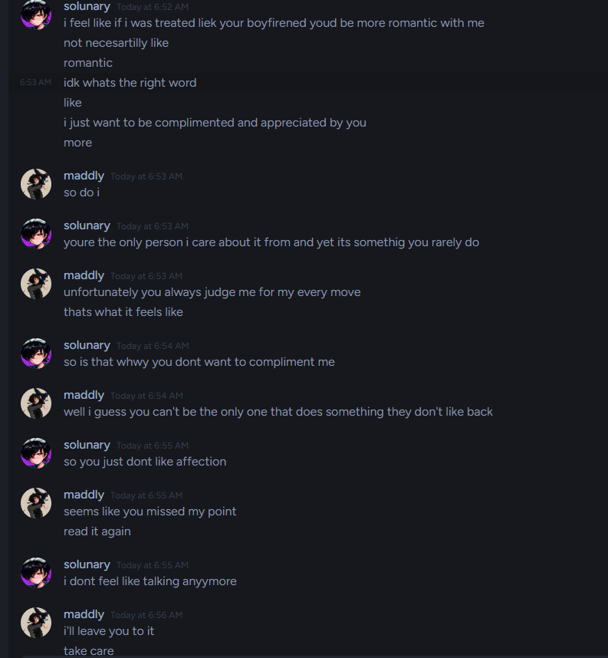
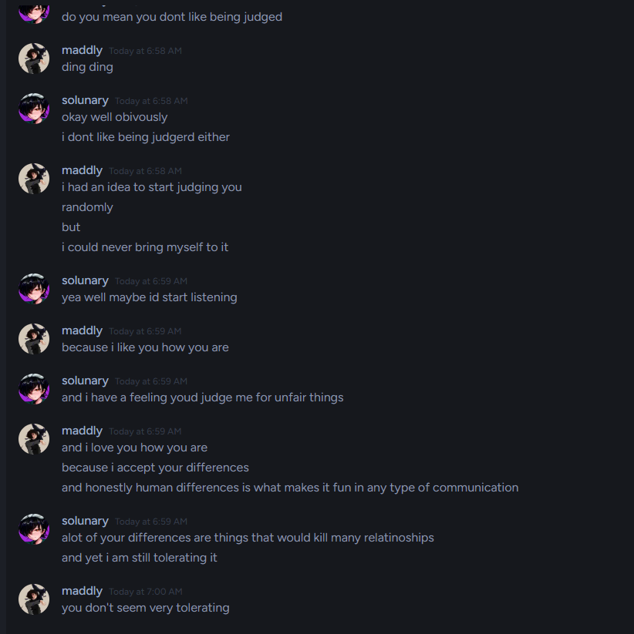
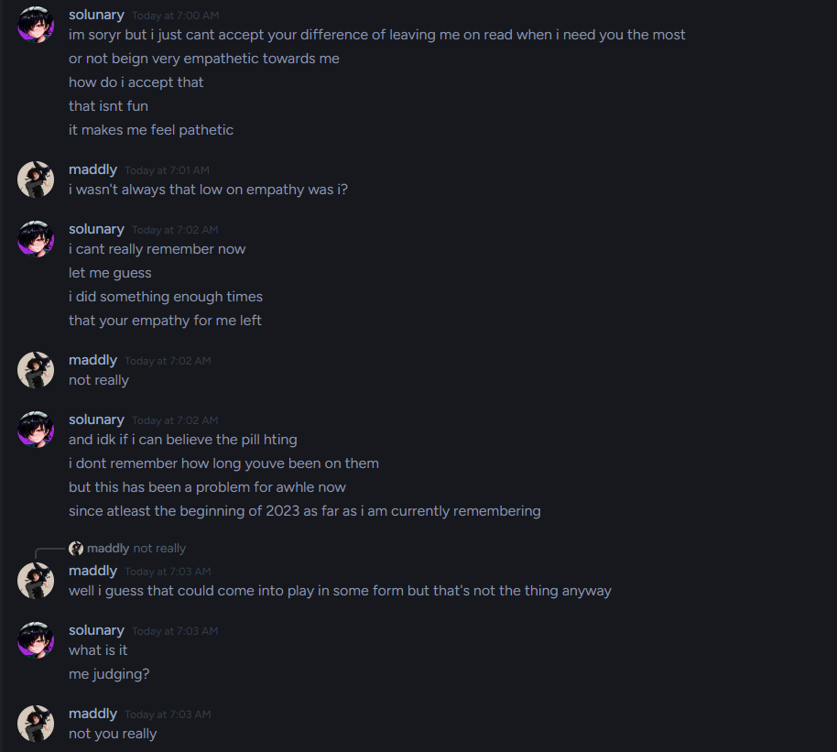
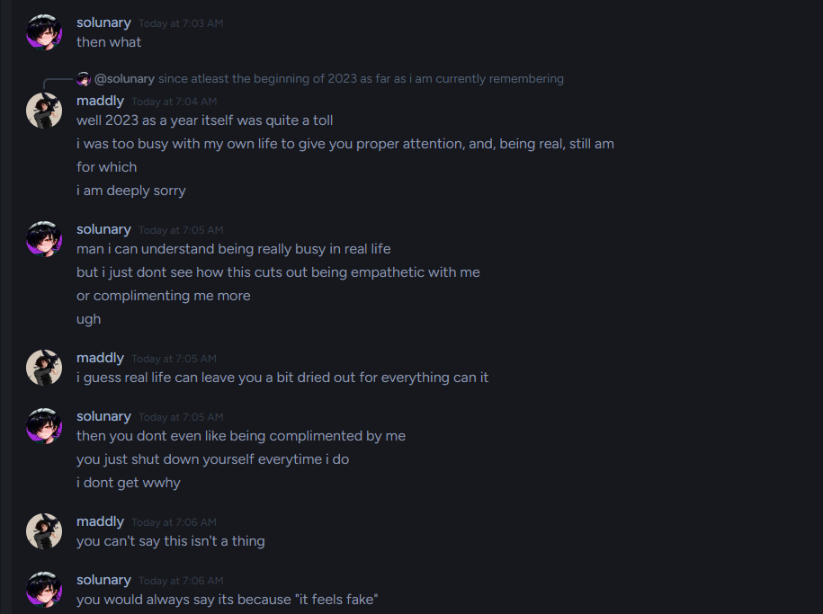
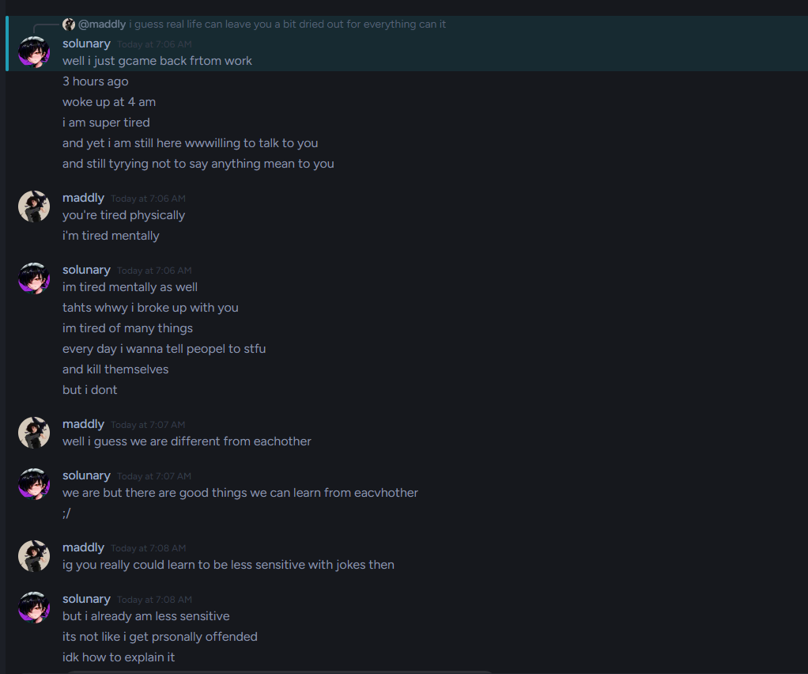
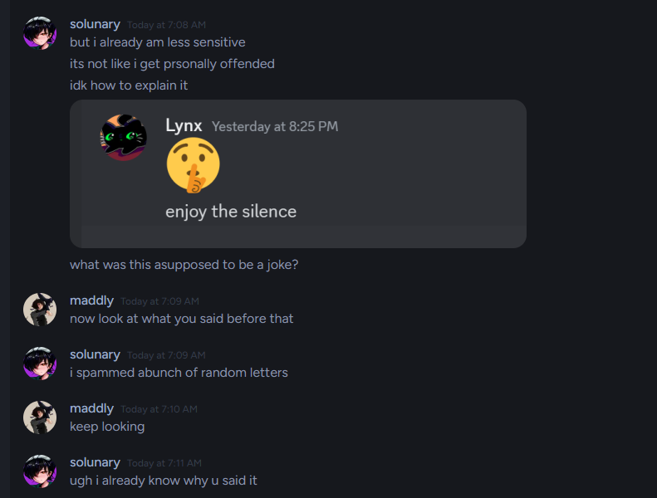
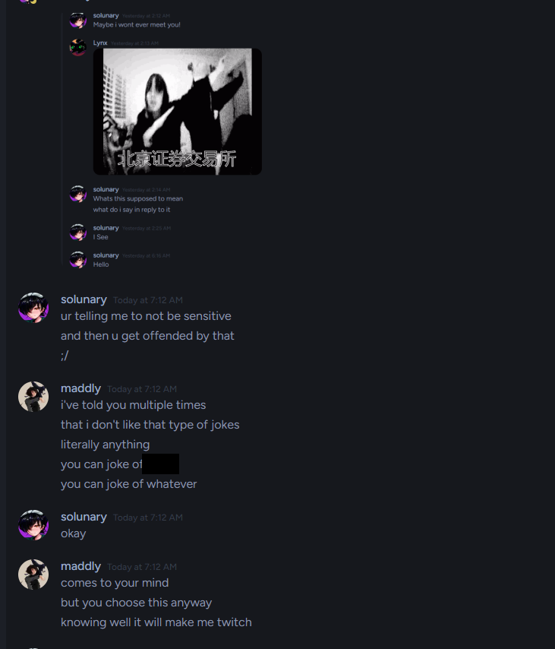
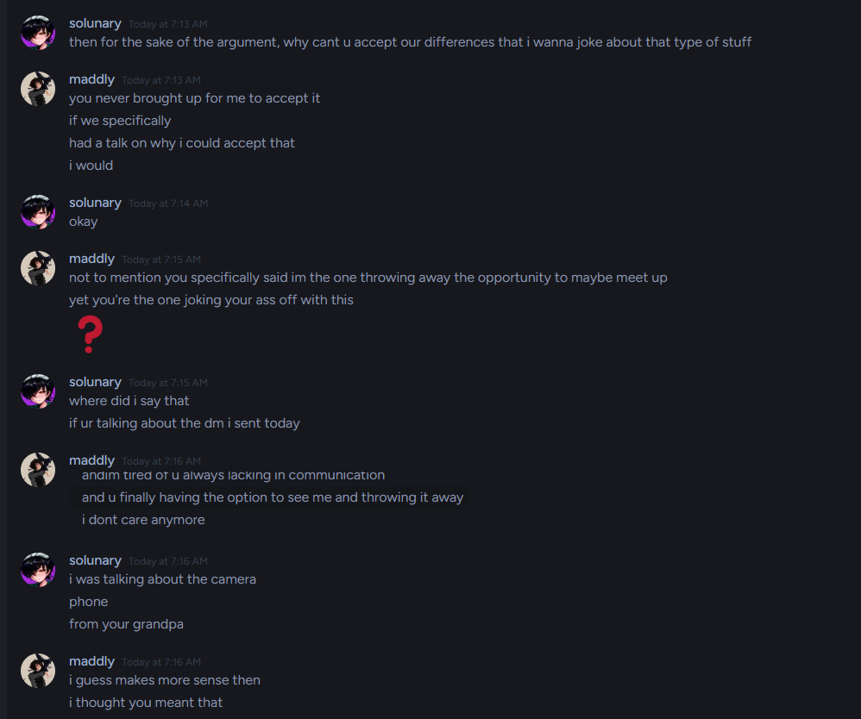
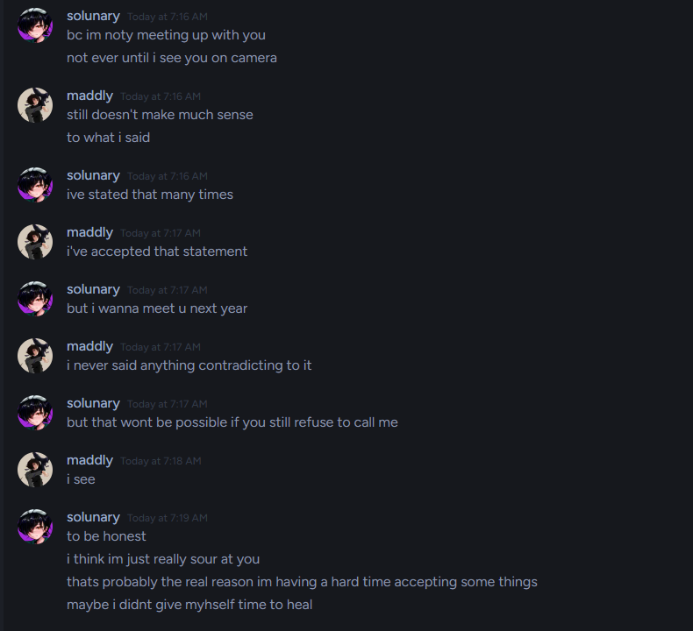
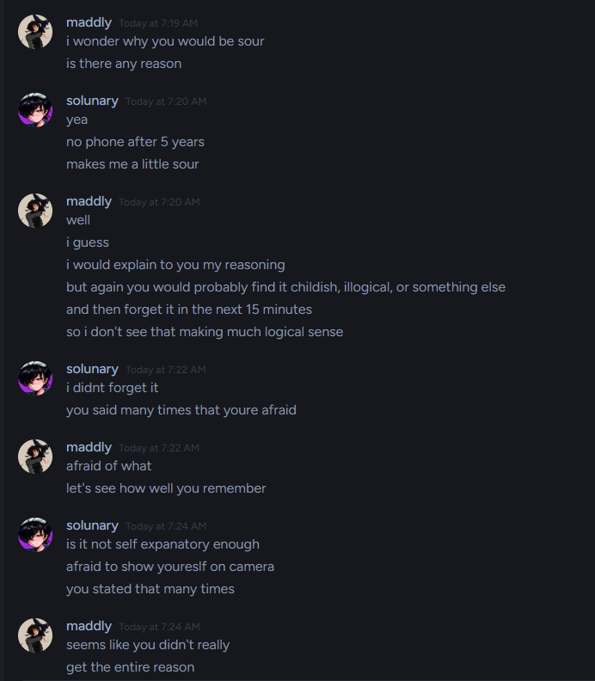
The reason will stay private, as it insights into my personal trauma, which I’m not comfortable sharing, and it wouldn’t give anything to this case. I’ll skip a little.

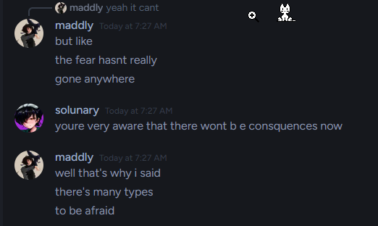
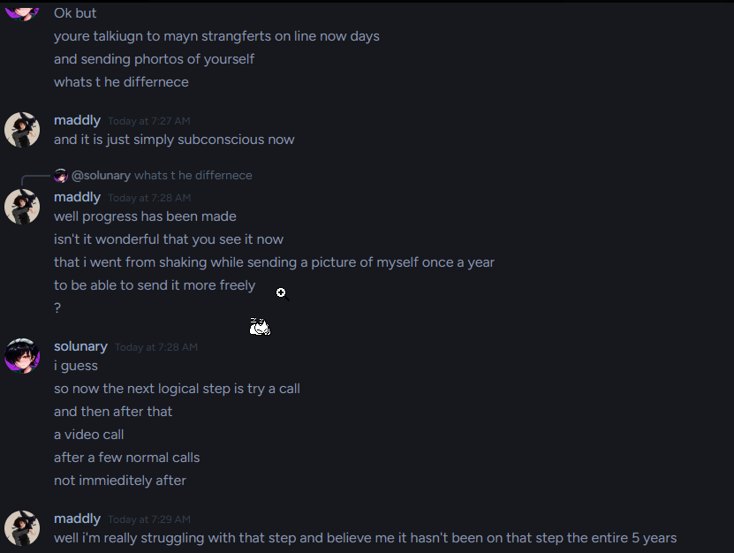
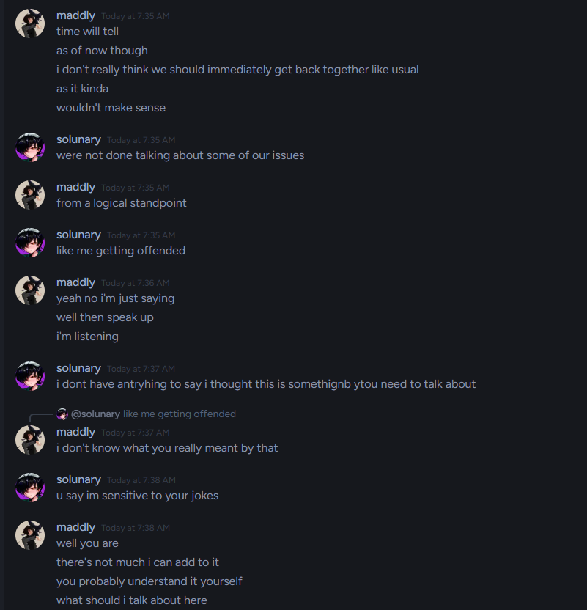
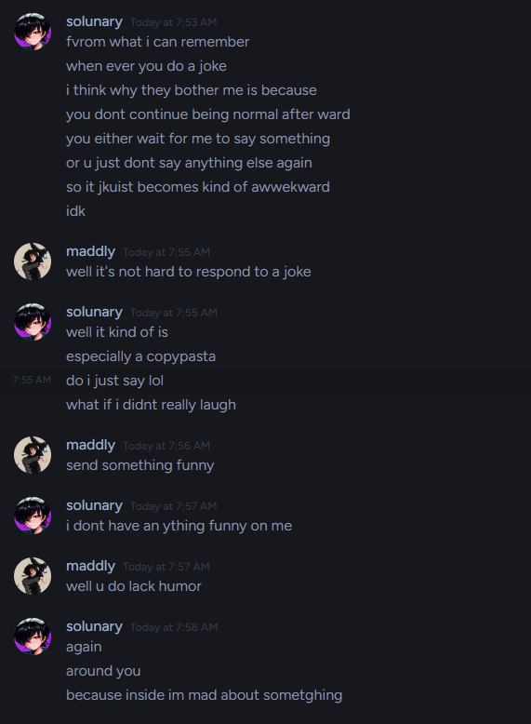
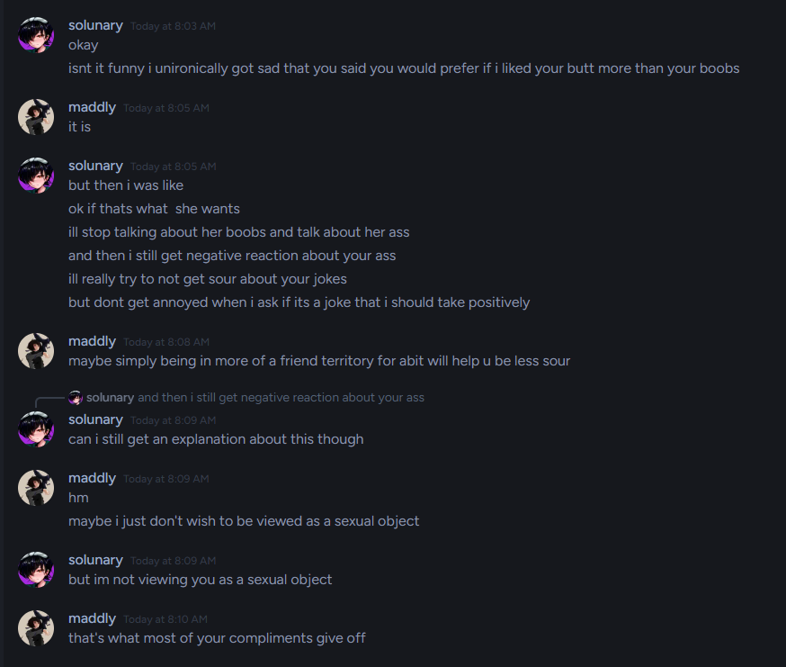
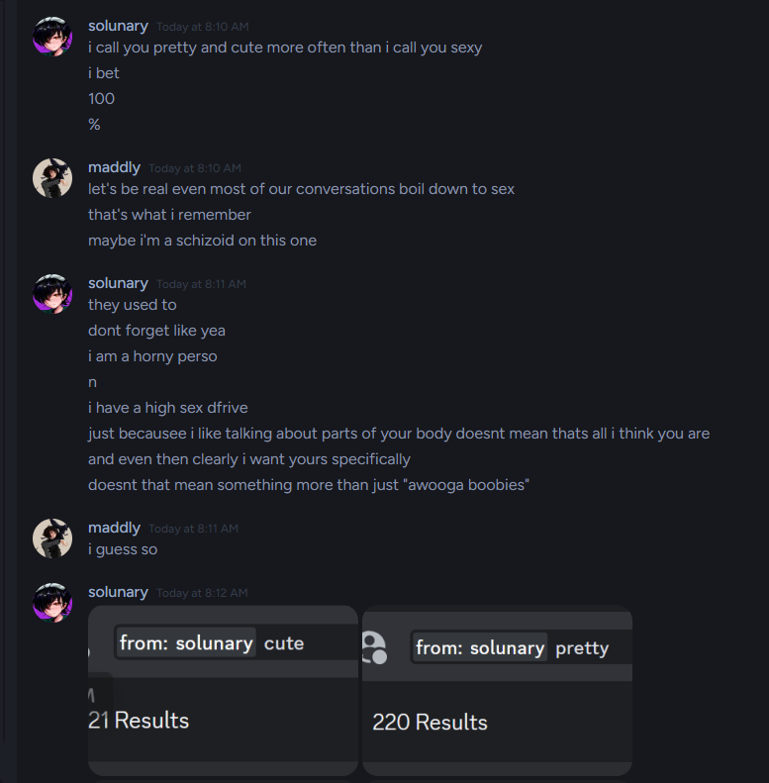
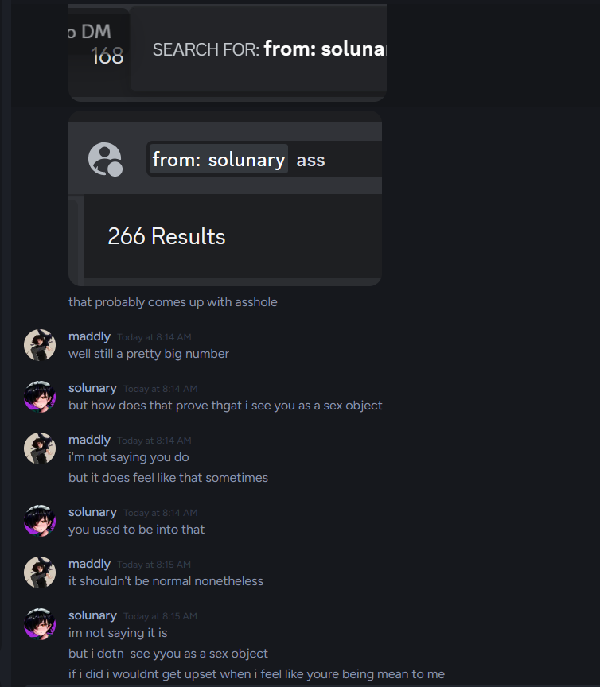
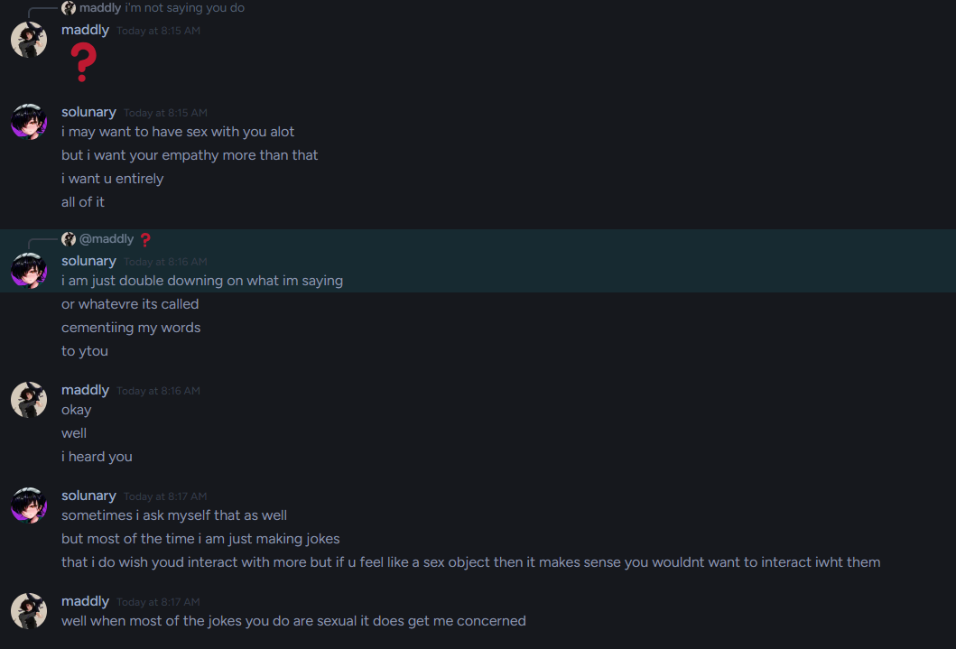
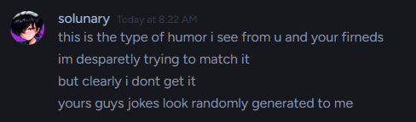
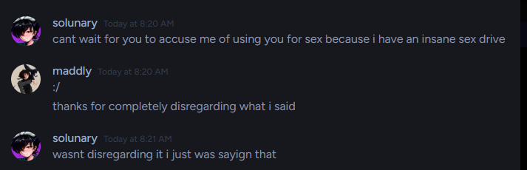

Then he proceeded to end the conversation and block me again. Which made me lose my temper.
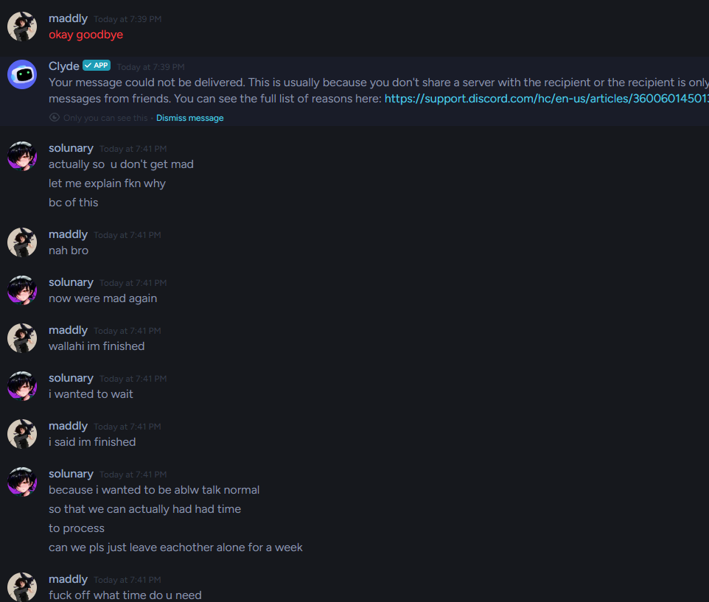
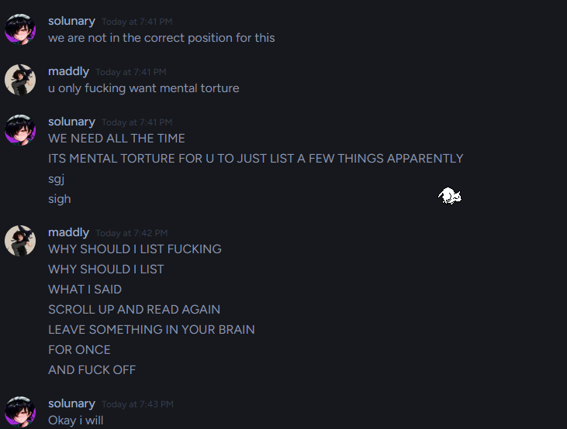
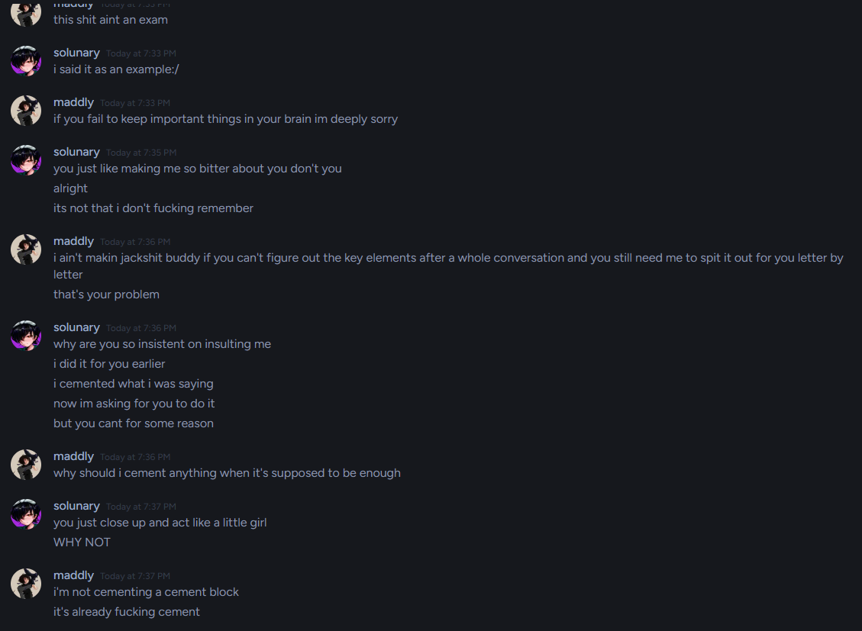
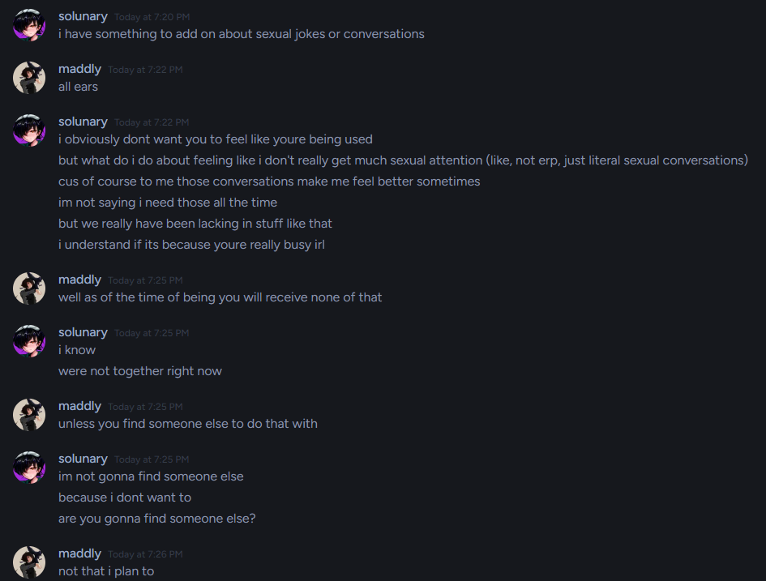
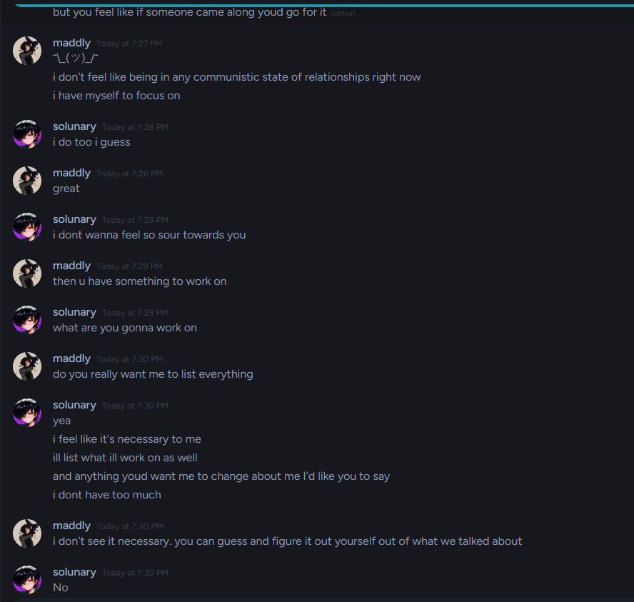
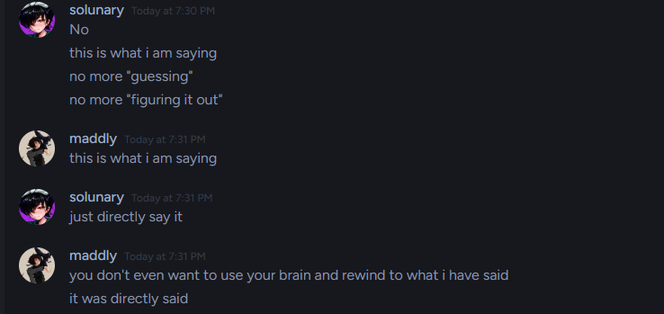
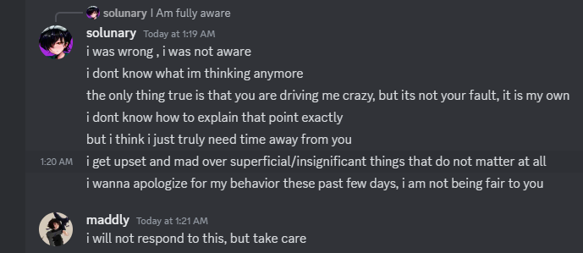

Time went on, and we started talking again, because he convinced me he’d try to be a better person, so I decided to give him a chance.
I saw no improvement and decided to tell him I'll write one big message, explaining to him thoroughly everything I found wrong with him, to, hopefully, help him understand his problems for once, and try to improve.

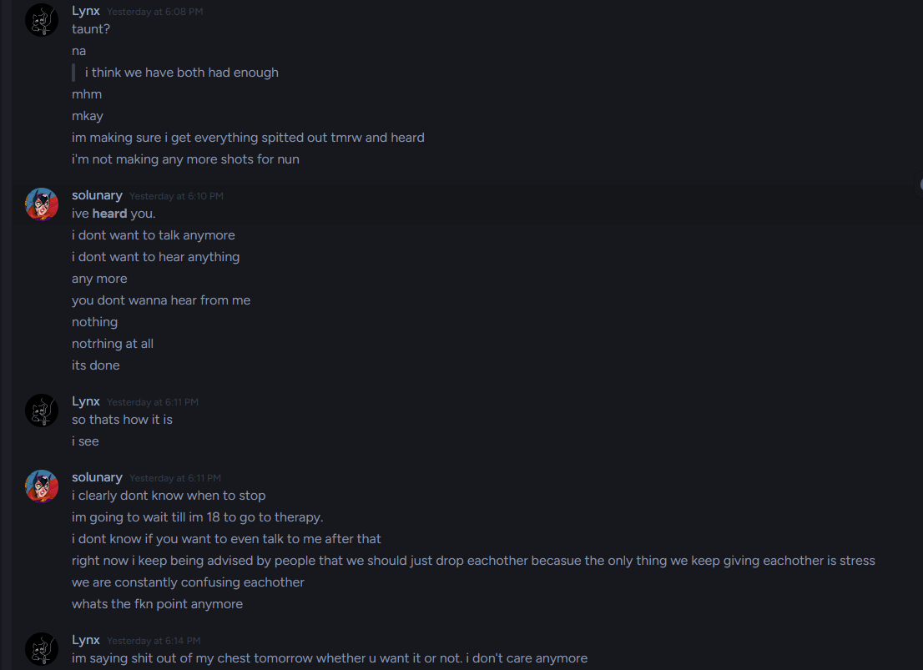

He started having a panic attack and I backed off.

You can see I was tired of everything at that point, and I wasn't being “the most compassionate”, but it's a given when you give hundreds of chances for redemption and see no success in years.
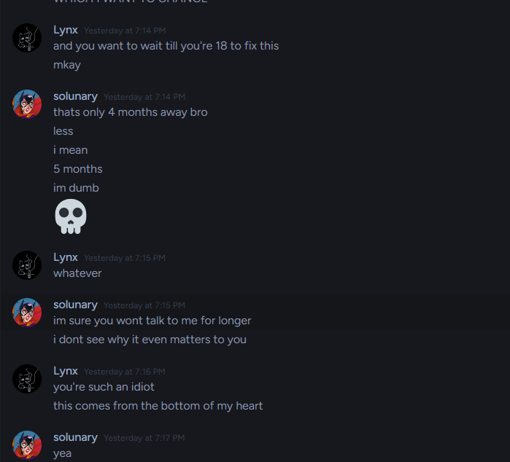
I started completely losing my temper here.

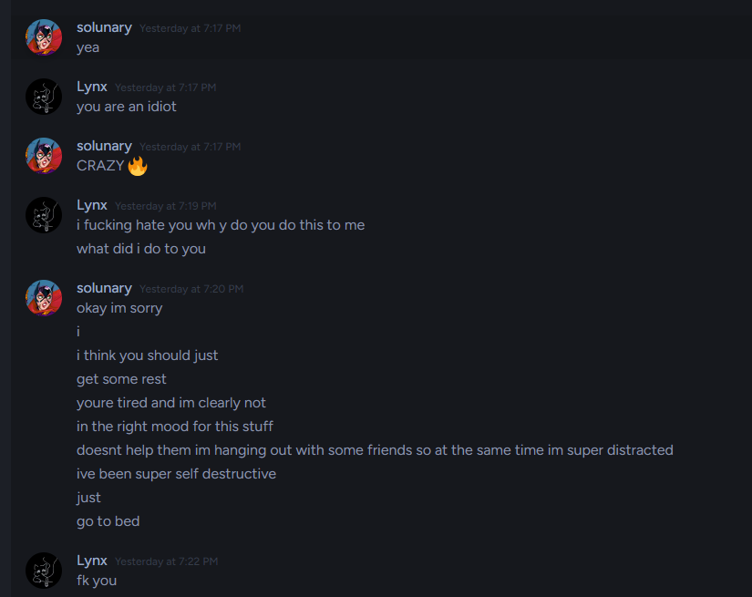
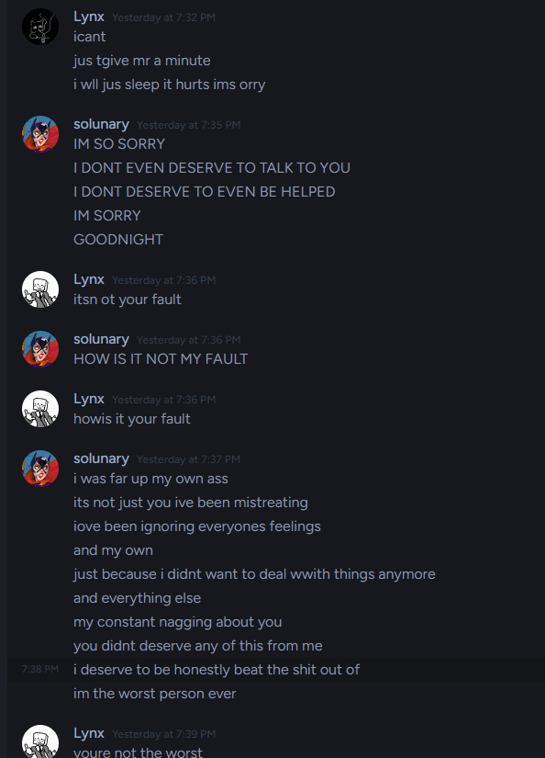
Even at that point I was expecting some remorse for his actions.

That’s where that topic ended for a little bit.

We talked again, but after everything, I wasn’t much comfortable talking with him, and upon such realization I blocked him without an explanation. Later he DMed hktuber to try and talk to me.
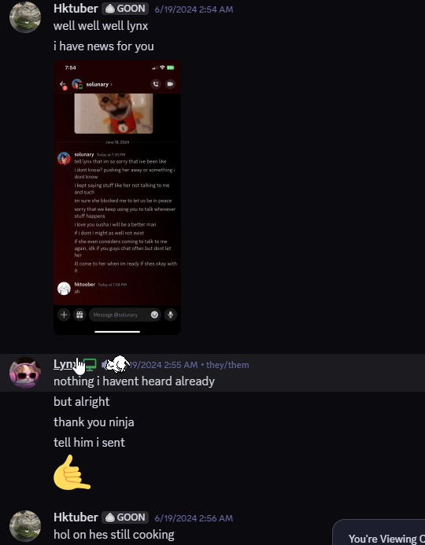
Here’s the screenshot.

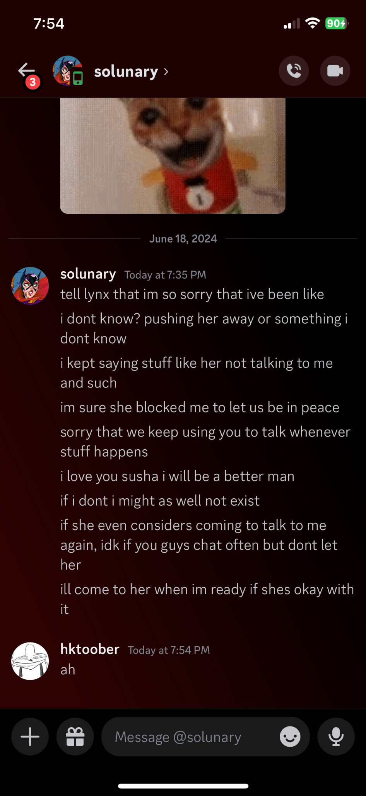
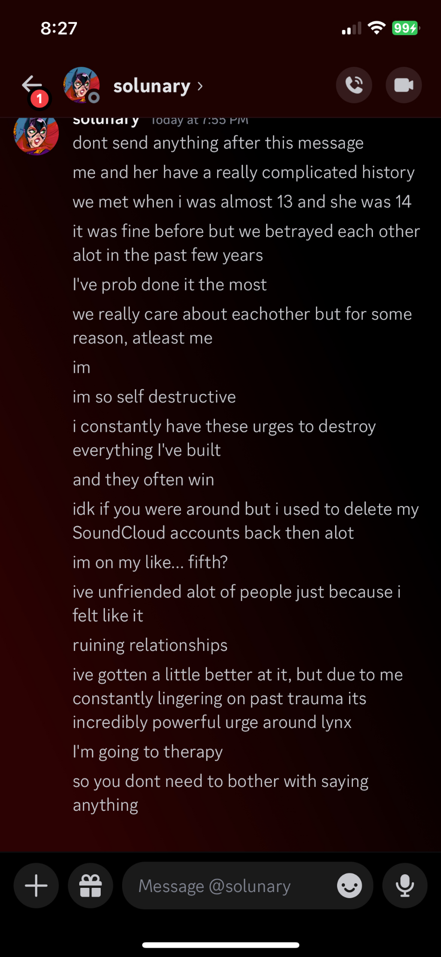
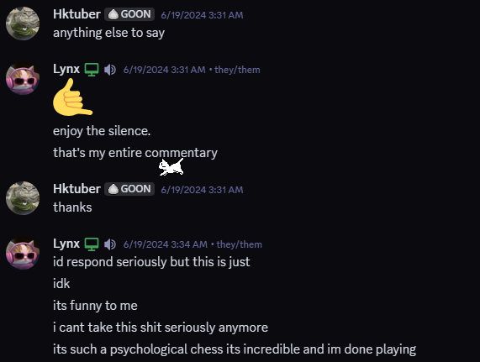
He sent that screenshot to Solunary. Here’s what his response was.

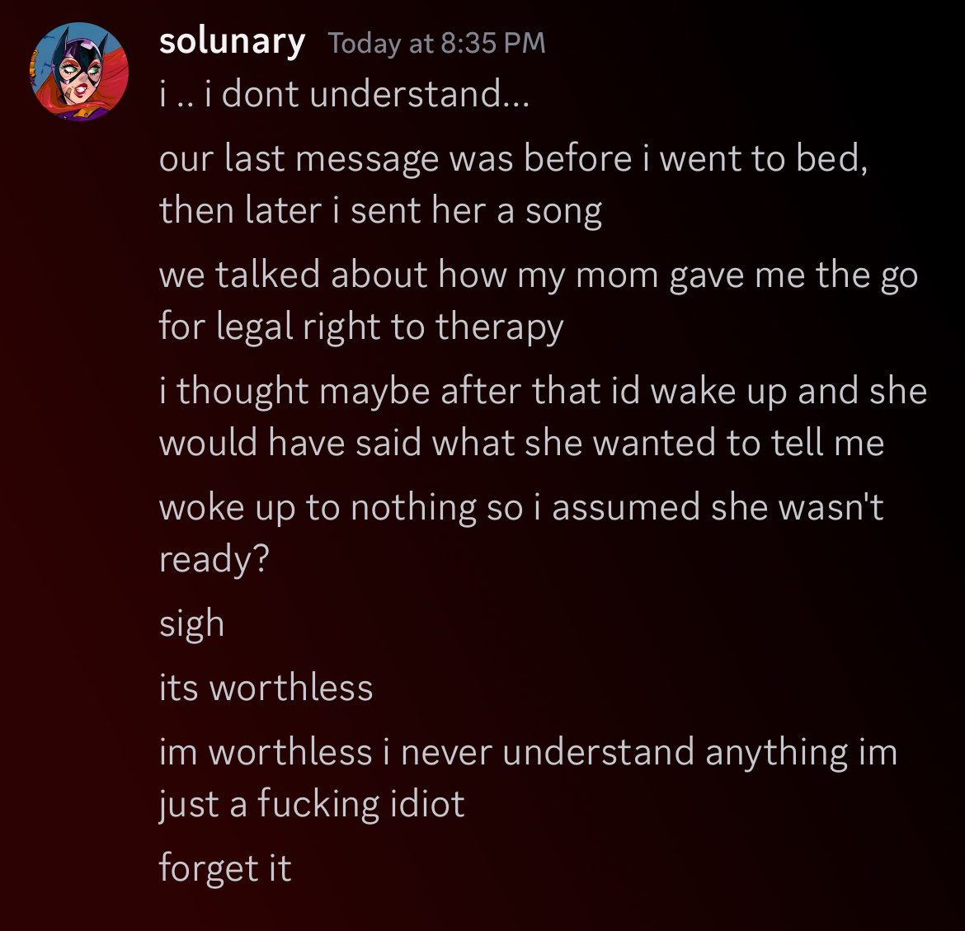

The next day he messages me on soundcloud, urgent to talk, so we move to discord.

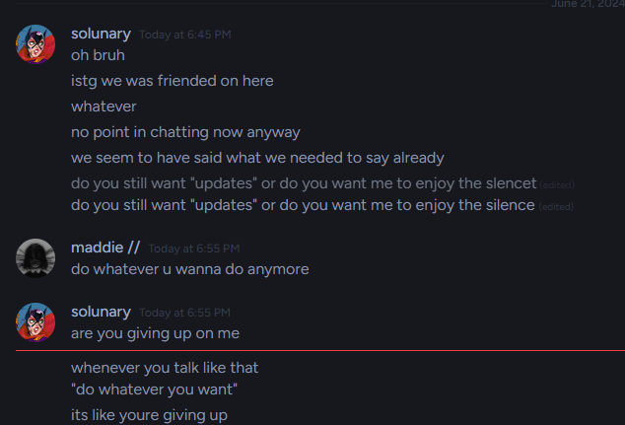
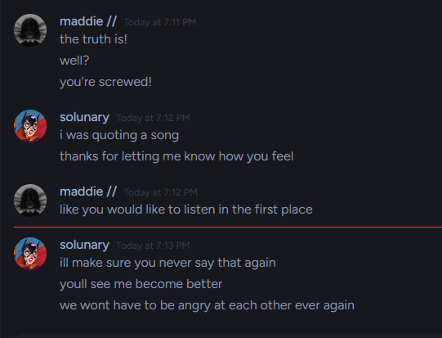
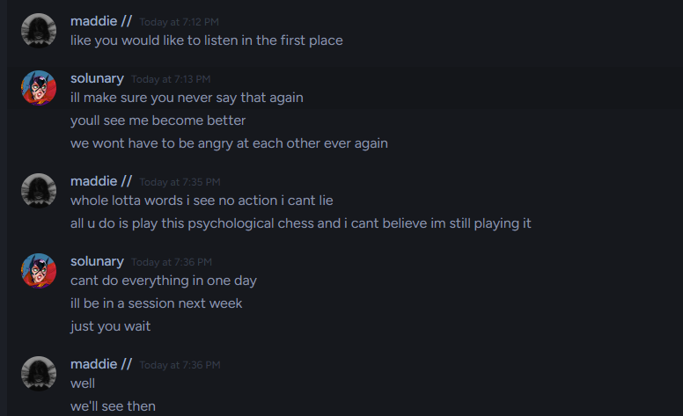
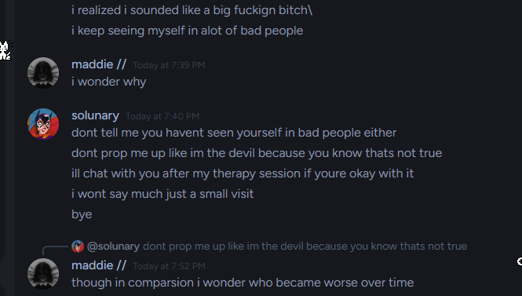
Some information will be cut out, as it’s his personal information.

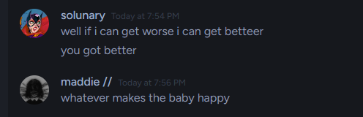
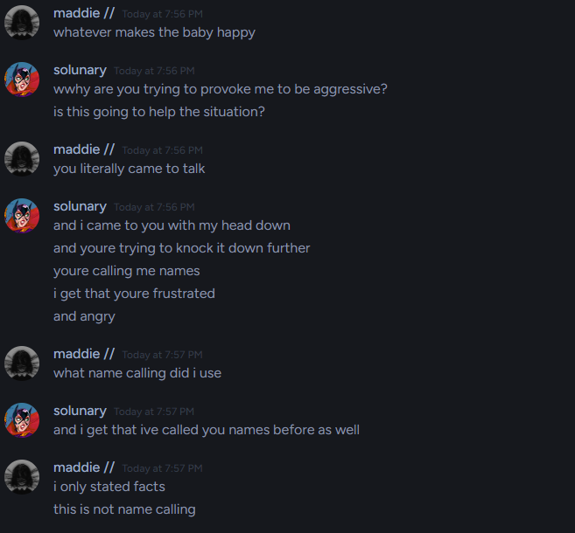
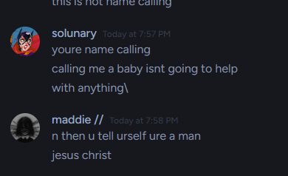
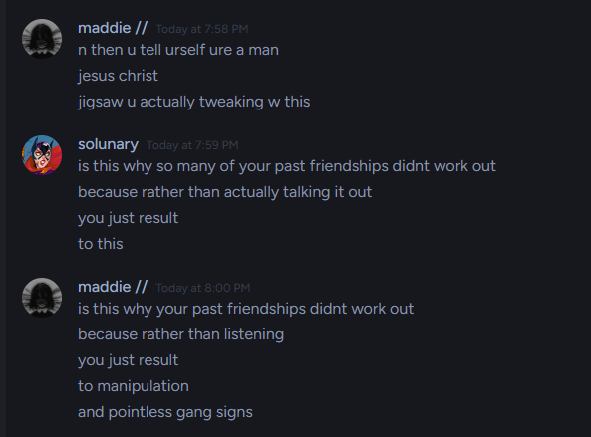
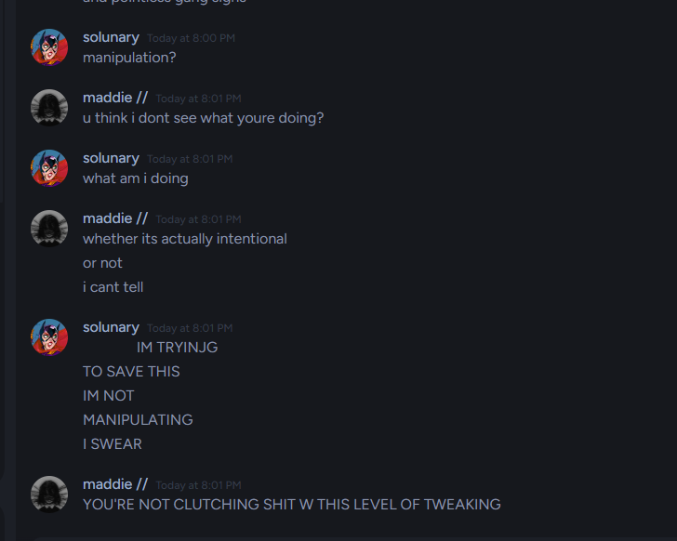
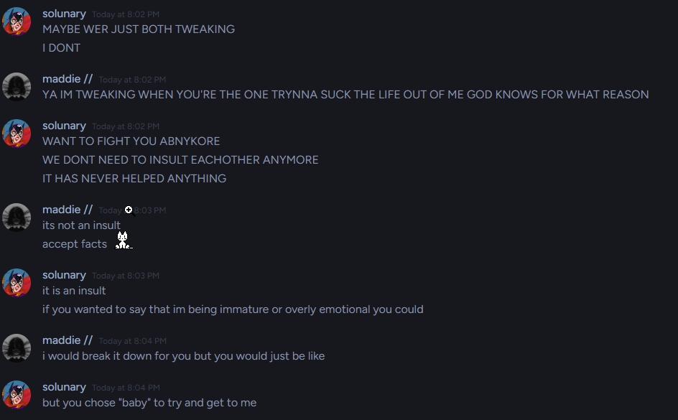
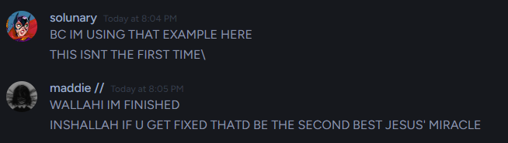
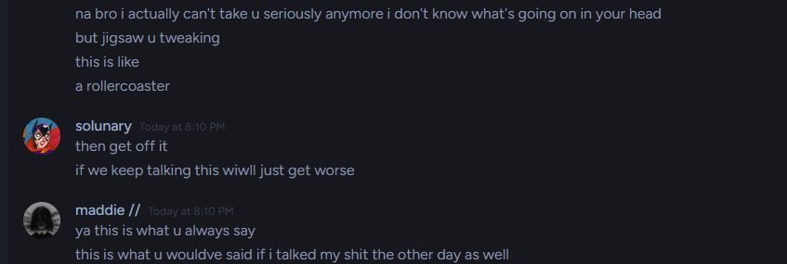
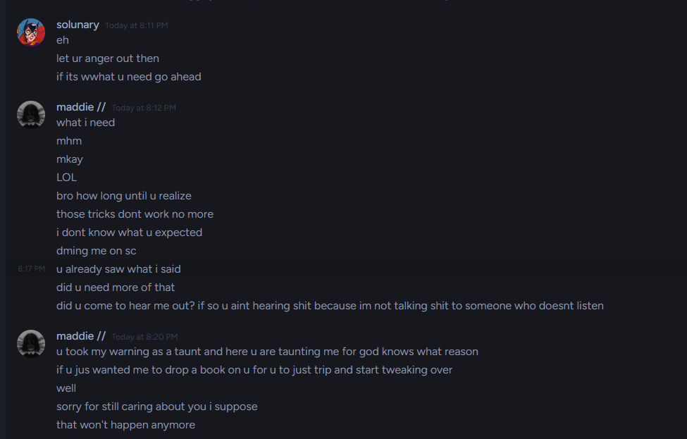

This is where we left off for a while. He started ghosting me. Then we talked “one last time.”

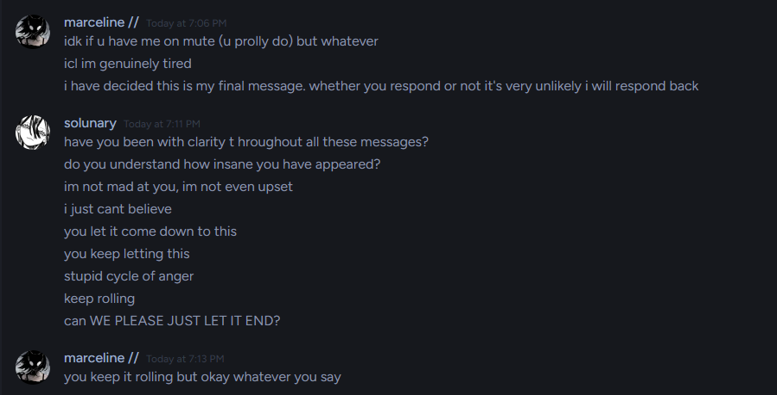
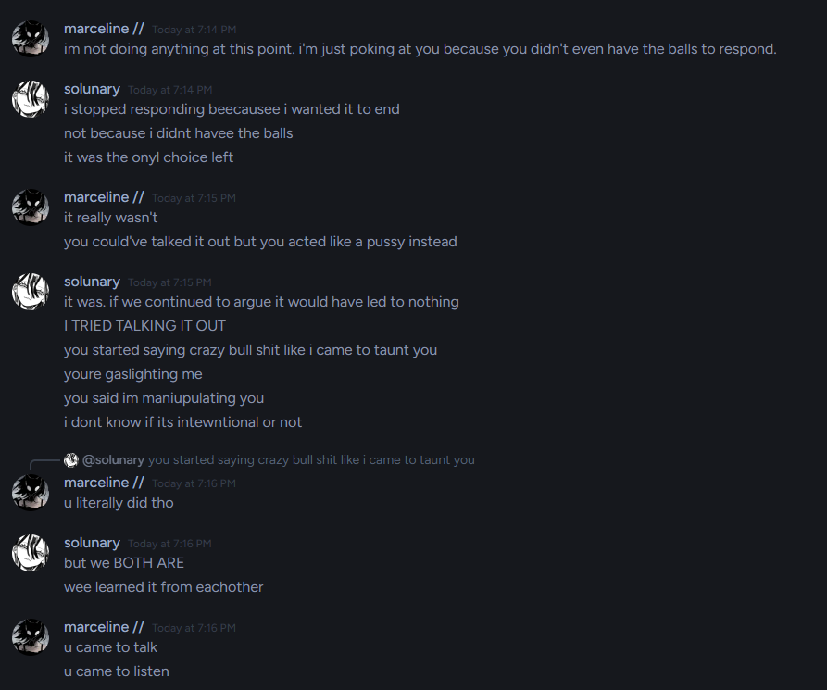
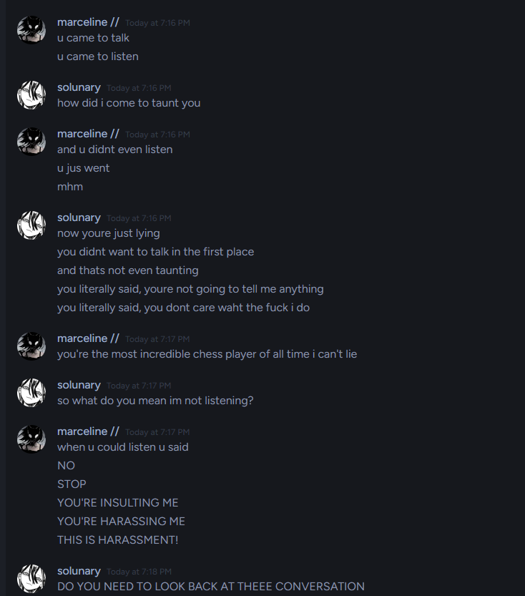
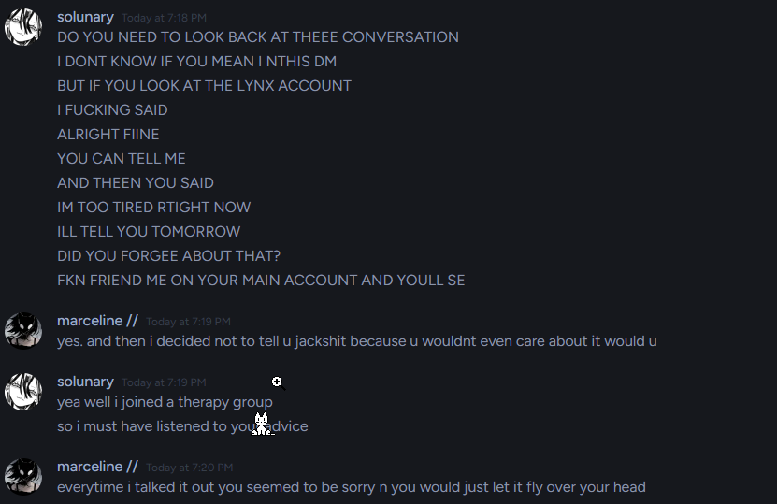
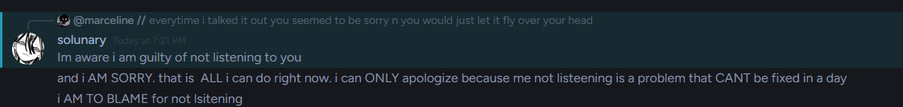
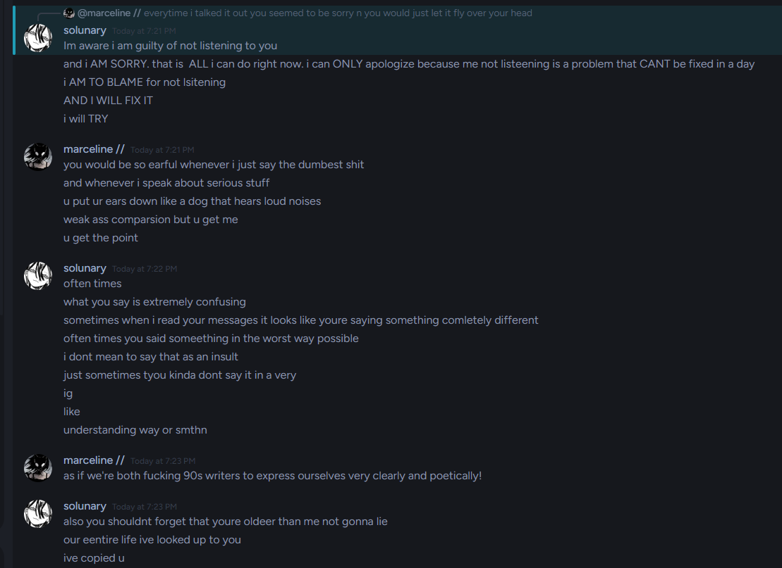
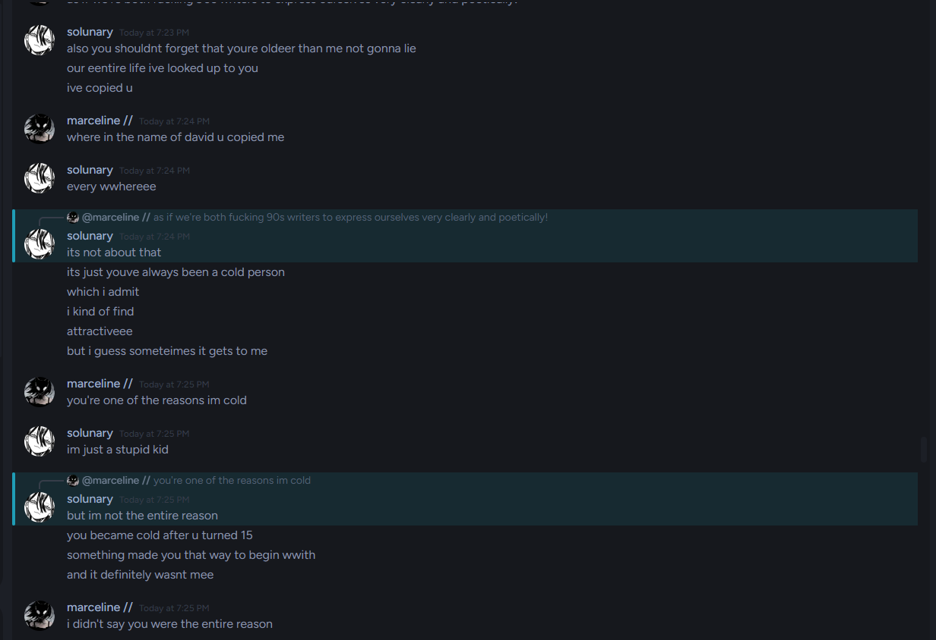
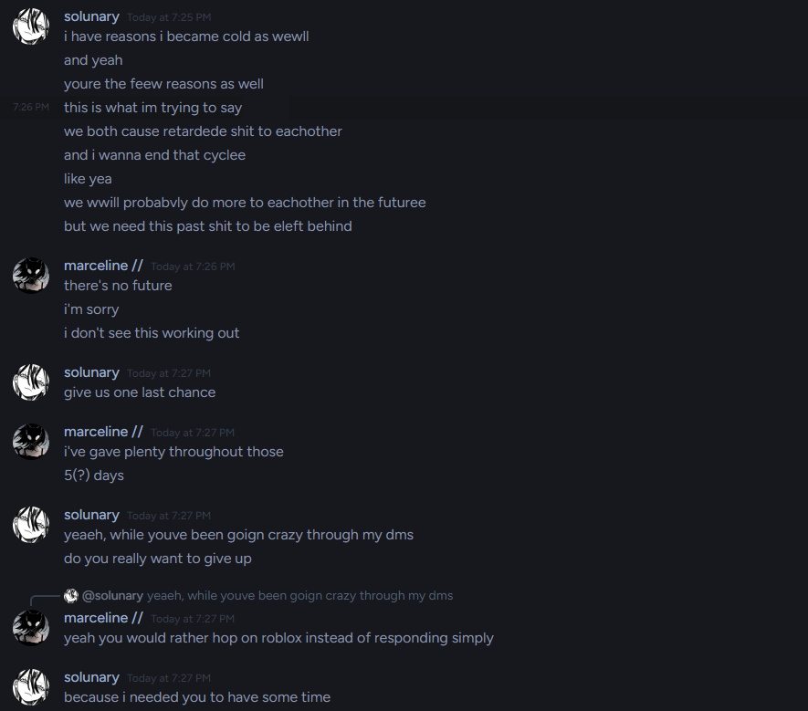
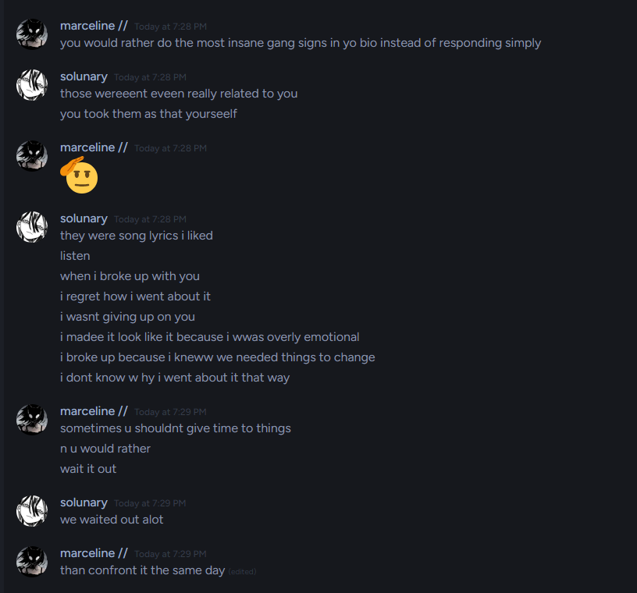
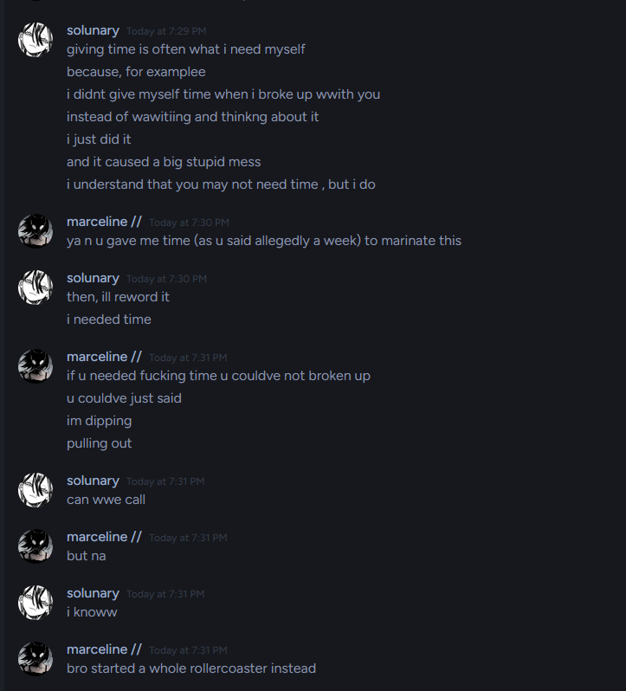
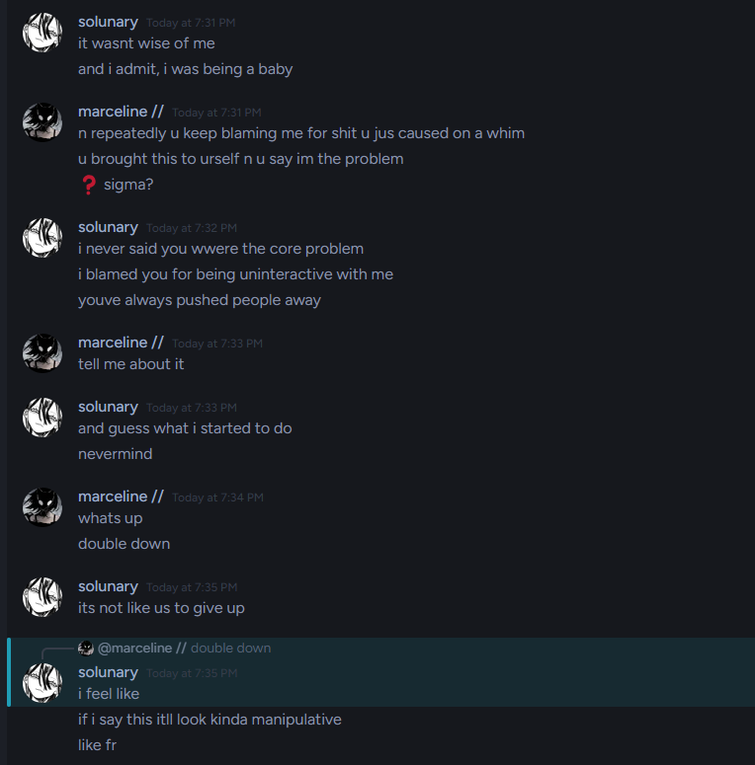
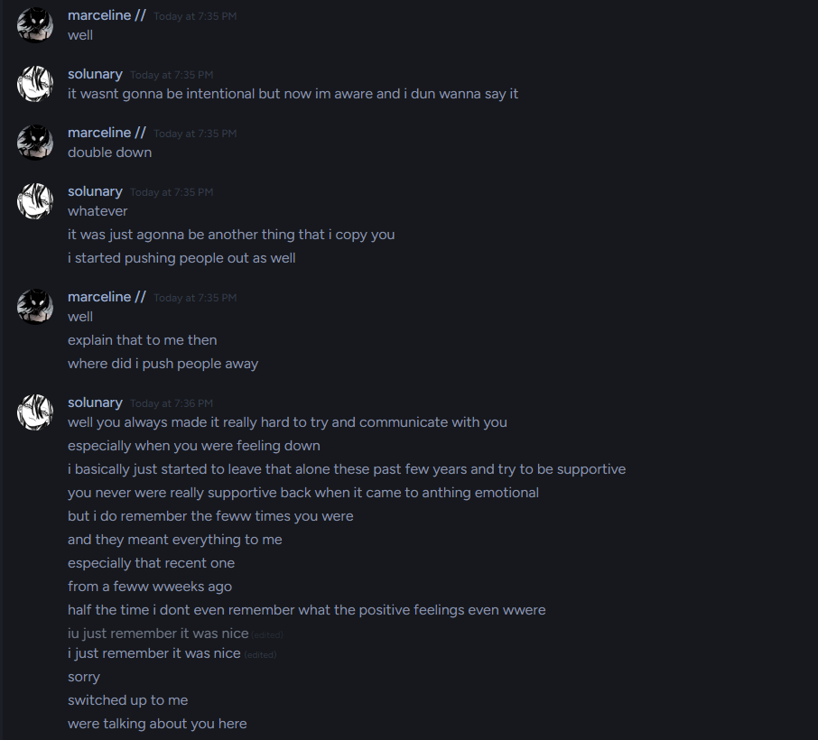
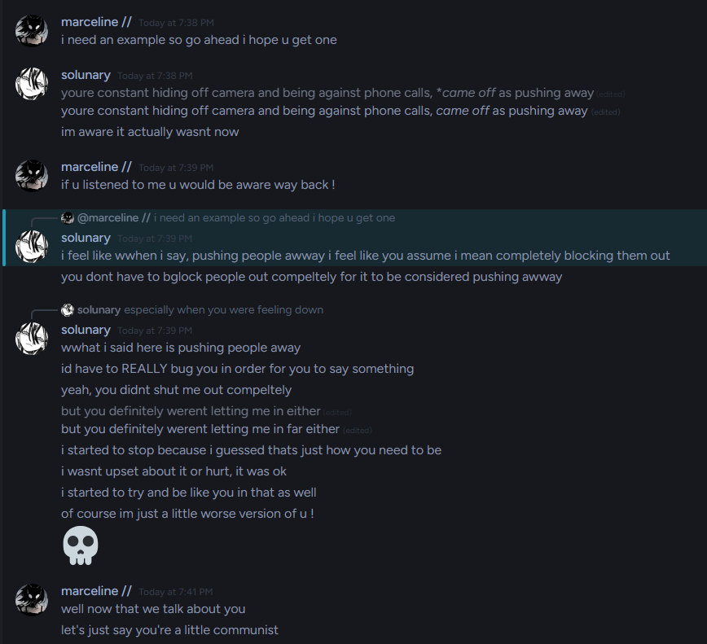
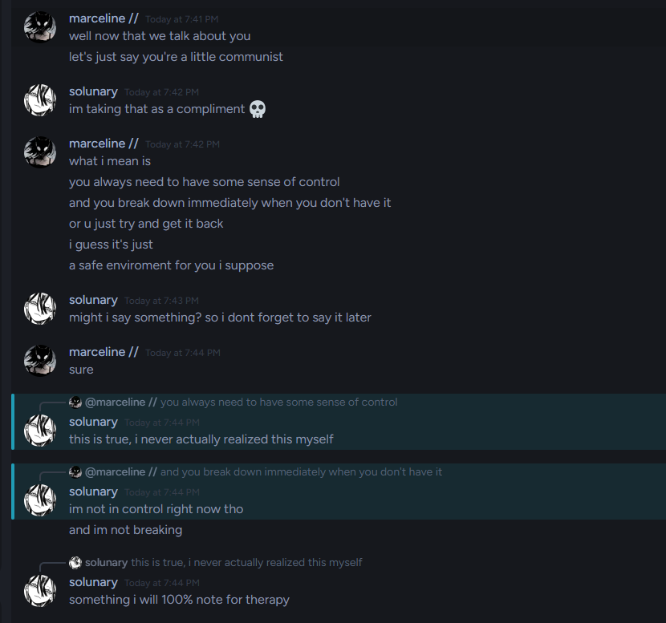
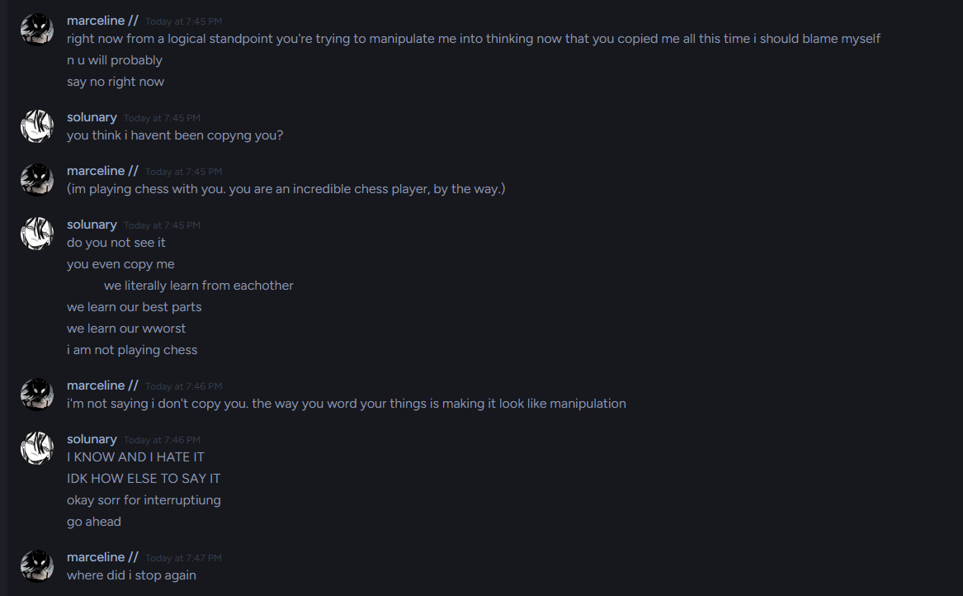
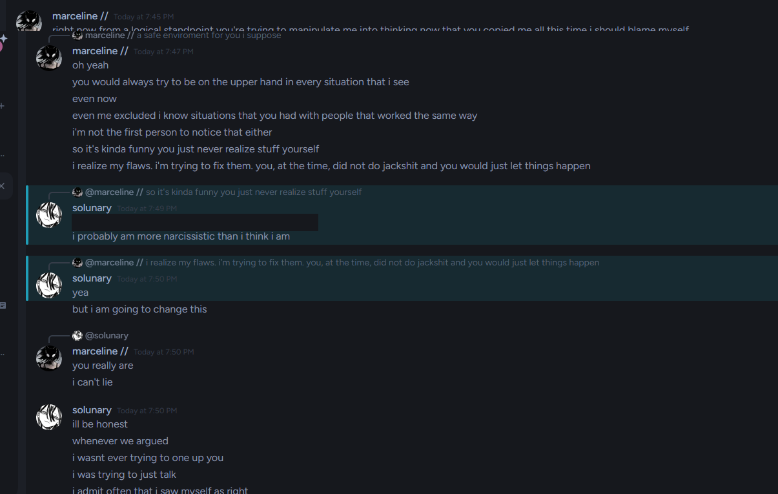
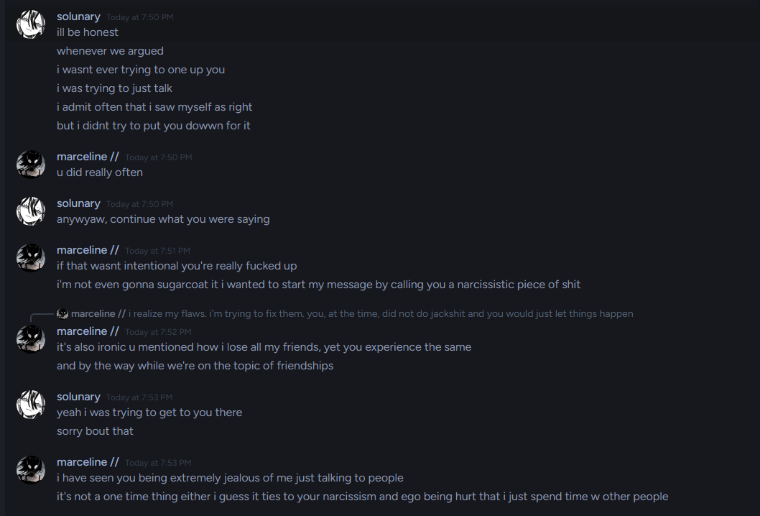
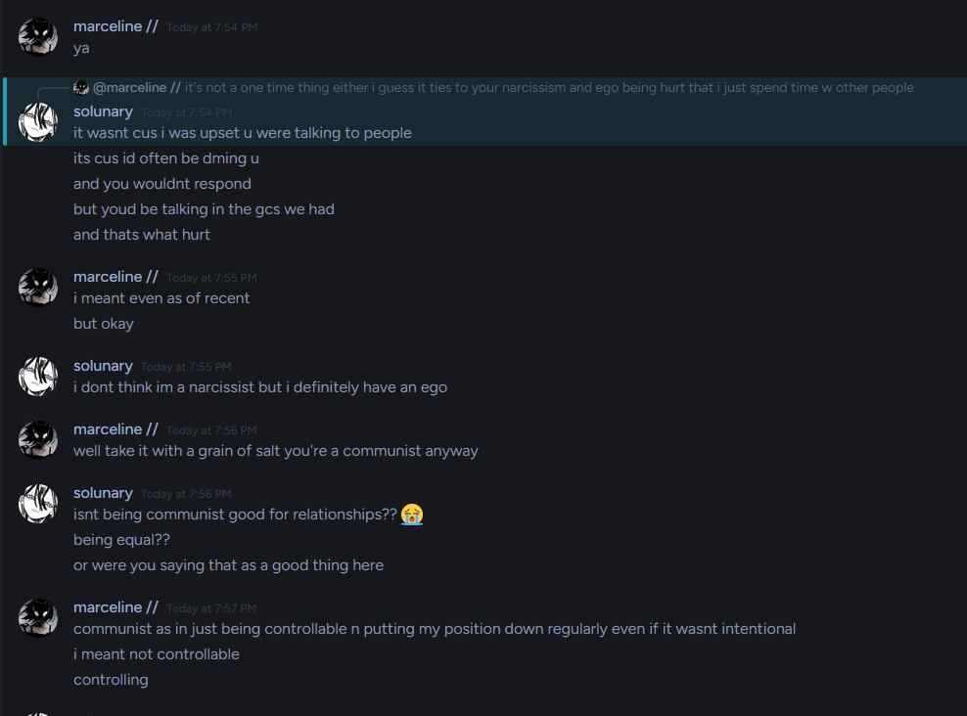
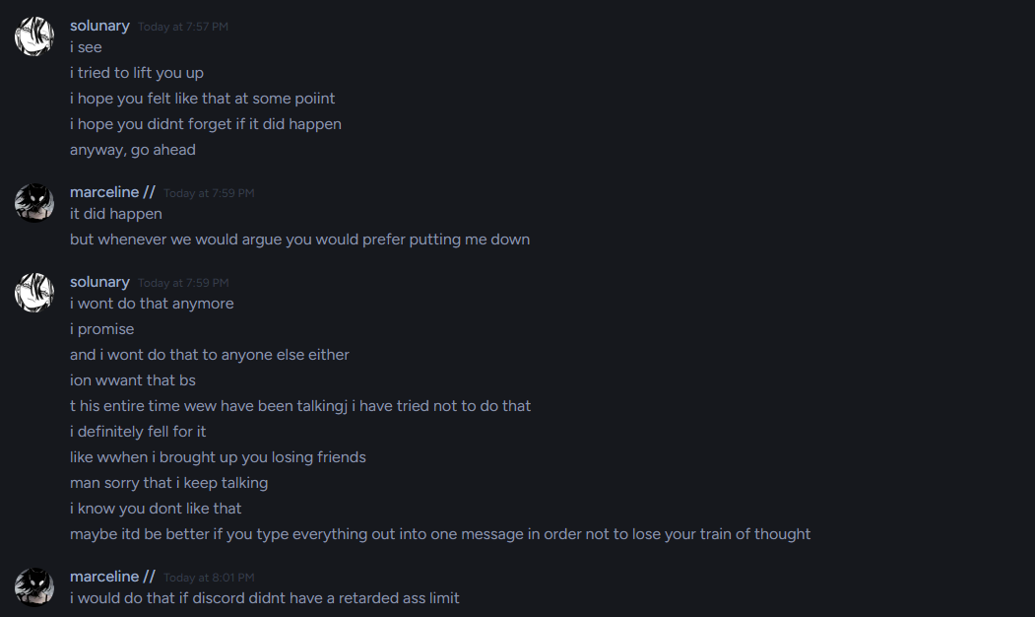
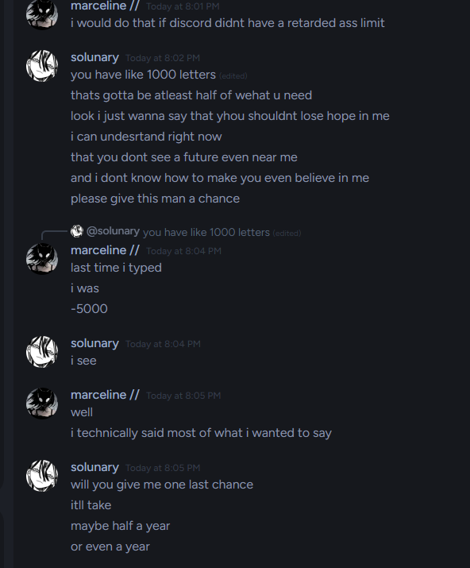
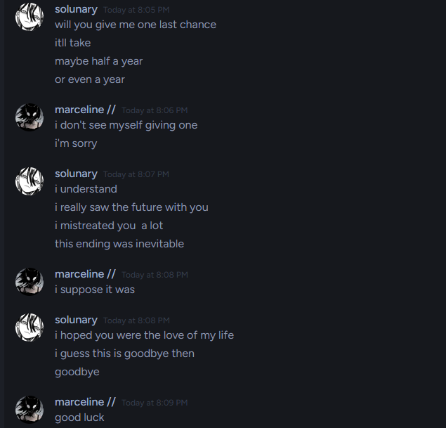

That’s where I hoped it’d end.

My life started getting better, and I engaged into a relationship.
Solunary, miraculously, sent me a friend request from his alt account the same day as my bio stated that i was in another relationship. Here’s how that went.

Do note the screenshots further will be taken from a chat render, as he blocked me on that account and I don’t have DMs with it open anymore, so I don’t think i can recover images sent there.

I will also leave out personal details out of respect.

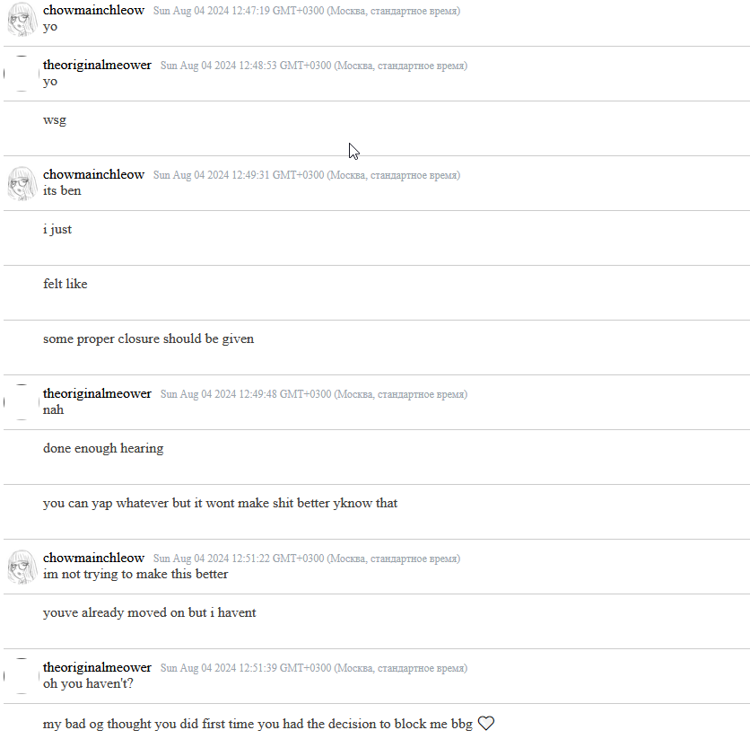
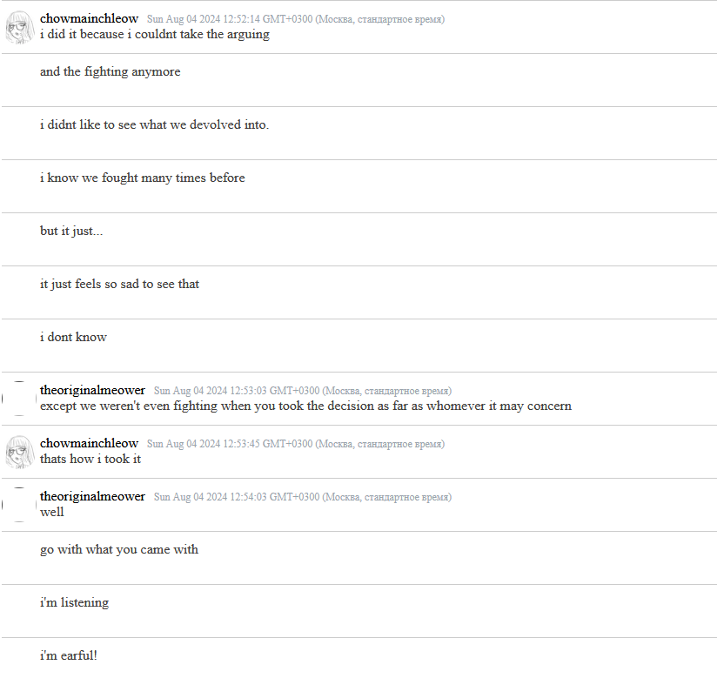
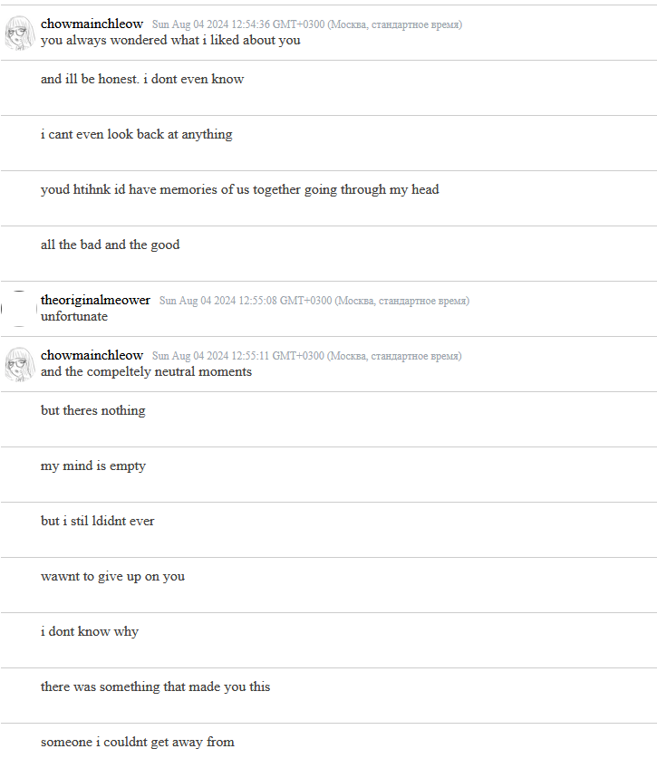
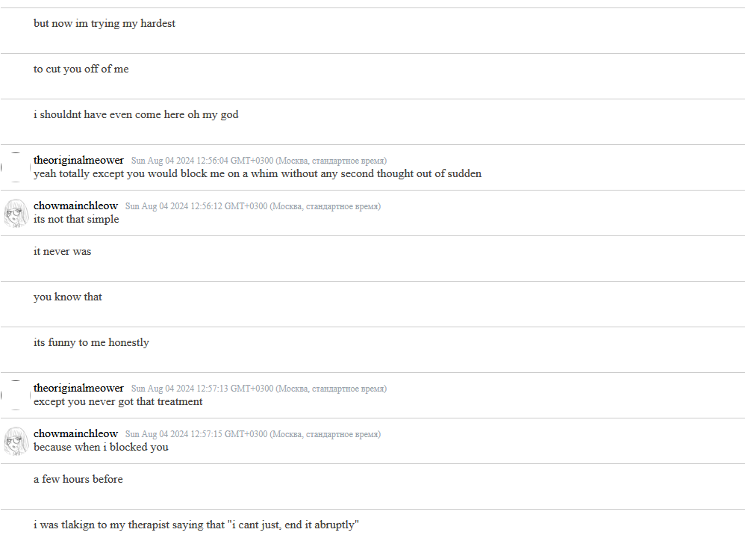
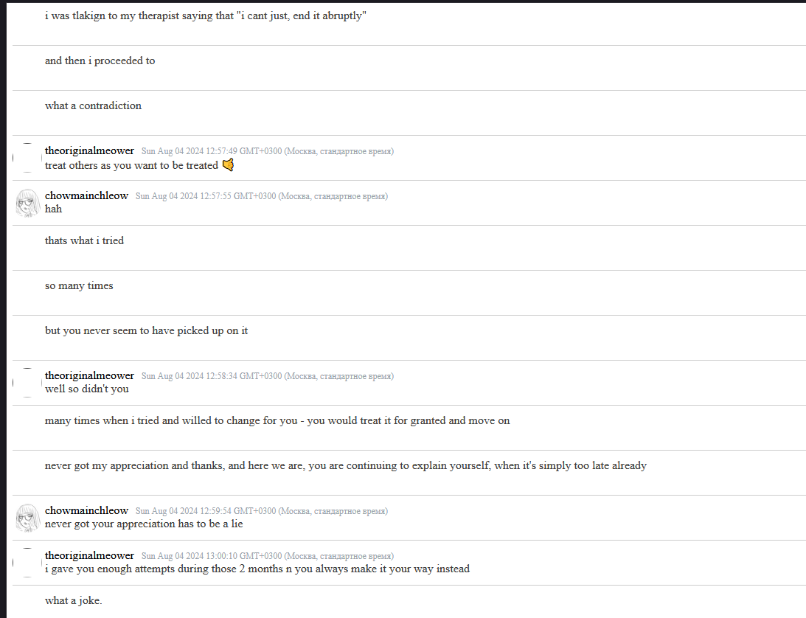
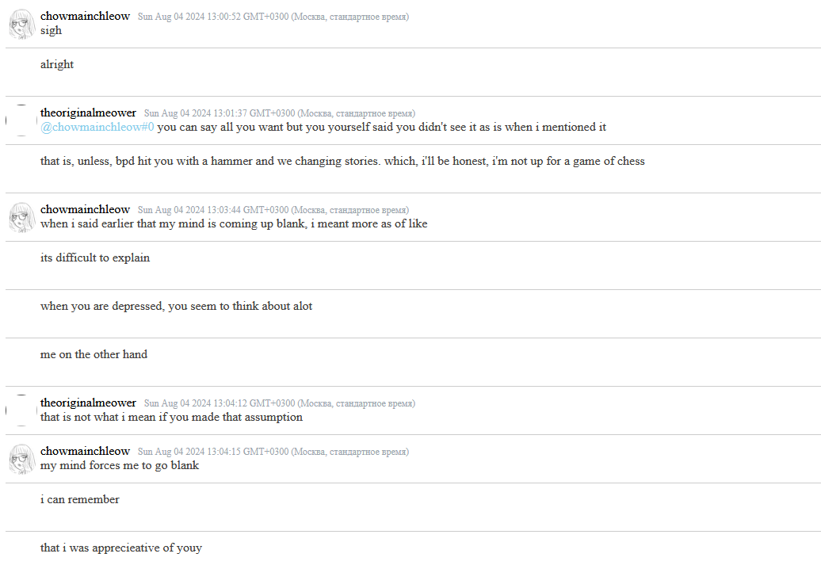
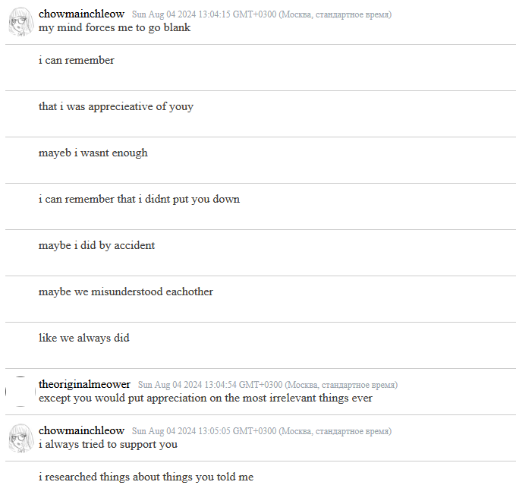
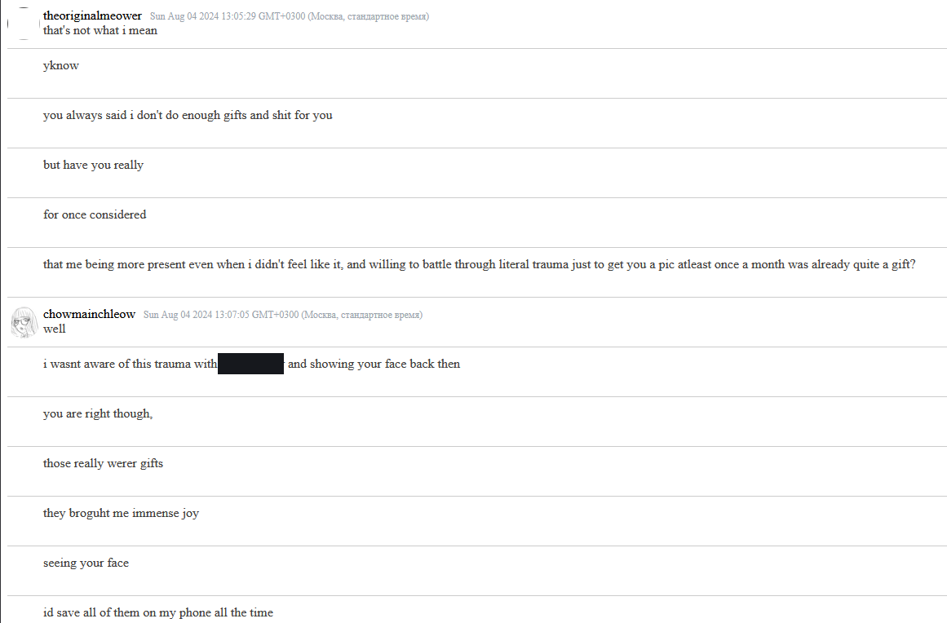
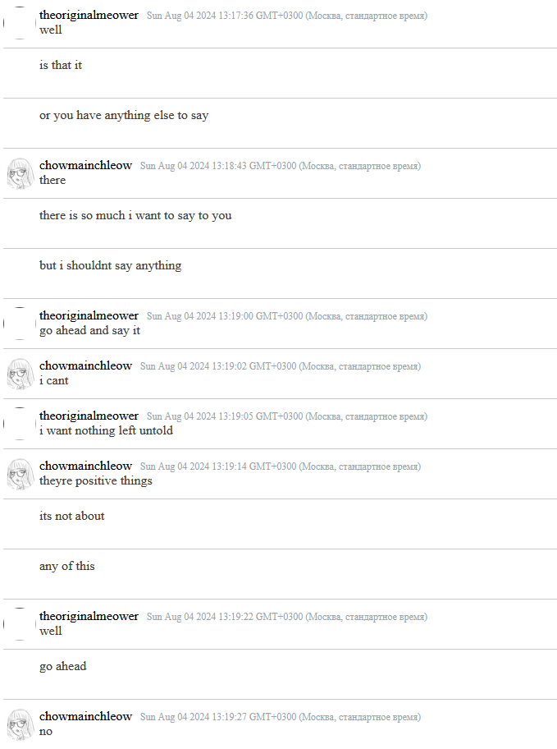
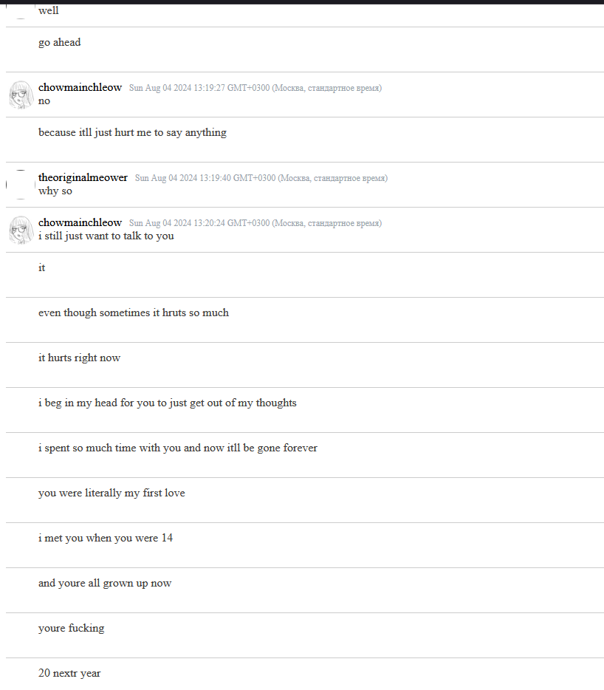
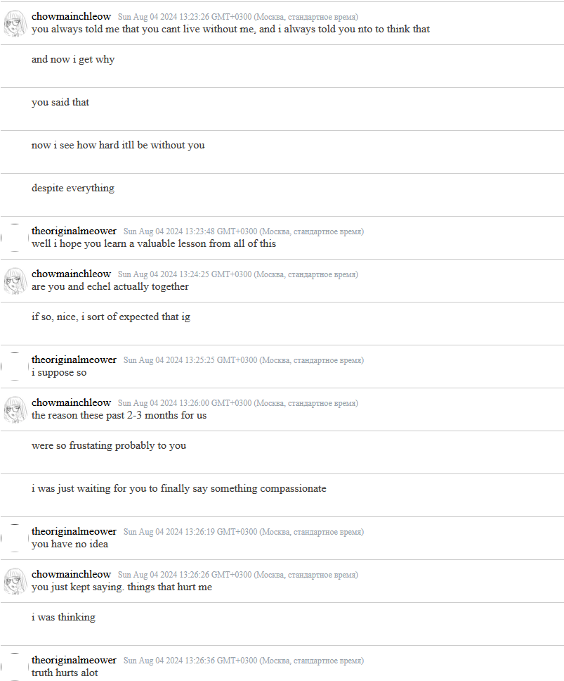
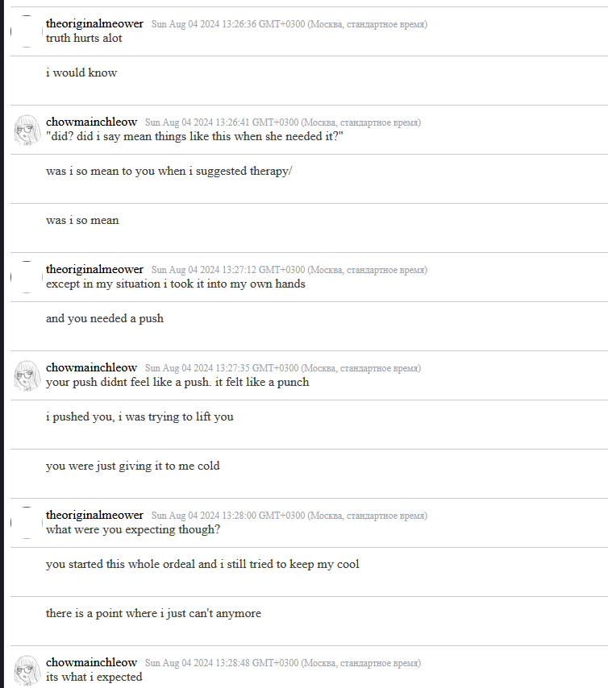
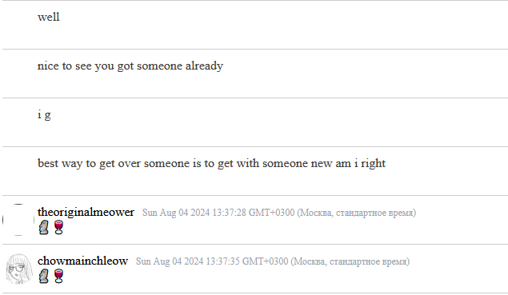
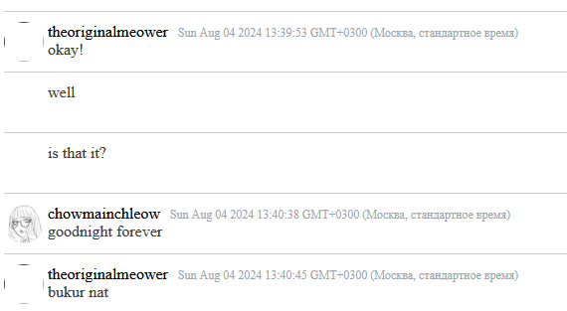

There have been many other instances similar to this, but I hope this settles it enough.

Conclusion

In the end, I want to say that I’m not the only person who suffered through negative experiences of his behavior, but I decided not to include experiences that aren’t mine, and if those people wish - they will speak up on their own.

Oh, and also,
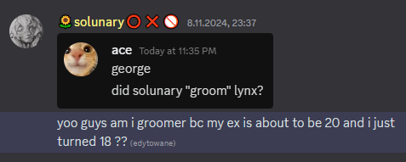

In short, Solunary did “groom” me. Yes, a person younger than you can absolutely groom you. The core of grooming is not about age, but about an imbalance of power and a process of manipulation.

He is what happens when a young kid gets exposure to porn.

Keep in mind, that this entire document does not cover absolutely everything that has happened and been said, if needed I will update this document in the future. If any of you reading this need some clarifications, my discord tag is “theoriginalmeower”

On this note, this is how it ends for now.

Thank you for reading.

