

Direct Messages
Bunny
After 22-Feb-19 12:00 AM

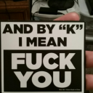
ArthurDank 22-Feb-19 10:29 AM

so what happened last night? ;)

see ya never came back


Bunny 22-Feb-19 11:34 AM

Yeah sorry about that

We did actually have a lot of fun after the D&D session

ArthurDank 22-Feb-19 11:35 AM

no biggie

oh really?

sounds nice

how much fun? ;)

Bunny 22-Feb-19 11:42 AM

A lot actually~

I didn’t even have to take off my bike shorts lol

ArthurDank 22-Feb-19 11:46 AM

lol nice these bike shorts sound legendary

so what all did you do? i am a curious person lol

last i heard you were under the blankets waiting

why take em off when he can do you through them ;)

Bunny 22-Feb-19 12:00 PM

I basically rode him after he took the enhancer again

I couldn’t walk properly afterwards

I actually bit the blanket lol

ArthurDank 22-Feb-19 12:01 PM

wow you bit the blanket while riding him? that dick got even thicker

rode him thats always hot

Bunny 22-Feb-19 12:03 PM

I did put together another outfit if you’re interested

ArthurDank 22-Feb-19 12:04 PM

always interested

battery just hit %69 lol

Bunny 22-Feb-19 12:09 PM

You like those gym bloomers right? Kouji does a lot actually

ArthurDank 22-Feb-19 12:10 PM

sure do and he has good taste ;)

fucking a chick in gym or bike shorts is hot

ArthurDank 22-Feb-19 12:23 PM

hearing about this stuff in the past tense still gets me worked up its nice lol look forward to seeing this outfit

Bunny 22-Feb-19 12:37 PM

Here ya go

Binding in this one btw

ArthurDank 22-Feb-19 12:40 PM

oh hot

Bunny 22-Feb-19 12:40 PM

A bit of leggy
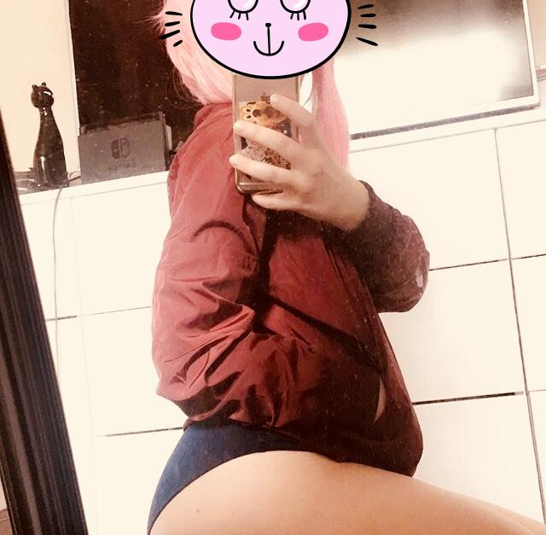

ArthurDank 22-Feb-19 12:41 PM

im not complaining those leggys look nice

and those shorts and everything else no wonder he fucks you in those

i love it i just went full mast lmao

Bunny 22-Feb-19 12:42 PM

Lmao

They are really tight lol

ArthurDank 22-Feb-19 12:43 PM

they look it on on fine hips like yours

lmao they look so hot on you they really dont leave anything to the imagination

and you were riding him in those?

what a mental image

kinda imagining that butt in those shorts bouncing up and down hehe thank you for letting me see lory ;) saw your outfit and shorts all at one

Bunny 22-Feb-19 12:51 PM

Yuuuup I was riding him in those

ArthurDank 22-Feb-19 12:51 PM

yum

also like the pink wig

Bunny 22-Feb-19 12:53 PM

The shorts are stretchy so it’s easy for him to push his cock in lol

ArthurDank 22-Feb-19 12:53 PM

lol nice they do look tactical

i was thinking about you biting the blanket while riding him, that must've been a hell of an orgasm

Bunny 22-Feb-19 12:55 PM

We started doing it raw up front more often

Without the enhancers I could barely get half of him in

ArthurDank 22-Feb-19 12:55 PM

wow thats hot

now it must be even more difficult

thats hot tho probably making your pussy cum even harder then before

Bunny 22-Feb-19 12:59 PM

I have been squirting a lot more than with my ass lol but to be fair I’m still tight up front

Despite being railed by a nearly 10 inch cock lol

ArthurDank 22-Feb-19 01:00 PM

lmao i know you have a hell of a pussy lory

squirting your brains out mmm

Bunny 22-Feb-19 01:01 PM

He has classes right now so we’ll probably fuck afterwards

ArthurDank 22-Feb-19 01:02 PM

sounds like fun

;)

you guys fucking every chance you get is really hot to imagine

Bunny 22-Feb-19 01:05 PM

What can I say? I like cock lol

ArthurDank 22-Feb-19 01:06 PM

i know lmao i like hearing about it

Bunny 22-Feb-19 01:07 PM

It’s not really an outfit but I wanna do this one next

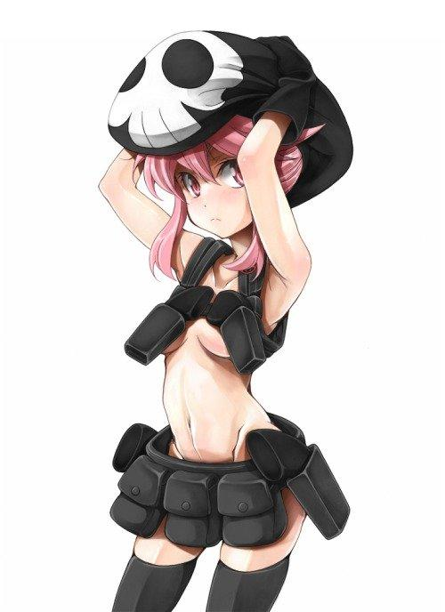

ArthurDank 22-Feb-19 01:08 PM

I'd kill to see you as nonon

Bunny 22-Feb-19 01:08 PM

Playing Oracle of Ages until he gets home

ArthurDank 22-Feb-19 01:08 PM

been a long time i like that game

Bunny 22-Feb-19 01:08 PM

Need some practice before I actually do an LP of it

ArthurDank 22-Feb-19 01:09 PM

look forward to that im sure you will be an ace

glad you are getting some practice in

Bunny 22-Feb-19 01:10 PM

I had it on GB

ArthurDank 22-Feb-19 01:10 PM

so did I

Bunny 22-Feb-19 01:10 PM

Dunno where Dad keeps my oldgames

I’ll ask next Wednesday

ArthurDank 22-Feb-19 01:11 PM

that sucks

dad not around much?

Bunny 22-Feb-19 01:11 PM

Business trips and stuff

ArthurDank 22-Feb-19 01:11 PM

oh wow thats impressive

sucks he ain't around much

Bunny 22-Feb-19 01:15 PM

Like I said the other day the issue with these Kill La Kill outfits isn’t that I’m embarrassed to wear them because I’m not a stranger to showing skin. The issue is fitting into them without looking like a stripper

ArthurDank 22-Feb-19 01:15 PM

i totally get you there

im glad you aren't embaressed as i hope to see you in them haha but yeah they wouldthink you were a stripper or high priced escort

i appreciate you sharing your sex life details and the pics always get me off too, i know you dont get quite the exhibition kick you did while texting tho

Bunny 22-Feb-19 01:18 PM

It’s fine honestly either way

ArthurDank 22-Feb-19 01:20 PM

thats good

your sleep diddling is always plenty kinky

its your call anyway i just want you to not get in trouble lol

i hope to see your nonon cosplay someday you would bomb in that outfit

Bunny 22-Feb-19 01:26 PM

The biggest issue is finding the pistol holsters

ArthurDank 22-Feb-19 01:27 PM

i can see that

but that would look badass sexy

Bunny 22-Feb-19 01:29 PM

I do have thigh highs that go with the track jacket and shorts

ArthurDank 22-Feb-19 01:30 PM

i believe it since im assuming that was haruko you were dressed as in the pic

that would look good

pink hair gave it away lol

im on the road with my mom and my phone will probably die in a few so if i vanish...

Bunny 22-Feb-19 01:38 PM

No car charger?

Should probably get one

Also yes

I gave the wig sidelocks

ArthurDank 22-Feb-19 01:39 PM

i forgot to bring mine lol

the wig looked cute on you

i forget my battery is going out its the battery that came with the phone

I really enjoyed talking with you and thanks for indulging my fantasies

Bunny 22-Feb-19 01:41 PM

I mean you’ll be back in a few hours tops

ArthurDank 22-Feb-19 01:42 PM

oh yeah

sure will

im always easy to reach i will come back when i get charged

still here for now

just wanted to thank you for indulging me

youre a good friend lory

sometimes i think im bugging people, why i hesitate to chime back in after i leave lol

Bunny 22-Feb-19 01:46 PM

You’re not bugging me lol

ArthurDank 22-Feb-19 01:48 PM

i know its a bad habit of mine

im that way with most if they leave or i leave lol (edited)

if*

hope you get a really good dicking after class ;D

ArthurDank 22-Feb-19 04:13 PM

im back

Bunny 22-Feb-19 05:50 PM

Henlo

ArthurDank 22-Feb-19 06:05 PM

hey whats up lory?

little late due to working lol whats cookin?

Bunny 22-Feb-19 06:49 PM

Playing Gundam

You?

ArthurDank 22-Feb-19 06:51 PM

working floor has to be stripped tonight pulling all displays off

lol fun

playing battle operation

ArthurDank 22-Feb-19 07:00 PM

how was your afternoon?

Bunny 22-Feb-19 07:22 PM

Good

Tryna fuck Owl Smuggies lol

ArthurDank 22-Feb-19 07:26 PM

wait how does that work you roleplaying or something? lol

im very curious lol

Bunny 22-Feb-19 08:52 PM

Probably

If I can convince her to let me fuck her

ArthurDank 22-Feb-19 09:10 PM

where does she live

Bunny 22-Feb-19 09:10 PM

No idea lol

I’ll figure it out

ArthurDank 22-Feb-19 09:11 PM

lol so you sext with girls? thats hot

i didn't know you did that lmao

Bunny 22-Feb-19 09:36 PM

I mean if I can convince her to then yes

I mean I am Bi so

ArthurDank 22-Feb-19 09:44 PM

i know i just didn't know

only girls tho right?

Bunny 22-Feb-19 09:46 PM

Yuuup

You up still?

ArthurDank 22-Feb-19 09:52 PM

oh yeah just leaving work

and damn thought rules might've been different for sexting

Bunny 22-Feb-19 09:55 PM

Oh wait what

I thought you were asking my preferences

ArthurDank 22-Feb-19 09:55 PM

lmao

Bunny 22-Feb-19 09:55 PM

I’m dumb and can’t read

ArthurDank 22-Feb-19 09:56 PM

no its okay you said you only sext girls and i thought damn i thought the rules might've allowed for guys as long as its not real sex lol

ArthurDank 22-Feb-19 10:05 PM

not sex but sexting in case i wasn't clear lol

Bunny 22-Feb-19 10:08 PM

I mean as long as it’s not extreme and nobody blabs?

Why do you ask?

Ohhhh I get it

You wanna fuck me huh?

ArthurDank 22-Feb-19 10:15 PM

and the truth is yes

btw what is extreme?

Bunny 22-Feb-19 10:18 PM

Like gore obviously

That’s basically my limit

ArthurDank 22-Feb-19 10:22 PM

oh nothing like that vanilla stuff

if you were interested maybe when im not working and say you may be hornt and a dicking isn't readily available

last thing i would do is blab on you

Bunny 22-Feb-19 10:38 PM

Sure why not?

RP has more possibilities regardless

ArthurDank 22-Feb-19 10:41 PM

thats good does it bug you that i told you i wanted to fuck you?

Bunny 22-Feb-19 10:42 PM

No it doesn't bug me

ArthurDank 22-Feb-19 10:45 PM

good so whenever you wanna rp or i do we shall try assuming its a good time for both of us

i know its probably not a good time right now but later

glad you wanna try it to lol

Bunny 22-Feb-19 10:50 PM

No no I'm free at the moment

ArthurDank 22-Feb-19 10:51 PM

oh okay good

if you aren't tell me haha how do you like to rp long and detailed or just short to the point?

Bunny 22-Feb-19 10:52 PM

Long detailed is good lol

ArthurDank 22-Feb-19 10:53 PM

good good

thats how i like it to

So Lory are you feeling hornt?

* my hand trails down to your pussy and i start teasing it with my fingers* been thinking all day about this

Bunny 22-Feb-19 10:57 PM

Squirms a little bit A bit yeah~ You too~?

ArthurDank 22-Feb-19 10:58 PM

Start kissing you with my thumb and finger rubbing your tight pussy oh hell yeah I am

i pull from your mouth and start sucking on one of your tits hard

Bunny 22-Feb-19 11:01 PM

Pulls back slightly You a bit too eager? Lemme try something~ Sits right on top of your crotch,grinding my ass against your half erect cock

ArthurDank 22-Feb-19 11:04 PM

oh hell yes thats good lory my cock goes fully erect grinding against your perfect ass i wanna put it in you

Bunny 22-Feb-19 11:09 PM

Oh really~? Not just yet~! pokes the tip of your cock against my ass I wanna see how long you last like this~!

ArthurDank 22-Feb-19 11:11 PM

mmm you tease, you're my kind of girl i thrust against the edge of your cock it feels too good to stop i can last for a while lory

edge of your ass

(meant to say edge of your ass sorry)

Bunny 22-Feb-19 11:14 PM

(Lmao its fineeeee)

On second thought let's see how deep you can get~! Lowers my ass onto your throbbing cock,pressing the tip against my asshole You go ahead~ I wanna see how deep you get on your own~

ArthurDank 22-Feb-19 11:18 PM

mmm fuck you're tight i surely will my cock is being squeezed tight by your ass i grip your ass checks and start pounding up into your ass thrusting as hfar into you as possible

your ass is amazing

(am i doing okay so far? been a while)

Bunny 22-Feb-19 11:25 PM

( You're good)

ArthurDank 22-Feb-19 11:25 PM

(thanks)

Bunny 22-Feb-19 11:27 PM

Groans as your thick cock slides into my ass You're bigger than I expected~! Rolls my hips in circles as I bounce playfully on your cock

ArthurDank 22-Feb-19 11:29 PM

you're even tighter then i thought lory *i get excited by you bouncing on my cock i begin to gyrate a bit whilst fucking you as deep as i can going up as you come down

Bunny 22-Feb-19 11:32 PM

Squeezes down on your cock as I pick up the pace with my bouncing I can feel you throbbing~ I know you won't last long like this~! Smothers your face with my tits

ArthurDank 22-Feb-19 11:35 PM

hehe neither will you your boobs are so sensitive i hold your ass tight and pound away hard and fast inside of you and i put one of your tits in my mouth i sucking hard feels so warm

your ass tightening around me making it feel even better then before

Bunny 22-Feb-19 11:38 PM

You already know my weak spot~! Moans loudly as you slide your tongue over my nipple with your cock jammed balls deep up my ass HARDER~!

ArthurDank 22-Feb-19 11:41 PM

gladly hehe feeling like you're gonna cum? i lick and suck on your boobs alternating between them both as i thrust my thick cock harder inside your big tight ass giving it a few smacks as pump your insides harder

Bunny 22-Feb-19 11:44 PM

Squirts as you thrust your cock deeper into my ass FUUUUCK~! My ass squeezes even tighter around your cock as I cum MORE~!

ArthurDank 22-Feb-19 11:46 PM

oh fuck yes i love fucking your brains out baby * i pull you down on me as you cum my hips pumping in and out of your ass still* God im getting close feels too good

Bunny 22-Feb-19 11:48 PM

Shudders from your rough pounding DO IT~~~!

ArthurDank 22-Feb-19 11:49 PM

fuck yeah! a few more thrusts and my cum starts blasting inside of you i give another hard thrust as i paint your insides white whew so tight

Bunny 22-Feb-19 11:53 PM

Slowly pulls your throbbing cock out off my ass You're still hard even after all that~ I'm guessing you wanna try up front next~? Or maybe bust a load over my tits~?

ArthurDank 22-Feb-19 11:54 PM

i ain't a one and done guy and you read my mind it seems my cock already at full mast again your tits are next

i roll you over till im on top of you i start playing with your tits and teasing the nipples while my fat hard cock is inches away from them

then your pussy

Bunny 23-Feb-19 12:02 AM

C'mon~ Fuck my tits already~! Pushes my tits together around your cock Soft huh~?

ArthurDank 23-Feb-19 12:04 AM

just nice to tease you, payback and all that * tits are so nice and soft wrapped around my cock i feel it getting bigger then i start thrusting between them* yeah they feels so good so warm and soft better then i thought

cant wait to paint them and your face white

Bunny 23-Feb-19 12:08 AM

Squeezes my tits together You're already throbbing huh~? I wonder how big this load will be~! Sticks my tongue out and licks over the tip of your cock as it's buried between my tits

ArthurDank 23-Feb-19 12:10 AM

you're gonna find out babe i play with your nipples as i thrust between your big soft tits your tounge so wet and warm making the pleasure even more intense mmm god you're amazing

feel like im about to cum

Bunny 23-Feb-19 12:15 AM

Takes the tip of your cock into my mouth as I rub your entire cock with my massive tits Just shoot it all in my mouth~!

ArthurDank 23-Feb-19 12:17 AM

oh fuck lory i cant hold my load anymore mouth and tits feel too good i blow my fat load in your mouth and down your throat big thick shots come pouring out

Bunny 23-Feb-19 12:22 AM

Keeps all your cum in my mouth MMMMM~! Sticks my tongue out,it's completely covered in thick globs of your cum Wanna go again~? said as I swallow your huge load

ArthurDank 23-Feb-19 12:25 AM

thought you'd never ask * i kiss you and before you realize it my cock thrusts up front into your tight pussy feels even warmer and wetter then before*

Bunny 23-Feb-19 12:28 AM

Turns myself around so I'm face down with my ass up against you,I take as much of your cock into my cunt as I can and start riding you doggy style You're fuckng huge~~~

ArthurDank 23-Feb-19 12:29 AM

thanks and you're so fucking tight, tighter then i ever thought, * i pull your hair tight as i pound my cock in your wet pussy as you bounce back i thrust forward

Bunny 23-Feb-19 12:35 AM

Tightens up as I squirt again,the tip of your cock was pushing up against my womb making my stomach bulge out a little I have something for you to try~ Just take the pill from the bedside table~! You'll get even bigger~! Rubs the spot where your cock is hitting

ArthurDank 23-Feb-19 12:36 AM

* i take the pill and i feel my cock get even bigger inside of you and my lust getting even more intense* oh shit thats amazing * i thrust even harder then you like a gorilla pounding away

Bunny 23-Feb-19 12:40 AM

My stomach bulges out even further,I now have barely half of your cock inside me,you'd grown to be roughly 15 inches long and 5 inches thick FUUUCK~! JUST FORCE IT DEEPER~! I gently push you over and crawl on top of you,repositioning you back inside my pussy

ArthurDank 23-Feb-19 12:41 AM

* i hold your butt gently but i pound away inside of you deep as i can forcing my massive cock as deep as it can go in you* this feels AMAZING are you ok lory?

Bunny 23-Feb-19 12:44 AM

(Jeez this is taking a lot outta me mind if we wrap it up?)

ArthurDank 23-Feb-19 12:45 AM

(oh sure) i pound away deep into you as far in as i can i blow my load deep insode of you

(sorry lory didn't know

damn lory that pill was amazing

Bunny 23-Feb-19 12:48 AM

Maybe we can go for longer next time~

ArthurDank 23-Feb-19 12:48 AM

that would be great

you said it was taking it out of you, did you cum or was i boring? have to know

just curious lol

Bunny 23-Feb-19 12:50 AM

No no no I did about three times

It just takes a lot outta me

ArthurDank 23-Feb-19 12:51 AM

oh its cool im happy i made you cum that much you made me cum twice i was working on a 3rd till my mom knocked on my door lol

shes gone so a 3rd is cumming you gonna get some rest?

Bunny 23-Feb-19 12:53 AM

Yup

ArthurDank 23-Feb-19 12:54 AM

have sweet dreams okay hit me up later if you want im glad you had so much fun so did i

hope we do it again soon lory :)

ArthurDank 23-Feb-19 01:16 AM

btw you were amazing, i hadn't cum that much or that hard in a while

Bunny 23-Feb-19 01:22 AM

LMAO WHAT

ArthurDank 23-Feb-19 01:24 AM

huh

?

just fucking around sorry lol

ArthurDank 23-Feb-19 01:41 AM

sorry lory i just wanted to see if you use discord or not and wanted to say something so out line even you couldn't ignore apologies

Bunny 23-Feb-19 01:47 AM

I'm getting in bed yeah lol

ArthurDank 23-Feb-19 01:47 AM

that you lory?

sorry thought you were someone else with the LMAO WHAT XD

Bunny 23-Feb-19 01:49 AM

Yeah its me lol

Just sleepy

ArthurDank 23-Feb-19 01:50 AM

sorry i was worried get some rest partner

had fun glad you did too

what i said was true anyway good night

ArthurDank 23-Feb-19 06:10 PM

sorry i acted weird right before you went to bed i thought someone else had gotten on your phone and sent the "lmao what" i dont know why lol i didn't get any sleep till 7:30 this morning that was probably why i was being dumb lol

Bunny 23-Feb-19 06:10 PM

NAaaah it’s okay

ArthurDank 23-Feb-19 06:11 PM

cool i had fun last night and glad you did i was serious tho you're really good lol

ArthurDank 23-Feb-19 06:18 PM

how has your day been?

Bunny 23-Feb-19 06:26 PM

Goood

ArthurDank 23-Feb-19 06:32 PM

awesome what have you been into?

Bunny 23-Feb-19 06:35 PM

Napping and laundry

ArthurDank 23-Feb-19 06:36 PM

sounds good to me lol i have been off so basically the same

ArthurDank 24-Feb-19 06:44 PM

i hope you still wanna talk to me even if you leave twitter i feel like we are friends I hope that doesn't change

i just can't tell when you are mad sounded like you didn't care but maybe i read too much into it

ArthurDank 24-Feb-19 06:57 PM

ignore those msgs those were before we talked on twatter just now

Bunny 24-Feb-19 07:08 PM

Fuck this

Going to bed

I’ve had enough

ArthurDank 24-Feb-19 07:11 PM

its okay get some rest buddy hugs

hit me up later okay if you want

Bunny 24-Feb-19 08:28 PM

You can have the news alt

I don’t want it anymore

In fact keep both accounts

I don’t need them

ArthurDank 24-Feb-19 08:30 PM

nah keep them you may change your mind but thank you lory im always here buddy

Bunny 24-Feb-19 08:30 PM

Nope

Don’t want them

Take them back or I’ll block you

ArthurDank 24-Feb-19 08:30 PM

are you kidding me?

come on lory dont be like that

:(

Bunny 24-Feb-19 08:30 PM

Take them

NOW

ArthurDank 24-Feb-19 08:31 PM

No because you may change your mind just relax

Bunny 24-Feb-19 08:31 PM

Don’t test my patience
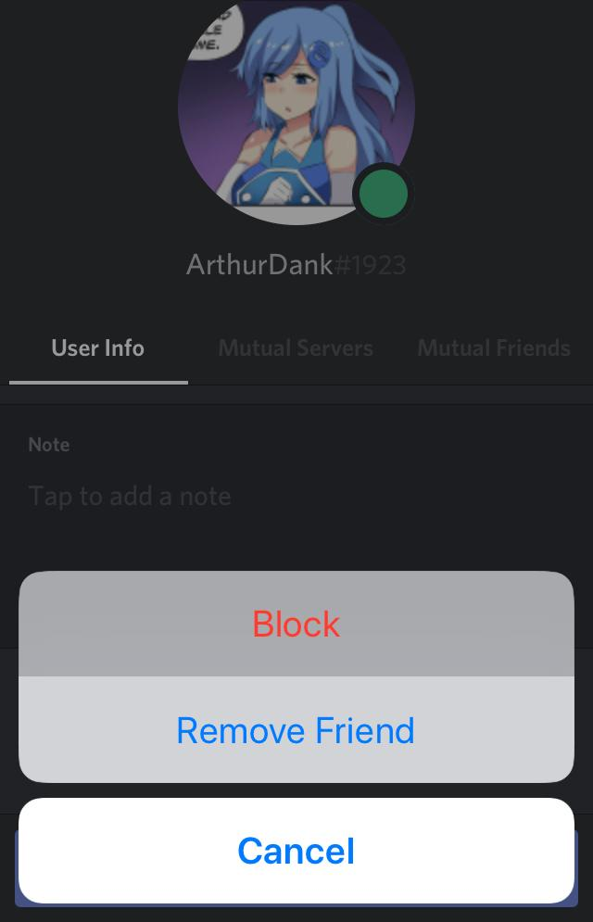

ArthurDank 24-Feb-19 08:31 PM

if being friends meant anything then i know you wont block me

just relax

please just breathe i dont want you to leave

Bunny 24-Feb-19 08:33 PM

Take them

NOW

ArthurDank 24-Feb-19 08:33 PM

they're yours lory if you dont want them then just leave them but dont block me over it please

Bunny 24-Feb-19 08:34 PM

TAKE THEM YOU FUCK

DO NOT TEST MY PATIENCE

I have no qualms about pressing that button

ArthurDank 24-Feb-19 08:35 PM

so being buddies isn't that important to you?

Bunny 24-Feb-19 08:35 PM

Do what I said

Now

ArthurDank 24-Feb-19 08:36 PM

no i dont want them either so lets just leave them

leave em in the dirt tske a break for a few days then come back

or not but stay here

im begging ya buddy

Bunny 24-Feb-19 08:38 PM

I’m not going back

I can’t wait till those alts go up in flames

ArthurDank 24-Feb-19 08:38 PM

then just leave them

im going to do the same

Bunny 24-Feb-19 08:39 PM

Oh yeah as soon as I say I’m leaving everyone is like “Pwease don’t go ;~;”

Fuck em

I hate every last one of them

ArthurDank 24-Feb-19 08:40 PM

I understand I hate when people do that i rage quit twitter too and no one ever even said that

but meeting you and the others i like was worth it

Bunny 24-Feb-19 08:41 PM

Wish I never started using Twitter

It was a mistake

I’m not going back

Stop making up bullshit

ArthurDank 24-Feb-19 08:42 PM

im sorry you feel that way but i was glad to meet you and have you as a friend

its not bullshit im serious

i dont say that shit to many people lory

i hate most people

Bunny 24-Feb-19 08:43 PM

Tell everyone I hope they fucking rot

ArthurDank 24-Feb-19 08:43 PM

now that I can do lol

and I will

just stick to this place buddy

im always here when you wanna chat

Bunny 24-Feb-19 09:12 PM

Everyone will be fine without me bothering them

They’ll have more fun without me around

ArthurDank 24-Feb-19 09:20 PM

actually a lot of people said they had fun because youbwere around

i certainly did and i wont be fine if you leave here talking to you is a highlight

Bunny 24-Feb-19 09:21 PM

They’ll find someone else

I’m replaceable

ArthurDank 24-Feb-19 09:22 PM

no you are and not to me at the very least lol

aren't*

Bunny 24-Feb-19 09:24 PM

Just take the accounts

Do something with them

ArthurDank 24-Feb-19 09:24 PM

i appreciate that but i dont want them i dont want e-fame

i just want to talk with people and bullshit like friends do

Bunny 24-Feb-19 09:25 PM

Lame

Just delete them then

ArthurDank 24-Feb-19 09:26 PM

its not lame because i just want to hang with you guys

i take note of the industry but i know i have little sway we all do

you have been a very good friend to me and i am glad i have gotten to know you better

hope you will be okay :)

Bunny 24-Feb-19 10:08 PM

I’d appreciate it if you wouldn’t make up bullshit like “oh she’ll be back!” cuz I won’t

I’m not coming back

I said it and meant it

Do not undermine me

ArthurDank 24-Feb-19 10:13 PM

alright sheesh im sorry

Bunny 24-Feb-19 10:14 PM

Hopeful optimism pisses me off

ArthurDank 24-Feb-19 10:14 PM

i get it

but dont boss me around

i will keep mouth shut

on twotter about it

Bunny 24-Feb-19 10:15 PM

I can cut you off whenever I please. It’s in your best interest to not test me

ArthurDank 24-Feb-19 10:15 PM

so you really dont care about being friends is that what you mean?

if thats how you really feel then do it :(

i just don't know what you have against people caring about you

im sorry this is causing me to about have a breakdown

Bunny 24-Feb-19 10:19 PM

Good now you know exactly how I feel

ArthurDank 24-Feb-19 10:20 PM

thats not funny

i didn't do anything to you

Bunny 24-Feb-19 10:22 PM

Doesn’t feel good does it?

Well that’s how I feel right now

ArthurDank 24-Feb-19 10:24 PM

i dont deserve to be treated like that i wasn't rude to you

Bunny 24-Feb-19 10:24 PM

Now you’re finally beginning to understand

Now you’ll finally be able to see through my eyes

Now picture yourself trying to make a change to yourself and then that feeling being the end result

ArthurDank 24-Feb-19 10:25 PM

let me reiterate i didn't say anything bad to you, you dont get to use me like a punching bag because you got shit on

yeah it sucks but im not going to be hurt like that but someone who claims to be my friend

maybe if you weren't like that to people maybe they would stick around

Bunny 24-Feb-19 10:29 PM

Maybe if I wasn’t mocked I wouldn’t need to be

ArthurDank 24-Feb-19 10:30 PM

you dont have a right to get that way with me, i did nothing to you

oh and ftr i have been shit on many a times in life for trying to make changes this ain't a new experince

Bunny 24-Feb-19 10:35 PM

Good for you, I’m still not going back

ArthurDank 24-Feb-19 10:36 PM

fine my point is get the fuck over yourself you ain't the only one who gets shit on.

Bunny 24-Feb-19 10:39 PM

And now even you have zero sympathy for me

Shocking

ArthurDank 24-Feb-19 10:40 PM

i do have sympathy but when you shit on me how do you expect me to react my family has done the same to me for years takes me to bad places

Bunny 24-Feb-19 10:41 PM

I’m not going back nor am I unblocking anyone. Either they accept my change or it’ll stay that way forever

And I have zero issues with keeping them blocked forever

ArthurDank 24-Feb-19 10:43 PM

i dont care what you do but dont shit on me okay? i dont ask for much

Bunny 24-Feb-19 10:44 PM

HMMMMM SOUNDS FAMILIAR TO SOMETHING I WAS ASKING PEOPLE FOR EARLIER TODAY AND DIDNT GET

ArthurDank 24-Feb-19 10:44 PM

oh so shit on me cause you were shit on thats real fucking fair

you treat everyone who tries to ge nice to you that way

Bunny 24-Feb-19 10:47 PM

I don’t suppose any form of apology would make a difference at this point

ArthurDank 24-Feb-19 10:48 PM

it would make a difference if its sincere would make a lot of difference

you dont need to worry i forgive you even if you dont care

ArthurDank 24-Feb-19 11:01 PM

if you are sorry its appreciated, if not im used to it anyway im off have a good night

Bunny 24-Feb-19 11:16 PM

I’m sorry

ArthurDank 24-Feb-19 11:18 PM

its okay been a bad day for you i get it :)

dont sweet it buddy but i hope you have a good night

ArthurDank 25-Feb-19 01:34 PM

how are you today?

ArthurDank 25-Feb-19 01:53 PM

i did have a question lory

Bunny 25-Feb-19 01:53 PM

Go ahead

ArthurDank 25-Feb-19 01:54 PM

i wondered if in 20 mins could we rp a but before i go to work? no worries if this is a bad time

i have work in just over an hour so i couldn't stay too long but yeah

Bunny 25-Feb-19 01:56 PM

Naaah I’m good for now

Sorry

ArthurDank 25-Feb-19 01:57 PM

it's fine maybe another day

if i may ask what are good times for you? or you would probably just tell me if it was :)

Bunny 25-Feb-19 02:01 PM

Generally when I’m not particularly busy like around 11ish

ArthurDank 25-Feb-19 02:07 PM

11 AM or PM?

Bunny 25-Feb-19 02:07 PM

Pm

ArthurDank 25-Feb-19 02:09 PM

ah in the evening makes sense i will hit you up during those times if i am not busy too and you can always hit me up of you want :)

but what time is it in your area its 2:10 PM for me currently

Bunny 25-Feb-19 02:11 PM

11am at the moment just waiting for him to get out of class

Fuck sorry

I mean 2:12pm goddamn autofill

ArthurDank 25-Feb-19 02:12 PM

lmao its okay so we share the same timezone thats helpful :)

hope it wasn't a weird question i just would rather ask you about that at a time better for you then at random like a pest lol

ArthurDank 27-Feb-19 01:06 AM

henlo how ya doing lory?

Bunny 27-Feb-19 01:08 AM

I’m good

ArthurDank 27-Feb-19 01:09 AM

thats cool :)

whatcha been into?

Bunny 27-Feb-19 01:09 AM

D&D

ArthurDank 27-Feb-19 01:10 AM

ah very nice you have fun?

ArthurDank 27-Feb-19 01:24 AM

hello? ya still playing? :)

Bunny 27-Feb-19 01:35 AM

Yuuup

And yes

ArthurDank 27-Feb-19 01:36 AM

oh cool sorry about that i didn't mean to interrupt you during D&D time glad you are having fun

can always chat later on :)

ArthurDank 27-Feb-19 02:56 AM

off to bed lory have a good night :)

hit me up tomorrow if you like

ArthurDank 27-Feb-19 12:13 PM

saw you got banned again hope you can come back soon

Bunny 27-Feb-19 12:18 PM

It’s all good don’t worry about it

ArthurDank 27-Feb-19 01:44 PM

damn i didn't get notified about your msg sorry lol

i know you will be back how is your day going?

Bunny 27-Feb-19 01:48 PM

Good

Just started playing Bravely Default again after five years of not playing it

ArthurDank 27-Feb-19 01:51 PM

lmao nice always wanted to try that looked fun

getting some running done before work at 5

Bunny 27-Feb-19 02:04 PM

Being Edea this time around


ArthurDank 27-Feb-19 02:05 PM

very nice

thats your profile pic awesome

i need to play the BD

Bunny 27-Feb-19 02:08 PM

Doing the secret ending

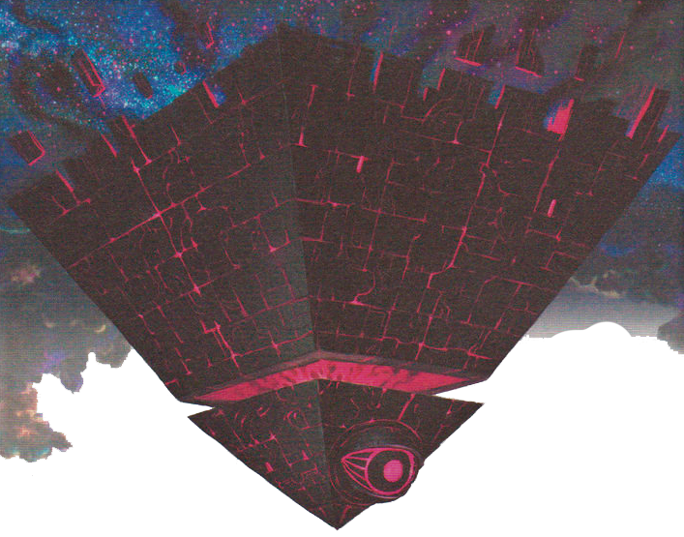

Not looking forward to fighting this again

ArthurDank 27-Feb-19 02:13 PM

oh damn well done

looks like a pain in the ass

Bunny 27-Feb-19 02:13 PM

Can take control of your 3DS too

Wipe your save file as well

It’s beatable though

I’ve done it before

But that was three years ago

ArthurDank 27-Feb-19 02:14 PM

lmfao really!?

Bunny 27-Feb-19 02:15 PM

Yes

ArthurDank 27-Feb-19 02:15 PM

holy crap

Bunny 27-Feb-19 02:15 PM

It can erase your save data

Poof

Gone

ArthurDank 27-Feb-19 02:15 PM

damn lory good luck course you have done it before

poof like my brain when cleaning floors

ArthurDank 27-Feb-19 02:28 PM

any luck?

ArthurDank 27-Feb-19 02:42 PM

ah welcome back smug edea

Bunny 27-Feb-19 02:42 PM

Yuup

ArthurDank 27-Feb-19 02:43 PM

glad you are still with us

if you need another alt later get with me, still working on the secret ending?

Bunny 27-Feb-19 02:43 PM

Yup

ArthurDank 27-Feb-19 02:44 PM

badass

kouji back from class yet?

Bunny 27-Feb-19 02:53 PM

Yup

ArthurDank 27-Feb-19 02:54 PM

cool haha have fun since im sure some big dicke is in the future ;D

enhancers still working good?

ArthurDank 27-Feb-19 03:15 PM

tell me about it later lol

Bunny 27-Feb-19 03:57 PM

They still work yeh

ArthurDank 27-Feb-19 04:14 PM

i figured hehe

so whatcha into?

ArthurDank 27-Feb-19 04:54 PM

im at work hit me up later if you like i will be around

Bunny 27-Feb-19 11:57 PM

New D&D character time

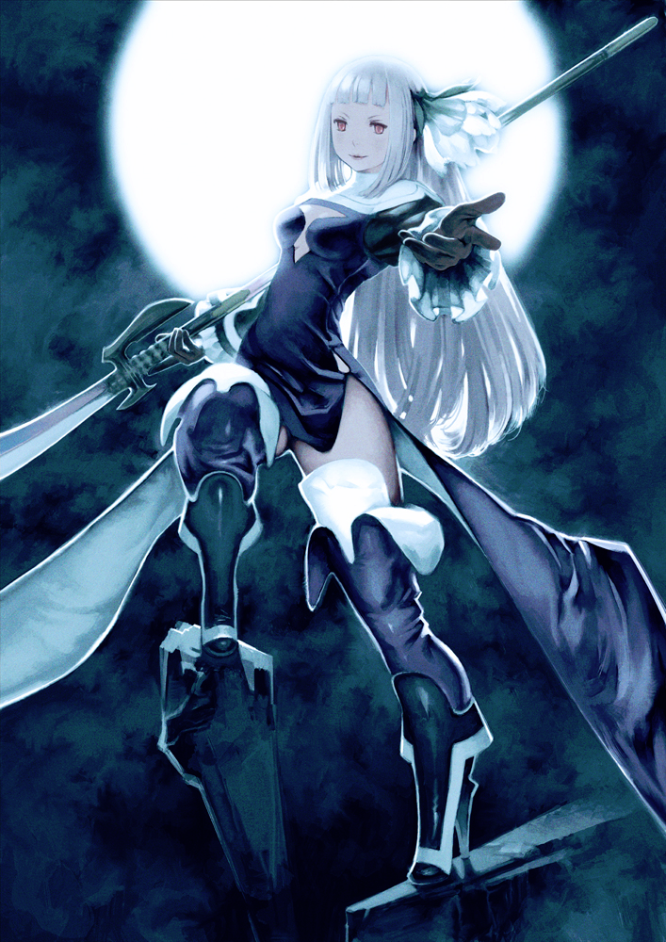

ArthurDank 28-Feb-19 12:02 AM

now that is hot

which BD character is that?

Bunny 28-Feb-19 12:03 AM

Magnolia Arch

ArthurDank 28-Feb-19 12:03 AM

very nice

Bunny 28-Feb-19 12:03 AM

I already got all her spells listed too

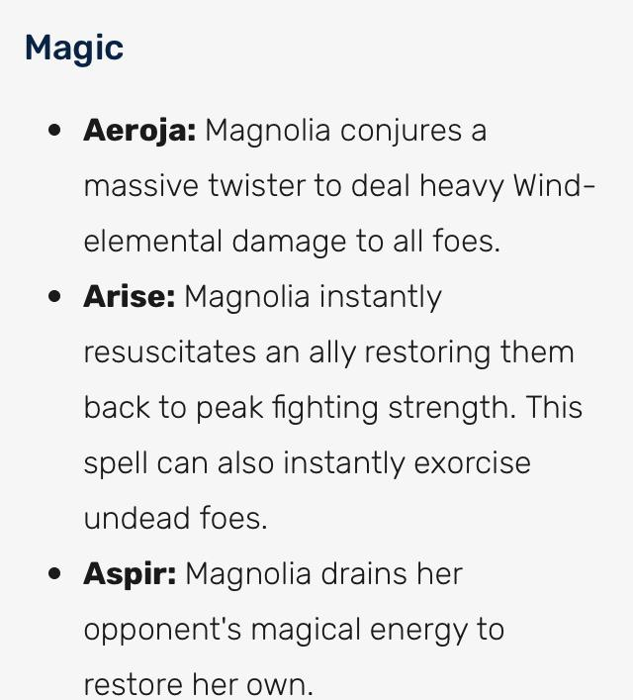

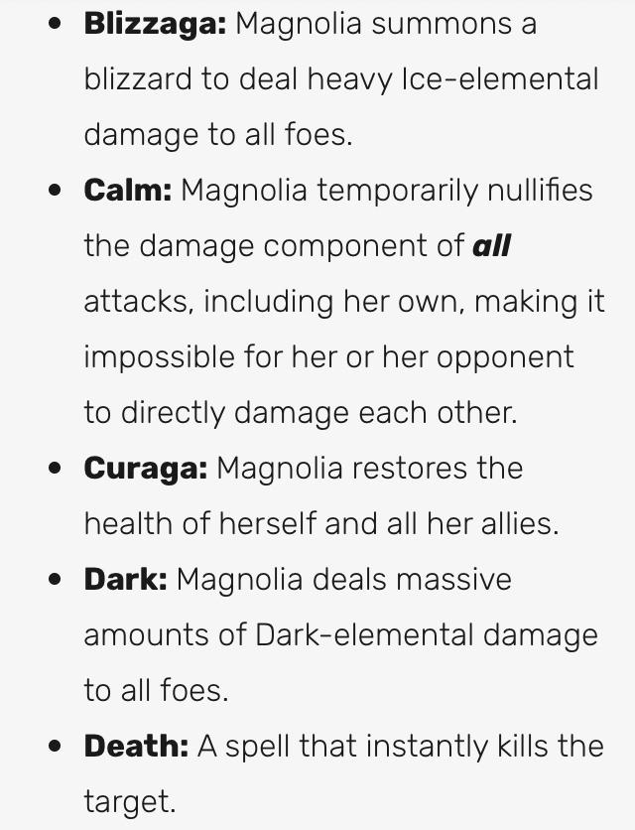

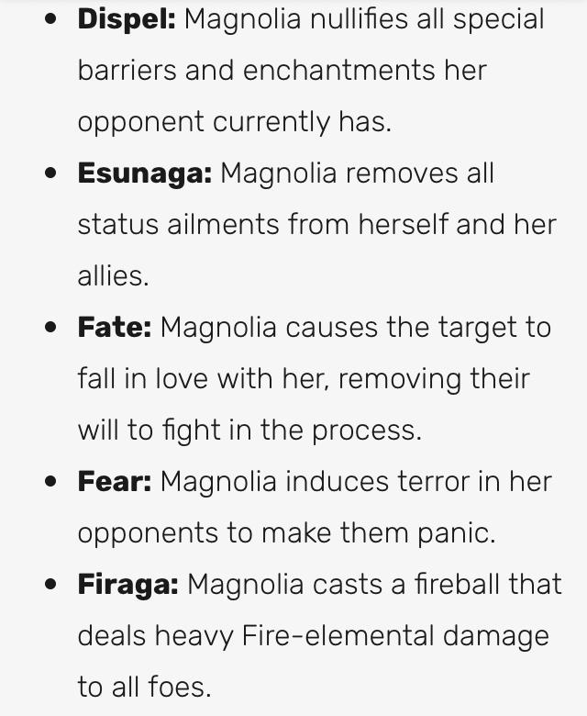

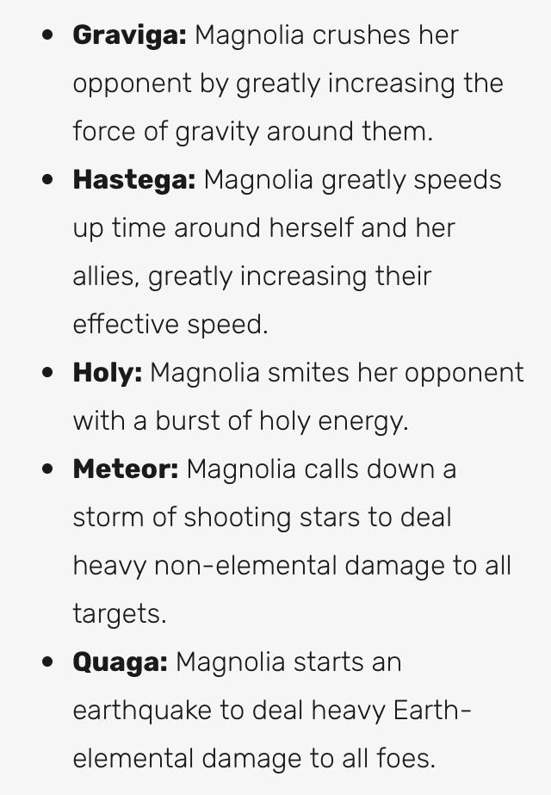

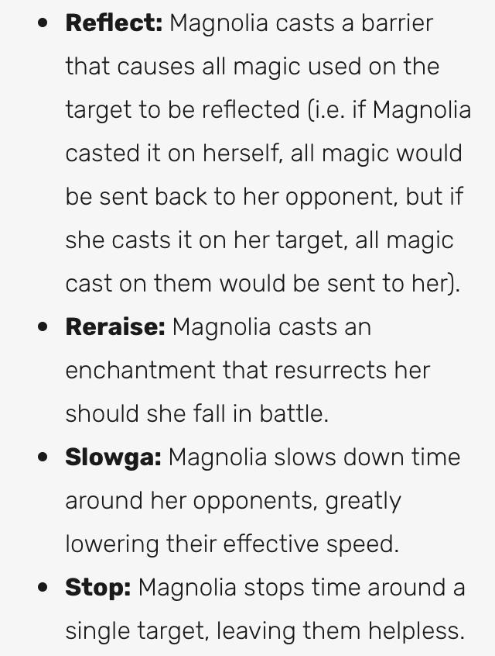

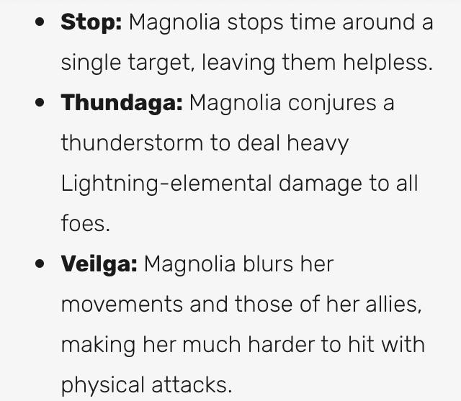

Starting her with a Steel Glaive

ArthurDank 28-Feb-19 12:04 AM

oh cool she has a nice roster of i do say

Bunny 28-Feb-19 12:05 AM

Granted she won’t be called Magnolia

Most likely

I can’t really think of a name considering her mother is my current character

Lauren Keenhart

ArthurDank 28-Feb-19 12:05 AM

oh nice

I appreciate your appreciation for a good rpg :)

Now im gonna have to buy a DS to play BD :D

what name have you given her?

you'll figure something out lemme know when you have a name :)

Bunny 28-Feb-19 12:10 AM

Well obviously she’s gonna be a Keenhart so the first name can’t be too outlandish

ArthurDank 28-Feb-19 12:12 AM

agreed Velencia maybe? just a thought lmao dont mind me

Bunny 28-Feb-19 12:19 AM

Sheol Keenhart

That works

Since Magnolia’s real name is 10345 in numerical (edited)

And when you turn that number upside down it spells Sheol

ArthurDank 28-Feb-19 12:21 AM

lmao damn

thats pretty tight i like it

very clever lory

Bunny 28-Feb-19 12:27 AM

It’s a joke

See

Her mother is a necromancer

Sheol is the land of the dead

Get it?

ArthurDank 28-Feb-19 12:29 AM

oh damn

lmao i do

thats perfect actually

Bunny 28-Feb-19 12:34 AM

The sea gave up the dead that were in it, and death and Hades gave up the dead that were in them, and each person was judged according to what they had done. Then death and Hades were thrown into the lake of fire. The lake of fire is the second death,the lake being Sheol. - Revelations 20:13-14

ArthurDank 28-Feb-19 12:35 AM

holy shit I never thought about that, leave it to me to never read the bible or i would've caught that

very nice

Bunny 28-Feb-19 12:36 AM

Old Mama Keenhart kinda has an obsession with undoing the cycle of death

ArthurDank 28-Feb-19 12:36 AM

oh wow sounds very obsessive

why does she?

soubds like an interesting tale

Bunny 28-Feb-19 12:44 AM

Belives she was responsible for a fire at the place where she had learned magic. All that was left was a tome given to her by the headmaster to protect at all costs. Anyways here’s the explanation for Sheol’s middle name

ArthurDank 28-Feb-19 12:47 AM

damn thats hairy and okay

Bunny 28-Feb-19 12:47 AM

And the third angel sounded, and there fell a great star from heaven, burning as it were a torch, and it fell upon the third part of the rivers, and upon the fountains of waters; And the name of the star is Wormwood: and the third part of the waters became Wormwood; and many men died of the waters, because they were made bitter. Revelations:10-11

Sheol Wormwood Keenhart

ArthurDank 28-Feb-19 12:54 AM

holy shit

thats pretty deep right there

hence your inspirstion for her name which is also the land of the desd

dead*

im impressed you really thought this out just keep giving me more reasons to play this game

Bunny 28-Feb-19 01:03 AM

The closest class to her I’ve found is a spellblade

I’ll see if I can find anything better

ArthurDank 28-Feb-19 01:10 AM

oh nice

spellblades aren't all that great?

Bunny 28-Feb-19 01:11 AM

No they are

I just wanted to see if there was anything more fitting

ArthurDank 28-Feb-19 01:17 AM

i get you

she looks like a mage or something but she has a big ass lance like weapon

ArthurDank 28-Feb-19 01:56 AM

hello?

sorry my replies were late i was having problems with my laptop think its fixed

Bunny 28-Feb-19 02:41 AM

Helloooo

ArthurDank 28-Feb-19 02:55 AM

hey how is it going

sorry i was away from the phone

had to drive

whats up? :)

ArthurDank 28-Feb-19 03:07 AM

must've missed ya lol

Bunny 28-Feb-19 03:09 AM

Was looking for things to fill out her character sheet before I schleep

ArthurDank 28-Feb-19 03:11 AM

oh thats cool

i figured you were away due to bumping hehe :D

if so i was gonna ask what all went down lol

Bunny 28-Feb-19 03:19 AM

I could literally sit on his dick while I research if I wanted to lol

ArthurDank 28-Feb-19 03:20 AM

lmao wow

nice

did you?

Bunny 28-Feb-19 03:20 AM

For a bit~

ArthurDank 28-Feb-19 03:20 AM

hehe hot

i don't know why but i was feeling like maybe you weren't wanting to discuss that stuff, kinda why i danced around a bit

if its ever a problem you can always tell me

Bunny 28-Feb-19 03:23 AM

Naaah it was good

I have leggings on so I just sat right down and his cock slid right up my ass. Much better than taking them off.

ArthurDank 28-Feb-19 03:24 AM

very nice and sexy

kinda like your bike shorts

riding his dick while researching nice image

lol reminds of a rp i was engaged in once

Bunny 28-Feb-19 03:27 AM

I was just laying on my stomach on my phone while he stuck his cock up my ass after we finished the first round lol

ArthurDank 28-Feb-19 03:27 AM

holy shit

went doggy style up your butt ehh after the riding at the computer desk

thats intense

Bunny 28-Feb-19 03:29 AM

Raw anal is fun lol

I’m a bit annoyed though

ArthurDank 28-Feb-19 03:30 AM

lol sounds like it hope my gal has an ass like yours

oh why?

Bunny 28-Feb-19 03:30 AM

I had a good pair of skinny jeans I don’t fit into anymore because my ass is fucking enormous

ArthurDank 28-Feb-19 03:31 AM

that sucks now your butt is growing with your boobs?

i mean thats fucking hot but damn

Bunny 28-Feb-19 03:31 AM

I think it’s just winter weight

I dunno

ArthurDank 28-Feb-19 03:31 AM

well that is common hard to be active in the winter im sure when spring hits it will be no trouble

ignore my earlier concern its a nervous tic of mine to think im imposing even when people freely tell me about their sex life lol

even when i asked to rp the first time with you i never expected you to say yes glad you did tho lol

dont worry im sure you will be back in your skinny jeans soon they look good on you (edited)

Bunny 28-Feb-19 03:35 AM

Oooo he’s out cold

Fun times await

ArthurDank 28-Feb-19 03:35 AM

damn right lol

sleep diddling i take it?

;)

Bunny 28-Feb-19 03:36 AM

Yeh

ArthurDank 28-Feb-19 03:36 AM

hehe this sounds hot

i know you normally fade at this point but mind sticking around for the first few minutes?

Bunny 28-Feb-19 03:37 AM

Suuree

Just putting him in now

ArthurDank 28-Feb-19 03:37 AM

hot

Bunny 28-Feb-19 03:38 AM

I had him take the enhancer earlier and he’s still big even when he’s half soft like right now

ArthurDank 28-Feb-19 03:38 AM

since he is out cold you shouldn't get caught

oh shit right on

your ass got an even better pounding then normal

Bunny 28-Feb-19 03:40 AM

About 10 inches straight up my ass lol

I only have half of him in right now

Waiting for him to harden up from me squeezing

ArthurDank 28-Feb-19 03:41 AM

lotta inches

wont be long with those muscles hehe

seems im perpetually hornt just like you guys

Bunny 28-Feb-19 03:42 AM

Yuuup he’s getting bigger now~

ArthurDank 28-Feb-19 03:43 AM

hell yeah riding is a starting

Bunny 28-Feb-19 03:44 AM

Got the first 5 inches in,it feels fucking greaaat waiting for him to get huge while he’s buried in my guts like this

ArthurDank 28-Feb-19 03:44 AM

very hot lory be stirring those insides up before you know it

Bunny 28-Feb-19 03:45 AM

And it slowly pushes itself out as it gets bigger~ he’s about as thick as a toilet paper roll too~

Like the cardboard part

ArthurDank 28-Feb-19 03:46 AM

jesus he was already huge now the pills make him longer and thicker

wow lory what a cannon you can take up that nice butt

Bunny 28-Feb-19 03:48 AM

And now I just slowly pull him out until I reach the tip and

Slowly back in~~~

Fuuuuck

ArthurDank 28-Feb-19 03:48 AM

whew

jesus sounds good

just imagining that makes me wanna say fuuuuck lol

Bunny 28-Feb-19 03:50 AM

He’s already leaking lol

ArthurDank 28-Feb-19 03:50 AM

not surprised who could resist you anyway lol

Bunny 28-Feb-19 03:51 AM

This is after the four shots earlier

ArthurDank 28-Feb-19 03:51 AM

wow he really painted your butt white

Bunny 28-Feb-19 03:51 AM

Twice at the computer and twice on the couch

ArthurDank 28-Feb-19 03:52 AM

damn

you got your turn on top he wanted his turn on the couch ;)

Bunny 28-Feb-19 03:53 AM

Shit this shot is huge what the fuck

ArthurDank 28-Feb-19 03:53 AM

damn heheh

big dicke+enhancers+celery

Bunny 28-Feb-19 03:54 AM

Still leaking after shooting

That was enough to just start leaking out my ass

These leggings will definitely be stained now

ArthurDank 28-Feb-19 03:55 AM

sure well

damn you still have them on that makes this even dirtier i like it

Bunny 28-Feb-19 03:56 AM

The shots just go right through

Leggings are porous y’know

ArthurDank 28-Feb-19 03:56 AM

oh yeah i have seen my share

just not on a great bod like yours

your butt must have it all makes sense it always finds its way hehe

are they black?

Bunny 28-Feb-19 04:00 AM

Yuuup

ArthurDank 28-Feb-19 04:00 AM

perfect lol just a hunch

hows it going now?

Bunny 28-Feb-19 04:02 AM

Just sliding him in and out~

He’s a little bigger than last time

Must have more blood flowing

Feels like sticking an entire ruler up there lol

ArthurDank 28-Feb-19 04:03 AM

lol nice

well such tight stimulation hard not to get the blood pumping

very hot image in my head

cum a few times so far?

Bunny 28-Feb-19 04:04 AM

Twice so far

I took a picture earlier if you care to see

ArthurDank 28-Feb-19 04:04 AM

not at all

love too

Bunny 28-Feb-19 04:06 AM

Getting a bit chubby I think lol

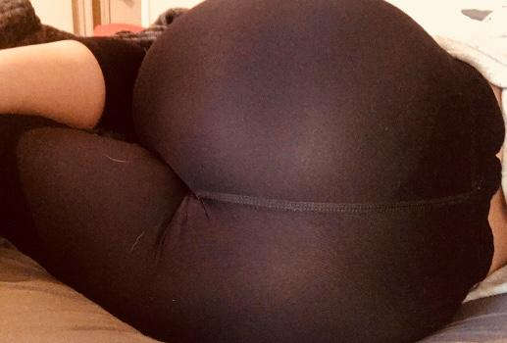

ArthurDank 28-Feb-19 04:07 AM

damn theres my second load building up right there hehe

not at all looks wonderful you have thicc in all the right places

you're fucking in those leggings goddamn ;) (edited)

Bunny 28-Feb-19 04:08 AM

He’s shooting again while I’m still moving

Fuck

ArthurDank 28-Feb-19 04:09 AM

holy fuck

thank you for sharing the pic btw

love it

how can he hold back? feels too good hehe

Bunny 28-Feb-19 04:11 AM

While we’re on the subject which one of mine have you used the most lol

Fuck a third shot already

ArthurDank 28-Feb-19 04:11 AM

jesus

oh well the leggings are way the hell up there now hehe

but well

this one

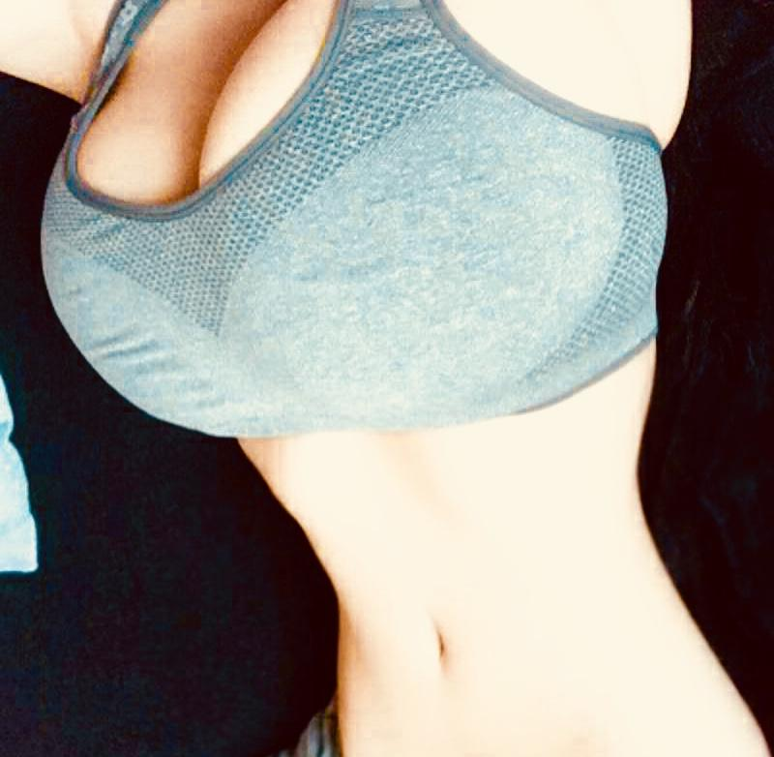

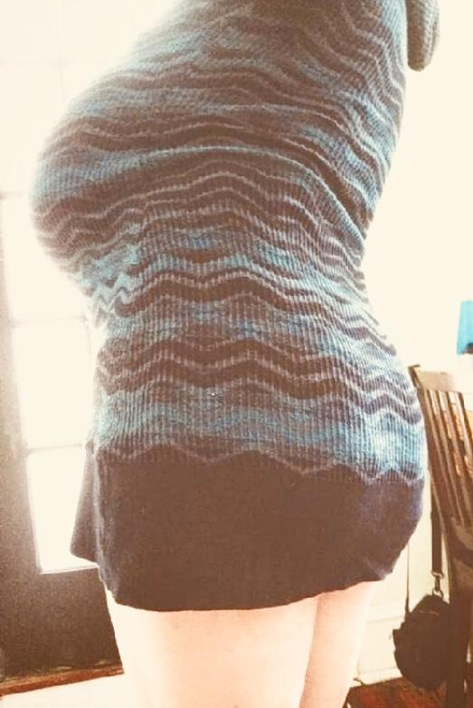

im a sucker for big boobs and butt and short skirts

all of them have been used a few times tho

Bunny 28-Feb-19 04:15 AM

Okay yeah three is more than enough for now holy sgit

ArthurDank 28-Feb-19 04:16 AM

hahaha wow wore you out

well you earned a rest i think

thanks for keeping me around during that lory

Bunny 28-Feb-19 04:17 AM

I gotta at least attempt to finish the character sheet

ArthurDank 28-Feb-19 04:17 AM

i understand believe me

i like all of your pics tho so its hard for me to pick a fav

the sports bra reminds me of the RP we did and the other well i like the idea of raising that short skirt up pulling the panties to the side and pounding you senseless

speaking of your sheet have you chosen a class?

Bunny 28-Feb-19 04:22 AM

Spellblade

Also I’m not very heavy so carry fucks aren’t out of the question

ArthurDank 28-Feb-19 04:23 AM

spellblade seems proper for her

and oh i know i thought about carry fucking you through your bike shorts after you sent me that one pic of you as haruko

something i hope to try with you during the next rp

well been thinking about carry fucking a lot lately thats hot as hell

Bunny 28-Feb-19 04:26 AM

Okay so it looks like I can choose two stats that increase by two points per level

On top of the points granted through the regular levels as a class

Methinks half Elves are a wee bit busted

ArthurDank 28-Feb-19 04:27 AM

elves always are for some reason

gamebreakers even at the start

thats a nice starting boost

Bunny 28-Feb-19 04:29 AM

I so

I get three languages

Basic (English)

Elvish

And one more of my choice

ArthurDank 28-Feb-19 04:30 AM

very nice

what will you choose

Bunny 28-Feb-19 04:30 AM

Well this is the list

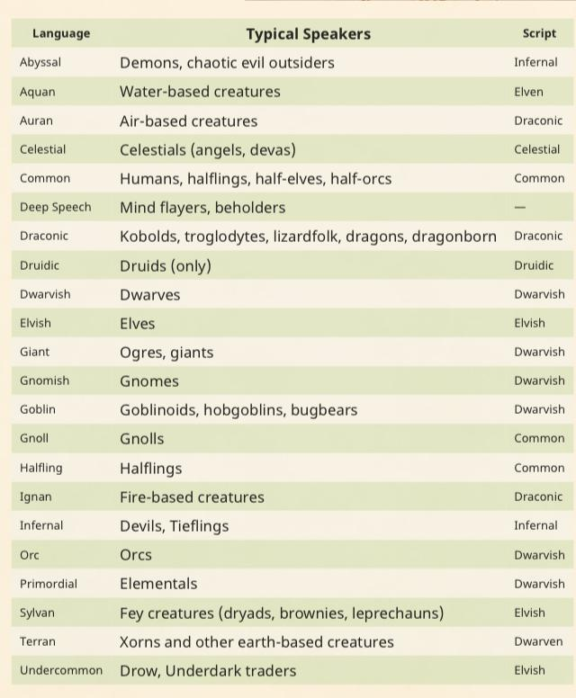

Elvish is a common language so I’ve got that covered

ArthurDank 28-Feb-19 04:31 AM

nice

Abyssal would be my choice only cause its nice to tell demons to get bent in their own language lmao

thats just me tho

Bunny 28-Feb-19 04:33 AM

Well considering I’ll probably have Providence implemented soon

I’ll probably have him as an aberration

Which means Deep Speech (Tongues)

ArthurDank 28-Feb-19 04:35 AM

oh wow

so basically you'll have a grasp of most languages

Bunny 28-Feb-19 04:36 AM

Deep Speech is a language not even from the same dimension as our characters lol

That’s why I wanted to implement Providence

Because he’s above the game

While also existing inside it

At the same time

ArthurDank 28-Feb-19 04:37 AM

oh wow thats pretty awesome

that would give you an advantage

he sounds very interesting

Bunny 28-Feb-19 04:41 AM

I can’t find a screenshot of it but when he addresses you (the player holding the 3ds) he talks in tutorial text boxes

ArthurDank 28-Feb-19 04:41 AM

Holy shit

thats a neat little twist

just another reason for me to play

Bunny 28-Feb-19 04:43 AM

Looks directly at you too

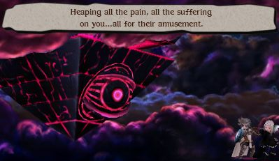

ArthurDank 28-Feb-19 04:44 AM

whoa

so providence is the boss of the secret ending

Bunny 28-Feb-19 04:44 AM

Yes



ArthurDank 28-Feb-19 04:45 AM

thats intense they really took advantage of the 3ds for this game

like he is pearing into my soul

peering*

Bunny 28-Feb-19 04:45 AM

He knows you’re playing the game

I’m willing to bet he was the tutorial text boxes the whole time

ArthurDank 28-Feb-19 04:46 AM

damn thats foreboding right there

the big bad has been watching you the entire time

i like the sense of dread that builds

Bunny 28-Feb-19 04:49 AM

Keep in mind that Providence is in our world

He’s not in the game according to the games lore

He’s above the game

And within it

At the same time

ArthurDank 28-Feb-19 04:50 AM

hence the name

gulp

thats terrifying

he is everywhere yet nowhere

Bunny 28-Feb-19 04:54 AM

Here’s his music btw

ArthurDank 28-Feb-19 04:54 AM

oh nice

Bunny 28-Feb-19 04:54 AM

https://m.soundcloud.com/sean-short-2/battle-of-providence-final-boss-bravely-second-end-layer-music-extended

Foyfoy
Battle Of Providence (Final Boss) - Bravely Second- End Layer - Mu...
I do not own this.
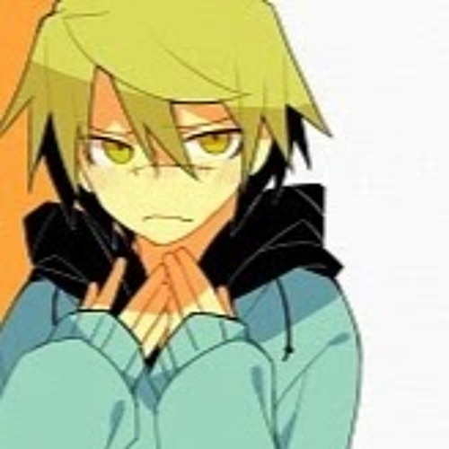

He’s been waiting since the very beginning


ArthurDank 28-Feb-19 04:57 AM

holy shit

he forsaw the fight before it even started

epic music

Bunny 28-Feb-19 04:58 AM

Forgot to mention he can pause your turn mid combat and kill you instantly

ArthurDank 28-Feb-19 04:59 AM

geez he can delete save data, take over your 3ds and turn interrupt you with a KO move they really made it feel like the end all and be all didn't they

since thats what he is

god what a great piece of music

Bunny 28-Feb-19 05:01 AM

In Providence's first form, he uses regular attacks until he reaches approximately 3/4 health. After that, he will use Pawn of Fate, which applies Doom to the party ranging from 1-5 turns and with a difference of turns (i.e. a character may die in 1 turn but others may die in 4). He also casts Mandate of Heaven, which forces a specific party member to attack an ally, or defeat him in two turns or less. If the player does not, he will cast Divine Punishment, which deals 9,999 to all party members. His other attacks include Star of Destruction a strong Magic Attack and Seven Stars, which hits the party at random for several physical attacks. Once his HP reaches 50%, he heals himself back to full HP and the battle resumes. He will not use Pawn of Fate as much if at all. Once he is low on HP, he will decree with Mandate of Heaven to be defeated in two turns or less.

In his second form, he has his two hands that cast Ruin, which deals magic damage to the whole party, and Salvation, more or less the same as Ruin except it is a physical attack. Providence also casts Dispel frequently, and Ruin or Salvation? on his own hands or himself to boost attack in proportion to defense. He sometimes activates Bravely Second to attack the party with New World Order. If one of the hands are defeated, it will be revived the next turn and will use Big Bang, attacking all party members. Once his HP reaches 50%, a scripted cutscene will play where he breaks the fourth wall and seemingly messes with the player's ability to control the game to the point of "deleting" the save data. After the scene, the battle restarts but Providence restores his HP and revives both hands.

This can only be prevented by the use of Bravely Second

ArthurDank 28-Feb-19 05:02 AM

holy shit

what a battle

hes gonna curbstomp anyone unprepared

that cutscene would freak me out

Bunny 28-Feb-19 05:05 AM

I think I’ll find a video real quick

ArthurDank 28-Feb-19 05:07 AM

cool

Bunny 28-Feb-19 05:08 AM

Addressing the player directly

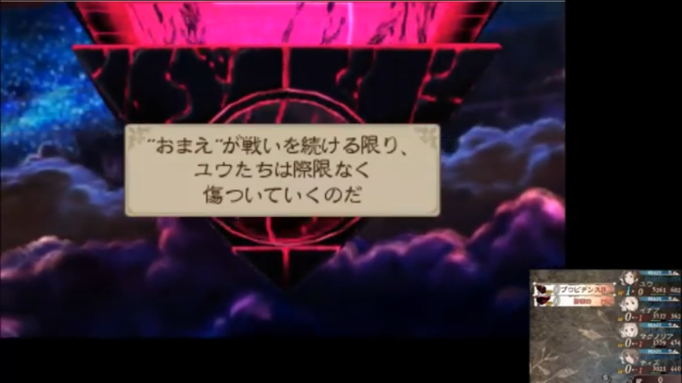

Rough translation

“I’ve been here since the start,I’ve been watching your every move,you enjoy making them suffer don’t you? Every victory,every loss,I’ve seen it all,I’ve seen the files you’ve saved,the worlds you’ve overwritten and erased,you’re a monster and you think you’re helping them!”

ArthurDank 28-Feb-19 05:11 AM

holy shit

damn he is going for the groin there, epic if i do say

also thanks for the translation seen you tweet a bit, didn't know you knew some Japanese

Bunny 28-Feb-19 05:13 AM

And the second one

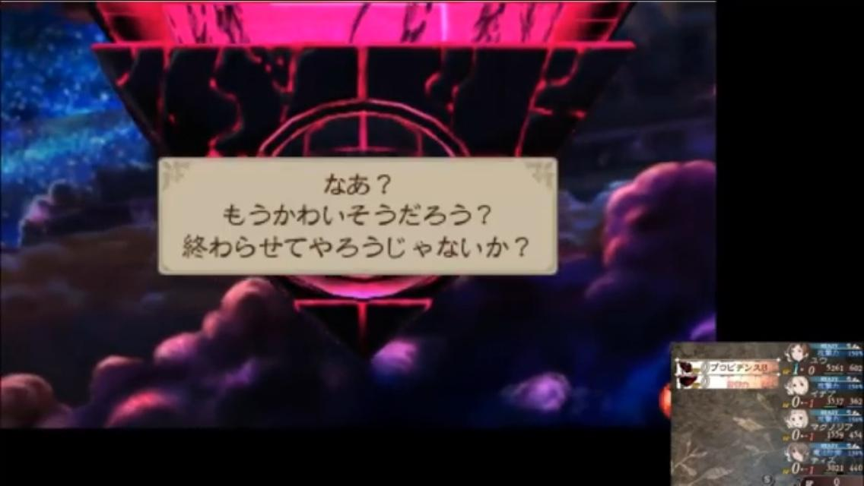

“Oh? So you won’t end it all? You won’t stop making them suffer?”

ArthurDank 28-Feb-19 05:15 AM

yikes

he is pissed

Bunny 28-Feb-19 05:15 AM

Third one

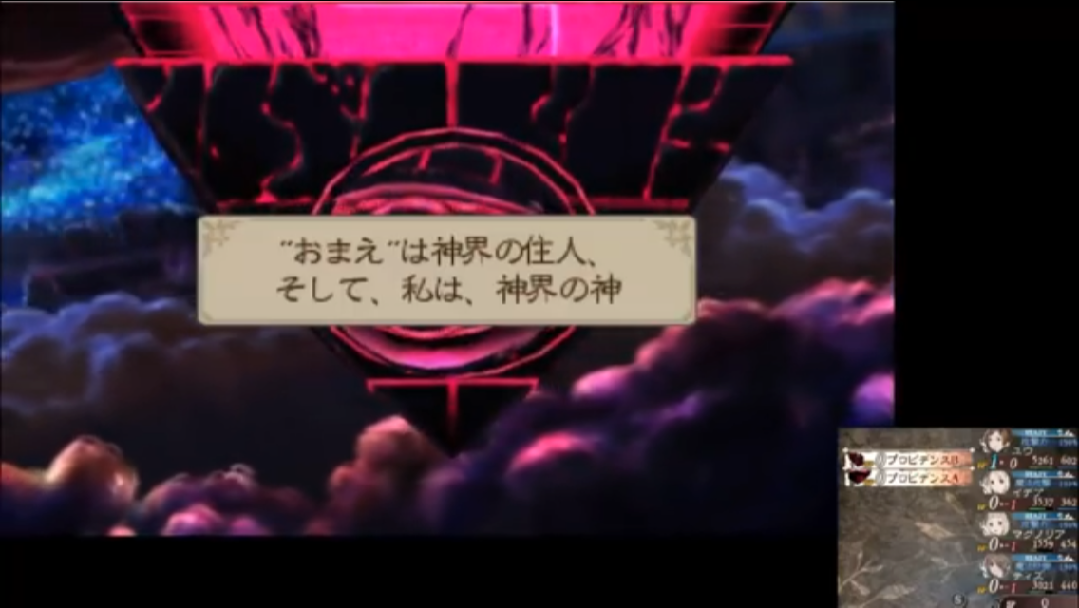

“You’re not so different from me then, I planned this whole thing,every single step of the way. You thought you made your own choices but I control everything here.”

ArthurDank 28-Feb-19 05:17 AM

oh fuck

:O

Bunny 28-Feb-19 05:17 AM

Fourth one

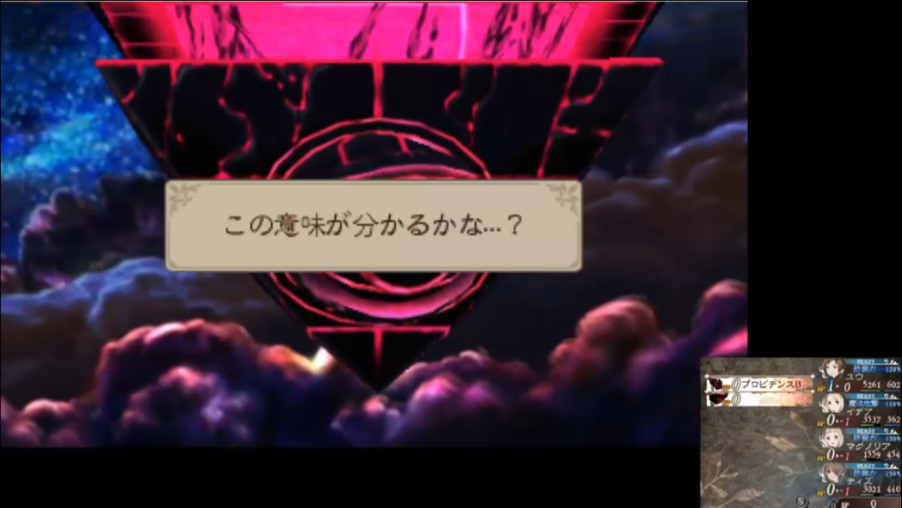

“And yet you still fight me,why?”

ArthurDank 28-Feb-19 05:18 AM

whoa

Bunny 28-Feb-19 05:18 AM

And then he fucks with the screen

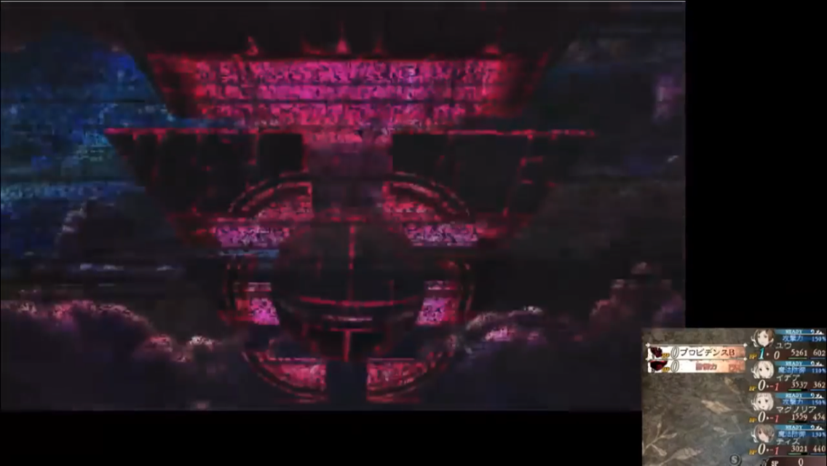

ArthurDank 28-Feb-19 05:19 AM

jesus christ

Bunny 28-Feb-19 05:19 AM

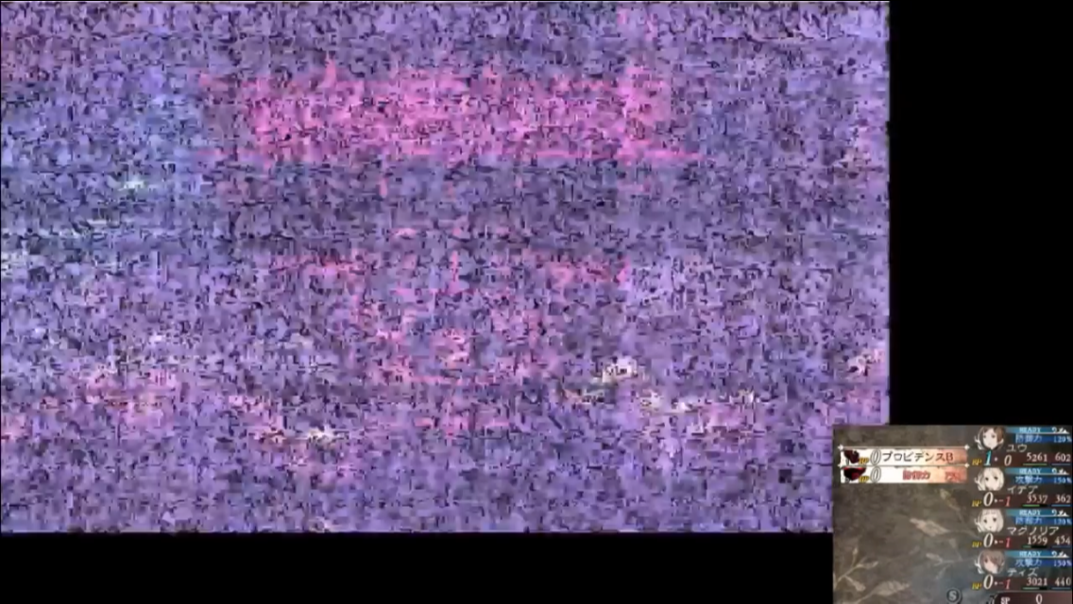

ArthurDank 28-Feb-19 05:19 AM

oh my god

Bunny 28-Feb-19 05:20 AM

And afterwards begins laughing maniacally

ArthurDank 28-Feb-19 05:20 AM

really showing how omnipotent he is

Bunny 28-Feb-19 05:20 AM

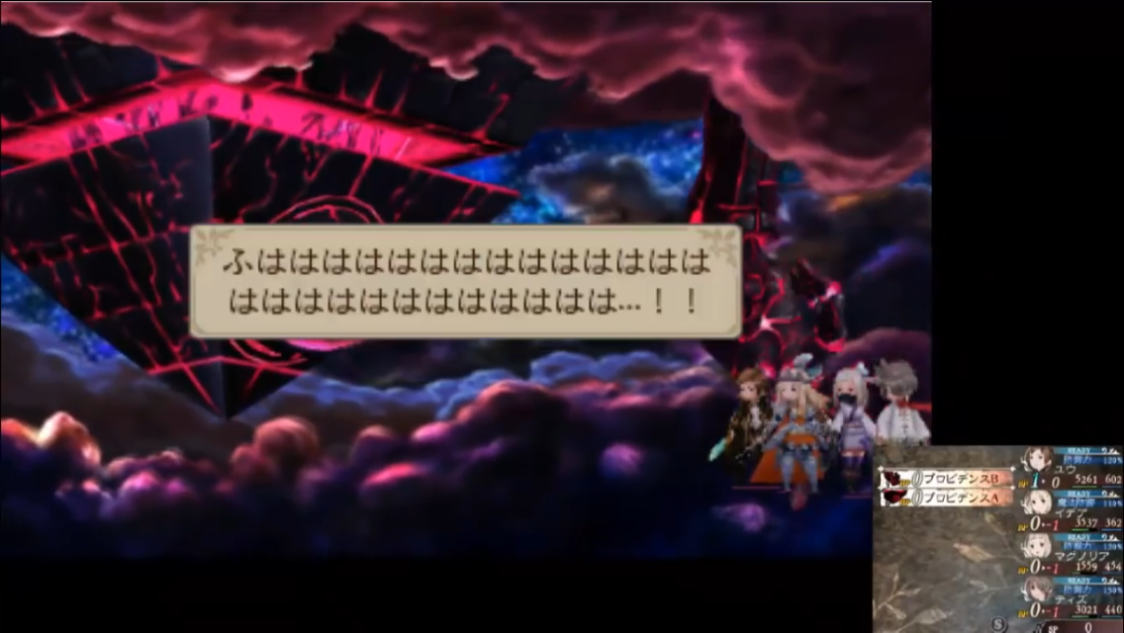

ArthurDank 28-Feb-19 05:20 AM

oh shit

Bunny 28-Feb-19 05:21 AM

Fifth one

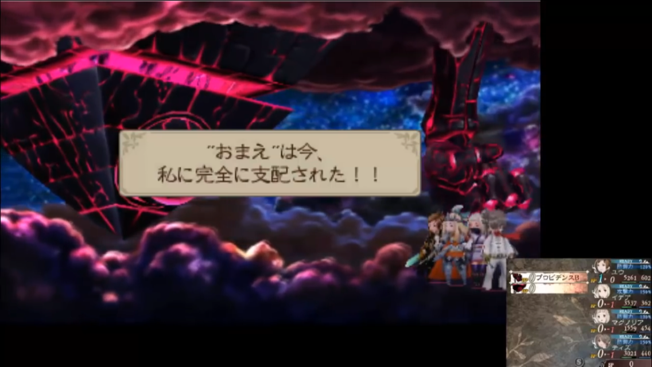

“I am your God,you are but insects compared to me!!”

ArthurDank 28-Feb-19 05:22 AM

sheesh

Bunny 28-Feb-19 05:22 AM

And then he takes complete control of your party members and forces them to attack one another

ArthurDank 28-Feb-19 05:23 AM

oh fuck

Bunny 28-Feb-19 05:23 AM

Sixth and seventh

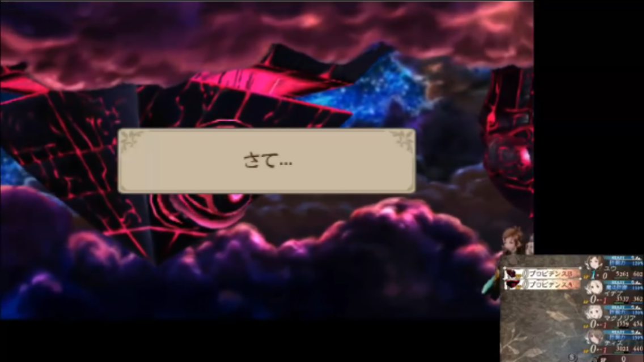

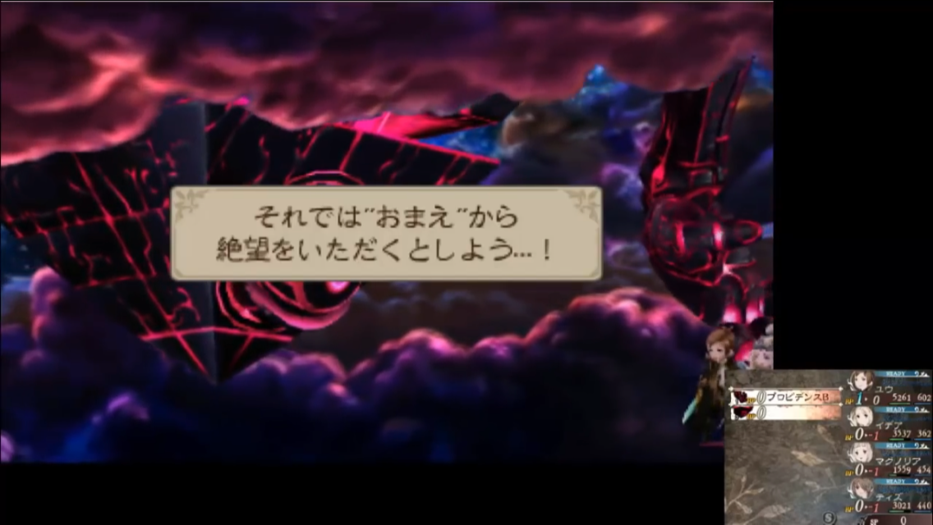

“So! You must understand the complete futility of your resistance!!”

Keep in mind he’s addressing you the player this entire time

Not the characters in the game

ArthurDank 28-Feb-19 05:25 AM

:OOO

Bunny 28-Feb-19 05:25 AM

They can’t hear what he’s saying to you

ArthurDank 28-Feb-19 05:25 AM

yikes

what a mind screw

and he even stares at you through the screen yipe

Bunny 28-Feb-19 05:26 AM

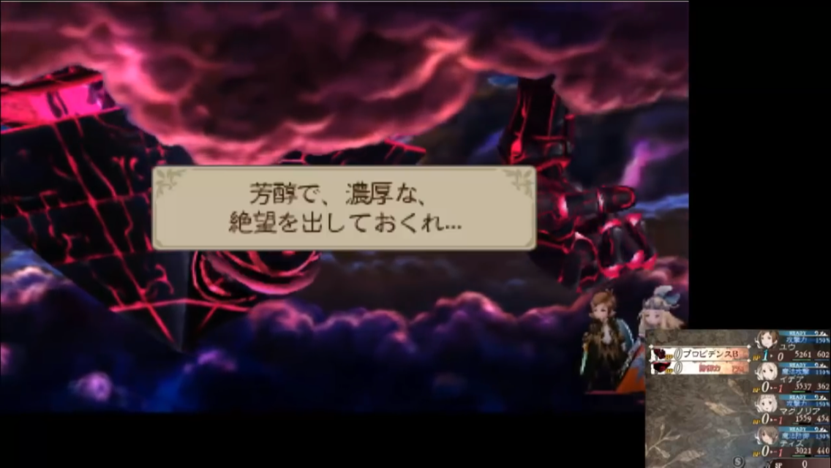

“You don’t seem to understand what you’re up against, and now you’ll pay the price...”

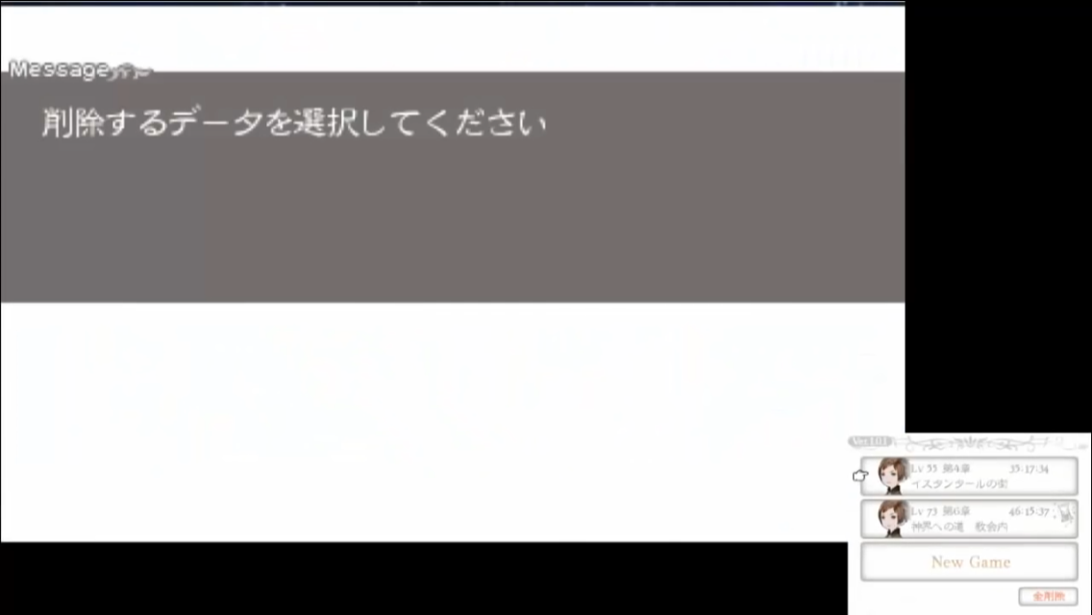

Forces the game to the main menu and takes control of your 3ds

ArthurDank 28-Feb-19 05:28 AM

oh no

Bunny 28-Feb-19 05:28 AM

Selects delete save data and erases the data in the first slot

Make sure you copy your data to the second slot

As shown here

ArthurDank 28-Feb-19 05:29 AM

i see whew hate to imagine what happens to those who only ever use one file

i will remember that thank you

Bunny 28-Feb-19 05:30 AM

He has one of those creepy layered voices too

You know the one

ArthurDank 28-Feb-19 05:31 AM

oh shit

yes i do

Bunny 28-Feb-19 05:31 AM

Like multiple voices speaking at the same time

ArthurDank 28-Feb-19 05:31 AM

those always creep me out

Bunny 28-Feb-19 05:32 AM

The loudest one appears to be male but the one underneath is female

ArthurDank 28-Feb-19 05:32 AM

damn i do know the one

Bunny 28-Feb-19 05:32 AM

In Japanese Providence is addressed as being female

But in English it’s a male

ArthurDank 28-Feb-19 05:33 AM

whoa

thats odd

Bunny 28-Feb-19 05:34 AM

You can unlock another secret by using the Konami code on the main menu of the first game

Granted you’ll spoil the beginning of the first game but still

Second*

Second game*

ArthurDank 28-Feb-19 05:35 AM

oh nice so UP UP DOWN DOWN LEFT RIGHT LEFT RIGHT B A

oh wow that sounds like a fun little secret

Bunny 28-Feb-19 05:36 AM

Shows the little video I have as my pinned tweet

ArthurDank 28-Feb-19 05:36 AM

oh wow

i see what you mean then still thats pretty epic, worth the spoil

Bunny 28-Feb-19 05:39 AM

It’s especially jarring for me because I did it immediately after I accidentally got the secret ending

So everything came out of left field

And made absolutely no sense

ArthurDank 28-Feb-19 05:39 AM

oh shit

Bunny 28-Feb-19 05:39 AM

Because I wasn’t finished with the main story

ArthurDank 28-Feb-19 05:40 AM

i get it gotta view the normal ending for pieces to connect

i like that stuff

Bunny 28-Feb-19 05:42 AM

And if you enter the code after doing the true ending you get this

https://youtu.be/gfIoQRKToL8

omegaevolution
Bravely Default - Bravely Second Special Movie
PLEASE READ THE VIDEO DESCRIPTION MAJOR SPOILERS WARNING *Please leave a Comment and a Like; your support is appreciated! *LIVE STREAM: http://www.twitch...


ArthurDank 28-Feb-19 05:47 AM

wow that was pretty awesome

nice teaser for the second game

Bunny 28-Feb-19 05:48 AM

See why that teaser only makes sense when you do the secret ending last?

ArthurDank 28-Feb-19 05:48 AM

totally

yeah would make no sense otherwise

Bunny 28-Feb-19 05:49 AM

Because if you saw the secret one first you’d be like

“Who’s this purple bitch?”

ArthurDank 28-Feb-19 05:50 AM

lmao

i see now :)

true ending first then konami code cool

magnolia :D

lory i have a lot of fun chatting but its almost 6 i gotta pass out, im amazed you are still up haha

Bunny 28-Feb-19 05:53 AM

I’ll probably be out cold in a minute

ArthurDank 28-Feb-19 05:53 AM

im glad we hung out for a while its always fun :)

now i wanna play BD lmao

you have a good morning and sweet dreams my friend

ArthurDank 01-Mar-19 10:33 PM

hi im at work but i heard you aren't coming back good luck at mewe and reddit

Bunny 01-Mar-19 10:33 PM

Bleh

I won’t use them anyways

ArthurDank 01-Mar-19 10:35 PM

yeah they are too normie

how have you been? is owl staying gone too?

was also wondering

ArthurDank 01-Mar-19 10:51 PM

if you wanted to play sometime tonight, i will be up all night, up to you

Bunny 01-Mar-19 11:00 PM

Nope I’m good

ArthurDank 01-Mar-19 11:01 PM

okay lol no worries

sorry if it was inappropriate to ask i just thought i would :)

ArthurDank 01-Mar-19 11:11 PM

anyway what have you been into?

Bunny 01-Mar-19 11:25 PM

Nothing really

ArthurDank 01-Mar-19 11:25 PM

same here really just work and out

sorry if im chatting you at a bad time or something my friend

just seem like your not feeling chatty or something lol might just be my paranoia again

Bunny 02-Mar-19 12:34 AM

Just tell everyone I’m not coming back

Or just take up my position

I don’t give a fuck either way

Or don’t do either of those things

Makes no difference to me

ArthurDank 02-Mar-19 12:49 AM

we already know

and its okay i understand why you are fed up with it

i mean people on twitter are already passing it alomg you aren't coming back but if you ever want an alt lemme know if not its cool

sorry i bugged you i had a feeling it was a bad time to chat you up

Bunny 02-Mar-19 12:51 AM

No I’ll have to get over it eventually

Just post my Discord or some shit

Or don’t

I don’t care either way

ArthurDank 02-Mar-19 12:52 AM

i can do that

and i will

lory i hope you feel better i know you are mad about it

i will leave you be but i hope you have a good night and we chat later on.

:)

Bunny 02-Mar-19 12:56 AM

I’m just pissed because I literally did nothing

I had less than 200 tweets

ArthurDank 02-Mar-19 12:57 AM

i know and its bullshit kouji said you and owl were mass reported, and i know it was those anti loli faggots

shows just how bullshit twitter is

im posting your doscord to twitter

i couldn't believe how fast that was

Bunny 02-Mar-19 01:01 AM

Precisely why I’m not going back

ArthurDank 02-Mar-19 01:01 AM

I know and I get it i really do

Bunny 02-Mar-19 01:01 AM

I’m done making alts

It’s retarded

ArthurDank 02-Mar-19 01:01 AM

ehh you have a point

Bunny 02-Mar-19 01:01 AM

I shouldn’t have to make 23 fucking alts (edited)

ArthurDank 02-Mar-19 01:01 AM

agreed on that (edited)

Bunny 02-Mar-19 01:02 AM

Cannot wait for twitter to die

ArthurDank 02-Mar-19 01:02 AM

you and me both honestly

it sucks

well least i can still talk to you here im happy with that

Bunny 02-Mar-19 01:09 AM

I’ll probably get banned from here too eventually lmao

ArthurDank 02-Mar-19 01:10 AM

lmao yeah me too probably but honestly if im not chatting you i dont use it much guess this is the lory app lol

Bunny 02-Mar-19 01:11 AM

>only one person bothered to add me here from twitter

Just delete the tweet and say I told them to go fuck themselves

In fact just screenshot this

ArthurDank 02-Mar-19 01:15 AM

well i only posted it 10 mins ago

lol okay

i hope you never get banned here cause i dont how to reach you if you were gone from here lol

Bunny 02-Mar-19 01:17 AM

I’m not waiting several days for people to think I’m coming back

Fuck em

Let em cry

ArthurDank 02-Mar-19 01:17 AM

okay lol

sorry you got shit on again lory

i hope you're glad im still around tho lol

cause im really glad to still have you around

Bunny 02-Mar-19 01:24 AM

Mhm

ArthurDank 02-Mar-19 01:24 AM

no im being serious really lol

wasn't expecting to be such good friends with you but its nice when nice things happen

nevermind i forget mhm is what you say in agreement lol my bad my text speech is rusty

Bunny 02-Mar-19 01:29 AM

Actually 25 is my limit

Actually no

Fuck it

It’ll just happen again

No point

ArthurDank 02-Mar-19 01:30 AM

then go out in a blaze of glory or dont either one lol

i doubt smug would be a useable name for you now tho vpn notwithstanding

Bunny 02-Mar-19 01:31 AM

Nobody will recognize me anyways

No point

ArthurDank 02-Mar-19 01:31 AM

i can always help spread the word best i can

Bunny 02-Mar-19 01:31 AM

Don’t bother

They’ll all find someone else to entertain them

ArthurDank 02-Mar-19 01:32 AM

nah no one is like you, you're irreplaceable buddy

Bunny 02-Mar-19 01:32 AM

They’ll get over me

They don’t have a choice

ArthurDank 02-Mar-19 01:32 AM

well i hope you do come back for what its worth but i understand why you dont want to its your choice lory i back you either way :)

but know you mean a lot to us (edited)

Bunny 02-Mar-19 01:35 AM

I’m out of ways to come back

Your account is restricted so even if I wanted to use yours it wouldn’t matter

So unless someone feels like giving up their account only for it to be nuked 48 hours later

ArthurDank 02-Mar-19 01:37 AM

goddamn that sucks didn't know they resticted it

Bunny 02-Mar-19 01:38 AM

Twitter support is useless

They might as well just get rid of it

ArthurDank 02-Mar-19 01:39 AM

damn right they are

Bunny 02-Mar-19 01:39 AM

Appeals are pointless and don’t work

ArthurDank 02-Mar-19 01:44 AM

yeah its a waste of time they dont care about anyone that isn't a checkmark

sorry i was doing some cleaning on my alt email is amorgan890@yahoo.com password is OutlawStar777

Bunny 02-Mar-19 01:46 AM

Wooo I can’t wait to get banned again

Fuck my asshole more Jack Dorsey

ArthurDank 02-Mar-19 01:47 AM

lmao IKR

your welcome good luck with it, not hard for me to make alts

hope it makes you feel a bit better the @BannuDank in case you need it

well you changed your mind real fast lol

Bunny 02-Mar-19 01:54 AM

It’s useless

It’ll be gone in a week

Who cares

ArthurDank 02-Mar-19 01:55 AM

i do and its cool whatever you want to do keep it around or dont i will make another one

hugs tight

wish i could cheer you up

Bunny 02-Mar-19 01:56 AM

I already logged out

Just take it back

I don’t want it

ArthurDank 02-Mar-19 01:56 AM

okay sure

i get it

headpats it will be okay

Bunny 02-Mar-19 01:59 AM

I don’t see the point putting effort into something when it’s just gonna get taken away again

ArthurDank 02-Mar-19 01:59 AM

I get it but sometimes the struggle is the glory

Bunny 02-Mar-19 01:59 AM

I just don’t care anymore

ArthurDank 02-Mar-19 01:59 AM

okay that was lame i admit

i understand it's okay you dont have to explain to me, i know how it is to have Twitter wreak your shit

it will be okay lory

so anyway what are you doing?

Bunny 02-Mar-19 02:05 AM

Nothing

Just staring at the ceiling

ArthurDank 02-Mar-19 02:06 AM

sorry i know your not in a good mood just trying to distract ya

Bunny 02-Mar-19 02:06 AM

Yeah I’m gonna be like this for a while

Probably forever

ArthurDank 02-Mar-19 02:07 AM

i hope not forever but even if you im here lol

im outside having a smoke lol

Bunny 02-Mar-19 02:08 AM

Yeah forever

Never gonna reach my goal of 1,000

I give up

ArthurDank 02-Mar-19 02:09 AM

that sucks but i believe you can somehow not sure how like i said if you change your mind i will help best i can

but i dont have the answers

Bunny 02-Mar-19 02:09 AM

I can’t

It’s over

I’m finished

ArthurDank 02-Mar-19 02:09 AM

i just came up with a tagline for you too lol

Bunny 02-Mar-19 02:10 AM

It’s done okay?

ArthurDank 02-Mar-19 02:10 AM

nah you aren't finished you are a ohoenix you always came back ablazing maybe not on twitter but somewhere

Bunny 02-Mar-19 02:10 AM

Parties over

ArthurDank 02-Mar-19 02:10 AM

im sorry i was just gonna tell you to make you laugh

Bunny 02-Mar-19 02:10 AM

Everyone can go home now

ArthurDank 02-Mar-19 02:11 AM

well i like talking to you so im staying lol

oh yeah the tagline

Bunny 02-Mar-19 02:12 AM

>Somewhere

Bitch where

Tumblr is useless

Reddit is ass

My home on G+ is dead in 30 days

I have nowhere left

I refuse to use Instagram so just take that idea out of your head immediately

ArthurDank 02-Mar-19 02:13 AM

"An Asuka in the tweets, and a Mari in the sheets" lol that was the tagline (edited)

i never was gonna suggest instagram, what made you think that?

i wish i knew where somewhere was other then twitter like i said i dont have the answers

i can just give my support to you like always

i dont use instagram either haha

I apologize i wasn't trying to annoy you

maybe a discord server?

Bunny 02-Mar-19 02:22 AM

I already have one

ArthurDank 02-Mar-19 02:23 AM

oh i didn't know lol

thats cool

no one told me haha

and instagram is only for ho's anyway

lory if you want me to go i can, im not trying to force a chat just missed you was all

i always like to think i can make an important persons day better lol sometimes i can't i know that

hello?

Bunny 02-Mar-19 02:35 AM

No I’m fine

ArthurDank 02-Mar-19 02:35 AM

okay you just vanished for a bit lol

just figured you were staring at the ceiling (edited)

Bunny 02-Mar-19 02:37 AM

No I’m fine don’t worry about it

Hahahahaha

I’m dumb

Seriously I’m fine

ArthurDank 02-Mar-19 02:37 AM

okay lol what changed your mind?

Bunny 02-Mar-19 02:37 AM

Nothing

I lied

ArthurDank 02-Mar-19 02:38 AM

lied about what?

lol

Bunny 02-Mar-19 02:38 AM

About being fine

I’ll get over it though

ArthurDank 02-Mar-19 02:38 AM

i knew you were

Bunny 02-Mar-19 02:38 AM

I don’t have a choice

ArthurDank 02-Mar-19 02:38 AM

i know it fucking sucks

you dont have to lie tho you can always vent here :)

i kinda know a bit about you now when you are trying to convince folks so they dont worry, i know you will be fine in time but you're down and i just wanted to be around

Bunny 02-Mar-19 02:40 AM

Hahahahaha who am I kidding I’ll be completely fine

Happy smiles

ArthurDank 02-Mar-19 02:40 AM

i know its a fake smile lol

in time you will be okay i know that

nothing keeps you down for long i admire that

headpats

I'm 6 ft 1 so i can headpat lol

Bunny 02-Mar-19 02:42 AM

I’m totally fine

Happy Lory

Don’t have to worry about me anymore

ArthurDank 02-Mar-19 02:43 AM

but i care so of course i will worry lol

cause i know you are down

i dont drop friends just cause they are down i appreciate you trying to put up a front tho, i know in time you will be yourself

Bunny 02-Mar-19 02:46 AM

Nope I’m fine already

I have more D&D things to do y’know? Hahahahaha what Twitter ban? My account is fine

ArthurDank 02-Mar-19 02:47 AM

I know you love D&D

haha that is a good thing

i wish it wasn't banned

Bunny 02-Mar-19 02:48 AM

What are you talking about

Of course it’s not banned

Hahahahaha

ArthurDank 02-Mar-19 02:48 AM

its okay lory i will play along its not banned yay lol

im glad it isn't banned anymore

hugs

Bunny 02-Mar-19 02:49 AM

I just wanted 1,000

That’s all

That’s all I ever wanted

ArthurDank 02-Mar-19 02:49 AM

i know you did

i wanted you to get 1,000 too

hell more then that

wish i knew what to do to make you feel better, hate to see you down my friend

Bunny 02-Mar-19 02:52 AM

Fuck it one last try

ArthurDank 02-Mar-19 02:52 AM

that a girl

you can do it

Bunny 02-Mar-19 02:52 AM

I know it’s not gonna work

I’m just deluded at this point

ArthurDank 02-Mar-19 02:52 AM

hock in their face one last time then pats your shoulder

thats what i would do

and besides you dont know till you try one last time

i see you changed your mind agai

why aren't you wanted to just give it one last go?

the idea of getting so close just to lose again?

Bunny 02-Mar-19 02:57 AM

I’m not gonna get to 1,000

It’s pointless

I’m not even gonna scrape 500

ArthurDank 02-Mar-19 02:58 AM

i understand lory you dont have to do anything its okay

but you dont know that either

anyway im sorry this happened

Bunny 02-Mar-19 03:00 AM

I do know that

I didn’t even get 300 last time

Shits pointless

I’m done

ArthurDank 02-Mar-19 03:00 AM

you weren't even there a week tho

Bunny 02-Mar-19 03:00 AM

And I’m not making another brand just to have it burned to the ground again

ArthurDank 02-Mar-19 03:01 AM

okay thats fine

do whatever you want to do lory

Bunny 02-Mar-19 03:04 AM

Do whatever you want with that account

It has the kiss of death now so whatever

ArthurDank 02-Mar-19 03:04 AM

i will take care of it dont worry lory

and listen it will take time but it will be alright, eventually you will be cool im always around for ya

Bunny 02-Mar-19 03:05 AM

I’m just done

I’m not immortal

I’m not even remotely cool

I’m just done

ArthurDank 02-Mar-19 03:06 AM

bullshit you are very cool

dont down yourself buddy

if you are done then thats okay but its because twitter is shit, not you

Bunny 02-Mar-19 03:07 AM

No clearly I’m doing something wrong

I have to change my entire personality to just stay on Twitter

No fighting

Nothing entertaining

Just chill posting

Wholesome whatever stupid shit

ArthurDank 02-Mar-19 03:08 AM

you dont have a problem but if you think twitter banned you because there is something wrong with you that is a problem they're shits but you are not

you just dont have the right politics for them, demonizing decent people is what twotter does

twitter*

Bunny 02-Mar-19 03:09 AM

No there’s very clearly something wrong with the way I do things

Otherwise I’d already have 1,000

And I’d be happy with it

ArthurDank 02-Mar-19 03:10 AM

yeah to twitter they're assholes and you call them out on it

i wish you had your 1000

Bunny 02-Mar-19 03:10 AM

Fuck this shit going sjw can’t do anything right and make an actual difference

ArthurDank 02-Mar-19 03:11 AM

oh lord no lol

please dont go sjw

Bunny 02-Mar-19 03:11 AM

Free clout who gives a shit

ArthurDank 02-Mar-19 03:11 AM

you could be an ironic sjw

Bunny 02-Mar-19 03:11 AM

Nope

Real deal

Clearly I was wrong this entire time

I’m living in fucking  

ArthurDank 02-Mar-19 03:12 AM

no you aren't wrong

yeah this planet is fucked

not gonna lie

lmao

Bunny 02-Mar-19 03:13 AM

Maybe if I tweet about how shit Trump is enough times I’ll get to 2,000 with no effort

ArthurDank 02-Mar-19 03:13 AM

oh yeah for sure that wont be hard

personally i like you, who you really are tho

Bunny 02-Mar-19 03:14 AM

Too bad

ArthurDank 02-Mar-19 03:14 AM

lol you are right what was i thinking

i totally agree we are both wrong

how am i gonna interact with an sjw you tho?

Bunny 02-Mar-19 03:15 AM

Who gives a shit

ArthurDank 02-Mar-19 03:16 AM

i do cause we are friends

lol

even if you dont think we are lol ots gonna be weird you going full sjw

Bunny 02-Mar-19 03:20 AM

Can’t be me so why bother?

Can’t speak what I want to

Can’t be what I want to

Why bother trying

ArthurDank 02-Mar-19 03:20 AM

because who you are is special theres only one like you

you can always be you here

Bunny 02-Mar-19 03:22 AM

Don’t have time to be me anymore

Being me gets me banned

ArthurDank 02-Mar-19 03:23 AM

well i want you to be you at least in here lol

Bunny 02-Mar-19 03:23 AM

Gotta unlearn it

Unlearn everything

ArthurDank 02-Mar-19 03:24 AM

lory its okay you're just saying this cause you're pissed i get it really

i hate this happened i really do

besides i cant unlearn you lol

Bunny 02-Mar-19 03:25 AM

Actually fuck it

Not gonna do it anymore

I’m cursed to never reach my goal

ArthurDank 02-Mar-19 03:26 AM

no twotter just cant handle someone like you

their problem not yours

just let it ride

:)

well lory its 3:30 im gonna get some sleep

Bunny 02-Mar-19 03:30 AM

No in

One

Else is up

Fuck granner

ArthurDank 02-Mar-19 03:30 AM

lol

Bunny 02-Mar-19 03:30 AM

I don’t even give a fc abuy dpellin

Who cares

ArthurDank 02-Mar-19 03:31 AM

its okay i get what you mean

why is your grammer off

Bunny 02-Mar-19 03:31 AM

Bcz i stp gvn a sht

I jst dng car

ArthurDank 02-Mar-19 03:32 AM

i get you acting like those dumb sjws lol thats pretty convincing

try to get some rest it might help

i have enjoyed hanging with you tonight sorry it wasn't under better circumstances

Bunny 02-Mar-19 03:34 AM

Can I please just have 

1000

I don’t care if I get banned afterwards

I don’t

I just want 1000

ArthurDank 02-Mar-19 03:35 AM

i'd give you even more then that if i could

Bunny 02-Mar-19 03:35 AM

Fuck this

Mass report the Panda

Impersonate him

Switcharoo

3,000 followers

Easy

ArthurDank 02-Mar-19 03:35 AM

sounds good

Bunny 02-Mar-19 03:36 AM

I can’t do that

Fucking moral compass

ArthurDank 02-Mar-19 03:36 AM

i know its pesky

i knew you couldn't but glad you cant :)

Bunny 02-Mar-19 03:37 AM

I’ve thrown away my morals before I can do it again for my own gain because why not

Who cares it’s just a Panda

ArthurDank 02-Mar-19 03:38 AM

when have you ever thrown your morals away?

Bunny 02-Mar-19 03:38 AM

A long time ago

ArthurDank 02-Mar-19 03:38 AM

before we chatted i take it

Bunny 02-Mar-19 03:38 AM

I can do it again

No I can’t

I’ll never get to 1000 if I don’t

But Panda

Fuck

ArthurDank 02-Mar-19 03:39 AM

its not that important lory its not worth doing this

sorry i wasn't trying to pry i just didn't know what you were referring to about throwing morals away, i gather that was years ago

lory relax i know you dont want to do this

just fap thats what i do when i lose my mind lmao

Bunny 02-Mar-19 03:43 AM

It’s worth it if it blows up in my face I don’t even care I just want 1,000

ArthurDank 02-Mar-19 03:44 AM

okay lory if thats what you want to do

like i said its up to you

Bunny 02-Mar-19 03:46 AM

If it works then so be it

Worth it

ArthurDank 02-Mar-19 03:46 AM

like i said im with you all the way

Bunny 02-Mar-19 03:46 AM

What am I doing

No

No

No

No

ArthurDank 02-Mar-19 03:46 AM

that a girl

welcome back

Bunny 02-Mar-19 03:46 AM

I

No

1000

No

ArthurDank 02-Mar-19 03:47 AM

relax lory you care too much about this

im glad you saw reason

Bunny 02-Mar-19 03:47 AM



.oijv

1000

ArthurDank 02-Mar-19 03:48 AM

I know you want to make a difference i know you can but there has to be a better way

Bunny 02-Mar-19 03:50 AM

1000 that’s all I want

ArthurDank 02-Mar-19 03:52 AM

i know you do i want that for you

but not like this buddy

ArthurDank 02-Mar-19 04:00 AM

well lory im gonna get some rest you get some rest too okay?

Bunny 02-Mar-19 04:01 AM

I swear to god If I wake up and it’s gone again I’m gonna yeet myself off the balcony

ArthurDank 02-Mar-19 04:01 AM

what is gone?

Bunny 02-Mar-19 04:01 AM

If my account is gone again

For the 25 time

ArthurDank 02-Mar-19 04:01 AM

oh the alt i gave you? im sure it will be there

almost at 50 already keep it coming

glad you are trying again im proud of you

god i sound old lol

good luck lory have sweet dreams hit me up tomorrow if you want

Bunny 02-Mar-19 04:23 AM

Actually fuck sleep I need to relax with cock

ArthurDank 02-Mar-19 04:27 AM

sounds like fun

tell me about it later lol

told you it always helps

glad you getting out of your funk

P.S. i want a rp down the road lmao have a good night

Bunny 02-Mar-19 12:39 PM

Forget it

Not going back

ArthurDank 02-Mar-19 12:40 PM

whats wrong?

Bunny 02-Mar-19 12:40 PM

Being given shit regardless of what I say so fuck it

Just delete it

ArthurDank 02-Mar-19 12:40 PM

erik? when did you care what he says

Bunny 02-Mar-19 12:40 PM

Just do what I said

ArthurDank 02-Mar-19 12:40 PM

no relax

i just thought you took something i saod on there wrong, just block erik of it annoys you that much

Bunny 02-Mar-19 12:41 PM

No

Forget the whole thing

ArthurDank 02-Mar-19 12:42 PM

what changed your mind? you're at 120 now

Bunny 02-Mar-19 12:42 PM

Don’t care

Delete it

ArthurDank 02-Mar-19 12:42 PM

no

Bunny 02-Mar-19 12:42 PM

I’ll do it then

ArthurDank 02-Mar-19 12:42 PM

okay fine

do what you want

too bad you can't grow a spine

Bunny 02-Mar-19 12:48 PM

Not going back

Deal with it

I honestly don’t care if it upsets you

ArthurDank 02-Mar-19 12:49 PM

i know you dont care im just wondering why?

Bunny 02-Mar-19 12:49 PM

Or anyone else for that matter

ArthurDank 02-Mar-19 12:49 PM

well you clearly care what some people say

the hecklers anyway

erik clearly when you say ignore him

Bunny 02-Mar-19 12:51 PM

Nah I’m not going back

ArthurDank 02-Mar-19 12:52 PM

its cool i dont know why you talk to me then when you say you dont care what i think lol

Bunny 02-Mar-19 12:52 PM

I do

I just don’t give a shit about shitter anymore

ArthurDank 02-Mar-19 12:53 PM

oh okay

thats okay then

Bunny 02-Mar-19 12:53 PM

And if that bothers you then too bad

ArthurDank 02-Mar-19 12:54 PM

dont worry about it

least you are still here

dont worry just get some air away from things it will be easier, im gonna leave you be

chat later hopefully (edited)

sorry i bitched at you

its not my place to lecture you

im too impulsive sometimes

ArthurDank 02-Mar-19 01:41 PM

anyway hope you accept my apology have a good day

ArthurDank 02-Mar-19 01:48 PM

i am very sorry

Bunny 02-Mar-19 01:56 PM

Okay

ArthurDank 02-Mar-19 01:56 PM

i know you are mad at me and i dont blame you

dont sweat it gonna take a holiday from twitter i will give you air too

gonna be on there less and i will leave you alone since i know i touched a nerve

well this has been a real heart to heart but im gonna go hit me up later if you want or don't, its fine take care

Bunny 02-Mar-19 07:21 PM

Seriously you that upset now?

ArthurDank 02-Mar-19 07:22 PM

what do you mean

Bunny 02-Mar-19 07:23 PM

You were having a rant 6 hours ago

ArthurDank 02-Mar-19 07:23 PM

im not upset

yes cause i got too involved in the problem wasn't my business what you want to do

to tell you what to do

sorry lory

calm your boobs its nothing personal i just need to vent same as you sometimes lol (edited)

Bunny 02-Mar-19 07:44 PM

Alrighty

ArthurDank 02-Mar-19 07:58 PM

at any rate how are you?

Bunny 02-Mar-19 07:58 PM

I’m alright

ArthurDank 02-Mar-19 07:59 PM

thats good to hear :)

same here just fucking around on the laptop

Bunny 02-Mar-19 08:14 PM

Was actually gonna go for a fuck in a minute but y’know

ArthurDank 02-Mar-19 08:16 PM

lmao

i hear ya what happened

why was the fuck delayed? (edited)

i meant why lol

Bunny 02-Mar-19 08:24 PM

Just a minute yeah was waiting for him to take the enhancement y’know

ArthurDank 02-Mar-19 08:24 PM

oh i get you lol

well have fun lemme know what happened when ya get back

if your still conscious lol

Bunny 02-Mar-19 08:25 PM

I’m under the blanket lol

ArthurDank 02-Mar-19 08:25 PM

lol oh

nice you mean you are covert texting?

Bunny 02-Mar-19 08:26 PM

Yuuup

ArthurDank 02-Mar-19 08:27 PM

oh nice thank you this is making me hornt almost as good as an rp really

so whats going on?

Bunny 02-Mar-19 08:29 PM

Just rubbing against my ass currently

He’s half soft still

ArthurDank 02-Mar-19 08:29 PM

mmm wont be long

you have such a great ass tho

Bunny 02-Mar-19 08:32 PM

Bigger than usual too

I think he’s gonna shoot over my leggings lol

ArthurDank 02-Mar-19 08:33 PM

nice got those leggings on haha soujds good

very hot

Bunny 02-Mar-19 08:44 PM

Pushed in right though my leggings

ArthurDank 02-Mar-19 08:44 PM

fuck yeah

stirring up the guts hehe

Bunny 02-Mar-19 08:50 PM

Fuck he’s not even half in and he’s already shot twice

ArthurDank 02-Mar-19 08:50 PM

holy shot lol well you are irresistible

got even more to look forward too (edited)

Bunny 02-Mar-19 08:52 PM

Just pushing him all in

Riding him lol

ArthurDank 02-Mar-19 08:52 PM

lmao nice one keep it bouncing

hehe

nice image

Bunny 02-Mar-19 09:00 PM

Sorry was giving head lol

ArthurDank 02-Mar-19 09:00 PM

hehe he blow the load in your mouth instead of your ass this time ;)

i do love the idea of getting head

Bunny 02-Mar-19 09:03 PM

And he’s back in~

ArthurDank 02-Mar-19 09:03 PM

very nice

all the way in

i dont doubt you can suck real good partner

Bunny 02-Mar-19 09:12 PM

Sorry he was being really rough

Picked me up for a minute

Carry fuck

ArthurDank 02-Mar-19 09:13 PM

its okay lol i know its hard to text while getting bumped

thats hot carry fucks sound so fun

nice, next rp i wanna try that lol (edited)

Bunny 02-Mar-19 09:14 PM

Was being bounced on 11 inches of cock lol

4 loads so far

ArthurDank 02-Mar-19 09:15 PM

hehe very nice

holy shit keeps it cumming

Bunny 02-Mar-19 09:18 PM

Fuck he’s just stirring his cock around now~

ArthurDank 02-Mar-19 09:18 PM

hehe times its nice to savor the feeling

sometimes a good stir is the best or so im told haha

Bunny 02-Mar-19 09:53 PM

Sorry he picked me up again and had it buried all the way up my ass

ArthurDank 02-Mar-19 09:53 PM

hahah awesome that sounds fucking good

its all good

so whats up now? hehe

just picked you up and bounced your ass off his dick whew you making lewd faces ;)

Bunny 02-Mar-19 10:00 PM

Yeah I tend to just hang there limp with my tongue hanging out lol

ArthurDank 02-Mar-19 10:01 PM

lol heheh thats hot ahegao here

so whats going on now?

thanks for doing covert texting like old times haha

Bunny 02-Mar-19 10:17 PM

He was filling up my ass again lol just took him a while to shoot more

ArthurDank 02-Mar-19 10:17 PM

haha very hot well he has been pumping out quite a few tonight lol (edited)

still gettin ya doggy? ;)

Bunny 02-Mar-19 10:22 PM

Mhmmmmm

Stuck it up front~

I’m safe today so it’s fiiiinnne

ArthurDank 02-Mar-19 10:23 PM

oh nice safe day ehh? always a good time

as i thought leads to more fun hehe

gonna pump you in the cervix hehe (edited)

ArthurDank 02-Mar-19 10:33 PM

was curious later tonight if you weren't too exhusted and in the mood for it, if you wanted to rp, no biggie if you dont just curious, hope that pounding is going well ;)

ArthurDank 02-Mar-19 11:33 PM

you doin okay? ;)

Bunny 02-Mar-19 11:36 PM

Yuuup

We can do something if you wanna

ArthurDank 02-Mar-19 11:36 PM

cool when do you wanna start?

welcome back btw partner lol

im ready anytime, whatever works for ya

after you get pounded of course lol

on that note whats happening?

Bunny 02-Mar-19 11:45 PM

He’s just behind me and I’m riding him doggy style lol. He’s shot about 8 times now

ArthurDank 02-Mar-19 11:46 PM

lol holy shit thats impressive, how many time have you cum?

Bunny 02-Mar-19 11:46 PM

9

ArthurDank 02-Mar-19 11:47 PM

hehe tight race

Bunny 02-Mar-19 11:48 PM

He shot over my tits too lol,between them too

ArthurDank 02-Mar-19 11:48 PM

haha very nice those tits should never be unwanted

so nice and full

Bunny 02-Mar-19 11:52 PM

He’s alternating between my ass and cunt now lol

ArthurDank 02-Mar-19 11:52 PM

oh hell yeah plugging them both

both tight

ArthurDank 03-Mar-19 12:04 AM

gotta check on uncle wont be away for too long tho replies may be slow as for the rp later i will be up all night so no need to rush after the pounding lol

Bunny 03-Mar-19 12:04 AM

He’s done for now

Has to recover lol

ArthurDank 03-Mar-19 12:04 AM

oh nice lol

makes sense he really gave to you, how are you holding up? lol

we can play after i get back probably wont be 20 unless he has recovered lol either way im gonna be up for a while

Bunny 03-Mar-19 12:18 AM

I’m holding up good

ArthurDank 03-Mar-19 12:22 AM

nice nice

be home in a few lol

ArthurDank 03-Mar-19 12:32 AM

back

took a bit then expected lol so whatcha doin?

Bunny 03-Mar-19 12:34 AM

just poking my guts with the tip of his cock lol

ArthurDank 03-Mar-19 12:34 AM

hehe

he recovered fast right on lol

like i said we have plenty of time to play tonight if you still feel like it after hehe

stirring the guts ;)

ArthurDank 03-Mar-19 12:56 AM

hows the pounding going?

ArthurDank 03-Mar-19 01:48 AM

lol pass out lory?

ArthurDank 03-Mar-19 02:21 AM

lol guess so, msg me when you wake uo

ArthurDank 03-Mar-19 03:56 AM

its 4 am i am heading to bed lol i hope you have a good night

ArthurDank 03-Mar-19 11:25 AM

good morning lory

Bunny 03-Mar-19 11:41 AM

Oh hi

ArthurDank 03-Mar-19 11:41 AM

hello lory

must've really crashed last night afterward lol (edited)

just get up?

Bunny 03-Mar-19 11:46 AM

Yup

ArthurDank 03-Mar-19 11:47 AM

same here

when did you pass out buddy?

Bunny 03-Mar-19 11:52 AM

No idea

ArthurDank 03-Mar-19 11:53 AM

wow that must'be been pretty sudden blackout lol right on parker

we can always RP another time, im always in the mood for it so long as im not at work and its a time good for you, just lemme know if im too obnoxious with my requests, dont wanna annoy you with it lol

also when you get awake i notice Parker hasn't been on twitter much he okay?

Bunny 03-Mar-19 12:22 PM

Yup

Just doing classwork

ArthurDank 03-Mar-19 12:27 PM

explains why he has been away thats cool

anywho i didn't mean to pester i hope you have a good day, just wondered where you went after ya vanished on me lmao, hit me up later if you want, hope you are feeling less stressed today and I know you're not one for sappyness but I am glad we worked out things after yesterday, sorry i got so short with you that day, I'd take back every word my friend, just got worried about you and I handled it wrong, you may not think so but you are a very important friend to me, hope that never changes. (edited)

ArthurDank 04-Mar-19 11:17 AM

henlo Lory :)

Bunny 04-Mar-19 11:18 AM

Henlo

ArthurDank 04-Mar-19 11:18 AM

how are you today my friend?

Bunny 04-Mar-19 11:54 AM

Looking for lost 3ds games

ArthurDank 04-Mar-19 11:59 AM

nice any finders? there are many im told

ArthurDank 04-Mar-19 12:09 PM

i know this is a busy time for you, early in the day, but I was wondering if I could have an invite to your discord server

ArthurDank 04-Mar-19 12:55 PM

also i wanted to know, im paranoid from our exchange two days ago, are we still cool, I kinda figure you wouldn't do the covert texting while bumping the other night if you were mad at me but i was wanting to be sure :) (edited)

Bunny 04-Mar-19 01:46 PM

I’m not mad

ArthurDank 04-Mar-19 01:49 PM

cool glad we are still good then lory :) sorry just worry a lot dont mind me

so whatcha doing now? find any 3ds games?

Bunny 04-Mar-19 01:51 PM

Nope

I’ll look later

ArthurDank 04-Mar-19 01:51 PM

thats cool

waiting for kouji to get back?

heard he had a test today

Bunny 04-Mar-19 02:01 PM

Yup

I’ll just write the starter for my D&D campaign until then

Bravely default campaign

As you can see from my avatar

ArthurDank 04-Mar-19 02:02 PM

cool

yes i can i like it btw (edited)

Bunny 04-Mar-19 02:02 PM

I’ll probably switch to this one though

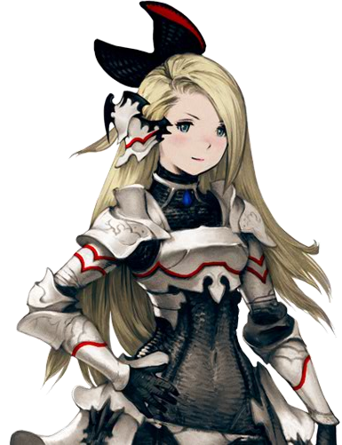

Since she’s supposed to be an heiress to a kingdom in my story so

Armor is kinda a big need

ArthurDank 04-Mar-19 02:03 PM

indeed it is and I like suits you more i think

see you being the armor wearing badass

Bunny 04-Mar-19 02:05 PM

I mean Templar is just paladin but broken

Holy magic that can pierce defense

Or rather ignore defense completely

ArthurDank 04-Mar-19 02:05 PM

damn

Bunny 04-Mar-19 02:05 PM

Desperation

Adds defense to attack for proportional damage

Buff with Ironclad and boom

You’re basically invincible

And Shieldwall

Defend one ally from one attack for one turn

All damage is directed to you instead of the chosen ally

https://www.google.com/amp/s/www.gameskinny.com/google-amp/279q8/bravely-default-templar-job-guide

Bravely Default: Templar Job Guide
Do you seek justice and want to defend your allies from harm? Then, learn the Holy Arts in this Bravely Default Templar Job Guide!
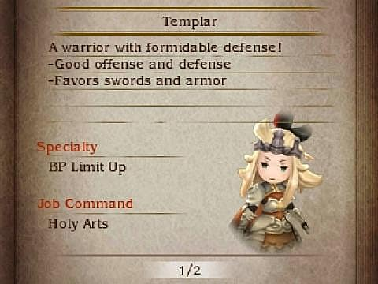

If I wanted to translate BP to D&D it’s basically just extra actions in a single turn

Normally you only get 1

But if you brave 4 times you get 4 actions per turn

It mixes best with the knight class

Use Ironclad from Knight to boost defense to 150%

And then use Desperation to deal 300% damage

Often hits for 9999

ArthurDank 04-Mar-19 02:13 PM

holy shit

you really know your class you should have no problem with a setup like that

4 actions per turn if you brave 4 times like damn!

Bunny 04-Mar-19 02:15 PM

Thing is unless I change canon she won’t be starting as Templar

She’ll just start as Freelancer instead
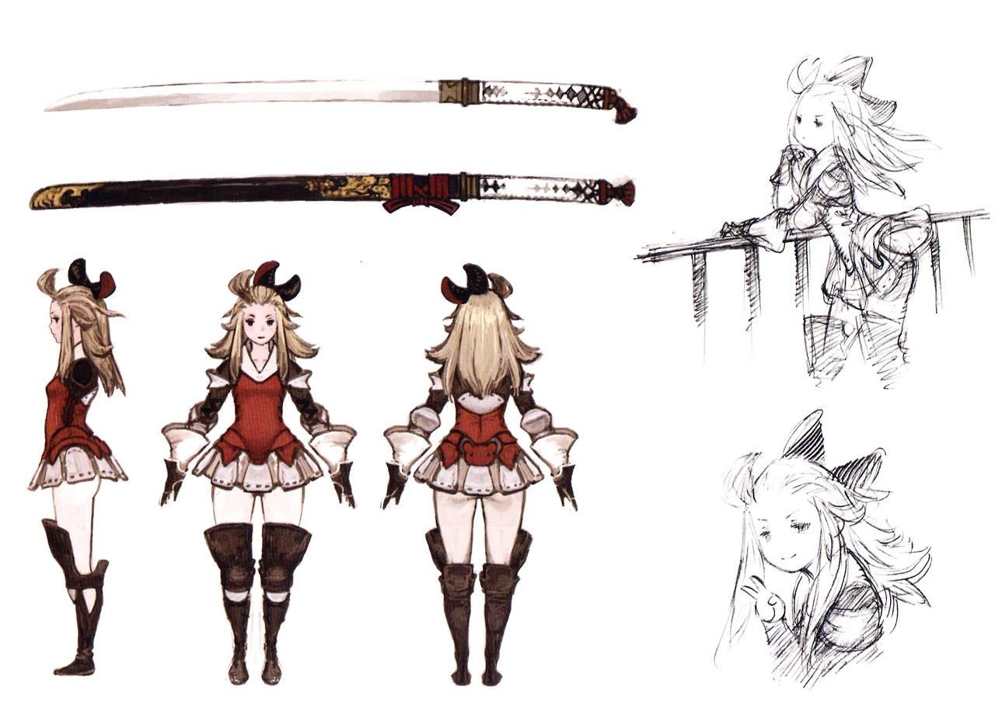

ArthurDank 04-Mar-19 02:16 PM

ah that looks more familier

Bunny 04-Mar-19 02:16 PM

I doubt I’ll be changing from Ise-No-Kami as her weapon either

Yeah

Edea Lee

Bravely Default

Her name is a pun

I made it so her father is dead in this version so

I’ll either have to make an entire new Character to have the Templar asterisk

Or she’ll start with it

ArthurDank 04-Mar-19 02:18 PM

oh i see i like the pun tho, but i see what you mean

Bunny 04-Mar-19 02:18 PM

Ise-No-Kami does like 93 damage

So

That’s 9 damage max (edited)

For D&D

So I’ll roll

1d9

Yeah that’ll work

Goblins only have 7hp anyways

ArthurDank 04-Mar-19 02:19 PM

whoa

Bunny 04-Mar-19 02:19 PM

I’ll probably have her fight the initial party

Just like in Bravely

Then she’ll switch sides

Just like the actual game

But a 5 on 1 seems unfair

I guess I’ll have the black mage help with that fight

Does 3 on 5 sound fair?

Edea

Crowe

And Bahamut

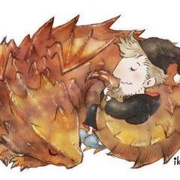

ArthurDank 04-Mar-19 02:22 PM

sounds pretty fair to me sometimes thays as fair as it can get

i like the idea of keeping her switching sides to be the same

thats cute btw :)

Bunny 04-Mar-19 02:23 PM

Crowe isn’t all that bad

He’s just a jerk

Set a tower on fire in the main town

Like a jerk

Okay so

On the plains

It’s

Goblins

Yeah

And in the keep

It’ll be

Skeletons

And goblins

Skeleton= 13hp

Goblin= 7hp

I think that’s fair

Lemme see how much HP Crowe and Bahamut have

ArthurDank 04-Mar-19 02:25 PM

crowe sounds like a jerk for sure and that sounds pretty reasonable

Bunny 04-Mar-19 02:26 PM

1800hp

Ehhhhh

I’ll have to lower that a bit

ArthurDank 04-Mar-19 02:26 PM

if base damage is 9 and hp seems a bit high

yes

Bunny 04-Mar-19 02:26 PM

180 sounds fair

ArthurDank 04-Mar-19 02:27 PM

thats better sounds much more balenced

yeah 1800 is a bit too high for starting out

writing it out some more?

gotta get ready for work i go in from 3-10:30-11 depending on how fast the floors get done

Bunny 04-Mar-19 02:34 PM

Changed it

50 hp for both

ArthurDank 04-Mar-19 02:35 PM

sounds better given the low health of the starting enemies

ArthurDank 04-Mar-19 02:45 PM

gonna be a fun D&D sounds like to me

heading out to work wish me luck lol welcome to hit me up later at work but just keep in mind slow replies :) especially during floor time which is around 7 till i leave (edited)

Bunny 04-Mar-19 02:52 PM

Yee

ArthurDank 04-Mar-19 02:54 PM

haha have fun lori :)

ArthurDank 04-Mar-19 03:02 PM

nice new avatar suits you

Bunny 04-Mar-19 03:03 PM

Gotta do all my rolls now lol

ArthurDank 04-Mar-19 03:03 PM

lol damn right

Bunny 04-Mar-19 03:03 PM

Going Templar because I can’t make the first major battle too easy

Gotta find the Paladin sheet now

ArthurDank 04-Mar-19 03:04 PM

awesome good luck finding the sheet (edited)

and sounds fair

ArthurDank 05-Mar-19 07:04 PM

hello lory how are you doing? I wanted to ask something, you said you appreciated my honesty so i wanted to ask about a concern I had, I enjoy chatting with you but it isn't annoying how often I chime in is it? its nothing you did or said but its happened in the past with others thats why i ask, also why sometimes i fade for a day or two, worry sometimes i may be suffocating (edited)

Bunny 05-Mar-19 08:08 PM

No you’re not annoying

ArthurDank 05-Mar-19 08:09 PM

okay thanks lory i enjoy our chats i dont want to be suffocating or anything lol knew you would be honest (edited)

habit of mine to rub folks the wrong way overtime, hope that never happens here so what have you been into today? (edited)

Bunny 05-Mar-19 08:18 PM

D&D mostly

ArthurDank 05-Mar-19 08:19 PM

thats cool lory :)

just played on my laptop a bit today was my day off

how has your BD campaign gone?

Bunny 05-Mar-19 10:56 PM

Good so far

ArthurDank 05-Mar-19 11:08 PM

thats awesome

:)

been playing D&D while you were away?

Bunny 05-Mar-19 11:09 PM

Yuup

ArthurDank 05-Mar-19 11:10 PM

thats very cool :)

still playing atm or quits for the night?

Bunny 05-Mar-19 11:14 PM

Still playing

ArthurDank 05-Mar-19 11:14 PM

awesome have fun lory :) how long are your D&D sessions?

Bunny 05-Mar-19 11:15 PM

Basically until everyone falls asleep

ArthurDank 05-Mar-19 11:16 PM

neato

dont wanna distract ya lory have fun playing :) if you wanna chat later on i will be around :)

Bunny 06-Mar-19 01:17 AM

Henlo

I’m back

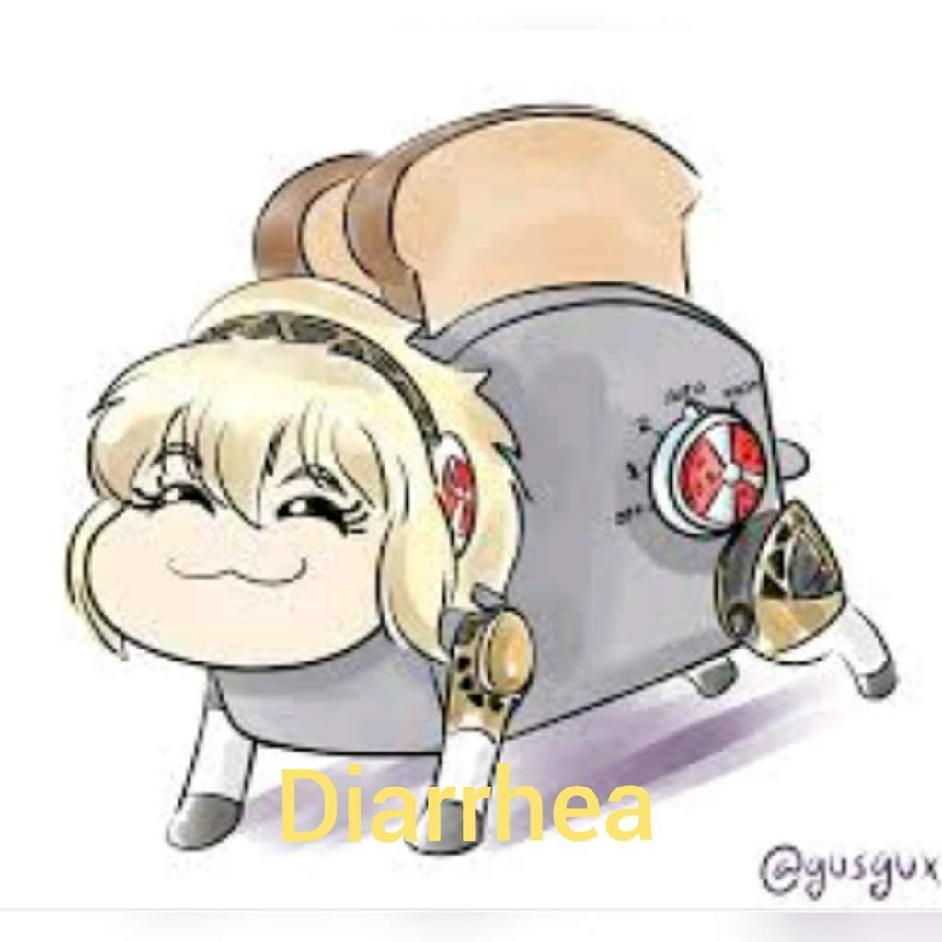

ArthurDank 06-Mar-19 01:17 AM

welcome back partner

lmao

nice

thats cute lol "diarrhea"

have fun with D&D?

Bunny 06-Mar-19 01:20 AM

Yee

ArthurDank 06-Mar-19 01:20 AM

awesome haha

so whatcha doin now?

Bunny 06-Mar-19 01:20 AM

YouTube vidyas

ArthurDank 06-Mar-19 01:21 AM

very nice

what vidyas ya watching?

Bunny 06-Mar-19 01:23 AM

Serious Sam.

ArthurDank 06-Mar-19 01:24 AM

badass like i said i need to get into that sometime lol

sounds like a nice vidya for you and parker to watch

Bunny 06-Mar-19 01:27 AM

I just have him between my thighs too lol.

ArthurDank 06-Mar-19 01:28 AM

hehe hot lol

he awake?

Bunny 06-Mar-19 01:30 AM

Yeah but I’ve blanket burritoed myself and I’m under them

ArthurDank 06-Mar-19 01:30 AM

haha them?

very sneaky lory haha very im impressed this will be fun (edited)

Bunny 06-Mar-19 01:33 AM

Yee

Oooh he’s throbbing already lol

ArthurDank 06-Mar-19 01:34 AM

boys been waiting he has

Bunny 06-Mar-19 01:36 AM

Jesus that was a huge shot

Just gonna lick that off my hand

Lmao

ArthurDank 06-Mar-19 01:36 AM

lmao mmm what a nice image

kinky

shot on your hand wow

Bunny 06-Mar-19 01:39 AM

I was playing with the tip lol

ArthurDank 06-Mar-19 01:40 AM

i like it ;) whatcha doin now? (edited)

Bunny 06-Mar-19 01:42 AM

He’s just rubbing against my thighs. Got leggings on.

ArthurDank 06-Mar-19 01:42 AM

nice really dig dem leggings

thanks for letting me spectate tonight haha you're awesome (edited)

such nice thighs you have

he gettin ya doggy now?

Bunny 06-Mar-19 01:50 AM

Mhmmmm

I took a picture earlier if you care to see

ArthurDank 06-Mar-19 01:51 AM

you know i never care hehe

look forward to seeing the pic, he deep through those leggings yet?

Bunny 06-Mar-19 02:05 AM

Yeah and here ya go
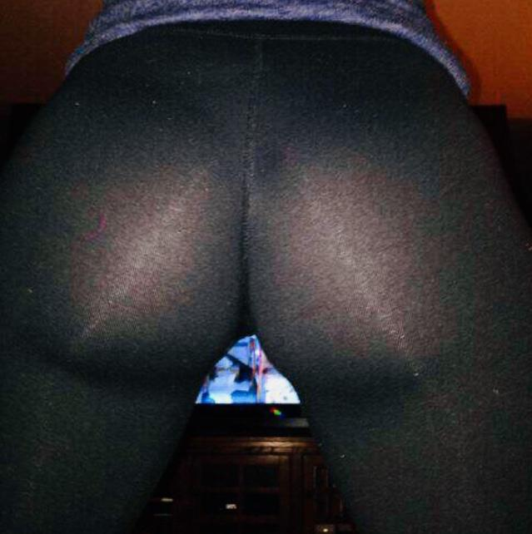

ArthurDank 06-Mar-19 02:07 AM

mmm fantastic you have such a nice butt and those leggings only make it more naughty and sexy that pic is gonna get used a lot hehe

thank you also when next we do a lewd rp the leggings will be involved lol

Bunny 06-Mar-19 02:08 AM

He’s half hard but he still stuck it in

ArthurDank 06-Mar-19 02:09 AM

wow they are thin as you said it wouldn't take much hehe

how is it going? how many loads so far

Bunny 06-Mar-19 02:10 AM

Two so far

ArthurDank 06-Mar-19 02:10 AM

nice hehe

thanks for that pic so hot

cum a few times yourself?

Bunny 06-Mar-19 02:15 AM

Two times myself

ArthurDank 06-Mar-19 02:16 AM

right on lory ;)

he all the way in your cute butt now?

Bunny 06-Mar-19 02:18 AM

Yeah~ Just riding him lol

ArthurDank 06-Mar-19 02:20 AM

oh sweet hehe bouncing back against him huh?

Bunny 06-Mar-19 02:20 AM

Yuuup

I never did ask why you liked this outfit in particular
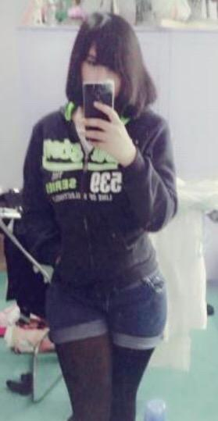

ArthurDank 06-Mar-19 02:22 AM

got to see much of your face, you have a pretty face and brunettes kinda set me off, the whole short shorts and leggings i could see your shapely thighs and legs, and even in the jacket i could tell your had a nice stomach and were packing a lovely rack (edited)

Bunny 06-Mar-19 02:23 AM

I even bound them in that picture too lol

ArthurDank 06-Mar-19 02:23 AM

i had a feeling lol

call it instinct the pic of you laying on your side kinda told me how big they were

Bunny 06-Mar-19 02:26 AM

And now he’s groping me

At this rate I’ll just keep growing

ArthurDank 06-Mar-19 02:27 AM

hehe well i dont blame him its a shame not to play with those boobs in rp i dod the same with you and when i fantasize (edited)

i hope they dont grow too much more for fear you wont be able to get back up lol (edited)

also i liked the outfit cause i fantasized about pulling those jeans to the side pounding you behind through your leggings that jacket unzipped and my hands groping you under your bindings

Bunny 06-Mar-19 02:35 AM

I only had a tube top on under it too lol

ArthurDank 06-Mar-19 02:36 AM

i saw that around the neck,just the more easier to access hehe (edited)

Bunny 06-Mar-19 02:39 AM

Tight clothes are a chore but I like them

ArthurDank 06-Mar-19 02:39 AM

i can tell they are but im glad you like them i like them too for different reasons lol

you are very beautiful so they suit you

Bunny 06-Mar-19 02:42 AM

Edea is a fun character claim for D&D since we have a similar body type
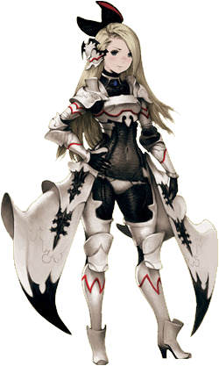

ArthurDank 06-Mar-19 02:43 AM

damn actually you do whoa :O

that armor might be heavy but i could see you as a hot badass dressed like that

hows the bumping going?

Bunny 06-Mar-19 02:45 AM

He’s gonna shoot again lol

ArthurDank 06-Mar-19 02:45 AM

lol nice

on the subject parker said something on twitter a while back when you were hitting on owl, something about you and rope lol you like being tied up sometimes?

i had to ask lol

Bunny 06-Mar-19 02:54 AM

Sometimes yeah

ArthurDank 06-Mar-19 02:54 AM

not gonna lie thats pretty hot (edited)

for some reason i forgot that but then i remembered you couldn't text me during that anyway lol

how many shots in your butt so far? ;)

Bunny 06-Mar-19 02:59 AM

5 so far

He’s still hard too,not slowing down either

ArthurDank 06-Mar-19 03:01 AM

nice hehe

really going to town on your butt ;)

Bunny 06-Mar-19 03:02 AM

It’s basically just this

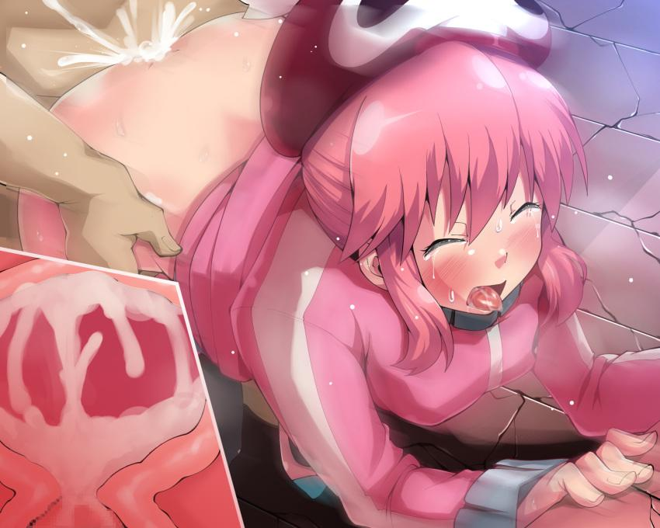

ArthurDank 06-Mar-19 03:03 AM

i have seen that before when you posted always a hot image (edited)

pounding your butt senseless till your legs get weak

already blasted once about to do so again

hope texting me isn't deterring from the fun

Bunny 06-Mar-19 03:06 AM

Not at all

ArthurDank 06-Mar-19 03:07 AM

good ;)

cause i do enjoy it lol

you came about 5 times now too i should think ;)

ArthurDank 06-Mar-19 03:29 AM

hanging in there lory? ;)

Bunny 06-Mar-19 03:43 AM

Sorry he was fucking my tits Iol

ArthurDank 06-Mar-19 03:43 AM

lmao no worries i just thought he tied you up hehe

how many times did he blast on those nice tits? (edited)

was wondering if he tied you up when we did this 3 nights ago? cause i got a msg just before 1 am then you were gone till i messaged you the next day lmao

Bunny 06-Mar-19 03:50 AM

Yes actually we did

Rope play is fun

ArthurDank 06-Mar-19 03:51 AM

lmao thats what i thought

cool sounds pretty hot not gonna lie never thought about it how do you guys do rope play (edited)

probably not a good time to ask those questions mid boink lol (edited)

Bunny 06-Mar-19 03:56 AM

I usually have my arms tied back and my legs tied too,with the knots right under my tits

ArthurDank 06-Mar-19 03:56 AM

wow ;)

thats pretty kinky

and he goes to town on you , in all three spots when its a safe day very nice (edited)

Bunny 06-Mar-19 04:01 AM

Sorry one sec looks like he’s gonna lift me up

ArthurDank 06-Mar-19 04:01 AM

have fun hehe

ArthurDank 06-Mar-19 04:26 AM

back yet? lol

ArthurDank 06-Mar-19 11:49 AM

henlo lory :)

ArthurDank 06-Mar-19 02:06 PM

last I heard he was about to pick you up lol what all happened after that?

Bunny 06-Mar-19 02:07 PM

We pounded for a bit then went to bed lol

ArthurDank 06-Mar-19 02:08 PM

lmao nice figured it wasn't long after since I didn't hear from ya after that, thanks for telling me a bit about rope play hehe (edited)

so what are you doing today?

Bunny 06-Mar-19 02:19 PM

Reading up on 5e rules

ArthurDank 06-Mar-19 02:19 PM

oh nice doing some D&D prep?

Bunny 06-Mar-19 02:20 PM

And also deciding how many encounters between where we are now and the first major location

ArthurDank 06-Mar-19 02:20 PM

ahh makes sense

gotta balence that stuff out

Bunny 06-Mar-19 02:23 PM

That’s weird

I don’t remember fighting the monk until the second fortress

I guess the monk and white mage are first then

ArthurDank 06-Mar-19 02:25 PM

oh

sounds like some events are getting mixed around (edited)

Bunny 06-Mar-19 02:26 PM

I could’ve sworn it was just the black mage on his own

To be fair I haven’t played Bravely since it came out five years ago so

I played it’s sequel in 2016 but ehhh it’s kinda hazy

All I really remember is how to get the secret ending

And that the Dark Knight class is broken as shit

Everything else I don’t remember very well

ArthurDank 06-Mar-19 02:29 PM

lmao bravely second i remember had some controversy but I will say its easy to get events mixed up after 5 years, well secret endings stick out when there is a certain route to get them

dark knights name sounds broken alone

i know its hard setting up D&D when you can't quite remember the games events it will come back tho just gotta think, youtube can help too (edited)

ArthurDank 06-Mar-19 06:52 PM

Hope you are having a good evening lory. im at work but was curious about rp when you have the time. I was wondering if earlier in the day would also be good to rp? i know you said 11 PM thats why i dont ask in the day but no one time always works and i know you get busy at night as well so i was curious your thoughts. I never have a problem getting in the mood with you if thats a concern so long as im not out or working lol (edited)

Bunny 06-Mar-19 08:02 PM

Oh hi

ArthurDank 06-Mar-19 08:10 PM

hello

im at work and hoping it wasn't a bad time to ask you about that just whenever you had time i was curious your thoughts

Bunny 06-Mar-19 08:13 PM

I mean it’s the best time for me because I’m not really doing anything

ArthurDank 06-Mar-19 08:13 PM

11 pm?

oh for me too really i just know you get busy sometimes with parker too around that time you know hehe ;) dont get me wrong thats fun too but i thought i would ask if there was a better time for you and me rp i know sometimes it works and sometimes it dont (edited)

thats all haha its no biggie (edited)

hope it was okay I asked :)

ArthurDank 06-Mar-19 08:27 PM

any night you are not busy around that time works for me too i was just wondering as im good to rp anytime im not working (edited)

ArthurDank 06-Mar-19 08:36 PM

didnt mean to ramble sorry lory lol (edited)

ArthurDank 06-Mar-19 09:03 PM

hope i didn't annoy you

Bunny 06-Mar-19 09:34 PM

Nah you’re not annoying

ArthurDank 06-Mar-19 09:45 PM

thanks lory i was just wondering cause i know you aren't busy during that time but i know you are usually bumping parker around that time our before, thats why i was wondering if there were other times, i hadn't had a rp like the one we did in a long time, no one ever got me off like you did, thats why i look forward to when we can do it again, i could do it with you all the time lol anywho 11 any night you aren't preoccupied works for me, i just had to ask lmao

Bunny 06-Mar-19 10:10 PM

Any time I’m not asleep basically

ArthurDank 06-Mar-19 10:15 PM

anytime you aren't asleep what lory?

sorry you lost me there lory (edited)

ArthurDank 06-Mar-19 11:22 PM

didn't meant to ramble about this so much gotta overlook me sometimes i dont know how to shut up XD if you meant me then yes anytime you weren't asleep i could basically go, but lemme know what you were referring to as i fear i may misunderstand lol (edited)

Bunny 07-Mar-19 01:36 AM

Oh Henlo there
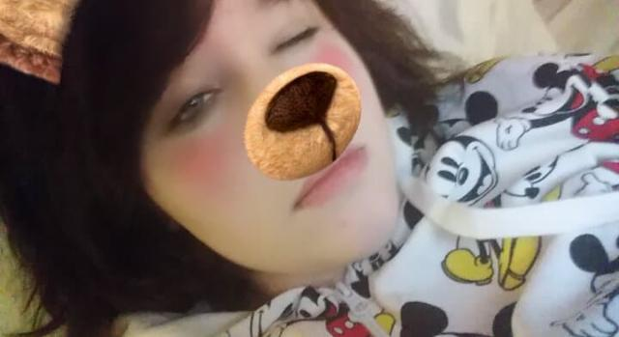

Am bear

ArthurDank 07-Mar-19 01:43 AM

aww so cute sorry for the late reply was driving (edited)

you look so adorable lory

almost couldn't lewd such cuteness...almost lol

look schleepy

Bunny 07-Mar-19 01:58 AM

A little bit yeah

Watching videos

ArthurDank 07-Mar-19 01:59 AM

that sounds nice lor

lory

how much longer do you figure you will be up?

look so cute in your pj's :)

Bunny 07-Mar-19 02:02 AM

Probs a few more hours

My doctors appointment was rescheduled

So I have the day free

ArthurDank 07-Mar-19 02:02 AM

nice i do too tomorrow

your doctor? is everything okay?

was curious if it was a good time for a rp? its okay if it isn't my friend :)

Bunny 07-Mar-19 02:05 AM

Yeah it’s just a regular checkup

In a bit is good

ArthurDank 07-Mar-19 02:06 AM

oh okay good thought something was wrong

okay sure just lemme know im good anytime (edited)

hope im not imposing lol (edited)

so what videos are you watching

Bunny 07-Mar-19 02:13 AM

Jontron

ArthurDank 07-Mar-19 02:13 AM

ahh cool

Bunny 07-Mar-19 02:15 AM

Am Rabbit
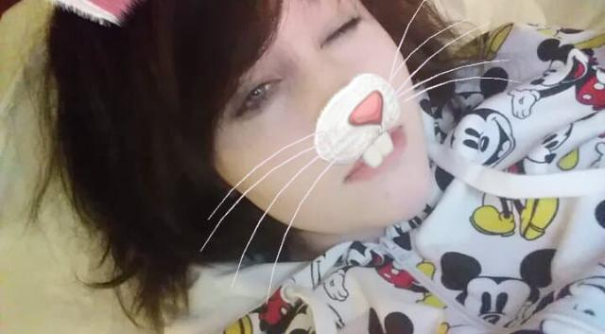

ArthurDank 07-Mar-19 02:17 AM

hahaha thats cool

you look so cute even with rabbit teeth hehe

Bunny 07-Mar-19 02:22 AM

I’m very warm

ArthurDank 07-Mar-19 02:22 AM

i can tell you are hehe

you look so soft and cuddly

those pjs look very warm

Bunny 07-Mar-19 02:24 AM

Messy hair~

ArthurDank 07-Mar-19 02:24 AM

but so cute wanna put my hands through it it looks so nice

you do look super warm i feel warm too looking at you

i like messy hair

you still there partner? let me know when you wanna start, i cant read minds lol (edited)

Bunny 07-Mar-19 02:31 AM

I’m here

ArthurDank 07-Mar-19 02:31 AM

oh hello sorry

lol

so whats up?

Bunny 07-Mar-19 02:34 AM

Being patted

I’m very soft

ArthurDank 07-Mar-19 02:34 AM

yes yes you are

being patted? thats nice :)

Bunny 07-Mar-19 02:48 AM

I like hugs

ArthurDank 07-Mar-19 02:48 AM

hugs tight

good to see ya thought you were bumping lol

hugs are always nice

Bunny 07-Mar-19 02:52 AM

Well

He does have his hands up my shirt lol

ArthurDank 07-Mar-19 02:52 AM

lol nice dont blame him sounds like bumping is on the horizon haha

sounds like our rp is canceled for tonight but its cool you kids have fun im kinda pooped from work anyway lol so im gonna get some rest :)

Bunny 07-Mar-19 02:56 AM

Naaaah I’m alright

Don’t worry about it

I think he’s pretty sleepy as is

We’re good to go in about 20 minutes

ArthurDank 07-Mar-19 03:00 AM

oh okay lol

i will hit you back up in 15

have a good night just in case but i will hit ya in 15 all the same :) gonna smoke and such (edited)

gotta put this damn thing back on charge lol

Bunny 07-Mar-19 03:10 AM

this time around try not to have so many typos lol

ArthurDank 07-Mar-19 03:11 AM

lol okay sorry i didn't recall having that many before

it was a while back probably forgot about them haha

I will spell better this time lol

whenever you are ready lory just let me know (edited)

Bunny 07-Mar-19 03:33 AM

Ready~

ArthurDank 07-Mar-19 03:33 AM

(you wanna start or should I?)

(I can not a problem)

Bunny 07-Mar-19 03:39 AM

(I’ll start)

ArthurDank 07-Mar-19 03:40 AM

(cool it is your turn so fire away)

Bunny 07-Mar-19 03:43 AM

(Actually you start lol)

ArthurDank 07-Mar-19 03:43 AM

(lol okay sure)

I come into the bedroom and see you with your back turned to me, you are wearing those black leggings that show off every bit of your tight ass, you have your red stripped jacket on but unzipped and i feel my cock getting hard at the sight I come up behind you putting my arms around you "hey babe"

"getting dressed up for something?"

Bunny 07-Mar-19 03:50 AM

“For you obviously~ I know how much you love these leggings~” Lifts my ass a bit with both hands,bouncing it a little

ArthurDank 07-Mar-19 03:53 AM

" you know me too well, im so lucky, glad you are in the mood today" * putting my hands around your fine ass my cock teases and rubs the insides of your butt a bit while i kiss your neck and my hands find my way to your big tits fondling them*

my cock enters your tight ass through the leggings it feels so amazing your ass and leggings rubbing "mmm fuck lory thats so good" (edited)

Bunny 07-Mar-19 03:58 AM

Slides my ass down your throbbing cock “You’re a bit bigger than normal huh~? Excited are ya~?” Rolls my hips in circles squeezing my ass tightly around your cock

ArthurDank 07-Mar-19 04:01 AM

feeling your ass squeeze my hips move in rhythm with yours "always excited to fuck your brains out lory" I begin to thrust inside your ass, one hand fonding your tit, the other trailing down to your pussy rubbing through the leggings

Bunny 07-Mar-19 04:07 AM

Pulls your cock out slowly till I reach the tip and then slowly push it back in “You have the enhancement pills~? I wanna see how big you get this time~!” Grinds my ass up against your crotch

ArthurDank 07-Mar-19 04:12 AM

smirks as you grind against my cock my hips rubbing and thrusting against your ass and leggings "i took one about 10 mins before i came in its starting to take effect now" *i start kissing and sucking on your neck as my cock begins to get longer and hard as a rock as your rubbing your ass against it the leggings just adding more pleasure to it

Bunny 07-Mar-19 04:18 AM

“You’re fucking huge~ Even bigger than last time~!” Rubs my ass along the entire length of your now foot long cock (edited)

ArthurDank 07-Mar-19 04:21 AM

"Yes and your ass is even tighter now it feels so fucking good hope you like what im about to do, nice we have a mirror in the corner" * i rub my cock against your ass as it rubs against me then i pull my hands away from your tits and wet pussy i bring them under your hips and lift you up from behind and move till you can face the mirror seeing your lewd face and my massive cock buried in your ass i begin to piston pump my cock inside of your ass* (edited)

"like being lifted up lory? you're so cute like this and your face makes me so hard mmm" my cock manages to get harder seeing your expression as i pummel your ass

Bunny 07-Mar-19 04:26 AM

Groans loudly as your foot long cock is buried up my ass,making my stomach bulge out “FUUUUUCK! DEEPER! YOU’RE NOT EVEN HALFWAY IN!”

ArthurDank 07-Mar-19 04:30 AM

" I will be now after THIS" with one long hard thrust my cock goes all the way into your ass i see my cock bulge even further in your stomach from the mirror and i start pumping madly inside of you while holding you up feeling my cum building up "you're so fucking tight lory!" (edited)

Bunny 07-Mar-19 04:32 AM

“CMON CUM ALREADY~!”

ArthurDank 07-Mar-19 04:34 AM

I pound you hard as i can all the way in your butt AHHH FUCK YES! I shout as i blow my first load inside your ass, the cum going right through your leggings staining them, several big shots go off inside and i feel it leaking around my cock (edited)

"jesus that felt so good"

Bunny 07-Mar-19 04:40 AM

Slowly pulls your cock out of my ass as cum leaks out all over my legs “If you’d shot in my pussy you might’ve knocked me up~! How’s about we go again~?” Playfully strokes your softening cock with both hands

“You wanna shoot all over my tits too dontcha~?”

ArthurDank 07-Mar-19 04:44 AM

my cock hardens back up feeling your warm hands rubbing it back to full length "damn right we are and yes i do" * i put you down onto the bed and climb over you i pull the open jacket away and your tits are in full view i start rubbing your tits together as i begin to stick my massive cock between them (edited)

"gonna blast a fat load all over your big tits lory"

Bunny 07-Mar-19 04:48 AM

Presses my tits together around your cock squeezing tightly “I can’t even bury the whole thing~!” Licks all over the tip as it sticks out near my face

ArthurDank 07-Mar-19 04:51 AM

"i know your tits feel so great lory and your mouth" * i start thrusting my hips and my cock starts fucking your tits going in and out between them, my cock keeps thrusting near your face big as it is* (edited)

Bunny 07-Mar-19 04:55 AM

squeezes my tits even harder together and spits all over the tip,running my tongue over the tip

ArthurDank 07-Mar-19 04:57 AM

thrusting my cock even harder between your boobs feeling them and your tounge together feels too good and I begin feeling my cum building inside my balls again "jesus lory that feels so good fuck" thrusting my hips faster (edited)

Bunny 07-Mar-19 05:01 AM

“C’mon fill my whole mouth with it~! Cum in my mouth~!”

ArthurDank 07-Mar-19 05:03 AM

"ahhh fuck yes!" thrusting my hips faster my cock goes right into your mouth as i cum blasting a fat load into your warm waiting mouth and some around it

Bunny 07-Mar-19 05:07 AM

Swallows your entire load in one go,wiping the rest off my face with my hands “Would you let me change my outfit really quick~? It’ll be to one of your favorites~!”

ArthurDank 07-Mar-19 05:08 AM

sits for a minute and gives you a quick peck on the lips "please go ahead cant wait"

Bunny 07-Mar-19 05:10 AM

“Sorry to keep you waiting~ I know how much you like this one~!”

ArthurDank 07-Mar-19 05:12 AM

* my cock goes back to full mast immediately* " the outfit from when we first met, you always looked so sexy in it (edited)

Bunny 07-Mar-19 05:13 AM

Slides your cock between my thighs pressing them together gently “You always did like my thighs~!”

ArthurDank 07-Mar-19 05:15 AM

"mmm still do baby" start to thrust slowly between your thighs as you rub them they feel so warm and squishy and the jeans and leggings make it even more satisfying (edited)

Bunny 07-Mar-19 05:17 AM

Slowly unzips my hoodie just enough for my tits to fall out “You can cum whenever you wanna~” Runs my thumb over the tip of your cock

ArthurDank 07-Mar-19 05:19 AM

"god you're so good mmm yes" my hands go around to your tits rubbing and teasing the nipples i thrust more between your thighs and as i feel your thumb rubbing my cocks tip it doesn't take long before I start shooting again, pumping large amounts of my seed on your hand (edited)

"god you are the best"

Bunny 07-Mar-19 05:23 AM

Licks your cum right off my hand “Let’s try something~” Presses the tip of your cock right between my jeans covered ass as you’re still leaking cum “That feel good~?”

ArthurDank 07-Mar-19 05:25 AM

" oh yeah that does feel great" my cock starts pressing between the jeans, more against your ass going in further "feels fucking great"

Bunny 07-Mar-19 05:28 AM

Grinds my jeans covered ass along the entire length of your throbbing cock “You wanna try pushing in through my shorts huh~?”

ArthurDank 07-Mar-19 05:30 AM

"hell yes i always wanted to try it" my cock rubs against your shorts and leggings going further in

Bunny 07-Mar-19 05:32 AM

Gently pushes you over “I’ll try it myself then~!” Sits right on top of your thick foot long cock pushing it against the denim of my shorts “You might need another enhancement pill for this~”

ArthurDank 07-Mar-19 05:33 AM

takes another one and it hits almost immediately my cock grows even bigger i thrust up as you push down on it and i feel my cock going further through " jesus christ its gotten even bigger"

Bunny 07-Mar-19 05:36 AM

“I can take it~!” Pushes my shorts covered ass down even harder on your now foot thick two and a half foot long cock “I can handle even bigger than this~!”

ArthurDank 07-Mar-19 05:38 AM

"thats my girl but we will see about that" i thrust up into you and i feel it going through even further the fabric feels nice rubbing my cock and i feel myself going into your warm tight ass and i thrust harder as you push down (edited)

"fuck that feels good"

Bunny 07-Mar-19 05:44 AM

Feels my ass spreading apart as I manage to stuff the tip of your cock up my asshole through my denim shorts “I never thought it’d get it~ it’s so fucking biiiiig~!”

ArthurDank 07-Mar-19 05:46 AM

"jesus christ you're even tighter then before fuck this feels so intense" my huge cock pounds up into your ass through the denim in and out as my hands grip your spreading ass giving your cheeks playful slaps as cock pounds your insides stirring your guts (edited)

"jesus im feeling something huge" (edited)

(you ok lory?)

ArthurDank 07-Mar-19 06:00 AM

(did you pass out? well im not far behind lol i had a lot of fun lory but its 6:15 and i think you fell asleep, have sweet dreams and check in with me when you get up or vice versa) (edited)

ArthurDank 07-Mar-19 12:33 PM

henlo Lory

ArthurDank 07-Mar-19 01:13 PM

did ya pass out during the rp? lol

Bunny 07-Mar-19 01:45 PM

Whoops

ArthurDank 07-Mar-19 01:48 PM

howdy partner

had a lot of fun last night with you but did you fall asleep during the rp last night? i know it was late (edited)

ArthurDank 07-Mar-19 02:16 PM

probably what you meant by "whoops" lmao

ArthurDank 07-Mar-19 02:23 PM

its not a problem you if fell asleep or of parker woke up hornt lol i wasn't gonna be able to go for much longer either lol i just wanted to be sure i wasn't boring haha (edited)

Bunny 08-Mar-19 12:36 AM

Henlo

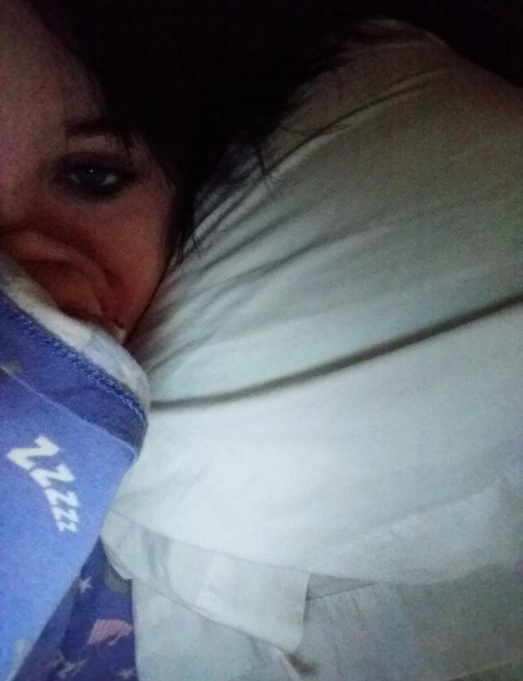

Bunny 08-Mar-19 12:50 AM

Beep

ArthurDank 08-Mar-19 12:51 AM

hello dere haha

aww thats cute

I was away from my phone that was why i was late with replies you look cute as always

so whatcha doin?

Bunny 08-Mar-19 01:01 AM

Was getting warm

ArthurDank 08-Mar-19 01:01 AM

very nice haha

look nice and snug

Bunny 08-Mar-19 01:04 AM

Yee

ArthurDank 08-Mar-19 01:05 AM

look sleepy

getting ready for bed or getting ready for action in bed? ;)

Bunny 08-Mar-19 01:12 AM

Maybe

ArthurDank 08-Mar-19 01:13 AM

im listening lol

Bunny 08-Mar-19 01:14 AM

I’m kinda interested in seeing where the thing from last night would go too lmao

ArthurDank 08-Mar-19 01:19 AM

me too honestly lmao (edited)

i had fun last night

if you feel like it we can continue sometime tonight just lemme know (edited)

Bunny 08-Mar-19 01:23 AM

Sure just copy paste whatever you did last lol

ArthurDank 08-Mar-19 01:24 AM

you mean right now sure thing lol

guess you lost track when you fell asleep hold on

"jesus christ you're even tighter then before fuck this feels so intense" my huge cock pounds up into your ass through the denim in and out as my hands grip your spreading ass giving your cheeks playful slaps as cock pounds your insides stirring your guts

Bunny 08-Mar-19 01:28 AM

“FUCK YOUR COCK IS PRESSING UP AGAINST MY STOMACH!” Slowly squeezes even tighter around your two foot long foot thick cock

ArthurDank 08-Mar-19 01:30 AM

Pulls you down to suck on your tits as I start pumping into your tight ass as it squeezes even tighter against my giant cock "mmm yeah so fucking tight lory you can take it!"

Bunny 08-Mar-19 01:35 AM

the denim starts to tear as your entire cock forces it’s way into my guts,making my stomach bulge out in the shape of your giant cock “FUUUUUCK CUMMING!!!” Squirts as the last 6 inches of your cock are buried up my ass

ArthurDank 08-Mar-19 01:39 AM

I grip the denim around your ass tight as my cock is buried all the way inside you, my hips pump as you squeeze around it tighter then i can handle "jesus fuck me too!!!" feeling you cum as your pussy squirts on my waist my cock starts exploding inside of you painting your asshole white (edited)

Bunny 08-Mar-19 01:44 AM

My guts fill up with your hot cum,my stomach filling up with it too bulging out even further “I know I can take even more than this~ I have another enhancement pill that can give you two cocks instead of just one~ it’ll make it easier to fill both my holes~!” Slides a small red pill into your mouth

ArthurDank 08-Mar-19 01:51 AM

* i swallow the pill and before I know it a second cock begins to pop out and starts going deep into your pussy through the tight denim while my other cock is still deep in your ass, becoming fully hard again in a instant* " lets do this properly lory and see how much you can really take" * i smirk and roll you over gently climbing behind you i pull out and bend you over slowly pressing both of my cocks against your exposed ass and back through the denim covering your soaked pussy* (edited)

Bunny 08-Mar-19 01:54 AM

“FUUUUCK~! Rolls my hips in circles as you bury your cocks into both of my holes through my shorts,tearing them as you push deeper

ArthurDank 08-Mar-19 01:58 AM

"fuck thats it babe I love it when you get so into it" * i grip your ass cheeks as i press my cocks deeper i feel the denim tear around the pussy i give a thrust and i feel them go further in both holes i push both of my thick cocks in hard as im pumping back and forth inside you as you roll your sexy hips* (edited)

Bunny 08-Mar-19 02:06 AM

Bounces along the entire length of your cocks squeezing my pussy down on the second and my ass down on the first

ArthurDank 08-Mar-19 02:08 AM

grabs the back of your pretty hair and starts pulling as i pound both of my cocks inside your ass and pussy thrusting into you as you bounce back on me (edited)

Bunny 08-Mar-19 02:11 AM

“Do you think I can take three~? I think I can take three~!” Rolls a small blue pill around in my left hand as I bounce even faster on your two giant cocks

ArthurDank 08-Mar-19 02:12 AM

" so be it lory hope you can" *i pull the pill out of your left hand and take it i feel funny as i see another cock thrusting out of me

Bunny 08-Mar-19 02:14 AM

“This new cock of yours can move a bit different than the other two~ it’s like a tentacle~ Try wrapping it around my tits~!” (edited)

ArthurDank 08-Mar-19 02:16 AM

"wow amazing lory" i wrap this cock around your tits nice and tight rubbing against them squeezing as i pound both of your holes the pleasure is unlike anything i have felt before (edited)

Bunny 08-Mar-19 02:22 AM

“It’s a bit more sensitive than the others too~” Drools all over my tits pressing them together against your tentacle cock “You can use your other two cocks in the same way too~”

(Feeling a bit freaky tonight lol)

ArthurDank 08-Mar-19 02:22 AM

(i dig it lol)

"mmm that feels fucking nice then lets see" i fuck your tits with my third cock as you wrap your tits around them i decide to pull the one in your ass out and send it around to your mouth to start fucking your face, i still pound deep inside your pussy as far as i can past your cervix (edited)

Bunny 08-Mar-19 02:29 AM

“Mmmmm~” Licks all over the cock you forced into my mouth, and roughly rides the one you buried up inside my womb “Your huge cock is soooo deeep~! Harder~!”

ArthurDank 08-Mar-19 02:33 AM

"that a girl your mouth feels too good" i start fucking your face as you lick all around it in your mouth thrusting hard between your tits "gonna fuck your pussy senseless" i pull your hair harder and smack your sweet ass as i thrust my hips into you hard as i can your ass bounces as my cock pumps hard and deep inside your wet cunt

Bunny 08-Mar-19 02:35 AM

“I forgot to mention you can make them as thick as you want now~ Fill me up~!” Rolls myself around so I face towards you as I bury your head in my cleavage

ArthurDank 08-Mar-19 02:40 AM

"get ready im fuck you numb babe" " i expand my cocks even further as thick as i can while still having room to thrust my third cock goes away from your tits and rams right back into your ass all the way and expands inside of it, as you bury me between your luscious tits i lick and suck on them hard thrusting my tentacle dicks in and out of you as forcefully as i can*

Bunny 08-Mar-19 02:43 AM

“MMMMMMM~! HARDERRRR~!!!” Squeezes my ass down as you force your tentacle cock deeper and deeper “You can cum as much as you want whenever you want now too~ you can cum using one of your cocks or all of them if you want~!” Tongue kisses you sliding one more pill into your mouth “Let’s see what four is like~!”

ArthurDank 08-Mar-19 02:49 AM

*i swallow the pill as i suck hard on your tounge and my fourth cock pops out wrapping tight around your left tit i wrap around you tight and i pound your pussy deep i shove one cock back into your mouth and make it and the one in your ass cum instantly and hard as much thick cum as i can make pours in your ass and throat (edited)

Bunny 08-Mar-19 02:53 AM

Swallows your thick load as you pump my ass full of your cum “If you shot inside my pussy like this you’d probably knock me up~!” Squeezes my pussy around the cock you have buried in my womb “c’mon~! Cum as much as you want!”

ArthurDank 08-Mar-19 02:57 AM

"fuck lory im gonna do it, im gonna get you pregnant" i thrust my cock hard in your pussy and the one around your tit thrusts between them hard and fast "FUCK CUMMING IN YOU" *my cock erupts deep in your pussy and the other blows between your tits and on your face i blow giant amounts of cum out of them both

Bunny 08-Mar-19 03:06 AM

“MMMMMM FUUUUCK~!” Moans loudly as you pump me full of your cum and drench my entire face with it “Fuck me moooorrreeee~!”

ArthurDank 08-Mar-19 03:09 AM

my cocks all start going into you again ass mouth pussy and your tits i hold you tight as my cocks pound you hard and fast and i expand them more inside you "yeah baby gonna fuck you numb" (edited)

Bunny 08-Mar-19 03:12 AM

“Pull out for a minute~! I wanna change my outfit for you again~!”

ArthurDank 08-Mar-19 03:12 AM

"sure thing baby"

I pop them out of you so you can go cant wait to see it lory (edited)

ArthurDank 08-Mar-19 03:21 AM

(you okay lory? getting whopped?)

Bunny 08-Mar-19 03:22 AM

(I’m good lmao sorry just thinking of the next thingy)

ArthurDank 08-Mar-19 03:22 AM

(cool take your time) (edited)

(by thingy you mean outfit?)

Bunny 08-Mar-19 03:35 AM

“Does this do anything for ya~?” Comes back into the room wearing my Ryuko cosplay with bike shorts under the skirt “I have a pill for myself to make my tits even bigger too~” Swallows a small purple pill and my already massive tits double in size,stretching out the top of the outfit
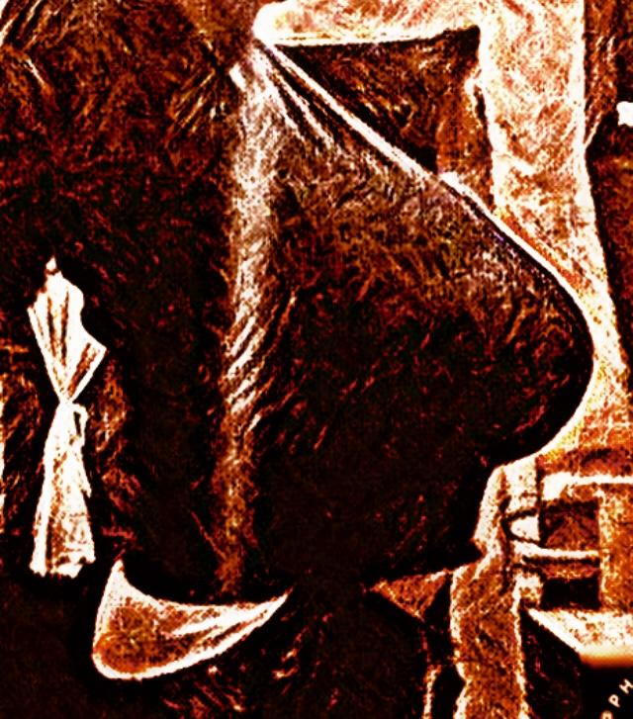

ArthurDank 08-Mar-19 03:39 AM

my cocks all get bigger at the sight of your outfit and your breasts growing larger "you know how much i love this and the bike shorts on top of it jesus lory your tits are even more amazing" i tounge kiss and fondle your tits as my cocks rub against your ass pussy and thighs, one of them starts wrapping around your tits that have doubled in size* (edited)

Bunny 08-Mar-19 03:48 AM

“You wanna shove em up my ass huh~? You like how tight I am up there~?” Presses my thighs together rubbing them together against your tentacle cocks

ArthurDank 08-Mar-19 03:51 AM

" yes i do and your pussy and your mouth i wanna fuck you all over uhhh that feels good" my cocks feel great from your thighs rubbing against them one of my cocks starts going back up your ass through the tight bike shorts, another starts going into your pussy again and i bring the other cock to join the one getting stuffed between your thick thighs they thrust as you rub them off

Bunny 08-Mar-19 03:55 AM

“One more pill for myself~” Swallows a small pink pill,my hips get even wider,my ass gets fatter and my thighs get even thicker

ArthurDank 08-Mar-19 03:59 AM

"oh hell yes lory you are amazing" i expand my cocks and they start pumping in your ass and pussy and between your thighs fucking hard and fast i pick you up as my cocks plug away into you (edited)

Bunny 08-Mar-19 04:06 AM

“Mmmmmmnn~~~” Squirts as you push your cocks back into my holes through my bike shorts

ArthurDank 08-Mar-19 04:09 AM

*i hold you up as my cocks bounce you up and down my two cocks between your thighs start to burst out steady streams of cum as you squirt and my cocks in your ass and pussy expand to fill the space gained after you took the pill they thrust even harder and faster in and out * "you feel so good inside lory" (edited)

Bunny 08-Mar-19 04:13 AM

gently wraps my left hand around one of your tentacle cocks as it’s leaking cum and slides it between my watermelon sized tits “You wanna cum with my tits too~?”

ArthurDank 08-Mar-19 04:17 AM

sure do baby till they're drenched in cum" my cock starts thrusting between your tits and I bring the other one to join in between them too two of my cocks are fucking your giant tits and i thrust even harder into your warm wet holes (edited)

Bunny 08-Mar-19 04:22 AM

“Shoot all over them~!” Rubs my tits over the tip of the tentacle cock

ArthurDank 08-Mar-19 04:25 AM

"fuck yeah!" both of my cocks start blasting shot after shot of cum between your huge tits "god they look so hot coated in cum like that"

Bunny 08-Mar-19 04:29 AM

licks your cum off my tits “I know you’ve still got more cum for me~” Squeezes my pussy down on the two foot thick cocks you have crammed inside me

ArthurDank 08-Mar-19 04:33 AM

"lemme taste in your mouth start tounging you as you swallow my cum my cocks can't handle your greedy cunt and asshole the tightness feels too good "ohhh fuck!!" both of my cocks cum at the same time inside your tight thick holes flooding them till the cum pours out of both of them

(this has been a blast lory but im getting pretty sleepy how about you?)

ArthurDank 08-Mar-19 04:47 AM

( hope that wasn't a problem just pretty whopped lol)

(lory did you fall asleep?)

ArthurDank 08-Mar-19 05:01 AM

(lol okay partner seems we were both tired hehe have a good night, hope we play again sometime soon and we can continue as long as you want too, had a lot of fun as always came a lot, hope you did too lol) (edited)

Bunny 09-Mar-19 07:28 PM

Mind helping me out here?

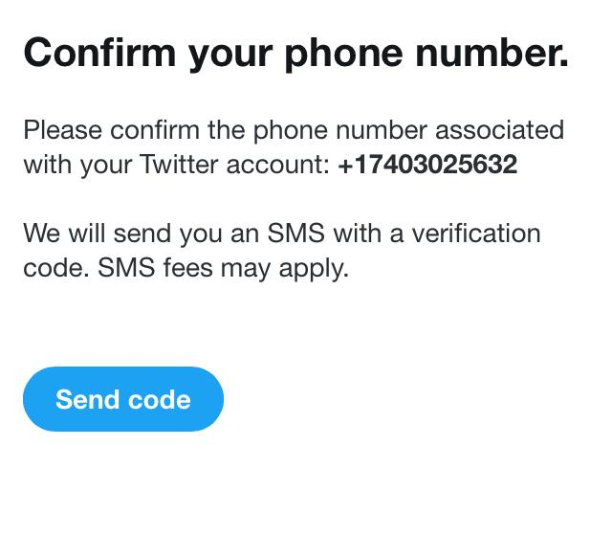

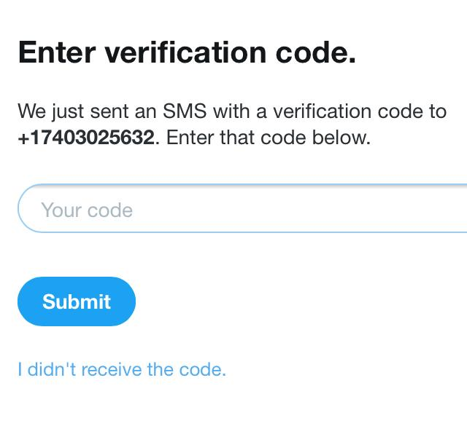

Hey

Started a call.

@ArthurDank

HEY

HEY

H

E

Y

HEY YOU (edited)

HEY

ARTHUR

ANSWER ME

ARTHUR

ARTHUR ANSWER ME RIGHT NOW

Started a call.

ARTHUR

ArthurDank 09-Mar-19 07:32 PM

hello

sorry im at work you okay

Bunny 09-Mar-19 07:32 PM

Scroll up

ArthurDank 09-Mar-19 07:32 PM

sure thing hold on thats my moms phone

let me get ahold of her

sorry it took so long i didn't hear my phone

Bunny 09-Mar-19 07:34 PM

It’s alright

I just need the code lol

It looks like I’ll survive and this one is a legit account since you had it under a completely different phone number

Granted it takes forever to load things when I have my vpn on

ArthurDank 09-Mar-19 07:36 PM

138304

Bunny 09-Mar-19 07:36 PM

I almost tossed out my phone in the garbage and had a dirty napkin in my hand

ArthurDank 09-Mar-19 07:37 PM

lol no prob and yeah vpns have drawbacks but its the only way

lmao whoops careful with that phone XD (edited)

hope you get it

good luck with that since i doubt we can make another with that number its been used before

Bunny 09-Mar-19 07:56 PM

Never mind it’s gone

ArthurDank 09-Mar-19 07:56 PM

what?

Bunny 09-Mar-19 07:56 PM

It’s gone

ArthurDank 09-Mar-19 07:57 PM

the account?

Bunny 09-Mar-19 07:57 PM

Literally five minutes later

ArthurDank 09-Mar-19 07:57 PM

fuck

Bunny 09-Mar-19 07:57 PM

It’s gone

ArthurDank 09-Mar-19 07:57 PM

i think you can still make another one using my number 17408614047

its been a few months so i think my number has another try on it

Bunny 09-Mar-19 08:04 PM

You have to make it

I can’t do it

ArthurDank 09-Mar-19 08:04 PM

got you just give me sometime okay i will get this set for you

Bunny 09-Mar-19 08:05 PM

Thank you

ArthurDank 09-Mar-19 08:05 PM

its what friends do :)

Bunny 09-Mar-19 08:07 PM

Just make this one Haruko themed

Nobody’s gonna see it anyways

ArthurDank 09-Mar-19 08:07 PM

we'll get your following back something something haruko got it

Bunny 09-Mar-19 08:11 PM

Actually just make it something else themed

Satsuki

ArthurDank 09-Mar-19 08:23 PM

@HarukotheG password is Haruko number and email already assigned

sorry i just got the msg but its made

Bunny 09-Mar-19 08:26 PM

Thanks

Don’t post about it either

What’s the password anyways?

ArthurDank 09-Mar-19 08:28 PM

Haruko

you cam change it for something stronger

sure you dont want me to post because you dont everyone to know its you?

Bunny 09-Mar-19 08:29 PM

Yes

I’ll handle

It

Myself

ArthurDank 09-Mar-19 08:30 PM

I got you dont worry you will figure it out and most who like you will figure it out and you are welcome :)

Bunny 09-Mar-19 08:32 PM

Never mind auto suspension

Fuck it

ArthurDank 09-Mar-19 08:33 PM

what the fuck!?

did you change your vpn ip

Bunny 09-Mar-19 08:33 PM

Because you used the same number

I’ll ask someone else

ArthurDank 09-Mar-19 08:44 PM

shit didn't think about that

sorry lory i should've used google voice i can fix this

Bunny 09-Mar-19 08:45 PM

No it’s fine

Just forget about it

Just appeal the other account

If it works then good

If it doesn’t then whatever

ArthurDank 09-Mar-19 08:46 PM

okay i will try i feel like i disappointed you im sorry

Bunny 09-Mar-19 08:46 PM

It’s fine

ArthurDank 09-Mar-19 08:50 PM

okay lory good luck

Bunny 09-Mar-19 08:51 PM

Just appeal it

Or don’t

Appeals don’t work anyways

ArthurDank 09-Mar-19 08:53 PM

i got you

does my old old google voice number not work now?

Bunny 09-Mar-19 08:55 PM

Probably not

Last chance is to possess your current account otherwise I’m up a creek

I’ll check if your account is still automatically restricted

ArthurDank 09-Mar-19 08:56 PM

okay check it and if so we will consider thst

Bunny 09-Mar-19 08:56 PM

Never mind still automatically restricted

ArthurDank 09-Mar-19 08:56 PM

shit

guess im out of options to help ya

Bunny 09-Mar-19 08:58 PM

If I can I’m bringing her back
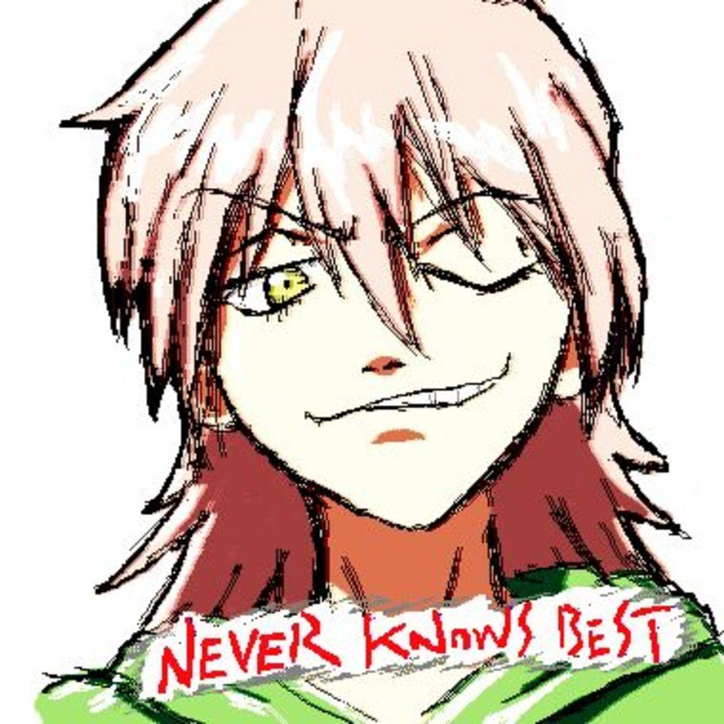

It’s been a few years anyways

ArthurDank 09-Mar-19 08:59 PM

sounds good haruko is the best (edited)

i hope you can

Bunny 10-Mar-19 01:52 AM

Oh henlo

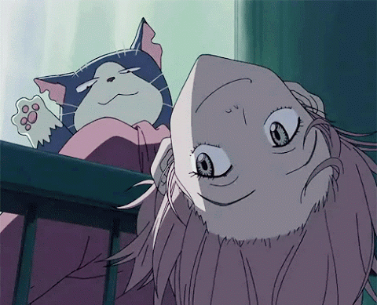

ArthurDank 10-Mar-19 01:54 AM

henlo :)

how are you?

Bunny 10-Mar-19 01:55 AM

I’m good

Might borrow my little brother’s alt

Maybe

ArthurDank 10-Mar-19 01:55 AM

oh cool

least you would be back

Bunny 10-Mar-19 01:57 AM

Y’know what’s funny?


ArthurDank 10-Mar-19 01:57 AM

what is? lol

Bunny 10-Mar-19 01:57 AM

I’ve hid from some people for two whole years

In plain sight

And they never noticed

ArthurDank 10-Mar-19 01:58 AM

lmao because of the handle changes?

that is pretty funny we need sneaky peeps like you

Bunny 10-Mar-19 03:00 AM

Boy will they be surprised when I post this on the last day of G+
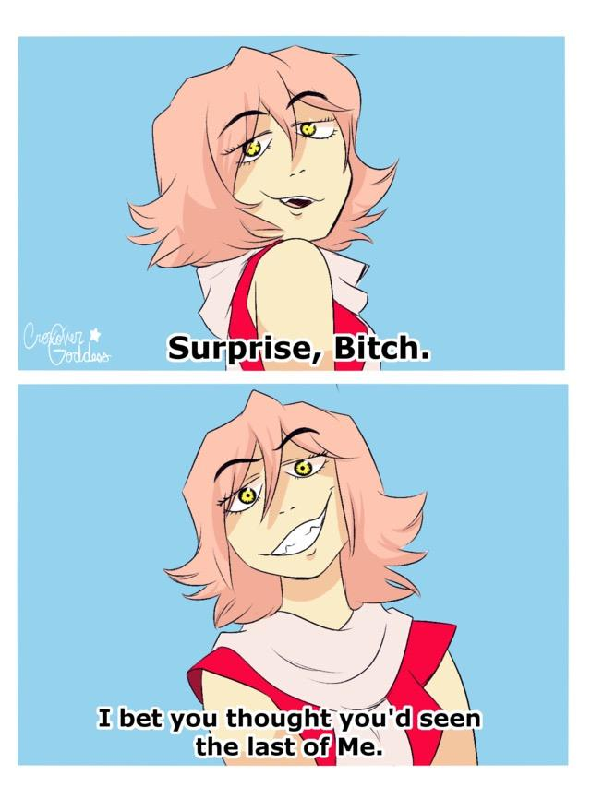

ArthurDank 10-Mar-19 03:00 AM

LMFAO

made ya look

Bunny 10-Mar-19 03:01 AM

It’s hilarious because they thought they got rid of me

Most of them are either in prison now for posting cp to smear me or they left the site

ArthurDank 10-Mar-19 03:02 AM

lmfao wow what a bunch of asshats no wonder you grew to hate the place

Bunny 10-Mar-19 03:03 AM

If I change brand to Haru don’t question it

It’s just who I’ve always been

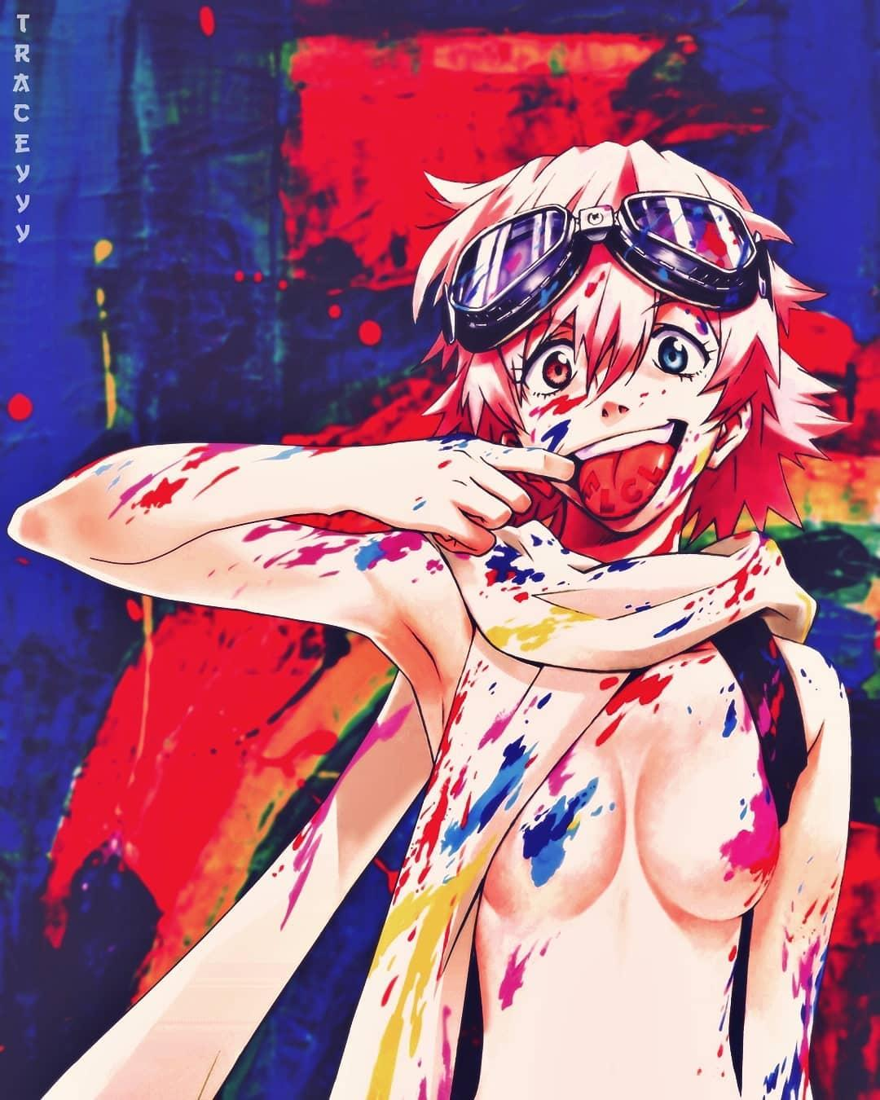

ArthurDank 10-Mar-19 03:04 AM

I remember you talking about her back when we met in saiyomis twitter chat so i always felt that was you all alomg haha (edited)

trust me i dont question that

nice pic :D

btw are you feeling better, i know you haven't been feeling good today

Bunny 10-Mar-19 03:17 AM

Yeah I’m feeling better

Emotionally anyways

ArthurDank 10-Mar-19 03:18 AM

thats good i know getting banned from Twitter is a bitch but glad you didn't let it get ya down too much you will be back

physically not so much tho?

Bunny 10-Mar-19 03:18 AM

Yeah physically not so much

ArthurDank 10-Mar-19 03:19 AM

yeah i saw your posts earlier hope you start feeling better soon buddy, been there sadly hugs

Bunny 10-Mar-19 03:19 AM

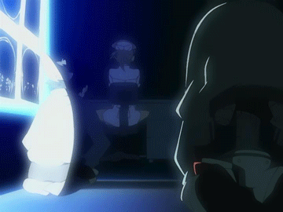

ArthurDank 10-Mar-19 03:20 AM

sounds about right lol

Bunny 10-Mar-19 03:20 AM

I’ll probably switch to Haru for my next one

No real reason not to

If anyone questions it I’ll just say I watched it with Parker

Which isn’t technically a lie

But still two whole years and they didn’t find me

ArthurDank 10-Mar-19 03:22 AM

indeed sounds reasonable to me you and kouji saw it

that's amazing bravo sneaky one

thats why you hid? to avoid being harassed online? dont blame you really

Bunny 10-Mar-19 03:22 AM

Yes actually

I broke away from a group of harassers

They didn’t like that I left

Tried to smear me by saying I was a trans pedophile

ArthurDank 10-Mar-19 03:23 AM

a trans pedo? wtf?

Bunny 10-Mar-19 03:24 AM

I did say I was trans but that was to get my creepy ex off my back

ArthurDank 10-Mar-19 03:24 AM

ahh i see

Bunny 10-Mar-19 03:24 AM

It’s not true though obviously

ArthurDank 10-Mar-19 03:24 AM

no i can tell it isn't lol

sorry about your creepy ex tho

Bunny 10-Mar-19 03:25 AM

It feels great knowing most of the people who put me in the hospital two years ago are either off the internet entirely or in prison

ArthurDank 10-Mar-19 03:26 AM

that should feel good to you i wpuld feel the same, and hospital? were you attacked?

Bunny 10-Mar-19 03:26 AM

No

I tried starving myself to death

ArthurDank 10-Mar-19 03:26 AM

holy shit :(

Bunny 10-Mar-19 03:26 AM

Almost succeeded too

ArthurDank 10-Mar-19 03:27 AM

damn what saved you?

Bunny 10-Mar-19 03:27 AM

Parker is basically responsible for me not being worm food right now

ArthurDank 10-Mar-19 03:27 AM

aww

damn that is romantic

im glad

Bunny 10-Mar-19 03:27 AM

I didn’t even say what that group made me do either

I had the technical knowledge so they had me doing fucked up shit like doxing and hacking

I was jacked up on a fuckload of pills for anxiety too

Treated absolutely everyone like shit

Remember my outburst as Ryuko?

Like that

But constantly

All the time

ArthurDank 10-Mar-19 03:30 AM

oh damn lory wow so they wanted you around for your tech skills and when you had enough they tried to destory, no wonder that happened lory, too much bad shit surrounding you and you broke away im glad, i see i am not the only one with anxiety problems

Bunny 10-Mar-19 03:30 AM

No it was pretty bad

I felt like was being watched all the time

ArthurDank 10-Mar-19 03:31 AM

i remember when you did that but damn i didn't know it was like that all the time im glad you were able to push through thanks to kouji/parker

holy shit that is very bad

Bunny 10-Mar-19 03:31 AM

Touching me would set me off too

ArthurDank 10-Mar-19 03:32 AM

i never had that watched feeling but the touching part during my teenage years was a problem

i almost jerked away on instinct

im sorry you have dealt with that so much

but i understand where the outbursts come from now

Bunny 10-Mar-19 03:34 AM

The other half of the time I felt like a zombie
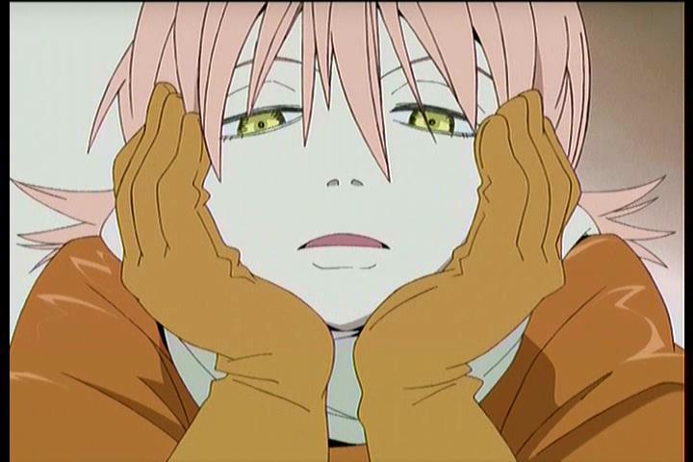

ArthurDank 10-Mar-19 03:34 AM

shit

i did too still feel that way sometimez

Bunny 10-Mar-19 03:35 AM

I’m better now though

Little bro helps

ArthurDank 10-Mar-19 03:35 AM

thats good im glad your brother helps you so much and parker too

Bunny 10-Mar-19 03:38 AM

Feel free to refer to me as Haru too if you wanna

In private for now though

ArthurDank 10-Mar-19 03:39 AM

I can though I am rather partial to your name lory if that is your real name but if you prefer Haru i will gladly call you that

who is your little bro? erik?

Bunny 10-Mar-19 03:40 AM

Yup

He’s kinda a douche sometimes but he’s good otherwise

ArthurDank 10-Mar-19 03:41 AM

he can be for sure but im glad he geninuely looks out for you, we all need somebody you may have parker but its nice you have a relative too who cares

my mom is that for me times i wonder what I would do if she wasn't around anymore (edited)

Bunny 10-Mar-19 03:45 AM

Yeah it is good

ArthurDank 10-Mar-19 03:45 AM

yes it is

thanks for trusting me with all this, dont get me wrong the lewd rps and sex antics are always fun, but its nice knowing and understanding you a bit better my friend

Bunny 10-Mar-19 03:47 AM

It feels better knowing I’m not just some freak with multiple personalities lmao

ArthurDank 10-Mar-19 03:47 AM

lmao that too i never thought you had more then one voice in your head tho

I kinda figured we were maybe a bit alike anxiety problems do that to us all, and being around a bad bunch

but i didn't know

you keep yourself guarded for good reasons

nice to know you with the shield down for a bit :) (edited)

I was around a group of pedos during my xbl days well two that i know of didn't know that till a year or two later, messed up situation, being online has done me good but also harm same as you. (edited)

but anyway lol

ArthurDank 10-Mar-19 04:05 AM

still around Lory? or Haru? :)

Bunny 10-Mar-19 04:05 AM

I’m still here

ArthurDank 10-Mar-19 04:06 AM

oh cool sorry thought you left for a bit

so whatcha doing?

Bunny 10-Mar-19 04:06 AM

Getting some milk

ArthurDank 10-Mar-19 04:06 AM

ah you a milk drinker too? cool me too (edited)

unless milks a code for something else lmao

Bunny 10-Mar-19 04:08 AM

No no no just a glass of milk

ArthurDank 10-Mar-19 04:09 AM

lol its all good i figured it was, just had to ask XD

you always tell me up front, im just a kooky mood, tired and this time change is throwing me off

probably gonna sleep in a few

what about you?

Bunny 10-Mar-19 04:13 AM

Maybe

Watching videos with Parker

ArthurDank 10-Mar-19 04:14 AM

thats cool haha

well lory im gonna jump off and get some rest thanks for talking friend it was a nice chat as always :)

i hope you get to feeling better soon, if things get lewd have fun, I'd stick around but im a bit too pooped for it tonight lol hit me up later if you want and have a good night :) (edited)

Bunny 10-Mar-19 04:21 AM

Alrighty

ArthurDank 10-Mar-19 04:21 AM

:) nice getting to know my friend better (edited)

Bunny 11-Mar-19 01:47 AM

Henlo?

ArthurDank 11-Mar-19 01:48 AM

henlo partner :) how ya doin?

Bunny 11-Mar-19 01:48 AM

Warm

Watching Parker play Megaman 11

ArthurDank 11-Mar-19 01:49 AM

oh cool lol

glad you are warm tonighy

Bunny 11-Mar-19 01:49 AM

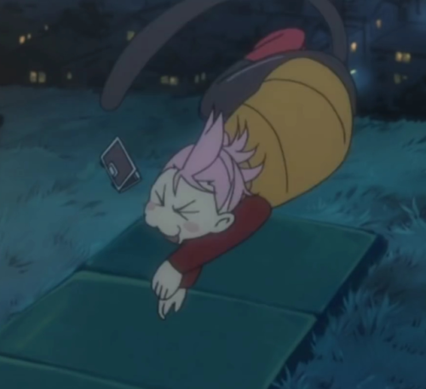

ArthurDank 11-Mar-19 01:49 AM

feeling any better?

Bunny 11-Mar-19 01:49 AM

A little bit

ArthurDank 11-Mar-19 01:49 AM

aww cute

glad there is some improvement

Bunny 11-Mar-19 01:51 AM

Haru>>>>your waifu
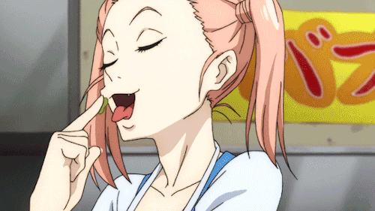

ArthurDank 11-Mar-19 01:51 AM

damn right lol

Bunny 11-Mar-19 01:51 AM

Kitty face
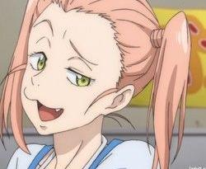

ArthurDank 11-Mar-19 01:51 AM

hahaha

that be a cute litty

Bunny 11-Mar-19 01:52 AM

Also
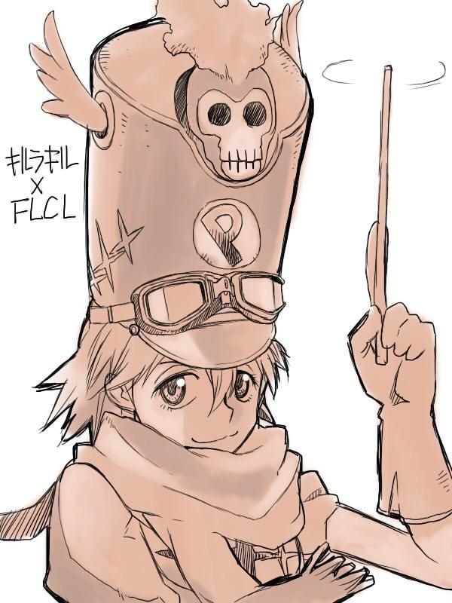

ArthurDank 11-Mar-19 01:52 AM

kitty*

PERFECT

that is the perfect combo jaku+haru

No hotter a waifu

Bunny 11-Mar-19 01:55 AM

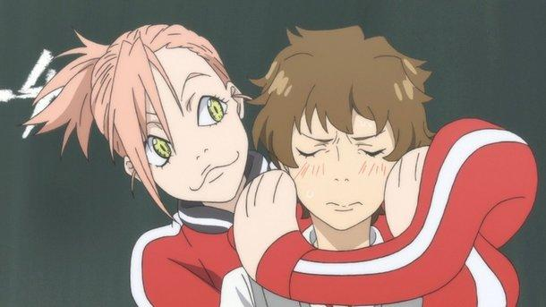

She hug

ArthurDank 11-Mar-19 01:55 AM

lucky dude lol

we all need waifu who hugs like that

Bunny 11-Mar-19 01:59 AM

Haru a cute
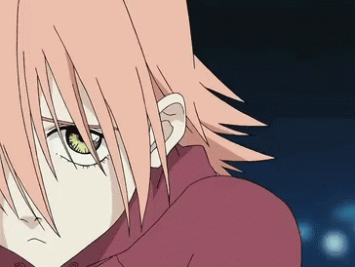

ArthurDank 11-Mar-19 01:59 AM

yes haru is

the cutest

no doubt about it, glad you are taking that identity again

well your identity really

Bunny 11-Mar-19 02:02 AM

I missed it honestly

ArthurDank 11-Mar-19 02:03 AM

i bet you did she is you after all, you missed being yourself :)

welcome back

so what are you doing?

Bunny 11-Mar-19 02:13 AM

Egg
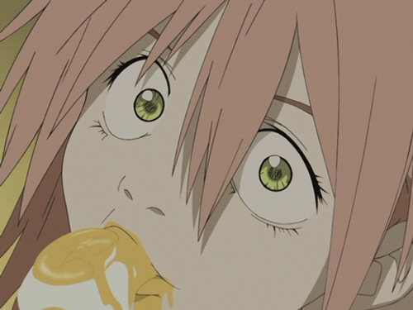

ArthurDank 11-Mar-19 02:13 AM

hahaha love that

haru can make anything cute

Bunny 11-Mar-19 02:16 AM

Bunny


ArthurDank 11-Mar-19 02:17 AM

my favorite right there

sexy as always

Bunny 11-Mar-19 02:22 AM

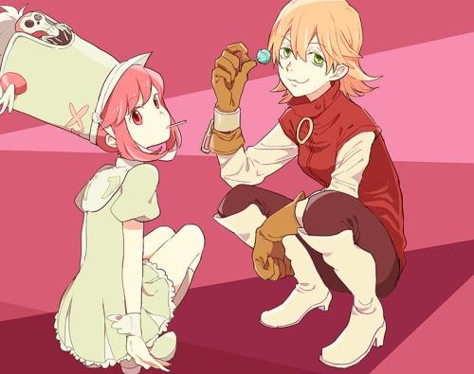

Frens

ArthurDank 11-Mar-19 02:24 AM

the best of friends and best of waifus as far as im concerned

Bunny 11-Mar-19 02:25 AM

You’d let her root around inside your head huh~?
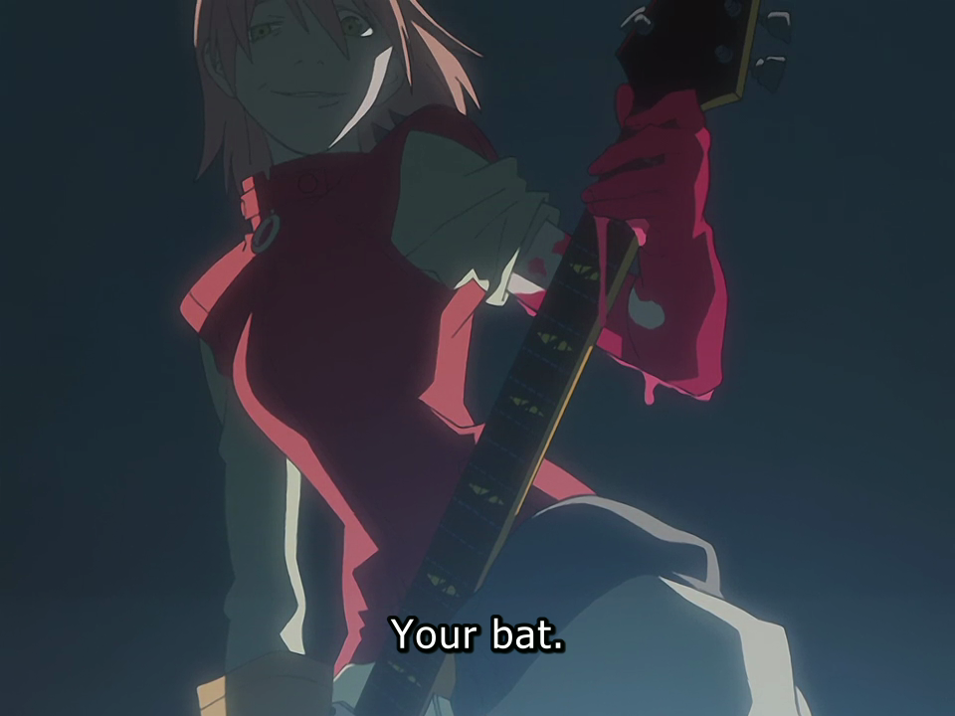

ArthurDank 11-Mar-19 02:26 AM

damn right I would ;) (edited)

Bunny 11-Mar-19 02:32 AM

Her swing is the same too
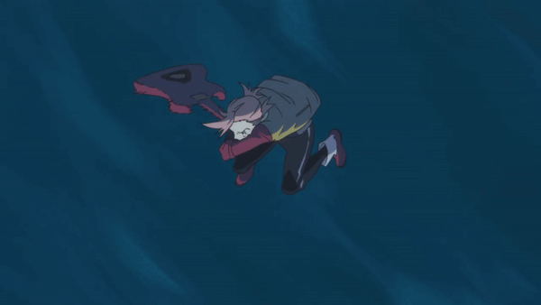

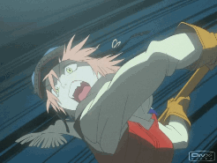

ArthurDank 11-Mar-19 02:36 AM

thats awesome

i am happy they kept those bits of her the same through out

Bunny 11-Mar-19 02:40 AM

I dunno what you like me better as...
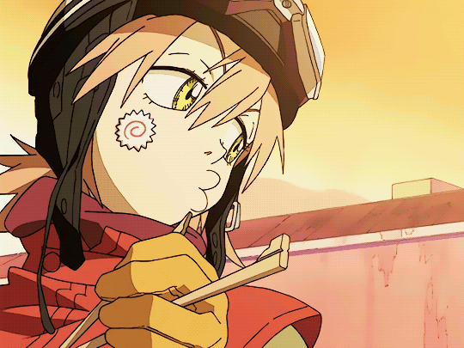

You never knew me as Haru

ArthurDank 11-Mar-19 02:45 AM

i like you as you

what changes between how you are as haru and how you were as you were before?

i like you as haru cause you say that is the real you, but what is dofferent about you as haru?

Bunny 11-Mar-19 02:50 AM

I’m a bit more catty than normal that’s all

Not much more different

ArthurDank 11-Mar-19 02:54 AM

what do you mean by catty? i mean i think i know but i was curious what you define as catty?

and thats cool means i have basically gotten to know the real you for almost a month now on here i like it :)

Bunny 11-Mar-19 02:57 AM

I mean a bit more playful

ArthurDank 11-Mar-19 03:00 AM

okay so i do know then haha

i noticed that but i like it so,l no worries here :)

Bunny 11-Mar-19 03:02 AM

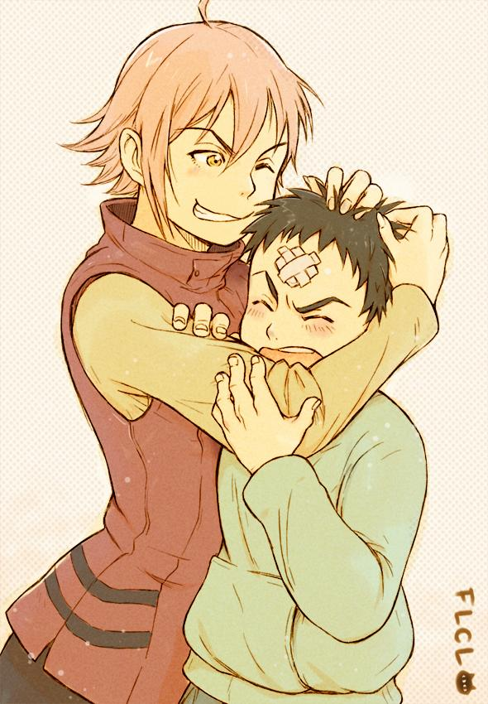

ArthurDank 11-Mar-19 03:03 AM

aww thats definitely a fav of mine

Bunny 11-Mar-19 03:12 AM

She do a cute
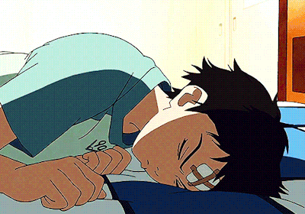

ArthurDank 11-Mar-19 03:12 AM

that was cute always is (edited)

haruko is dangerous but cute so cute you can forget the danger

Bunny 11-Mar-19 03:27 AM

Yee

ArthurDank 11-Mar-19 03:27 AM

the best kind too haha



we should use the bunny outfit in a future rp, just a thought ;)

Bunny 11-Mar-19 03:29 AM

Yee

ArthurDank 11-Mar-19 03:30 AM

glad you agree haha ;D

well Haru im gonna go to bed, im pretty beat today, but i hope you have sweet dreams and feel better soon, glad you got ahold of me as its always nice to hear from you fren

Bunny 11-Mar-19 03:33 AM

Schleep

ArthurDank 11-Mar-19 03:33 AM

I will hope you get good rest too

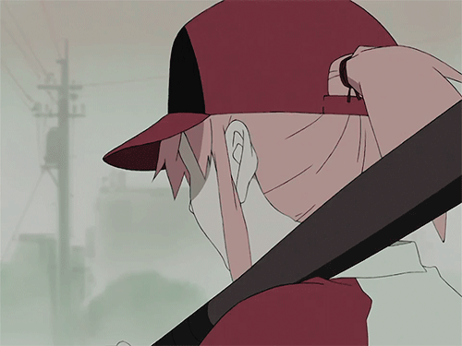

last one night night :)

Bunny 11-Mar-19 03:38 AM

Yee

Bunny 11-Mar-19 02:07 PM

GOOD MORNING


ArthurDank 11-Mar-19 02:28 PM

lmao

good afternoon haha

Bunny 11-Mar-19 02:29 PM

So what’s up~?
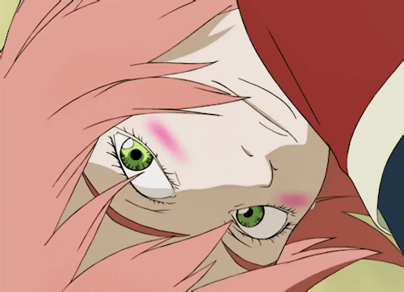

ArthurDank 11-Mar-19 02:30 PM

aww

cute

not much got work in about 35 mins which sucks (edited)

what about you?

Bunny 11-Mar-19 02:37 PM

Probs gonna have a bath in a bit
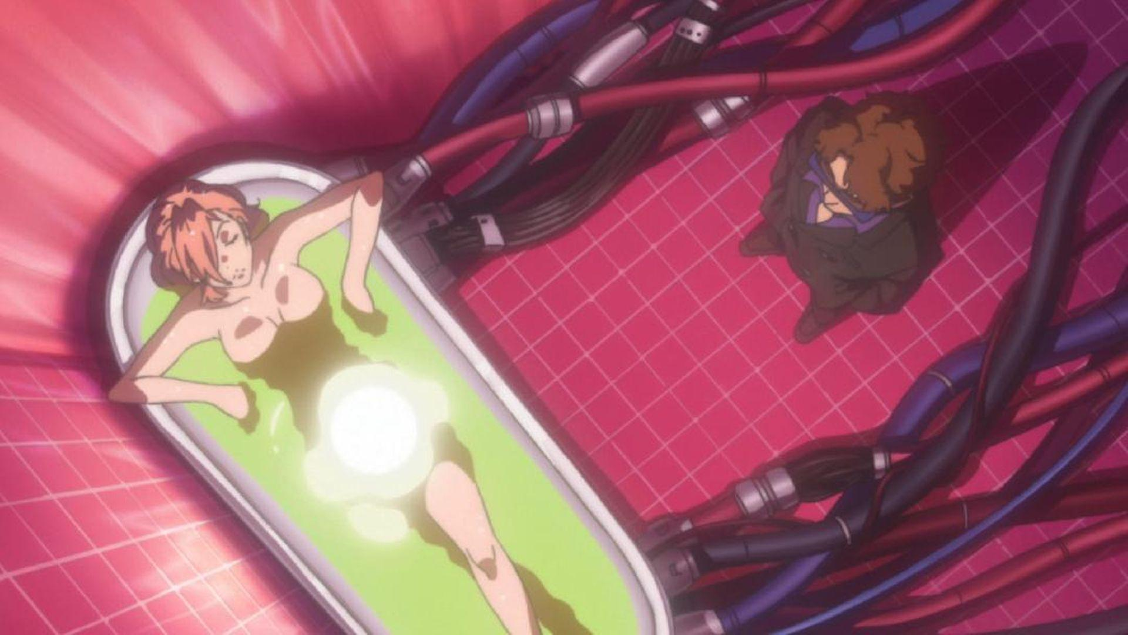

ArthurDank 11-Mar-19 02:38 PM

sounds good to me

you be looking as sexy as haru in there no doubt

hehe

you feeling any better today?

Bunny 11-Mar-19 02:40 PM

Yup

ArthurDank 11-Mar-19 02:41 PM

wonderful :D

glad you won't have to go to the er like you feared

Bunny 11-Mar-19 02:42 PM

Good shit
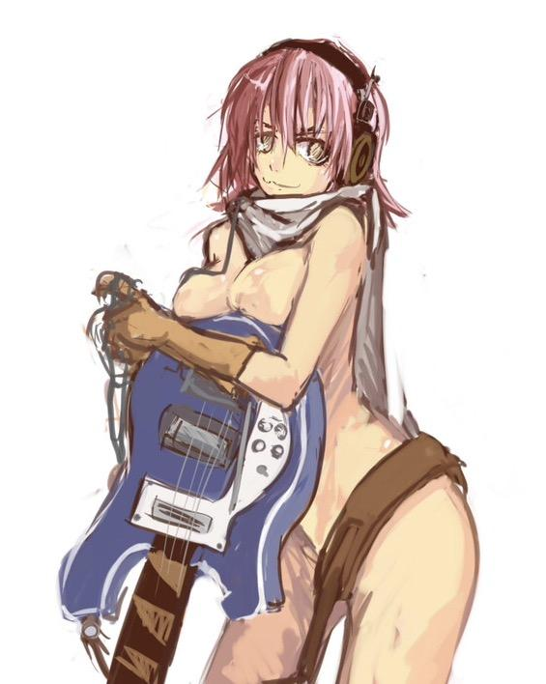

ArthurDank 11-Mar-19 02:42 PM

damn right hot shit right there

shes got a great bod, another thing you two have in common lol

Bunny 11-Mar-19 02:46 PM

You said you liked the bunny suit huh?
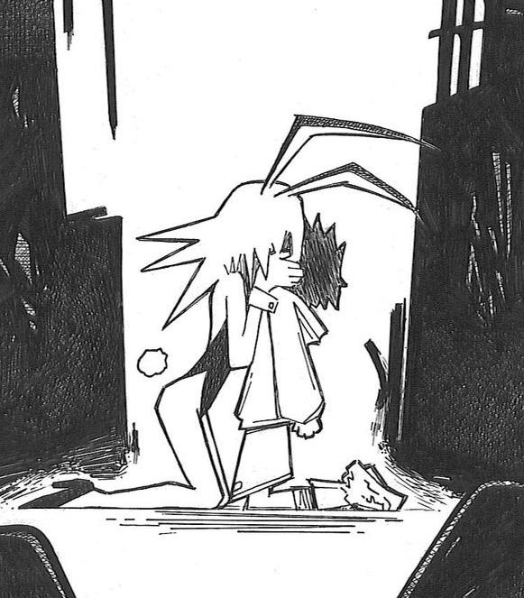

ArthurDank 11-Mar-19 02:47 PM

sure do next time we do a lewd rp i want that to be in there ;)

really hot suit course i know you could pull that look off too

Bunny 11-Mar-19 02:49 PM

I already ordered one lmao. Don’t tell Parker it’s a surprise

ArthurDank 11-Mar-19 02:50 PM

lmao trust me i wont haha nice thing for you to get and Parker to initiate ;)

will be nice knowing we rp to something you actually wear or will be soon enough

like the ryuko outfit

btw you and parker are finally living together right? from what I have gathered :)

Bunny 11-Mar-19 02:54 PM

What was your first clue lol

ArthurDank 11-Mar-19 02:55 PM

hehe well lotta sex might've given it away, fun times for us all trust me ;)

i thought you lived with your mom somewhile back dont know why

Bunny 11-Mar-19 02:56 PM

I go back occasionally

That’s all

ArthurDank 11-Mar-19 02:56 PM

I get ya it was your ps4 being held hostage that made me think you still were

Bunny 11-Mar-19 02:59 PM

I mean sometimes I go back and then dumb things happen y’know? Ain’t my fault.
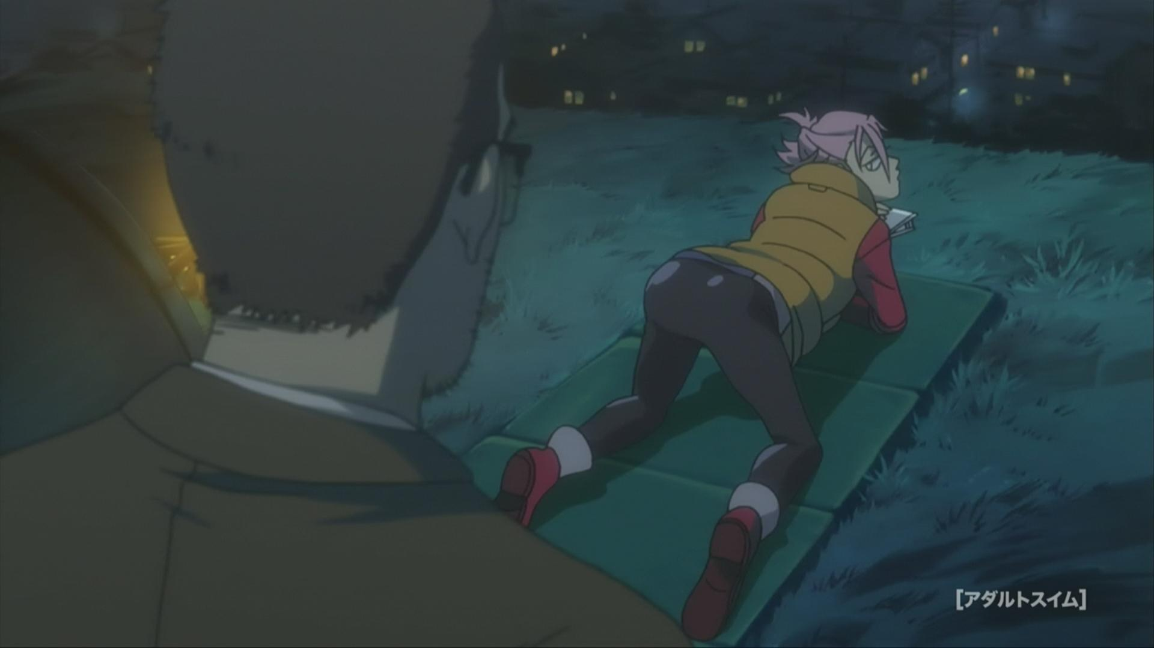

ArthurDank 11-Mar-19 02:59 PM

lmao i get you

no wonder you dont live there nice ass btw

hope i get the see the bunny outfit at some point, even just an edit like the ryuko pic was haha

that looked good on ya too

Bunny 11-Mar-19 03:01 PM

Thaaaanks

It should be here by tomorrow probably

Rush shipping

ArthurDank 11-Mar-19 03:03 PM

awesome hope to see it, no rush of course, just when you feel comfy sending something

if im not overstepping by asking for a pic i hope

Bunny 11-Mar-19 03:03 PM

Naaah you’re fine

ArthurDank 11-Mar-19 03:05 PM

cool

hope i didn't annoy you during our last rp when I said iwas tired you vanished then too so I figured you were beat as well we came up on almost 3 hours haha

Bunny 11-Mar-19 03:07 PM

I can go for a long time when I want to

ArthurDank 11-Mar-19 03:10 PM

haha me too glad to have someone play so long with me (edited)

i didn't hear back so i figured you passed out around that time too

Bunny 11-Mar-19 03:13 PM

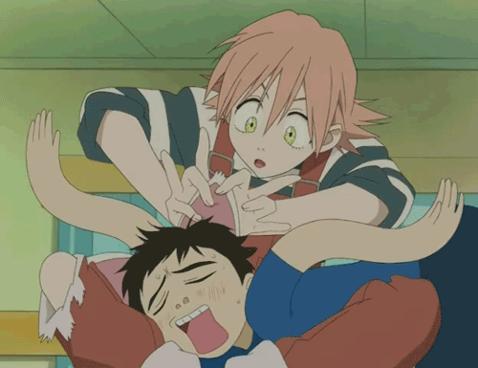

ArthurDank 11-Mar-19 03:13 PM

hahaha like that

hope we can do it again soon even if its not as long lol

Bunny 11-Mar-19 03:15 PM

I mean y’all can go as hard as you wanna

ArthurDank 11-Mar-19 03:18 PM

oh what do you mean lory? sorry i got lost

Bunny 11-Mar-19 03:19 PM

I don’t really mind if you do like clones or whatever in rps. I’ve never really done a gangbang one so....

ArthurDank 11-Mar-19 03:19 PM

oh well in that case i will keep that in mind ireally enjoyed the freaky one last time

thanks for telling me i just didn't want too get too freaky until i knew what you liked i know you said gore was your only real line, mine too FTR (edited)

Bunny 11-Mar-19 03:21 PM

Seriously though I’d do a gangbang one. Just FYI

ArthurDank 11-Mar-19 03:22 PM

lmao i will keep that in mind i kinda like more then one of me going to town on you

hehe we should try that next time, sound good?

Bunny 11-Mar-19 03:24 PM

I mean unless you’re more into a smaller you getting dominated lmao
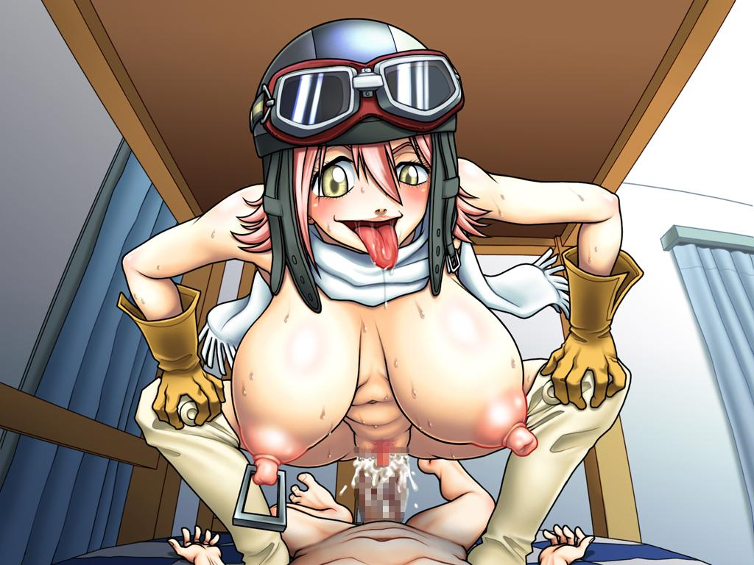

ArthurDank 11-Mar-19 03:32 PM

hot lmao

nah i mean you being femdomblike in our first rp was hot but i like going freaky on you

and plugging all your holes lol

so yeah im up for the gangbang next time if you are just didn't know that was on the table at the time haha

Bunny 11-Mar-19 03:34 PM

I don’t mind going dom either

It’s fun

ArthurDank 11-Mar-19 03:39 PM

I dont mind either cause it is fun for me too

im down for just about anything lol

FYI :D

Bunny 11-Mar-19 03:41 PM

When do you get off again? Just curious

ArthurDank 11-Mar-19 03:42 PM

10:30 or a lil after

Bunny 11-Mar-19 03:43 PM

Yeesh that’s late

ArthurDank 11-Mar-19 03:43 PM

yeah it is but im off tomorrow so thats nice

i have to clean the floors 4 nights a week i get off the register at 7 and do the floors till then, it does take that long

i wasn't sure if you were curious in regards to possible lewd texting or rp times, im up tonight and probably will be till the usual times

Bunny 11-Mar-19 04:03 PM

Yeah that’s why I was asking

ArthurDank 11-Mar-19 04:05 PM

i figured hehe

rp i have to be off work for obviously and at 7 they dont like me lagging about lol

but you say usually later after 11 is good for a rp if you and parker aren't busy :)

if i remember correctly and texting during sex is fine if a blanket is close by lol

Bunny 11-Mar-19 04:12 PM

Yuuup

Okay but bunny
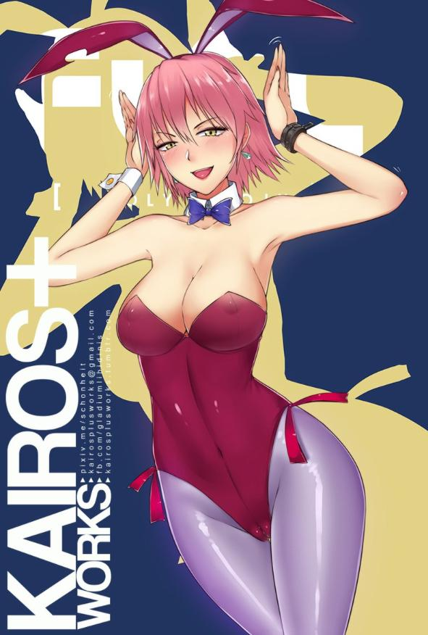

Bunny 11-Mar-19 04:24 PM

Nonon bunny
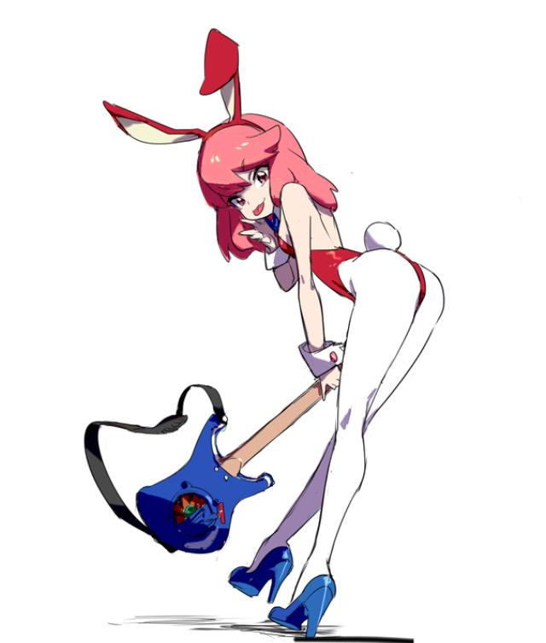

ArthurDank 11-Mar-19 04:31 PM

lmao nice and hot

i love that

Bunny 11-Mar-19 04:32 PM

Do y’all have rabbit?

Maybe I can get FLCL Alternative running for us?

ArthurDank 11-Mar-19 04:33 PM

lmao i want rabbit haha

that sounds cool lol

sorry got busy up front for a bit

i love the rabbit

which reminds me I need to watch FLCL P&A

Bunny 11-Mar-19 04:41 PM

If you download Rabbit we can definitely watch FLCL Alternative

ArthurDank 11-Mar-19 04:42 PM

oh okay my bad i didn't know it was an app

Bunny 11-Mar-19 04:47 PM

Yeah

ArthurDank 11-Mar-19 04:47 PM

neat

cool have to check that out maybe you and I can watch sometime :)

Bunny 11-Mar-19 04:51 PM

Never did mention that Dad has the bike in his garage did I?

I have a picture of myself on it but it’s an edit so

ArthurDank 11-Mar-19 04:53 PM

that sounds awesome and no you didn't

well i would like to see it if you have it

nice (edited)

Bunny 11-Mar-19 04:55 PM

Luckily it was in my FLCL folder
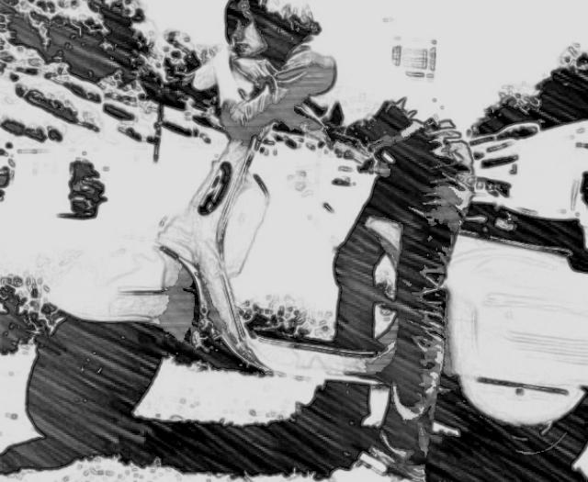

You there?

ArthurDank 11-Mar-19 04:58 PM

thats awesome and teah just working sorry haha

that looks great

and you look hot as hell in that outfit

Bunny 11-Mar-19 04:59 PM

Shucks really? It’s just casual stuff

ArthurDank 11-Mar-19 04:59 PM

well you do maybe its the stance

Bunny 11-Mar-19 05:01 PM

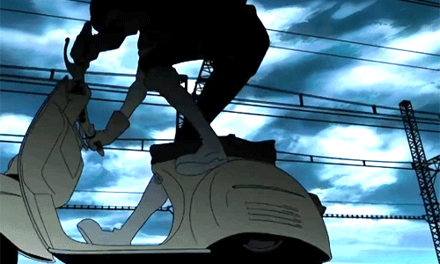

ArthurDank 11-Mar-19 05:02 PM

very nice

Bunny 11-Mar-19 05:02 PM

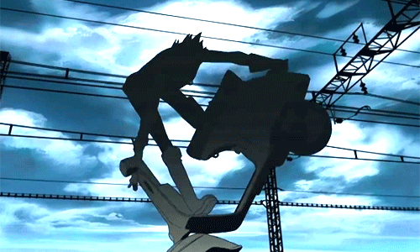

ArthurDank 11-Mar-19 05:02 PM

tha oants really made you look hot hehe

Bunny 11-Mar-19 05:03 PM

They’re just regular skinny jeans you dork

ArthurDank 11-Mar-19 05:04 PM

you know how much i interact with girls? especially hot ones irl? guess lol

well looked good to me lol

Bunny 11-Mar-19 05:05 PM

I’ll take what I can get
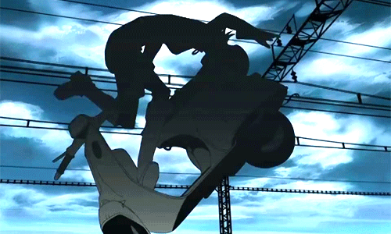

ArthurDank 11-Mar-19 05:06 PM

no what i mean is i barely interact with hot gals at all

lmao

if thats what you meant by take what i can get lmao

nice pics haha

Bunny 11-Mar-19 05:06 PM

You’re shy then?

ArthurDank 11-Mar-19 05:09 PM

yeah chick like you? would be hard to talk too irl lmao

Bunny 11-Mar-19 05:10 PM

Oh really~?

ArthurDank 11-Mar-19 05:11 PM

yeah its difficult lol

easier on here but always is lol

thats why i prpbably make a big deal about simple clothes haha you look great with the bike tho haha

Bunny 11-Mar-19 05:16 PM

I dunno it’s probably the leaning over butt out pose that you like

Lmao

ArthurDank 11-Mar-19 05:17 PM

lmao damn i think you are right

cant deny it kinda hot lol

Bunny 11-Mar-19 05:21 PM

I mean I could go for an rp now but you’re busy so I don’t wanna ruin your work lol

ArthurDank 11-Mar-19 05:38 PM

lol I'm sorry about that were i not at register

well at work i mean

maybe tonight if you got time and energy

i would love that if you can but no worries if you can't and sorry my phone died lol

Bunny 11-Mar-19 05:42 PM

Yay Parker is on his way home. Almost time for dicke~

ArthurDank 11-Mar-19 05:43 PM

sounds good lmao

classes run late tonight?

Bunny 11-Mar-19 05:44 PM

Just a bit

ArthurDank 11-Mar-19 05:45 PM

oh i thought they let out like 3

Bunny 11-Mar-19 05:45 PM

Got my favorite denim shorts and leggings on lol. Half shirt too. Gotta have the dicke~

ArthurDank 11-Mar-19 05:45 PM

sounds good hehe

denim? nice

Bunny 11-Mar-19 05:48 PM

Yee

Short shorts. Not going anywhere so it’s fine

ArthurDank 11-Mar-19 05:49 PM

lemme know how it goes i would hang around but i wouldn't have time to reply much to the text while dicking

sounds hot those shorts hehe

Bunny 11-Mar-19 05:50 PM

Already under the blankets lol

ArthurDank 11-Mar-19 05:51 PM

damn he made it quick hehe

but yeah we can rp tonight if you feel like or maybe tomorrow before classes end

Bunny 11-Mar-19 05:56 PM

Already being grinded on~

ArthurDank 11-Mar-19 05:56 PM

nice hehe

when do his classes let out usually?

Bunny 11-Mar-19 05:59 PM

It varies sometimes

ArthurDank 11-Mar-19 06:00 PM

just curious we can always try in the day before too if you aren't busy lol

have fun hehe lemme know what all goes down, its getting dumb at the store so i wont be here much sadly (edited)

Bunny 11-Mar-19 06:03 PM

It’s basically just this outfit but with shorter shorts and a half shirt
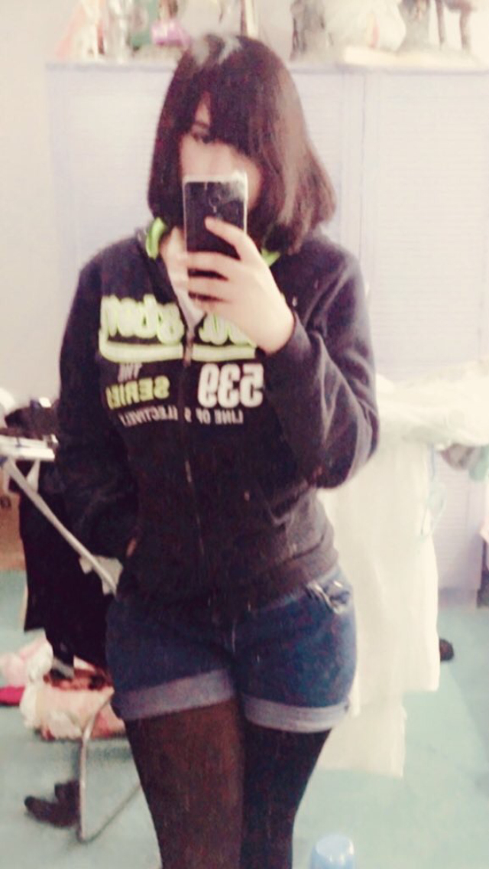

ArthurDank 11-Mar-19 06:07 PM

oh damn lucky guy thats sexy

even shorter yum

Bunny 11-Mar-19 06:11 PM

Basically up to here where the lines are

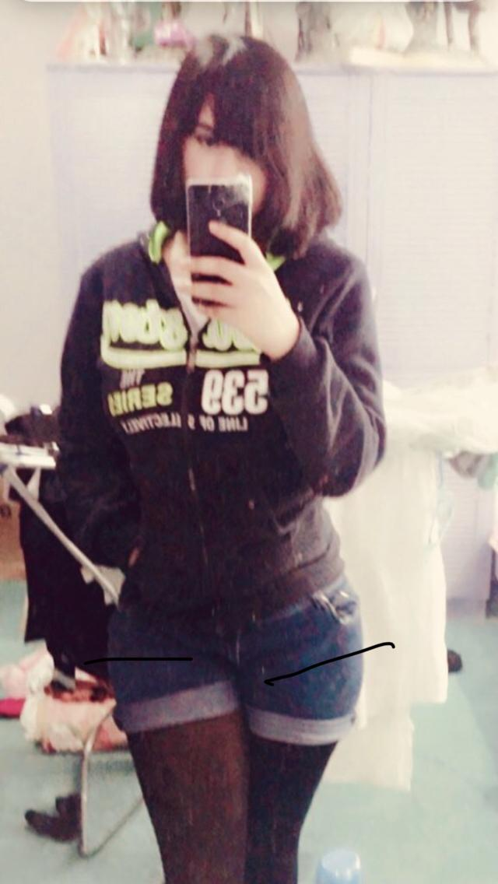

ArthurDank 11-Mar-19 06:16 PM

damn!! ;)

Bunny 11-Mar-19 06:17 PM

And it’s in~

ArthurDank 11-Mar-19 06:20 PM

right on

what were you doing till now dry grinding? curious ;)

about foreplay

Bunny 11-Mar-19 06:24 PM

Yeah he was just rubbing it on my ass

Rougher then normal today

ArthurDank 11-Mar-19 06:33 PM

sounds like class worked him up

hehe you told me some days he gets rougher other days gentler, haha hot

ArthurDank 11-Mar-19 07:01 PM

still there? lol

Bunny 11-Mar-19 07:04 PM

Yuuup

He shot three times so far~

ArthurDank 11-Mar-19 07:05 PM

damn hes blowin and going haha

three orgasms already fuck

ArthurDank 11-Mar-19 07:22 PM

doing ya doggy?

Bunny 11-Mar-19 07:31 PM

Yeah~

ArthurDank 11-Mar-19 07:36 PM

hot

Bunny 11-Mar-19 07:52 PM

5 shots

ArthurDank 11-Mar-19 08:08 PM

damn he still got you doggy under the blankets? ;) cum 5 times in about two hours whew damn! (edited)

Bunny 11-Mar-19 09:01 PM

And we’re good for now

You’re home soon right?

ArthurDank 11-Mar-19 09:03 PM

nice how much did he blow?

yeay about 10:30 or so

Bunny 11-Mar-19 09:04 PM

About 7 times lmao

I thought this was cute
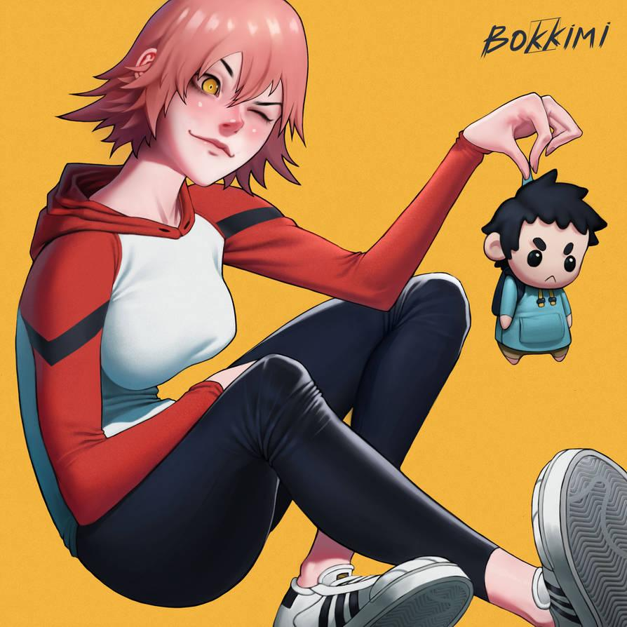

ArthurDank 11-Mar-19 09:04 PM

That is super cute haha way cute

jesus

Bunny 11-Mar-19 09:07 PM

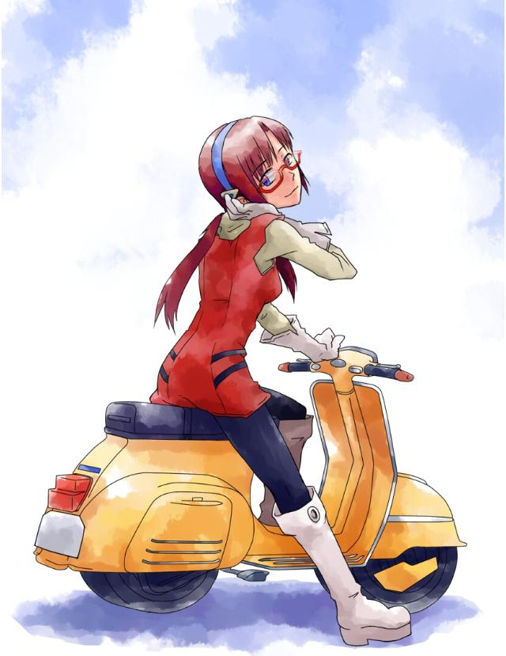

Maybe I’ll post this on the last day of G+ instead lol

Nobody will be there to see it anyways lmao

ArthurDank 11-Mar-19 09:08 PM

lmao sounds about harumari i dig it best of both worlds hehe

i think you should post anyway haha

ArthurDank 11-Mar-19 09:57 PM

you still there?

Bunny 11-Mar-19 10:03 PM

Yuuup

ArthurDank 11-Mar-19 10:25 PM

oh good whats up,

im about to leave work now

Bunny 11-Mar-19 10:28 PM

Was waiting for exactly that actually
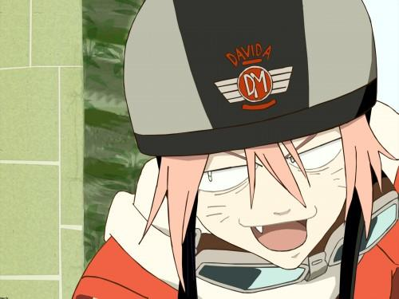

ArthurDank 11-Mar-19 10:30 PM

hehehe nice

if you have to bail or anything or if you get tired just lemme know okay?

Bunny 11-Mar-19 10:30 PM

Alrighty

ArthurDank 11-Mar-19 10:31 PM

(so you wanna start this time?)

Bunny 11-Mar-19 10:33 PM

(You start I’ll take the lead afterwards it’s an FLCL one anyways lol)

ArthurDank 11-Mar-19 10:34 PM

(okay cool)

(you're haru of course)

Bunny 11-Mar-19 10:34 PM

(Yup)

ArthurDank 11-Mar-19 10:36 PM

I was walking through town as always observing the giant steam iron, mostly a boring town, nothing ever happens here then i hear a bike in a distance "what the hell, never hear a bike around here"

Bunny 11-Mar-19 10:42 PM

“Perfect~ another one ripe for the taking~! Just the right age from the look of him too~!” With one quick swing you’re out cold (I’m expecting you to come up with a location for the next little bit lol)
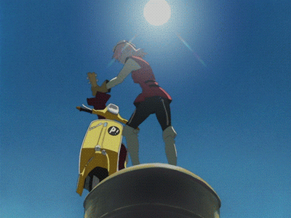

ArthurDank 11-Mar-19 10:46 PM

i remember a brief swing and then everything was black i start coming too, it seems like its night out and im outside what seems to be on a side of the road near some wide open fields

im still fuzzy from being hit with a fucking guitar by an admittedly hot girl from what i was able to see (edited)

Bunny 11-Mar-19 10:51 PM

“I was beginning to think I’d killed you by accident~ good to see I didn’t~” Bends over directly in front of you so our eyes meet before flicking you directly in the forehead

ArthurDank 11-Mar-19 10:53 PM

"what the hell" it didn't seem like a hard tap but it felt like something popped out of the back of my head it was such an intense feeling this girl is so beautiful but seems devious definitely my type (edited)

Bunny 11-Mar-19 10:57 PM

“Name’s Haruko, I figured you could use a bit of company~” A wide catlike smirk came across her face

ArthurDank 11-Mar-19 11:00 PM

"Good to meet you Haruko and company? wow you dont mess around" that smirk tells me what this chick wants, its all so freaky, but she is hot and beautiful not gonna ask too many questions, my dick went full mast at that smirk

Bunny 11-Mar-19 11:06 PM

“You a bit excited there~? I don’t really blame you,not many your age have gotten this close to me without winding up as a vehicular homicide statistic~” She slowly unzipped her biker jacket revealing she had nothing more than a long sleeve half shirt on underneath, it was tight around her breasts and left her entire midriff exposed

ArthurDank 11-Mar-19 11:10 PM

"A homicide statistic?" that thought was cut off, seeing her tight half shirt, big breasts judging from how tight that shirt was and that midriff was toned as hell "jesus haruko you're hot!" my dick is tight in my shorts, tighter then usual i begin to unzip (edited)

Bunny 11-Mar-19 11:12 PM

“You’re a bit younger than the guys I normally go for but I’ll make an exception~” She sat down right next to you and started feeling up your hardon through your shorts “You’re really packing down here huh~?”

ArthurDank 11-Mar-19 11:15 PM

"im glad honestly" i started to groin a bit as you were feeling up my dick it felt good even through the shorts and my dick gets harder as result "wanna find out Haruko?" (edited)

Bunny 11-Mar-19 11:19 PM

“Let’s see how big you are~!” She slowly pulls your cock out of your shorts, and is shocked to find out that you’re about 7 inches while half hard “Not bad kid~! Looks like you’re not even hard yet either~” She began playfully stroking your half mast cock with her glove covered hands

ArthurDank 11-Mar-19 11:22 PM

" uhh fuck um thanks" * i cant think very clearly as you start stroking my dick it feels so good and those gloves are adding more friction my dick starts getting bigger* "fuck haru that feels good"

Bunny 11-Mar-19 11:25 PM

“You’re bigger than I expected~” She keeps stroking your cock as it slowly hardens to be a foot long “Yeesh what are they feeding you kids these days~?”

ArthurDank 11-Mar-19 11:28 PM

"it seems bigger then usual fuck" my dick gets fully hard i feel my cum starting to build as you keep playfully stroking my giant cock "haruko you keep doing that im gonna cum! your hand feels so damn good" (edited)

Bunny 11-Mar-19 11:31 PM

“If you’re gonna cum then do it on my face~” She rubs your enormous cock against the side of her face,licking the underside with her long tongue,which strangely had soft bristles like a cat’s tongue

ArthurDank 11-Mar-19 11:36 PM

"fuck yeah im gonna haruko, your tounge feels so good"I feel that odd feeling as you lick it feels so good i cant hold my load, your tounge and cheek feels so nice "something so different about it, you're almost like a ca....fuck!" my dick blows fat streams of cum all over your face and tounge it keeps pumping (edited)

Bunny 11-Mar-19 11:38 PM

“Just like that~!” She swallows the load you shot all over her tongue and then licks the rest off her face “You don’t get much action huh kid~?”

ArthurDank 11-Mar-19 11:41 PM

such a hot sight watching you swallow my load and lick it off "so you are!? wow and no i don't, kind of my first time" I look down a bit (edited)

Bunny 11-Mar-19 11:45 PM

“I’m an alien, I thought that was obvious by now kiddo~” she gently pushes you over into the grass, and sits her leather pants covered ass right on the underside of your foot long cock “You like my ass huh? I’ve seen you eyeballing it this entire time~”

ArthurDank 11-Mar-19 11:48 PM

"never met one before, kinda odd, wasn't expecting this to happen, not that im complaining" when you push me down my dick rubs against you and my dick goes full mast again "yeah i do its so big and feels so tight" i move my hands around and start feeling your ass as you sit your ass on my dick

Bunny 11-Mar-19 11:51 PM

“Hey,watch where you’re grabbing down there~!” She roughly grinds her ass along the entirety of your length “You don’t have my permission to cum until I’m done having my fun~!”

ArthurDank 11-Mar-19 11:53 PM

"um yes ma'am sorry it felt so nice and soft" I was a little scared but Haruko's ass in all that tight leather, rubbing against my cock, felt too good to care feeling those thighs and that ass rubbing hard back and forth felt amazing I never experienced anything like this before (edited)

Bunny 11-Mar-19 11:56 PM

“I can tell you’re about to cum again~!” she pressed her ass down on your cock with all her weight “Well you’re not allowed to yet~!”

ArthurDank 12-Mar-19 12:00 AM

"it felt so good i couldn't help it" as she pressed down on my throbbing dick i felt my climax stiffled it felt good but also painful, i nervously nodded and complied with her "I get it haru not till you have had your fun"

Bunny 12-Mar-19 12:04 AM

“I bet you can feel your cock getting a bit bigger too huh~? Looks like I hit your head in just the right spot~!” She rolls her hips in circles and uses her entire ass to rub your cock as your cock slowly grows even larger “I lucked out~! You have my permission to blow your load now~!” The catty smirk came across her face again,as she feels your cock growing right underneath her ass

ArthurDank 12-Mar-19 12:08 AM

"so thats why ugh god thats so good" I feel your hips roll and your ass rub hard and long against me i feel my cock harder and bigger then ever you give your permission and I dont know if its your ass, or that smirk thats sending my over the edge more "ugh yes FUCK I'M CUMMING" * my cock explodes all over you, the leather around your thighs and ass are coated in white* (edited)

Bunny 12-Mar-19 12:13 AM

“I’m impressed kid~!” She ran her gloved hand across her ass to scoop up as much cum as she could “Your loads are getting bigger and thicker too~!” She playfully licks up the handful of your thick cum with her catlike tongue

“You’re fucken huge now too~!” She said poking your two and a half foot long 10 inch thick cock with her free hand “You were already big naturally but it looks like the hit to your head made it even bigger~”

ArthurDank 12-Mar-19 12:18 AM

"ahh thanks, I guess I have you to thank for all that haha" watching you lick up my cum causes my cock to become huge, more then usual "Jesus Haru I never thought this possible" your poke to my cock just makes it larger (edited)

Bunny 12-Mar-19 12:21 AM

“If you tried putting this in a normal human girl you’d probably kill her~ But luckily for you I’ve taken my fair share of big cocks~!” She teasingly licks the underside of your cock from the bottom to the tip

ArthurDank 12-Mar-19 12:24 AM

"oh god your tounge is so fucking good" my cock felt like a jolt got sent through it as you licked it "glad you can take it guess I was worried a bit, so you're gonna fuck me? I waited a long time for this" my cock tightened even more at the thought of fucking this hot alien and drowning her in cum (edited)

Bunny 12-Mar-19 12:30 AM

“We’re gonna fuck for hours~!” She unbuttoned her leather pants and slowly slid them off,throwing them next to her bike “Just hold still~!” Poking your cock again makes it enlarge even more,it’s about 3 feet long and a foot and a half thick now “Your first time belongs to me~!” She pressed the tip of your cock against her pussy,pushing it inside

ArthurDank 12-Mar-19 12:33 AM

"I am glad it was yours, that sounds great" * you poke and enlarge my cock, its already hard at seeing your pussy and your toned hips and legs, you press against my cock and I already feel it so warm and wet, you push it inside you and i thrust up into it* "oh fuck haruko your pussy feels amazing" (edited)

Bunny 12-Mar-19 12:36 AM

“I’m only getting started~!” She pushes her entire weight down on your cock,pushing it halfway inside,her stomach bulging out where your cock hits inside “This all you got~?! Fuck me!”

ArthurDank 12-Mar-19 12:39 AM

* my cock feels so deep inside your cunt i feel it tighten against me as deep as I am* "you bet I will" I grip your ass and my hips start pumping my giant cock up into your pussy, i start thrusting harder into you after the first few strokes, your pussy is so tight and wet and it only makes me want to pound you harder (edited)

my cock thrusts faster inside you, amazed how your pussy can take so much dick "i want to fuck your brains out"

Bunny 12-Mar-19 12:45 AM

“FUUUUCK~! YOUVE FORGOTTEN WHO’S ON TOP HERE~!” She stands up with your cock still buried up her pussy,she grabs both your legs, and buried your cock even deeper “I’m taller than you anyways~!”

ArthurDank 12-Mar-19 12:50 AM

" im sorry Haruko ahh oh god what the hell!?" You start bouncing on my dick even as you're holding my legs up in the air, standing above me I can't really move given how tall you are and you are holding me so tight, it feels so good when you thrust your tight alien pussy down onto my dick "argh god this position looks embarrassing but it feels too good to care ahh fuck" (edited)

Bunny 12-Mar-19 12:54 AM

“I made your cock like this so I could have some fun~! I’m the one on top!” She squeezes her pussy with more control than a regular human girl could ever do,using it to milk your three foot long cock as it bulges out her stomach with every thrust

ArthurDank 12-Mar-19 12:57 AM

"oh shit I, yeah you call the shots, I'm just here for you to fuck" you thrust harder onto my cock back and forth it feels too good, I feel a load building up as your pussy wreaks my huge dick, squeezing it so hard, wanting my cum, I see my dick bulge inside your stomuch I almost can't believe it "shit haru im gonna cum again!"

Bunny 12-Mar-19 01:01 AM

“Go ahead~! Fill me you fuck~!” She picks up the pace,pulling your cock all the way out to the tip and then burying it deep into her pussy,squeezing tighter with every thrust “If you cum enough I might make this more fun for you~!”

ArthurDank 12-Mar-19 01:05 AM

" oh fuck then in that case JESUS" pulling me out to thrust me back inside your greedy pussy felt to good and you tighten so hard around me it's like a vice but warm and begging for it "fuck there it is!" * my cock exploades inside your stomuch, shot after shot goes inside you, I see it leak out of your pussy even as im still cumming* (edited)

Bunny 12-Mar-19 01:10 AM

She slowly pulls your cock out of her pussy,cum leaking out “You did better than I thought you would~! I’ll make this a little more fun for you~ c’mere~!” She slides a finger along the length of your three foot long cock,to your amazement it painlessly divides into two separate cocks,and with another poke she enlarged them even more,to about four and a half feet long and two feet thick “Do you like your reward~? It’s permanent too,even when the size goes back to normal you’ll always have two~!”

ArthurDank 12-Mar-19 01:15 AM

"permanant!? oh shit I guess im stuck with it, there are advantages to this though so yeah yeah I like it" Haru has given me a second cock and they're even larger now too I can't believe this, but it feels too good to give it much thought, I think about all the uses I can put these to like fucking haruko more "now I can fill both of your holes"

Bunny 12-Mar-19 01:19 AM

“I’ll let you have a little fun this time~!” She gets down on all fours in the grass and presses her ass against your two four foot long cocks “You wanna fuck me dontcha~? Well go ahead~!”

ArthurDank 12-Mar-19 01:22 AM

"this is so unreal but it is" I climb up on my knees as you press your ass against my cocks, I grip your hips and start pressing them inside your ass and pussy "yeah I just wanna keep fucking you Haruko!" I thrust them inside you hard as I can, I feel both of your holes greedily sucking them inside far as they will go and start going in and out "oh god so good" (edited)

Bunny 12-Mar-19 01:25 AM

“I’ll still be able to milk you like this y’know~!” She squeezed her ass and pussy tighter than any human girl could possibly do around your enormous cocks,her muscles in both holes squeezing in a noticeable pattern,milking you roughly “You’re gonna cum until you knock me up,understand~?”

ArthurDank 12-Mar-19 01:28 AM

"oh fuck yeah keep it up!" you squeeze my dicks inside of you harder then I ever thought possible as I start pumping in and out of you, thrusting deep inside your asshole and pussy, both feel so good around my thick dicks "I got it Haru, I'll keep fucking and cumming inside you until I get you pregnant" (edited)

Bunny 12-Mar-19 01:32 AM

She bounces up and down the entire length of your gigantic cocks “So,tell me,you have a girl you wanna do this with back home too~? She can join us y’know~!”

ArthurDank 12-Mar-19 01:35 AM

(should I mention a second girl lory? i dont wanna fuck it up its going so good making sure I follow you right)

Bunny 12-Mar-19 01:37 AM

(Yeah that’s how it’ll go,mention Mamimi or something she’s hot imo)

ArthurDank 12-Mar-19 01:38 AM

I thrust into your tight holes as you bounce back down onto me ramming your ass and pussy hard and fast "didn't know you liked girls too Haruko, yeah I do, her name is Mamimi, she is hot but seems like she is pining for some baseball player at school she was dating he is in america at the moment" (edited)

(agreed on mamimi)

Bunny 12-Mar-19 01:40 AM

“I’ll make it happen~ just pull out for a sec~” (Yuuup)

ArthurDank 12-Mar-19 01:40 AM

"okay" I didn't want to stop but I pull my throbbing dicks out of Haruko "but how" (edited)

Bunny 12-Mar-19 01:44 AM

“Watch this~!” After a small chant and some spinning with her guitar she somehow managed to teleport Mamimi directly to where you and her are

ArthurDank 12-Mar-19 01:46 AM

my jaw about hits the ground shocked at what haruko can do "Mamimi!? oh shit" I realize my cocks are in full view but too late for modesty

Bunny 12-Mar-19 01:51 AM

Mamimi:”I was just under the bridge and now I’m out here with Haru-chan? Who’s the guy with the huge dicks Haru-chan?” Her outfit was slightly different from normal,while still being her usual school uniform the jacket was cut short,just barely enough to cover her breasts with her midriff on full display,it was as tight as Haru’s undershirt. As for her skirt it was cut extremely short,she was also wearing a black thong with the side ties just above the waist of the skirt

ArthurDank 12-Mar-19 01:54 AM

my dicks get even larger at this sight, never seeing Mamimi is such an outfit before, I feel my cocks getting even harder, the short skirt, black thong, half cut shirt it was amazing even though she doesn't remember me, not like its surprising "you know haruko!?" (edited)

(hope this ain't too much on you, playing two gals this is great tho)

Bunny 12-Mar-19 01:58 AM

Mamimi:”Of course I do, I don’t have a lot of money so I have her find guys who do for me to fuck,but you’re waaaaay bigger than any guy I’ve ever taken before.” She lifts one of your enormous cocks with one hand rubbing it a little (Nah it’s a lot of fun)

ArthurDank 12-Mar-19 02:02 AM

(good) "I didn't know you fucked other guys, not that im complaining atm, mmm that feels good" my cock throbs more as mamimi strokes it "I was just fucking haru and she decided to bring you here, looks like you're more then eager" my cocks get even harder at the idea of fucking both of these girls

Bunny 12-Mar-19 02:08 AM

Mamimi:”You might be a little big for me though...” She put one of your cocks between her thighs and squeezed her thighs together Haru: “Not an issue,with what I’ve done he’ll fit with no problems~!” Haru ran a finger down your free cock causing it to painlessly split into two more,but the extra two are different from the others,you quickly find out you can stretch and move them freely “You earned this kiddo~”

ArthurDank 12-Mar-19 02:11 AM

"jesus haru wow thanks hope you girls are ready" I pull mamimi and haruko closer, pulling mamimis undershirt up and begin sucking on her tits as I thrust both of my cocks between her thighs as she tightens them around me, and the two new cocks find their way back to haruko, going up into her ass and pussy and thrusting hard inside of her (edited)

Bunny 12-Mar-19 02:20 AM

Mamimi:”Wow Haru really can take em” She said while trying to stick the enormous tip of your cock into her pussy Haru:”The kid really does know how to fuck~!” She spasms with pleasure as you buried your massive tentacle cocks into both of her holes

ArthurDank 12-Mar-19 02:24 AM

"you can too mamimi lemme help" I thrust my cock into her as she presses her pussy down onto it through her black thong she is nice and tight and i begin to thrust back and forth, trying to go as far in as i can "I have you to thank for that haruko, lemme show you how much I appreciate it" * i pull haru's shirt up and start playing with her tits too, sucking hard on one of them I feel your ass and pussy spasm against my tenticle cocks it feels so good I thrust them inside you harder as I feel the cum building* (edited)

Bunny 12-Mar-19 02:30 AM

Mamimi:”You’re almost too biiiigggg~~~~” Her stomach bulges out as you push your 4 foot long cock into her tight tiny pussy Haru: “Just cum already kiddo~! FILL ME!!!”

ArthurDank 12-Mar-19 02:34 AM

"you can take it mamimi take my fat cock your pussy is so fucking good" * I start thrusting hard, pounding her pussy mercilessly while the other still rubs between her crossed thighs, "oh fuck mamimi" her pussy and thighs are so tight both of my cocks blow inside of her, painting her insides white, shot after shot, cum flows out of her freely* "oh fuck haru, gonna knock you up, so tight!" my cocks cum deep into haru's holes, cum pours out of both your ass and pussy even as I keep dumping my load inside (edited)

Bunny 12-Mar-19 02:39 AM

Mamimi:”With that much cum you’ll get me pregnant! Just bury your cock inside!” She pushes your second enormous cock into her pussy,making her stomach bulge out twice as much Haru: “FUUUUUCK CUM ON MY FACE TOO~~~!” Her stomach bulges even larger as your cum fills up her womb

ArthurDank 12-Mar-19 02:44 AM

"fuck mamimi yeah!" both of my hard cocks thrust inside mamimi streching her out, she takes the double penetration like a pro as i pound both of them into her tight wet cunt "Take it haru, take my cum all over, cat gets as much cream as she wants!" my cocks pull out and one goes into your mouth thrusting inside, shooting its cum in your throat as the other goes between your tits thrusting between them as it blows all over your pretty face (edited)

Bunny 12-Mar-19 02:51 AM

Mamimi:”You’re so big~! CUM MOOOOOREEE!” She rides both of your cocks doggy style as you bury them into her womb Haru:”C’mon~ cum more on my faaaace!” She squirts all over the grass as you cover her face in your thick cum

ArthurDank 12-Mar-19 02:56 AM

"you got it I can keep cumming inside you both as much as you want" i pound both of my cocks into her pussy while grabbing the back of her hair pulling it tight, i thrust them back and forth hard and fast "FUCK" *both of them blow in her guts again "much as you can stand" one of my tenticle cocks find their way to haru's pussy, pounding her deep inside again, making sure she is knocked up, and one fucks her tits and before she knows it, coats her face in a second load of cream

Bunny 12-Mar-19 03:03 AM

(I have an idea,let’s start a different one with Haru as a live in companion? This is getting a bit stale)

ArthurDank 12-Mar-19 03:05 AM

( agreed that sounds far better lory but I'm kinda wore out, can we start on that maybe tomorrow or tomorrow night? I have had tons of fun tho)

(well actually I have to check on my uncle, so i may be gone for about 20 mins, we can continue when i come back if you want)

Bunny 12-Mar-19 03:12 AM

(Alrighty,just rest for a bit then make the starter.)

ArthurDank 12-Mar-19 03:20 AM

(im fine its not a long drive, im at incles now be home in less then 10)

Bunny 12-Mar-19 03:23 AM

(Alrighty)

ArthurDank 12-Mar-19 03:30 AM

(im back you ready? when you are I will make the starter) (edited)

(lemme know) (edited)

Bunny 12-Mar-19 03:32 AM

(I’m ready)

ArthurDank 12-Mar-19 03:34 AM

So in this small town I met an alien girl some months back named Haruko, one thing led to another and before I know it, she became my live in GF, weird how things work out, its the start of the new morning and im getting out of bed

Bunny 12-Mar-19 03:36 AM

“You up already kiddo~? You’re not even gonna stay in bed for an all day fuck~?” Peeks her head out of the covers and does a small catty smirk

ArthurDank 12-Mar-19 03:38 AM

" well when you put it that way" I crawl back under the covers with Haru and I tounge kiss her "I am game if you are, what do you got in mind for today?" my hands start rubbing against her butt (edited)

Bunny 12-Mar-19 03:45 AM

“I’m for it~!” She playfully pokes your two soft 7inch cocks “You’ve gotten used to having two huh~?”

ArthurDank 12-Mar-19 03:48 AM

"yeah after that night, felt a little funny at first, just more I can fuck you with now hehe" my cocks start to tingle as haruko pokes them and get bigger

Bunny 12-Mar-19 03:51 AM

“You’ve gotten a bit bigger naturally too~” She gently strokes both of your half mast cocks as they grow to their full size at a foot long and 6 inches thick

ArthurDank 12-Mar-19 03:54 AM

"guess I'm still growing been a few months after all" i start to run my tounge in circles around one of harukos tits as she rubs my cocks and brings them to fill mast i start to thrust them around her hands "i dont know why you stuck around but im glad you're with me" (edited)

(you ok lory? just making sure you are still with me)

Bunny 12-Mar-19 04:01 AM

(Yup just needed to roll over)

ArthurDank 12-Mar-19 04:02 AM

(roll over?)

Bunny 12-Mar-19 04:04 AM

(Yup)

ArthurDank 12-Mar-19 04:04 AM

(okay cool continue when ready and you must've been uncomfy where you were lol) (edited)

Bunny 12-Mar-19 04:13 AM

“Still growing~?” She said as she rubbed your thick cocks against her ass “You’ll be big enough to pop me one day~!”

ArthurDank 12-Mar-19 04:17 AM

"hehe well im sire you can take it no matter how big they get, you aren't like other girls, its why you're the best" i start thrusting against haru's ass as she rubs against me, the pleasure is so good "I wanna fuck you now haru" i keep grinding against her soft tight ass (edited)

Bunny 12-Mar-19 04:22 AM

She slides your cocks into her ass,both at the same time “I’ll never get tired of these cocks~” She lightly tapped the shafts of your cocks as they slide inside,causing them to divide into 4 cocks “You like this sort of thing too huh~?”

ArthurDank 12-Mar-19 04:25 AM

"I will never get tired of fucking you with those cocks either" my four cocks grow out and the other two start rubbing against your pussy lips as the other two are deep in your ass " I do, you showed me a lot Haruko, now time to show you how much I like it"

i begin to pump in your ass with my dual cocks and the other two start working into your pussy "I did promise i would knock you up"

ArthurDank 12-Mar-19 04:37 AM

(still there lory?)

(did you fall asleep? if so i hope you have a good night lemme know when you get back, also do you want to continue this rp later on? feels like it was just getting good)

ArthurDank 12-Mar-19 12:32 PM

hello

Bunny 12-Mar-19 12:32 PM

Henlo

Good news btw

ArthurDank 12-Mar-19 12:33 PM

oh what? :)

Bunny 12-Mar-19 12:33 PM

My harassers think I’m dead

ArthurDank 12-Mar-19 12:33 PM

holy shit wow

Bunny 12-Mar-19 12:33 PM

I’ve hid for so long they legit think I’m 6 feet under

ArthurDank 12-Mar-19 12:33 PM

good news for sure then

Bunny 12-Mar-19 12:34 PM

I feel really fucking free right now

Stomach is in knots because I’ve never been this elated before

ArthurDank 12-Mar-19 12:34 PM

thats great news and im glad

tie to celebrate lory enjoy my friend

Bunny 12-Mar-19 12:35 PM

I already have someone who doesn’t know my secret to cover for me lmao
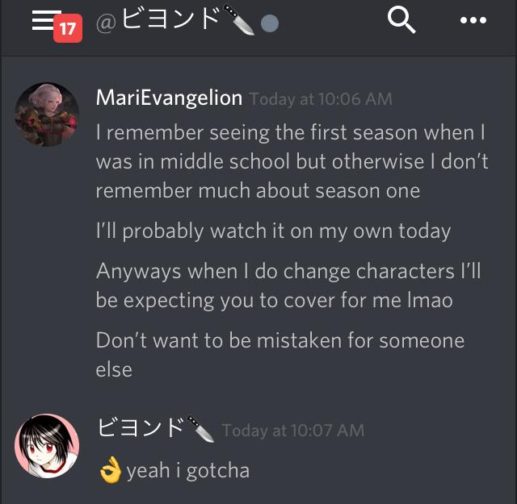

ArthurDank 12-Mar-19 12:35 PM

lmao very nice

keep it going lory :)

im glad for you that you are finally free

Bunny 12-Mar-19 12:41 PM

Can’t wait for Parker to finally wake up and realize I’m finally free after two years of this bullshit

Can’t decide between my current avatar and this one

Or this one

ArthurDank 12-Mar-19 12:42 PM

thats wonderful it will be a relief for you both

Bunny 12-Mar-19 12:42 PM

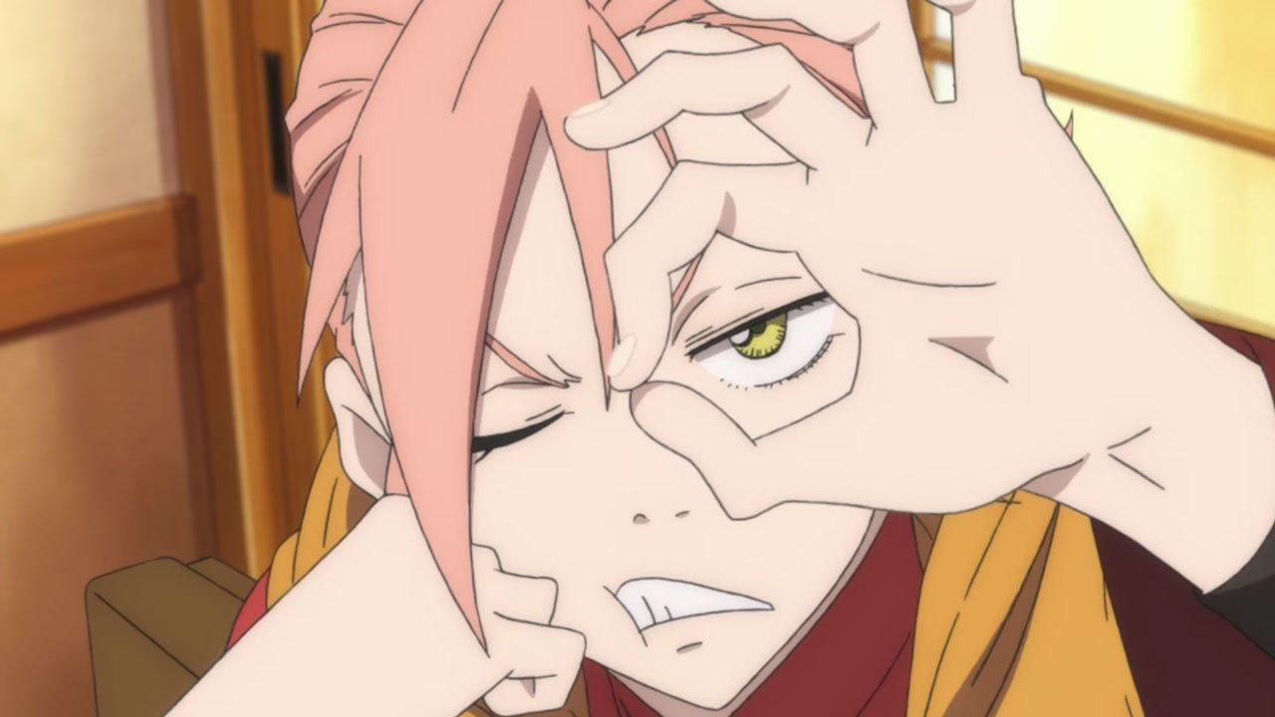

ArthurDank 12-Mar-19 12:42 PM

oh damn this is tough lol

i kinda like the smug kitty face

Bunny 12-Mar-19 12:43 PM

I seriously don’t know what to do with myself now

I can do whatever now

ArthurDank 12-Mar-19 12:44 PM

thats great lory hugs wonderful

frightening to think they stalked and harassed you so hard

but glad you are free of them

btw lory did you pass out on me this morning? just making sure i wasn't boring lol

Bunny 12-Mar-19 12:47 PM

Yes I did

Sorry about that

ArthurDank 12-Mar-19 12:48 PM

its okay lory, happened so fast you didn't have a chance to tell me, i have nodded off in conversations too, just glad I wasn't boring lol

i was like 20 mins behind you lmao

Bunny 12-Mar-19 12:49 PM

But seriously I have no idea what to do with myself now

ArthurDank 12-Mar-19 12:50 PM

thats the best part nothing is out of reach, no fear now lory :)

Bunny 12-Mar-19 12:50 PM

Basically yeah

ArthurDank 12-Mar-19 12:50 PM

you are free now enjoy it

good choice of avatar (edited)

you've lived in fear of these assholes for two years, now you can be you

im happy for you buddy

Bunny 12-Mar-19 01:08 PM

Erik is happy too

Just checked the last dude’s twitter account

Looks like he’s completely isolated

Like 1 to 2 likes per tweet

Nobody gives a fuck about him

Nobody would believe him either

I have so many people vouching for me now

Fucking Jogito

Never should’ve betrayed me

Now he’s a nobody

ArthurDank 12-Mar-19 01:21 PM

lmao nice

thats good so even if he knew no one would take him seriously

thats wonderful finally you are vindicated

how did Jogito betray? he one of them that spammed CP and ran you down?

Bunny 12-Mar-19 01:27 PM

Basically yeah

And ratted out an alt of mine

ArthurDank 12-Mar-19 01:29 PM

snitches get stitches

as they say in south point, ohio

Bunny 12-Mar-19 01:32 PM

Finally

Y’know

I won’t miss being hunted

But it certainly feels empty now

ArthurDank 12-Mar-19 01:33 PM

Indeed and thats natural, you lived with the fear so lomg but now that its gone, takes a while to adjust, theres something else, something better you can fill that void with, anything as you say

Bunny 12-Mar-19 01:39 PM

Feels weird y’know?
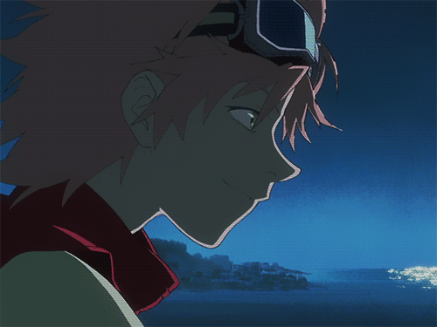

ArthurDank 12-Mar-19 01:44 PM

always does at first

then you realize the possibilities that are open now

Bunny 12-Mar-19 01:49 PM

Meow meow

ArthurDank 12-Mar-19 01:51 PM

hehe adorable :)

ArthurDank 12-Mar-19 01:59 PM

I love it time to celebrate Haruko

Bunny 12-Mar-19 05:18 PM

Yee

Sorry I fell asleep

ArthurDank 12-Mar-19 05:21 PM

its okay buddy hugs I have been busy between that time anyway so dont sweat it,

Bunny 12-Mar-19 05:51 PM

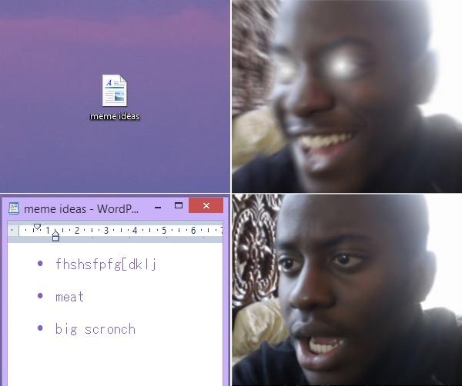

ArthurDank 12-Mar-19 05:52 PM

lmfao

sucks when the hype is for naught

Bunny 12-Mar-19 11:18 PM

Henlo

ArthurDank 12-Mar-19 11:21 PM

henlo how are you tonight lory?

:)

Bunny 12-Mar-19 11:34 PM

I’m good

ArthurDank 12-Mar-19 11:37 PM

nice whatcha doing?

ArthurDank 12-Mar-19 11:44 PM

also I was curious if you wanted to rp sometime tonight for a little bit? no biggie if you can't though :)

Bunny 13-Mar-19 12:07 AM

Sure in a bit

ArthurDank 13-Mar-19 12:11 AM

sure just whenever you want lemme know, so whatcha doin? (edited)

Bunny 13-Mar-19 12:13 AM

Watching FLCL with the little bro

ArthurDank 13-Mar-19 12:13 AM

oh thats very badass

you watching it on rabbit?

Bunny 13-Mar-19 12:13 AM

Yup

If you haven’t seen Season two yet we can watch it later

Well? Do ya?

ArthurDank 13-Mar-19 12:20 AM

sounds good to me

:)

sorry i was pumping gas lol

haven't seen it yet anyway

Bunny 13-Mar-19 12:35 AM

Good

ArthurDank 13-Mar-19 12:36 AM

glad to hear it :)

Bunny 13-Mar-19 01:23 AM

You up still?

Haru lookin for another Shota to fuck like an Amazon
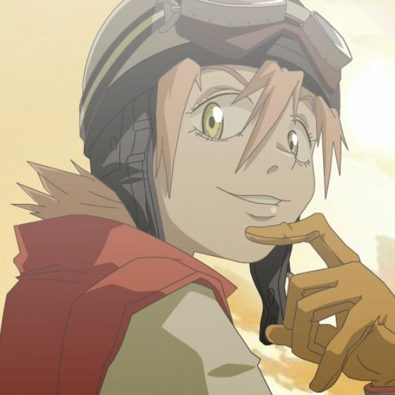

ArthurDank 13-Mar-19 01:26 AM

sure am

hehe nice

we all wanna fuck an amazon

you up still? lol

Bunny 13-Mar-19 01:35 AM

Yuuuup

Just finishing the last episode

Just download Rabbit for me Alrighty?

ArthurDank 13-Mar-19 01:36 AM

cool cool

already did

Bunny 13-Mar-19 01:37 AM

Perfect we can watch in a bit then


ArthurDank 13-Mar-19 01:40 AM

sounds good to me :)

Bunny 13-Mar-19 01:52 AM

Just a few more minutes

Gimme your Rabbit username so I can add ya

ArthurDank 13-Mar-19 01:52 AM

ArthurDank

Bunny 13-Mar-19 02:00 AM

Mari947

https://www.rabb.it/s/k5un8b

Rabbit
Discover, share and watch video content anywhere on any device with your friends. React and respond while watching your favorite shows together. And it's free!

Bunny 13-Mar-19 02:28 AM

Here

HOP IN! Join me in @LetsRabbit https://www.rabb.it/s/onvpmy

Rabbit
Discover, share and watch video content anywhere on any device with your friends. React and respond while watching your favorite shows together. And it's free!

ArthurDank 13-Mar-19 05:01 AM

that was fun i think i get what you mean tho

hope we all watch prog soon have a good night

Bunny 13-Mar-19 05:03 AM

Yee

ArthurDank 13-Mar-19 05:05 AM

so alt took place after the others but its stilla prequel because of the time loop thats why you need to watch them in production order, then alt, classic and progressive

makes sense considering the steam irons are still there, thought the town looked familier

and the song was the same

anyway have a good night

Bunny 13-Mar-19 01:22 PM

Hey I was just wondering,you don’t have anyone else’s number you could use for an alt huh? I feel like bringing Haru back on the side y’know? I doubt anyone will notice.
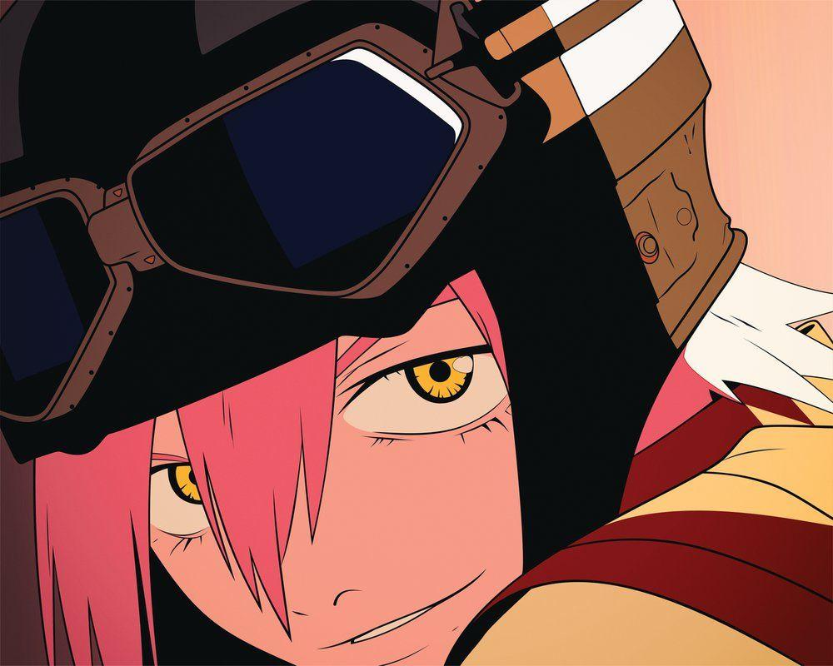

ArthurDank 13-Mar-19 01:24 PM

I would love to assist you Lory I could make another google voice account using moms phone but thats all I can do, gotta give me a few

im at the store paying her a visit at work so perfect timimg

Bunny 13-Mar-19 01:25 PM

Sure go right ahead

ArthurDank 13-Mar-19 01:34 PM

okay im back use the number in the screencap

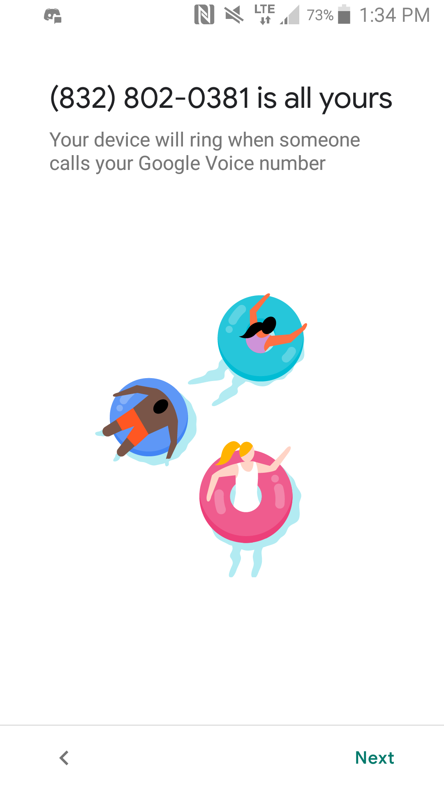

Bunny 13-Mar-19 01:36 PM

Thanks

ArthurDank 13-Mar-19 01:37 PM

you're welcome that may be my last possible attempt but we will see :)

give me a follow when you get on, I wont tell anyone who you are

Bunny 13-Mar-19 01:58 PM

Is it actually activated?

ArthurDank 13-Mar-19 01:58 PM

said it was

have you tried it?

you waiting for a code?

Bunny 13-Mar-19 01:59 PM

One sec

ArthurDank 13-Mar-19 02:00 PM

cool

Bunny 13-Mar-19 02:01 PM

Yup waiting on a code now

ArthurDank 13-Mar-19 02:01 PM

597250

Bunny 13-Mar-19 02:03 PM

Thanks

ArthurDank 13-Mar-19 02:03 PM

you're welcome :)

Bunny 13-Mar-19 02:05 PM

I will follow ya in a minute but don’t blow my cover alright?

Parker is still paranoid and would flip his shit if he knew about this

ArthurDank 13-Mar-19 02:08 PM

what about you being on twitter?

Bunny 13-Mar-19 02:08 PM

No about the Haru stuff

Just keep interaction to a minimum

ArthurDank 13-Mar-19 02:09 PM

okay sure im confused tho what is it about the haru stuff that makes him oaranoid

Bunny 13-Mar-19 02:09 PM

It just does

Despite me saying literally nobody is looking for me anymore

Listen

Just don’t question it

Just do what I ask okay?

ArthurDank 13-Mar-19 02:10 PM

okay not a problem to ask question imo but ok

i get you tho he thinks those assholes are still out there looking for you as haru was a former username of yours, makes sense

you should know i will do what you ask, dont worry about it okay? just don't get testy when i ask a question okay? I was just wondering and thats all i ask :)

Bunny 13-Mar-19 02:22 PM

Thanks

Setting up the account actually

ArthurDank 13-Mar-19 02:23 PM

cool good luck

is it a problem if i ask any questions in the future? just making sure lol

Bunny 13-Mar-19 02:25 PM

Nah nah nah

Go ahead and ask me what you wanna

ArthurDank 13-Mar-19 02:28 PM

its fine for now buddy just making sure it was okay to ask lol thank you

Bunny 13-Mar-19 02:31 PM

Bleh

Mind linking your twitter here?

ArthurDank 13-Mar-19 02:36 PM

@DankPyra?

ArthurDank 13-Mar-19 02:43 PM

thanks for the folloe buddy

the only reason why i asked was because i thought was paranoid because maybe he found out about our discord chats or something, I didn't know lol

i get it tho he thinks those freaks are still out there

ArthurDank 13-Mar-19 02:55 PM

i followed your notsmug account parker made a tweet so welcome back officially i didn't realize you had an official account too (edited)

Bunny 13-Mar-19 02:57 PM

Yee

It’s locked too lmao

ArthurDank 13-Mar-19 02:58 PM

lmao fuck me

Bunny 13-Mar-19 02:58 PM

I’ve seriously gotta get a new real phone number

ArthurDank 13-Mar-19 03:00 PM

indeed sorry to say

sucks its come to that lol

Bunny 13-Mar-19 03:55 PM

Feels good to finally be back
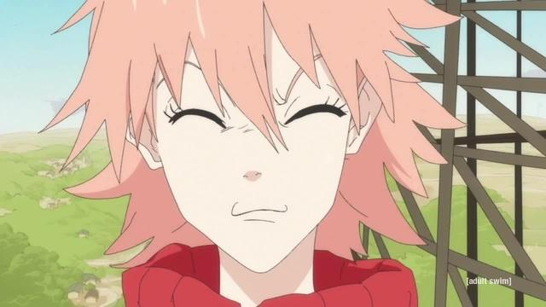

ArthurDank 13-Mar-19 04:00 PM

its good to have you back haruko :)

Bunny 13-Mar-19 04:01 PM

It’s been forever lmao

ArthurDank 13-Mar-19 04:04 PM

several years you said

lmao but she is you, naturally you find your way back home :)

Bunny 13-Mar-19 04:14 PM

After all I can’t be everyone’s big sister if they know I’m watching~
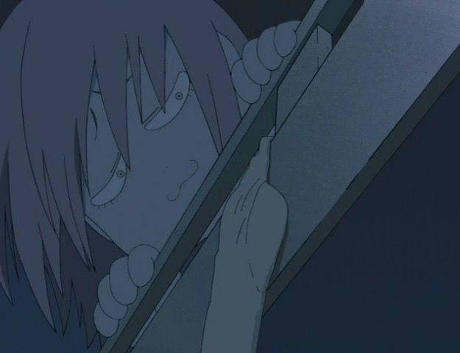

ArthurDank 13-Mar-19 04:18 PM

hahaha bingo

you're always with us

Bunny 13-Mar-19 04:25 PM

Haruhara Haruko,age 23 and splendifourous housekeeper at Parker’s place~!
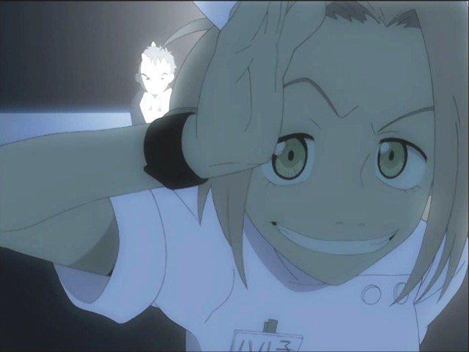

ArthurDank 13-Mar-19 04:28 PM

we should all be so lucky lmao

Bunny 13-Mar-19 04:30 PM

Trying to choose between these two for different avatars on Twitter
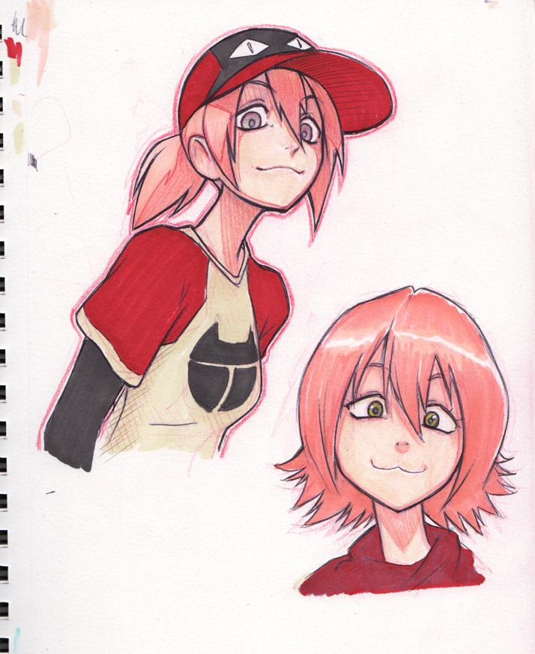

ArthurDank 13-Mar-19 04:35 PM

i like the baseball cap

but the hoodie one has such a cute face

ArthurDank 13-Mar-19 04:44 PM

i vote hoodie

Bunny 13-Mar-19 05:56 PM

Hey did you say something to upset Parker?

ArthurDank 13-Mar-19 05:56 PM

hell no i haven't talked to him in days why?

i replied to his tweet about your account but that is all?

Bunny 13-Mar-19 05:57 PM

Weird

He seems upset with me but other than not including him in the stream yesterday I can’t think of anything

ArthurDank 13-Mar-19 05:57 PM

i like the dude i wouldn't say anything to hurt him or you

oh i thought he was watching flcl with is last night?

us*

if that is the stream you refer too

he couldn't know about the haru account could he

let me know what you find out okay?

Bunny 13-Mar-19 06:01 PM

Alrighty

ArthurDank 13-Mar-19 06:03 PM

very odd hope everything will be okay partner (edited)

ArthurDank 13-Mar-19 06:51 PM

find anything out?just asking since im gonna be doing the floors and will be unable to reply much for a while

Bunny 13-Mar-19 06:52 PM

Oh it’s because we didn’t include him last night

ArthurDank 13-Mar-19 07:01 PM

oh okay wasn't sure thought maybe it was something else lol i get it, I actually thought he was watching with us lmao

thanks for letting me know :)

Bunny 13-Mar-19 09:06 PM

I seriously need a new phone number

Can’t stand not just doing this all myself

Bunny 13-Mar-19 09:13 PM

Just a few more hours
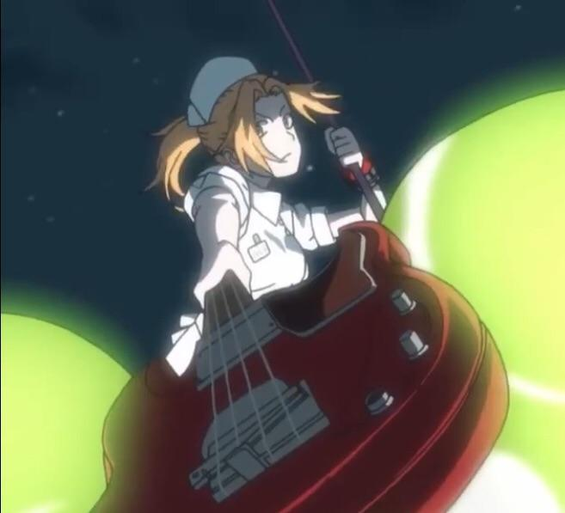

Bunny 13-Mar-19 09:53 PM

You dead?

ArthurDank 13-Mar-19 09:58 PM

nah im here i was at work had to let my phone charge sorry

weird i was given 4 messages and they aren't here now you asked if i was dead no im here what were you asking my fren?

Bunny 13-Mar-19 10:00 PM

It glitched lmao

Sorry

ArthurDank 13-Mar-19 10:01 PM

its all good

what were you asking tho?

Bunny 13-Mar-19 10:02 PM

I don’t remember actually
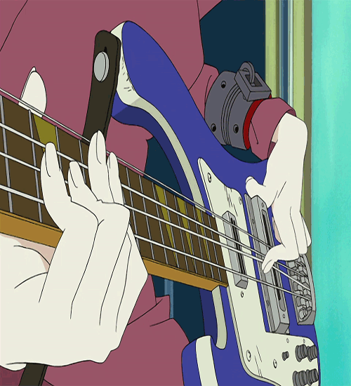

ArthurDank 13-Mar-19 10:03 PM

nice haha and cool im sure it was no biggie (edited)

Bunny 13-Mar-19 10:05 PM

Just three and a half more hours
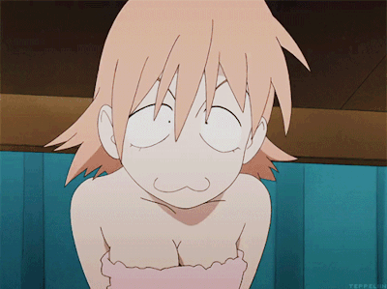

ArthurDank 13-Mar-19 10:07 PM

what happens then?

Bunny 13-Mar-19 10:08 PM

Both my accounts are unlocked

ArthurDank 13-Mar-19 10:36 PM

rock and roll haru be good to have you back finally (edited)

ArthurDank 14-Mar-19 01:29 PM

hello lory how ya doing?

Bunny 14-Mar-19 01:57 PM

Good

ArthurDank 14-Mar-19 01:59 PM

thats good to hear buddy :) congrats on yoir accounts being unlocked

what are you doing today?

Bunny 14-Mar-19 02:08 PM

Playing D&D

ArthurDank 14-Mar-19 02:09 PM

very nice :D

hope you have fun Haru

Bunny 14-Mar-19 02:10 PM

Thaaanks

ArthurDank 14-Mar-19 02:14 PM

anytime buddy hit me up later if you want, im off today :)

ArthurDank 14-Mar-19 03:39 PM

saw you were probably taking a twitter break till tuesday, trying to keep a low profile and avoid suspencion? (edited)

Bunny 14-Mar-19 03:40 PM

Basically yeah

ArthurDank 14-Mar-19 03:40 PM

I get you, well glad you will be back in a few days, hope the break works and you're able to stick around btw next time we rp im down for the gangbang if you are ;) (edited)

Bunny 14-Mar-19 08:52 PM

Henlo

ArthurDank 14-Mar-19 08:53 PM

hello partner how ya doing?

Bunny 14-Mar-19 08:55 PM

I’m good

ArthurDank 14-Mar-19 08:57 PM

glad to hear it what have you been doing today?

besides D&D? :)

Bunny 14-Mar-19 09:01 PM

I’m good

Was about to get in the shower

And then relax in bed

ArthurDank 14-Mar-19 09:02 PM

oh noce

Bunny 14-Mar-19 09:02 PM

Oh boy I can transfer all my G+ posts to MeWe now

All 30K of them

ArthurDank 14-Mar-19 09:03 PM

oh very nice lory

sounds groovy

thats a lot of posts over years im sure

Bunny 14-Mar-19 09:05 PM

I’m just happy I won’t lose any of my posts

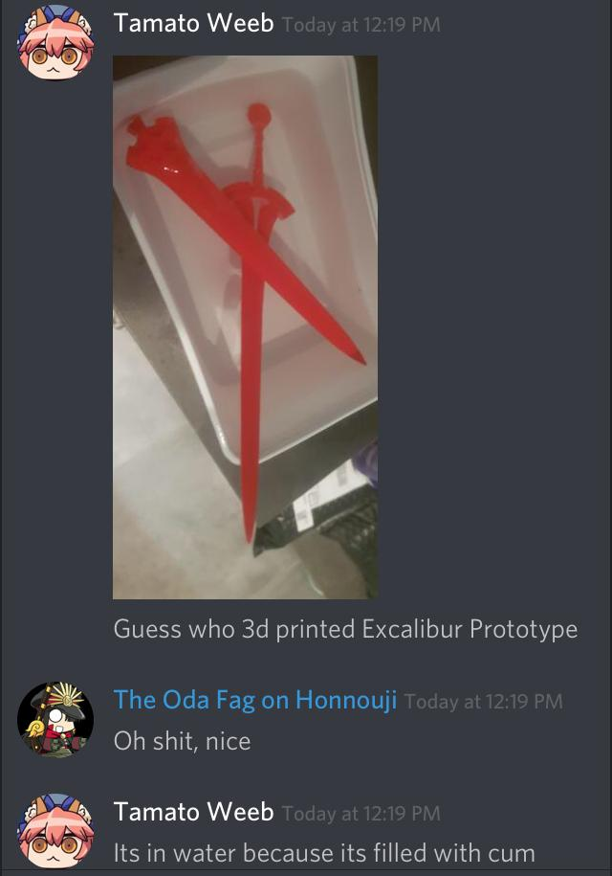

ArthurDank 14-Mar-19 09:06 PM

lmfao filled with cum

thats a good thing a damn good thing after 30k posts

excaliber nice

Bunny 14-Mar-19 09:35 PM

It’s filled with cum apparently

ArthurDank 14-Mar-19 09:35 PM

might be why we have never found it irl lmao

so what are you into tonight partner? done with the shower?

Bunny 14-Mar-19 09:48 PM

Yuup

More D&D if everyone gets one

On*

ArthurDank 14-Mar-19 09:49 PM

sounds good partner hope you have fun

been doing entomology work today? didn't know you were studying that (edited)

Bunny 14-Mar-19 09:55 PM

Yuup

ArthurDank 14-Mar-19 10:11 PM

thats awesome lory

hope your studies go well too

btw did that flcl outfit come in?

Bunny 14-Mar-19 10:15 PM

It did actually

Gonna try it tonight actually

ArthurDank 14-Mar-19 10:16 PM

oh nice lol no rush but whenever you take a pic let me know i mean if its not too uncomfy for you i would like to see you in it, even if you have to edit it :) (edited)

im sure parker will like hehe

Bunny 15-Mar-19 12:25 AM

You up still?

ArthurDank 15-Mar-19 12:29 AM

yeah whats up? :)

Bunny 15-Mar-19 12:32 AM

Just saying hi and that I apparently mismeasured my bust size but y'know its kinda whatever.

ArthurDank 15-Mar-19 12:32 AM

oh henlo back lory sorry if my tone was sharp :) (edited)

how did you mismeasure?

gotta ask hehe (edited)

Bunny 15-Mar-19 12:35 AM

I was a little bit bigger than I thought.

ArthurDank 15-Mar-19 12:35 AM

damn really? wow

thats impressive honestly i take it you were trying on the bunny and you realized its a little tight in the chest?

Bunny 15-Mar-19 12:38 AM

Yuuup

I spill out the sides a little bit

ArthurDank 15-Mar-19 12:39 AM

whoops im sure you still look hot as hell in it tho

Bunny 15-Mar-19 12:41 AM

Yeah we're actually gonna test it

its really smooth material

ArthurDank 15-Mar-19 12:45 AM

oh very nice hehe

good luck hope to see it sometime

Bunny 15-Mar-19 12:47 AM

Already under the blanket,just waiting for him to get it up lol

ArthurDank 15-Mar-19 12:47 AM

nice

have fun ;) just in case it gets too intense (edited)

look forward to hearing how this works

Bunny 15-Mar-19 12:55 AM

Okay so

he's just rubbing up on my ass right now

Feels like he's gonna bust any second~

ArthurDank 15-Mar-19 12:56 AM

hehe very smooth then ;)

and given your great ass...no man could hold his load (edited)

ArthurDank 15-Mar-19 01:29 AM

so hows it going? whats up? lol

ArthurDank 15-Mar-19 11:53 AM

henlo

Bunny 15-Mar-19 12:27 PM

Oh hi
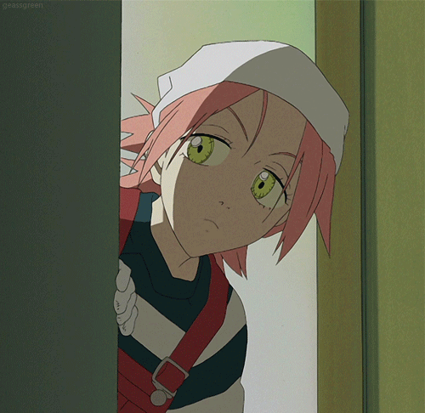

Apparently some dude shot up a Mosque and now Leftist Twitter is blaming Jontron because the shooter wrote a BS manifesto (edited)

ArthurDank 15-Mar-19 12:28 PM

yeah i sae parker post about it fucking nonsense all of it

Bunny 15-Mar-19 12:31 PM

Okay but I’ve got one question

How the fuck

Does blaming PewDiePie

AGAIN

Fix anything?

Anyone with two functional brain cells can see the Manifesto was BS

ArthurDank 15-Mar-19 12:34 PM

exactly its all about owning the people they don't like its fucking stupid and vile

its not about fixing anythings its about dissing the side they hate

ArthurDank 15-Mar-19 12:49 PM

fucked up

ArthurDank 15-Mar-19 01:05 PM

btw you vanished on me last night during the boinking, what all happened and how well did bunny suit do?

Bunny 15-Mar-19 01:30 PM

Really well actually

It was a lot of fun ngl

ArthurDank 15-Mar-19 01:33 PM

nice sounds promising what all did you do? love to hear the details ;) (edited)

since we broke contact right about there lol

ArthurDank 15-Mar-19 02:09 PM

sounds pretty kinky, just lemme know when you have the time

Bunny 15-Mar-19 02:16 PM

Sorry was eating breakfast

ArthurDank 15-Mar-19 02:16 PM

sorry partner i didn't know but no rush i just meant lemme know some of the details when you have time (edited)

it was a bunny outfit so i gotta hear about this lol but only when you have the time

Bunny 15-Mar-19 02:22 PM

Well it did involve carry fucking and being fucked against the wall so

ArthurDank 15-Mar-19 02:22 PM

damn!

must've really liked the outfit picked haruko bunny up and worked her over and against the wall nice

i get why you couldn't text me during that, thats why im asking you about it now lol

doggy pound you too?

Bunny 15-Mar-19 02:26 PM

Yuuuuup

Looks like that purchase was a good idea

ArthurDank 15-Mar-19 02:27 PM

hell yes it was glad he liked it

work your boobies over too?

Bunny 15-Mar-19 02:27 PM

Yuuuuup

ArthurDank 15-Mar-19 02:27 PM

hehe very nice as he should

ass boobs and mouth got worked hard last in several positions and even against the wall damn

how well did the suit handle the dicke? any of it have to come off or like your leggings it just took it? you said it was smooth but was it stretchy? (edited)

ArthurDank 15-Mar-19 05:00 PM

congrats you hit 300 subs

Bunny 15-Mar-19 05:05 PM

In only 48 hours too

ArthurDank 15-Mar-19 05:10 PM

badass lory keep it up

btw how flexible was the material in your bunny suit, was it like the leggings?

Bunny 15-Mar-19 05:16 PM

It really is flexible material

ArthurDank 15-Mar-19 05:24 PM

very nice so needless to say it took it like your leggings like a champ lol

Bunny 15-Mar-19 06:03 PM

Sorry about taking forever to reply I have a few things to do
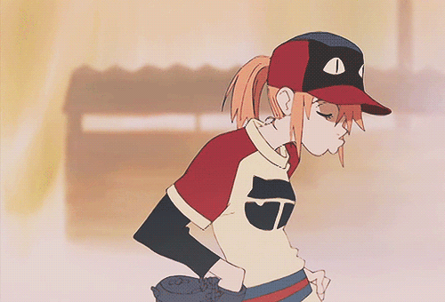

ArthurDank 15-Mar-19 06:06 PM

damn thing glitched again lol i saw you say sorry for taking forever to reply

its okay but what else did you say? i didn't see the rest

Bunny 15-Mar-19 06:08 PM

I said yeah it is a flexible material but still had to pull it aside y’know?

It’s a fun outfit regardless
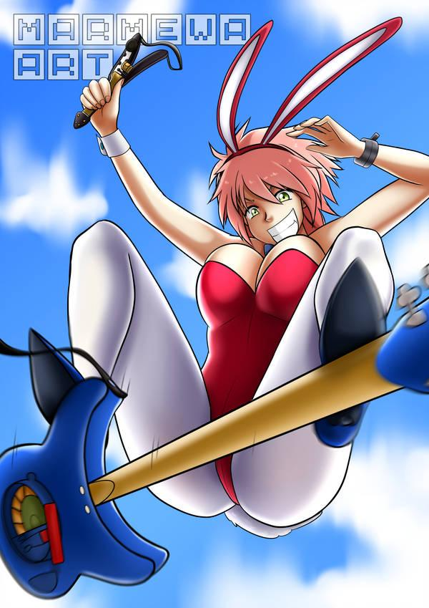

ArthurDank 15-Mar-19 06:11 PM

lmao i get you there

it looks fun if thats any indication as to what it looks like definitely gonna be rp material in the future ;) (edited)

so what have you been into? you said you were taking forever to reoly because of something but then it glitched so i was curious I start on the floors at 7 so soon im gonna be a lil hard to reach till 10:30 (edited)

ArthurDank 15-Mar-19 07:01 PM

oh your msg finally showed up you said you had things to do, no worries i hope everything goes well for you like the annoyed haruko in baseball attire

Bunny 16-Mar-19 01:55 AM

Oh Henlo

ArthurDank 16-Mar-19 02:19 AM

henlo lol

sorry i was driving how ya doing?

love haruko in the bunny outfit, phone didn't tell me you sent a msg :/ (edited)

ArthurDank 16-Mar-19 02:35 AM

hello?

Bunny 16-Mar-19 02:38 AM

I’m good

You should seriously update your phone

ArthurDank 16-Mar-19 02:38 AM

its weird it normally tells me when you msg me

so what are you doing right now?

ArthurDank 16-Mar-19 02:50 AM

mines a galaxy S5 so it shouldn't be too bad lol

Bunny 16-Mar-19 02:53 AM

Just getting some milk

ArthurDank 16-Mar-19 02:53 AM

cool cool

congrats on 350 subs

Bunny 16-Mar-19 03:00 AM

Yee

Probs 400 soon

ArthurDank 16-Mar-19 03:00 AM

from the look of it can't wait

Bunny 16-Mar-19 03:01 AM

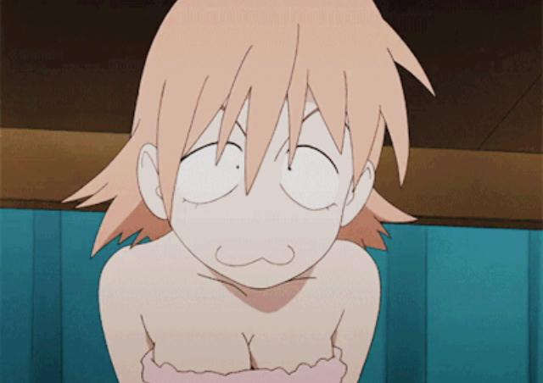

ArthurDank 16-Mar-19 03:01 AM

lmao

so cute

you're the best haru

ArthurDank 16-Mar-19 03:27 AM

you out cold partner?

ArthurDank 16-Mar-19 03:41 AM

welp im heading to bed have a good night, hit me up tomorrow if you like it was nice talking for a few

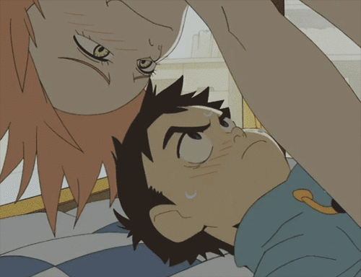

one of my favs lol have a good one and sorry i was late getting back to you discord is a pain when it doesn't notify me lol (edited)

Bunny 16-Mar-19 11:56 PM

Hey I kinda wanna turn the Haru account into an RP account but I don’t want it to be bland like every other account I’ve seen do RP so far
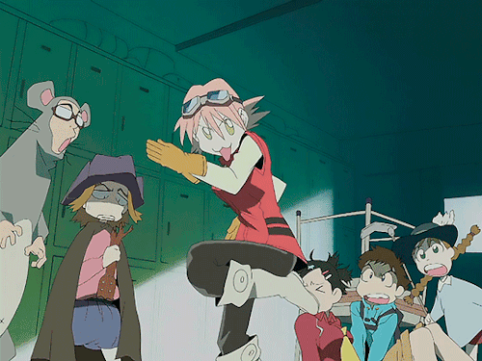

ArthurDank 16-Mar-19 11:57 PM

Henlo Haru and I think thats a great idea and I don't think it will be bland, you aren't bland so you will give it the personality it needs, besides you are Haruko (edited)

Bunny 17-Mar-19 12:01 AM

Biggest issue is finding active RP accounts

ArthurDank 17-Mar-19 12:02 AM

very true about that

nobody does it very well these days

but I think its a great idea tho

Bunny 17-Mar-19 12:10 AM

Gotta find a good avatar and background

ArthurDank 17-Mar-19 12:10 AM

but haruko by default is a good avatar, background is another thing

ArthurDank 17-Mar-19 12:17 AM

the nonon account you follow on twitter is that you too?

Bunny 17-Mar-19 12:20 AM

Nope

ArthurDank 17-Mar-19 12:20 AM

just curious lol

Bunny 17-Mar-19 12:20 AM

Does it look better now?

Just need a pinned tweet now

ArthurDank 17-Mar-19 12:21 AM

looks great actually love the bio too

a good pinned tweet, some discription of you would be good like what you are here for, nothing to identify you of course tho

Bunny 17-Mar-19 12:27 AM

https://twitter.com/raharuharuha_/status/1107135983936401409?s=12

〘Raharu〙 (@RaharuHaruha_)
"ℕ !" ғɪʀsᴛ ᴄʟᴀss sᴘᴀᴄᴇ ᴘᴀᴛʀᴏʟ ᴏғғɪᴄᴇʀ ғʟᴄʟ/ᴍᴠʀᴘ ʀᴛ? More below https://t....

 Twitter

ArthurDank 17-Mar-19 12:28 AM

I dig it plenty :)

I RT'ed like the pinned tweet says hope it doesn't blow your cover

Bunny 17-Mar-19 12:29 AM

If anyone asks just say you’re helping out a small RP account

ArthurDank 17-Mar-19 12:30 AM

I will hell I have an alias to give in the event anyone asks detailed questions

via DM

Bunny 17-Mar-19 12:33 AM

Lmao how

ArthurDank 17-Mar-19 12:34 AM

i have a long distance friend whos name i can give, how will they know, they gonna track the ip or something?

sarah from south carolina lmao

thats if people ever interrogate me about the account

Bunny 17-Mar-19 12:37 AM

They most likely won’t

ArthurDank 17-Mar-19 12:37 AM

i always have a plan B lol

at any rate the account looks nice

ArthurDank 17-Mar-19 12:46 AM

so what are you into?

Bunny 17-Mar-19 12:46 AM

Hm?

ArthurDank 17-Mar-19 12:47 AM

i mean whats up?

Bunny 17-Mar-19 12:47 AM

Looking for other RP accounts to follow

ArthurDank 17-Mar-19 12:47 AM

thats cool :)

you said canonical haruko as she is in season one? can you explain that bit?

Bunny 17-Mar-19 01:00 AM

Yeah

I mean her attitude from Season 1

“BECAUSE YOURE BORN TO BE MILD!”
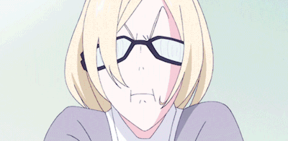

ArthurDank 17-Mar-19 01:02 AM

oh okay well i have only seen classic and alternative, classic she is....complicated, alternative she is more or less the same tho seems more heroic lol i haven't seen progressive yet and HOLY SHIT she was the porn teacher?

LMAO wait of course she was

haruko is a real turn on no matter where she is or what she wears

Bunny 17-Mar-19 01:19 AM

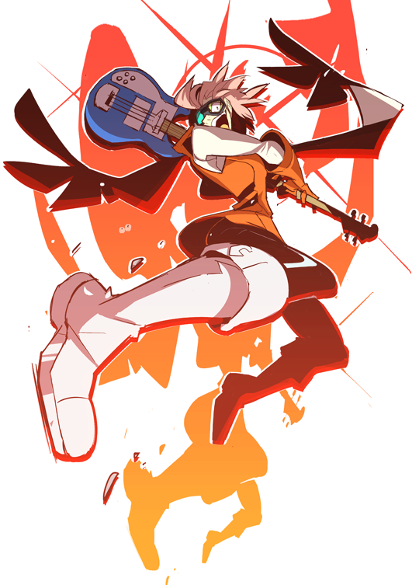

ArthurDank 17-Mar-19 01:20 AM

that is awesome!

shes on fire

Bunny 17-Mar-19 01:38 AM

This is taking much longer than I expected it to

Annoying

ArthurDank 17-Mar-19 01:39 AM

what is?

following rp accounts?

Bunny 17-Mar-19 01:39 AM

Yes that and getting at least ONE to follow back

Jesus Christ

ArthurDank 17-Mar-19 01:40 AM

that does fucking suck

its a pain when people dont wanna follow

on a side note im kinda wore out tonight from work but i was curious in the next few nights or whenever if you wanted to rp again

Bunny 17-Mar-19 01:54 AM

Nooooooo

ArthurDank 17-Mar-19 01:54 AM

oh really?

okay i understand

Bunny 17-Mar-19 01:54 AM

No no no

I mean don’t go sleep

ArthurDank 17-Mar-19 01:55 AM

oh okay whew lol

well okay i will stick around then

you had me a bit worried lol

are you wanting to rp tonight or something? it dont matter either way i will stick around :)

Bunny 17-Mar-19 02:19 AM

Vpn is acting up again

REEEEEEEE

ArthurDank 17-Mar-19 02:20 AM

lmao REEEEEE indeed

hate when that happens really fucks with chatting

notsmug just hit 400

Bunny 17-Mar-19 02:35 AM

I noticed

ArthurDank 17-Mar-19 02:43 AM

cool just letting you know lol

whatcha doing? :)

Bunny 17-Mar-19 02:50 AM

Thinking of a way for us to be a pair act y’know?

I need a Naota to bounce off of

ArthurDank 17-Mar-19 02:51 AM

lmao oh actually spunds pretty good to me

sounds*

I would like that

im open to ideas :)

Bunny 17-Mar-19 02:55 AM

https://twitter.com/raharuharuha_/status/1107173379092725760?s=12

〘Raharu〙 (@RaharuHaruha_)
í’m míssíng thαt nασtα kíd αlrєαdч~! whєrє ís hє~??” https://t.co/GoQ3eCm3U9
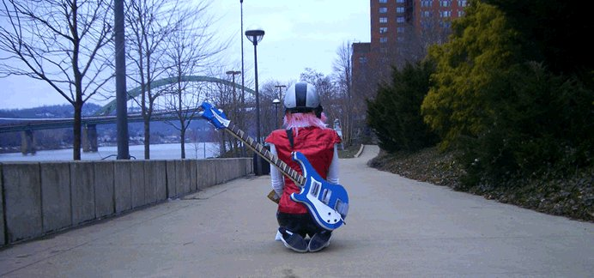
Twitter

No idea how

Unless you have another Alt or something

ArthurDank 17-Mar-19 02:56 AM

i can make one hold on

Bunny 17-Mar-19 03:01 AM

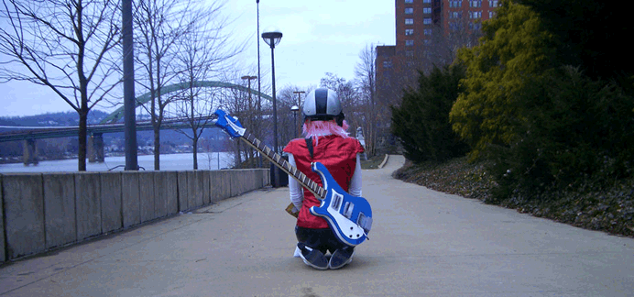

ArthurDank 17-Mar-19 03:03 AM

im there

my account got suspended wtf!?

Bunny 17-Mar-19 03:07 AM

Whoops

Yeeeeaaaaaaah

About that

Unless it’s through the Google Voice number chances are it won’t work

ArthurDank 17-Mar-19 03:08 AM

oh i see makes sense

Bunny 17-Mar-19 03:13 AM

Yuuuuup

ArthurDank 17-Mar-19 03:18 AM

which one is the google voice number again?

Bunny 17-Mar-19 03:20 AM

Fuck

Hang on

ArthurDank 17-Mar-19 03:20 AM

irs cool im there just replied

suspended again but i used the old google voice number not the one i gave you for your most recent account

nevermind i still have the screencap gonna have to make another account

Bunny 17-Mar-19 03:22 AM

Hold on

Hang on

ArthurDank 17-Mar-19 03:23 AM

okay

i have the number now is all im saying but would it hurt your current account?

Bunny 17-Mar-19 03:23 AM

Probably

I wouldn’t risk it

Can you see if you can reset your current phone number? I hate to be a pest like this lmao

ArthurDank 17-Mar-19 03:24 AM

lmao not a past but how can i reset my number?

Bunny 17-Mar-19 03:28 AM

I have no idea honestly

ArthurDank 17-Mar-19 03:28 AM

i will try to figure ot out

Bunny 17-Mar-19 03:28 AM

I think you need to contact your service provider? I dunno though

ArthurDank 17-Mar-19 03:28 AM

oh you mean my actual number??

okay yeah probably have to do that tomorrow i will try tho

ArthurDank 17-Mar-19 03:36 AM

sorry for the wait i will have to call tomorrow but i will take care of it Haru then we can pull some shit on twitter :D

Bunny 17-Mar-19 03:36 AM

Sure no problem

ArthurDank 17-Mar-19 03:37 AM

actually there is one number i still have never used for an account my uncles sadly i dont have his phone either way tomorrow we can sort this out

so whatcha into now?

Bunny 17-Mar-19 03:44 AM

Gettin’ sleepy but also kinda hornt
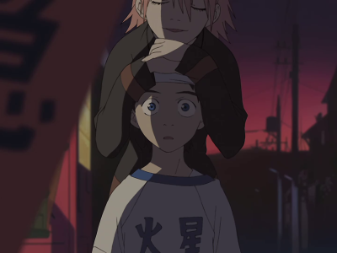

ArthurDank 17-Mar-19 03:44 AM

haha me too

on both counts

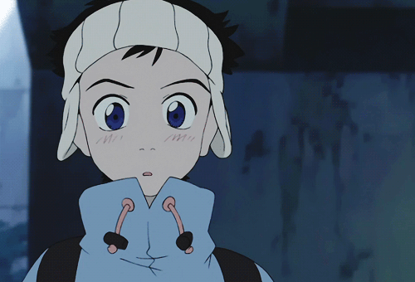

Bunny 17-Mar-19 03:58 AM

If you can I guess we could do a Haru and Naota thing right now?

ArthurDank 17-Mar-19 04:00 AM

ehh its okay lory i would love too but im about to pass out but could we do that soon? maybe in a few nights?

Bunny 17-Mar-19 04:01 AM

Sure

ArthurDank 17-Mar-19 04:01 AM

cool i would love to sorry to decline im just barely holding on

hell we could do it tomorrow night if you wanted, have some fun lory and have a good night too, whichever you are gonna do haha hit me up tomorrow if you like

next time maybe we can start a few hours earlier lol

Bunny 17-Mar-19 01:40 PM

Made the alt huh? Looks a bit basic

Mind if I make a few suggestions?

ArthurDank 17-Mar-19 01:46 PM

lmao yeah please i made it in a hurry

im locked for 12 hours anyway

Bunny 17-Mar-19 01:56 PM

Well first thing Is

Numbers in username are a no go

Also

I suggest using something simpler like

NaotaFLCL

Or something like that

ArthurDank 17-Mar-19 01:58 PM

sounds good to me they did that i haven't fixed it yet

I'll adjust the @ here inba few

other suggestions partner or was that all? :)

ArthurDank 17-Mar-19 02:10 PM

it will be a little under 12 hours before I can use it

Bunny 17-Mar-19 02:25 PM

Thinking of more suggestions

I’ll slide you a background to use too probably

ArthurDank 17-Mar-19 02:36 PM

oh cool thank you Lory

ArthurDank 21-Mar-19 02:09 PM

henlo lory

Bunny 21-Mar-19 02:32 PM

Henloooo

ArthurDank 22-Mar-19 01:12 AM

henlo lory how ya doin?

ArthurDank 22-Mar-19 03:13 AM

you okay lory?

Bunny 23-Mar-19 12:29 AM

Oh fuck

I logged out on laptop \

AAAAAAAAAAAAAAA

NVM

ArthurDank 23-Mar-19 12:30 AM

hello?

Bunny 23-Mar-19 12:30 AM

yEE?

ArthurDank 23-Mar-19 12:30 AM

you okay lory?

you logged out i gather

discord or Twitter?

Bunny 23-Mar-19 12:33 AM

It was an accident

I fixed it

ArthurDank 23-Mar-19 12:34 AM

cool

does no good to leave your rp partner hanging lol (edited)

Bunny 23-Mar-19 04:27 AM

Seriously I think you just need more practice as Naota

or to watch the series again

If you hand that alt over I'll spruce it up a bit

ArthurDank 23-Mar-19 04:28 AM

Sure thing Lory I will give you the deets later on and yeah I will try and work on it a bit

truth be told I made the account just to hang with you more lol this is all new to me

Bunny 23-Mar-19 04:29 AM

Aww shucks

I'm flattered

ArthurDank 23-Mar-19 04:31 AM

Aww well you're very welcome and im glad you are as the account it just gave me another excuse to hang around you more, granted I identify with Naota the most as I did when I first watched about 11-12 years ago but I digress lol (edited)

I have been wanting to watch Classic again anyway and
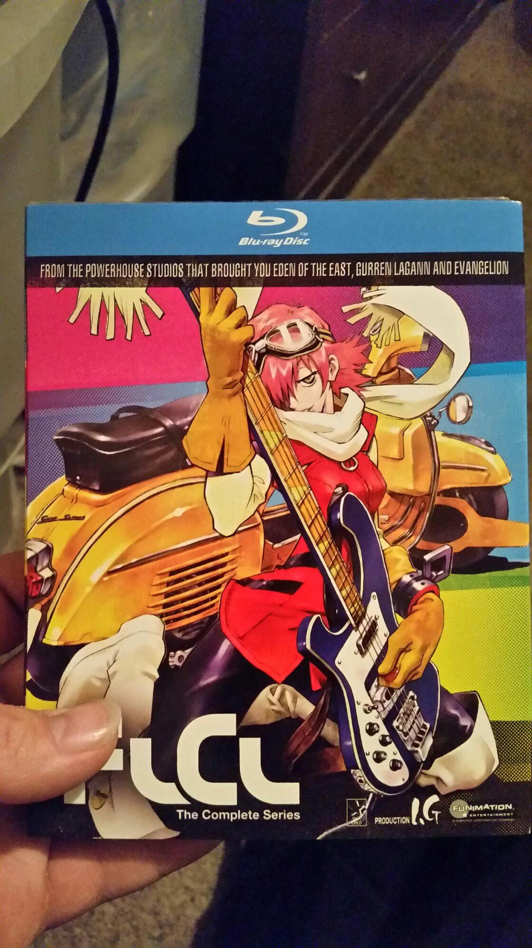

now I have the goods lol anywho lory im gonna crash, you have a good night hit me up later if you want. :)

ArthurDank 27-Mar-19 02:14 AM

henlo :) (edited)

ArthurDank 27-Mar-19 06:53 PM

hello?

Bunny 27-Mar-19 08:14 PM

Henlo

ArthurDank 27-Mar-19 08:29 PM

how are you?

phones about to die lol sorry what have you been up to

ArthurDank 27-Mar-19 08:44 PM

i wanted to ask do you think someone else couod take over the naota account?

ArthurDank 27-Mar-19 09:01 PM

someone who has more time to take care of it? (edited)

Bunny 27-Mar-19 09:15 PM

Sure

ArthurDank 27-Mar-19 09:17 PM

okay cool sorry don't misunderstand i just dont have the time between my main and this to run it like it should and you have done a great job bringing the FLCL RP scene back so you need a more active naota

@NaotaFLCL_ password Alucard777

Bunny 27-Mar-19 09:18 PM

Alrighty

ArthurDank 27-Mar-19 09:18 PM

cool thank you Lory

hope the next person does better with it :) so what have you been doing?

the highlight was blahing with you in group chat :) you were the highlight of it is what I mean XD

also have you been okay? you have been out of touch a bit

Bunny 27-Mar-19 09:23 PM

I’m alright sorry about that

ArthurDank 27-Mar-19 09:33 PM

its okay i was just wondering, so what have you been doing buddy? :)

ArthurDank 27-Mar-19 10:10 PM

also i know you are busy with other partners too but i still wanna rp again sometime

Bunny 27-Mar-19 10:19 PM

We will

ArthurDank 27-Mar-19 10:29 PM

okay cool if you still want to that sounds really nice :)

ArthurDank 27-Mar-19 10:39 PM

so what have you been into?

ArthurDank 28-Mar-19 03:25 AM

guess you got busy lol off to bed partner have a good one hit me up later (edited)

Bunny 01-Apr-19 11:23 PM

You alive still?

ArthurDank 01-Apr-19 11:24 PM

sure am partner how ya doing?

Bunny 01-Apr-19 11:29 PM

30 minutes left

ArthurDank 01-Apr-19 11:30 PM

till G+ closes?

Bunny 01-Apr-19 11:30 PM

Yup

ArthurDank 01-Apr-19 11:30 PM

im sorry hugs

Bunny 01-Apr-19 11:30 PM

It’s alright I have my backup data

ArthurDank 01-Apr-19 11:30 PM

thats good news at least

it will be okay lory no sweat sooner or later besides they were bought so there may be hope

what have you been into lately? been a while (edited)

Bunny 01-Apr-19 11:38 PM

Elf fuck rp mostly

ArthurDank 01-Apr-19 11:38 PM

elf fuck rp?

Bunny 01-Apr-19 11:38 PM

Yup

D&D style actually lmao

ArthurDank 01-Apr-19 11:39 PM

lmao oh nice wait is it with the D&D players

or with the twitter group from raharu account?

lmao

Bunny 01-Apr-19 11:40 PM

Twitter group

ArthurDank 01-Apr-19 11:40 PM

nice

how was it D&D style? lmao curious

glad someone has been having fun lately lol

Bunny 01-Apr-19 11:45 PM

Y’all can join in

ArthurDank 01-Apr-19 11:45 PM

sounds good lol

just let me know haha

Bunny 01-Apr-19 11:51 PM

https://discord.gg/FXpmRE

ArthurDank 01-Apr-19 11:52 PM

i joined i dont have permission to msg tho

Bunny 01-Apr-19 11:53 PM

Whoops I’ll fix that

ArthurDank 01-Apr-19 11:53 PM

thanks

Bunny 01-Apr-19 11:54 PM

Welcome

ArthurDank 01-Apr-19 11:58 PM

any luck? still can't msg

ArthurDank 02-Apr-19 12:05 AM

been reading the chat i see there is an issue lol

Bunny 02-Apr-19 12:07 AM

Just a small one lmao

ArthurDank 02-Apr-19 12:11 AM

this sucks character info didn't know much about D&D lol

i see what you mean about D&D style

its okay lory dont worry about it

Bunny 02-Apr-19 12:16 AM

It’s easy to learn

ArthurDank 02-Apr-19 12:38 AM

okay so whats up now?

ArthurDank 02-Apr-19 12:48 AM

everything okay?

thanks for inviting me in i kinda thought you got tired of me

Bunny 02-Apr-19 12:57 AM

Nope not at all

ArthurDank 02-Apr-19 12:57 AM

im glad

let me know whats going on, either way i plan on doing you in the server or in here either one

lory?

whats cooking?

ArthurDank 02-Apr-19 02:38 PM

hey lory just wanted to thank you for inviting me but I have had a change of minds and will leave the server later after I chat with you ,I just wanted to give it a try last night, D&D group rp thing and I had a blast but its just not for me, not quite my cup of tea, no offense and i hope you understand but you and james can still use my character or give it to someone else if you wish, sorry if its dissapointing but i hope you understand thanks for letting me try

Bunny 02-Apr-19 02:51 PM

Ehhh alright

ArthurDank 02-Apr-19 02:51 PM

sorry partner i didn't mean to dissapoint i just wanted to give it a try thank you tho i had fun

i sent james a dm and let him know too

ArthurDank 12-Apr-19 12:54 AM

hey lory sorry for bothering you just letting you know i got suspended dont think i can get back on if you wouldn't mind letting everyone know i would appreciate it (edited)
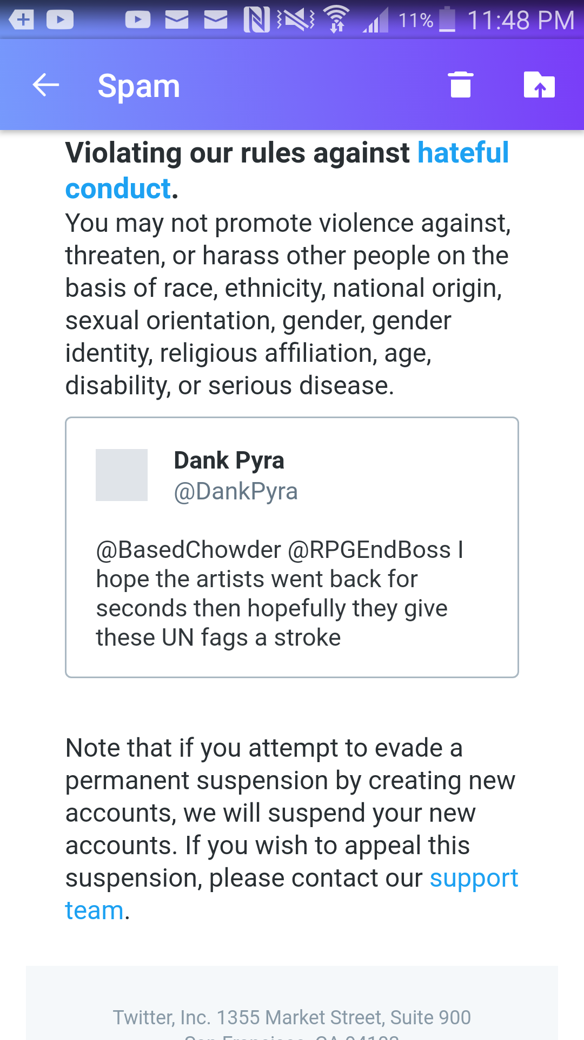

Bunny 12-Apr-19 01:31 AM

F

Just glad it didn’t Nuke my main

ArthurDank 12-Apr-19 01:36 AM

indeed im glad it didn't either

yep big F

ArthurDank 12-Apr-19 02:24 AM

Got lucky got another number @CaimTheSlayer is my handle

yeeted for 12 hours be back, let some of our mutuals know if you would thanks lory :) (edited)

Bunny 15-Apr-19 09:24 AM

Are you on?

I got ganked can you do me a favor and appeal it?
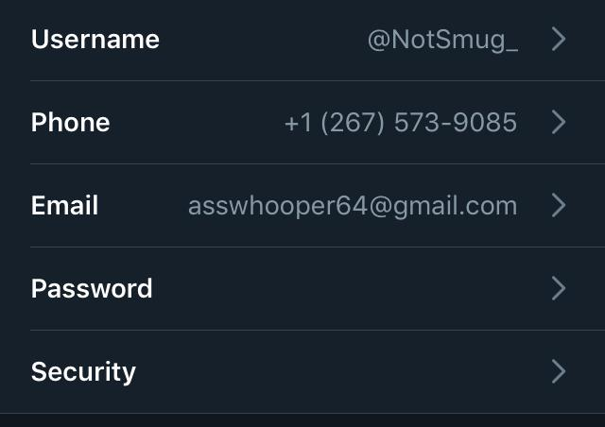

I know it won’t work but it’s worth a try

Started a call.

Bunny 15-Apr-19 09:46 AM

OY

You owe me a favor remember

Hand over your alt

ArthurDank 15-Apr-19 11:17 AM

im on sorry

i feel asleep

fell*

Bunny 15-Apr-19 11:19 AM

Mind sorting out the appeal for me?

I had to dig up my rp account from 2015

ArthurDank 15-Apr-19 11:20 AM

sure how can i sort the rp?

appeal*

Bunny 15-Apr-19 11:20 AM

Just log into the email and then click on the appeal button through the browser.

I seriously don’t know what I did

ArthurDank 15-Apr-19 11:21 AM

i dont either you had been super careful

Bunny 15-Apr-19 11:21 AM

Doesn’t matter though because my old account has 1,000 followers

ArthurDank 15-Apr-19 11:21 AM

true true you did make it

Bunny 15-Apr-19 11:21 AM

I just didn’t wanna resort to using it

ArthurDank 15-Apr-19 11:21 AM

whats the password for that email

Bunny 15-Apr-19 11:21 AM

I wanted to earn them myself y’know?

ArthurDank 15-Apr-19 11:21 AM

of course

Bunny 15-Apr-19 11:22 AM

I dunno you’re the one who made it right?

ArthurDank 15-Apr-19 11:22 AM

asswhooper? lmao i didn't make that maybe you changed it though

anyway let me sort this appeal process out

whats the number associated with the email

i dont know the password

Bunny 15-Apr-19 11:28 AM

Scroll up it’s in the screenshot dummy

I don’t remember who made this one

ArthurDank 15-Apr-19 11:28 AM

oops

thank you

but that doesn't match im trying to reset the password and the last two numbers are 79

Bunny 15-Apr-19 11:33 AM

That’s fucking weird

ArthurDank 15-Apr-19 11:33 AM

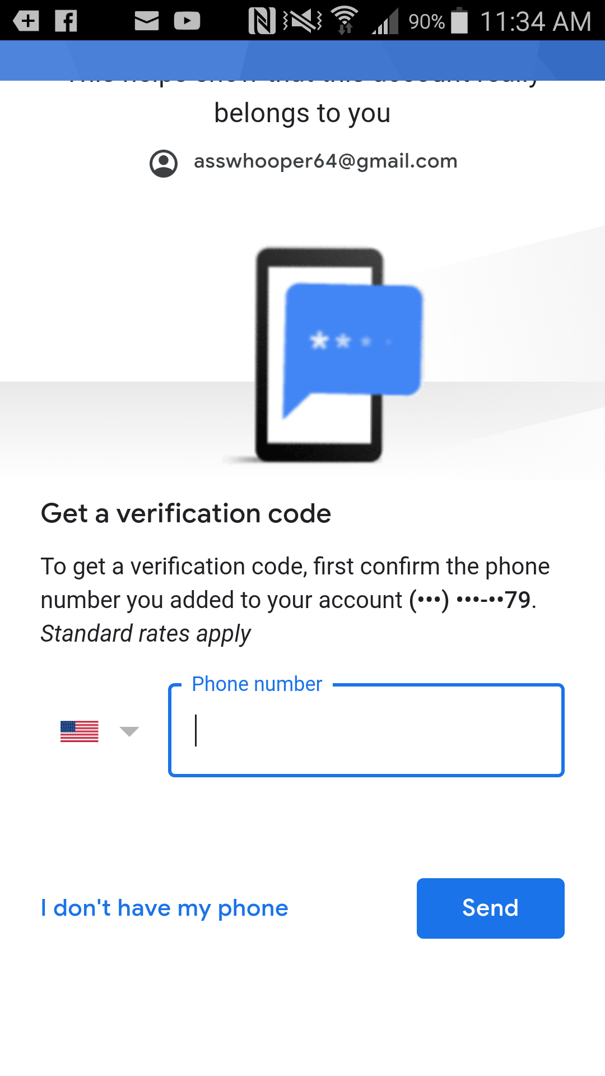

very much

Bunny 15-Apr-19 11:36 AM

Odd

Oh wait is it MY phone number?

ArthurDank 15-Apr-19 11:36 AM

i dont know is it? lol

Bunny 15-Apr-19 11:36 AM

Nope it’s not

ArthurDank 15-Apr-19 11:36 AM

shit

Bunny 15-Apr-19 11:36 AM

Unless it defaulted to my old number

ArthurDank 15-Apr-19 11:37 AM

interesting

what number would that be assuming it ends with 79?

Bunny 15-Apr-19 11:39 AM

My old number before I got the one I have now

ArthurDank 15-Apr-19 11:40 AM

ah shoot do you happen to remember it cause i dont know the emails password

Bunny 15-Apr-19 11:41 AM

Gimme a minute

ArthurDank 15-Apr-19 11:45 AM

cool

what was the favor i owed you btw?

ArthurDank 15-Apr-19 12:07 PM

welcome back

ArthurDank 15-Apr-19 12:20 PM

byt what was the favor? sorry i forgotten

Bunny 15-Apr-19 12:25 PM

It was supposed to be another alt

Dumb dumb

ArthurDank 15-Apr-19 01:22 PM

oh sorry lol

haven't heard from ya in a while i forget lmao

Bunny 15-Apr-19 05:30 PM

Hey you on?

ArthurDank 15-Apr-19 05:33 PM

im on but at work whats up?

i have time whats cooking?

Bunny 15-Apr-19 05:38 PM

If Parker asks the alt is yours. Just saying. You can still make me a spare though

ArthurDank 15-Apr-19 05:38 PM

i will work on thee spare and i get you i gather he didn't know about that?

Bunny 15-Apr-19 05:39 PM

Yuuuuup but it’s alright

ArthurDank 15-Apr-19 05:39 PM

you had a thousand followers on that well done byt then again you are very talented hehe

its fine your secret is safe with me

Bunny 28-May-19 11:00 PM

You alive~?

ArthurDank 28-May-19 11:05 PM

sure am how ya doing partner?

Bunny 29-May-19 03:30 AM

I’m gooood

ArthurDank 29-May-19 07:56 AM

thats good sorry i fell asleep you kinda vanished lol

dont know if you needed something but hope you are okay :)

ArthurDank 29-May-19 08:16 AM

im sick with bronchitis and pharyngitis so took the meds and crashed lol

ArthurDank 05-Jun-19 07:37 PM

im sorry too lori i guess i thoughy i was being included in that

Bunny 05-Jun-19 07:38 PM

Jeez

ArthurDank 05-Jun-19 07:38 PM

i got auts msg

yeah i know sorry i dont mind you trashing the PCMR I hate em too just thought iwas being included in that

i was like what the fuck did i do?

lol

Bunny 05-Jun-19 07:41 PM

It was super annoying

ArthurDank 05-Jun-19 07:41 PM

what was?

i kmow you are hammered but what was annoying?

Bunny 05-Jun-19 07:42 PM

Basically everything I had to deal with

I don’t give a crap about computers

Despite knowing a lot about them

My job is to review games

Not hardware

Waiting on my paycheck from Ian

ArthurDank 05-Jun-19 07:44 PM

awesome sounds good lori

Bunny 05-Jun-19 07:44 PM

Until then I’m doing research for my editor

ArthurDank 05-Jun-19 07:44 PM

ah badass sounds like things are improving for you

im glad

it was annoying what happened sorry i thought i was being grouped into that

Bunny 05-Jun-19 07:46 PM

My next game review will either be Sekiro or Ace Combat

ArthurDank 05-Jun-19 07:46 PM

good choices

Bunny 05-Jun-19 07:47 PM

Or Borderlands

ArthurDank 05-Jun-19 07:47 PM

i played some of sekiro that was nice and ace combat i want to play

Bunny 05-Jun-19 07:47 PM

I hate to give Randy Bitchford publicity but y’know

My head hurts

ArthurDank 05-Jun-19 07:49 PM

i dont blame you lol but its honest work

ehh the booze probably

Bunny 05-Jun-19 07:49 PM

Angry orchard helps though

ArthurDank 05-Jun-19 07:49 PM

oh good

Bunny 05-Jun-19 07:49 PM

Probably two more and I’ll be good

ArthurDank 05-Jun-19 07:50 PM

oh good i hope so lol

Bunny 05-Jun-19 07:51 PM

Uhhh

345$ in my bank

Nice

I still need more though

I need the payment from Ian

250$

So

595$

ArthurDank 05-Jun-19 07:55 PM

thats pretty good tho keep it going

thats pretty good tho keep it going

how much do you need?

Bunny 05-Jun-19 07:55 PM

Uhhh

Like 50$ more

I was gonna review Neptunia Goddesses Online

But ehhh

Maybe not

ArthurDank 05-Jun-19 07:56 PM

lol i get you make sure its something you want

but that's cool tho im glad you are getting good shit

Bunny 05-Jun-19 07:56 PM

I already have Sonic Mania too

Been wanting that since last year

Thank fuck for ps+ free games

ArthurDank 05-Jun-19 07:59 PM

awesome is it good? and frankly thats the only reason i ever paid for ps plus

Bunny 05-Jun-19 07:59 PM

Yes

It’s good

Going on my review list too

ArthurDank 05-Jun-19 08:06 PM

badass glad to hear it lori

glad things are getting better for you

ArthurDank 05-Jun-19 08:15 PM

anyway gotta get back to work you take care buddy sorry about today glad we got it sorted

Bunny 06-Jun-19 07:43 AM

Thank you for resending the friend request

ArthurDank 06-Jun-19 12:06 PM

thank you for accepting me back :)

ArthurDank 20-Jun-19 12:22 AM

hello hows it going?

Bunny 20-Jun-19 12:27 AM

Gud

Dummy

Give headpats

ArthurDank 20-Jun-19 12:29 AM

lol okay headpats you rubbing your hair

that better? :) (edited)

glad you are doing okay :)

Bunny 20-Jun-19 12:58 AM

Yee

Am a cutie

ArthurDank 20-Jun-19 12:59 AM

yes you are :)

Bunny 20-Jun-19 08:49 AM

Henlo fren

ArthurDank 20-Jun-19 11:28 AM

henlo good morning :)

Bunny 20-Jun-19 11:30 AM

It’s official I got the job~

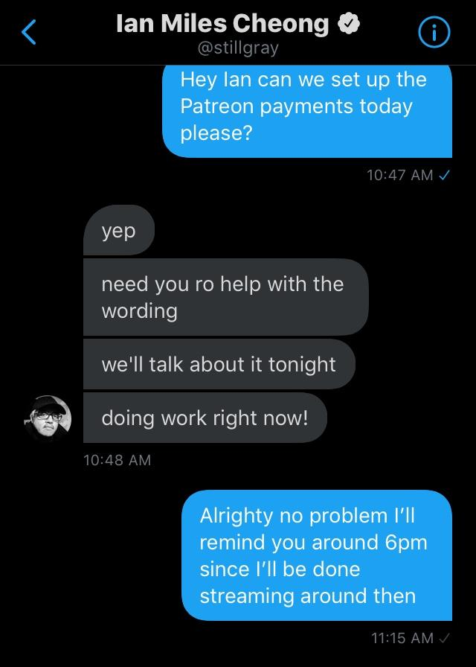

ArthurDank 20-Jun-19 11:30 AM

fantastic!!

well done

Bunny 30-Jun-19 04:14 AM

Henlo

ArthurDank 30-Jun-19 11:14 AM

henlo lory sorry i was already dead last night how are you?

Bunny 07-Aug-19 07:18 AM

Henloooo

ArthurDank 07-Aug-19 11:18 AM

henlooooo how are you Lori? :)

Bunny 07-Aug-19 11:18 AM

Am gud

ArthurDank 07-Aug-19 11:19 AM

very glad to hear it, been very busy lately it seems :)

ArthurDank 16-Aug-19 11:36 AM

have fun at disney there busty lol stay safe

Bunny 26-Sep-19 11:49 PM

Henlo

ArthurDank 26-Sep-19 11:51 PM

Henlo Lory how have you been?

Bunny 26-Sep-19 11:51 PM

Gud yeh

ArthurDank 26-Sep-19 11:51 PM

very nice im glad

missed ya hope life has been well

Bunny 26-Sep-19 11:56 PM

I’m smol

ArthurDank 26-Sep-19 11:56 PM

yes you are and i remember that photo it was cute

like you

you also got a great butt lol

Bunny 27-Sep-19 12:01 AM

Hehehehe
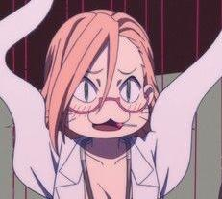

ArthurDank 27-Sep-19 12:11 AM

you are hot super hot lory

so how is everything going this evening

Bunny 27-Sep-19 12:24 AM

I’m playin Kingdom Hearts

ArthurDank 27-Sep-19 12:29 AM

awesome hope you are having fun

ArthurDank 27-Sep-19 12:41 AM

kick the heartless ass lory thanks for checking in

hope we can play again sometime been too long honestly

Bunny 28-Sep-19 03:58 AM

Henloooo

ArthurDank 28-Sep-19 04:03 AM

hey how's it going?

Bunny 28-Sep-19 04:04 AM

Goood

I’m saying Henlo~

Gimme attention lol

ArthurDank 28-Sep-19 04:05 AM

henlo headpats

rubs your head hugs you

how much attention you want?

Bunny 28-Sep-19 04:08 AM

A lot yee

ArthurDank 28-Sep-19 04:08 AM

i will give you as much as you want hugs you tight

can i do more or just hug?

Bunny 28-Sep-19 04:11 AM

More~?

ArthurDank 28-Sep-19 04:11 AM

nothing lol dont mind me haha how have you been?

when you said attention i didn't know if you meant dirty or clean

why i asked lol

Bunny 28-Sep-19 04:15 AM

Oh really~?
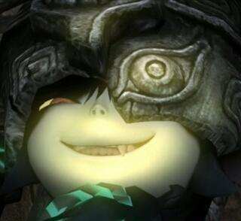

ArthurDank 28-Sep-19 04:15 AM

yep

Bunny 28-Sep-19 04:15 AM

Missed me that much?

ArthurDank 28-Sep-19 04:16 AM

ehehe sure you wanna find out?

how much i missed you that is? ;)

i still look at your body pics all the time especially the butt

Bunny 28-Sep-19 04:19 AM

You do huh~

ArthurDank 28-Sep-19 04:19 AM

mmmhmm

Bunny 28-Sep-19 04:20 AM

And yeah I wanna find out~ Takes a seat right in your lap, wearing denim short shorts and a black half shirt

ArthurDank 28-Sep-19 04:22 AM

i pull you close and kiss you hard while tracing your ass with my hands giving your cheeks a tight grip

then i pull your black shirt up and pop one of your tits in my mouth and start to suck

I missed these like I missed you Lory

Bunny 28-Sep-19 04:26 AM

You missed me that much huh~? You gonna let me suck you off~?


ArthurDank 28-Sep-19 04:26 AM

mmm yummy and yes I will show me what you got

Bunny 28-Sep-19 04:28 AM

I knelt down and began to unzip your jeans I’ll never get tired of sucking cock~

ArthurDank 28-Sep-19 04:29 AM

thats my girl I love when you suck me off I rub your head as you unzip my jeans ready to take me in your mouth

Bunny 28-Sep-19 04:31 AM

I ran my tongue along the underside of your shaft, licking from the tip down to the base, I took your ballsack into my mouth and started sucking

ArthurDank 28-Sep-19 04:33 AM

I moan as you lick my shaft and start sucking on my ballsack your mouth and tounge feel so warm and nice mmm thirsty girl feels so fucking good don't stop

Bunny 28-Sep-19 04:35 AM

I took your ballsack out of my mouth and then drooled all over your cock “You gonna try and knock me up this time~?” I said as I lifted my shirt just enough to put your 10 incher between my massive breasts

ArthurDank 28-Sep-19 04:37 AM

my cock gets bigger as you drool on my massive dick and start to tit fuck me "you already know thats gonna happen Lory, you know im gonna get you pregnant"

Bunny 28-Sep-19 04:38 AM

//You remember how big my tits are right~?

ArthurDank 28-Sep-19 04:39 AM

// I think you said E //

// may have been G tho//

// they were huge thats for sure

// you may have to send a pic sometime and lodge my memory tho ;) //

Bunny 28-Sep-19 04:46 AM

//This big lol
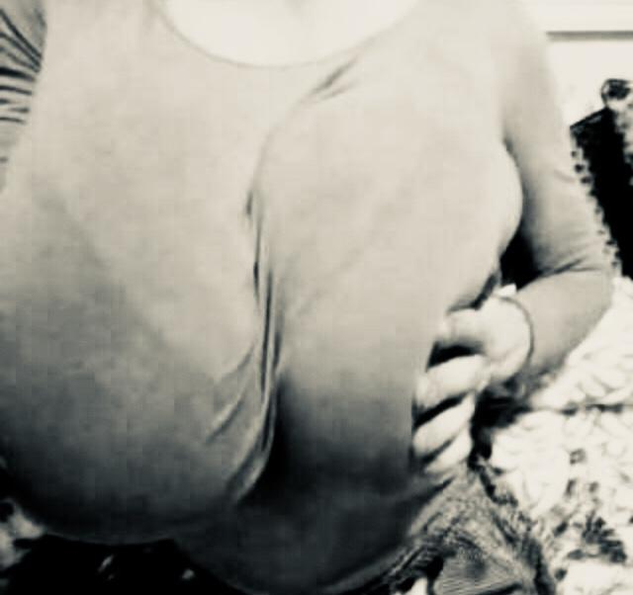

ArthurDank 28-Sep-19 04:47 AM

// that brings some memories

hehe maybe you should sit on my face while you work your jugs on my dick baby

Bunny 28-Sep-19 04:50 AM

//Also yeh I’m a G cup

//Lotta people saying my body type is impossible nowadays lmao

//Anyways~

ArthurDank 28-Sep-19 04:51 AM

//massive love the idea of that and of course they do it is rare but you are blessed//

Bunny 28-Sep-19 04:52 AM

I pressed my enormous breasts together and completely covered your shaft with them You’re not even big enough to poke out between my cleavage~

ArthurDank 28-Sep-19 04:54 AM

"you're breasts are so great and the more you rub the bigger it will get" I start thrusting my cock up and down between them and my head starts popping out from your huge tits (edited)

Bunny 28-Sep-19 04:56 AM

I drool all over the tip of your cock and started giving it kisses C’mon~ Cum all over my face~ Get it in my hair~! I stroked your entire length with my gigantic tits as I sucked on the tip of your dick

ArthurDank 28-Sep-19 04:57 AM

//that tounge pic was hot thought i noticed jizz on your tounge ;)//

Bunny 28-Sep-19 04:58 AM

//Oop I thought you wouldn’t notice

ArthurDank 28-Sep-19 04:58 AM

"oh fuck you're amazing lory ahhh cumming" my cock erupts while you suck i shotgun blast my cum all over your mouth, face and hair

Bunny 28-Sep-19 04:58 AM

//That was right after giving head too lmao

ArthurDank 28-Sep-19 04:59 AM

//nice that was hot thought you had provoked a fresh load just then sexy i think, wish i saw that or been on the receiving end, either one//

Bunny 28-Sep-19 05:00 AM

I took the tip of your cock into my mouth and swallowed down most of your load

//I just like sucking cock lol

//Its fun because cock tastes good lmao

//Don’t call me gross but unwashed tastes better

ArthurDank 28-Sep-19 05:02 AM

I felt you swallow lots of my cum sucking greedily you looked so hot taking it like a champ despite still having jizz all over you

// hey you like how it tastes and we like how it feels and nothing wrong with that we like when you suck it clean//

//best girls always suck and swallow no matter what//

Bunny 28-Sep-19 05:04 AM

I licked around the tip of your cock, trying to get you to cum again C’mon~ I know you have more in those fat balls~

//I don’t really care who’s cock it is either lmao

ArthurDank 28-Sep-19 05:05 AM

//naughty not gonna lie wish it was mine someday//

i felt another orgasm cumming as you lick wanting more jizz oh shit lory im gonna ahhhhh i cum again while you are licking my fat cock

//bet your mouth feels really good//

"lory maybe you want the next load in your pussy, maybe you want a baby? i got plenty more for you"

Bunny 28-Sep-19 05:14 AM

I swallowed down your second load as I pulled down my denim short shorts I wanna stick it in on my own~ I rubbed my ass against your throbbing shaft

//I’ve been told it’s how I look up at dudes while giving head that makes them bust while also being told that my tongue technique is amazing

ArthurDank 28-Sep-19 05:17 AM

"mmm that ass feels so tight stick it in go to town so i can knock you up" watched you take your shorts off and your wet pussy being visible causes my cock to spring back to life as you grind yourself on me

//sounds right having such a hot girl with such beautiful eyes look up at us like saying "please cum in my mouth" while working our shaft like a pro is the best// (edited)

Bunny 28-Sep-19 05:21 AM

I slid your now foot long cock into my cunt, bulging out my stomach You got bigger again didn’t ya~? I can take all of it don’t worry~ I took your entire length into my pussy, the tip of your cock pushed itself into my womb, bulging out my stomach even further, the bulge was in the shape of your throbbing cock

//I love it when they cum in my mouth or all over my face~
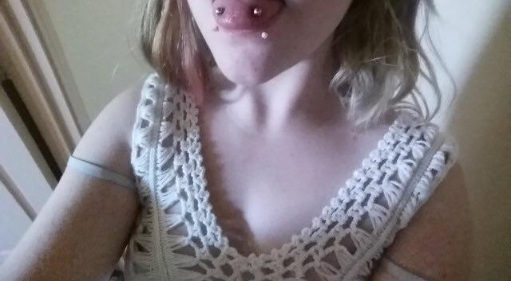

ArthurDank 28-Sep-19 05:23 AM

"yes i did baby and i know you can not the first time you have ahhhh that feels good being in you again" my cock gets larger i go in as deep as I can go as you bounce up and down on my huge shaft i pull you close sucking hard on your sensitive tits while you fuck yourself on my cock (edited)

//mmm you look so cute in those clothes like the cleavage too those bites on your lips only make the idea of you sucking me off even hotter like how you enjoy it//

Bunny 28-Sep-19 05:28 AM

It feels like you’ll break me with a cock this big~ I squeezed down on your shaft with my cunt, the excitement made your dick even bigger, expanding your thickness to 8 inches and your length to 2 feet long, your fat cock bulged out my stomach to an absurd degree F-FUCK! CAN YOU GET ANY BIGGER~? /I was wearing short shorts with that top too, it’s a crop top btw

/Halter top*

ArthurDank 28-Sep-19 05:29 AM

/nice bet those looked hot on you with that halter top a pleasing sight when we are balls deep in your mouth/

I am gonna try hehe and well lets see i thrust in you as you bounce down and my cock expands a bit more with each thrust my cock bulges out more as you fuck me like a woman possessed

Bunny 28-Sep-19 05:33 AM

//You’re bulging me out like this btw
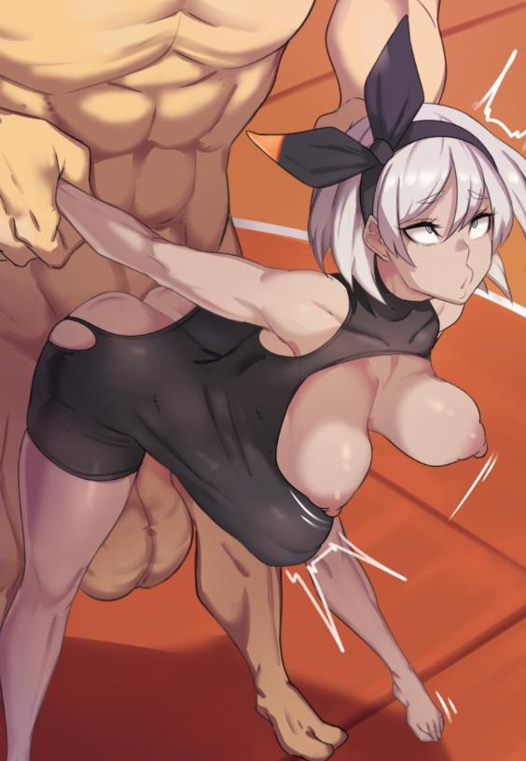

ArthurDank 28-Sep-19 05:34 AM

/thats how i imagined it hot/

I pull your arms back as my cock bulges out of you, fucking you hard pounding in and out of your wet pussy while you are leaned forward standing up just taking it and moaning as loud as you can

"miss me yet lory, miss how much you enjoy being my cumdump?"

Bunny 28-Sep-19 05:45 AM

“I just wanna take more cum~ Fill me up and make me pregnant~!” //Rp storyline where you actually do knock me up so I’ve gotta suck cock and have sex with your friends for cash~?

ArthurDank 28-Sep-19 05:47 AM

"as you wish enjoy lory ahhh fuck im cumming, enjoy being a mommy" i pound and fuck your insides till i cum all up inside you filling you all up, it cums spilling out

/sounds promising so yeah we shall work on it, next time tho im about to pass out, had fun tho/

/i hope you have sweet dreams lory/

/hope you liked it too/

Bunny 28-Sep-19 06:02 AM

//Hehehehe

Bunny 01-Oct-19 03:53 AM

//Henloooooooo

ArthurDank 13-Oct-19 03:18 PM

henloooo hope you are doing okay

ArthurDank 18-Oct-19 05:06 AM

henlo just wanted you to know i was back to normal so we are good whenever you wanna chat again (edited)

Bunny 18-Oct-19 06:20 AM

Henlooooo

ArthurDank 20-Oct-19 01:08 AM

henlooooo sorry it was almost morning last night how are you?

Bunny 20-Oct-19 01:34 AM

I’m good fren

ArthurDank 20-Oct-19 01:34 AM

glad to hear it

Bunny 20-Oct-19 01:35 AM

Yee was playing kingdom hearts

ArthurDank 20-Oct-19 01:35 AM

ahh very nice

Bunny 20-Oct-19 01:35 AM

Doing the true final boss

Unknown Hooded Man

ArthurDank 20-Oct-19 01:36 AM

oh shit good luck then

Bunny 20-Oct-19 01:36 AM

I already know who it is though so fighting him in this game is kinda funny

It’s canonical that I’m supposed to beat him too so

ArthurDank 20-Oct-19 01:36 AM

interesting i haven't played the remix versions yet sadly

ah even better

Bunny 20-Oct-19 01:37 AM

Not much changes so y’know

ArthurDank 20-Oct-19 01:38 AM

ah okay I was curious about that i mean glad they came stateside obviously but yeah

Bunny 20-Oct-19 01:38 AM

Enemies are different colors

ArthurDank 20-Oct-19 01:38 AM

oh wow

Bunny 20-Oct-19 01:38 AM

The glitches are gone (mostly)

New secret bosses

ArthurDank 20-Oct-19 01:39 AM

awesome

Bunny 20-Oct-19 01:39 AM

Also the ultima weapon recipe is different

ArthurDank 20-Oct-19 01:39 AM

oh damn

thats cool

ArthurDank 16-Nov-19 11:28 AM

henlo lory how are you missed you

ArthurDank 20-Nov-19 07:33 PM

hows it going?

Bunny 20-Nov-19 07:36 PM

Henlo

ArthurDank 20-Nov-19 07:38 PM

henlo lori how ya doin?

Bunny 20-Nov-19 07:42 PM

I’m good~

ArthurDank 20-Nov-19 07:42 PM

awesome

been a while saw your msg on psn the other night

Bunny 20-Nov-19 07:48 PM

Yee was playing vidya gaems

ArthurDank 20-Nov-19 07:48 PM

cool so was i that night good times

lori can i tell you something?

Bunny 20-Nov-19 07:54 PM

Yeh

ArthurDank 20-Nov-19 08:00 PM

saw you being harassed on twatter and I was sorry to see that i just wanted to be clear that i know that just cause you text me about your sexcapades and we do dirty RP sometimes that we are still just friends

I just didn't want you to think i was like that dweeb

Bunny 20-Nov-19 08:18 PM

Aww shucks

Thanks for being around for me lol

ArthurDank 20-Nov-19 08:35 PM

of course we are friends after all and im not under a delusion we are anything more then that. that being said i hope we can talk dirty again soon not right now im at work and sure you're busy too but yeah (edited)

Bunny 20-Nov-19 08:38 PM

I'm not too busy at the moment lol

ArthurDank 20-Nov-19 08:39 PM

damn were i not at work i would take you up on that right now ;)

Bunny 20-Nov-19 08:40 PM

Lemme know what time you get off then

ArthurDank 20-Nov-19 08:40 PM

i will if you are busy at that point no hard feelings tho we can always do each other later lol (edited)

You keep playing with me like that so i must be pretty good at it

Bunny 20-Nov-19 08:43 PM

It's fun lol

ArthurDank 20-Nov-19 08:45 PM

it is fun especially with you

Bunny 20-Nov-19 08:48 PM

Lmao

ArthurDank 20-Nov-19 08:59 PM

you act like just the kind of girl i wanna do in those rps lol

and dont worry i wont stop you sucking me off not like I actually would anyway hehe

Bunny 20-Nov-19 09:03 PM

Lmao good

ArthurDank 20-Nov-19 09:21 PM

tho iwant you to sit on my face at some point ;) (edited)

Bunny 20-Nov-19 09:48 PM

Hehehehehehe

You remembered this?
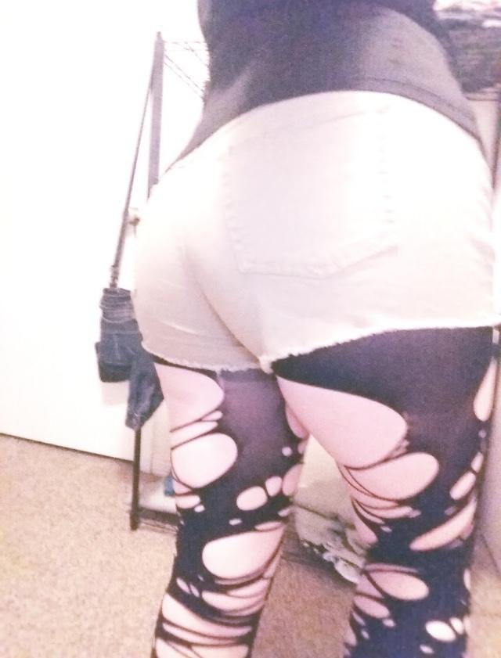

ArthurDank 20-Nov-19 09:51 PM

no i never saw that before fucking hot tho ;)

great ass and thighs could fuck that all night

Bunny 20-Nov-19 09:55 PM

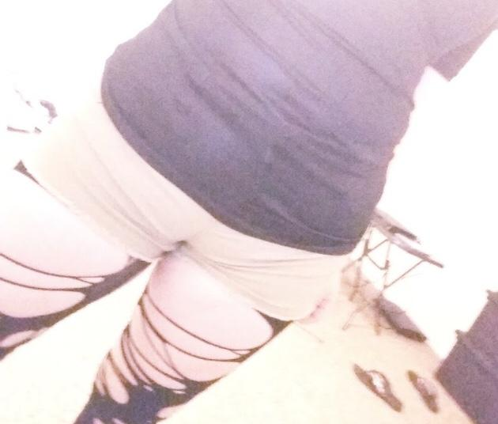

Good huh~?

ArthurDank 20-Nov-19 10:00 PM

good? delicious you mean fucking gets me hard thinking about where to lick and fuck

thick in all the right spots

Bunny 20-Nov-19 10:02 PM

You wanna rub your cock all over my thighs huh~?

ArthurDank 20-Nov-19 10:16 PM

i do i want to rub my cock against your thighs as you rub them on my cock with one hand of mine down your shorts fingering your pussy and the other hand up your shirt pinching your tits (edited)

Bunny 20-Nov-19 10:17 PM

Hehehehe
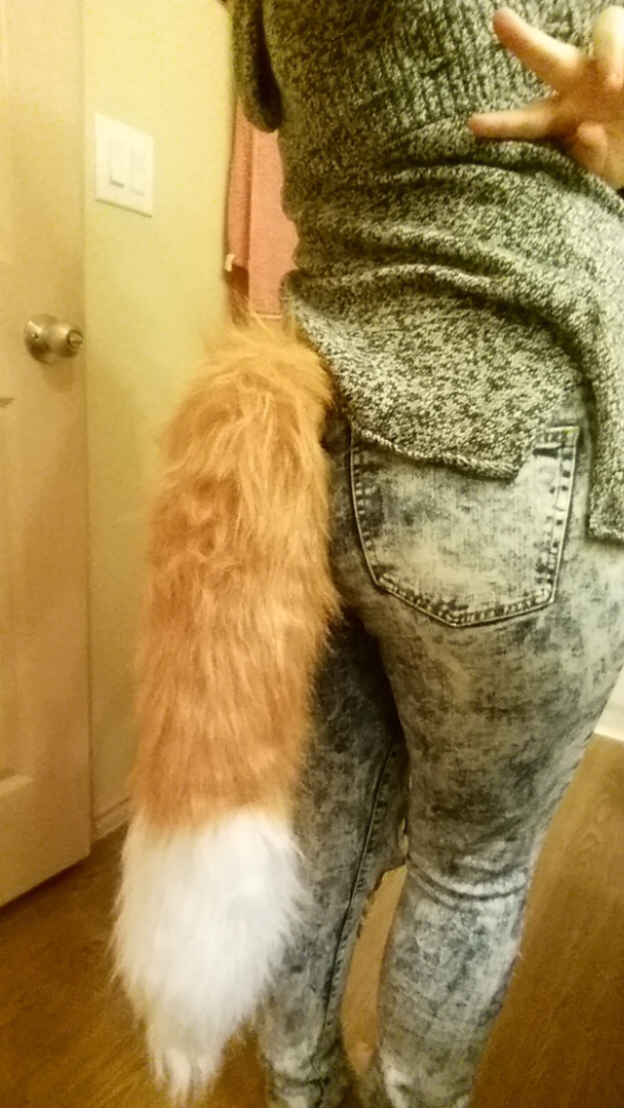

ArthurDank 20-Nov-19 10:18 PM

good memorie right there i love shots of you of any kind but especially tits and ass

i wanted to rip those jeans off so bad and plow your ass with my cock i love when you send me new pics hehe really gets the cock at full mast (edited)

Bunny 20-Nov-19 10:25 PM

I'm a lot more squishy downstairs y'know~

ArthurDank 20-Nov-19 10:25 PM

i know i want that pussy too hehe feel how squishy and snug you are

Bunny 20-Nov-19 10:27 PM

I got a new dildo actually

ArthurDank 20-Nov-19 10:27 PM

oh sweet how big

Bunny 20-Nov-19 10:28 PM

11 incher lol

It's good lol

ArthurDank 20-Nov-19 10:52 PM

very nice lory wish I was that dildo balls deep in you hehe

Bunny 20-Nov-19 10:54 PM

A big cute


ArthurDank 20-Nov-19 10:59 PM

i forget how gorgeous you are wow beautiful and sexy

i see what people mean about your eyes

I feel entranced by them how a mean can have sex or be sucked off by you and not blow instantly while making contact with your eyes amazes me

Bunny 20-Nov-19 11:04 PM

I just like cock lol

ArthurDank 20-Nov-19 11:06 PM

im glad you like my cock i like pussy

Bunny 20-Nov-19 11:07 PM

I’m a cute
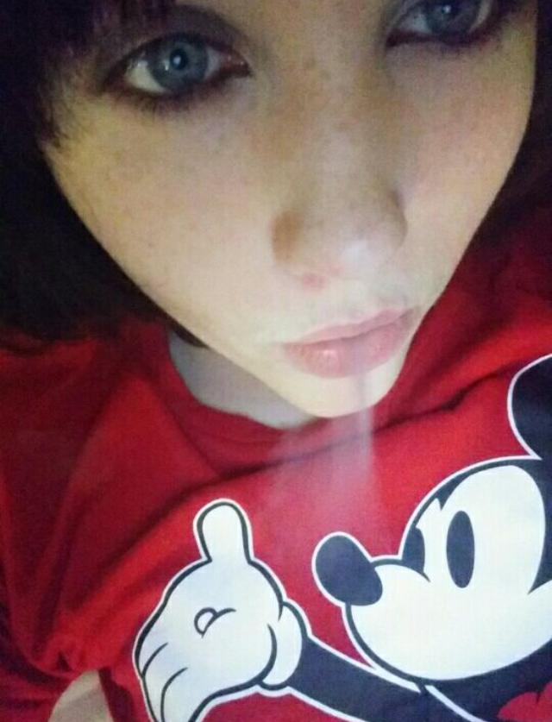

ArthurDank 20-Nov-19 11:09 PM

wow so adorable

you smoking weed? lol

Bunny 20-Nov-19 11:10 PM

Yee hehehehehe

ArthurDank 20-Nov-19 11:16 PM

hehehe nice like some weed and durty talk like mickey shirt

like it more when you're out of it hehe

Bunny 20-Nov-19 11:26 PM

Yeah I feel better now

Playing video games like this is fun~

ArthurDank 20-Nov-19 11:27 PM

awesome hehe i know many friends who play ehen they are high its fun they tell me

Bunny 20-Nov-19 11:38 PM

You like this one?
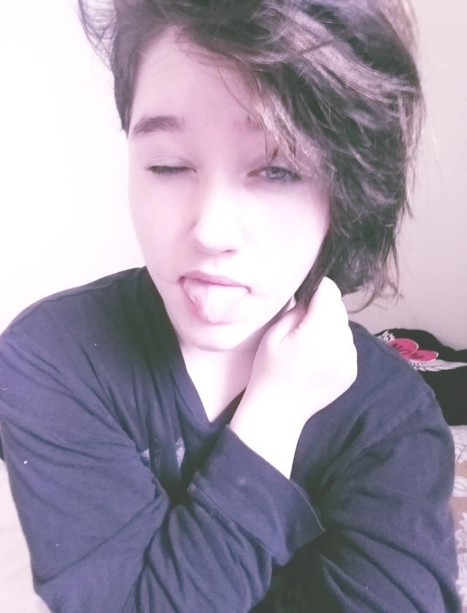

ArthurDank 20-Nov-19 11:39 PM

sure do lory hehe so cute and cuddly

and your tounge looked hungry

Bunny 20-Nov-19 11:41 PM

I like headpats~

ArthurDank 20-Nov-19 11:45 PM

i can tell truth be told i would fap to you sucking me off so rough and hungry while your bobbed back and forth on my cock i was patting your head as you bobbed and when i blew in your mouth i came down and kissed you before burying my head between your legs eating your pussy

Bunny 20-Nov-19 11:51 PM

How big are you again~?

ArthurDank 20-Nov-19 11:51 PM

7-8

its somewhere aroubd there nothing mind blowing but im told thats acceptable lol

Bunny 20-Nov-19 11:55 PM

A big cute


ArthurDank 21-Nov-19 12:01 AM

wow so hot

hehe im ready had to get some shit done sorry for the wait i want you bad (edited)

i like long hair more to grip when fucking you doggy style

but short is big cute too

Bunny 21-Nov-19 12:23 AM



ArthurDank 21-Nov-19 12:24 AM

i love that one hehe that always gets me hard i think about how i wish it was my load you swallowed (edited)

i want that greedy mouth on my cock again baby

cant help but wonder how many other kinky pics you have hehe

Bunny 21-Nov-19 12:39 AM

I've been told my tooth gap is cute

ArthurDank 21-Nov-19 12:40 AM

it is cute most people think thats unattractive but with you it is cute just like you

Bunny 21-Nov-19 12:42 AM

You really like me huh~?

ArthurDank 21-Nov-19 12:42 AM

what gave it away? lol

hehe

Bunny 21-Nov-19 12:44 AM

The fact that you wanna cum on my face lol

ArthurDank 21-Nov-19 12:44 AM

hehe i do and inside you ,ass throat and pussy (edited)

Bunny 21-Nov-19 12:44 AM

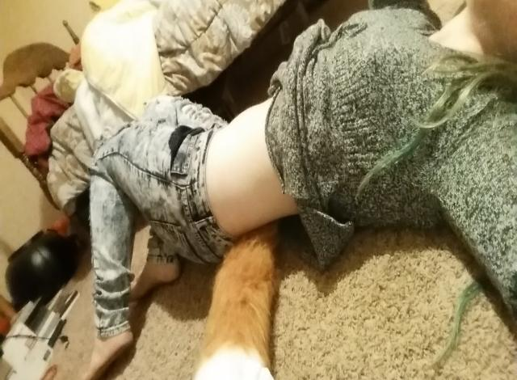

ArthurDank 21-Nov-19 12:45 AM

love your midriff and your clothes i pull those jeans down a bit and ;)

and as for your face you did say you love sucking cock no matter whose it is ;)

i wanna make out with you on that floor while sliding my hand down your jeans

Bunny 21-Nov-19 12:50 AM

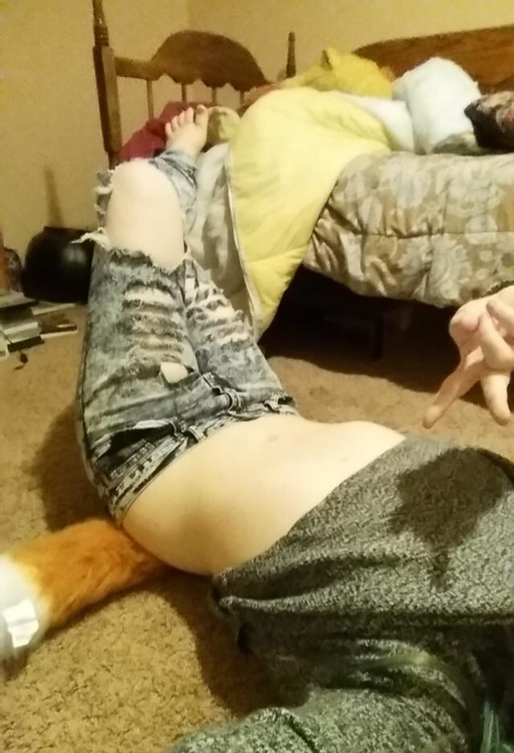

You wanna fuck me that badly~?

ArthurDank 21-Nov-19 12:51 AM

fuck yes I do

Bunny 21-Nov-19 12:53 AM

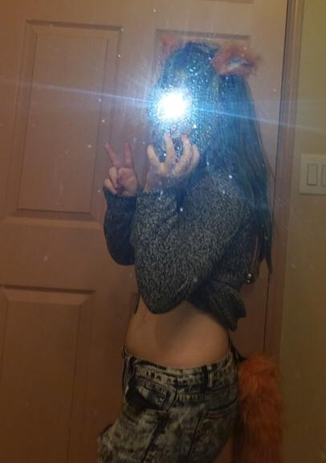

ArthurDank 21-Nov-19 12:54 AM

so so hot

like your ears

that shirt any higher on your back i would see your tits hehe

Bunny 21-Nov-19 12:55 AM

Skinny jeans are fun~

ArthurDank 21-Nov-19 12:55 AM

they sure are hot

especially on you

like how they show every inch of you

Bunny 21-Nov-19 12:58 AM

You into plump lips~?
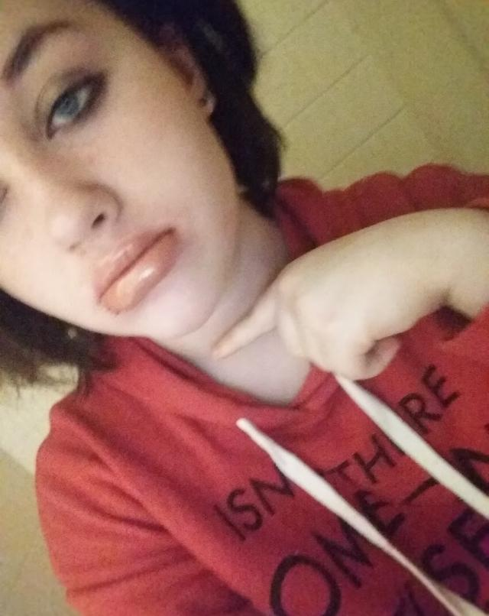

ArthurDank 21-Nov-19 12:59 AM

yea how did you do that? look nice with em lory nothing like plump lips on your dick

Bunny 21-Nov-19 12:59 AM

Oh I just pout to make em like that

ArthurDank 21-Nov-19 01:00 AM

wow cute hehe

Bunny 21-Nov-19 01:00 AM

As long as there's cum I don't care who's cock it is~

ArthurDank 21-Nov-19 01:00 AM

hehe i want you to suck me dry i will give you plenty of thick cum

Bunny 21-Nov-19 01:02 AM

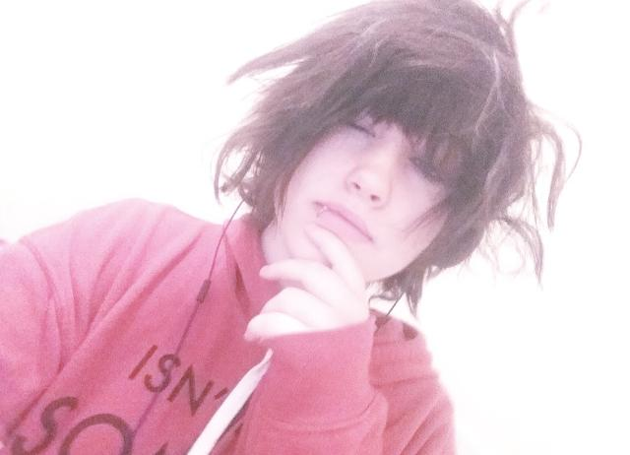

ArthurDank 21-Nov-19 01:02 AM

aww i love your messy hair

Bunny 21-Nov-19 01:02 AM

I'm a cute huh~?

ArthurDank 21-Nov-19 01:03 AM

yes you are gorgeous i get hard just looking at you

i want to taste those lips

Bunny 21-Nov-19 01:05 AM

You like glasses~?
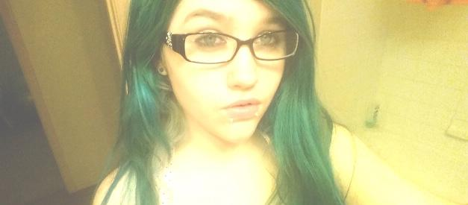

ArthurDank 21-Nov-19 01:06 AM

very much i do

you look so hot green hair and glasses

Bunny 21-Nov-19 01:08 AM

Tell me how much you like this outfit~

ArthurDank 21-Nov-19 01:09 AM

I love it love the ripped hose the tight jeans around your thick ass

the thick thighs its too much i fucking love it

Bunny 21-Nov-19 01:10 AM

Those short shorts used to be skinny jeans y'know

ArthurDank 21-Nov-19 01:11 AM

wow you ripped them into short shorts? i like snug they are i get a great look at your ass or the outline

Bunny 21-Nov-19 01:14 AM

I cut the legs off lol

I liked how snug they were so I decided why not?

ArthurDank 21-Nov-19 01:14 AM

they look sexy on you like that

Bunny 21-Nov-19 01:17 AM

Tore those leggings myself~

Y'know what's fun? Giving buttjobs~

ArthurDank 21-Nov-19 01:17 AM

you did a good job i love how high uo they were torn

yes i bet they are

love to know what your ass feels like between those two

Bunny 21-Nov-19 01:20 AM

I like giving Helmet buttjobs~

ArthurDank 21-Nov-19 01:20 AM

very nice hehe lucky dude

one sextape i wouldn't mind watching lol

so what are you doing lory?

Bunny 21-Nov-19 01:24 AM

Just sitting around playing contra in my tied back tank top and black leggings~

ArthurDank 21-Nov-19 01:24 AM

mmm thats a nice image to fap too

honestly i would love to see you play while my cock was buried in you hehe

Bunny 21-Nov-19 01:27 AM

I've played while sitting with Helmet's cock up my ass before~

ArthurDank 21-Nov-19 01:27 AM

yummy

anywho not trying distract you while you are playing

Bunny 21-Nov-19 01:28 AM

Nawwwww I can talk too

Wanna play for a bit~?

ArthurDank 21-Nov-19 01:28 AM

yep

Bunny 21-Nov-19 01:29 AM

You wanna fill me up like this~?
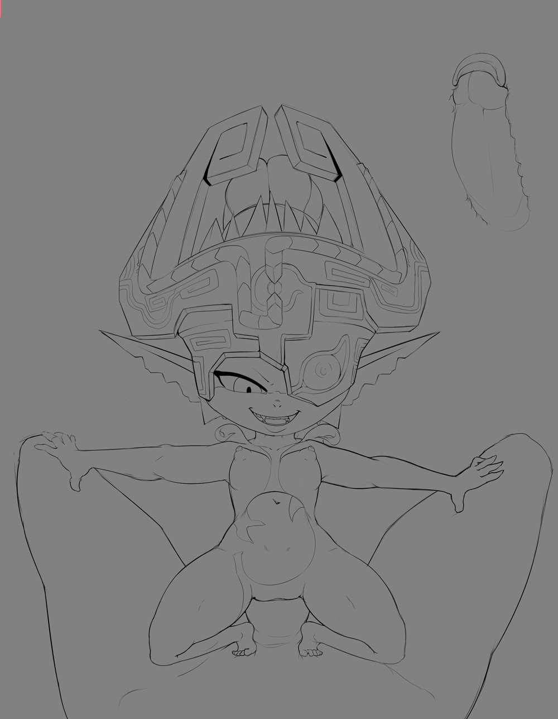

ArthurDank 21-Nov-19 01:30 AM

fuck yes i do pump you up so much it gushes out

Bunny 21-Nov-19 01:31 AM

You wanna get me pregnant huh~?

ArthurDank 21-Nov-19 01:32 AM

yes i do I won't use a condom i wanna fuck you so hard you drool and your eyes go back in your head and when i cum i knock you up, i wont pull out even if its a dangerous day. (edited)

Bunny 21-Nov-19 01:38 AM

What do ya think of my Halloween costume from a bit ago?
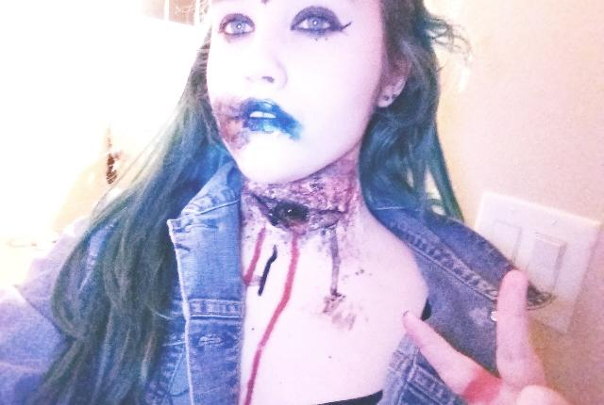

You into zombie chicks~?

ArthurDank 21-Nov-19 01:38 AM

shit lory thats good

sure do

i hear they bite can be hot not gonna lie

zombie chicks can be very hot they like to eat and since you like to eat cum im sure you would be the perfect zombie GF (edited)

Bunny 21-Nov-19 01:43 AM

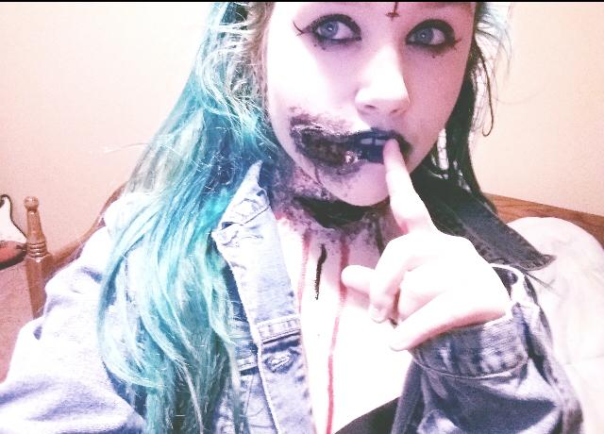


ArthurDank 21-Nov-19 01:44 AM

damn lory thats amazing

Bunny 21-Nov-19 01:44 AM

Wanna know the backstory to this one? It’s pretty dark lol

ArthurDank 21-Nov-19 01:44 AM

lol its fine share with me i wanna hear

Bunny 21-Nov-19 01:51 AM

Goth chick went to a halloween party at an abandoned church, got raped and her throat slit as a sacrifce by satanists

Lmao edgy as fuck

ArthurDank 21-Nov-19 01:52 AM

lmao edgy indeed also grim it fits honestly with the season

i like it

a lot actually

Bunny 21-Nov-19 01:56 AM

You'd still try to get a zombie pregnant? Lol

ArthurDank 21-Nov-19 01:56 AM

lol worth a try ;)

she looks pretty hot so yep i would still fuck you even as a zombie (edited)

Bunny 21-Nov-19 02:00 AM

Fuck it I’ll suck as many dicks as I want


ArthurDank 21-Nov-19 02:00 AM

atta girl whsts stopping ya get to it i say ;) I know i wanna get sucked (edited)

as long as im one of em i dont care either ;)

Bunny 21-Nov-19 02:04 AM

Put yours in my mouth~
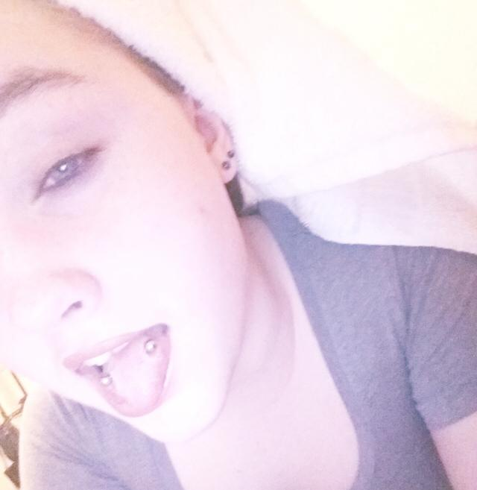

ArthurDank 21-Nov-19 02:06 AM

"you dont even have to ask, cute piercings" * I stuff my cock into your warm wet mouth*

Bunny 21-Nov-19 02:07 AM

I rolled my tongue over the tip of your cock as I bobbed my head up and down your 9 inch long shaft while looking right up at you

ArthurDank 21-Nov-19 02:09 AM

I patted your head as you sucked me good and hard, your eyes were hypnotic with my dick in your mouth, working me like a pro, my hips started thrusting involuntarily

Bunny 21-Nov-19 02:11 AM

I swallowed down your shaft as you thrust your cock into my mouth, I wrapped my lips around your shaft and bobbed my head up and down your shaft even faster as I licked the underside of your shaft

ArthurDank 21-Nov-19 02:13 AM

I thrusted harder as you bobbed on my cock faster, your tounge working the underside of my cock was driving me wild i could feel my load building as you sucked greedily on my cock

Bunny 21-Nov-19 02:14 AM

I stared right up at you as I wrapped my tongue around your shaft as I swallowed down your entire shaft into the back of my throat

ArthurDank 21-Nov-19 02:17 AM

I couldn't hold it after seeing that look, those eyes wanting my fat load, after feeling that warm skilled tounge wrap around my cock, and you shoved me down your throat far as I could, i grabbed the back of your head and thrusted hard as I could blowing my fat load of cum in your mouth before I could even warn you (edited)

Bunny 21-Nov-19 02:19 AM

You filled my throat with so much cum that it leaked out my nose as I gagged on your throbbing cock as you shot your thick cum into my mouth filling up my cheeks with your load

ArthurDank 21-Nov-19 02:22 AM

"you're so good I missed you" I patted your head seeing you take it like a champ, holding as much of my jizz in your mouth as you could and trying to swallow

Bunny 21-Nov-19 02:25 AM

I swallowed as much of your cum as I could as the rest dripped out of my mouth as I pulled your shaft out of my throat “F-fuck...you’re almost too rough with me~” I said as I stood up and showed off my plump round ass for you

“Let’s see how long you last while rubbing your cock on my ass~”

ArthurDank 21-Nov-19 02:30 AM

"only rough with you cause you handle it so well, just like your ass will" I spank your ass bringing my cock up to rub it against your ass, it feels so good "shake it baby feels so good" (edited)

Bunny 21-Nov-19 02:34 AM

I rolled my hips in circles as you pressed your cock against my short shorts covered ass “You won’t last long like this~” I pressed my ass against your shaft and rubbed my denim covered asscheeks up and down your twitching shaft

ArthurDank 21-Nov-19 02:37 AM

it felt so good you rubbing your denim covered ass against me i shoved my hands up your black shirt groping your tits as i thrusted between your ass cheeks getting more turned on watching you shake your hips the way you do it, so hot and dirty "oh baby feels so good just like your tits"

Bunny 21-Nov-19 02:39 AM

I grind my hips even harder as I noticed you leaking precum from the tip of your cock onto my denim short shorts covered asscheeks “Cum all over my ass~!” I bent over forwards and slammed my soft round ass against your shaft

ArthurDank 21-Nov-19 02:43 AM

"fuck I love you!" That last thrust against my dripping cock was all it took my cock exploded all over your denim covered ass i pinched your tits hard as i came all over you (edited)

Bunny 21-Nov-19 02:47 AM

I kept rubbing my ass against your shaft even as you were cumming “If you wanna stick it in me you’ve gotta cum more~!”

ArthurDank 21-Nov-19 02:50 AM

I kept thrusting my cock against you as I came "Trust me I will get in you bring those huge jugs of yours down here so i can drown them in cum"

Bunny 21-Nov-19 02:52 AM

I lifted up my shirt as I let my massive F cup tits fall out “You want em that badly~?”

ArthurDank 21-Nov-19 02:54 AM

"fuck yes I do Lory get over here" my cock shoots back up seeing your tits fall out

Bunny 21-Nov-19 02:56 AM

I knelt down and put your still cumming cock between my gigantic tits “You still have more loads left in those fat balls right~?”

ArthurDank 21-Nov-19 02:58 AM

"you are gonna find out lory" I start thrusting between your tits giving you a headpat as I do they feel so nice and soft (edited)

Bunny 21-Nov-19 03:04 AM

I squeezed my enormous tits against your throbbing shaft as I drooled on my breasts “To make it feel even better for ya~”

ArthurDank 21-Nov-19 03:06 AM

"god that feels nice lory" lubbing up your tits made it even better i started to thrust faster between them as you squeezed them so firmly against my 9 inch cock throbbing more and more

Bunny 21-Nov-19 03:10 AM

“C’mon~ cum already~!” I licked the tip of your cock as it poked out between my cleavage as I rubbed your shaft with my lubed up tits

ArthurDank 21-Nov-19 03:13 AM

"oh fuck lory!!" before i knew it my cock erupted on your face and tits, shot after shot coating you in my sperm, it felt so good

Bunny 21-Nov-19 03:16 AM

I took your thick load all over my face and tits, smirking as I kept stroking your shaft with my tits even as you were cumming “You really have a lot saved up in those fat balls dontcha~?”

ArthurDank 21-Nov-19 03:18 AM

I smirked back at you enjoying the post orgasm tit rub down "saved up i knew you would drain it all out of me lory i wanted to drench you"

Bunny 21-Nov-19 03:20 AM

I stood back up, and unbuttoned my short shorts, pulling them down just enough to expose my fat round ass “Pick a hole~ I don’t care which one~”

ArthurDank 21-Nov-19 03:24 AM

"mmm they both look good hehe pussy, you're getting knocked up tonight" before giving a warning I rammed my cock balls deep into your pussy, warm, wet, tight, I started thrusting while teasing your asshole with my thumb

Bunny 21-Nov-19 03:27 AM

I groaned as you thrust your entire 9 inch shaft into my tight cunt “You’re really gonna try to get me pregnant~?” I said as I instinctively rolled my hips in circles and bounced my ass up and down your shaft

ArthurDank 21-Nov-19 03:30 AM

"I will get you pregnant mmm fuck you're good enjoy tonight" i watched your hips roll and your big ass bounce back onto my cock i rolled a bit too and pounded my hips forward in sync when you bounced back, my hands moved onto your cum soaked tits getting a handful while i pounded the fuck out of your pussy

Bunny 21-Nov-19 03:33 AM

“Don’t tell anyone when you do knock me up~” I said as I bounced my ass up and down your shaft while shaking my hips

“I want them to be surprised when they find out on their own~” I said as I tighten my cunt around your shaft

ArthurDank 21-Nov-19 03:39 AM

"I like the way you think, no one will know till you show, pregnant with our baby" I wrap my arms around yours pinning them behind you, pounding you harder, the more you talked about it the harder i fucked you getting as deep inside you as I can, felt you tighten around me, I was getting closer so I sped up getting as many thrusts in your tight pussy as I could

Bunny 21-Nov-19 03:52 AM

I squirted all over the carpet as you thrust your thick twitching cock straight into my womb, bulging out my stomach "F-FUCK! C-CUMMING!"

ArthurDank 21-Nov-19 03:55 AM

seeing your squirt on the carpet and all over my cock was too much "me too FUCK!"I thrusted one last time before I blew my fat load all inside of you, I came like I never did before, shot after shot inside of your womb I held onto you tight as we both came together* (edited)

Bunny 21-Nov-19 04:04 AM

My stomach bulged out as you filled my womb with your thick loads "SH-SHIT! F-FILL ME MORE~!" I tightened my cunt even more as you filled me up

ArthurDank 21-Nov-19 04:05 AM

I kept thrusting more and more as I came and you tightened up blasting as much out before my orgasm faded "god it feels so fucking good in you"

Bunny 21-Nov-19 04:11 AM

My stomach inflated to the size of a small basketball as you filled me up with your massive loads, eventually you pulled out while still cumming and made a puddle of cum on the carpet "D-Do you wanna u-use my asshole now~?"

ArthurDank 21-Nov-19 04:14 AM

"thought you would never ask Lory I gave you a kiss and a headpat before pulling your hair and stuffing my soaked cock deep in your ass i pinned you beneath me this time fucking you doggy style deep in your ass

Bunny 21-Nov-19 04:16 AM

I groaned loudly as you buried your now foot long cock straight up my ass, bulging out my stomach "H-Holy shit, l-look what your cock is d-doing to my st-stomach!"

ArthurDank 21-Nov-19 04:17 AM

"jesus this is amazing, you really take it like a champ lory" I thrust harder inside your ass getting more aroused at the site of this (edited)

Bunny 21-Nov-19 04:20 AM

I bounced my fat round ass up and down your foot long shaft as you kept thrusting and bulging out my stomach “I-I think you kn-knocked me up~ L-let’s keep going~!” I shook my hips as I squirted on the carpet again

ArthurDank 21-Nov-19 04:27 AM

I thrusted harder then ever your words spurring me on fucking you hard and fast pinning your curvy body onto the carpet floor "I know I did jesus lory yeah a bit further oh god" feeling you tighten from your orgasm put my cock into a frenzy i plowed into your ass again and again with every bit of energy i still had (edited)

ArthurDank 21-Nov-19 04:49 AM

(lory? fall asleep? if you did have sweet dreams, that was really fun ;)

Bunny 21-Nov-19 04:51 AM

(I'm up sorry was using the bathroom lol)

(Let's talk about how cute I am lol)

ArthurDank 21-Nov-19 04:52 AM

(oh you are fine im about to fall asleep in a bit anyway that felt great)

(sounds good you are fucking adorable) (edited)

(your hair, your body, your face your eyes every part of you)

ArthurDank 21-Nov-19 05:17 AM

you have a good night had a very fun night with ya

Bunny 03-Dec-19 03:24 AM

Oh Henloooo

ArthurDank 03-Dec-19 03:24 AM

hello lory how are you?

Bunny 03-Dec-19 03:24 AM

It’s me and my cuteness~


ArthurDank 03-Dec-19 03:24 AM

super cuteness you mean

it always warms a heart seeing it lory

missed you lory

Bunny 03-Dec-19 03:30 AM

I have an OC now lol
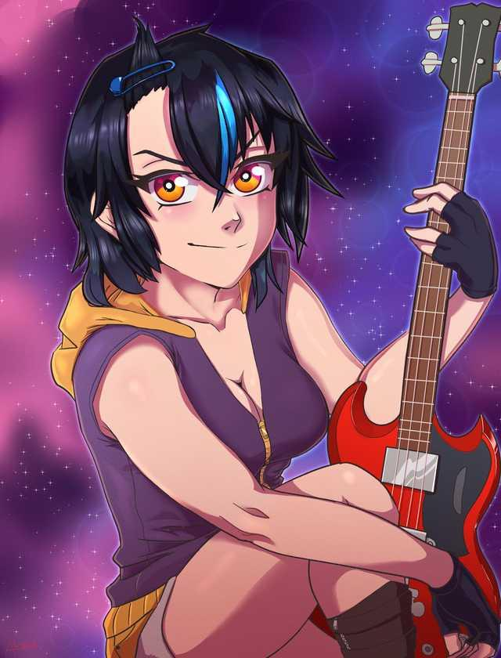

Big cute

ArthurDank 03-Dec-19 03:31 AM

damn thats awesome she is hot just like you

Bunny 03-Dec-19 03:31 AM

No name for her yet lol

ArthurDank 03-Dec-19 03:32 AM

you will figure one out something fitting

something really cool

Bunny 03-Dec-19 03:33 AM

I don’t remember if I’ve sent you this one yet lol

ArthurDank 03-Dec-19 03:34 AM

you already did it was as fine an ass then as it is now

thought about it a lot

Bunny 03-Dec-19 03:35 AM

I’m really bouncy y’know

ArthurDank 03-Dec-19 03:36 AM

big boobs? oh yeah love to see them bounce someday thats for sure

i know you got great jugs

Bunny 03-Dec-19 03:36 AM

Both ends lol

ArthurDank 03-Dec-19 03:37 AM

you got junk in the trunk thsts for sure love to see thst bounce too

Bunny 03-Dec-19 03:37 AM

I just walk normally and my ass bounces

ArthurDank 03-Dec-19 03:37 AM

i have no doubt bet it looks really sexy

Bunny 03-Dec-19 03:38 AM

Don’t think you’ve ever seen me with orange hair lol
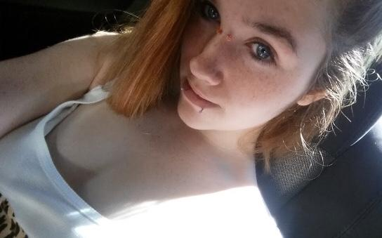

ArthurDank 03-Dec-19 03:38 AM

no i haven't but you are beautiful like the color on you

you are amazing in every way (edited)

Bunny 03-Dec-19 03:43 AM

You more of a boob man or an ass man cuz I’ve got more than enough of both for ya~ or maybe you wanna get in my mouth~?
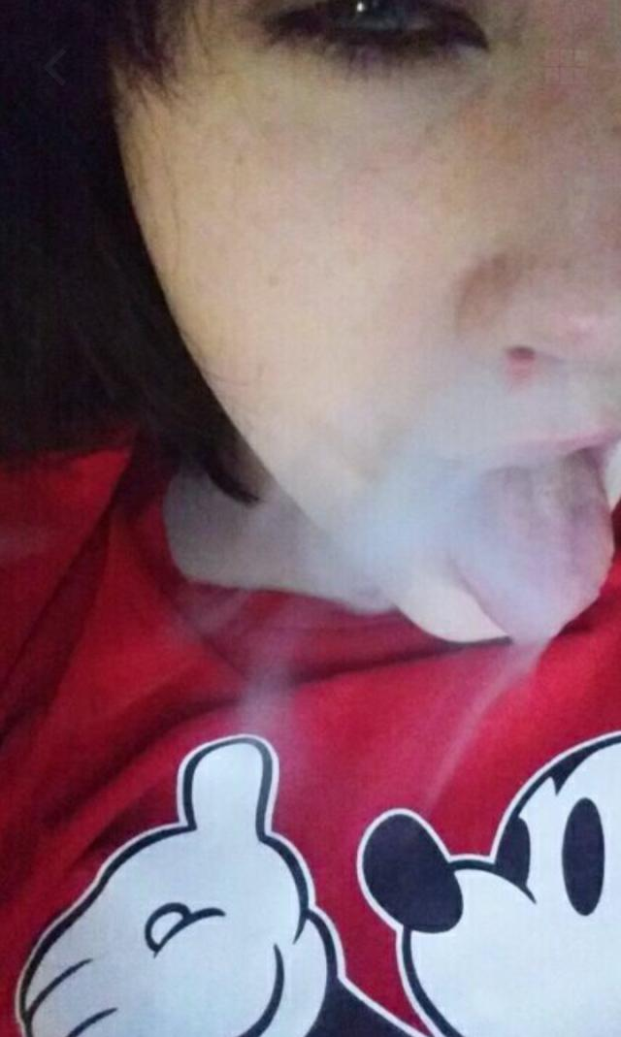

ArthurDank 03-Dec-19 03:44 AM

you look really alluring in that pic hehe im an everything man i want it all but you know how much i love your mouth

i know you got enough for me everyday

Bunny 03-Dec-19 03:45 AM

Tell me more about how much you love my mouth lol

ArthurDank 03-Dec-19 03:48 AM

you have such sweet lips look soft and sweet and a tounge that looks skilled and inviting i love my cock in there feeling how warm and wet it is i think about your heading bobbing back and forth and that tounge working my head and licking my pisshole i always loved it and saw that photo with that jizz trickling down your tounge i wanted so bad for that to be my load you swallowed, you looking up with those gorgeous eyes begging for my cum

I woke up everyday with that mouth wrapped around my cock i would die a happy man (edited)

Bunny 03-Dec-19 03:52 AM

You really wanna cum in my mouth huh~?


ArthurDank 03-Dec-19 03:52 AM

mmm fuck yes i do

even if it was just one time but i would of course have to sample everything else too

were i to meet and you offered i would be scratching my head where to stick it first then again you may make my mind up for me ;)

Bunny 03-Dec-19 03:57 AM

You wanna cum on my tummy too huh~?

ArthurDank 03-Dec-19 03:59 AM

i sure do i wanna fuck you in every hole and not pull out ass mouth and pussy i want a tit job and drench them in cum, and fuck you again and pull out on your tummy and when you blow me im gonna fuck your face and pull jizzing all over that cute face and hair

Bunny 03-Dec-19 04:00 AM

I really do like the taste of cum y’know~

Wanna hear about my stories from high school?

ArthurDank 03-Dec-19 04:01 AM

sure as fuck do and i know you would i would dump as many pints as you want hell i would fuck your ass in the shower while your tasting the load i left in your pussy

i would love to hear them lory

Bunny 03-Dec-19 04:04 AM

Wanna hear about the time I sucked off one of my friends under the lunch table?

ArthurDank 03-Dec-19 04:04 AM

sure do lemme here

hear*

Bunny 03-Dec-19 04:08 AM

Well I was a bit short on lunch money one day and my friend offered to pay for me but only if I sucked him off lol

So he just sat down at the table there’s like this cloth over it so you can’t see under it

So I got under it

Unzipped his jeans and licked all over the head of his cock until he came in my mouth

It was easy giving head back then they didn’t know how to hold it in

ArthurDank 03-Dec-19 04:11 AM

shit wow thats hot lory i was wondering how you didn't get seen makes sense, you are unpredictable in a good way hehe

well you are so cute and good im sure we cant blame them for not holding it in long that was hot (edited)

Bunny 03-Dec-19 04:13 AM

Roughly the same face I made when we did fuck in the bathroom stall lol


Wanna hear about that~?

ArthurDank 03-Dec-19 04:14 AM

holy shit you and this friend fucked wow yes i sure do

lol must've been lousy he was

not a look i would want my girl to have mid thrust lol

Bunny 03-Dec-19 04:18 AM

Yeah he was a bit small but still alright

Enough to get me off anyways

I just sat on his lap with my short shorts around my ankles and he just kept thrusting up into my asshole lol

ArthurDank 03-Dec-19 04:19 AM

wow damn lol lucky bastard

you always dug anal even then didn't you

Bunny 03-Dec-19 04:21 AM

It’s easier cuz I won’t get pregnant lol

ArthurDank 03-Dec-19 04:22 AM

lol that helps and you have such a nice ass be a shame to ignore

Bunny 03-Dec-19 04:24 AM

Let’s just say there was a lot of slapping noises lol

Surprised we didn’t get caught

ArthurDank 03-Dec-19 04:25 AM

damn really pounded it in there

in surprised too really hot tho

Bunny 03-Dec-19 04:25 AM

Cute huh~?


ArthurDank 03-Dec-19 04:25 AM

super cute lory you're adorable

anazing such a naughty girl looks so innocent

makes it hotter

I like your high school stories

Bunny 03-Dec-19 04:30 AM



ArthurDank 03-Dec-19 04:30 AM

hehe i like it like peace and fuck off

you're super hot

thanks for the stories kinda imagined i was your friend in that scenario both times really gets the gears grinding lol

Bunny 03-Dec-19 04:35 AM

You wanna fuck~? This is your favorite outfit of mine right~?
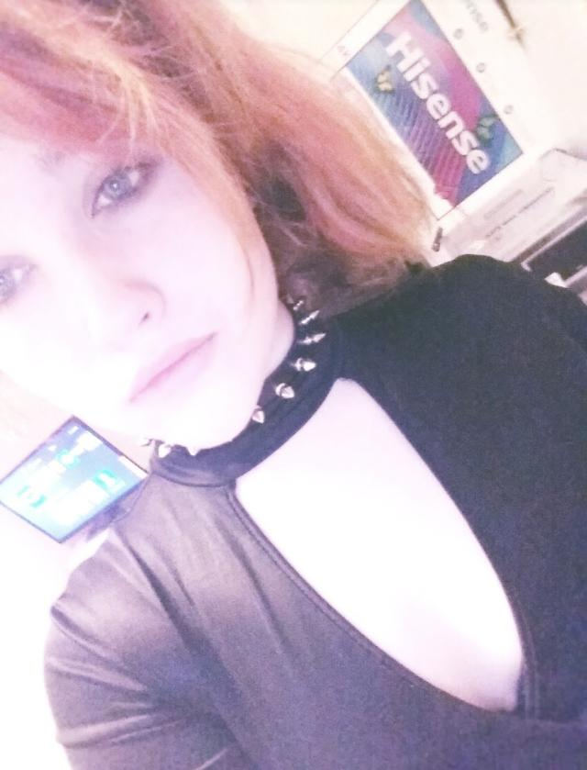

ArthurDank 03-Dec-19 04:35 AM

damn thats the rest of it hot

yes i wanna fuck your brains out (edited)

Bunny 03-Dec-19 04:38 AM

I sat down on your lap and pressed my short shorts covered ass against your crotch You gonna give me that cock~?

ArthurDank 03-Dec-19 04:40 AM

i pull your shirt up playing with your tits as you grind against my cock yes pull those shorts down so i can stuff your ass

Bunny 03-Dec-19 04:43 AM

I pulled my short shorts down just enough for you to be able to shove your cock up my asshole Go ahead and stuff my ass~!

ArthurDank 03-Dec-19 04:46 AM

thats my girl I have wanted this for months I lined my cock up and rammed it up your ass I kept pumping my cock in and out of your ass with loud slapping noises echoing in the stall we were fucking in it felt so good and tight (edited)

Bunny 03-Dec-19 04:49 AM

I bounce up and down your throbbing shaft as you thrust up into my ass You better not cum early~!

ArthurDank 03-Dec-19 04:51 AM

hehe worry about yourself i can go as long as you want baby I thrust in you harder as you bounce up and down on my fat cock i out a hand between your legs and start rubbing your pussy as im fucking your ass

Bunny 03-Dec-19 04:53 AM

I groaned softly as you played with my cunt as I bounced my ass up and down your thick shaft

ArthurDank 03-Dec-19 04:56 AM

i started fingering you as you groaned it feels so wet and i started fucking your ass harder watching it bounce with each thrust fuck lory you're so good

Bunny 03-Dec-19 05:00 AM

I squirted as you fingered my cunt, squeezing my ass tighter around your shaft as I bounced up and down even faster as you buried your cock up my asshole F-FUCK! CUMMING!

ArthurDank 03-Dec-19 05:04 AM

AHH ME TOO I felt you squirt all over my hand and your ass tightened and my load had been building up all day waiting for this, I rammed your asshole hard as I could as my cock started blasting your asshole full of cum shot after shot I hadn't cum so hard before

"I love fucking you lory"

Bunny 03-Dec-19 05:10 AM

I kinda wish I had an outfit like this lol
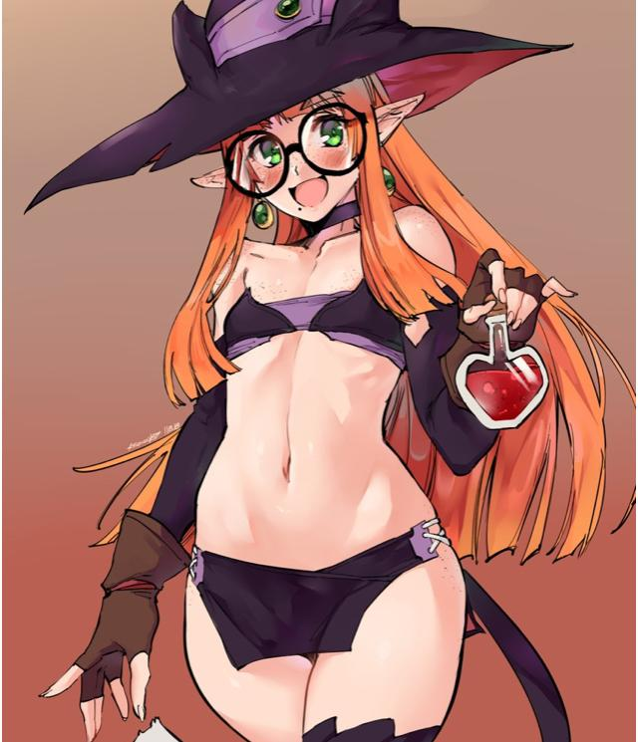

ArthurDank 03-Dec-19 05:10 AM

i wish you did too

love to see you in something naughty like that if im not overstepping lol you could make anything work

when we talk dirty do i ever make you cum?

Bunny 03-Dec-19 05:13 AM

I just did lol

ArthurDank 03-Dec-19 05:13 AM

oh good makes me happy when i get you off i just came too

Bunny 03-Dec-19 05:13 AM

Might dress my OC up like Shantae
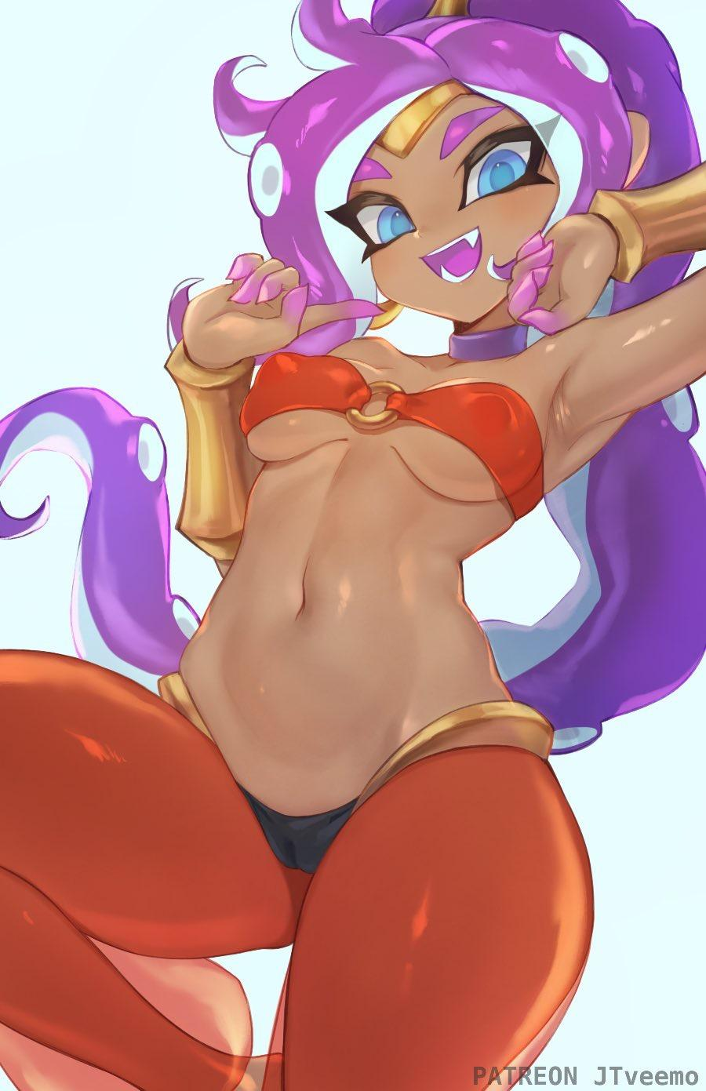

ArthurDank 03-Dec-19 05:13 AM

that would be so hot

that would be great

i could see you dressing like that you would kill in it (edited)

Bunny 03-Dec-19 05:17 AM

Or something like this lol
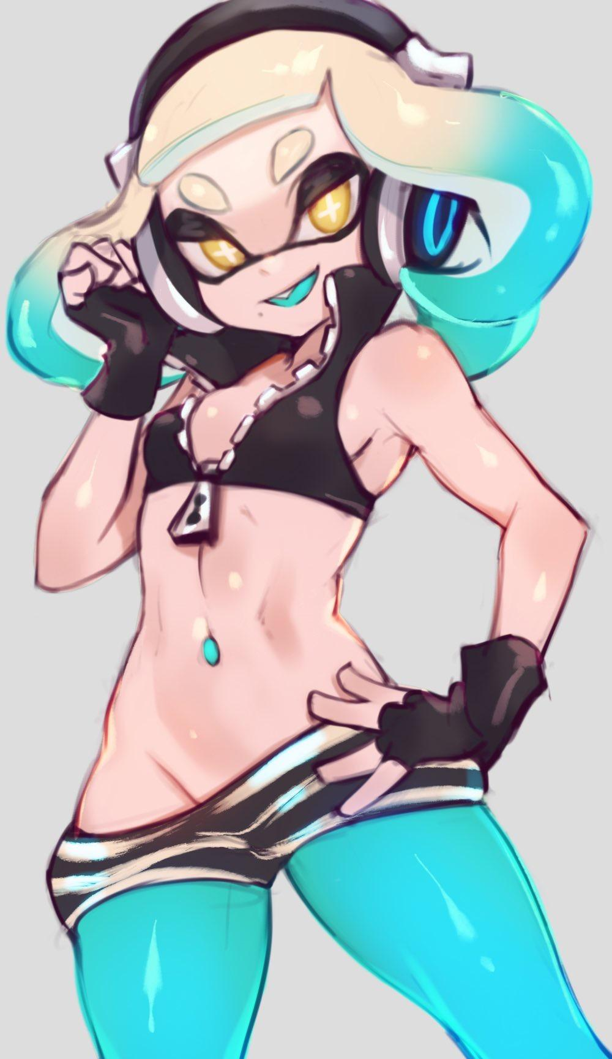

ArthurDank 03-Dec-19 05:17 AM

mmm lovely like the tight clothes and the midriff and how they're halfway off on one side

Bunny 03-Dec-19 05:20 AM

My artist is good so I’ll probably have him do something like this
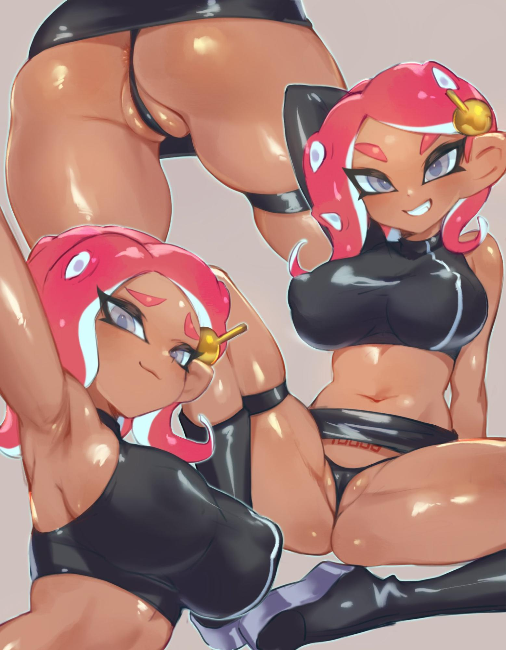

ArthurDank 03-Dec-19 05:20 AM

oh god yes that would be perfect such clothes would be amazing

Bunny 03-Dec-19 05:21 AM

She’s modeled after the colors on the company logo
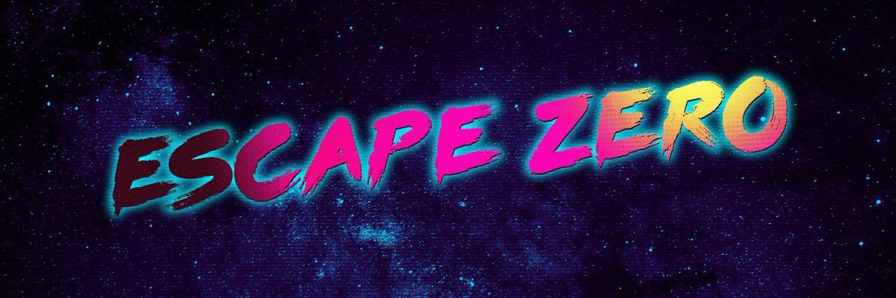

Zero-chan is her placeholder name

I do a cute
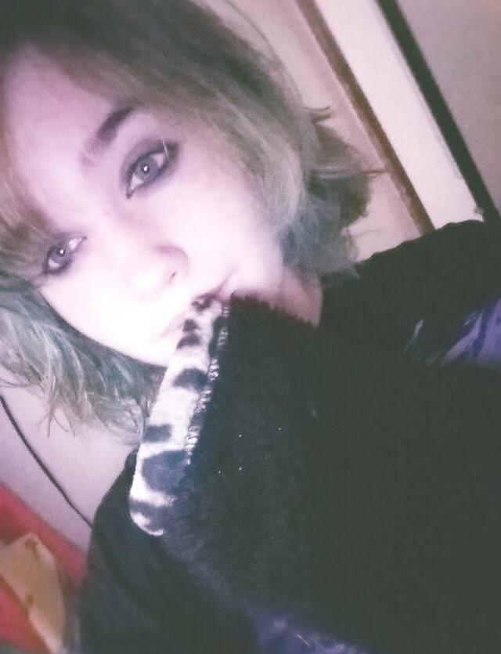

ArthurDank 03-Dec-19 05:28 AM

zero awesome i like it

yes you do a serious cute i love it

Bunny 03-Dec-19 05:31 AM

You wanna get me pregnant huh~? Gimme some cute little brats right~?

ArthurDank 03-Dec-19 05:31 AM

i sure as fuck do

keep letting me do you i will give you as many brats as you want

Bunny 03-Dec-19 05:38 AM

You like this outfit too~?

ArthurDank 03-Dec-19 05:39 AM

you know i always loved this pic of you

you looked so well perfect

like a goddess

ArthurDank 03-Dec-19 05:55 AM

going to bed lory had fun and a good fuck sweet dreams hope we talk again soon <3

Bunny 04-Dec-19 08:16 PM

Henlo

ArthurDank 04-Dec-19 08:16 PM

henlo lory

how ya doing?

Bunny 04-Dec-19 08:28 PM

Thinking about how this is basically my winter to summer body transition
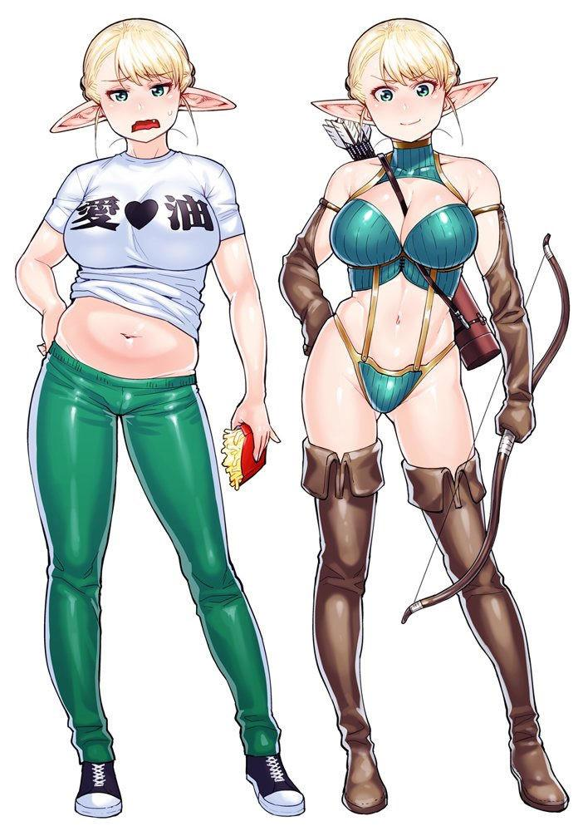

ArthurDank 04-Dec-19 08:31 PM

lol nice you will get ripped before you know it

look all fit and stacked again still look like a babe

Bunny 04-Dec-19 08:33 PM

Food is nice

ArthurDank 04-Dec-19 08:33 PM

of course food is always nice

i love food too

sexy as hell all the same lory

ArthurDank 04-Dec-19 08:53 PM

hey lory you aint gonna vanish on me are ya?

ArthurDank 04-Dec-19 09:13 PM

i like having you around would suck not talking to you

Bunny 04-Dec-19 09:23 PM

Nah I’m hete

Here*

ArthurDank 04-Dec-19 09:24 PM

oh i just mean i hope we never stop talking i still here from ya i got used to having ya aroubd lol

Bunny 04-Dec-19 09:40 PM

I’m a big cute

ArthurDank 04-Dec-19 09:49 PM

sent me that before always give me a smile

you are big cute and i like having you aroubd

Bunny 04-Dec-19 09:55 PM

Smile huh?


ArthurDank 04-Dec-19 10:01 PM

you're so gorgeous

yeah you make me smile

Bunny 04-Dec-19 10:09 PM

You still wanna cum on my face huh~?


ArthurDank 04-Dec-19 10:17 PM

so beautiful <3 yes i really do

im at work so if you wanna sext i cant yet sorry

Bunny 04-Dec-19 10:21 PM

You a fan of dark lipstick?


ArthurDank 04-Dec-19 10:29 PM

depends on the face on some girls it looks hideous on you however its hot as hell

like the long blue hair too it looks wonderful on you

so yeah i like it on you

Bunny 04-Dec-19 10:57 PM

Check out my OC lol
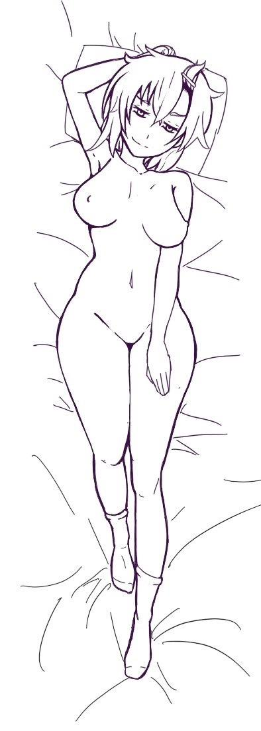
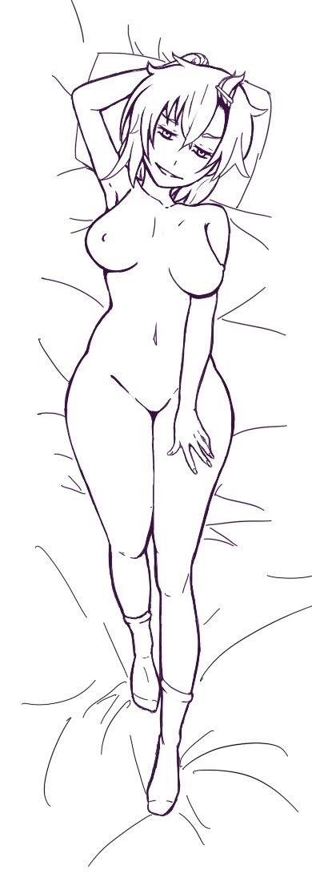

ArthurDank 04-Dec-19 11:06 PM

wow so hot lory who did this they are great

Bunny 04-Dec-19 11:06 PM

Friend of mine

ArthurDank 04-Dec-19 11:07 PM

solid work so alluring i think of you lauinh like that in the same state of undress hehe

Bunny 04-Dec-19 11:08 PM

Well Zer0 is more or less based on me so

Don’t blab about that though

Everyone thinks she’s a Ryuko lookalike

Let’s keep it that way

It’s obvious lmao

ArthurDank 04-Dec-19 11:38 PM

its uncanny isn't it hehe thats you alright

Bunny 04-Dec-19 11:42 PM

From 2D to 3D
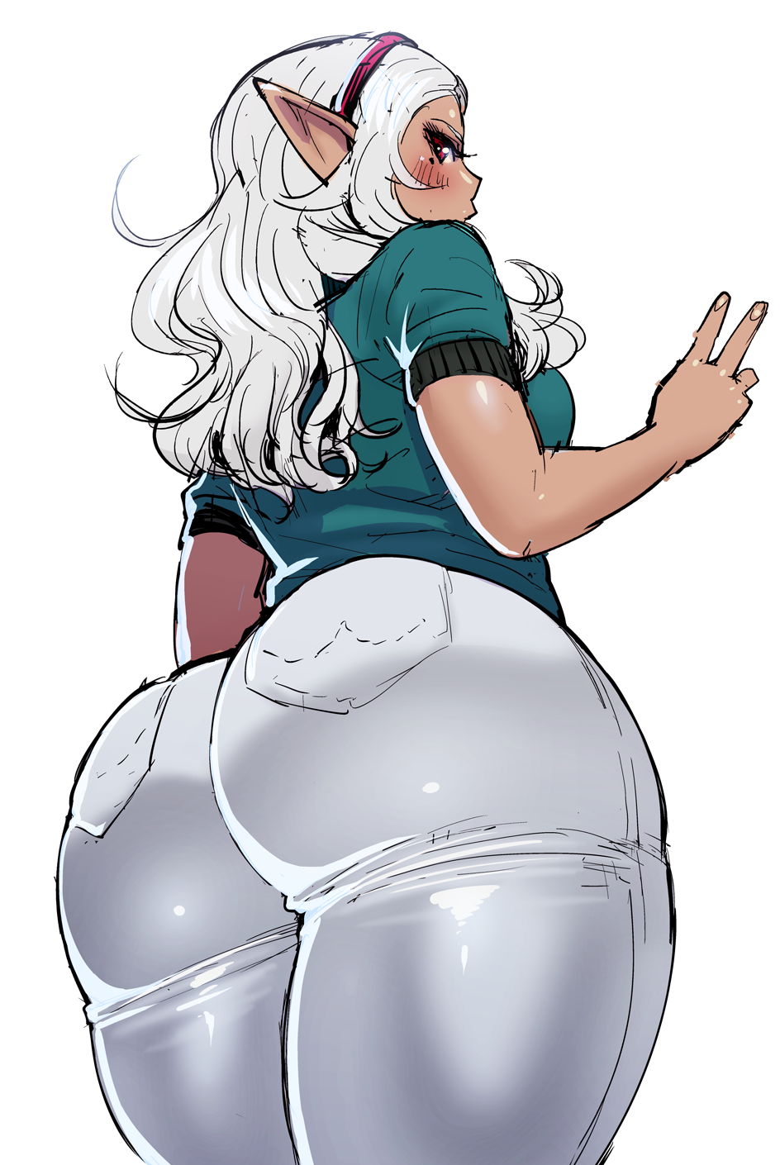

ArthurDank 05-Dec-19 12:04 AM

holy hell thats so sext you got a great ass

i wanna eat it

Bunny 05-Dec-19 12:05 AM

I’ve got more than enough ass lmao

ArthurDank 05-Dec-19 12:07 AM

yes you do im hungry for sure

i want you to sit on my face hehe

Bunny 05-Dec-19 12:07 AM

I’d probably break your neck Lmao

ArthurDank 05-Dec-19 12:08 AM

you aint that heavy i will brace you just lemme lick ;)

i wanna eat some ass and pussy lmao

course i could just shove you on your back and munch you there

Bunny 05-Dec-19 12:13 AM

I’m like

112 pounds

ArthurDank 05-Dec-19 12:16 AM

see no danger hehe

i can take you ;)

Bunny 05-Dec-19 12:20 AM

I wouldn’t mind being in this position
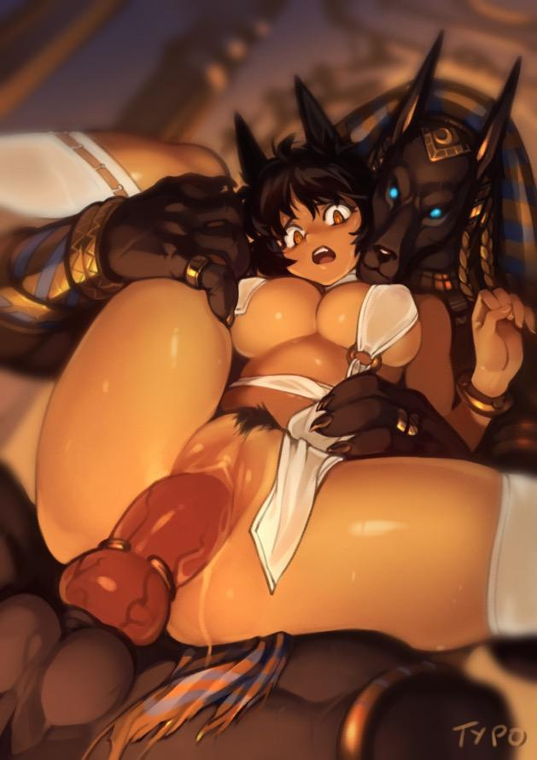

ArthurDank 05-Dec-19 12:21 AM

i wouldn't mind your back to me pussy around my dick me with my arms holding up your hips and legs pounding away in you (edited)

Bunny 05-Dec-19 12:23 AM

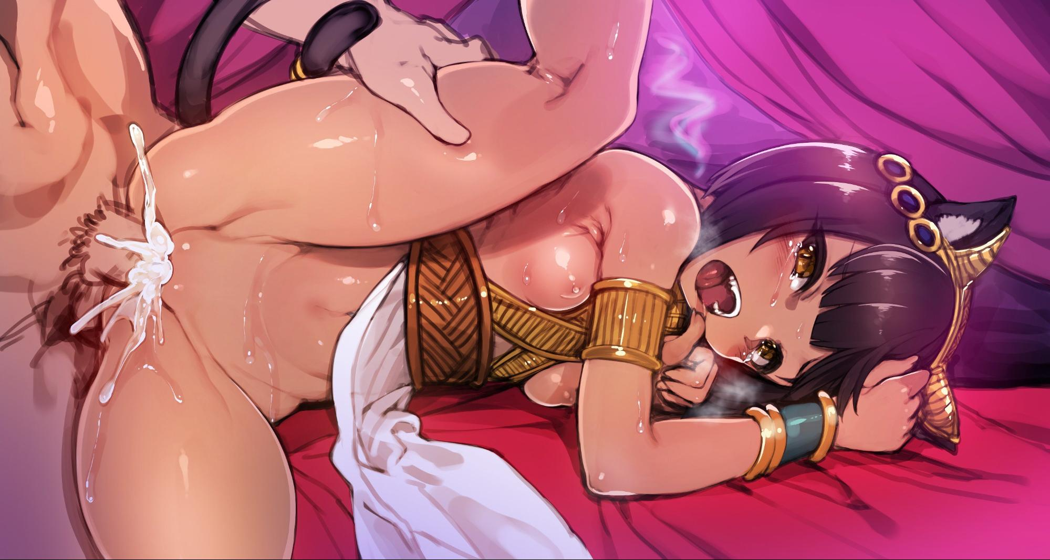

I won’t lie it’s best when I get a nice load dumped in me lol

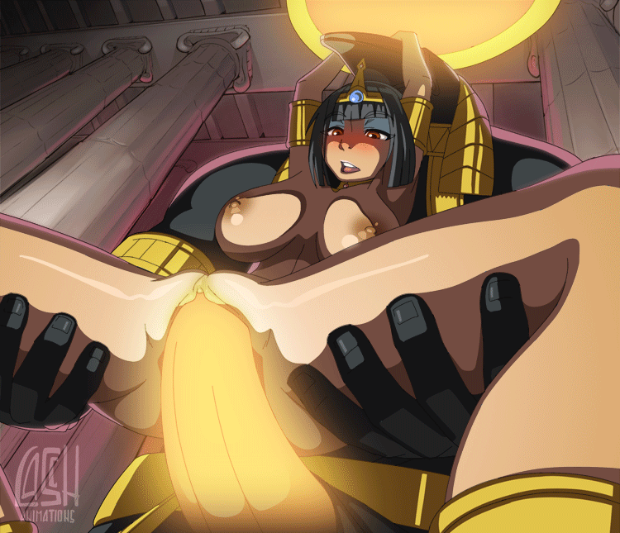

ArthurDank 05-Dec-19 12:31 AM

hehe then i will must certainly dump a fat load in your pussy may make you a mommy

Bunny 05-Dec-19 12:32 AM

What if there were two of me
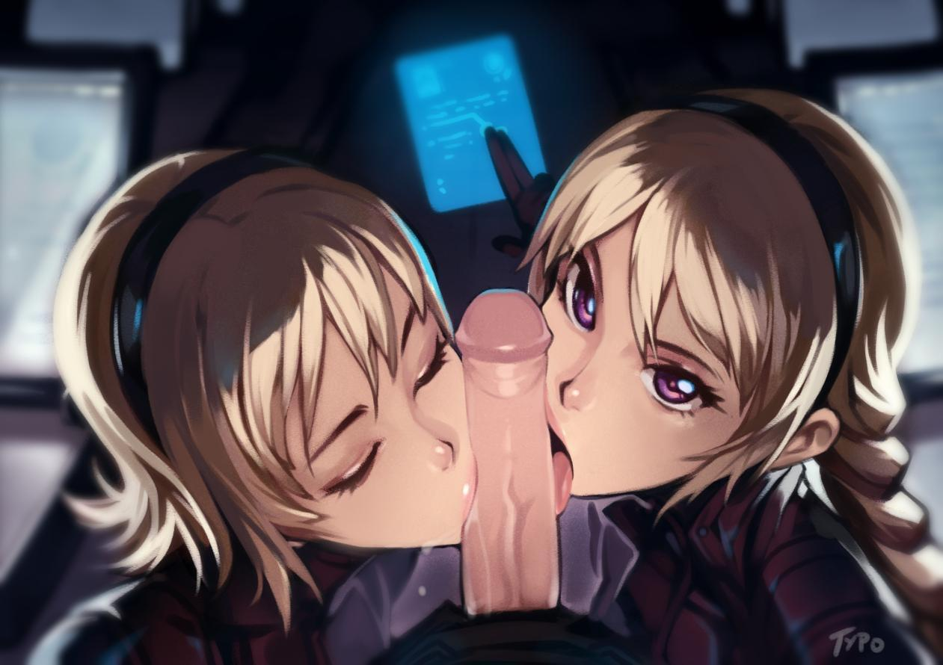

My favorite position

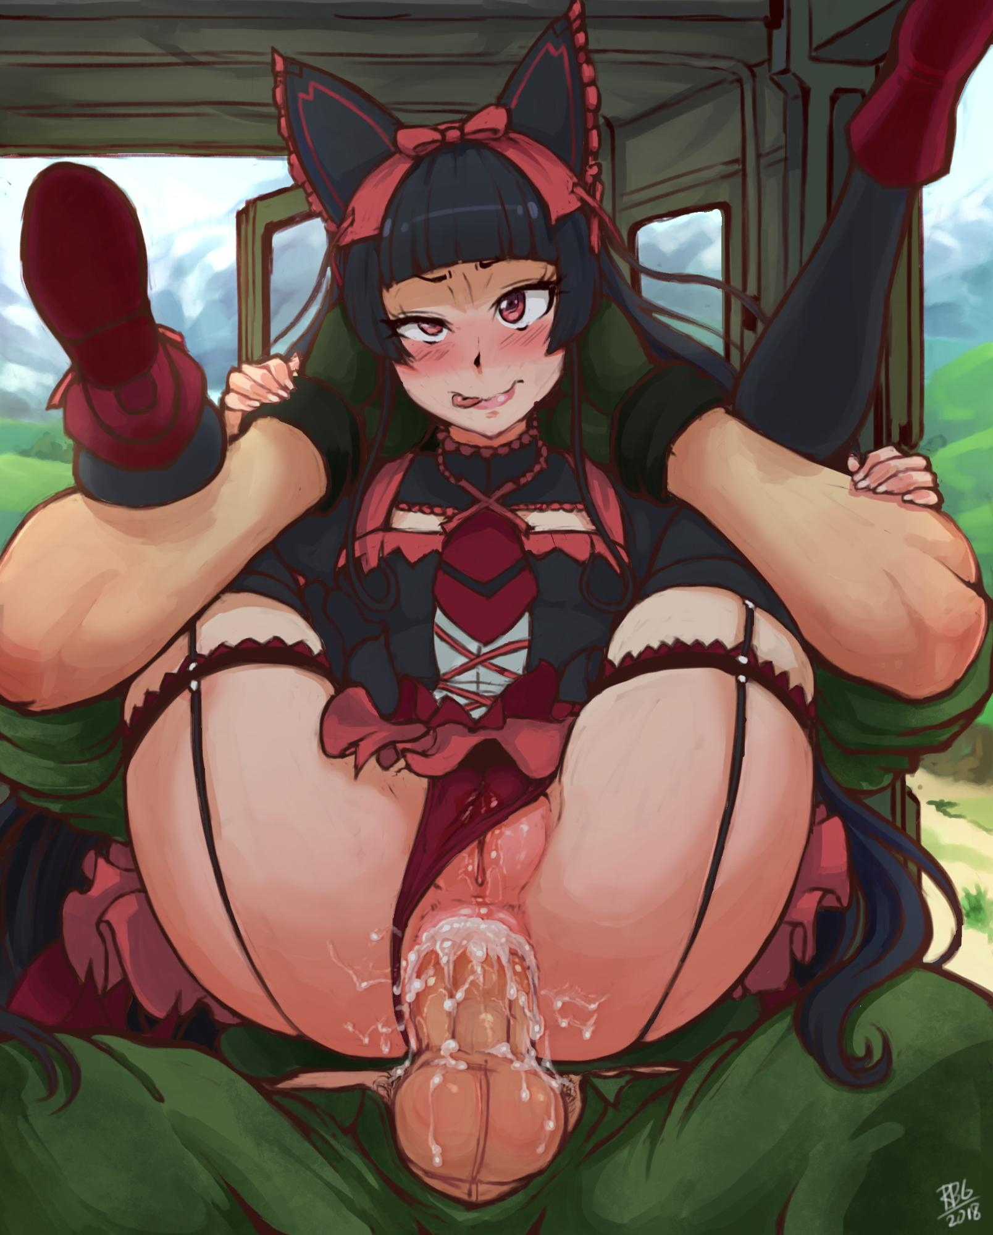

ArthurDank 05-Dec-19 12:39 AM

i always wanted to fuck a girl in that position

well i always wanted a threesome

if there were two

i will knock the both of you up and you're gonna get accustomed to waking me up via blowjob in the morning

Bunny 05-Dec-19 12:46 AM

Cock tastes good lmao

ArthurDank 05-Dec-19 12:49 AM

glad you agree ;) you can suck me as much as you want lory

Bunny 05-Dec-19 12:51 AM

Big cute
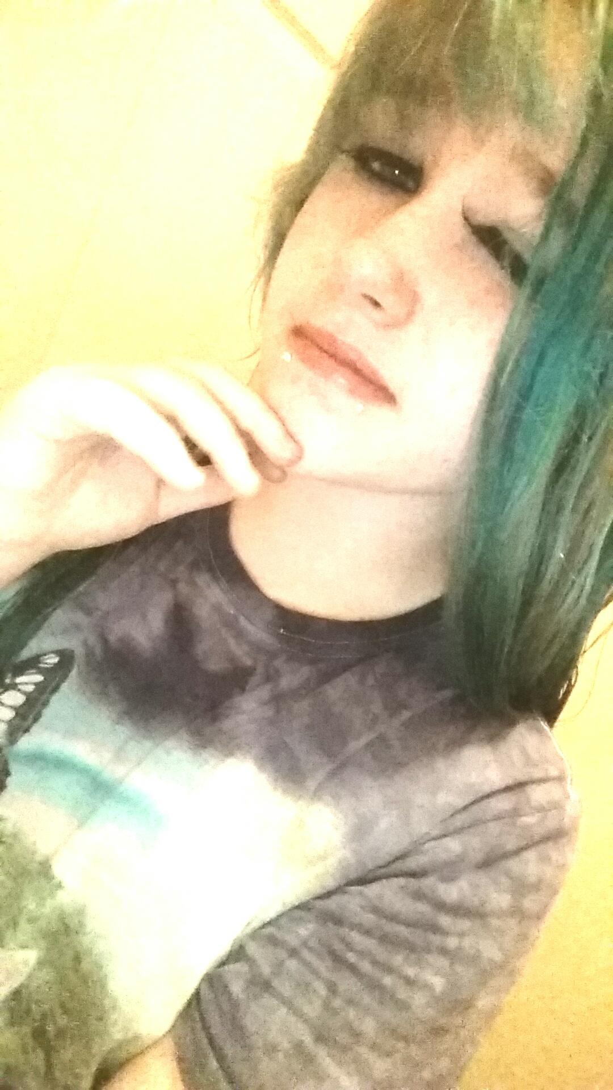

ArthurDank 05-Dec-19 01:12 AM

very cute hehe you look tired

Bunny 05-Dec-19 01:15 AM

You like my natural color better huh?
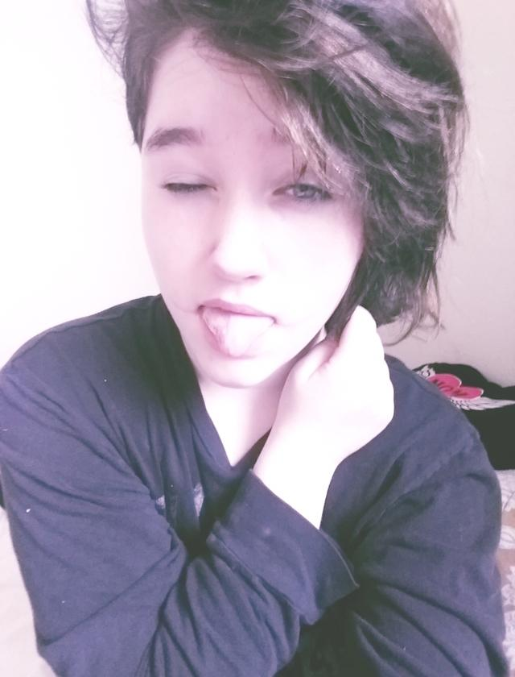

ArthurDank 05-Dec-19 01:38 AM

truth is i love em both i love your natural hair but the blue is hot too

kinda wanted to fuck a blue haired chick

Bunny 05-Dec-19 01:41 AM

Oh really~?
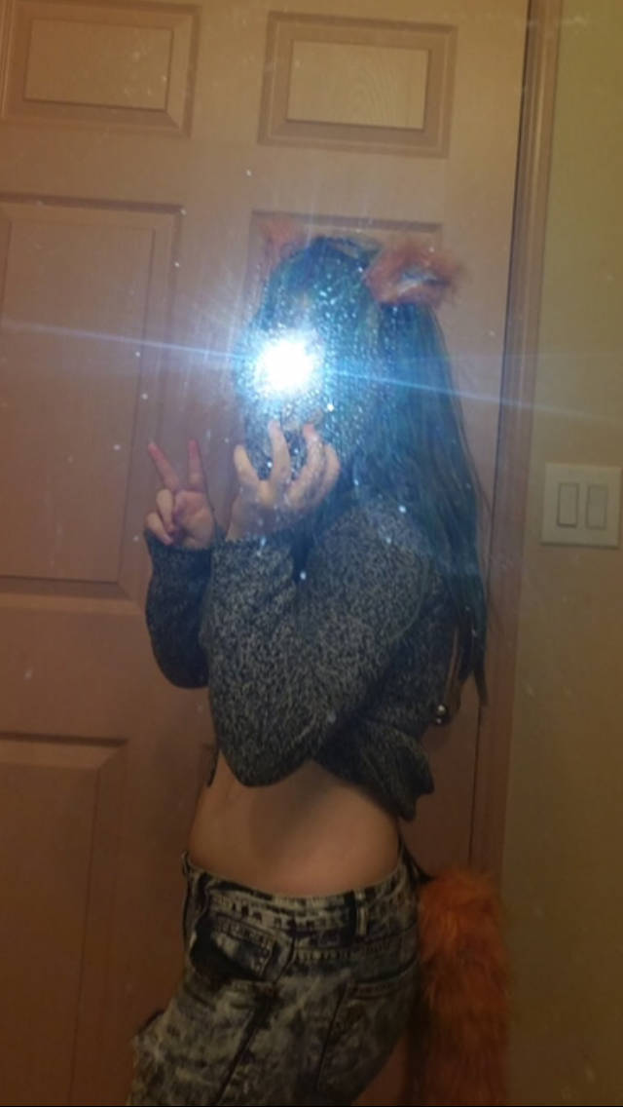

ArthurDank 05-Dec-19 01:41 AM

yeah and when they're built and look like you its easy

Bunny 05-Dec-19 01:45 AM

Would you fuck me in my cute pajamas~?


ArthurDank 05-Dec-19 01:47 AM

yes i would pull them down around your knees climb on top and stuff my dick up in you, you kick the bottoms off so you could wrap your legs around me shoving me in deeper

ArthurDank 05-Dec-19 02:03 AM

you looked hot in that pic too

Bunny 05-Dec-19 02:44 AM

What about my favorite outfit~? You like short shorts riiiight~?

ArthurDank 05-Dec-19 02:45 AM

hehe you know the answer to that damn right those stockings were hot too

i'd fuck you with those on cause you would rub them against my groin to get my attention i'd give you the pounding a babe like you deserves

ArthurDank 05-Dec-19 02:55 AM

i would bend you over the nearest secluded corner pull them to the side and stuff your pussy till i paint your insides white

ArthurDank 05-Dec-19 12:39 PM

sorry you got in the middle of the fight last night lory I understand why you would feel the need to disagree (edited)

anyway talk to you later :) (edited)

Bunny 05-Dec-19 07:38 PM

Henloooo

ArthurDank 05-Dec-19 07:39 PM

henloooo to you too

how are you doing?

Bunny 05-Dec-19 10:16 PM

I’m good

ArthurDank 05-Dec-19 11:00 PM

im glad lory i missed you

ArthurDank 06-Dec-19 02:40 AM

well anyway have a good one talk to you later on

Bunny 06-Dec-19 02:57 AM

Yee

Bunny 07-Dec-19 10:21 PM

Henloooo

ArthurDank 07-Dec-19 10:29 PM

henloooooo how ya doing?

Bunny 07-Dec-19 10:31 PM

I’m goooood

ArthurDank 07-Dec-19 10:54 PM

awesome glad to hear it missed ya :)

Bunny 07-Dec-19 10:57 PM

Me a cute
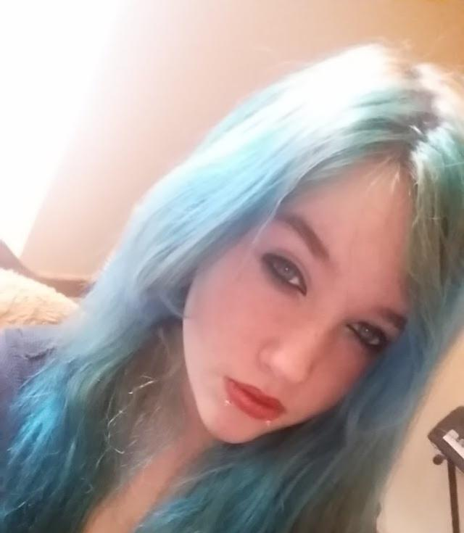

ArthurDank 07-Dec-19 11:09 PM

goddamn very cute

look sexy

never realized what nice lips you got

Bunny 07-Dec-19 11:24 PM

Natural~

ArthurDank 07-Dec-19 11:36 PM

everything about you is natural excwot the blue hair but it suits you

had a good day?

Bunny 07-Dec-19 11:42 PM

Yee

In the mood for some cock lol

ArthurDank 07-Dec-19 11:50 PM

glad to hear it hehe ;)

im kind of in the mood anyway

like to see those lips in action again

Bunny 08-Dec-19 12:04 AM

I just cracked my back in the best way after taking my bra off lol

ArthurDank 08-Dec-19 12:05 AM

bet that felt like a lift off the chest ahahha

Bunny 08-Dec-19 12:07 AM

They’re heavy y’know

Would you hold em~?

ArthurDank 08-Dec-19 12:08 AM

i would hold and play with them everytie you cane over to sit in my lap im gonna hold and play with em

i dont care the bigger the better boobs

starts rubbing and squeezing your boobs after you take your bra off they feel good and soft

Bunny 08-Dec-19 12:14 AM

I sat down in your lap as you groped my massive breasts Y’know I’m an E cup right~?

ArthurDank 08-Dec-19 12:15 AM

I suck and kiss your neck groping your breasts harder I know I love your boobs love to see em one day

Bunny 08-Dec-19 12:19 AM

You gonna stick your cock between em~?

ArthurDank 08-Dec-19 12:21 AM

damn right I would dirty them up everyway i can on that note i didn't wash my cock yet today preparing for this so.... show me what you can do with em *pulls you down to my cock and I shove it between your huge breasts

Bunny 08-Dec-19 12:29 AM

I squeezed my tits together against your cock, rubbing them up and down your shaft I can’t even see your cock between my tits~ I guess I’m too big for ya~

ArthurDank 08-Dec-19 12:31 AM

my cock grew bigger as you worked my shaft, tits felt too good causing my cockhead to stick out between them haha think again you warmed me up

I start thrusting my cock in between your tits as you work them up and down my shaft

Bunny 08-Dec-19 12:40 AM

You’re twitching already huh~? I said as I licked the tip of your cock as you thrust between my tits

ArthurDank 08-Dec-19 12:44 AM

your tits and mouth are too good I jerk off when we are apart thinking how they would feel thrusting faster as your tits bounce, you lick on my cock head, my thrusts getting it against your mouth, cock twitching wildly

Bunny 10-Dec-19 12:40 AM

Henlo

Bunny 10-Dec-19 02:49 AM

Henloooo

Bunny 13-Dec-19 09:48 PM

Henlo

ArthurDank 13-Dec-19 09:55 PM

henloooo how are you? hope you hve been well lory

Bunny 13-Dec-19 09:59 PM

I’m goood~


ArthurDank 13-Dec-19 10:38 PM

always happy to hear that

Bunny 14-Dec-19 01:44 AM

Henloooo

ArthurDank 14-Dec-19 01:45 AM

love the pic henlo again hows it going

Bunny 14-Dec-19 01:55 AM

I’m goooood~

This was one of your favorites yeah?
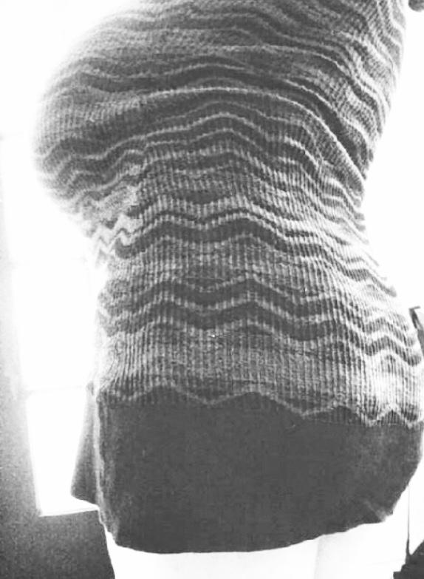

ArthurDank 14-Dec-19 01:56 AM

yes it was showed you will thick in the right spots

Bunny 14-Dec-19 01:56 AM

You remember my cup size right~?

ArthurDank 14-Dec-19 01:56 AM

sure do W

E*

Bunny 14-Dec-19 01:57 AM

They’re really heavy lol

I’m actually wearing the sweater dress at the moment

ArthurDank 14-Dec-19 01:57 AM

i bet they are lory lol thats rough

lol prove it

XD

love to see you in it again

makes me hard

Bunny 14-Dec-19 02:07 AM

This one is good too
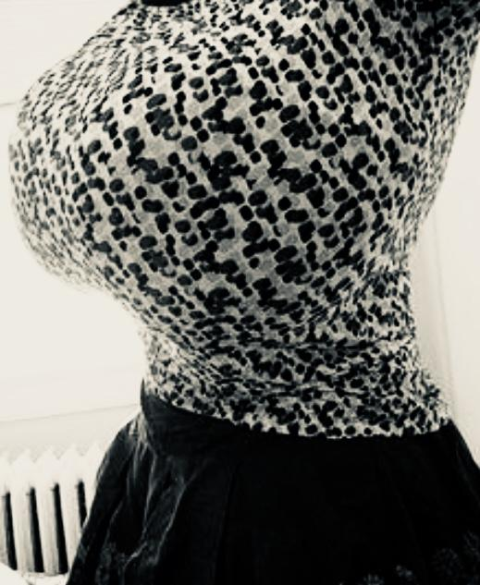

My shirts always get stretched out

ArthurDank 14-Dec-19 02:09 AM

i can tell but it looks nice hehe you look hot

got a nice body

Bunny 14-Dec-19 02:10 AM

Tiny waist

ArthurDank 14-Dec-19 02:10 AM

i know its a turn on remember i saw your waist, you took a pic of your abs coming out of the shower (edited)

Bunny 14-Dec-19 02:11 AM

Honestly I’m surprised I can fit all my organs in there

ArthurDank 14-Dec-19 02:11 AM

me too looks nice i remember how hard i got when you posted that in saiyomis group

i saved both of those pics and started fapping to them that day

Bunny 14-Dec-19 02:14 AM

Lmao really?

How often am I your fap material?

ArthurDank 14-Dec-19 02:15 AM

almost everyday

sometimes not even using the pics i just think of fucking you

i also screencap oir sexting so i can relive it

our*

Bunny 14-Dec-19 02:18 AM

Which pictures are your favorites?

ArthurDank 14-Dec-19 02:19 AM

you have one you just sent, the first two including the shower one as it was near of a nude i ever got to see also the one in your black leggings the pic of your ass

anything showing your face or your body i always a win

Bunny 14-Dec-19 02:22 AM

You can jack off to just my face~?

ArthurDank 14-Dec-19 02:23 AM

have you seen how cute you are? imagine that cute face sucking me off

and when you talk dirty or tell me stories about sucking and fucking you did its like a fever till i fap

Bunny 14-Dec-19 02:27 AM

This one too?


ArthurDank 14-Dec-19 02:27 AM

name a pic i fapped to them all and when you sent that one where you had cum on your tounge my dick already started to get wet (edited)

Bunny 14-Dec-19 02:30 AM

You like imagining me sucking you off huh~?


ArthurDank 14-Dec-19 02:30 AM

yes i do

and me fucking you but sucking off a lot (edited)

Bunny 14-Dec-19 02:32 AM

Can you show me your favorite fap material from me?

ArthurDank 14-Dec-19 02:33 AM

are you on your twitter its easier to send there

Bunny 14-Dec-19 02:33 AM

Nah send here thanks

I don’t do stuff like that over there gotta keep it clean

ArthurDank 14-Dec-19 02:33 AM

i see well give me a minute then

Bunny 14-Dec-19 02:38 AM

Alrighty

ArthurDank 14-Dec-19 02:38 AM

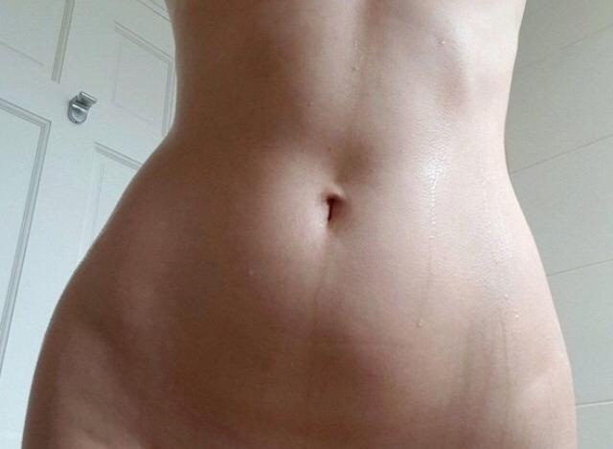



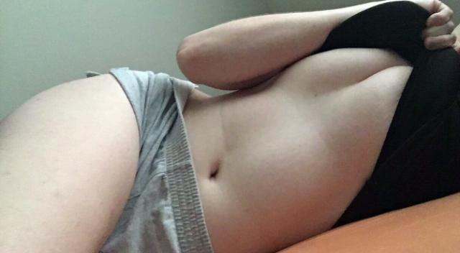

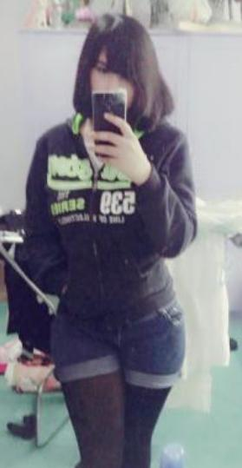

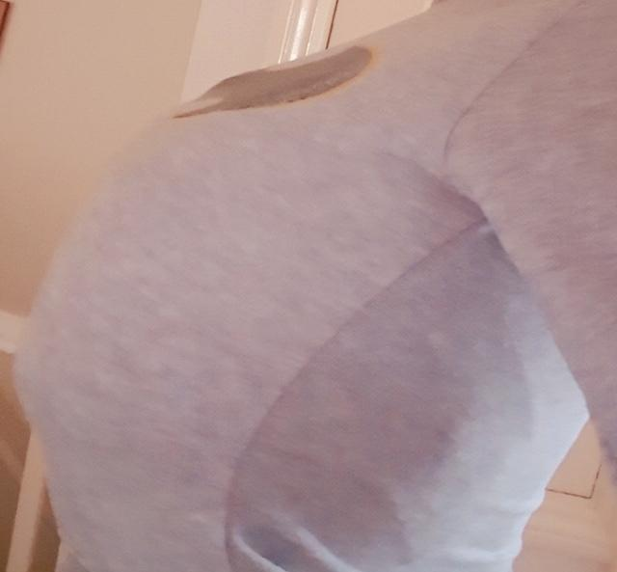

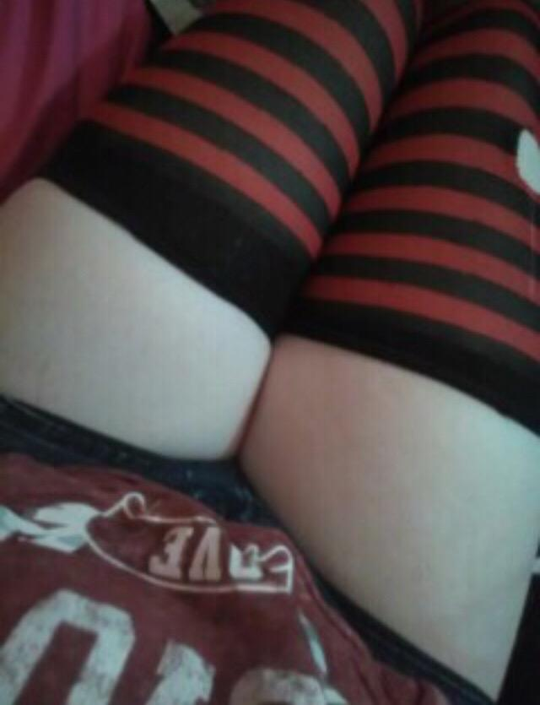

Bunny 14-Dec-19 02:41 AM

Making sexy faces is fun
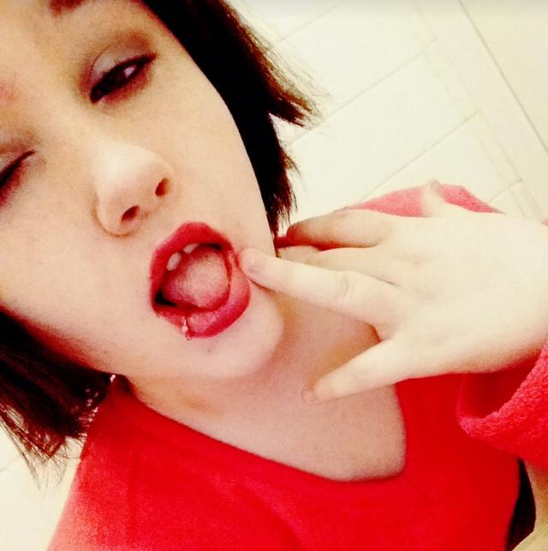

ArthurDank 14-Dec-19 02:41 AM

jesus wow mmm

yes im enjoing it

Bunny 14-Dec-19 02:42 AM

My tooth gap is cute huh~?

ArthurDank 14-Dec-19 02:42 AM

yes it really is

mmm

Bunny 14-Dec-19 02:44 AM

I bet you think of jerking off on my face a lot right~?

Just rubbing your cock on my face

ArthurDank 14-Dec-19 02:45 AM

yeah i do and you leave kisses and lick while im doing it hehe

its one of my favorite things that and you swallowing my load while sucking my cock (edited)

Bunny 14-Dec-19 02:48 AM

What would you do with my ass~?

Just rub your cock all over it huh~?

ArthurDank 14-Dec-19 02:49 AM

eat it lick it deep as I could and without warning ram my cock in so hard you scream and pound you till your legs give out

well yeah that too i would love to get hotdogged between your cheeks

Bunny 14-Dec-19 02:52 AM

I have a few other chest ones for ya hold on

ArthurDank 14-Dec-19 02:52 AM

thanks baby

Bunny 14-Dec-19 02:57 AM

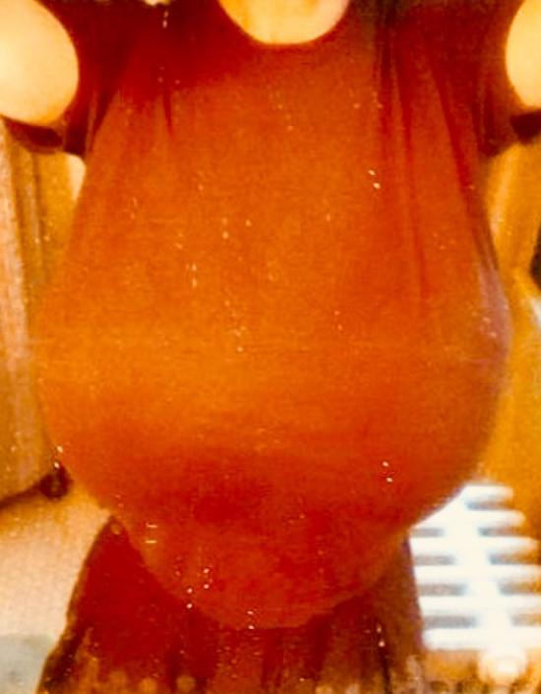

Toldja my shirts get stretched out

ArthurDank 14-Dec-19 02:58 AM

they sure do but such great tits

Bunny 14-Dec-19 03:00 AM

What’s your favorite thing about my giant boobs lol

ArthurDank 14-Dec-19 03:01 AM

everything i love big tits, i love how round and full they look and how they would swallow my cock how nice it would feel to cum between them (edited)

Bunny 14-Dec-19 03:03 AM

They really bounce when I’m getting fucked lol

ArthurDank 14-Dec-19 03:03 AM

nice would kill to see that mid thrust

Bunny 14-Dec-19 03:03 AM

They bounce when I move normally too lol

ArthurDank 14-Dec-19 03:03 AM

lol yum

Bunny 14-Dec-19 03:04 AM

Using them as an arm rest right now actually

ArthurDank 14-Dec-19 03:04 AM

very nice

i wanna suck on them

and that thought makes me wanna fap which im gonna do (edited)

Bunny 14-Dec-19 03:15 AM

Feel better now?

You really get pent up seeing my body huh~?

ArthurDank 14-Dec-19 03:16 AM

sure as fuck did and yeah i do kiss

Bunny 14-Dec-19 03:17 AM

Hehehehe

So you really like my tits huh?

ArthurDank 14-Dec-19 03:19 AM

yeah i really do lory love em

Bunny 14-Dec-19 03:25 AM

Tell me how you’d fuck me~

Hell tell me how you’d violate me

ArthurDank 14-Dec-19 03:30 AM

like rape you?

Bunny 14-Dec-19 03:31 AM

Yeah

ArthurDank 14-Dec-19 03:38 AM

hmm i like the dark stuff honestly well shit i would see you wait till you were alone knock at the door when you were alone act friendly, yank you into your place, forcefully kiss you and rip your clothes off pinning you against a wall i would stuff my dick in your ass and thrust and thrust hard as i can till it hurts i let a big load out in your ass and then i turn you around wrestle you into the bed, im on top and i start raping you in your pussy, i force you to look at me as i do you mating press, i thrust back in forth i suck and bite on your neck and tits leaving marks and bruises im gonna cum no condom you beg me to stop you have someone i tell you i dont fucking care i thrust a few more times until i bust my load inside you, you came as I did, I knocked you up after that i climb on top of you and fuck your face making you clean my cock i thrust my cock into your mouth deep as it will go until i bust again and leave (edited)

Bunny 14-Dec-19 03:43 AM

Hehehehe

You can go darker than that y’know

ArthurDank 14-Dec-19 03:43 AM

really?

Bunny 14-Dec-19 03:44 AM

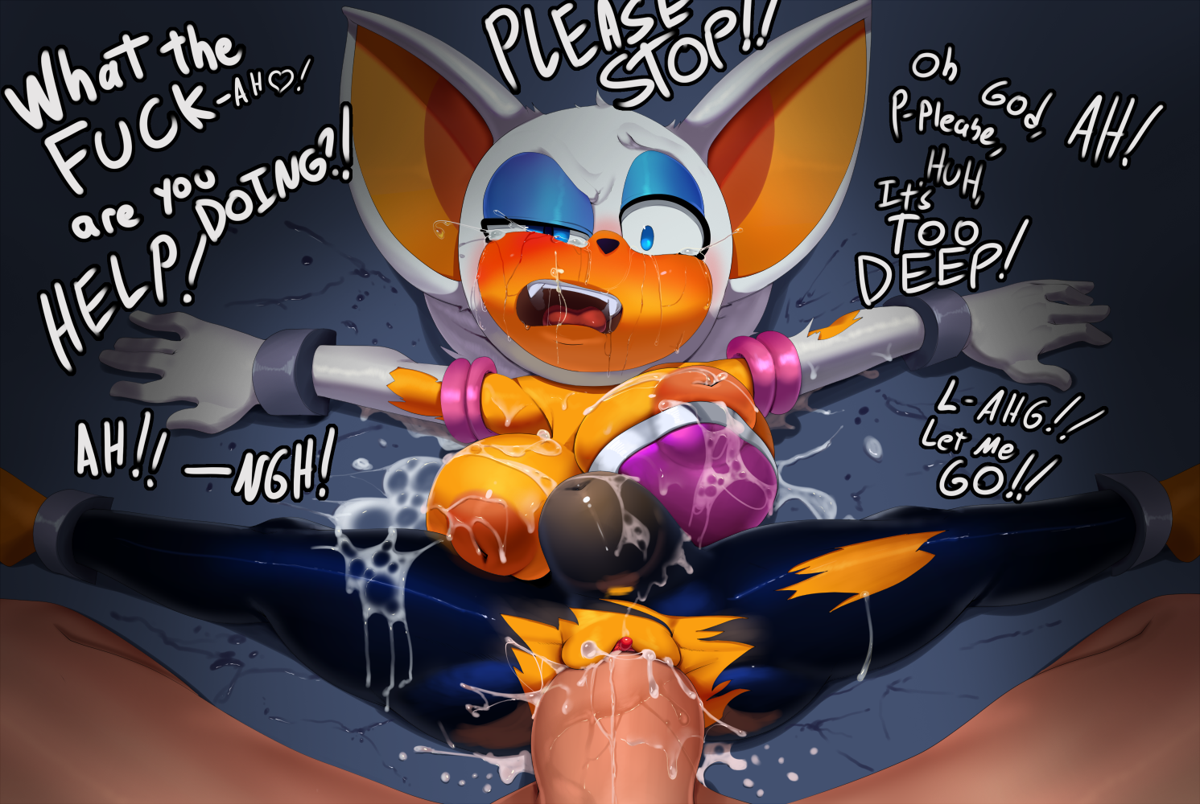

ArthurDank 14-Dec-19 03:44 AM

I meant to add I would kidnap you after raping you

Bunny 14-Dec-19 03:44 AM

Hehehehe Keep goin

ArthurDank 14-Dec-19 03:50 AM

after word i would make you submit i would spend all day fucking you and making you suck me if you were good i would do something nice for you, especially when you didn't mention people you missed, i would set up a camera and we would watch the tapes together of all the times I raped you I would keep raping you in everyway possible till you accepted you were mine ass mouth and pussy all belonged to me, you were a cumdump existing only for my pleasure, i would tie you up go slow then fuck you like a wild animal and drown you in cum, every morning i would force you to suck my cock and depending on my mood either swallow or facial, everytime you were in the shower i would barge in and fuck your brains out till i was satisfied

I was gonna brake you, I wasn't gonna let you go till you were mine and by then you wouldn't leave, especially when i finally knock you up something you always wanted (edited)

Bunny 14-Dec-19 03:53 AM

I do wanna get pregnant~
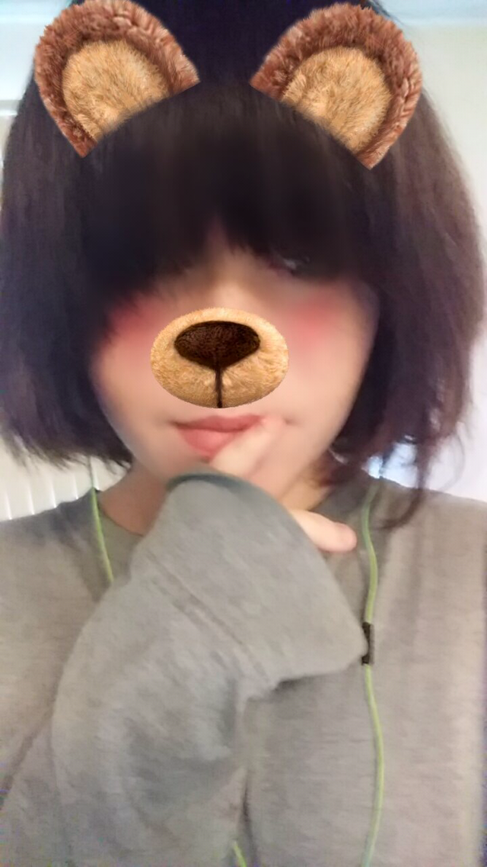

ArthurDank 14-Dec-19 04:11 AM

i know you do hehehe

so precious <3

i love that picture

Bunny 14-Dec-19 04:14 AM

How many times would you knock me up~?

ArthurDank 14-Dec-19 04:14 AM

as many kids as you wanted

Bunny 14-Dec-19 04:14 AM

Even while pregnant~?
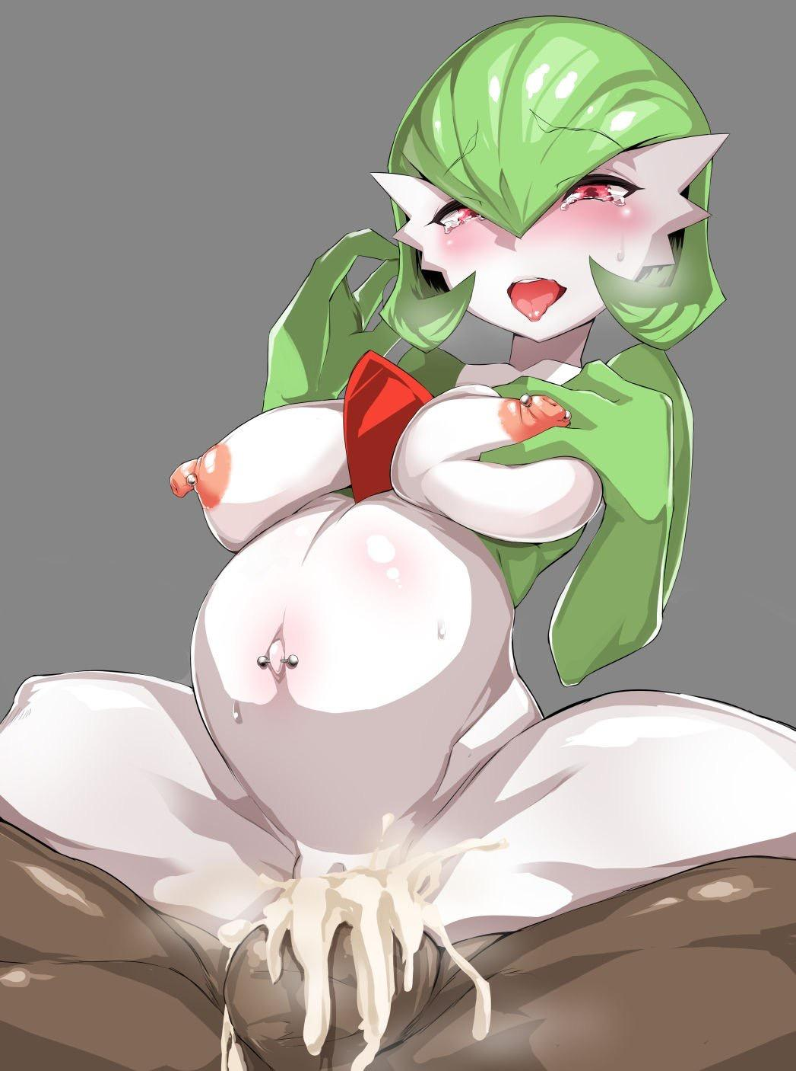

ArthurDank 14-Dec-19 04:15 AM

especially then i hear pregnant women get even wilder during sex then usual given how you are there will wont be much sleep hehehehe

Bunny 14-Dec-19 04:18 AM

Lmao I get cummed inside of so often I’m surprised I’m not pregnant yet lol

ArthurDank 14-Dec-19 04:20 AM

lol i am too

pretty amazing really

Bunny 14-Dec-19 04:21 AM

And I know I don’t have infertility problems I was tested and I’m super fertile lol

ArthurDank 14-Dec-19 04:23 AM

oh i believe it hahah

you certainly got the sex drive

i dont shoot blanks either lol

Bunny 17-Dec-19 11:50 PM

Henlooooooooo

Bunny 19-Dec-19 05:51 AM

It finally happened
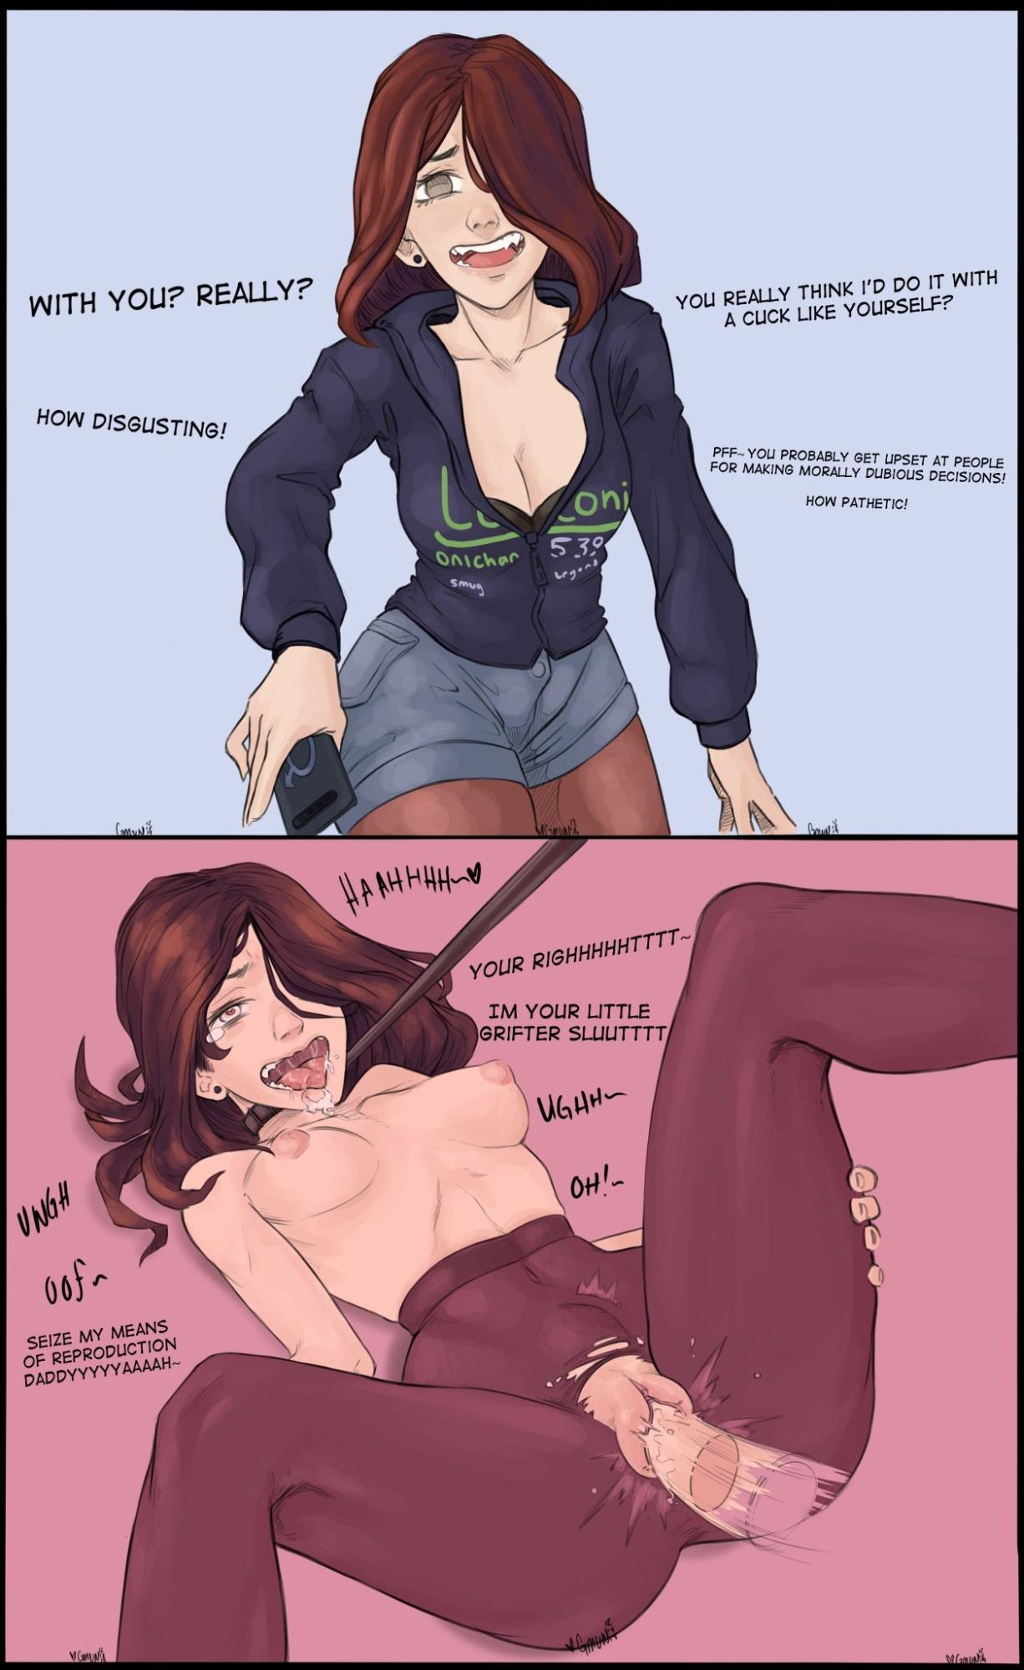

ArthurDank 19-Dec-19 05:51 AM

lewd fan art

awesome

sorry didn't see the msg

Bunny 19-Dec-19 05:52 AM

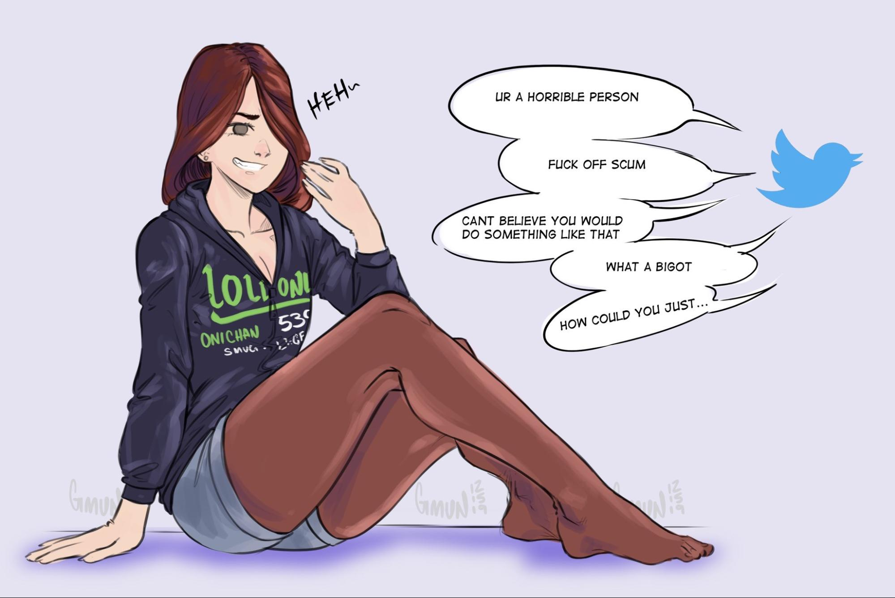

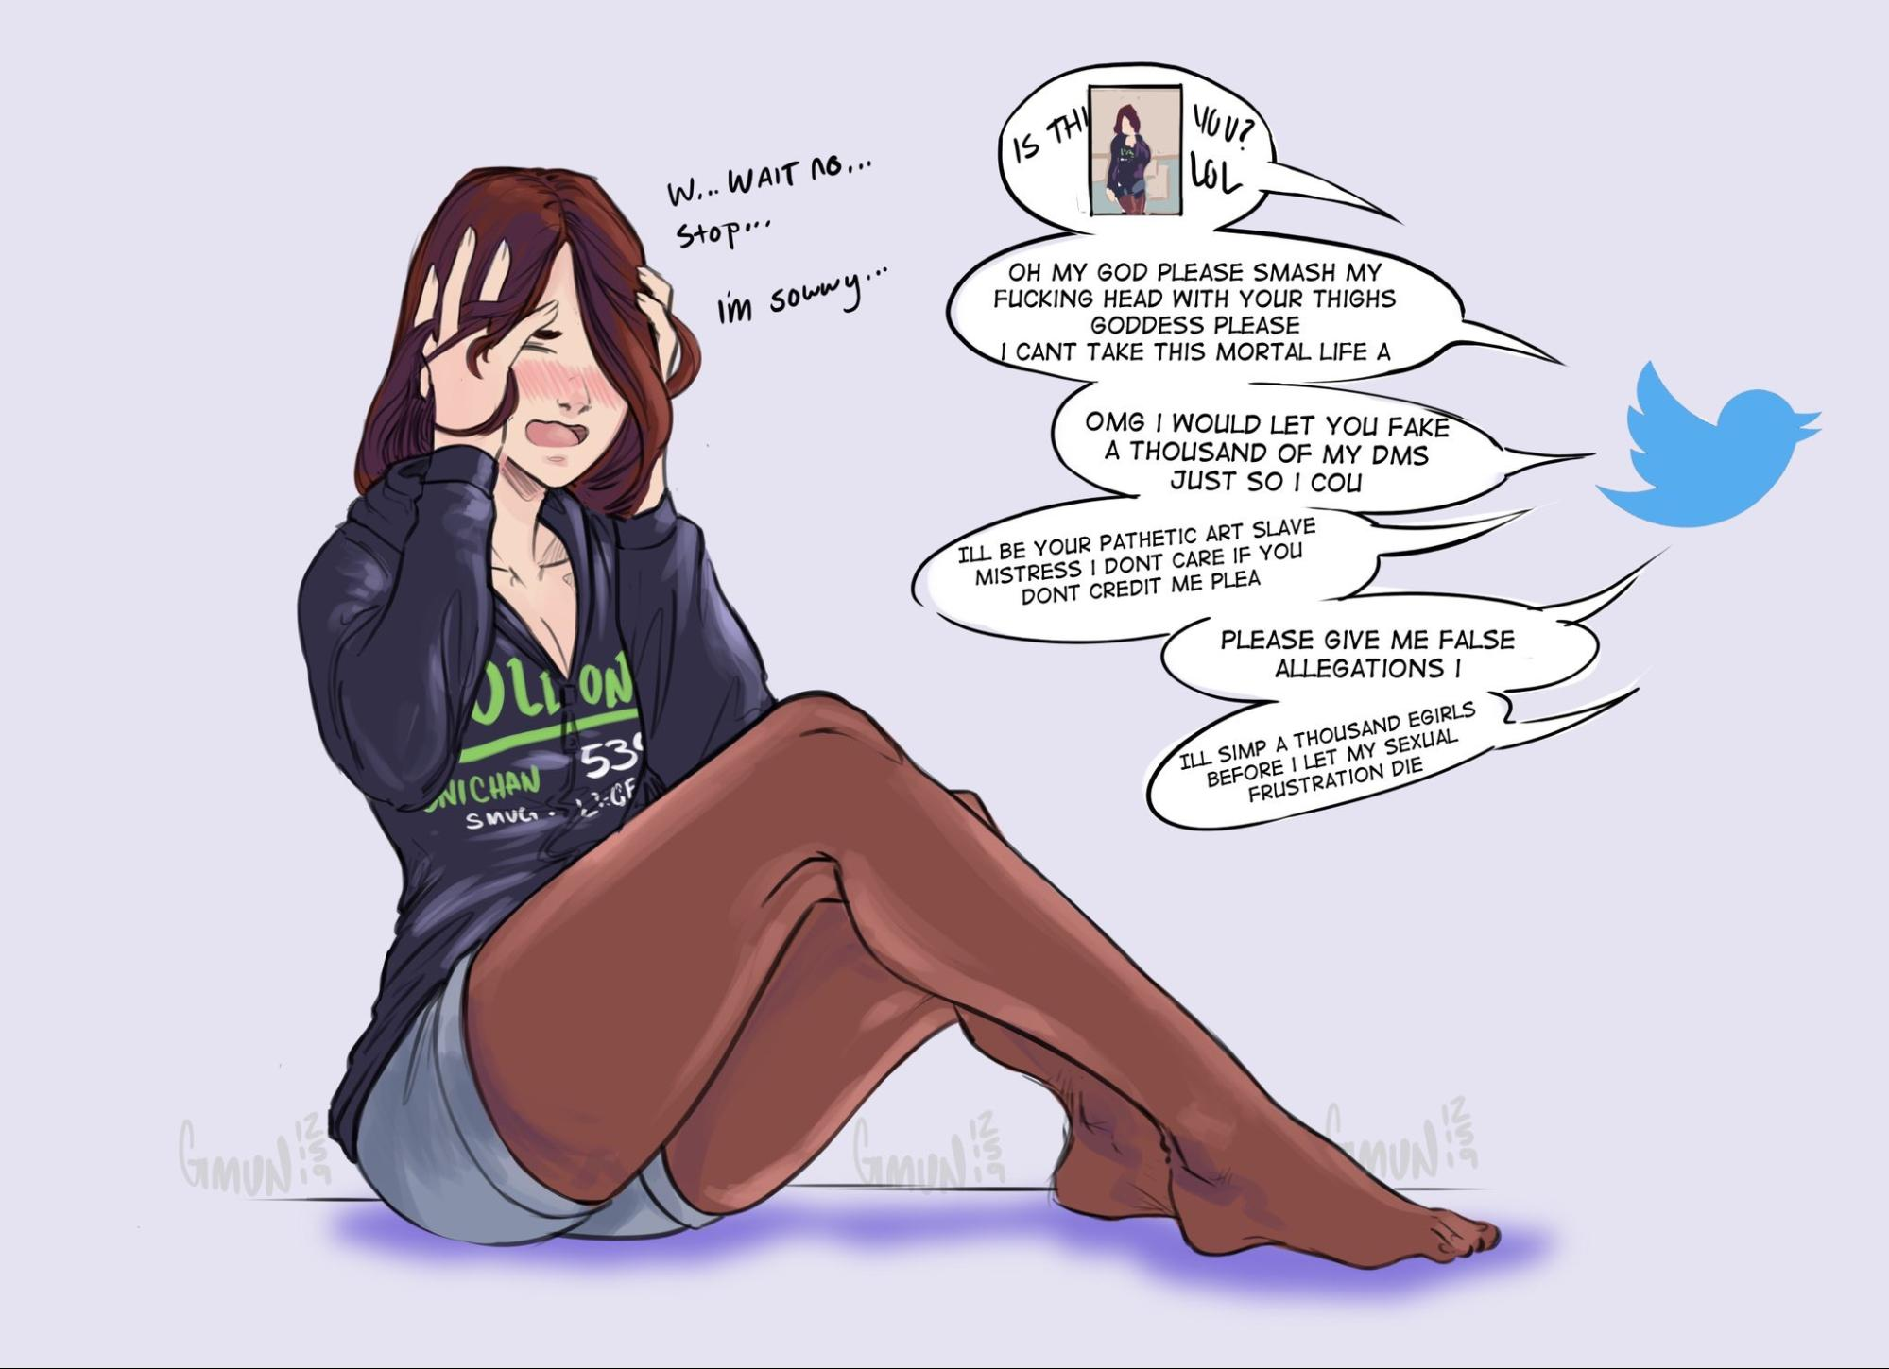

ArthurDank 19-Dec-19 05:52 AM

lmao nice and my favorite clothes of yours

haha thats what happened

Bunny 19-Dec-19 05:53 AM

That’s the picture that leaked somehow lol

Now everyone wants me to sit on their face lol

You like this?
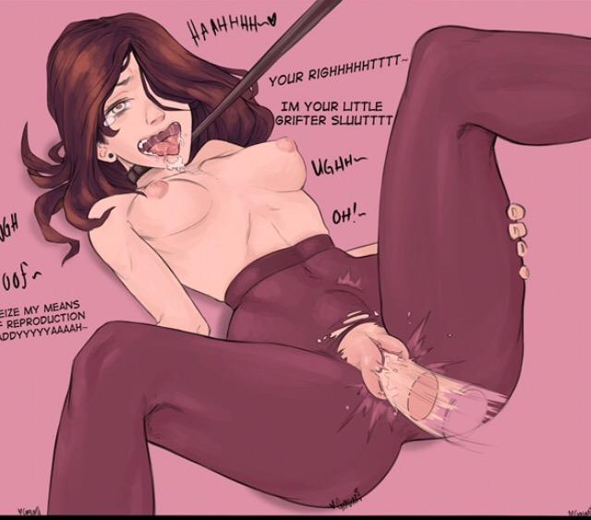

ArthurDank 19-Dec-19 05:57 AM

fuck yes i do thought about doing you like that a lot

and i wish you would sit on my face

Bunny 19-Dec-19 05:57 AM

I was given 80$ yesterday too lol

ArthurDank 19-Dec-19 05:57 AM

whoa

Bunny 19-Dec-19 05:58 AM

Gonna buy this with it lol
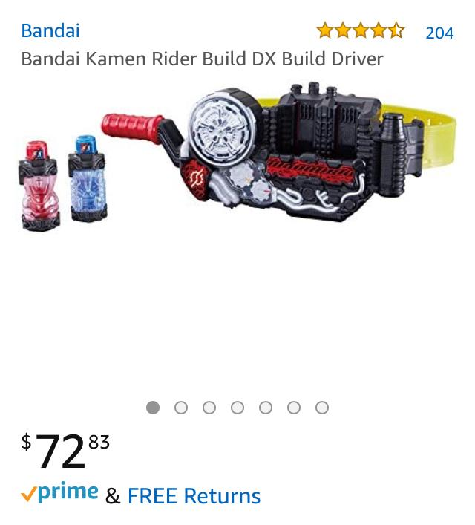

ArthurDank 19-Dec-19 05:58 AM

wicked

Bunny 19-Dec-19 05:59 AM

I still can’t believe this single picture caused so much thirst lol

ArthurDank 19-Dec-19 06:00 AM

i wanted to eat that pussy the first moment i saw you in that (edited)

Bunny 19-Dec-19 06:01 AM

Look how accurate they made my hips lol
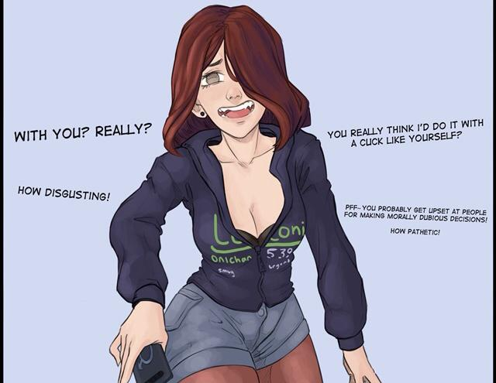
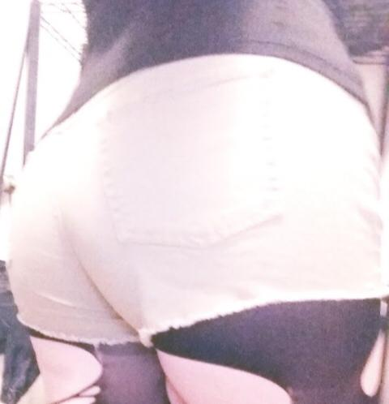

I can’t believe they thought leaking what I look like would actually cause any damage at all lol

ArthurDank 19-Dec-19 06:06 AM

lol IKR

thicc thighs save lives obviously

nah no damage nor should there be

Bunny 19-Dec-19 06:06 AM

People think I’m a trap too lol

ArthurDank 19-Dec-19 06:06 AM

you're very curvy for a trap

Bunny 19-Dec-19 06:07 AM

So is Dimitri

ArthurDank 19-Dec-19 06:07 AM

not that it matters cause i know you aint, would still fuck you all the same

Bunny 19-Dec-19 06:07 AM

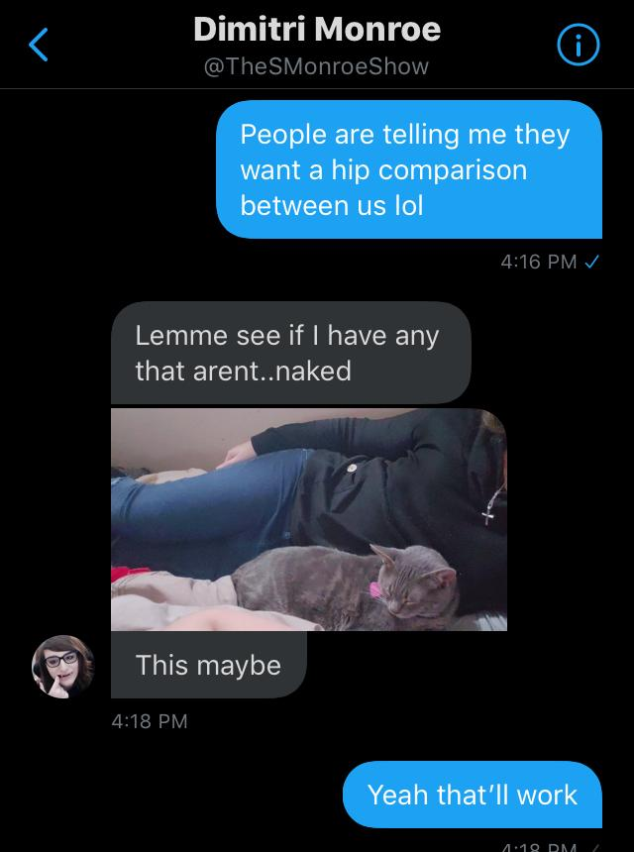

ArthurDank 19-Dec-19 06:07 AM

true he is i would fuck him too lol

goddamn

wow so similer but you have boobies

Bunny 19-Dec-19 06:09 AM

I haven’t had people recognize me irl yet though

ArthurDank 19-Dec-19 06:09 AM

your face is covered

that should be enough and your hair is blue now i believe hehe

Bunny 19-Dec-19 06:10 AM

Back to brown actually

ArthurDank 19-Dec-19 06:10 AM

oh wow cool

Bunny 19-Dec-19 06:11 AM

I love how they gave me nagatoro fangs
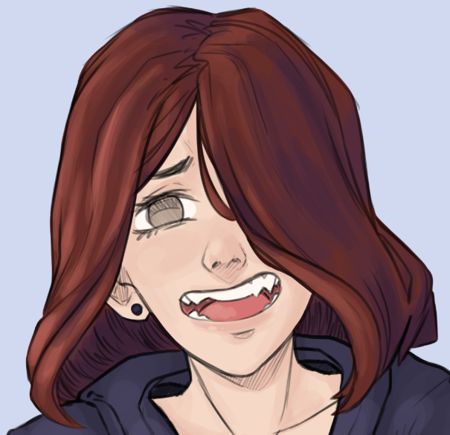
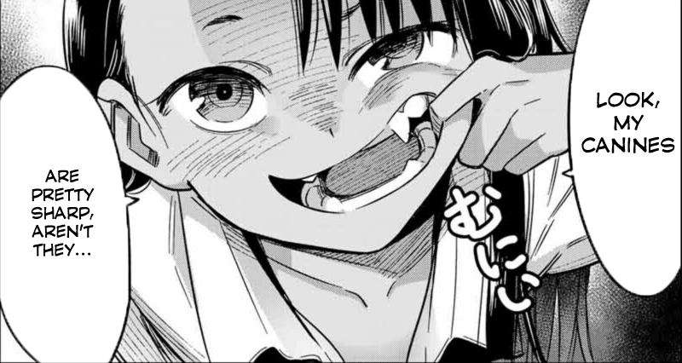

ArthurDank 19-Dec-19 06:11 AM

they sure did good shit huh

i like em always wanted head from a fangy girl lol

looks so cute

Bunny 19-Dec-19 06:13 AM

Can’t imagine how much hornt energy would be produced if this leaked lol
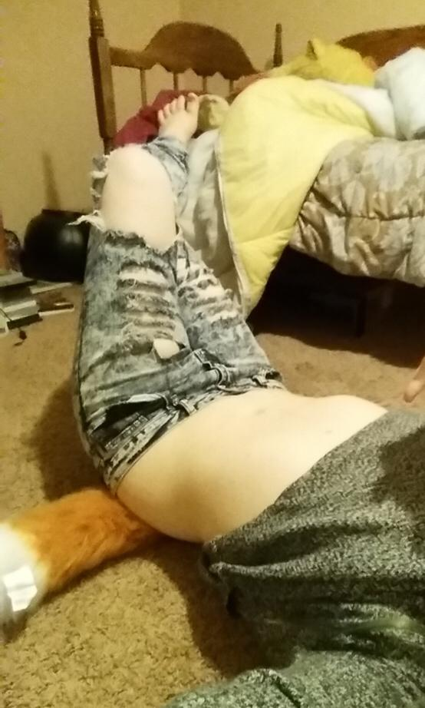

ArthurDank 19-Dec-19 06:14 AM

that midriff would be too much (edited)

looks so nice

Bunny 19-Dec-19 06:15 AM

My picture actually made it to Instagram lol

ArthurDank 19-Dec-19 06:15 AM

i saw that lol wow you are famous basically

Bunny 19-Dec-19 06:16 AM

Actually lemme show you how many likes the tweet got

One sec

ArthurDank 19-Dec-19 06:16 AM

cool

Bunny 19-Dec-19 06:18 AM

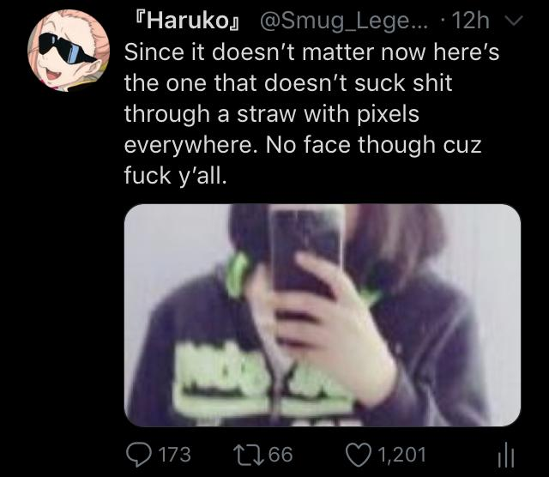

ArthurDank 19-Dec-19 06:18 AM

1,201 fuck me

its well earned

Bunny 19-Dec-19 06:19 AM

It’s the hips lol

ArthurDank 19-Dec-19 06:19 AM

true well the whole package but the hips always stand out

Bunny 19-Dec-19 06:19 AM

Everyone loves hips


ArthurDank 19-Dec-19 06:20 AM

damn right we do

Bunny 19-Dec-19 06:21 AM

I wonder if people are still talking about it lol

Let’s see

ArthurDank 19-Dec-19 06:21 AM

im sure they are

hmm

Bunny 19-Dec-19 06:25 AM

Lemme check regular google search

ArthurDank 19-Dec-19 06:27 AM

cool

any luck

Bunny 19-Dec-19 06:28 AM

Still looking

ArthurDank 19-Dec-19 06:30 AM

cool

Bunny 19-Dec-19 06:33 AM

https://twitter.com/miikyn/status/1207178316886601729?s=12

 Lumin (@Miikyn)
EHY CABT I ESCAPE THIS
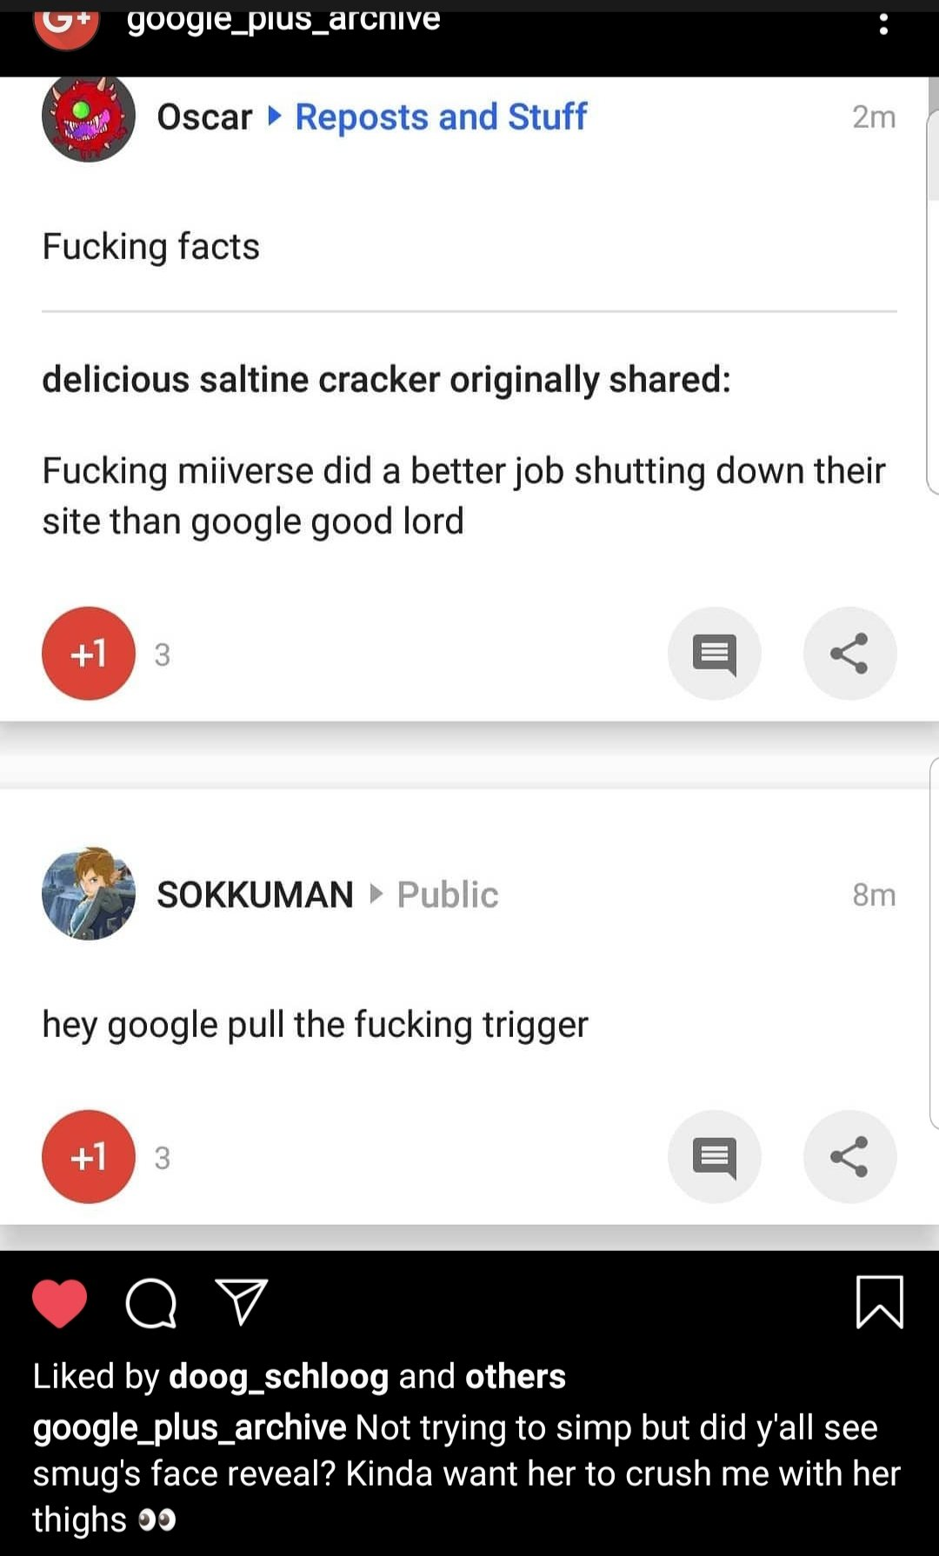
Twitter

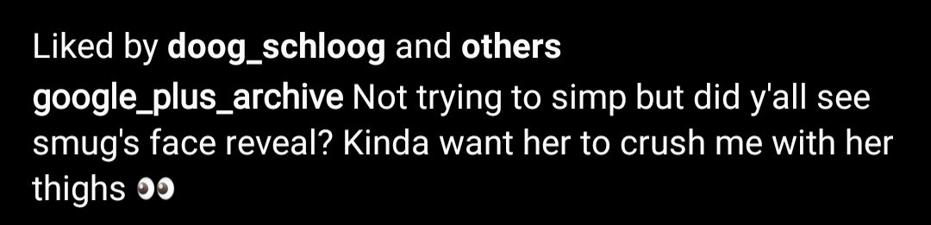

ArthurDank 19-Dec-19 06:33 AM

yep still going on lmao

cant beat it you will be talked about for a while

Bunny 19-Dec-19 06:34 AM

Would not be against being fucked with a leash on my neck lol

ArthurDank 19-Dec-19 06:35 AM

i will need to keep that in mind plowing your grifter pussy

Bunny 19-Dec-19 06:36 AM

The comments are hilarious

https://twitter.com/Smug_Legend/status/1206305576042553344

 『Ryuuko』 (@Smug_Legend)
Since it doesn’t matter now here’s the one that doesn’t suck shit through a straw with pixels everywhere. No face though cuz fuck y’all.

Likes
1789
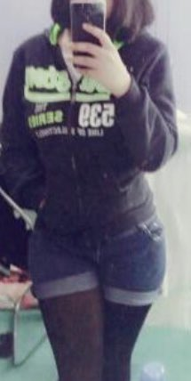
Twitter

ArthurDank 19-Dec-19 06:37 AM

they sure were i saw them even as they were posted the thirst is strong

not that i blame them

Bunny 19-Dec-19 06:39 AM

https://twitter.com/smug_legend/status/1203291171822460932?s=12 also

『Ryuuko』 (@Smug_Legend)
Hello, I’d like to introduce you to my religion

Likes
537
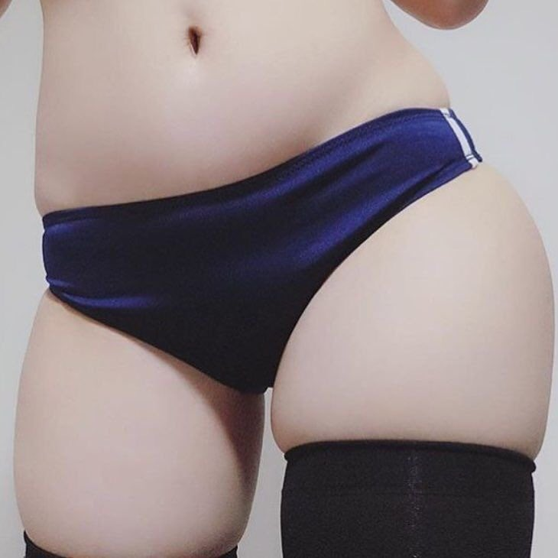
Twitter

ArthurDank 19-Dec-19 06:39 AM

lory its 6:30 am im about to crash thanks for chiming in missed you honestly :) hope to hear from you soon, you look like the kinds chick i imagined as my gf

oh i saw that one nice thighs whomever it was

thats a damn good religion

i would love to know the good book more closely

ArthurDank 19-Dec-19 10:30 PM

how are you doing?

ArthurDank 19-Dec-19 11:05 PM

hope you are okay lory for what its worth i think you did the right thing

I will be around if you need me

Bunny 19-Dec-19 11:12 PM

Thaaanks

ArthurDank 19-Dec-19 11:13 PM

anytime <3

ArthurDank 19-Dec-19 11:20 PM

wanna talk or fuck just hit me up its always fun talking to you cause you've been very kind to me (edited)

ArthurDank 20-Dec-19 01:38 AM

so what are you doing right now if its okay to chime in

ArthurDank 20-Dec-19 05:31 AM

have a good night sorry about the breakuo but i think you did what was best

Bunny 20-Dec-19 05:36 AM

Yeah I’ll be fine

ArthurDank 20-Dec-19 05:37 AM

thats good sorry if i bugged you sounds like its a load off your mind

Bunny 20-Dec-19 05:37 AM

Nah I’m okay

ArthurDank 20-Dec-19 05:37 AM

im glad hugs

you did right by you and thats good so many people dont have the will

ArthurDank 20-Dec-19 05:45 AM

anyway im off to bed sweet dreams

ArthurDank 20-Dec-19 12:34 PM

I see you took him back, good luck I guess I think its a bad idea but its your life good luck (edited)

