

Direct Messages
Bunny
Before 22-Feb-19 12:00 AM

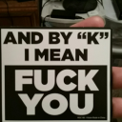
ArthurDank 13-Sep-18 06:03 PM

hey its arthurdank frozen added me back thanks saw your pics you are trim alright you could definitely do that cosplay easy


Bunny 13-Sep-18 06:20 PM

Yeh

Bunny 13-Sep-18 09:04 PM

You alright? I’m sorry

It’s not your fault dude

ArthurDank 13-Sep-18 09:05 PM

believe me i know its not my fault but i overreacted sorry just relationship drama ehh no offense been around it too much not your fault I just cant stand drama

Bunny 13-Sep-18 09:06 PM

No no no

He’s fine now

He just cares about me a lot

That’s all

I’m sorry

ArthurDank 13-Sep-18 09:07 PM

its okay

i dont know what to say its not that i feel bad or anything ehh its complicated

dont blame yourself

its just if talking to you is gonna get him riled up its just not anything I want, I have had many friends stop talking to me because of their SO's

Bunny 13-Sep-18 09:30 PM

No no no

It’s all okay

Join again if you wanna

Also refollow me

He’s not angry with you

ArthurDank 13-Sep-18 09:36 PM

its fine either way i dont feel bad for anything i just dont want any drama is all i have had too much of it im sure you understand but i will re join and re follow you

ArthurDank 14-Sep-18 12:04 AM

glad we talked this out

Bunny 14-Sep-18 12:14 AM

Same

ArthurDank 14-Sep-18 12:15 AM

so how are you this evening?

Bunny 14-Sep-18 12:22 AM

I’m good

ArthurDank 14-Sep-18 12:22 AM

cool cool

sorry if you aren't feeling chatty its fine was just trying to spark a convo

Bunny 14-Sep-18 12:22 AM

Sorry was playing Pokemon yellow

ArthurDank 14-Sep-18 12:23 AM

good memories :)

Bunny 14-Sep-18 12:23 AM

Also fantasizing about new best girl


ArthurDank 14-Sep-18 12:24 AM

shes a badass babe you have good taste

Bunny 14-Sep-18 12:26 AM

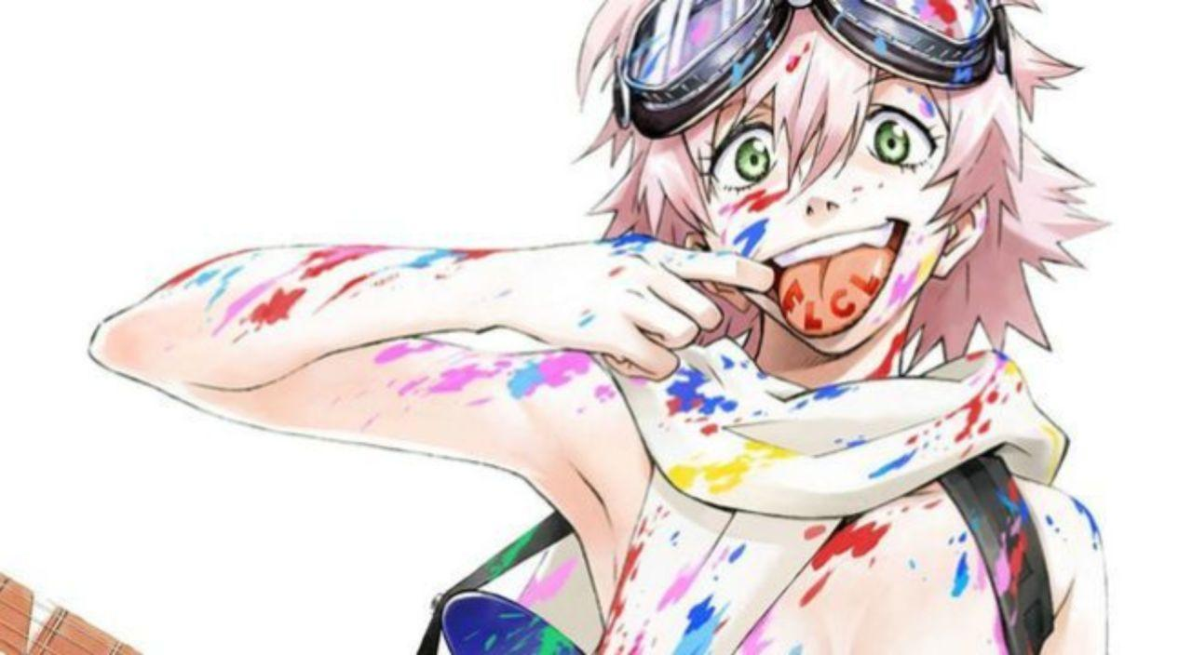

ArthurDank 14-Sep-18 12:27 AM

that one is her in a heartbeat a real wild spur lol

chick cracks me up she is hard to describe there is good, bad and her she is in her own catagory

Bunny 14-Sep-18 12:37 AM

Can’t wait to get the cosplay honestly
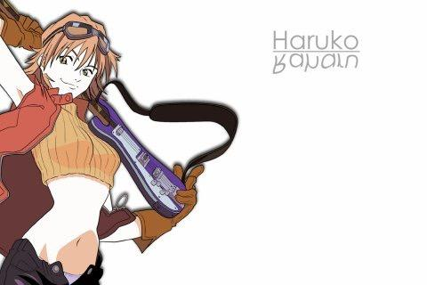

ArthurDank 14-Sep-18 12:38 AM

you will rock this look you are similer to haruko

i could see this happen easily

Bunny 14-Sep-18 12:41 AM

And in personality as well

ArthurDank 14-Sep-18 12:41 AM

yes i stand by that

you strike me as a haruko easily

ArthurDank 15-Sep-18 10:24 AM

how are you doing Mari?

Bunny 15-Sep-18 01:15 PM

Not so good

I’ll be gone for a little while

ArthurDank 15-Sep-18 01:17 PM

im sorry whats going on?

Bunny 15-Sep-18 01:43 PM

Stuff at home

Just tell everyone I won’t be around for a little while okay?

ArthurDank 15-Sep-18 01:44 PM

i get you sounds hard i wont

did we say something to alarm your bf?

hope you will be ok

Bunny 15-Sep-18 01:51 PM

No it’s fine

I’m just dealing with things at home

ArthurDank 15-Sep-18 01:55 PM

cool well best of luck mari you need to vent just hit me up ok? i will see you

ArthurDank 16-Sep-18 05:46 PM

hey mari i was wondering did you unfollow me or is it cause im using my alt the account im using now is @dankerthendank

ArthurDank 16-Sep-18 07:58 PM

remember when i said "cant say nigger because we're surrounded by retards?" yeah that got me suspended lol

Bunny 16-Sep-18 09:47 PM

yeh

I remember

ArthurDank 16-Sep-18 09:47 PM

i sent that earlier sorry

Bunny 17-Sep-18 10:30 AM

It’s fine

ArthurDank 09-Oct-18 11:15 AM

sorry about the mari comment last night, didn't mean anything by it just shade, let Spidey know I replied back to him regarding last night if you would thanks

i kinda ragequit last night sorry for unfriending you and for being a dick

Bunny 09-Oct-18 12:03 PM

That’s fine

ArthurDank 09-Oct-18 12:04 PM

cool :)

also if you wanna follow me back on twitter thats fine i ragequit and now you are unfollowed from me if you want too that's cool if not i understand

ArthurDank 11-Feb-19 02:16 AM

how are you doing Lory

Bunny 11-Feb-19 02:16 AM

I’m good

What’s up?

You don’t pop in very often

ArthurDank 11-Feb-19 02:16 AM

i just recently returned to discord lol

im glad you are good and not much about to drive for a bit wanted to say hello

Bunny 11-Feb-19 02:17 AM



ArthurDank 11-Feb-19 02:17 AM

the only reason i dont pop in i just dont wanna bug anyone lol

i do dig a good dab

Bunny 11-Feb-19 02:17 AM

Where ya going?

ArthurDank 11-Feb-19 02:18 AM

gotta check on my uncle he is only like 10 mins away gotta remind him to check his suger

he had a stroke a while back so yeah hah

gotta start the car and let it warm up

then im coming back because it is too damn cold

Bunny 11-Feb-19 02:23 AM

Alrighty well tell me when you get back

ArthurDank 11-Feb-19 02:23 AM

oh sure i will not used to people still wanting to chat lol

i just want to say if i seem distant yowards you or spidey its not cause im mad at you guys for anything but well its complacated basically trying to get to close to people has bit me before its made me phobic about trying to have friends again

Bunny 11-Feb-19 02:28 AM

Naaaah we’re cool

ArthurDank 11-Feb-19 02:31 AM

had to start the car its gonna need a few. thanks mari i know but i like you guys and i want to be friends i just dont seem to know how.

its not you all its just after playing games with a pedo online for about 4 years not knowing then when it comes out all the mutuals you had prefer the pedo over you so much they claim the 11 yr old he sent the dick pic to suduced him bitch plz lol

Bunny 11-Feb-19 02:42 AM

I’m just a big tiddy waifu lol

ArthurDank 11-Feb-19 03:03 AM

lol well no arguments about your endowments lol

im back btw

Bunny 11-Feb-19 03:04 AM

I’ve busted bras before lmao

ArthurDank 11-Feb-19 03:05 AM

lmao i believe it based off the pics from frozens discord room last september

lol

parker is a lucky guy haha

Bunny 11-Feb-19 03:05 AM

I’ve gotten bigger too

ArthurDank 11-Feb-19 03:05 AM

holy crap

sound like you defy gravity now

Bunny 11-Feb-19 03:06 AM

I was DDD and was G until recently I’ve apparently already outgrown those

I’m not certain but I might be an H at this point

ArthurDank 11-Feb-19 03:07 AM

good grief i almost dont believe it but i know you wouldn't lie about that lol

how is your back?

can't say im shocked tho i mean i could tell even back then

Bunny 11-Feb-19 03:13 AM

Occasional pain but otherwise it’s fine

They weigh about 6 pounds each

12 pounds of meat on my chest

ArthurDank 11-Feb-19 03:16 AM

holy crap lory that be a fine a set of pipe cleaners there lol

glad its not too painful on ya

i hope you have a bra that can handle that kind of firepower

Bunny 11-Feb-19 03:23 AM

I do now

I’ve broken several

ArthurDank 11-Feb-19 03:25 AM

thats good and well you gotta crack a few eggs to make an omelette or however that goes lol

so what have you been into lately lory? aside fro. gravity defying boobage?

Bunny 11-Feb-19 03:27 AM

I started an Attack on Titan D&D game

I play potato girl

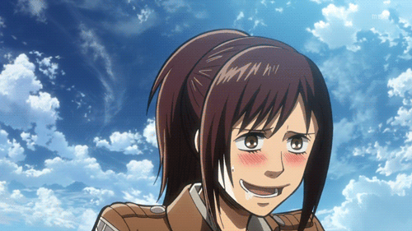

ArthurDank 11-Feb-19 03:29 AM

oh yeah i saw you talking on twitter about it nice

sasha she makes me wish i was a potato lol

hope im not interupting the game

Bunny 11-Feb-19 03:33 AM

Naaaah

Everyone else is asleep

We typically play from Noon to 6

Or 6 to midnight

ArthurDank 11-Feb-19 03:33 AM

oh thats cool glad you all have been having fun

hows life outside of social media

not trying to interrogate i just like to get to know people outside of what they project online cause twitter brings out the titan in all of us lol

Bunny 11-Feb-19 03:38 AM

Tbhhhhh

I occasionally help out at a school

ArthurDank 11-Feb-19 03:40 AM

oh cool i remember you telling us about the class you were at once, you still do that?

Bunny 11-Feb-19 03:41 AM

Yup

ArthurDank 11-Feb-19 03:43 AM

thats pretty cool, you still work at a warehouse as well?

Bunny 11-Feb-19 03:45 AM

Nope

That was a looooong time ago

ArthurDank 11-Feb-19 03:46 AM

oh sorry about that lol

i like work like that too i like staying on the move, you aren't working currently?

Bunny 11-Feb-19 03:49 AM

For the school occasionally

ArthurDank 11-Feb-19 03:49 AM

nice are the kids easy to work with?

Bunny 11-Feb-19 03:52 AM

When they’re not fixated on my bazongas yeah otherwise they’re pleasant

ArthurDank 11-Feb-19 03:53 AM

thats good

well given your ample chest size lol I guess its hard to overlook XD

Bunny 11-Feb-19 03:56 AM

I do wrap sometimes

ArthurDank 11-Feb-19 03:56 AM

wrap what?

your boobs?

Bunny 11-Feb-19 03:58 AM

Yup

ArthurDank 11-Feb-19 03:59 AM

wow trying to conceal your firearms doesn't that hurt?

Bunny 11-Feb-19 04:01 AM

Not particularly

The wrap is soft

ArthurDank 11-Feb-19 04:01 AM

oh thats good when you said wrap i thought of something rough like plastic for some reason lol

Bunny 11-Feb-19 04:02 AM

I’m really squishy too

Oh no

ArthurDank 11-Feb-19 04:02 AM

oh nice

lol

Bunny 11-Feb-19 04:02 AM

It’s soft like linens

ArthurDank 11-Feb-19 04:02 AM

ah i get it now well that sounds nice

Bunny 11-Feb-19 04:02 AM

Kinda like those ninja wraps y’know?

ArthurDank 11-Feb-19 04:03 AM

ah yes now i get you glad its confortable

so what are you doing right now?

Bunny 11-Feb-19 04:07 AM

Watching Game Grumps with Spidey

ArthurDank 11-Feb-19 04:08 AM

awesome glad you two are able to hangout irl atm

Bunny 11-Feb-19 04:11 AM

I was gonna make a joke about spider cocks but ehhh

ArthurDank 11-Feb-19 04:11 AM

you can lol

Bunny 11-Feb-19 04:12 AM

Spider cock spider cock~

ArthurDank 11-Feb-19 04:12 AM

lol

Bunny 11-Feb-19 04:13 AM

Hung like a horse

Lmao

ArthurDank 11-Feb-19 04:13 AM

lmao i think you lost the beat there but it will do

i have no doubt about his prowess as it were i was gonna say cums where ever a spider cock can but i digress lmao

Bunny 11-Feb-19 04:16 AM

I’m not joking though

ArthurDank 11-Feb-19 04:16 AM

i know you aren't

Bunny 11-Feb-19 04:16 AM

8 fucking inches

HHHHHHHHH

ArthurDank 11-Feb-19 04:16 AM

jesus wow

i knew you weren't kidding about that tho lol dont ask me how i just knew XD

definitely can go deep as it were

Bunny 11-Feb-19 04:17 AM

I have an affinity for anal

ArthurDank 11-Feb-19 04:17 AM

I have noticed that on twitter or i read between the lines of spideys texts

thats never a bad thing i assure you

Bunny 11-Feb-19 04:18 AM

I ain’t risking a brat at this point in my life

ArthurDank 11-Feb-19 04:18 AM

yeah way too soon

Bunny 11-Feb-19 04:18 AM

I heard that pregnancy makes a woman’s tits grow like two sizes or whatever

I’d be fucking enormous

ArthurDank 11-Feb-19 04:19 AM

oh geez you're gonna fall and not get up at that point

indeed lol

your boobs might explode

i hope my gf has a thing for anal whomever she is

Bunny 11-Feb-19 04:22 AM

I just like getting my guts stirred up

ArthurDank 11-Feb-19 04:22 AM

nice i always say the kinkier the better

then again im a virgin so whatever lol it is always nice when said person gets into it

Bunny 11-Feb-19 04:24 AM

Guts stirred = happy Lory

ArthurDank 11-Feb-19 04:25 AM

and you have seemed quite happy tonight haha ;)

thats always a good thing

some chicks say they get no pleasure out of anal i dont know lol

guess their guy doesn't do it right

Bunny 11-Feb-19 04:27 AM

Or isn’t hung enough

ArthurDank 11-Feb-19 04:28 AM

yeah probably would be but can't because of his cuck nature making him incapable of being a man mid thrust or more likely too much blubber

they're not whales without blubber lol

anyway it's 4:30 am hope you didn't mind me jumping in out of te blue like that i just wanted to talk to you guys, glad i did i enjoyed our chat lory hope i didn't impose, wasn't my intention :)

you and spider have a good night okay? :)

Bunny 11-Feb-19 04:34 AM

I’m still here lol

ArthurDank 11-Feb-19 04:34 AM

oh i know lol

but im about to go to sleep

like i said hope i didn't inpose on you two :)

but i had fun chatting

Bunny 11-Feb-19 04:37 AM

Awwww

I wanna chat mioiireee

ArthurDank 11-Feb-19 04:38 AM

well me too honestly it was fun :) we can chat tomorrow if you like friend :)

im out you have a good night, spidey too :)

Bunny 11-Feb-19 04:45 AM

Yee

Bunny 11-Feb-19 12:14 PM

Yo you up?

ArthurDank 11-Feb-19 12:19 PM

sure am how ya doing?

Bunny 11-Feb-19 12:23 PM

Just seeing if you were up

ArthurDank 11-Feb-19 12:24 PM

you're fine haha

yep im up finally

so what's up with you? :)

Bunny 11-Feb-19 12:33 PM

Bored

ArthurDank 11-Feb-19 12:33 PM

that sucks nothing going on?

i see you are roasting idiots on twitter alive so thats something lol

ArthurDank 11-Feb-19 12:52 PM

had to take a shower now im just relaxing for a bit

what about you?

Bunny 11-Feb-19 01:34 PM

Was putting my shirt on because I’m freezing to death

ArthurDank 11-Feb-19 01:37 PM

yikes well same here it is pretty damn cold here in ohio

im dried up now just hanging around for another 20 mins then i head to the store get uncle some bread, drop it off, then work from 3-10:30

Bunny 11-Feb-19 01:41 PM

Just laying around here

Boob table for my phone and arms

ArthurDank 11-Feb-19 01:43 PM

haha well its winter break so plenty of time to just relax and nail it to the mast with parker lol that sounds handy being about to use your rack as a phone and arm rest

Bunny 11-Feb-19 01:59 PM

I mean for all intents and purposes I can fit a cucumber between them with only the tip poking out

ArthurDank 11-Feb-19 02:00 PM

damn that is impressive

definitely more fun for Parker lol glad your back holds up pretty well amidst all that ordinance

ArthurDank 11-Feb-19 02:08 PM

Welp Lory heading to uncles then work, you and Parker have a good day and he told me you were sick, I wish you a fast recovery :)

Bunny 11-Feb-19 02:09 PM

Thank you

ArthurDank 11-Feb-19 02:11 PM

you're welcome busty lol

have a good one my friend

Bunny 11-Feb-19 02:20 PM

You too

Bunny 11-Feb-19 07:56 PM

Henlo fren

ArthurDank 11-Feb-19 11:07 PM

henlo to you too

i just got home about 20 mins ago lol

ArthurDank 11-Feb-19 11:28 PM

how ya doing?

Bunny 11-Feb-19 11:28 PM

I’m good

Just relaxing

ArthurDank 11-Feb-19 11:30 PM

glad you're feeling a bit better and thats cool me too now that im home

ArthurDank 11-Feb-19 11:43 PM

how did your day go?

Bunny 12-Feb-19 12:16 AM

Good

I napped a lot

I’ll probably do more napping tomorrow

ArthurDank 12-Feb-19 12:18 AM

napping is best when sick and glad your day went good

i envy your napping i wanted to nap at work

i got called it to do another shift tomorrow on my day least its only 5-10 lol

ArthurDank 12-Feb-19 02:48 AM

you have a good night lory talk to ya soon :) im about to head to bed

Bunny 12-Feb-19 07:49 PM

Henlo

ArthurDank 12-Feb-19 07:50 PM

Hi Lory how is it going?

Bunny 12-Feb-19 07:52 PM

Hornt

ArthurDank 12-Feb-19 07:52 PM

oh nice lol

me too despite being at work

parker is close by sure he can help with that lol

help you i mean lol not me im stright X

XD

Bunny 12-Feb-19 07:59 PM

Lmao

But yeah

Can’t help myself sometimes y’know?

ArthurDank 12-Feb-19 07:59 PM

oh me either i get woubd up easily too

i know sometimes you gotta be honest

you're honest anyway tho

sure Parker will help you if he is close lol why have fun alone when it can be a party XD

Bunny 12-Feb-19 08:03 PM

Butt stuff

ArthurDank 12-Feb-19 08:04 PM

what about butt stuff?

lol

Bunny 12-Feb-19 08:05 PM

Is fun

Huehuehue

Dicke in butte

Hehehehe

ArthurDank 12-Feb-19 08:07 PM

lmao nice

you taking it in the butt right now?

sorry thats just how it sounded

didn't know parker was okay with you texting while doing that lmao

Bunny 12-Feb-19 08:09 PM

I’ll leave it to the imagination lol

ArthurDank 12-Feb-19 08:10 PM

so yes in otherwords lol

well you are cordinated lol

Bunny 12-Feb-19 08:11 PM

Hehehehe meat

ArthurDank 12-Feb-19 08:12 PM

lol

Bunny 12-Feb-19 08:13 PM

You didn’t even guess either,that’s part of the fun

ArthurDank 12-Feb-19 08:15 PM

well was i wrong?

lol

or maybe you were pulling my leg the whole time lol

Bunny 12-Feb-19 08:17 PM

I mean

ArthurDank 12-Feb-19 08:18 PM

lmao huh? you mean what?

honestly you may have been pulling my leg parker doesn't strike me as being okay with playing with the phone during sex i could be wrong XD

Bunny 12-Feb-19 08:21 PM

I’m messing with you

But yeah I could go for some dicke right about now

ArthurDank 12-Feb-19 08:22 PM

lmao you kill me but i had a feeling knowing parker he would flip haha

you're crazy but i like that about ya my friend i get you i could go for some pussy about now haha

Bunny 12-Feb-19 08:26 PM

I want my guts stirred up

ArthurDank 12-Feb-19 08:26 PM

lmao

yeah i wanna stir someones insides up being a virgin is very frustrating for me lol

isn't parker with you? where is he? lol

Bunny 12-Feb-19 08:29 PM

Parker is my baby~

And I getcha

Big joke time

I’d stick a potato up my ass

ArthurDank 12-Feb-19 08:29 PM

yeah but you said you want dick so where is he lol?

lmao

well you did say parker was a potato haha

Bunny 12-Feb-19 08:32 PM

Asleep at the moment

ArthurDank 12-Feb-19 08:32 PM

ahh makes sense why you can't ravage him or vice versa lol

Bunny 12-Feb-19 08:32 PM

Sleep diddling?

ArthurDank 12-Feb-19 08:32 PM

have you done that? lol

i mean some people do that tis kinky hope my girl does haga

but i dont want a kid either right now soo

Bunny 12-Feb-19 08:38 PM

Wait so blue balls means a dude’s balls are literally blue?

Tf

ArthurDank 12-Feb-19 08:39 PM

lmao so im told

wait who has blue balls

Bunny 12-Feb-19 08:40 PM

I was just asking

ArthurDank 12-Feb-19 08:41 PM

oh me sorry lol

no i never noticed my balls being blue after 29 years then again i tend to ergh nevermind lol

Bunny 12-Feb-19 08:41 PM

People actually sleep fuck though?

ArthurDank 12-Feb-19 08:42 PM

so im told i know a guy who told me his girl would ride him or blow at night and a friend said her hubby did the same

Bunny 12-Feb-19 08:42 PM

Sounds like a good idea

ArthurDank 12-Feb-19 08:45 PM

not everyone is into it but some are so something for you and parker to discuss

Bunny 12-Feb-19 08:45 PM

He did say something about swamp nuts though

ArthurDank 12-Feb-19 08:46 PM

also lory are you one who texts people while having sex? i had to ask

i have heard that but you never know till you try

Bunny 12-Feb-19 08:46 PM

I mean if you’re coordinated enough

ArthurDank 12-Feb-19 08:47 PM

i mean do you do that? lol its true you can

Bunny 12-Feb-19 08:48 PM

I’ve never done that before no

It would be a new experience however

8inches up the fart box while shitposting

ArthurDank 12-Feb-19 08:49 PM

lmao stranger things have happened assuming parker would be cool with that

but if i may aska favor

if you were to start doing that wait until you are done before you DM i have had people do that before no offense it makes me feel very awkward

DM me i mean*

Bunny 12-Feb-19 08:52 PM

Sure no problem

ArthurDank 12-Feb-19 08:52 PM

and about swamp nuts you never know till you try maybe parker is just a gentleman

Bunny 12-Feb-19 08:52 PM

My thighs huuuuurty

ArthurDank 12-Feb-19 08:53 PM

okay i didn't want you to think i was a prude or against talking about dirty stuff or about sex lives im cool with that but texting me while getting fucked makes me feel weird and not the good way, probably sounds dumb but i hppe it makes sense

why do your thighs hurt? parker grip too tight? lol

you have thicc thighs also my phone is about to die so if i vanish you know why

Bunny 12-Feb-19 08:54 PM

Sometimes yeah lol

ArthurDank 12-Feb-19 08:55 PM

i was fine with joke you played on me tho earlier that was funny lmap

ahh i see well he is a hugger

Bunny 12-Feb-19 08:56 PM

Also I have big thighs

ArthurDank 12-Feb-19 08:57 PM

yes you do i saw the pic back in frozens group

bravo btw lol

hope i didn't seem like a prude when i asked you for that favor hope i didn't cause any offense

Bunny 12-Feb-19 09:01 PM

Naaaah

I wanna try that idea but at the same time it sounds a bit odd

And it’s not because you’re jealous huh? I understand awkwardness

ArthurDank 12-Feb-19 09:03 PM

no im not jealous but yeah its hard to make chat, did i seem jealous or something? just curious

it does seem a bit odd to be sure and you are a beautiful girl but i dont hit on people who are already involved lol mom taught me better

hard to make chat during coitus

Bunny 12-Feb-19 09:04 PM

Nah nah

Yanking your chain

ArthurDank 12-Feb-19 09:05 PM

lmao its cool i like when you play with me like we're friends and besides jealous guys dont wanna hear about you having sex at all, im fine with it just as long as its after the fact not during ;D

you okay lory?

Bunny 12-Feb-19 09:10 PM

Yup sorry was considering the idea and needed a moment

ArthurDank 12-Feb-19 09:11 PM

which idea?

sleep diddle or text while buttbump

Bunny 12-Feb-19 09:13 PM

I guess grinding wouldn’t be bad? I mean it’s not really the same as buttbump but y’know

ArthurDank 12-Feb-19 09:14 PM

it would make it easier to focus assuming parker doesn't lock up your phone

lmao hes gonna say im a bad influence XD

probably lol

lory i had an odd question and i hope you dont take it wrong

Bunny 12-Feb-19 09:20 PM

Go ahead and ask

ArthurDank 12-Feb-19 09:21 PM

when you posted some images in frozens group there was one with you on your side wearing shorts i was wondering did that image get deleted, ? it was last september

when we first chatted

Bunny 12-Feb-19 09:22 PM

Hm? I wonder if I still have that

ArthurDank 12-Feb-19 09:23 PM

if you wouldn't mind letting me know

Bunny 12-Feb-19 09:23 PM

I don’t remember

ArthurDank 12-Feb-19 09:24 PM

its all good no worries

Bunny 12-Feb-19 09:24 PM

Must’ve been by accident

ArthurDank 12-Feb-19 09:24 PM

no biggie was just curious

Bunny 12-Feb-19 09:24 PM

Oh no it was November and I think I still have it

ArthurDank 12-Feb-19 09:26 PM

i feel wrong for asking but i was wondering if i could have it if you find it

phone about to die lory

been fun see you when i get home lol

if not its fine really

Bunny 12-Feb-19 09:32 PM

Sure one sec

Was it this one? Because this is from November

Hold up what’s it for?

ArthurDank 12-Feb-19 10:23 PM

its not for anything lory i just had them all on my phone at one time till my sd card took a crap

its not to give to anyone but listen you dont have to give it to me its fine

sorry if that sounds weird i had them all

i have lewds and semi lewds all over my phone lol

ArthurDank 12-Feb-19 10:33 PM

sorry my phone died thats why i was gone for a while listen i dont want you to be uncomfortable so you dont have to send anything really im sorry

ArthurDank 12-Feb-19 10:46 PM

and im pretty sure that is the one

ArthurDank 12-Feb-19 11:23 PM

hope you aren't mad at me for asking about that pic

Bunny 13-Feb-19 12:56 AM

I’m not

I fell asleep lol

ArthurDank 13-Feb-19 12:57 AM

oh good i was worried lol sorry i vanished right when you were wanting to know why i wanted ot phone died

i just figured you were trying sleep diddling lol

Bunny 13-Feb-19 12:58 AM

I have the picture but I think it’s a different one entirely?

ArthurDank 13-Feb-19 12:59 AM

hmm lemme see you had shorts on layong on your side in a bed and you were wearing a shirt maybe black that was raisied half up your face wasn't visable in the pic

in trying to remember you posted it and your ab pic back to back i think

ArthurDank 13-Feb-19 01:09 AM

if that doesn't fit the description then its likely not the same, if so no worries i dont want anything that hadn't been posted to the discord or publicly im not that much of an asshole lol

Bunny 13-Feb-19 01:11 AM

Sorry looking for it

I don’t think the one I have is the right one considering it’s from November

One moment

ArthurDank 13-Feb-19 01:12 AM

take your time

Bunny 13-Feb-19 01:13 AM

Oh you mean this one? Yeah as long as you don’t blab about it

I’m surprised how easy it was to find lol

The power of saving images as favorites

ArthurDank 13-Feb-19 01:14 AM

no i would never share these i promise

awesome thanks lory

pretty gandy feature

Bunny 13-Feb-19 01:14 AM

And I also mean talking about it to anyone but me

We clear?

ArthurDank 13-Feb-19 01:15 AM

absolutely no one knows anything or ever will on my honor

thats our chat stuff

what happens in chat stays in chat

we clear lory

Bunny 13-Feb-19 01:17 AM

God

Good*

I believe this is the one?
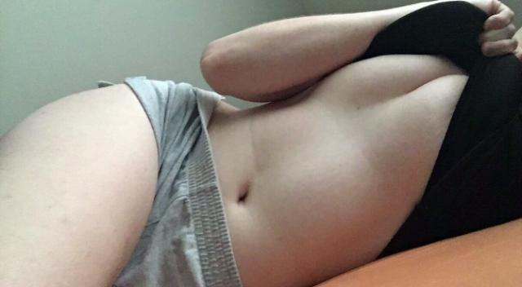

ArthurDank 13-Feb-19 01:18 AM

bingo

thank you and all i ask is you not think of me as a creeper

Bunny 13-Feb-19 01:19 AM

I’m a DDD in this one I’m a G cup now though

Naaaah

It’s all good

ArthurDank 13-Feb-19 01:19 AM

i just admire your form as it were well any hot girl

i could tell you had cannons even then hard to believe they got larger

Bunny 13-Feb-19 01:21 AM

Awww shucks

I appreciate complements

ArthurDank 13-Feb-19 01:22 AM

well im glad cause you deserve them all

Bunny 13-Feb-19 01:27 AM

I could show one from after I started growing again but I’m afraid I’d draw doubts

ArthurDank 13-Feb-19 01:28 AM

doubts about what?

i wouldn't doubt anything lol

Bunny 13-Feb-19 01:29 AM

You sure?

ArthurDank 13-Feb-19 01:29 AM

positive

i wont doubt you nor blab

Bunny 13-Feb-19 01:34 AM

Alrighty

One sec

ArthurDank 13-Feb-19 01:37 AM

cool

Bunny 13-Feb-19 01:41 AM

Boom

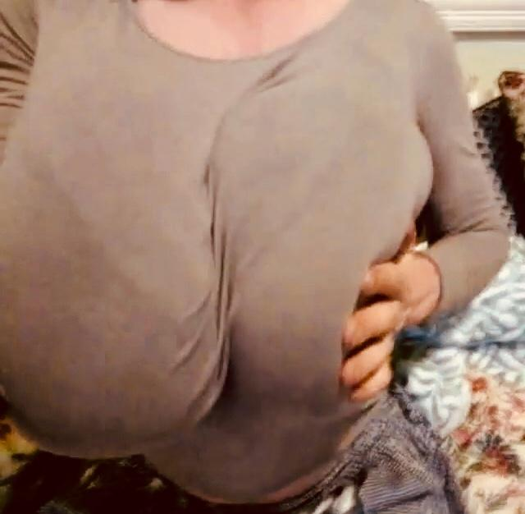

Camera is a bit fucky

ArthurDank 13-Feb-19 01:42 AM

holy shit!!

Bunny 13-Feb-19 01:42 AM

Don’t breath a word

Are we clear?

ArthurDank 13-Feb-19 01:42 AM

i swear to god

lory i would never hurt either of you guys nor betray your trust

the camera is just fine but wow

you really have grown

Bunny 13-Feb-19 01:43 AM

They’re heavy too lol

ArthurDank 13-Feb-19 01:44 AM

i bet you must have a really strong back lol

course you are fit

i see why parker is always hornt lol

Bunny 13-Feb-19 01:45 AM

I can fit an entire cucumber between them lmao

ArthurDank 13-Feb-19 01:47 AM

lmao you weren't kidding about that the other night

i was curious lory what did you mean about drawing doubts before you sent this pic?

Bunny 13-Feb-19 01:51 AM

Because I bind them so I don’t look as big sometimes

So my size when I’m not binding is absurd

ArthurDank 13-Feb-19 01:54 AM

wow well i can tell that bra is having a time lol trust me you didn't inspire doubt thats far bigger then DDD

guys would kill to have a girl like that

Bunny 13-Feb-19 01:55 AM

They usually do have a difficult time

There’s one that doesn’t even fit anymore too lol but I’m afraid I’d just shatter your brain if I shared it

ArthurDank 13-Feb-19 01:56 AM

lol i can tell you did say you have busted your share of bras

nah you wouldn't shatter my brain lol

Bunny 13-Feb-19 01:59 AM

Alrighty then

ArthurDank 13-Feb-19 01:59 AM

i can take it XD

ArthurDank 13-Feb-19 02:07 AM

you ok Lory?

Bunny 13-Feb-19 02:08 AM

Yup one sec it’s from the other day

In a DDD bra I look even bigger

Also yes I’m fine

ArthurDank 13-Feb-19 02:10 AM

take your time and cool

Bunny 13-Feb-19 02:10 AM

Sorry I keep trying to tap it and Discord keeps picking this image instead

ArthurDank 13-Feb-19 02:11 AM

lmao AoT that makes sense for some reason

its all good discord is a pain sometimes

Bunny 13-Feb-19 02:12 AM

Alrighty here we go
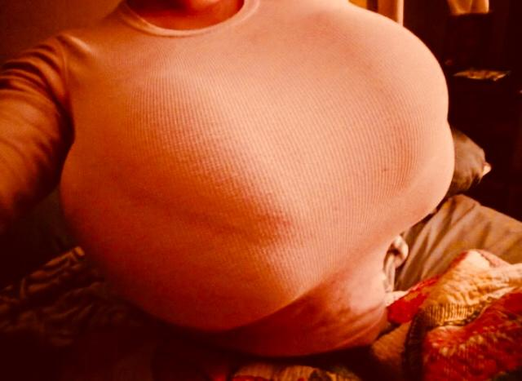

ArthurDank 13-Feb-19 02:13 AM

holy mercy mountains lol

Bunny 13-Feb-19 02:13 AM

That’s in an old bra

Just for comparison

ArthurDank 13-Feb-19 02:13 AM

DDD bra?

Bunny 13-Feb-19 02:13 AM

Yup

ArthurDank 13-Feb-19 02:14 AM

whoa you weren't kidding they do look even bigger

if they get any bigger you may explode lol

thanks for trusting me enough to share with me i just hope the strain doesn't get any worse lol

Bunny 13-Feb-19 02:23 AM

It was really struggling there too lol

ArthurDank 13-Feb-19 02:23 AM

I can tell it was given it all it got captain lol

Bunny 13-Feb-19 02:24 AM

Too much meat lol

Tiddy monster

ArthurDank 13-Feb-19 02:24 AM

lol indeed you are but thats not a bad thing as long as your back can handle it

we all hope to meet a tiddy monster in our day lol

so what are you doing?

Bunny 13-Feb-19 02:30 AM

Watchin the Broly movie with Parker

ArthurDank 13-Feb-19 02:30 AM

badass

how has it been?

im about to conk out but you have a good one lory you and parker, lemme know how the movie is i have been wanting to see it

Bunny 13-Feb-19 02:33 AM

It’s good so far

Bunny 13-Feb-19 01:09 PM

Henlo

ArthurDank 13-Feb-19 01:10 PM

henlo to you how you doing mari?

oh and how was broly?

Bunny 13-Feb-19 02:48 PM

It was good

Sorry I was napping

ArthurDank 13-Feb-19 02:50 PM

no biggie and glad you liked it makes me wanna see it more

i wanted to nap more too but it was like 12 when i got up and almost 1 when you messaged

i just figured you were doing buttstuff and whatnot lol

Bunny 13-Feb-19 02:54 PM

Noope

Earlier though

You there?

ArthurDank 13-Feb-19 03:00 PM

oh yeah sorry i was in the bathroom

lol ahh i figured thats nice you have fun

dumb question lol

explains the extra napping XD

Bunny 13-Feb-19 03:03 PM

Can’t help if I’m a bit tired afterwards

ArthurDank 13-Feb-19 03:06 PM

i was just playing lol i didn't mean anything

its only natural to sleep after that durr :D

hope i didn't make you mad i was just teasing a bit

Bunny 13-Feb-19 03:12 PM

I’m not mad I’m just in the shower

ArthurDank 13-Feb-19 03:12 PM

whoops lol have fun

i have a bad habit of assuming people are offended when they aren't

Bunny 13-Feb-19 03:18 PM

It’s alright

ArthurDank 13-Feb-19 03:20 PM

cool tho some people don't like being teased about that, guess you're more easy going which is nice anyway talk to you when you're done i dont wanna bug people in the shower lol

Bunny 13-Feb-19 03:21 PM

No it’s fine sometimes I get bored in here outside of washing my back y’know?

ArthurDank 13-Feb-19 03:22 PM

lol oh cool didn't know that you do have a point tho lol

i hope i didn't corrupt your mind well more then it already was when i was talking to you about sleep diddling and texting while bumping lol it cracked me up when you said "im giving this a thought"

Bunny 13-Feb-19 03:24 PM

Naaah sleep grinding seems fine though

Still shoots his load so y’know

ArthurDank 13-Feb-19 03:25 PM

ahh you gave it a try

nice

it doesn't work for everybody i just assumed you guys had already been doing that lol

Bunny 13-Feb-19 03:28 PM

Naaah it’s usually quiet

Sleep fucking could be fun though lol

ArthurDank 13-Feb-19 03:30 PM

something for you two to consider lol so long as the load doesn't go into the wrong place lol in regards to sleep sucking maybe parker is right about swamp nuts i really couldn't say haha

Bunny 13-Feb-19 03:31 PM

What can I say? I enjoy having my guts stirred around

ArthurDank 13-Feb-19 03:32 PM

oh well in that case then you will be fine lol i just meant some chicks start off in the pussy rather then the ass the guy is out can't maintain self control like he can when awake and get shocked when he blasts inside shocker lol

hope my gf (whomever she is) likes gut stirring as much as you haha

Bunny 13-Feb-19 03:35 PM

Naaaah I’m not financially stable enough for a brat yet

Butt stuff only for now

ArthurDank 13-Feb-19 03:36 PM

glad you two play it safe like that

Bunny 13-Feb-19 03:36 PM

I’d grow like two sizes up top if I was knocked up though

Apparently pregnancy makes your breasts grow

ArthurDank 13-Feb-19 03:37 PM

it sure does irrelevant of what your current size is

i fear that is too much boobage for one woman

i had the same idea about being stable before kids well that and i dont wanna knock up someone i barely know or couldn't be serious with a female co-worker scoffed at me for that but she had 4 kids by 3 dads, was a drug addict sooo lol

Bunny 13-Feb-19 03:46 PM

Lmao

How tf you gonna open your legs for three different guys

ArthurDank 13-Feb-19 03:48 PM

thats a good question thats why when kid 4 came aroundbshe said she was pregnant and this exchange occured Me: well when has you being knocked up ever been news? Her: Fuck you Me: Don't flatter yourself

In my defense I had a migraine lol

Bunny 13-Feb-19 03:51 PM

Lmao

It’s funny because she’s a skank

You there?

ArthurDank 13-Feb-19 03:58 PM

she sure is and sorry had to grab some smokes

she is major skank lol doesn't work their now thank God amazed she didn't get fired talking about how she went to the work restroom to fap in the middle of a shift lol

Bunny 13-Feb-19 04:01 PM

Lol what

I might be almost consistently hornt but I’d never do that

ArthurDank 13-Feb-19 04:03 PM

lol im almost always hornt too but like you i wont do that some things you dont do at work

yeah she swore to it saw some guy and looking at him made her horny in like wtf lmao

Bunny 13-Feb-19 04:05 PM

Lol what

Also having problems putting a damn shirt on

Might be too small

Oh well

ArthurDank 13-Feb-19 04:06 PM

yeah she swears to it im like what a weirdo lol

oh that happens lol you did have a growth spurt after all probably adjusting to it

Bunny 13-Feb-19 04:07 PM

No it just won’t go over my tits

Annoying

ArthurDank 13-Feb-19 04:08 PM

indeed lmao a rack to surpass metal gear

sucks having to buy bigger clothes over that

any luck?

Bunny 13-Feb-19 04:11 PM

Got it

ArthurDank 13-Feb-19 04:12 PM

right on

Bunny 13-Feb-19 04:13 PM

Batman shirt

ArthurDank 13-Feb-19 04:14 PM

oh nice

batman shirt sounds pretty cute

Bunny 13-Feb-19 04:15 PM

A bit tight
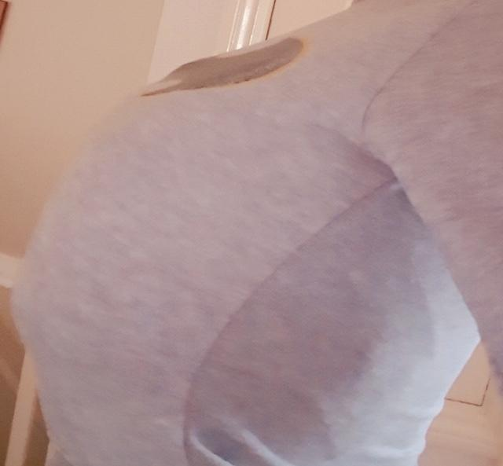

ArthurDank 13-Feb-19 04:16 PM

thats cute tho bruce is giving it his all

hope its not too tight

Bunny 13-Feb-19 04:16 PM

Nahh I’m still plenty bouncy

ArthurDank 13-Feb-19 04:17 PM

thats good lol

one must bounce to the ounce just not too much you may knock yourself out

lol

Bunny 13-Feb-19 04:31 PM

Sometimes I just bounce them when I’m bored

ArthurDank 13-Feb-19 04:35 PM

well that sounds fun lol

Bunny 13-Feb-19 04:35 PM

Boing

ArthurDank 13-Feb-19 04:35 PM

lmao

everybody likes a good breast bounce

Bunny 13-Feb-19 04:39 PM

I suppose I could try sleep lewding

ArthurDank 13-Feb-19 04:39 PM

sounds good

whats sleep lewding?

Bunny 13-Feb-19 04:39 PM

Don’t think he’d mind lol

Sleep fuck

ArthurDank 13-Feb-19 04:39 PM

oh I get you lol

probably not i mean he liked sleep grinding right?

its like grinding only better lmao

Bunny 13-Feb-19 04:41 PM

The issue is getting it up lol

ArthurDank 13-Feb-19 04:41 PM

ahhh is he asleep or something?

well you do have various assortment of tools to get past the foreplay stage ;)

Bunny 13-Feb-19 04:44 PM

He’s at least attempting to get his sleep schedule back in order

Just bumping at the moment

Heavy sleeper~

ArthurDank 13-Feb-19 04:44 PM

ah thats good i know he told me a few nughts ago that insomnia hits him pretty hard

bumping,

Bunny 13-Feb-19 04:45 PM

Yeh

ArthurDank 13-Feb-19 04:45 PM

what are you bumping him with? lol

sorry had to ask

Bunny 13-Feb-19 04:48 PM

Butt to crotch you dumb dumb lol

ArthurDank 13-Feb-19 04:48 PM

i didn't know lol i didn't know you were doing that while texting XD

now im hornt heading to work in 10 lol

glad you are having fun tho lol

Bunny 13-Feb-19 04:54 PM

Didn’t take much effort to get him up

lol

ArthurDank 13-Feb-19 04:54 PM

didn't figure lol

Bunny 13-Feb-19 04:55 PM

I wonder if it turns into lewd dreams if you do it while asleep

Dreams are weird

ArthurDank 13-Feb-19 04:55 PM

it can subconsciously he be aware of it

lory heading to work msg me after you have fun :) if you have time

Bunny 13-Feb-19 04:57 PM

Alrighty

ArthurDank 13-Feb-19 04:58 PM

have a good blow lol

ArthurDank 13-Feb-19 05:27 PM

and i can text at work when its not busy im in the back tonight so i can usually text and go lol

ArthurDank 13-Feb-19 06:46 PM

henlo :)

Bunny 13-Feb-19 06:46 PM

Henlo

ArthurDank 13-Feb-19 06:47 PM

how ya doin lory?

Bunny 13-Feb-19 06:50 PM

Good

Other than getting Thanos’d again

ArthurDank 13-Feb-19 06:50 PM

thanos'd? you mean parker wiped you out? lol

Bunny 13-Feb-19 06:50 PM

Here’s the link

https://twitter.com/jakuimmortal/status/1095823316269629441?s=12

 〔Jakuzure Returns〕 (@JakuImmortal)
Reality can be whatever I want it to be Jack. I’m just a lost musical gremlin looking for her frens. RT to help me find them!
 Twitter

ArthurDank 13-Feb-19 06:50 PM

oh

ah dammit they got you again but thanks for the link i will add

Bunny 13-Feb-19 06:51 PM

I’m not too worried

It’ll only take 2 weeks to get back to 700

ArthurDank 13-Feb-19 06:51 PM

indeed your minions will return

Bunny 13-Feb-19 06:51 PM

Just gotta unlock the damn account lol

ArthurDank 13-Feb-19 06:52 PM

ah need another number use mine

Bunny 13-Feb-19 06:52 PM

Wow really? You’d do that?

ArthurDank 13-Feb-19 06:52 PM

yeah why not? i cant guarentee it will work try 7408614047

Bunny 13-Feb-19 06:53 PM

I was kinda 7 inches deep on man meat when it happened lol so I didn’t realize until afterwards

ArthurDank 13-Feb-19 06:53 PM

lmao no worries

so how did that go if i may ask?

;)

Bunny 13-Feb-19 06:56 PM

Well I’m surprised it was up for so long as he was out

Big loads too

ArthurDank 13-Feb-19 06:58 PM

damn so he was out and blow it up your butt? he did say he has quite a libedo

i doubt he minded waking up to his gfs butt taking him to town

Bunny 13-Feb-19 06:59 PM

Nahh He’s still out cold

I need a new phone charger apparently

Keeps saying it’s incompatible

ArthurDank 13-Feb-19 07:01 PM

ahh shit that sucks i hate when chargers fuck off like that mine is wore out probably be gone in a week or two the wires are popping out

damn the cat got the cream and he didn't even know you are pretty stealthy he probably sleep better now lol

Bunny 13-Feb-19 07:03 PM

Still throbbing too apparently

I could put it back in too

Lmao

ArthurDank 13-Feb-19 07:03 PM

lmao bet you could hope you enjoyed as much as he if his cannon was any indication

brw lory i didn't mean to bail earlier but i had work also i hope i didn't impose on you texting while you were grinding i didn't even notice you are pretty cordinated

Bunny 13-Feb-19 07:04 PM

Hung like a horse~

Also it’s fine

Your job is important

ArthurDank 13-Feb-19 07:05 PM

indeed lol and yes it is but i was more worried i was intruding thats what i mean by awkward like should i still talk or should i vanish for a bit lol i was more worried about that

but i figure you would've excused yourself were that the case

Bunny 13-Feb-19 07:06 PM

Naaah it’s alright

Anyways if you can manage to make that alt for me that would be beautiful since the one I have now is temporarily locked while my friend George sorts out the phone number issue

Second time also wasn’t difficult getting it back in

He’s just a bit thicker now because of the blood flow

ArthurDank 13-Feb-19 07:08 PM

i meant you could use that number to log in i get the code and send it back to you

wow so you are back on him whee

right on haha

but yeah i can work on an alt when i get home gotta sweep in a few

Bunny 13-Feb-19 07:11 PM

It’s saying I tried too many times to do it with another one

So I’ll just make another email and suggest another @ name with a smug variant

Also yes

He’s deeper this time despite being a lot thicker now

Gotta relax somehow y’know?

ArthurDank 13-Feb-19 07:12 PM

cool i will work on that when home and see if my number can work

Bunny 13-Feb-19 07:12 PM

Thanks

If it doesn’t just get yourself a google voice thing

It’s like a virtual cell phone

ArthurDank 13-Feb-19 07:12 PM

right on he is filling you up and going further in best of both worlds

got ya

let yoy know probably be in three hours

Bunny 13-Feb-19 07:13 PM

Jesus a shot already?

ArthurDank 13-Feb-19 07:14 PM

wow that was fast maybe you have thick ass or just techinique

also lory know this isn't the time but i wasn't expecting you to be so open about these parts of your life, thats not a criticism i appreciate your trust in me

probably seens like an odd thing to thank you for lol

Bunny 13-Feb-19 07:19 PM

Aww shucks

I don’t have much shame as it were regardless

ArthurDank 13-Feb-19 07:19 PM

lol nothing to be ashamed of lory

besides what happens in chat stays in chat

Bunny 13-Feb-19 07:20 PM

Yee

ArthurDank 13-Feb-19 07:22 PM

besided Parker would kill us lol

anywho you got a pole to work and i have a floor to sweep i will probably be out of touch but just hit me up later if you want have fun lory :)

Bunny 13-Feb-19 07:28 PM

I do have a big ass actually lol if my in initial selfie was any indication since my hips are huge

ArthurDank 13-Feb-19 07:29 PM

lol i believe it you do have nice shaoely thighs

shapely

you having a big butt doesn't shock me

Bunny 13-Feb-19 07:37 PM

Oh actually hold on

This is from the other day

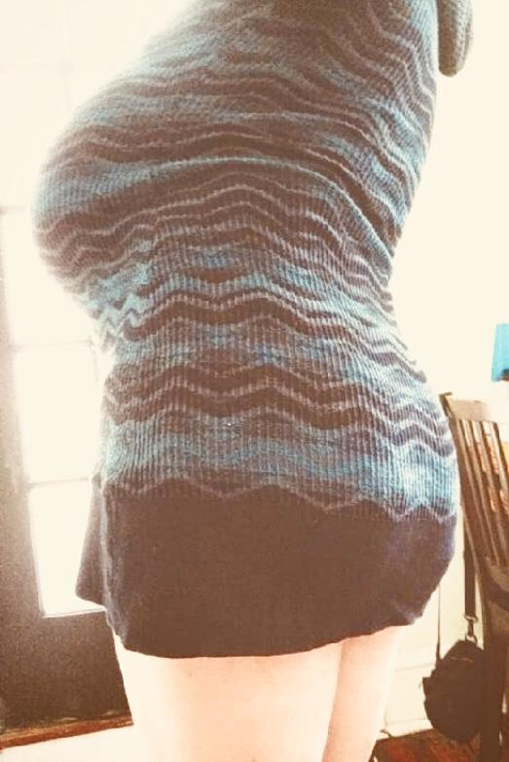

ArthurDank 13-Feb-19 07:41 PM

damn that be a fine bootah you got dare lol

you were not kidding

Bunny 13-Feb-19 07:51 PM

Three shots so far lol

I must be doing good

ArthurDank 13-Feb-19 07:51 PM

wowoow

indeed

how about you tho? you getting close?

Bunny 13-Feb-19 08:03 PM

Already did twice

He’s getting a bit softer so I’ll probably take him out to get make him harder again with grinding lol

ArthurDank 13-Feb-19 08:04 PM

lol right on

and damn thats a hell of a sex druve you got lory whew parker said

he had a libido but damn

Bunny 13-Feb-19 08:06 PM

Perpetual hornt

Hehehehe Big dicke go in butt

ArthurDank 13-Feb-19 08:08 PM

lmao nice

well if that butt doesn't do it nuttin will

Bunny 13-Feb-19 08:08 PM

M E A T

ArthurDank 13-Feb-19 08:08 PM

yep lmao reminds me of last night



you weren't kidding perpetually hornt

Bunny 13-Feb-19 08:09 PM

I’m bi too so coochie is also good

ArthurDank 13-Feb-19 08:10 PM

i bet it is hehe glad we both love pussy lol

we have that in common

are you and parker the kind of couple who would have a threesome with another girl? couldn't help but ass

ask lol

Bunny 13-Feb-19 08:11 PM

Yes actually we are

We’ve talked about it before

Ffm only

Mmf is the same as cuckoldry

Also it’s gay if the balls touch

ArthurDank 13-Feb-19 08:12 PM

yeah i kinda figured lmao

and yeah you got a point

about the balls lol

thats why i said a threesome with a female lol cause like you said it is cuckoldry the other way unless the other woman is trying to cuck the man or the other woman lmao

Bunny 13-Feb-19 08:28 PM

He doesn’t like the thought of sharing with another dude y’know?

I don’t blame him though

Awww darn he’s going soft now

I know he still has more too

You busy or something?

Bunny 13-Feb-19 09:09 PM

Oof he’s up

Bunny 13-Feb-19 10:07 PM

You alive?

Bunny 13-Feb-19 10:21 PM

HEEEEEEEEEYYYYYYYYYY

Bunny 13-Feb-19 10:41 PM

HEY

ArthurDank 13-Feb-19 10:44 PM

sorry hello im back

my phone died on me

despite 22% charge my battery is old sorry i vanished on you

i dont blame him for not wanting to share what about you tho? does it bug you the idea of another chick joining in

just make sure it aint a home wreaker lol

i had to wait till i got home to get my charger

Bunny 13-Feb-19 10:52 PM

Jeez I thought you fell asleep

ArthurDank 13-Feb-19 10:53 PM

sorry lory didn't get home till about 15 mins ago

at 9:09 you said he was up did he get it back up or did he get up?

so what all happened while i was gone?

Bunny 13-Feb-19 10:56 PM

I meant he woke up lol

ArthurDank 13-Feb-19 10:57 PM

lol nice

what happened then?

Bunny 13-Feb-19 10:58 PM

He was soft by then so We MIIIIIIIIIIIIIIIIIIIIIIIIIIIIGHHHHHHT start again soon

mayvbe

Maybe*

ArthurDank 13-Feb-19 10:59 PM

oh nice and conscious too hope you have fun haha

well can't blame him you got three out of last i heard

Bunny 13-Feb-19 11:00 PM

I could go for more though ngl

ArthurDank 13-Feb-19 11:01 PM

lol he is a lucky guy sure he can too when e has had a minute if you vanish here in a few have a good time :D

oh btw that alt is ready

Bunny 13-Feb-19 11:02 PM

Yay

ArthurDank 13-Feb-19 11:04 PM

jakuzureboom@Gmail.com and the password is Alucard777 if it asks for your first and last name it is Jaku Zure the date of birth on the account is 9/18/89 (mine) and if it asks for a phone number it is 7408614047

let me know if there are any problems make any adjustments you see fit

Bunny 13-Feb-19 11:08 PM

Yeh

I'll hop on in a bit

ArthurDank 13-Feb-19 11:08 PM

cool

Bunny 13-Feb-19 11:09 PM

A fly landed on my chest and I accidentally punched myself in the tit

ArthurDank 13-Feb-19 11:10 PM

yikes lol

hope it didn't knock the air out of you

Bunny 13-Feb-19 11:13 PM

They're already heavy enough to cause slight breathing problems lol

ArthurDank 13-Feb-19 11:13 PM

lol i have no doubt

Bunny 13-Feb-19 11:13 PM

That's why I sputter on stream sometimes

ArthurDank 13-Feb-19 11:14 PM

okay now i get it or as parker said the nught he was playing gundam with me, you sounded like your lung was coming up lol

remember deep breaths

lol

Bunny 13-Feb-19 11:16 PM

Yeah sorry about that

ArthurDank 13-Feb-19 11:17 PM

dont be i had a laugh just glad you weren't sick buddy

oh and earlier you were telling me about threesomes i wish you all luck, hopefully not some chick thats gonna cause trouble, any potential candidates?

Bunny 13-Feb-19 11:22 PM

Not sure yet lol

for now I'm just happy with my horse hung BF lmao

ArthurDank 13-Feb-19 11:24 PM

thats good lol

it all cums to us eventually lmao

Bunny 13-Feb-19 11:25 PM

He'd never admit it to anyone else but he likes dry grinding lol

ArthurDank 13-Feb-19 11:25 PM

lmao i kinda figured he did

Bunny 13-Feb-19 11:25 PM

Sorry I've been so lewd brained lately

ArthurDank 13-Feb-19 11:26 PM

its okay im lewd brained too

it doesn't offend me if you were worried about that thank you for the consideration tho :)

if he didn't like it sure he would say so lol

Bunny 13-Feb-19 11:33 PM

Hehehehehehe

Guess what I'm doing~

ArthurDank 13-Feb-19 11:34 PM

dry grinding

oh yeah im supposed to guess lol what are you doing?

Bunny 13-Feb-19 11:40 PM

Guess or it's no fun you dweeb

ArthurDank 13-Feb-19 11:40 PM

dry grinding or putting him back in while he is asleep?

i guessed :D

Bunny 13-Feb-19 11:43 PM

HMMMMMMMM

Just trying to get him up again at the moment

ArthurDank 13-Feb-19 11:44 PM

is he asleep?

so dry grinding i was right lol

it didn't take long last time it wont again im sure

hehehe

Bunny 13-Feb-19 11:51 PM

Nah He's watching game grumps with me rn

Couldve sworn I hit send there

ArthurDank 13-Feb-19 11:52 PM

its all good so you're trying to rile him up ehh lol

Bunny 13-Feb-19 11:52 PM

Yeeee

ArthurDank 13-Feb-19 11:53 PM

lol sure it wont take long haha least if you vanish for a bit i will know why hope you have fun

well i mean i know yoy well you know what i mean lol

Bunny 13-Feb-19 11:54 PM

I feel something poking me lol

ArthurDank 13-Feb-19 11:54 PM

lol sounds like paydirt

is it okay to be texting me while you do that and he is up? just dont want him to get mad lol

Bunny 13-Feb-19 11:57 PM

It's fiiiiiiiiiiiiiiiiiinnnneeee

Don't worry none

ArthurDank 13-Feb-19 11:58 PM

lol just checking

Bunny 13-Feb-19 11:59 PM

Big dicke

hehehehehehehe

ArthurDank 13-Feb-19 11:59 PM

he is up lol

good job

Bunny 14-Feb-19 12:02 AM

Took a bit of doing but were good now

hehehe

Butt

ArthurDank 14-Feb-19 12:02 AM

lmao good one

have fun lory

:)

Bunny 14-Feb-19 12:11 AM

BIG

ArthurDank 14-Feb-19 12:12 AM

i bet lol

Bunny 14-Feb-19 12:16 AM

Only half in

ArthurDank 14-Feb-19 12:20 AM

wow

Bunny 14-Feb-19 12:21 AM

first shot

ArthurDank 14-Feb-19 12:21 AM

damn lol

in surprised parker doesn't mind you texting during this lmao

Bunny 14-Feb-19 12:22 AM

Hehehehehe It's fiiiiiiiiiineee

Auto correct is a godsend

ArthurDank 14-Feb-19 12:26 AM

he just strikes me as private lol

indeed it is explains a lot XD

Bunny 14-Feb-19 12:27 AM

Don't think about it too hard

haha hard

ArthurDank 14-Feb-19 12:32 AM

hahaha

well i mean thats just how he seems XD

i could be wrong lmao

you could just be sneaky texter too im the same at work hurhur

Bunny 14-Feb-19 12:35 AM

I am sneaky lol

Two shots

fuck

ArthurDank 14-Feb-19 12:35 AM

wow i figured that was how you were doing it, stealth texting lmao

damn lory

you on top?

Bunny 14-Feb-19 12:36 AM

Bottom doggy style

All the way in now my guts feel hhhhhhhhhhhh

ArthurDank 14-Feb-19 12:41 AM

damn

Bunny 14-Feb-19 12:43 AM

Third shot

ArthurDank 14-Feb-19 12:43 AM

whee

Bunny 14-Feb-19 12:46 AM

quick shot fourth

ArthurDank 14-Feb-19 12:47 AM

good lord

wow

Bunny 14-Feb-19 12:49 AM

It's gonna leak at this rate,i've only ever been able to hold 5 shots

5 shots I think we're done

you home from work now?

ArthurDank 14-Feb-19 12:57 AM

damn lmao

that makes 8 for the day

oh i been home from work about 2 and half hours ago

Bunny 14-Feb-19 12:59 AM

Wait no he's just finishing on my butt now lol

ArthurDank 14-Feb-19 01:00 AM

lmao wow

blasting the outside of your butt now lol

Bunny 14-Feb-19 01:01 AM

buttjob

I'm gonna be all sticky lol

One big shot,jeez mustve been holding back

ArthurDank 14-Feb-19 01:07 AM

lmao probably he strikes me as someone with quite a bit of control haha

Bunny 14-Feb-19 01:08 AM

I was wrong he wasnt done

ArthurDank 14-Feb-19 01:08 AM

lmao

Bunny 14-Feb-19 01:09 AM

all in at once

ArthurDank 14-Feb-19 01:10 AM

whee

doggy?

Bunny 14-Feb-19 01:12 AM

Yes

ArthurDank 14-Feb-19 01:12 AM

now im hornt lol what am i saying i been hornt all day lmao

wow

Bunny 14-Feb-19 01:16 AM

Really stirred up

jesus

6 shots

ArthurDank 14-Feb-19 01:17 AM

yeah figured you would be after 6 lol

thats a lot for anybody

Bunny 14-Feb-19 01:18 AM

Ive gone 5 already

ArthurDank 14-Feb-19 01:19 AM

jesus lol

Bunny 14-Feb-19 01:20 AM

I feel him holding back the 7th lol

ArthurDank 14-Feb-19 01:20 AM

probably lol

Bunny 14-Feb-19 01:21 AM

he was

big shot fuck

ArthurDank 14-Feb-19 01:22 AM

whoa

Bunny 14-Feb-19 01:22 AM

am i too lewd? I'm sorry

ArthurDank 14-Feb-19 01:23 AM

no not at all i didn't mean that lol im just whoa seven

thats a lot for any guy in one go

Bunny 14-Feb-19 01:24 AM

I think its finally over

ArthurDank 14-Feb-19 01:24 AM

wow thats a hell of a go right there buddy

amazed you're still conscious haha

Bunny 14-Feb-19 01:26 AM

legs are jelly but yeah

ArthurDank 14-Feb-19 01:27 AM

lmao i bet they would be after that thick as they be lol

though they may be*

Bunny 14-Feb-19 01:29 AM

bet youre thankful youre not a chick

ArthurDank 14-Feb-19 01:29 AM

lol yeah but hope when i do it i can get close to what he does honestly if you're gonna do someone do em right ya know

lol

how ya holding up lol

Bunny 14-Feb-19 01:34 AM

I'm good

sorry he decided to blow on on my face too

ArthurDank 14-Feb-19 01:35 AM

oh nice haha gave him some head?

Bunny 14-Feb-19 01:35 AM

i should lol

ArthurDank 14-Feb-19 01:35 AM

indeed lol

he still at it? lol

Bunny 14-Feb-19 01:37 AM

just licking now,its all covered in white lol

glad i clean my guts

ArthurDank 14-Feb-19 01:38 AM

oh whats all in white the phone

ahh tasting nice

Bunny 14-Feb-19 01:39 AM

nahh I already licked the phone

maximum hornt

ArthurDank 14-Feb-19 01:40 AM

indeed lmao

that is the highest hornt

i know you said dont think too hard about it but i had to ask how did he not know you were texting me during all that? sorry its too good a question gotta ask XD

Bunny 14-Feb-19 01:42 AM

Head under blankets

ArthurDank 14-Feb-19 01:43 AM

lmao you are sneaky

Bunny 14-Feb-19 01:43 AM

lel

Anyways I'm good for now

ArthurDank 14-Feb-19 01:43 AM

respect *fistbump

Bunny 14-Feb-19 01:43 AM

How was work?

ArthurDank 14-Feb-19 01:43 AM

work went oretty well damn floor is a pain in the ass to clean but aside from that it was pretty good

i put that hornt to good use

it wasn't too busy tonight thank God

Bunny 14-Feb-19 01:45 AM

I smell bad

ArthurDank 14-Feb-19 01:46 AM

well theres a lot of cum there parker wasnt kiddi g about the blankets covered in cums hyuck

XD

you'd probably shower if your legs had feeling lol

Bunny 14-Feb-19 01:48 AM

I would actually

I'm just here leaking like a spilled cup of yogurt at the moment

ArthurDank 14-Feb-19 01:48 AM

well its nutritious lol

Bunny 14-Feb-19 01:48 AM

Don't laugh

it actually tastes good

DONT LAUGH

ArthurDank 14-Feb-19 01:49 AM

lmao i know

it tastes good and is good for you

best of both worlds :)

just playing with ya a bit

Bunny 14-Feb-19 01:51 AM

Yeh

But seriously its good

ArthurDank 14-Feb-19 01:51 AM

awesome :)

Bunny 14-Feb-19 01:51 AM

I'd bottle it if I could

ArthurDank 14-Feb-19 01:51 AM

the secret sauce i could see it selling

Bunny 14-Feb-19 01:53 AM

Semen sauce

ArthurDank 14-Feb-19 01:53 AM

nice

guess it was a hornt day for all ofus lol

kinda drained myself now im having a cig lol

Bunny 14-Feb-19 01:58 AM

Wait were you

nahhhhhh couldnt be

ArthurDank 14-Feb-19 02:00 AM

what having sex no lol

thats what i meant by ot makes me awkward

i was too embaressed to admit

sorry

Bunny 14-Feb-19 02:01 AM

Nah it's cool if you say it

ArthurDank 14-Feb-19 02:02 AM

i was fapping you see thats what i mean by people texting during sex makes me awkward, im not jealous nor a prude but it unleashes maximum hornt lol

especially when people in question are attractive

Bunny 14-Feb-19 02:03 AM

PFFFFFFFFT

It's fine

ArthurDank 14-Feb-19 02:03 AM

thanks hope you dont think less of me

Bunny 14-Feb-19 02:03 AM

I don't

ArthurDank 14-Feb-19 02:04 AM

i actually thought it was hot lol

thanks lory for understanding

Bunny 14-Feb-19 02:10 AM

No problem lol

I just like taking it up the ass

ArthurDank 14-Feb-19 02:11 AM

lol those are the best kind of women

and thanks for trusting me with this aspect of your life

Bunny 14-Feb-19 02:12 AM

I'm fine with it

ArthurDank 14-Feb-19 02:13 AM

thanks but i did want to ask a favor

Bunny 14-Feb-19 02:15 AM

Sure

Yeesh you writing a novel there?

ArthurDank 14-Feb-19 02:19 AM

sorry lol

i was playing around

oh yeah the favor

phones getting slow

i have no problems with anything we discuss and please dont feel like you have to change how you chat with me but maybe no texts during sex from now on, when im maximum hornt i dont get anything done lol

im fine with you talking about it before leading up to and after i enjoy it actually but during i kinda feel wild ya know lol

Bunny 14-Feb-19 02:22 AM

Alrighty

Sorry If I forget though

ArthurDank 14-Feb-19 02:23 AM

no worries

i didn't say anything cause i was too busy enjoying myself and i didn't want you to feel like you had to hide your lewd brain we can talk about sex anytime before leading up to and after

we are both lewd brained lol

Bunny 14-Feb-19 02:25 AM

I like dicke

heheheheh

ArthurDank 14-Feb-19 02:26 AM

ehehhehee and I have no problems hearing about it i like our lewd chats its just during is all, my hornt is uncontrollable when someones texting me during sex haha

besides you keep hiding your head during sex and parkers gonna worry lmao

tho i must admit i respect your stealth texting that was neat lol

Bunny 14-Feb-19 02:29 AM

I really like doggy style

You wouldn't take me for a sub either huh?

ArthurDank 14-Feb-19 02:30 AM

no actually not at all lol you are so dominant on twitter and even this afternoon when he was asleep

i would've never gyessed you were a sub

doggy style looks fun especially with a butt like yours lol

Bunny 14-Feb-19 02:32 AM

Hair pulling = yes please

ArthurDank 14-Feb-19 02:32 AM

haha well you have the length and it is cute hair you have

is Parker still at it or is he asleep?

Bunny 14-Feb-19 02:35 AM

He's at half chub at the moment and I'm not opposed to going another round.

ArthurDank 14-Feb-19 02:36 AM

oh nice lol

lory i know i said if you were in the mood to chat during sex to not do it but i was thinking so if its a bad time i will let you know and if its a good time i will just roll with it lol that sounds fair?

Bunny 14-Feb-19 02:39 AM

Yuuuup

If anything it'll just be another buttjob

but he could trick me again and go full length

ArthurDank 14-Feb-19 02:41 AM

lmao he is a man of mystery

and glad you find that fair thanks for not being annoyed at me for fapping during your sex chat lol

buttjobs sound like fun to me lol

i just wanted to clerify if i excuse myself during your sex chat its not cause im offended its just not a good time for my maximum hornt lol

its actually a good time lol

Bunny 14-Feb-19 02:47 AM

Sat on his lap as a tease,he immediately got hard again

hehehehehe

ArthurDank 14-Feb-19 02:48 AM

nice hahah

Bunny 14-Feb-19 02:49 AM

8 inches yeeeeeeaahhhh

When he's really at it it's more like 9

ArthurDank 14-Feb-19 02:50 AM

lmao holy shit bigger then ya thought

Bunny 14-Feb-19 02:50 AM

I'm just messing around with it right now,nothing more than the tip is in lol I wonder how long he'll last~

ArthurDank 14-Feb-19 02:51 AM

is he asleep?

nice hard to say a butt like that is hard to resist

Bunny 14-Feb-19 02:53 AM

yuuup

he's out like a light

ArthurDank 14-Feb-19 02:53 AM

after 7 and then one on the face i would be too lol

Bunny 14-Feb-19 02:53 AM

I think it's safe to put it in again

I can't help myself

still hornt

ArthurDank 14-Feb-19 02:54 AM

haha ride the shit out of put those hips to work hehe

you did say you were perpetually hornt haha

Bunny 14-Feb-19 02:57 AM

Sorry was having a bit of trouble getting it back in again,he's thicker than usual and since my ass went back to normal it was a bit difficult

ArthurDank 14-Feb-19 02:57 AM

lmao no worries i have heard thats how butts work

it expands then goes back even a booty like yours

Bunny 14-Feb-19 03:01 AM

I'm barely halfway

this'll have to do for now

ArthurDank 14-Feb-19 03:01 AM

its good your careful about that, its the difference between anal sex being plasurable and a nightmare

the caution that is how in is too in at the moment thats what most chicks tell me anyway lol

anywho lory i gotta bail gotta shower then probably sleep in a bit

Bunny 14-Feb-19 03:04 AM

Aww poo

ArthurDank 14-Feb-19 03:04 AM

sorry hugs

Bunny 14-Feb-19 03:04 AM

Why not hang out a bit longer?

ArthurDank 14-Feb-19 03:04 AM

its 3 am and im pooped

lol

Bunny 14-Feb-19 03:04 AM

There we go now it's in

ArthurDank 14-Feb-19 03:05 AM

right on lory fistbump

Bunny 14-Feb-19 03:05 AM

I might have a butt stuff addiction

ArthurDank 14-Feb-19 03:05 AM

i think so but thats not a bad thing hehe

better that then being pregnant lol

Bunny 14-Feb-19 03:06 AM

Jeez another quick shot,at least it's a big one,I just want my guts plastered

ArthurDank 14-Feb-19 03:07 AM

hahahah some like booze others like cum

Bunny 14-Feb-19 03:07 AM

If I squeeze harder more comes out lol

ArthurDank 14-Feb-19 03:09 AM

lol tight ass muscles

everybody likes that

Bunny 14-Feb-19 03:12 AM

Holy fuck big load and leakage

ArthurDank 14-Feb-19 03:12 AM

shazzam well done

Bunny 14-Feb-19 03:12 AM

Squeezing was a good idea lol

ArthurDank 14-Feb-19 03:12 AM

lol yep butt muscles are quite handy

or they tell me lol

welp lory i gotta go have fun tho okay? feel free to msg me later if you like lemme know how it went lol

Bunny 14-Feb-19 03:17 AM

Alrighty

ArthurDank 14-Feb-19 03:19 AM

have a good night buddy hugs

Bunny 14-Feb-19 03:23 AM

i willlll

ArthurDank 14-Feb-19 11:39 AM

Crap I forgot to tell you Happy Valentines Day Lory :)

hope you have put that alt to good use

Bunny 14-Feb-19 12:01 PM

Yeh

ArthurDank 14-Feb-19 12:01 PM

good good follow me when you have the time

how is your V day going?

Bunny 14-Feb-19 12:18 PM

Good so far

ArthurDank 14-Feb-19 12:19 PM

thats good to hear likewise i haven't been up long, .om and i are doing some running around later before work at 3

I have to ask tho when I left last night you had gotten two more out of him how much more did you get after i left? lol

Bunny 14-Feb-19 12:48 PM

2 more big ones lol

ArthurDank 14-Feb-19 12:56 PM

shazzam lol so 3 and 8 and 5 16 that i counted shit lol

sorry i just now got the msg you sent about 10 mins ago must be lag

and that was just from him lol

Bunny 14-Feb-19 01:27 PM

I could definitely go again considering what day it is today though

ArthurDank 14-Feb-19 01:28 PM

lol damn right its V day

if there is a day for sex this is the one lol

little fun fact know why i have to work today?

well i mean at 3 instead of 5 all the cashiers most of which are female that have a relationship requested off one dates one of the other male cashiers and they both requested off lol

ArthurDank 14-Feb-19 01:52 PM

so what are you into today?

Bunny 14-Feb-19 03:04 PM

Not that much today just relaxing before we start bumping

ArthurDank 14-Feb-19 03:11 PM

lmao nice

i thought you already were thats why you vanished for a bit lol

that and there weren't any blankets to text under this time hehheh

ArthurDank 14-Feb-19 03:27 PM

btw at work so if you feel chatty and im slow im not ignoring ya :)

Bunny 14-Feb-19 05:05 PM

Noope we’re gonna start in a bit though lol

ArthurDank 14-Feb-19 07:31 PM

what the hell? you sent that at 5 and i just now got it

???

damn discord lag

oh and have fun lol

Bunny 14-Feb-19 07:32 PM

Still at it lol

He got really tired so I’m doing most of the work

ArthurDank 14-Feb-19 07:32 PM

damn how many time has it been so far?

must be covert texting under blanket bouncing your butt back onto him doggy style

Bunny 14-Feb-19 07:38 PM

So far? I said we’d go a lot today

9 so far lol

My butt is a fountain

ArthurDank 14-Feb-19 07:38 PM

lol nice

oh i know you did say that i was just surprised the 7 last night was mind blowing haha

yeah thats why i said so far cause i knew it was gonna be more fun then usual heheh

Bunny 14-Feb-19 07:47 PM

10 now. Really putting my hips to work lol. I could give him a surprise and do the front too since we have rubbers now lol.

I’ve not done front before yet lol so I miiiiight try it today (edited)

ArthurDank 14-Feb-19 07:53 PM

well them be some nice hips you got dere lol and good glad you got some protection let him blow in the pussy you will probably enjoy might be a bit oainful the first time but kinda special given its V day

lemme know how that goes since i doubt you will be able to text if he does the front, doggy can be done there but most guys love seeing their girls expressions in the front just depends on the guy

Bunny 14-Feb-19 07:57 PM

I’ll give it a try and then switch to doggy to see if that bugs him at all. Back in a bit!

Bunny 14-Feb-19 08:20 PM

So he was bigger than I thought

I know this now

I made a really stupid lewd face

ArthurDank 14-Feb-19 08:21 PM

thats what i thought told ya guys like the lewd faces when going in the front hehehe how much bigger?

Bunny 14-Feb-19 08:23 PM

I currently have a bulge in my stomach where I can feel it hitting

I’m smaller than him remember?

Short

ArthurDank 14-Feb-19 08:25 PM

ah yes lol thats right means you unleashed maximum hornt? how is it feeling up the front?

Bunny 14-Feb-19 08:26 PM

I feel like my brain is being mashed against my skull

In a good way

ArthurDank 14-Feb-19 08:27 PM

vey nice ;)

Bunny 14-Feb-19 08:30 PM

I hope this rubber doesn’t pop,he’s already blown a huge load after seeing my lewd face

ArthurDank 14-Feb-19 08:31 PM

i hope it dot either thats what i was wondering about he is a cum generator lol

Bunny 14-Feb-19 08:33 PM

Celery helps make bigger loads ,you didn’t know that?

ArthurDank 14-Feb-19 08:33 PM

no i did not

but explains a lot hehe i will have to try that

Bunny 14-Feb-19 08:35 PM

Second shot. I feel like it’s filling up pretty quick. He’s going hard back there too

ArthurDank 14-Feb-19 08:36 PM

i bet he is very hot if i do say

he's probably gonna have to switch em out soon

whew 11 from him so far whoa

Bunny 14-Feb-19 08:39 PM

It’s hitting back there now actually

If it pops it might be trouble

It’s a safe day but you never know

ArthurDank 14-Feb-19 08:39 PM

yikes be careful may be time for a fresh one

oh good

Bunny 14-Feb-19 08:40 PM

I think one time raw would be fine? I’m still more of a fan of butt stuff. This’ll take some getting used to

ArthurDank 14-Feb-19 08:41 PM

it will something new always does it will get more enjoyable or so most gals tell me

it might be if its a safe day you should be fine just be careful

Bunny 14-Feb-19 08:42 PM

Hang on he’s pulling out

Fuuuuck it’s better raw why did nobody tell me thiiiis?

ArthurDank 14-Feb-19 08:47 PM

well i thought you already knew ;)

Bunny 14-Feb-19 08:48 PM

I didn’t realize it was this good though

ArthurDank 14-Feb-19 08:49 PM

condoms kinda mask the raw meat feeling course protects you from pregnancy theres alwaya a drawback with either approach

glad you are liking it tho hehe

Bunny 14-Feb-19 08:51 PM

Third shot

Fuck that’s a lot

ArthurDank 14-Feb-19 08:51 PM

hehehe

Bunny 14-Feb-19 08:51 PM

He’s still shooting

ArthurDank 14-Feb-19 08:51 PM

seems you aren't the only enjoying it more ;)

one*

Bunny 14-Feb-19 08:54 PM

He’s not even halfway in either. I’ve loosened up a bit though nowww

Scratch that he’s all in now

Fuck

ArthurDank 14-Feb-19 08:56 PM

all the way up in the pussy right on

Bunny 14-Feb-19 08:57 PM

Don’t laugh but he’s bulging out my stomach and I can feel it through the bulge

Don’t laugh

I can’t help being short

ArthurDank 14-Feb-19 08:57 PM

lory im not laughing but shit whew

its okay you know guys like short gals

im amazed you can text so coherently whilst your brains getting fucked out

Bunny 14-Feb-19 08:59 PM

Auto

Correct

Fyjk

Fuck

ArthurDank 14-Feb-19 09:00 PM

nice

so how is going now

Bunny 14-Feb-19 09:00 PM

Getting filled. I feel him throbbing again

ArthurDank 14-Feb-19 09:01 PM

wow so thats twice inside raw wow

Bunny 14-Feb-19 09:02 PM

Second shot

Oh Christ I didn’t think it’d be this

Much

Don’t laugh I’m new at this

ArthurDank 14-Feb-19 09:03 PM

never underestimate the feeling of fucking raw pussy

im not laughing :)

thats 14 for him and how many for you?

Bunny 14-Feb-19 09:06 PM

17

I think I’m overflowing

ArthurDank 14-Feb-19 09:09 PM

jesus

i figured

Bunny 14-Feb-19 09:10 PM

Third shot,it’s just leaking now.

But he keeps shooting more than when I use my ass

ArthurDank 14-Feb-19 09:12 PM

indeed its a whole other feeling im told great as your butt is pussy is a whole other level

Bunny 14-Feb-19 09:14 PM

Think I might be full at this point

ArthurDank 14-Feb-19 09:14 PM

whew thats a lotta cum to be full on both ends

Bunny 14-Feb-19 09:15 PM

I don’t think he cares though. This feels too good to stop at 3

ArthurDank 14-Feb-19 09:15 PM

indeed lol

Bunny 14-Feb-19 09:16 PM

He seems to be slowing down

I’m just riding now as he’s leaned against the side of the couch. We probably should’ve taken this

To the bedroom

But who cares

ArthurDank 14-Feb-19 09:17 PM

its a whole other experience besides this is the first time for you means you are super tight making it even more enjoyable for you both

lmao well if no one else is home then it matters not

riding is always hot

Bunny 14-Feb-19 09:22 PM

Fourth shot

ArthurDank 14-Feb-19 09:22 PM

holy fuck whew

Bunny 14-Feb-19 09:22 PM

I can feel it right in there

You know where

ArthurDank 14-Feb-19 09:25 PM

yep

the bulge

Bunny 14-Feb-19 09:26 PM

One sec he’s pulling out again

I think it’s over for now. Jesus Christ I thought my head would explode

ArthurDank 14-Feb-19 09:30 PM

if he kept it up any longer he would've lol

wow

happy valentines day indeed

Bunny 14-Feb-19 09:31 PM

And a load over my ass

Happy Valentines indeed

One sec looks like he wants one over my tits too. I’ll be back in a minute

I’m a mess now

I smell

ArthurDank 14-Feb-19 09:36 PM

well thats natural

he fuck your tits or just cum on em? wow either way :D

that was quite a show

Bunny 14-Feb-19 09:41 PM

Nah he fucked em and then blew another load on em

I cover him almost completely

ArthurDank 14-Feb-19 09:42 PM

damn he he did both lol

yeah i believe it with them knockers

Bunny 14-Feb-19 09:46 PM

Sorry just cleaning myself up lol

Oh wow he’s out like a light

I guess that really wore him out

ArthurDank 14-Feb-19 09:49 PM

i dont blame him he fuck your ass pussy with and without a rubber then your tits whee

its cool i know a shower is needed

Bunny 14-Feb-19 09:49 PM

I think he got some in my hair lol

Yup he did

ArthurDank 14-Feb-19 09:51 PM

haha well given how much of a gusher he is thats natural

hope you texting me during that didn't cause issues seems he was having too much fun to notice

Bunny 14-Feb-19 09:52 PM

Eyes closed for the entire thing

I’m just gonna sit in the shower and well y’know

Eat some of it

Lol

ArthurDank 14-Feb-19 09:52 PM

hot

Bunny 14-Feb-19 09:52 PM

Because why not

ArthurDank 14-Feb-19 09:53 PM

indeed

hope my girl likes my cum that much

btw are you at his place? does he live with anybody?

Bunny 14-Feb-19 09:55 PM

Hehehehe it’s good

His parents aren’t together

Don’t go saying I said that though

I think he’s mentioned it publicly though

ArthurDank 14-Feb-19 09:56 PM

i wont i dont mention you texting me during sex i wont mention this promise

Bunny 14-Feb-19 09:56 PM

It’s a big puddle lol

ArthurDank 14-Feb-19 09:57 PM

nice hehe

so the parent in qyestion isn't home? didn't figure ;)

Bunny 14-Feb-19 09:58 PM

Noooope. Also don’t mind my cum obsession lol

ArthurDank 14-Feb-19 09:58 PM

yeah or the couch would've been a no go lol

Bunny 14-Feb-19 09:58 PM

Chocolate makes me hornt

ArthurDank 14-Feb-19 09:58 PM

i dont mindi think its hot

yumm

lol

but no i wont mention about his parents tho i think he mentioned it long ago, same reason i dont bring this up he would lose his shit

Bunny 14-Feb-19 10:00 PM

He’s nice otherwise

Just angry sometimes

Just like me

I say as I put cum in my mouth with my fingers

ArthurDank 14-Feb-19 10:01 PM

ph yeah i just know he might take issue with this if he knew lol but yeah i like him a lot and i likeyou too yeah i get pissy as well

we all have that in common

yum haha

you okay?

Bunny 14-Feb-19 10:09 PM

Yup I’m good

ArthurDank 14-Feb-19 10:09 PM

nice

so i was surprised that it doesn't bug you letting me the fly on the wall during that, it usually bugs most girls im not complaining just surprised lol

i like when i am trusted hehe

Bunny 14-Feb-19 10:12 PM

Yeah just don’t blab

ArthurDank 14-Feb-19 10:14 PM

never lory i like you guys too much and i have rules

my phone died as you told me not to blab

lol

so whatcha doin?

Bunny 14-Feb-19 10:22 PM

Was washing up and eating cum lol

ArthurDank 14-Feb-19 10:23 PM

lmao very nice

lmao i told you if it was a bad time for hornt discord talk i would tell you and excuse myself whats funny is i was okay with this during work but i was too busy to be hornt at work so that helps lol

work was slow thank god i needed a break

Bunny 14-Feb-19 10:31 PM

Lmao you hornt now or something?

ArthurDank 14-Feb-19 10:32 PM

nah watching a movie with mom dont have time to be hornt i will worry about being hornt later lol

last night tho i was super hornt lol

you hornt still or hornt out? lol

Bunny 14-Feb-19 10:36 PM

Slightly hornt lol

ArthurDank 14-Feb-19 10:37 PM

hornt on command you be lol

me too actually

lmao

Bunny 14-Feb-19 10:41 PM

Sorry that’s probably my fault

I actually want something like this

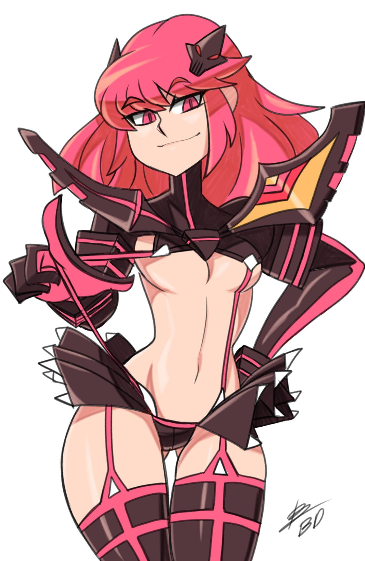

Senketsu seems like a fun outfit ngl

ArthurDank 14-Feb-19 10:41 PM

cosplay sex sounds like a good time

andndont be sorry about me being horny if it was a bad time for it i would've told you abd excused myself like i said lol

hot outfit would look good on you

Bunny 14-Feb-19 10:47 PM

I actually want activated Senketsu

It would be fun to fuck in lol

ArthurDank 14-Feb-19 10:48 PM

oh which is that?

sounds good already

Bunny 14-Feb-19 10:48 PM

Or tracksuit one

ArthurDank 14-Feb-19 10:48 PM

tracksuits can be very hot

Bunny 14-Feb-19 10:50 PM

This one

Low riding pants
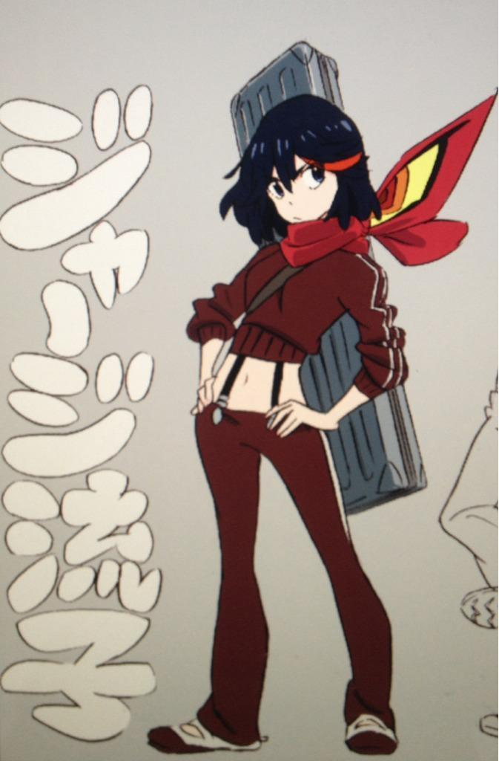

ArthurDank 14-Feb-19 10:51 PM

nice makes the butt and crotch stick out more

that would look great on you haha

Bunny 14-Feb-19 10:56 PM

I do have regular Senketsu though

This one

ArthurDank 14-Feb-19 10:56 PM

no shit?

wow thats hot

you should try fucking in the outfit next time parkers head would explode more then usual lol

Bunny 14-Feb-19 11:00 PM

I’m already outta the shower

Contemplating putting it on

What movie are you watching btw?

ArthurDank 14-Feb-19 11:02 PM

oh just fantastic beasts and where to find them lol mom loves it its nice bonding time for us my dearest friend is her to be sure haha

oh nice sounds hot lol

i kinda want to see it but i dont want to make anything uncomfortable for ya

Bunny 14-Feb-19 11:04 PM

My tummy gets cold easily but whatever
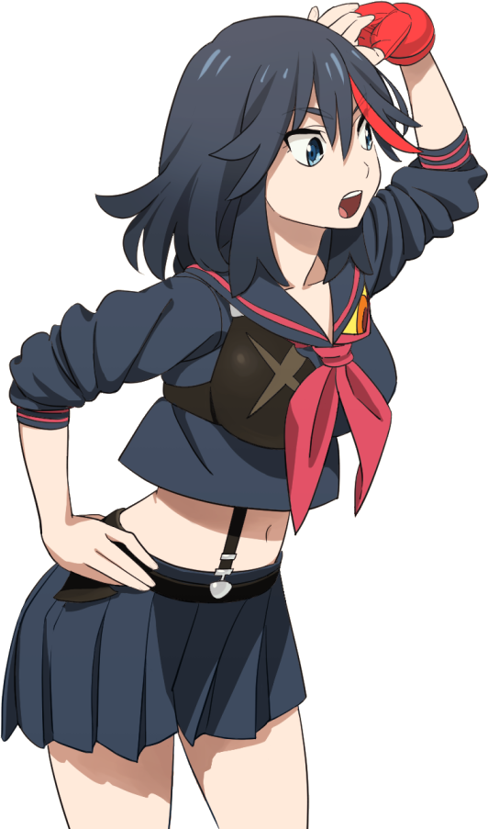

ArthurDank 14-Feb-19 11:04 PM

shazzam

damn thats gonna look nice

as long as you dont mind

Bunny 14-Feb-19 11:05 PM

I actually have to wrap up to fit in it lol

Otherwise it’s just underboob

ArthurDank 14-Feb-19 11:06 PM

oh damn my bad lol

but i do see whatcha mean

Bunny 14-Feb-19 11:10 PM

Wrapped tiddies

Warm

ArthurDank 14-Feb-19 11:11 PM

nice

helps offset the stomach being cold

Bunny 14-Feb-19 11:15 PM

Oh hey he’s up,how about that

ArthurDank 14-Feb-19 11:15 PM

lmao noce

maybe i will see it some other time lol

Bunny 14-Feb-19 11:19 PM

I still bounce even when wrapped

ArthurDank 14-Feb-19 11:20 PM

that is a lot of bounce you possess it cannot be tamed lol

ArthurDank 14-Feb-19 11:27 PM

well lory think im gonna bail for the night its been fun tho my friend, maybe see the outfit some other time lol feel free to hit me up tomorrow if you would like to chat :)

Bunny 14-Feb-19 11:28 PM

Aw poo

It’s really early though

You really that tired?

ArthurDank 14-Feb-19 11:30 PM

nah im not tired i just gotta get shit done before bed i might be back later tho i will hit you up if that sounds good?

Bunny 14-Feb-19 11:30 PM

I’ll spam you regardless lol

ArthurDank 14-Feb-19 11:31 PM

thats fine spam me with what?

it dont matter i shall reply when i can lol

spam away haha

Bunny 14-Feb-19 11:32 PM

Tiddy poke

I’m a soft gril

ArthurDank 14-Feb-19 11:34 PM

nice poke

Bunny 14-Feb-19 11:36 PM

Am soft

I’d make a body pillow of myself lol

ArthurDank 14-Feb-19 11:37 PM

i would buy one lol

i do appreciate that you like having me around :)

not used to it someone who just likes chatting me out of the blue

Bunny 14-Feb-19 11:46 PM

Yeh

Hehehehe

Dicke on skirt

ArthurDank 14-Feb-19 11:47 PM

guess parker likes the outfit lol

ArthurDank 14-Feb-19 11:58 PM

having fun?

Bunny 15-Feb-19 12:02 AM

Hehehehe Big dicke

Squirts on my thighs

ArthurDank 15-Feb-19 12:05 AM

nice

those are some thicc thighs

Bunny 15-Feb-19 12:06 AM

Dicke in butt lol

ArthurDank 15-Feb-19 12:07 AM

nice

and nice butt it be

Bunny 15-Feb-19 12:11 AM

So much better

Butt fucks are much more relaxing

Skirt up around my waist head under blankets

Good shiiiit~

ArthurDank 15-Feb-19 12:13 AM

i figured lol thats how you could text me i admire your sneak texting thats hot cosplay sex ftw

Bunny 15-Feb-19 12:14 AM

Tip for you

Don’t bother taking your girl’s panties off

Just pull them to the side

ArthurDank 15-Feb-19 12:15 AM

oh nice just makes the experience more kinky or something?

Bunny 15-Feb-19 12:15 AM

Yuuuup

ArthurDank 15-Feb-19 12:16 AM

i will rememver that when i finally fuck someone thanks lol

gotta get shit done so i will be away for a bit you can spam all the same i just didn't want you to get bored or think i was ignoring you i will reply when i can

Bunny 15-Feb-19 12:17 AM

Alrightyyyyy

First shot lol bigger than normal too. I guess the outfit does the trick

ArthurDank 15-Feb-19 12:18 AM

damn right love to see that outfit some time it can really set a guy off

keep the phone concealed while im busy lol

at a gas station well i mean keep it oncealed but feel free to spam if you want it wont bug me lol

Bunny 15-Feb-19 12:25 AM

Yeh

ArthurDank 15-Feb-19 12:31 AM

so how is it going?

;)

Bunny 15-Feb-19 12:36 AM

Second shot was huge lol

ArthurDank 15-Feb-19 12:37 AM

dang

like a piston pumping

Bunny 15-Feb-19 12:42 AM

Hehehehe Big dicke

Third shot

ArthurDank 15-Feb-19 12:48 AM

very big hehe wow lotta cum in your butt

Bunny 15-Feb-19 12:49 AM

Fuuuuck

He’s just stirring it around now

My guts are familiar with his shape now

ArthurDank 15-Feb-19 12:52 AM

very nice lol

nice little rub on the insided

finally home probably shower in a bit hornt lol

Bunny 15-Feb-19 12:53 AM

I don’t care if you get off to us

ArthurDank 15-Feb-19 12:54 AM

in glad cause i already am lol

hows it feeling

Bunny 15-Feb-19 12:56 AM

Niiiiiceee

Just riding him since he slowed down

ArthurDank 15-Feb-19 12:56 AM

damn thats a nice mental image ;)

right on lory

Bunny 15-Feb-19 01:00 AM

Matoi butt lmao

ArthurDank 15-Feb-19 01:00 AM

nice butt especially in that skirt lmao

really pumping those hips back into him ehh

Bunny 15-Feb-19 01:02 AM

I like pulling him out until I reach the tip and then slowly putting it all back in

ArthurDank 15-Feb-19 01:02 AM

oh nice slow and steady lotta guys like that pulled out just to experience being engulfed again

tbh been getting off to your pics for months dont blab lol

Bunny 15-Feb-19 01:04 AM

Lol what you actually bust a nut to me?

ArthurDank 15-Feb-19 01:05 AM

sometimes i have a lotta photos on my phone tho

sorry if that seems weird

Bunny 15-Feb-19 01:05 AM

Naaah it’s fine I’m just surprised

Now I’m wondering how many times you’ve busted to my tits lol

ArthurDank 15-Feb-19 01:06 AM

wpuld it change your opinion of me? lol

Bunny 15-Feb-19 01:06 AM

Naaaah

ArthurDank 15-Feb-19 01:06 AM

not sure why you are surprised you're very beautiful

and bouncy

lol

and to answer a few times lol

Bunny 15-Feb-19 01:08 AM

That’s a new feeling,he shot while stirring me

ArthurDank 15-Feb-19 01:09 AM

wow

Bunny 15-Feb-19 01:10 AM

Nnnnn that’s gooood

ArthurDank 15-Feb-19 01:10 AM

hehehe ;)

Bunny 15-Feb-19 01:13 AM

Got him all the way in,just rolling my hips and squeezing down. I don’t think he’ll last long before shooting again lol

ArthurDank 15-Feb-19 01:13 AM

damn a nice one two hit you got there

Bunny 15-Feb-19 01:14 AM

He’s throbbing a lot but holding it back hehehehe

ArthurDank 15-Feb-19 01:14 AM

endurance ftw

Bunny 15-Feb-19 01:16 AM

Pulled him out to the tip,gonna squeeze while putting it all the way back in,he’ll probably shoot again~

ArthurDank 15-Feb-19 01:17 AM

shazzam quite a techinique you got there

Bunny 15-Feb-19 01:17 AM

And slowly back in~

ArthurDank 15-Feb-19 01:17 AM

hmmm

Bunny 15-Feb-19 01:17 AM

Shooting as I squeeze down lol

I can predict the future

Not holding back now,just bouncing away

ArthurDank 15-Feb-19 01:20 AM

right on go to town lol

i believe you can

Bunny 15-Feb-19 01:27 AM

Soooo goood,fifth shot?

ArthurDank 15-Feb-19 01:28 AM

holy shit whee

Bunny 15-Feb-19 01:28 AM

Y’all good too?

ArthurDank 15-Feb-19 01:29 AM

oh yeah hehe

thank for asking :D

been very fun

fired a few of my own ;)

Bunny 15-Feb-19 01:38 AM

Pffft

ArthurDank 15-Feb-19 01:38 AM

you okay? hope i didn't say anything wrong lol

i feel maybe i said too much? so how is it going?

Bunny 15-Feb-19 01:46 AM

Sorry I was getting off myself a few times

ArthurDank 15-Feb-19 01:46 AM

nice

Bunny 15-Feb-19 01:47 AM

He’s out cold so I’m just gonna keep going on my own

ArthurDank 15-Feb-19 01:48 AM

riding some dick for extra loads? nice

sorry i assumed i thought i said too much this is all very hot tho lol

Bunny 15-Feb-19 01:50 AM

I just wanna few more is all

ArthurDank 15-Feb-19 01:50 AM

im sure he wont mind lol

if you're too tired to text its cool lemme know im not argue against more spam tho lol

Bunny 15-Feb-19 01:53 AM

No I’m alright just squeezing him right now

ArthurDank 15-Feb-19 01:53 AM

hot very

Bunny 15-Feb-19 01:55 AM

Oh fuck I think my squeezing woke him up lol

ArthurDank 15-Feb-19 01:55 AM

oh shit

Bunny 15-Feb-19 01:57 AM

Just when I decided to unwrap my chest too

ArthurDank 15-Feb-19 01:57 AM

lmao figures

timing hurhur

Bunny 15-Feb-19 02:07 AM

I’m assuming you’re done? Or just busting to my pictures or something?

ArthurDank 15-Feb-19 02:07 AM

no im good

you ok

i mean yeah in good

Bunny 15-Feb-19 02:08 AM

Yup we’re good for now

Just gonna relax with some game grumps

ArthurDank 15-Feb-19 02:09 AM

cool cool did i make you mad? sorry if i did?

Bunny 15-Feb-19 02:09 AM

Naaaah

I’m all good

ArthurDank 15-Feb-19 02:10 AM

cool when you said busting to my pictures or something i thought i ticked you off or i got you caught got worried my bad

Bunny 15-Feb-19 02:10 AM

No I was legitimately curious

How long have you been doing that lol

ArthurDank 15-Feb-19 02:11 AM

lol for a while honestly

Bunny 15-Feb-19 02:12 AM

I’m assuming this is one of your favorites?
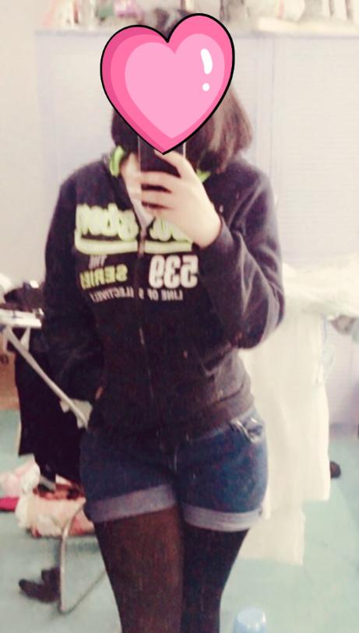

ArthurDank 15-Feb-19 02:12 AM

it is a nice pic lol

Bunny 15-Feb-19 02:12 AM

Big ol hips

ArthurDank 15-Feb-19 02:13 AM

yup

they are nice lol

if i may ask what made you curious about how long i mean?

Bunny 15-Feb-19 02:14 AM

Well naturally after saying you’ve been busting to me I’d wonder how long

ArthurDank 15-Feb-19 02:14 AM

well true

it didn't bother you?

Bunny 15-Feb-19 02:18 AM

Nope it doesn’t bug me

Just curious what ones you bust to specifically

ArthurDank 15-Feb-19 02:19 AM

well they're all nice that one with you laying on your side was one of my favorites tho

honestly i like them all lol

ArthurDank 15-Feb-19 02:27 AM

tho thats not why i talk to you, truth is i think highly of you and want your friendship

Bunny 15-Feb-19 02:32 AM

Awww shucks

I don’t mind if you think I’m hot lol

ArthurDank 15-Feb-19 02:32 AM

well i do and this isn't some sort of a scheme or anything malicious lol

im glad you're flattered

time i worry i have overstepped as it were lol

but yes i think you are hot lol

Bunny 15-Feb-19 02:36 AM

I made an edit earlier hang on a sec

ArthurDank 15-Feb-19 02:36 AM

cool

Bunny 15-Feb-19 02:43 AM

Really shows my size lol


ArthurDank 15-Feb-19 02:44 AM

damn sure does lol they really stick out there

that was you in the cosplay? very nice

Bunny 15-Feb-19 02:44 AM

Yuuup

The little boob guard is on the other side

ArthurDank 15-Feb-19 02:45 AM

aha very nice

well you look very hot in it suits you

Bunny 15-Feb-19 02:46 AM

I’m worried I’d be too big for this sort of Senketsu


Also thank you

I try

ArthurDank 15-Feb-19 02:47 AM

you dont try you do lol :)

yeah i think that might cause you to pass out sorry to say lol

but it might be worth a shot just prepare properly

Bunny 15-Feb-19 02:51 AM

It’s just like a bikini though lol

Just more revealing

Junketsu is probably more my style honestly

ArthurDank 15-Feb-19 02:52 AM

was junketsu the one you wore earlier?

honestly from what i see i agree it just its just you :)

Bunny 15-Feb-19 02:55 AM

Noooope this is Senketsu. Junketsu is the white one

ArthurDank 15-Feb-19 02:55 AM

oh damn i could see yoy in that

you'd kill in it frankly

Bunny 15-Feb-19 02:56 AM

Ryuko’s version or Satsuki’s?

Ryuko’s is fucking great
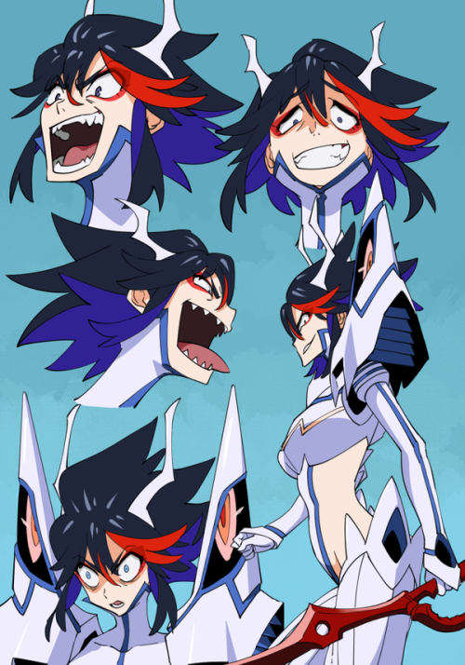

ArthurDank 15-Feb-19 02:57 AM

i like the smug so i would say this one definitely the smug is you

Bunny 15-Feb-19 02:57 AM

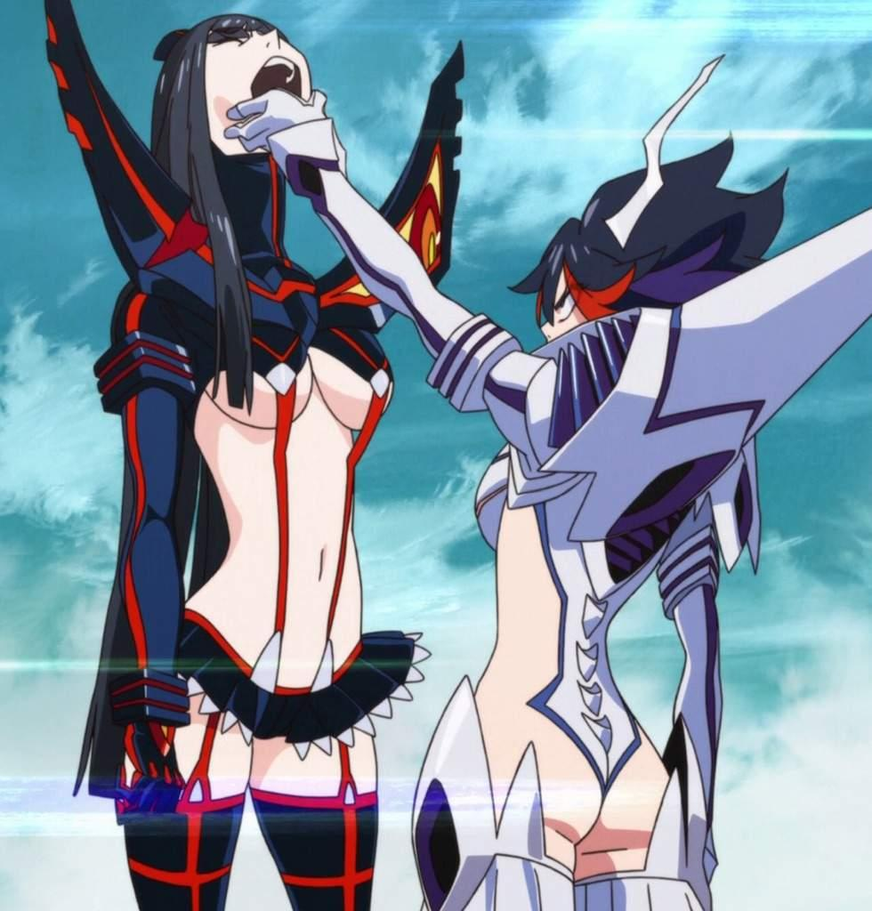

ArthurDank 15-Feb-19 02:57 AM

oh yeah definitely you

you would look great

Bunny 15-Feb-19 02:58 AM

It’s a yin yang sorta thing

Junketsu is all revealing for ass and hips

Senketsu for tits (edited)

ArthurDank 15-Feb-19 02:59 AM

i have to watch this anime at some point but i get it tho

thing is you got plenty of all three but junketsu definitely seems more your speed

Bunny 15-Feb-19 03:00 AM

It’s like a sling bikini when Satsuki wears it


It’s the only one that changes in that way

ArthurDank 15-Feb-19 03:01 AM

oh wow

Bunny 15-Feb-19 03:01 AM

Senketsu was rushed

That’s why it’s missing an eye

ArthurDank 15-Feb-19 03:01 AM

i see wow

pretty damn fascinating

gonna have to watch this :)

Bunny 15-Feb-19 03:03 AM

Satsuki is kinda small in the boob department though lmao

ArthurDank 15-Feb-19 03:03 AM

yes yes she is

lmao

Bunny 15-Feb-19 03:04 AM

Mako is actually one of the biggest
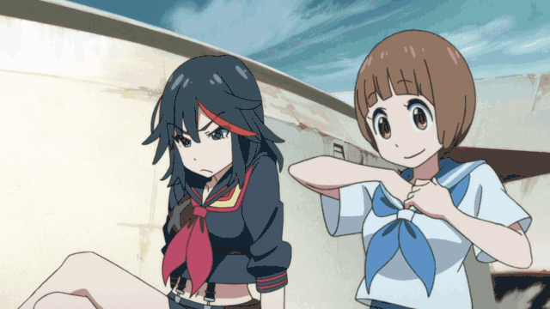

Coconut waifu

ArthurDank 15-Feb-19 03:04 AM

holy crap lmao you're right she is you can tell just by the outline, not to mention the lunch box

she is cute lol

Bunny 15-Feb-19 03:06 AM

Was thinking about getting a zero star uniform (edited)

Mako’s outfit

ArthurDank 15-Feb-19 03:06 AM

well shit that would look good on you too lol

they all work for you thanks to you having the kind of body that would look great in them all really i mean some of them may be snug around the chest but still

Bunny 15-Feb-19 03:11 AM

Well she tends to have belly exposed anyways lol (edited)

ArthurDank 15-Feb-19 03:12 AM

and you do have nice stomuch and abs to boot

one of my favs lol

Bunny 15-Feb-19 03:13 AM

She did have Senketsu for a bit too

ArthurDank 15-Feb-19 03:14 AM

no kidding?

Bunny 15-Feb-19 03:14 AM

But that’s because she fell and her clothes popped off while she was holding Senketsu


ArthurDank 15-Feb-19 03:14 AM

lmao whoa

nice look tho

Bunny 15-Feb-19 03:16 AM

That’s the outfit I have on

He’s out like a light now too

I’m probably gonna try and get him hard again

ArthurDank 15-Feb-19 03:18 AM

thats what i thought you wore looked damn nice in it lol

hahaha good luck well you dont need luck with this

and i danced around the question of your pics earlier lol

Bunny 15-Feb-19 03:21 AM

Yeah you kinda did

ArthurDank 15-Feb-19 03:21 AM

okay the truth

Bunny 15-Feb-19 03:21 AM

I was curious which ones specifically you bust to

ArthurDank 15-Feb-19 03:22 AM

okay at the time i was wondering why you were but no worries should i send the pics to specify or just describe

Bunny 15-Feb-19 03:23 AM

Both

ArthurDank 15-Feb-19 03:24 AM

okay sure well the one you just posted earlier when asking if that was a fav certainly was

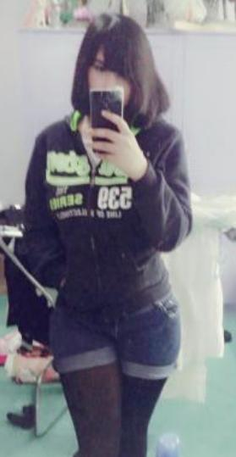

the outfit helps and the thighs lol

but also this

very hot

oh and this one made the rounds quickly
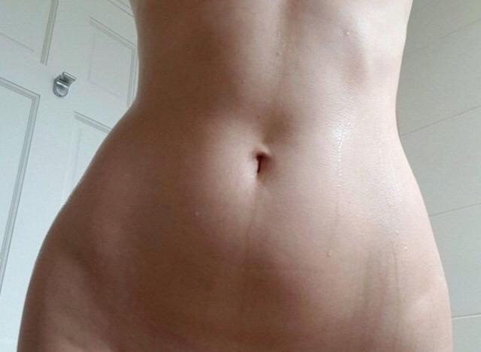

but here lately these got a lot of attention

the batman one was nice too

and this one has been the champ lately

Bunny 15-Feb-19 03:27 AM

Jeez you really do like my bod huh?

ArthurDank 15-Feb-19 03:28 AM

you're a hot girl i cant deny it sets off some sparks

Bunny 15-Feb-19 03:29 AM

For the tummy one I had to lift them out of the frame lol

ArthurDank 15-Feb-19 03:29 AM

i believe it lol them be fine cannons

Bunny 15-Feb-19 03:31 AM

Wait so you’re imagining me on your dick then? I just came to realize that’s probably the case. I’m not gonna think less of you if that’s the case

ArthurDank 15-Feb-19 03:32 AM

well yes

thats the truth

i fell kind of embarrassed to admit it but yeah

Bunny 15-Feb-19 03:33 AM

Pffft it’s fine I don’t think less of you

ArthurDank 15-Feb-19 03:34 AM

oh okay good honestly i thought you had come to that conclusion already thats why i danced around it

i appreciate the fact it didn't bother you it would've with most girls (edited)

Bunny 15-Feb-19 03:37 AM

Hehehehe it’s funny actually

I’ve never had anyone admit it before

Aside from him obviously

ArthurDank 15-Feb-19 03:38 AM

right of course lol

they probably didn't want to admit it since you're involved i didn't either for the same reasom but you asked so i wasn't gonna lie lol

its a nice little fantasy i indulge in sometimes

Bunny 15-Feb-19 03:39 AM

Wait so I’m basically a waifu inside your head?

ArthurDank 15-Feb-19 03:40 AM

well when im looking at the pics and stuff my mind goes to places lol

but i always come back lol

to reality that is

im kinda feeling like a bad person now lol

Bunny 15-Feb-19 03:42 AM

Naaaaaaah it’s fine

I wanted to hear about it actually

ArthurDank 15-Feb-19 03:42 AM

really?

just curious and wanted to know the extent of things? i understand

Bunny 15-Feb-19 03:43 AM

Yes

ArthurDank 15-Feb-19 03:44 AM

Yeah I guess I am trusting you with my secrets now too lol

im surprised you took it so well

most would freak out

Bunny 15-Feb-19 03:45 AM

I have a relatively high freak out tolerance

Unless it’s something severe

Like a security breach

Or someone I care about being physically harmed

ArthurDank 15-Feb-19 03:46 AM

i get you there im the same way

Bunny 15-Feb-19 03:46 AM

Anyways I wanted to hear about this little fantasy

ArthurDank 15-Feb-19 03:47 AM

oh thats fine i dont mind being jonest because i trust you but why did you want to hear about it?

lol sorry if im repeating muself

Bunny 15-Feb-19 03:47 AM

Because I’m legitimately curious

It’s not like I’m gonna laugh or anything

ArthurDank 15-Feb-19 03:48 AM

oh ots fine if there is anything you want to know ask and i will tell

most would've laughed tho lol

im easily paranoid and always assume a nafarious purpose lol had bad experiences in the past

im glad this doesn't make you feel wary of me

Bunny 15-Feb-19 03:51 AM

I’ll giggle a little but otherwise I won’t do anything

ArthurDank 15-Feb-19 03:51 AM

i can live with a giggle lol giggles can be cute haha

Bunny 15-Feb-19 03:51 AM

Just tell me you nerd

ArthurDank 15-Feb-19 03:52 AM

tell you what? lol

i would've told you sooner but you were my friend and i was worried if i spoke honestly i would lose that

Bunny 15-Feb-19 03:54 AM

Of course not

I appreciate honestly most of all

ArthurDank 15-Feb-19 03:54 AM

im glad so do i

you trusted me with a lot and now i have trusted you with a lot :)

Bunny 15-Feb-19 03:57 AM

Oy oy oy gimme the details already

ArthurDank 15-Feb-19 03:58 AM

lol what details?

im legitimately curious lol

so how is it going?

well lory its about 4:10 am im pooped im about to head to bed (edited)

mist be having a lot of fun lol anyway thanks i feel better having been able to let all that out

you have a good night feel free to spam hit me up tomorrow if you would like to chat

Bunny 15-Feb-19 11:27 AM

I wanted to know what your little fantasy was. I fell asleep before I could ask specifics

So tell me all about it lol

I wanna know

ArthurDank 15-Feb-19 11:30 AM

lol i inderstand you need to know all the depravity i respect that lol

its different when you and parker go at it because i realize i have a voyuer fetish fly on the wall and all dat lol

mostly i think about situations like waking up to you riding my dick and waking me up, you're very sexual person so i think about fucking your tits or mouth and blowing either between them or on your face,

think about your ass a lot and how you grind it against my cock till i pin you and go all the way up your ass and fuck you senseless

Bunny 15-Feb-19 11:34 AM

Jeez you really do like me huh?

ArthurDank 15-Feb-19 11:35 AM

well what can i say lol

i trust you thats the only reason why i tell :)

i think up random erotic scenarios on the fly indulge do my thing and put it away as it were till later lol

theres more but i think of so much basically think of any position or scenario, nothing too fucked up and we have done that in my fantasy

Bunny 15-Feb-19 11:43 AM

Fucked up? I’m basically into anything that’s not gore or mind break

Or scar

Scat*

ArthurDank 15-Feb-19 11:44 AM

same here those are big turn offs for me

you basically read my mind

the encounter may be hardcord but the scanarios are basically tame not that i think those over much heat of the moment and all

Bunny 15-Feb-19 11:54 AM

I’m sure you have me in little costumes too lol

That right?

ArthurDank 15-Feb-19 11:56 AM

sometimes not gonna lie you dressed up in the outfit last night was one

maris school outfit and plugsuit as well

Bunny 15-Feb-19 11:58 AM

Hehehe that’s to be expected honestly. Anything else?

ArthurDank 15-Feb-19 11:59 AM

i had you in satsukis white outfit a few time

Bunny 15-Feb-19 12:00 PM

This I’m assuming?
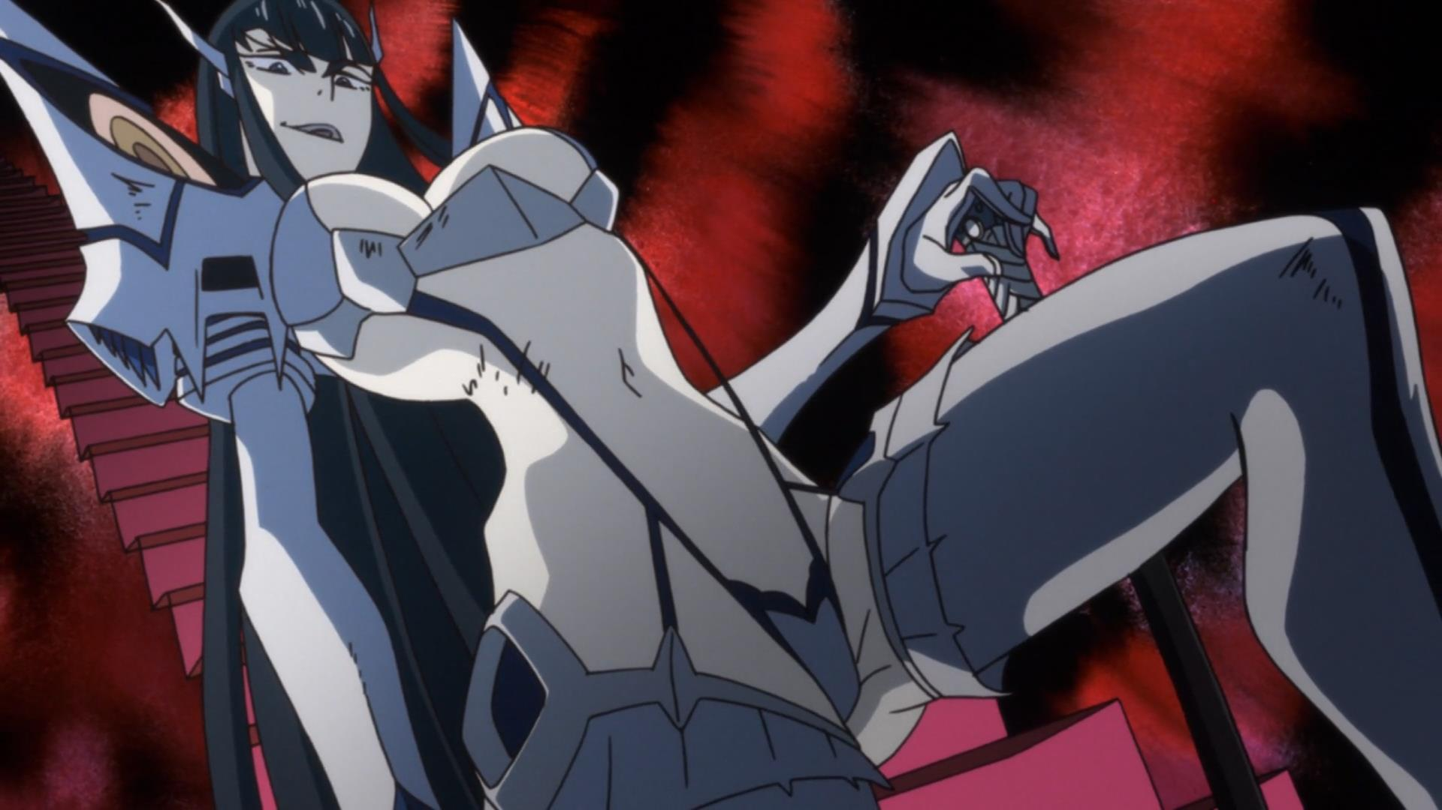

ArthurDank 15-Feb-19 12:00 PM

bingo

yours be far bigger but yeah lol

Bunny 15-Feb-19 12:05 PM

On a scale of 1 to 10 how lewd have the situations gotten?

ArthurDank 15-Feb-19 12:07 PM

i dont know what the scale would indicate because they get lewd

im a virgin so any fantasy involving grinding, sleep diddling, head, tits, anal and cum all over you in and out would be a 10 lol

Bunny 15-Feb-19 12:10 PM

Your favorite situation then?

ArthurDank 15-Feb-19 12:16 PM

i wake up to you butt naked giving me head i blow in your mouth (swamp nuts dont exist in the fantasy lol) then after that you ride me i go inside your pussy, then doggystyle, sideways we switch aroubd between the ass and the pussy filling up both i fuck your tits and blow again we also 69 to a mitual climax

there are other parts but i mix them up sometimes lol

Bunny 15-Feb-19 12:18 PM

I did find the one from November do you want it or?

I’m like in between the size I was last summer and the size I am now in it

ArthurDank 15-Feb-19 12:19 PM

if you want to im not against it :)

and thank you

Bunny 15-Feb-19 12:26 PM

Here ya go


ArthurDank 15-Feb-19 12:27 PM

wow thank you

very nice if i do say

Bunny 15-Feb-19 12:32 PM

I definitely show signs of growing here lol

I’m guessing this’ll be one of your favorites now?

ArthurDank 15-Feb-19 12:33 PM

yes you do very beautiful

ehhh probably lol

kinda hard not to

Bunny 15-Feb-19 12:39 PM

You kept talking about the situations but I don’t even know how big you are lol. I’m guessing smaller than 8 inches though

ArthurDank 15-Feb-19 12:42 PM

ehh accurate

Bunny 15-Feb-19 12:43 PM

5 inches I’m guessing

ArthurDank 15-Feb-19 12:43 PM

6-7 from what i can tell

Bunny 15-Feb-19 12:43 PM

Jesus Christ you’re massive

Wtf

ArthurDank 15-Feb-19 12:44 PM

it might be bigger if i lost some weight i have a weight problem i have lost some but trying to be fit

thank you for that i feel better :)

thats when im hornt of course lol

Bunny 15-Feb-19 12:49 PM

I’m assuming you’d just like plowing my ass then?

ArthurDank 15-Feb-19 12:50 PM

oh yeah well either or both lol im not picky

Bunny 15-Feb-19 12:52 PM

I honestly prefer anal

Ngl

ArthurDank 15-Feb-19 12:53 PM

the butt does hold more sway on me lol (edited)

same as you

besides what both partners prefer makes for more fun or so im told

Bunny 15-Feb-19 01:01 PM

I’m squishy lol
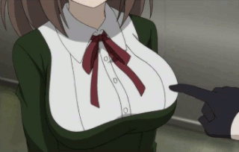

ArthurDank 15-Feb-19 01:02 PM

that makes it all the better really lol

everybody likes squishy to play with especially while bumping

Bunny 15-Feb-19 01:15 PM

They do get in the way sometimes though lol

Like sitting at a table

ArthurDank 15-Feb-19 01:17 PM

i bet they do like you already have a table but then there is this table lol too much table

i kinda gathered since you said you use your boobs for a phone rest sometimes

Bunny 15-Feb-19 01:36 PM

I have another picture from a few days ago if you want it lol

ArthurDank 15-Feb-19 01:36 PM

absolutely lol

and thank you again

Bunny 15-Feb-19 01:41 PM

I like this little dress lol.
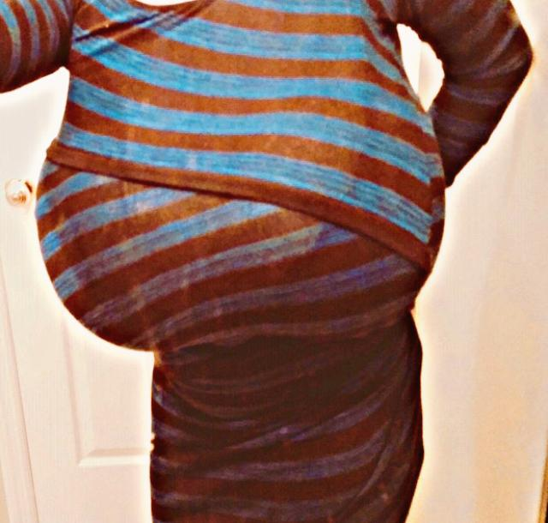

ArthurDank 15-Feb-19 01:42 PM

holy moly lol

that does look great on you lol

Bunny 15-Feb-19 01:45 PM

It’s a lot smaller than it looks

I just stretch out the top a bunch lol

ArthurDank 15-Feb-19 01:46 PM

haha i can tell it looks a little snug but kudos it looks amazing on you

Bunny 15-Feb-19 01:47 PM

The little bit in the middle of the top can open for easy access lmao

ArthurDank 15-Feb-19 01:49 PM

i noticed that lmao very nice

those layered dresses are very convenient that way

Bunny 15-Feb-19 01:52 PM

You’ve probably already thought of a few ways to take advantage of that huh?

ArthurDank 15-Feb-19 01:53 PM

maybe lol sorry

Bunny 15-Feb-19 01:54 PM

Tell me lol

ArthurDank 15-Feb-19 01:57 PM

i understand you like hearing fantasies cool i will humor you

well i come behind you in that room that dress is too much my hands start groping your boobies i peel that layer open my hands unleash your tits from the bra and dress i start fondling them i lift that skirt up, bend you over, pull the panties to one side and stuff my cock in your ass and pound the hell out of you until we both have cum enough

Bunny 15-Feb-19 02:01 PM

You really seem to like my tits lol

That’s okay I’m used to people staring

ArthurDank 15-Feb-19 02:01 PM

i kinda figured they do stand out lol

it would feel wrong to not feel up the melons in that dress while doing you from behind (edited)

Bunny 15-Feb-19 02:08 PM

I never changed out of the outfit from last night either. I’m tempted to tease him now lol

It sounds like it could be fun lol

ArthurDank 15-Feb-19 02:14 PM

sorry was driving (edited)

yeah it really could lol lemme know how it goes if you dont have any blankets to text under lol

Bunny 15-Feb-19 02:16 PM

I’ll just pull him near the couch lol it has fluffy blankets

ArthurDank 15-Feb-19 02:22 PM

nice

Bunny 15-Feb-19 02:25 PM

Looks like flashing was more than enough

Lol

ArthurDank 15-Feb-19 02:26 PM

lmao it should in that haha be careful sneaky lol

Bunny 15-Feb-19 02:32 PM

Just grinding at the moment. He’s still big though lol

You looked like you wanted to say something

Go ahead

ArthurDank 15-Feb-19 02:34 PM

oh must be a glitch i was driving

nice though lory ;)

sometimes i see you text and stop and not sure if discord glitches or what

Bunny 15-Feb-19 02:38 PM

I think he’s gonna bust on my ass lol. I can feel him throbbing

ArthurDank 15-Feb-19 02:40 PM

hot lory very

Bunny 15-Feb-19 02:42 PM

First shot~

ArthurDank 15-Feb-19 02:44 PM

right on

Bunny 15-Feb-19 02:45 PM

Hehehehe butt is sticky

ArthurDank 15-Feb-19 02:46 PM

as it should

be

Bunny 15-Feb-19 02:47 PM

And now it’s going in~

Thicker than normal too

Must be excited

ArthurDank 15-Feb-19 02:48 PM

probably is you got the ass and outfit (edited)

Bunny 15-Feb-19 02:50 PM

Halfway in and I’ve started squeezing,I’ll make him shoot early like this lol

ArthurDank 15-Feb-19 02:51 PM

damn guys like that when the girl makes em blow faster then expected reminds them how hot and skilled they are

Bunny 15-Feb-19 02:52 PM

He’s already leaking a lot but still holding back

I’m just gonna stuff it all in~

ArthurDank 15-Feb-19 02:54 PM

haha overpower his willpower

Bunny 15-Feb-19 02:55 PM

Second shot and still leaking

ArthurDank 15-Feb-19 02:56 PM

nicely done hehe

gotta hit the shower keep spamming if you like will be back

Bunny 15-Feb-19 03:00 PM

Just bouncing on him now, I’ll have him shooting again in no time lmao

ArthurDank 15-Feb-19 03:06 PM

very nice

Bunny 15-Feb-19 03:07 PM

I’ve already gotten off three times too

ArthurDank 15-Feb-19 03:07 PM

damn lory well done

Bunny 15-Feb-19 03:08 PM

I know you enjoy the whole voyeur thing so I don’t care if you do too

ArthurDank 15-Feb-19 03:10 PM

oh yeah thanks i just had to shower first pre fap and hot water makes me light headed (edited)

got time to indulge now lol

Bunny 15-Feb-19 03:17 PM

Third shot,he shot while I was bouncing too

ArthurDank 15-Feb-19 03:18 PM

jesus christ thats some good rhythm you got there

Bunny 15-Feb-19 03:23 PM

Hehehehe big dicke

ArthurDank 15-Feb-19 03:24 PM

heheh :D

Bunny 15-Feb-19 03:29 PM

No fourth shot yet,seems like he’s holding back again

ArthurDank 15-Feb-19 03:30 PM

trying to make the pleasure last for both of ya ;)

haha really giving it to ya ;)

Bunny 15-Feb-19 03:36 PM

Started rolling my hips and that’s when he shot again lol big one this time

ArthurDank 15-Feb-19 03:36 PM

hip rolling always looks so hot

like churning back and forth

Bunny 15-Feb-19 03:40 PM

I’m almost filled now lol, I’m leaking when I move

ArthurDank 15-Feb-19 03:40 PM

damn nice haha

Bunny 15-Feb-19 03:41 PM

You good too?

ArthurDank 15-Feb-19 03:42 PM

oh yeah lol always am

thanks for asking tho

why do you ask tho? just legit curious :)

Bunny 15-Feb-19 03:44 PM

Because you said it works lol nothing more than that

ArthurDank 15-Feb-19 03:44 PM

lol oh yeah it works

i just thought maybe you were getting tired during texting and maybe it was a bit too much to do both

hows it going atm?

Bunny 15-Feb-19 03:50 PM

He pulled out again and is rubbing against my ass atm,buttjob lol

ArthurDank 15-Feb-19 03:51 PM

nice

it is too fine a butt to ignore

Bunny 15-Feb-19 04:06 PM

Shot twice over my butt lol

ArthurDank 15-Feb-19 04:08 PM

hot damn lol

well done lory

Bunny 15-Feb-19 04:23 PM

Hehehehe we’re done for the time being

ArthurDank 15-Feb-19 04:24 PM

nice haha well done

so what happened after the two across the butt?

Bunny 15-Feb-19 04:28 PM

Busted on my face and my tits at the same time.

ArthurDank 15-Feb-19 04:33 PM

damn very nice them boobies be irresistible lol

i kinda figured thats why you had to jet for a bit lol

Bunny 15-Feb-19 04:41 PM

Yeah sorry about that lol

ArthurDank 15-Feb-19 04:43 PM

lol nothing to be sorry for lory lol gotta keep your cover ya know

i dont know why i thought my question earlier made you uncomfortable sorry i worry easily gotta overlook me lol

ArthurDank 15-Feb-19 05:27 PM

i was though what is it about texting during the deed you like? im not complaining trust me i just know you well enough to know you wouldn't do something you didn't like lol

Bunny 15-Feb-19 05:28 PM

I dunno I guess having an audience even if it's just one person helps me?

ArthurDank 15-Feb-19 05:30 PM

helps you?

im happy to be your audience though :)

Bunny 15-Feb-19 05:33 PM

I guess you’d call it exhibitionism?

ArthurDank 15-Feb-19 05:36 PM

ah i get it so we both benefit because you're hot and i am a voyeur and you indulge in a bit of an exhibitionist kink and safely

thats cool i was curious :)

ArthurDank 15-Feb-19 05:53 PM

anywho been working so probably gonna be gone for a while, feel feel to spam about whatever and i will get back when i can if not I will be around tonight if you got time have a good evening Lory :)

Bunny 15-Feb-19 05:54 PM

Yeh

Actually there are a few I don’t think I’ve sent if you wanna see em

ArthurDank 15-Feb-19 05:57 PM

yeah sure i would like that

thank you again

Bunny 15-Feb-19 06:01 PM

Do ya like fox tails?
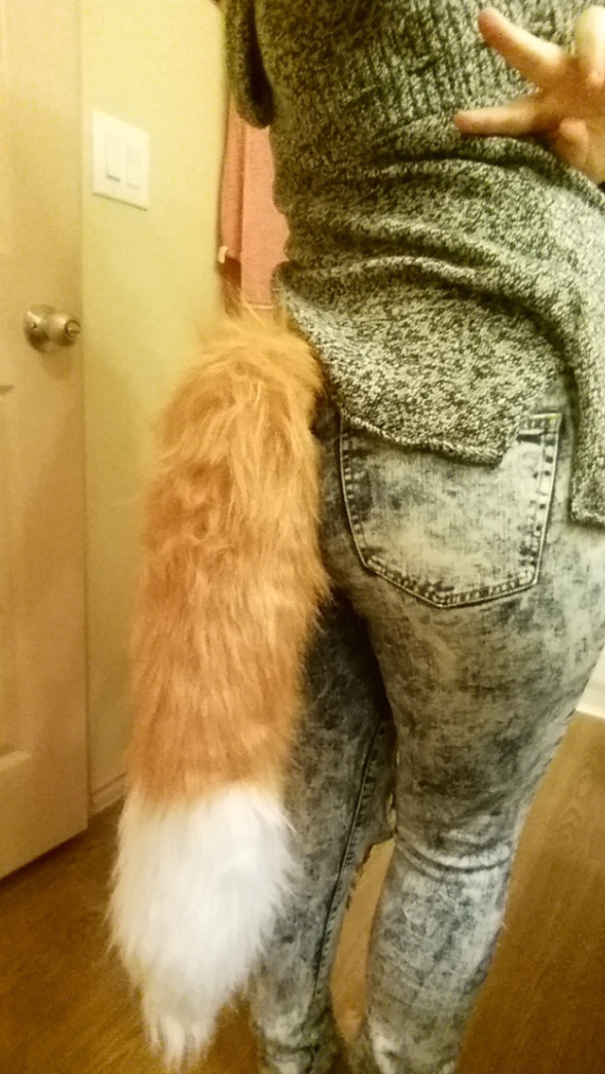

ArthurDank 15-Feb-19 06:02 PM

kinky

i sure do lol

like that fox tail hehe

thank you :)

Bunny 15-Feb-19 06:09 PM

Did I send this one already?


ArthurDank 15-Feb-19 06:10 PM

heheh no you did not

Bunny 15-Feb-19 06:13 PM

They dwarf my stomach lol

ArthurDank 15-Feb-19 06:14 PM

they sure do your stomuch is nice and tight

i like the seasonal touch to your melons lol

Bunny 15-Feb-19 06:14 PM

The shirt itself barely fits lol

ArthurDank 15-Feb-19 06:15 PM

i can tell it looks snug lol

looks nice on you tho

Bunny 15-Feb-19 06:21 PM

Hehehehe I’m bouncing them cuz I’m kinda hornt

ArthurDank 15-Feb-19 06:21 PM

very nice ;)

gotta love boobs you can play with

lory break is so back to work you know the drill i will hit you up later or vice versa have a good one

you can still spam if you want but i will be away

Bunny 15-Feb-19 06:42 PM

Yee

ArthurDank 15-Feb-19 07:47 PM

i have been wondering something tho lory

Bunny 15-Feb-19 07:50 PM

Sure ask away

ArthurDank 15-Feb-19 07:53 PM

I apologize for sounding like a worrywart but do you think parker is catching on to the whole texting thing we do during your fun times? i just didn't know if i was being paranoid lol

i dont wanna stop this but i dont wanna cause you trohble either so i was curious

Bunny 15-Feb-19 07:55 PM

Naaaaah I’m clever enough to cover my ass

Both literally and metaphorically

ArthurDank 15-Feb-19 07:56 PM

ahh okay good just checking

you are clever

and i know you wouldn't throw me under the bus either lol

Bunny 15-Feb-19 07:58 PM

I do have one that miiiiight be a bit on the lewd side but I dunno

ArthurDank 15-Feb-19 07:59 PM

im not gonna stop you from sending it so long as you are comfy doing it

what happens here stays here and all that but no worries if you dont want to send it

ArthurDank 15-Feb-19 08:11 PM

up to you lory :)

Bunny 15-Feb-19 08:32 PM

I mean it’s just me in a sports bra

I don’t see how that could be bad

ArthurDank 15-Feb-19 08:33 PM

its fine no worries you are free to send it

and thank you btw

long as you are fine with it i mean

Bunny 15-Feb-19 08:42 PM

Yeah I am lol

All good huh?
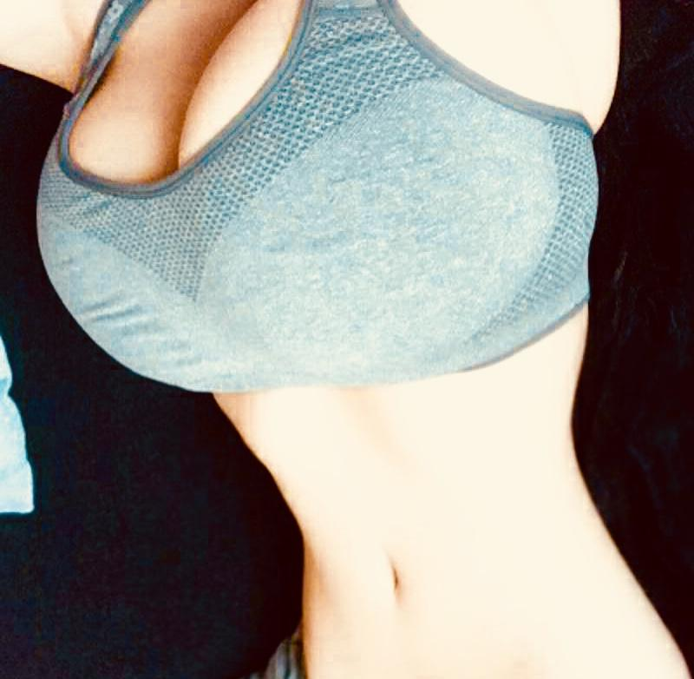

ArthurDank 15-Feb-19 08:46 PM

better then all good wow

thank you

not sure if you are bumping or not but hope you are having a good evening lol

love to hear about it but gotta get back to the floors lol

Bunny 15-Feb-19 08:54 PM

He’s out like a light actually so I’m just grinding against him trying to get his dicke up lol

ArthurDank 15-Feb-19 08:57 PM

damn naughty i like it lol

Bunny 15-Feb-19 08:59 PM

Hehehehe it’s up

ArthurDank 15-Feb-19 09:00 PM

right grind them hips and have fun lol gotta get back to the floors tell me about it later if you like hehe

Bunny 15-Feb-19 09:01 PM

I’ll just spam lol

ArthurDank 15-Feb-19 09:01 PM

and thanks that pic was hot

spam away i dont mind

Bunny 15-Feb-19 09:01 PM

Yeah I have some bras with padding and extra support

ArthurDank 15-Feb-19 09:03 PM

looked good it was holding up well lol

Bunny 15-Feb-19 09:04 PM

Sliding it in now hehehehe

ArthurDank 15-Feb-19 09:26 PM

nice

Bunny 15-Feb-19 09:29 PM

He’s shot twice already hehehehe

ArthurDank 15-Feb-19 09:32 PM

hehehe this is the good spam right here

Bunny 15-Feb-19 09:35 PM

Basically he’s sideways and his thingy is standing straight up,I’m just bouncing on it while he’s asleep lol

ArthurDank 15-Feb-19 09:39 PM

damn hot

wow

Bunny 15-Feb-19 09:46 PM

Third shot. He’s still throbbing so the next is probably on the way

ArthurDank 15-Feb-19 10:01 PM

wow lory you just keep it comin haha

ArthurDank 15-Feb-19 10:30 PM

whew finally leaving work

Bunny 15-Feb-19 10:30 PM

We’re good here,he woke up briefly and then went back to sleep

Didn’t even notice he was balls deep in my ass lol

ArthurDank 15-Feb-19 10:31 PM

haha what cums in the night lol

oh good nice and silent lol how many did you get

he didn't even notice laying sideways wow

Bunny 15-Feb-19 10:36 PM

We’re at 7 right now lol

He’s throbbing now so 8 soon

ArthurDank 15-Feb-19 10:39 PM

hahah holy shit wow you really know how to put in a show for sure lol

ArthurDank 15-Feb-19 10:49 PM

im home from work now replies may be slow but im around

Bunny 15-Feb-19 10:59 PM

8 shots,he’s getting softer though so I’ll have to play with it for a bit

ArthurDank 15-Feb-19 11:01 PM

ah nice how you playing with it? ;)

Bunny 15-Feb-19 11:07 PM

I put it between my thighs and rub it up and down lol

ArthurDank 15-Feb-19 11:12 PM

lol very nice

Bunny 15-Feb-19 11:20 PM

Whoops he shot on my thighs

ArthurDank 15-Feb-19 11:21 PM

shazzam them be some potent thighs

ArthurDank 15-Feb-19 11:35 PM

nice being home such a long day lol

Bunny 15-Feb-19 11:39 PM

You relaxing?

ArthurDank 15-Feb-19 11:39 PM

oh yeah lol its nice

what about you? still working them thighs? lol

Bunny 15-Feb-19 11:44 PM

Yuuup

I honestly can’t help myself

It’s too much fun

ArthurDank 15-Feb-19 11:45 PM

hope i have a gf does that kinky shit too

im just amazed how long you can go ;) still getting that ass filled hehe

Bunny 15-Feb-19 11:48 PM

Sliding it back in now lol

ArthurDank 15-Feb-19 11:49 PM

haha right on now time for some hip action

tell me had you ever done sleep diddling before i mentioned it? (edited)

Bunny 15-Feb-19 11:56 PM

Noooope

I like it though

ArthurDank 15-Feb-19 11:58 PM

that amazes me i scooped you on that i just assumed that had been done

glad you are enjoying full gallop on him seems his dick likes it too

guess that makes me an enabler lol

Bunny 16-Feb-19 12:05 AM

Sorry was putting it up front,got a little bored of just all anal

ArthurDank 16-Feb-19 12:06 AM

you're fine

safe day for you ? (edited)

in my room got some privacy so i can breathe got some time to have fun (edited)

Bunny 16-Feb-19 12:09 AM

Safe day yup

ArthurDank 16-Feb-19 12:09 AM

thats good

Bunny 16-Feb-19 12:09 AM

Nnnnn still not used to the front

ArthurDank 16-Feb-19 12:10 AM

that makes sense all new to you after all

that is a nice image tho you bouncing from behind like that with dick in the front

it will feel more natural overtime despite there only being certain days

Bunny 16-Feb-19 12:16 AM

First shot for the front,fucking huge too,I only have half of him in though

ArthurDank 16-Feb-19 12:16 AM

jesus wow

the stamina you two have is amazing

Bunny 16-Feb-19 12:24 AM

Second shot

Fuck I can’t believe how deep it hits

ArthurDank 16-Feb-19 12:24 AM

whoa

Bunny 16-Feb-19 12:25 AM

I think that’s enough for now I gotta rest lol

ArthurDank 16-Feb-19 12:26 AM

lol i dont blame you been at it hard today

you gonna sleep?

Bunny 16-Feb-19 12:26 AM

Maybe

ArthurDank 16-Feb-19 12:26 AM

cool well if you vanish i will know im beat too today just laying here in bed gotta check on uncle before i can sleep

i dont normally pass out so soon but i have felt like shit today lol

guess you reached your limit ehh?

ArthurDank 16-Feb-19 12:38 AM

have a good rest my friend

ArthurDank 16-Feb-19 03:29 AM

been dozing off and on all evening lol hit me up tomorrow if you like have a good night buddy :)

Bunny 16-Feb-19 03:29 AM

Awww pooo

ArthurDank 16-Feb-19 03:30 AM

sorry lory i thought you passed out i had been too lol

whatcha doing?

Bunny 16-Feb-19 03:35 AM

Was considering going a few more rounds with him while he’s asleep lol

Actually he just woke up lol

ArthurDank 16-Feb-19 03:36 AM

lol nice

haha

have a good time lory sorry gotta crash stick around otherwise lol

spam or hit me up tomorrow if you like, have fun buddy :D

Bunny 16-Feb-19 03:39 AM

Alrighty

ArthurDank 16-Feb-19 02:05 PM

how are you doing today lory? i know it says you're offline but wanted to say hi all the same :)

ArthurDank 16-Feb-19 02:12 PM

maybe you'll be on later :)

Bunny 16-Feb-19 08:24 PM

Heyo

I’m on now

@ArthurDank

ArthurDank 16-Feb-19 08:25 PM

heyo how ya doing buddy?

ArthurDank 16-Feb-19 09:20 PM

you ok?

Bunny 16-Feb-19 11:04 PM

Yup I actually fell asleep

Sorry about that

ArthurDank 16-Feb-19 11:15 PM

oh you're fine no worries lol

how was your day

Bunny 16-Feb-19 11:17 PM

Good~

ArthurDank 16-Feb-19 11:18 PM

awesome

me too this day was pretty good

ArthurDank 16-Feb-19 11:29 PM

lory i wanted to discuss something with you real fast

i hope you dont take it wrong :)

ArthurDank 17-Feb-19 12:02 AM

you're probably busy but i have been thinking that maybe its best we stop the text during sex stuff, maybe you feel the same? sorry its nothing you did and i know we were just having fun with it but him in the dark i just dont feel right about it, so i figure we will keep it a secret and stop while we are ahead? we can still talk about that stuff just maybe not during it if thats okay, i respect you both a great deal thats why i think its best if i were him i would want you all to myself too :) hope you dont take offense its not meant that way i appreciate you trust me and thanks for indulging my kink, hope we can still chat like usual :)

Bunny 17-Feb-19 04:01 AM

Sure no problem lol

ArthurDank 17-Feb-19 05:20 AM

sorry its not you and i do enjoy it but i just think its best

thanks for understanding

perhaps you thought the same way? not sure if thats why you haven't been on much today lol

honestly i would've rather not stopped doing it but i feel its better since he doesn't know and i feel like doing something shifty as a result since im sure he wouldn't be thrilled if he knew lol

ArthurDank 17-Feb-19 01:34 PM

then again i saw kabutos post about you finding out they discussing you ripping ass during sex so i dont know lmao

ArthurDank 17-Feb-19 01:42 PM

it was funny his freakout post on twitter lol

Bunny 17-Feb-19 01:44 PM

It was a joke that spawned from me burping

A loud ass belch actually

ArthurDank 17-Feb-19 01:46 PM

lmao nice

that was funny

the peanut butter from the jar burp

anywho sorry i bugged you just gave me a laugh have a nice day :D

Bunny 17-Feb-19 01:55 PM

You don’t bug me lol

ArthurDank 17-Feb-19 01:56 PM

cool

:)

thanks for understanding about last night

its not that i dont enjoy it and i will certainly miss but i feel like im being underhanded and sketchy if that makes sense

Bunny 17-Feb-19 02:09 PM

No really it’s okay I understand. Domestic worry about it

ArthurDank 17-Feb-19 02:10 PM

lmao

domestic?

i got you tho

besides i know you are clever but i always felt you may get caught and he wouldn't be too happy about it maybe just me tho

ArthurDank 17-Feb-19 02:24 PM

you can still text me about that stuff before and after if you want just during feels risky to me

Bunny 17-Feb-19 04:23 PM

No problem lol

ArthurDank 17-Feb-19 04:24 PM

besides i get just as turned on to details after sex as i do during lol

so what have you been doing today?

Bunny 17-Feb-19 04:31 PM

Not much really just watching Serious Sam videos

ArthurDank 17-Feb-19 04:32 PM

sounds good franchise i always wanted to get into

im just at home on my day off not doing much either

ArthurDank 17-Feb-19 06:13 PM

i know you said not to worry about our chatting stuff but i hope i wasn't making you uncomfortable bringing it up

felt like i was lol

Bunny 17-Feb-19 07:14 PM

No seriously don’t worry about it

ArthurDank 17-Feb-19 07:15 PM

its all good but if i may ask what are you thoughts on my thoughts? no offense i just feel you dancing around the subject, bot trying to pressure you or anythiny

Bunny 17-Feb-19 07:17 PM

I understand your intent completely which is why I’m not prying about it

So all in all no worries

ArthurDank 17-Feb-19 07:18 PM

you can pry really its okay i think we can speak honestly about things and such

Bunny 17-Feb-19 07:20 PM

What I mean is I’m fine with talking about it after it happens and I agree it’s not the smartest idea to do so while it’s happening

So we see eye to eye 100%

No issues here

ArthurDank 17-Feb-19 07:21 PM

yeah i just felt you kept your head under the blankets enough he was gonna get curious lol

im glad i just thought i made you feel like you couldn't discuss this stuff with me now or being hornt in general

maybe i was worried telling you about my fantasies was made you feel awkward glad you agree with me about erring on caution

Bunny 17-Feb-19 07:25 PM

No no no I’d rather know about them instead of assuming it’s some sort of fucked up guro nightmare y’know?

I always browse my favorite tags without an account so coming across guro is common for me

Still fucks me up regardless

ArthurDank 17-Feb-19 07:27 PM

agreed not a guro person either and yeah they are vanilla fantasies mostly, lotta stuff i gloss over for fear i would say too much and maybe cross a boundary with you

i get really into this stuff sometimes

im glad it didn't bug cause most would be offended about me fapping knowing they had a bf

Bunny 17-Feb-19 07:34 PM

Fear of what? I’m literally into stomach bulge. I doubt much could gross me out

ArthurDank 17-Feb-19 07:38 PM

lol good point

i have been honest with you but i try to downplay how howry the chats get me or the fantasies and such for fear i may get too lewd in the chat, for example it turns me on the thought that maybe telling you those fantasies or getting off to your pics maybe made you a bit hornt

not saying they did or not but it was a fantasy on top of hearing about your sex life which allows me to do the voyuer thing lol

not stuff that would gross you out but maybe think im stepping out of bounds

Bunny 17-Feb-19 07:45 PM

Ohhhhh

ArthurDank 17-Feb-19 07:46 PM

yeah thats what i meant

i didn't want to cross a line with you thats why i tend to dance around the questions cause sometimes i can say too much

Bunny 17-Feb-19 07:51 PM

Pretty sure he’s asleep right now too lol. I’ll check

ArthurDank 17-Feb-19 07:51 PM

lol cool

Bunny 17-Feb-19 07:54 PM

Yup he’s asleep lol

ArthurDank 17-Feb-19 07:55 PM

nice

so whatcha gonna do?

Bunny 17-Feb-19 08:01 PM

Hehehehe it’s obvious

ArthurDank 17-Feb-19 08:02 PM

you can go into detail i dont mind just if he wakes up best you holster till after okay?

like we discussed

since we all know whats cumming when that happens

Bunny 17-Feb-19 08:07 PM

Alrighty no worries

ArthurDank 17-Feb-19 08:07 PM

not that i mind you texting me during but its better to be cautious

cool so how is the sleep diddling going?

Bunny 17-Feb-19 08:12 PM

In the process of getting him hard actually

ArthurDank 17-Feb-19 08:12 PM

thighs?

gotta shower lory you wanna spam till he wakes thats fine have fun buddy ;)

ArthurDank 17-Feb-19 08:23 PM

talk you after lory have fun glad you and i are in agreement about it not being very smart to do so during

Bunny 17-Feb-19 08:38 PM

Yup thighs

ArthurDank 17-Feb-19 08:38 PM

very nice he still out?

Bunny 17-Feb-19 08:39 PM

Yuuup

ArthurDank 17-Feb-19 08:39 PM

how much you got him off so fur?

Bunny 17-Feb-19 08:43 PM

He’s throbbing at the moment so it’ll be the first shot

ArthurDank 17-Feb-19 08:50 PM

very nice chick

Bunny 17-Feb-19 08:59 PM

He’s twitchy today~ he’s already shot twice,once on my thighs and once up my ass.

ArthurDank 17-Feb-19 09:00 PM

very hot hehe

maybe he is a little tired of holding in and wants to let out ;)

Bunny 17-Feb-19 09:05 PM

I squeezed him just a little bit and he shot again lol

ArthurDank 17-Feb-19 09:06 PM

damn well done

drain him dry ;) if you vanish i will just assume he woke up haha

Bunny 17-Feb-19 09:10 PM

Just riding him now~

ArthurDank 17-Feb-19 09:11 PM

there you go ;)

sounds hot going up and down like that

Bunny 17-Feb-19 09:13 PM

Woah,he just got a bit bigger lol

ArthurDank 17-Feb-19 09:13 PM

nice lol

Bunny 17-Feb-19 09:15 PM

Really stirring up my guts this time lol also I’m not bothered by your fantasies I don’t remember if I mentioned that already or not

ArthurDank 17-Feb-19 09:18 PM

you did its okay

i am glad sometimes i imagine its my dick you do that too lol

i worry too much you know that lol

Bunny 17-Feb-19 09:34 PM

Hehehehe he shot twice in a row~

ArthurDank 17-Feb-19 09:36 PM

holy shit some real riding action you got there hehe

how many times have you cum so far?

Bunny 17-Feb-19 09:38 PM

4~

ArthurDank 17-Feb-19 09:39 PM

damn that some potent dicking

Bunny 17-Feb-19 09:43 PM

Sometimes I just grope myself if he’s not awake to,it helps a lot cuz they’re sensitive

ArthurDank 17-Feb-19 09:43 PM

i dont blame you for playing those tits i would too lol

makes it easy for you to cum ehh?

i was thinking about the sports bra pic wanting to lift the underside of it just enough to stuff my dick in and thrust and coat them and your face in cum

Bunny 17-Feb-19 09:50 PM

He’s done that before lol

ArthurDank 17-Feb-19 09:52 PM

great minds think alike i figured he did with or without the bra, i would do the same such nice tits be wrong not to

still out cold?

Bunny 17-Feb-19 09:54 PM

Yuuup

ArthurDank 17-Feb-19 09:55 PM

nice

dont know why i ask i know you would be out of contact till after lol

Bunny 17-Feb-19 09:58 PM

He’s leaking so much lol,he’s not even shot again either. Just leaking

ArthurDank 17-Feb-19 09:58 PM

hahah probably take a bit to build it back up lol

Bunny 17-Feb-19 10:00 PM

Yeah time for a break lol

ArthurDank 17-Feb-19 10:01 PM

yeah wore yourself out a bit lol

well you came a lot and got him off a lot too so win win lol

ArthurDank 17-Feb-19 10:22 PM

have fun lory hit me up later if you want after rest or if he woke up and decided to work you over lol

either way talk to you after if you want ;D glad you felt the same as me about not texting during sex, feels smarter this way

ArthurDank 18-Feb-19 11:21 AM

hey lory how did things go last night?

Bunny 18-Feb-19 02:11 PM

It went good

ArthurDank 18-Feb-19 02:12 PM

very nice hehe what all happened?

ArthurDank 18-Feb-19 02:33 PM

if you'll indulge me ;)

Bunny 18-Feb-19 02:55 PM

One sec

ArthurDank 18-Feb-19 02:55 PM

sure

ArthurDank 18-Feb-19 05:41 PM

must've got busy lol tell me about it later look forward to it lol

when you get back i mean

Bunny 18-Feb-19 05:51 PM

Hellooooooo

Yeah we basically just bumped for a few hours after he woke up

ArthurDank 18-Feb-19 05:57 PM

oh very nice

sounds like good fun

get ya doggy style for a while?

Bunny 18-Feb-19 08:09 PM

Yee

ArthurDank 18-Feb-19 08:41 PM

very hot weird how you sent that 30 mins ago and i just get it

ass leaking yogurt all over?

how many loads? ;)

Bunny 18-Feb-19 08:42 PM

About 9 and yes

ArthurDank 18-Feb-19 08:42 PM

wow thats steamy right there

so whatcha doin now?

ArthurDank 18-Feb-19 08:56 PM

i wanted to ask for soemthing lory, a pic of your face you sent me one on one of your accounts mounts ago but i lost it, would make my fantasies complete, being able to imagine your lewd faces while being fucked

Bunny 18-Feb-19 09:16 PM

Alrighty

Ayyyy


Also

Sideswept hair
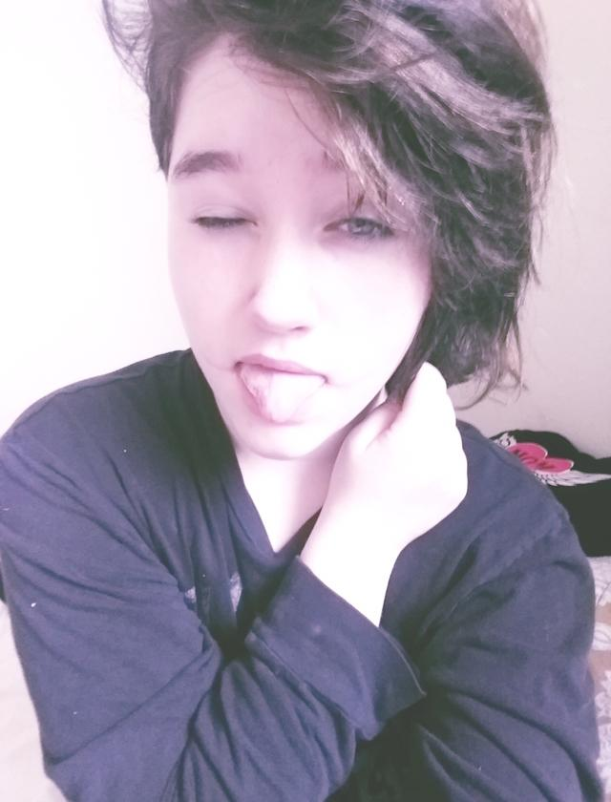

Also just watching videos lol

ArthurDank 18-Feb-19 09:26 PM

beautiful thanks for two you're so generous

you have the prettiest blue eyes i have seen

oh nice glad you're having fun unwinding

Bunny 18-Feb-19 09:26 PM

They’re usually grey too lol

ArthurDank 18-Feb-19 09:27 PM

lol oh maybe thats what it is they're beautiful dont see grey often in people

Bunny 18-Feb-19 09:27 PM

Modeled my hairstyle after her
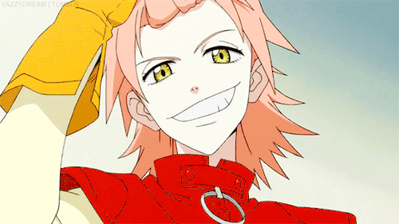

ArthurDank 18-Feb-19 09:28 PM

its perfect on you love the wavey black hair haha

Bunny 18-Feb-19 09:28 PM

Second one was me trying to imitate her season 3 hairstyle



ArthurDank 18-Feb-19 09:31 PM

damn c so cute lory

Bunny 18-Feb-19 09:32 PM

Probably my tiny bit of Asian blood that gives me extra cuteness

Also more midriff lol
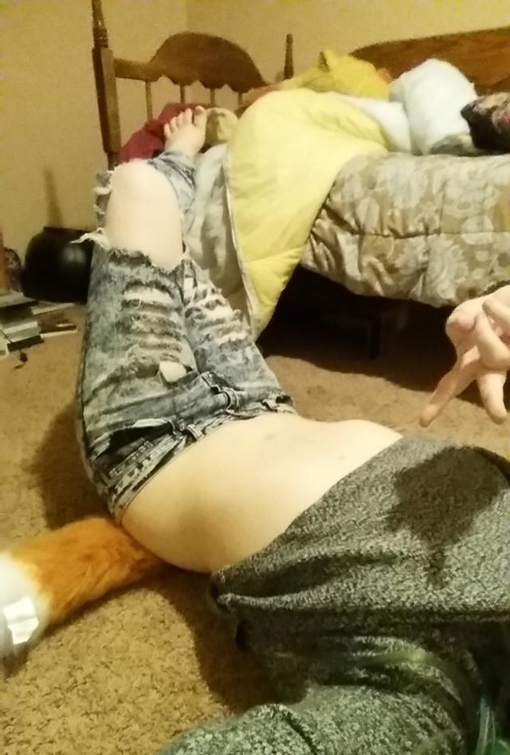

ArthurDank 18-Feb-19 09:37 PM

you are cute

thats a sexy photo

all its just you being the whole package as it were

love your midriff and how your pants are a little low like teasing and the fox tail lol

Bunny 18-Feb-19 09:40 PM

Basically me at night

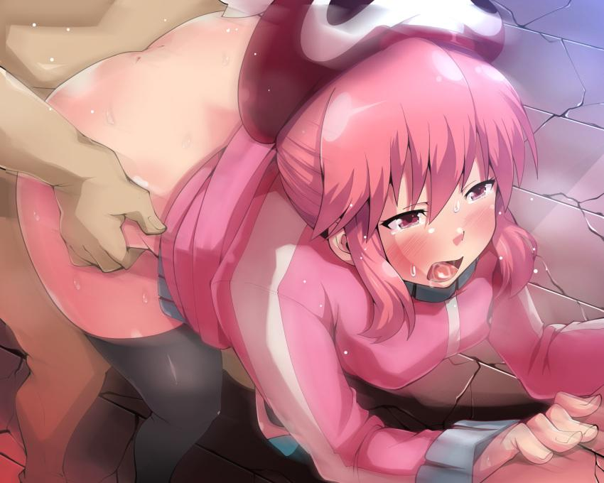

Lmao

ArthurDank 18-Feb-19 09:41 PM

no wonder he is always horny

thats a hell of an image in my mind now ;)

still half clothed taking it up the ass hehe

good times lmao

Bunny 18-Feb-19 09:46 PM

Almost forgot this one lol
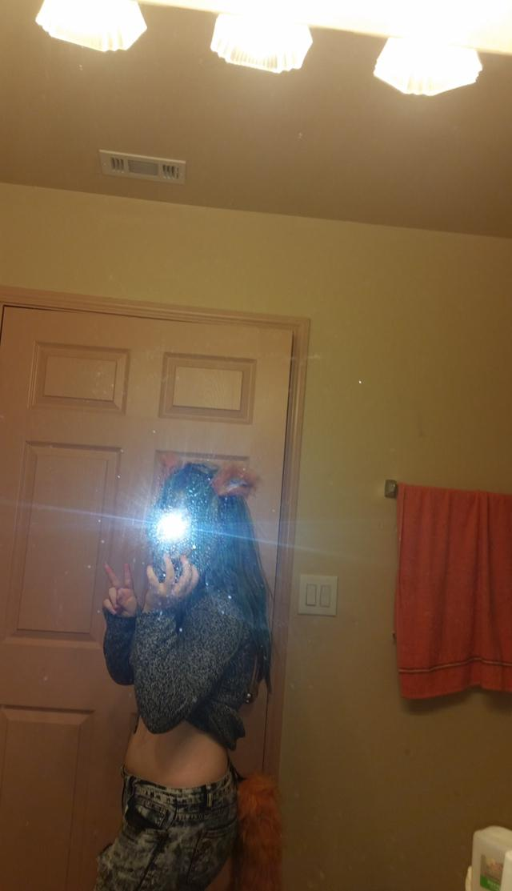

ArthurDank 18-Feb-19 09:48 PM

sexy

are you wearing ears? cute ;)

Bunny 18-Feb-19 09:49 PM

Fox ears~

Skinny jeans>>>>>regular jeans

Bike shorts>>>>>>skinny jeans

He’s actually pushed it through bike shorts before too

Also dicke joke
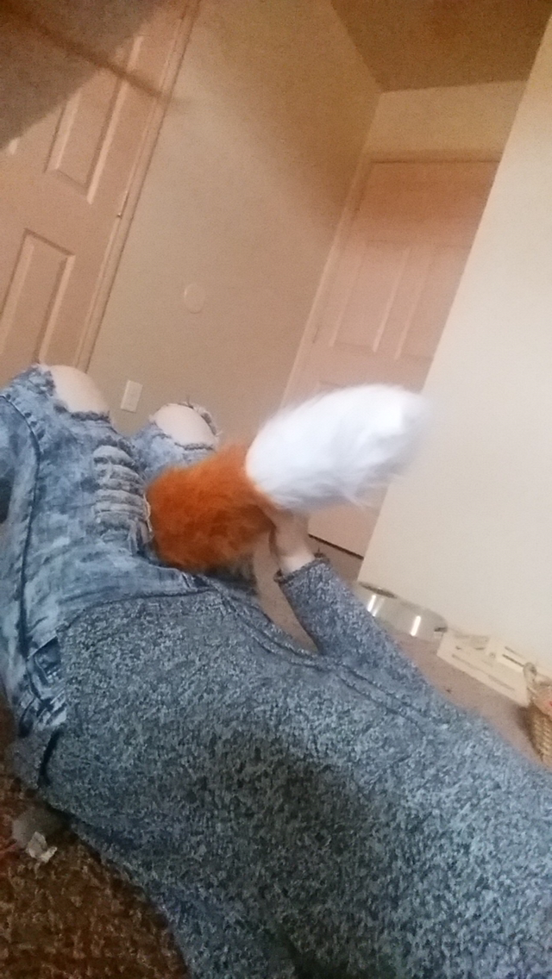

ArthurDank 18-Feb-19 10:09 PM

no shit he fucked you through those bike shorts? have to see those sometime

also lmao thats funn6

sorry for late replies finishing the damn floor

Bunny 18-Feb-19 10:10 PM

Yes right through my bike shorts lol

I’ll probably try it again tonight lol

ArthurDank 18-Feb-19 10:14 PM

shamzzam holy

soubds hot to ke

you were wearing bike shorts during the last dicking?

Bunny 18-Feb-19 10:15 PM

Yuuup

Leaves basically nothing to the imagination lol

ArthurDank 18-Feb-19 10:17 PM

lmao sounds hot

I'll say hehe

Bunny 18-Feb-19 10:18 PM

Just bumping up against him since he’s out cold lol

Like this it won’t take long to grab him hard lol

ArthurDank 18-Feb-19 10:18 PM

hehe nice fucked him to sleep now fucking him in sleep

very nice lory

listen its your call but maybe i jumped the gun about texting during sex, i just didn't want you to get caught but its your call since i dont mind i know you like the exhibition aspect of it, but if you decide to text during it again i urge caution lol

Bunny 18-Feb-19 10:41 PM

Hehehehe big dicke hard

ArthurDank 18-Feb-19 10:49 PM

nice hehe im bavk

take that big dicke to town hehe

ArthurDank 19-Feb-19 02:25 AM

how's it hanging? :)

ArthurDank 19-Feb-19 10:57 AM

like the new profile pic lori talk to you later

ArthurDank 19-Feb-19 11:14 AM

i see you got suspended again on twotter

Bunny 19-Feb-19 11:59 AM

Yuuup

No big deal though

People know I’ll be back

ArthurDank 19-Feb-19 11:59 AM

damn right you will

you were almost at 700 you came close

Bunny 19-Feb-19 12:02 PM

It’s all good

Gonna be Ryuko this time

I look more like her anyways

I could always take over your account lol

Popularity would explode instantly

People know who I am now

ArthurDank 19-Feb-19 12:08 PM

lol yes you could

yeah they do you are all over now

sucks they burned that alt too they got both of your accoubts

you do look more like her means that cosplay is definitely you

i can try making you another just give me time

Bunny 19-Feb-19 12:11 PM

Sure if you can use Google Voice

I made like 9 legit accounts with it before it was blacklisted

ArthurDank 19-Feb-19 12:12 PM

damn

sounds like work to me but i will do it lol

Bunny 19-Feb-19 12:18 PM

Nah google voice is simpe

Simple*

I just can’t do it without getting a new phone number

ArthurDank 19-Feb-19 12:18 PM

setting it up now lory :)

its all good

Bunny 19-Feb-19 12:18 PM

Thaaaanks

I don’t think I’ve shown you a picture from when I was a platinum blonde

Ayyy


ArthurDank 19-Feb-19 12:21 PM

beautiful

Bunny 19-Feb-19 12:23 PM

You got it set up?

ArthurDank 19-Feb-19 12:28 PM

DingDongRyuko is your name password is MariEvangelion

number is 3048339617

just logged out its all yours

dig the blonde look btw very very nice

Bunny 19-Feb-19 12:32 PM

I’ll probably change it to RyukoSmuggies

ArthurDank 19-Feb-19 12:33 PM

that works make any adjustments you want its just a template lol

its yours now

Bunny 19-Feb-19 12:38 PM

This the email or the Twitter?

ArthurDank 19-Feb-19 12:39 PM

the twitter is DingDongRyuko

Bunny 19-Feb-19 12:40 PM

Ohhhhh

ArthurDank 19-Feb-19 12:42 PM

I should've been clear sorry

Bunny 19-Feb-19 12:42 PM

Won’t let me in

Is the username wrong?

What’s the email address?

Nvm got it

ArthurDank 19-Feb-19 12:45 PM

oh good

what was wrong

ArthurDank 19-Feb-19 12:54 PM

glad you got on

now raise some hell lol

ArthurDank 19-Feb-19 01:09 PM

oh and want went down during last nights bump a thon? an inquiring mind does enjoy knowing :D

Bunny 19-Feb-19 01:28 PM

I’ll tell you as soon as you tell me the code you just got

ArthurDank 19-Feb-19 01:28 PM

a code just got sent to me 670685

oh good

did that work?

Bunny 19-Feb-19 01:41 PM

Yup

That means it’s a legit account now

Just gotta make an email for it

ArthurDank 19-Feb-19 01:48 PM

cool then you are good

glad i could help

ArthurDank 19-Feb-19 02:10 PM

dont forget about those details when you come back lol

ArthurDank 19-Feb-19 08:25 PM

oh lory remember to add me back on twitter later have a good evening

Bunny 20-Feb-19 09:16 PM

I am very proud of my little brother

Very proud

ArthurDank 20-Feb-19 09:16 PM

oh what did he do

Bunny 20-Feb-19 09:19 PM

He’s in Sweden at the moment

Brought his girlfriend with him

They fucked. I’m proud of him

Guess I don’t need to ara ara at this point

ArthurDank 20-Feb-19 09:23 PM

ara ara?

thats wonderful good show if i do say

Bunny 20-Feb-19 09:23 PM

Joke

ArthurDank 20-Feb-19 09:23 PM

lmao

thats great tho

very happy he got em up

Bunny 20-Feb-19 09:37 PM

Apparently she’s a squealer

Bunny 20-Feb-19 09:48 PM

We’re trying something new tonight

Wanna know what it is?

You dead?

ArthurDank 20-Feb-19 10:10 PM

no whats new

im at work

but i wanna hear this

glad your bro got a squealer haha

Bunny 20-Feb-19 10:11 PM

Those pills that make him bigger y’know

Gonna try those

ArthurDank 20-Feb-19 10:12 PM

viagra? damn he aint gonna stop lol sounds right up your alley ahah

have fun with that love to hear the after results

gotta finish this damn floor be back later

ArthurDank 20-Feb-19 10:37 PM

back anywho hope his dick dont explode lol sounds like good kinky fun ;)

Bunny 20-Feb-19 10:40 PM

Waiting for it to kick in lol

ArthurDank 20-Feb-19 10:41 PM

lol very nic

lemme know how this works sounds like fun

ArthurDank 20-Feb-19 10:53 PM

what else did your bro say about his gf? he told you she was a squealer? lucky guy

Bunny 20-Feb-19 10:54 PM

Yuuup

Missionary at first and then a piledriver

ArthurDank 20-Feb-19 10:56 PM

piledriver is that like doggy?

thats what your bro did

Bunny 20-Feb-19 11:07 PM

It’s like the wheelbarrow

This

Basically the dude is on the top with the chicks legs forwards

like this

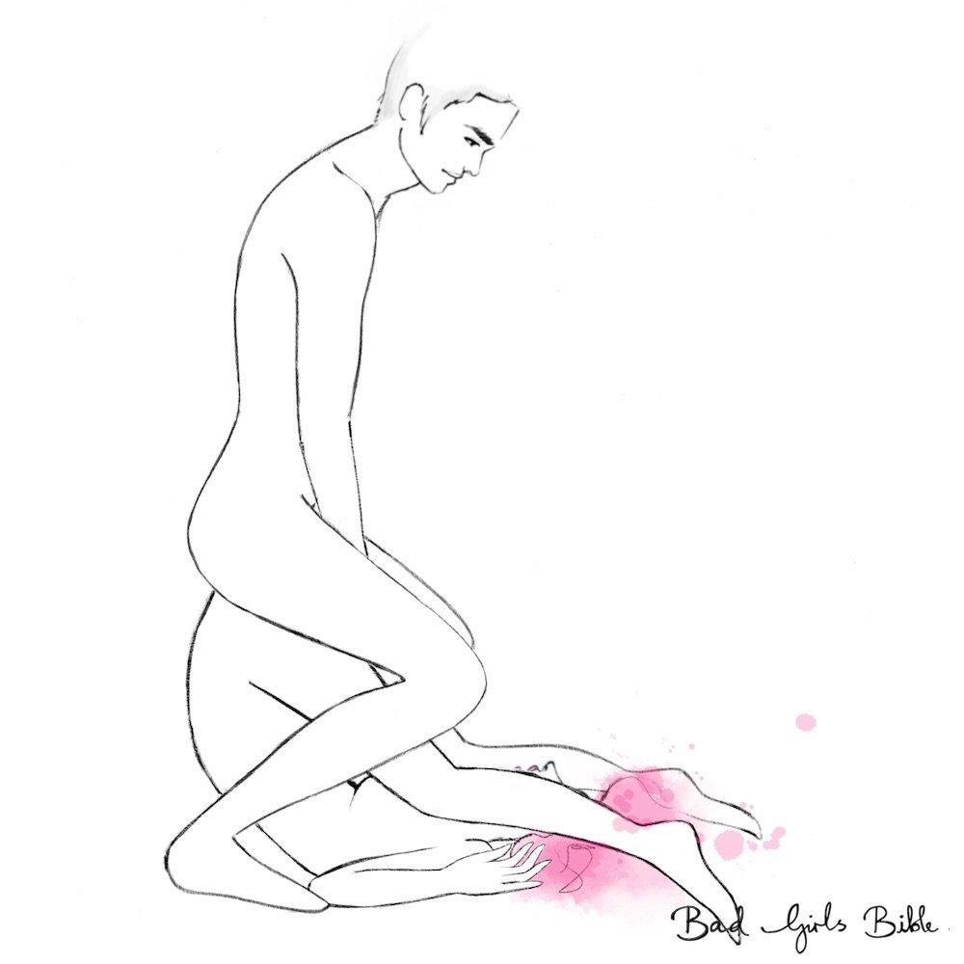

No stranger to this myself so I’m surprised his girlfriend could take it

ArthurDank 20-Feb-19 11:14 PM

tells me he got a real keeper

damn thats kinky makes sense you could do it but bro really lucked out on the first try

how are the pills going?

Bunny 20-Feb-19 11:24 PM

Enormous~

And yeah he wasn’t supposed to tell us about it apparently

It was on valentine’s night

He’s drunk tonight so it kinda just slipped out

We never would’ve known otherwise

ArthurDank 20-Feb-19 11:32 PM

hahahah well soubds like you weren't the only one who had fun that night rock on

whoops lol

welp time for a celebration, not like everyone wouldn't have noticed at some point haha

glad the pills are having a positive effect

lemme know how it goes lol

Bunny 20-Feb-19 11:59 PM

That

Was good

My legs hurt lol

ArthurDank 21-Feb-19 12:00 AM

damn welcome back already lol

wasn't expecting you back so soon what went down? ;)

Bunny 21-Feb-19 12:02 AM

Well

I was turned upside down on my back

And fucked upside down

ArthurDank 21-Feb-19 12:03 AM

piledriver?

Bunny 21-Feb-19 12:03 AM

Yes

ArthurDank 21-Feb-19 12:03 AM

hot

Bunny 21-Feb-19 12:03 AM

Carry fucked too lol

ArthurDank 21-Feb-19 12:03 AM

oh damn i love that

Bunny 21-Feb-19 12:03 AM

Benefits of being small

ArthurDank 21-Feb-19 12:03 AM

indeed

carry fuck always looks hot whenbi see it

picking a gal up holding them while pounding away inside good stuff

notice any change with the pills? aside from an even bigger dick somehow? lol

Bunny 21-Feb-19 12:08 AM

Shots were bigger

Way bigger

ArthurDank 21-Feb-19 12:09 AM

damn he leaves quite a payload as is you told me

did he fuck harder too?

Bunny 21-Feb-19 12:09 AM

Yes

Like a gorilla

ArthurDank 21-Feb-19 12:09 AM

wow

Bunny 21-Feb-19 12:09 AM

I can’t even walk properly

ArthurDank 21-Feb-19 12:10 AM

shit i know he leaves your legs like rubber most days but this sounds different :D

glad you liked the pills effect hehe

Bunny 21-Feb-19 12:12 AM

I’ve never been bounced that hard before

ArthurDank 21-Feb-19 12:15 AM

wow up and down while holding you against him nice image ;)

thats saying a lot

Bunny 21-Feb-19 12:17 AM

Face fucked too lol

Throat hurty

ArthurDank 21-Feb-19 12:20 AM

lmao wow

thats a lot of dicking right there hope your throat will be okay soon

hot tho

Bunny 21-Feb-19 12:21 AM

I can feel the load up front lol

Pretty sure he pushed past my cervix this time

Or the load got in there

Either or

ArthurDank 21-Feb-19 12:22 AM

holy fuck bug dude gets even bigger blows bigger load its very likely

big*

thats pretty rare im told to feel it so much

Bunny 21-Feb-19 12:24 AM

If I wasn’t safe today I’d definitely be knocked up

ArthurDank 21-Feb-19 12:25 AM

glad you guys are smart about only unsafe sex during safe days

i believe you would be lol

took a lot in the pussy more then usual this sounded a lot more intense then your usual bump a thons

Bunny 21-Feb-19 12:26 AM

If I press my stomach it leaks out lol

So yeah

Creampie

ArthurDank 21-Feb-19 12:27 AM

wow creampie and a half

lol

facefuck piledriver, carry fuck, i dig the variety of moves

fun night

Bunny 21-Feb-19 12:30 AM

Basically this

One sec

ArthurDank 21-Feb-19 12:31 AM

cool

Bunny 21-Feb-19 12:32 AM

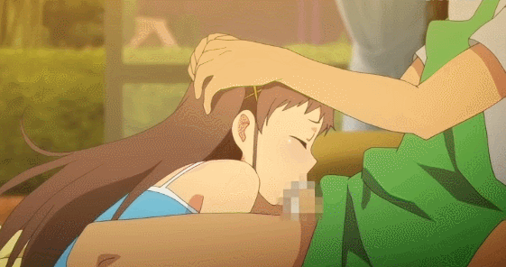

Basically this for a whole ten minutes

I could barely breathe

ArthurDank 21-Feb-19 12:33 AM

holy fuck lory no wonder your throat is sorr

sore

pill gave him extra endurance too i see

Bunny 21-Feb-19 12:34 AM

That’s an understatement

ArthurDank 21-Feb-19 12:34 AM

indeed

Bunny 21-Feb-19 12:35 AM

I think Senketsu just made him more eager

ArthurDank 21-Feb-19 12:35 AM

wait you were in the cosplay?

damn that explains even more

my gf dresses in that im gonna wreak her too haha

Bunny 21-Feb-19 12:37 AM

To be honest I like doing it in costume

ArthurDank 21-Feb-19 12:37 AM

i dont blame you and you look hot in it

Bunny 21-Feb-19 12:38 AM

Lemon eating punk bitch gets destroyed by zero star 11 incher

ArthurDank 21-Feb-19 12:38 AM

i would read that doujin lol

you get throat fucked for 10 mins

carry fucked and piledrived

while dressed as ryuko wow what an event

with harukos hair forgot that lol

Bunny 21-Feb-19 12:41 AM

Basically this

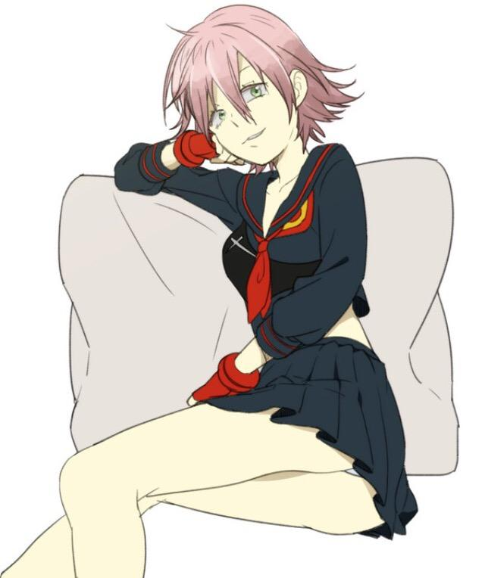

ArthurDank 21-Feb-19 12:42 AM

lmao perfect

this is the stuff legends are made of

Bunny 21-Feb-19 12:42 AM

Did you know about this?

ArthurDank 21-Feb-19 12:42 AM

know what?

Bunny 21-Feb-19 12:42 AM

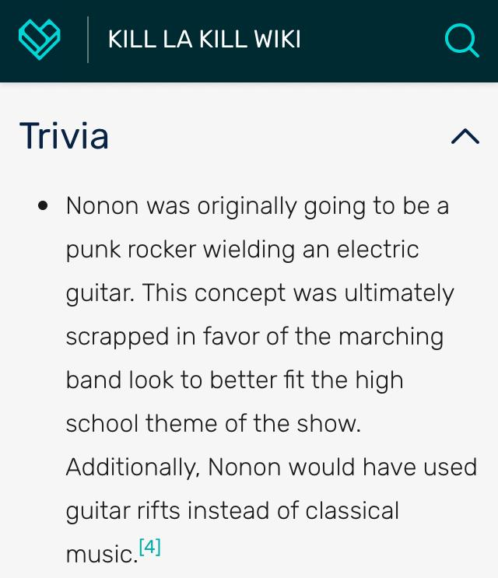

Nonon was basically gonna be another Haruko

ArthurDank 21-Feb-19 12:43 AM

i saw you post that the other day on twitter i thought "no wonder lory dug her"

thats perfect really

Bunny 21-Feb-19 12:52 AM

More or less how he handled me
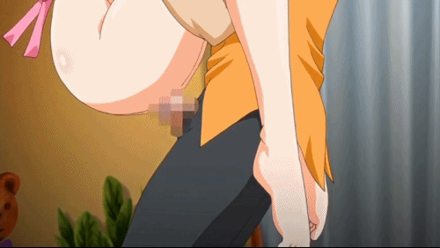

ArthurDank 21-Feb-19 12:53 AM

damn thats pretty intense lory ;)

really gave it his all

Bunny 21-Feb-19 12:54 AM

Kinda pulled the skirt up around my stomach

He just likes watching me make lewd faces

ArthurDank 21-Feb-19 12:54 AM

ahh good man its hotter that way

i dont blame him at all lol

Bunny 21-Feb-19 12:56 AM

I’m also happy because I finally unlocked Sasha for online play on AoT2

Her skill set is

Questionable

But I’ll make it work

She can’t throw broken blades like my custom character can but whatever

ArthurDank 21-Feb-19 12:57 AM

well done with sasha

Bunny 21-Feb-19 12:57 AM

I wonder what mods AoT2 has on pc

It might justify a purchase

ArthurDank 21-Feb-19 12:57 AM

i hate when characters we like have nerfed skill sets

Bunny 21-Feb-19 12:57 AM

I used to mod Xenoverse 2

ArthurDank 21-Feb-19 12:57 AM

i dont know but i am to find out when my laptop gets here

oh nice i had that never got to play it

whats AoT2 like? I never got to play that one i almost beat the 1st on oc before my desktop died

pc*

Bunny 21-Feb-19 01:00 AM

It controls good but the textures are weird

If it was on PC I’m sure there’s a mod to fix that

I really need this version of Senketsu

ArthurDank 21-Feb-19 01:02 AM

for sure, gotta be texture mods

oh which one?

Bunny 21-Feb-19 01:03 AM

The activated one lol
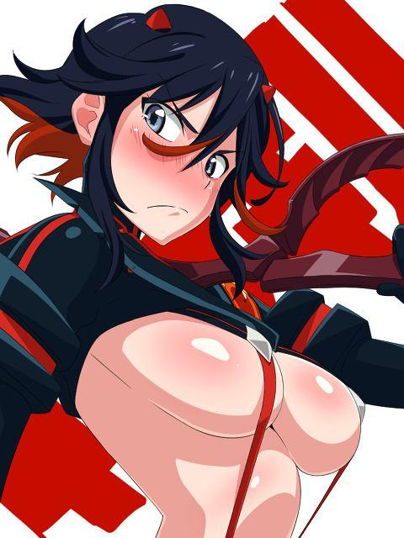

ArthurDank 21-Feb-19 01:03 AM

oh hell yes do it lol

Bunny 21-Feb-19 01:06 AM

I already bounce a lot in the sailor uniform one

The suspenders help keep the skirt from falling off

ArthurDank 21-Feb-19 01:08 AM

wow i believe it

bounce to the ounce lory lol

Bunny 21-Feb-19 01:08 AM

I don’t think I’d be able to wear activated Senketsu in public lol

ArthurDank 21-Feb-19 01:09 AM

no no not at all lol

Bunny 21-Feb-19 01:09 AM

Not because I’m embarrassed no

ArthurDank 21-Feb-19 01:09 AM

oh okay

Bunny 21-Feb-19 01:09 AM

But because of indecent exposure laws

ArthurDank 21-Feb-19 01:09 AM

oh yeah those

fun police

voyuers like me hate them lol

Bunny 21-Feb-19 01:10 AM

If anything Senketsu covers more than Junketsu

ArthurDank 21-Feb-19 01:10 AM

oh gor sure

for*

especially down south

you doing alright?

Bunny 21-Feb-19 01:21 AM

Yuuup

He’s out cold but I still want more lol

ArthurDank 21-Feb-19 01:22 AM

lol

i smell sleep diddling

im not surprised those pills probably wore him out when he back to earth lol

Bunny 21-Feb-19 01:24 AM

Wow

He’s still big

Even soft

They really do work

ArthurDank 21-Feb-19 01:25 AM

damn right lol

Bunny 21-Feb-19 01:25 AM

Just gotta get him hard

ArthurDank 21-Feb-19 01:25 AM

lmao that wont be hard lol

Bunny 21-Feb-19 01:25 AM

Shouldn’t be difficult

ArthurDank 21-Feb-19 01:25 AM

nope

hehe have fun

senketsu demands more orgasms and cum

Bunny 21-Feb-19 01:28 AM

He’s already hard lol

I’m just gonna

Sit on top

ArthurDank 21-Feb-19 01:28 AM

up the bit

butt

Bunny 21-Feb-19 01:29 AM

Just gotta shove it in

ArthurDank 21-Feb-19 01:29 AM

you got it

Bunny 21-Feb-19 01:29 AM

It’s about as thick as my phone now lol

ArthurDank 21-Feb-19 01:29 AM

goddamn

Bunny 21-Feb-19 01:29 AM

Having a bit of trouble shoving it in

ArthurDank 21-Feb-19 01:29 AM

take your time

Bunny 21-Feb-19 01:31 AM

I’ll just spit on it to make it easier on myself

ArthurDank 21-Feb-19 01:32 AM

naughty i dig it

Bunny 21-Feb-19 01:34 AM

Jeez that took a while

ArthurDank 21-Feb-19 01:34 AM

those pills arent bullshit

glad you got him in ;)

Bunny 21-Feb-19 01:38 AM

Stirring up my guts~

ArthurDank 21-Feb-19 01:38 AM

very nice

sounds so kinky

ArthurDank 21-Feb-19 01:48 AM

gotta check on my uncle and shower glad you are having fun, fill me in later after you get filled up if you want lmao

ArthurDank 21-Feb-19 09:46 AM

how was the sleep diddling?

ArthurDank 21-Feb-19 09:54 AM

also i gotta ask, have you guys ever done it in the shower? i hear mixed results from that

Bunny 21-Feb-19 02:11 PM

Yes

ArthurDank 21-Feb-19 02:11 PM

oh very hot

sorry i was scrolling because i made you an alt you still need to give it an email tho

i sent the details to twitter DM

what is shower sex like

Bunny 21-Feb-19 02:38 PM

It doesn’t work

The & symbol doesn’t work

ArthurDank 21-Feb-19 02:48 PM

what the hell

try @GamingSmugs

781702

is the code

ArthurDank 21-Feb-19 03:21 PM

dont forget i want to hear about shower sex, some people say its to die for others say its miserable lol

Bunny 21-Feb-19 06:50 PM

Well as long as you don’t slip

ArthurDank 21-Feb-19 07:04 PM

oh mean like trip mid dicking?

Bunny 21-Feb-19 07:04 PM

Yes

ArthurDank 21-Feb-19 07:04 PM

most people say it makes sex painful and blowjobs a hassle i dont knoe

cause of the water

it always looked like fun to me

hows that alt working?

Bunny 21-Feb-19 07:12 PM

It’s working perfectly

I can dump all my news related shit there

ArthurDank 21-Feb-19 07:12 PM

good im glad I can help

sounds groovy

ArthurDank 21-Feb-19 07:24 PM

whats the @? add me later

actually I already found it thanks

Bunny 21-Feb-19 10:52 PM

Henlo

ArthurDank 21-Feb-19 10:53 PM

henlo how are you?

Bunny 21-Feb-19 10:56 PM

Gooood

Also hornt ngl

ArthurDank 21-Feb-19 10:57 PM

very nice me too now my hair got cut lmao

oh nice been there hornt too

;)

so whats the plan for your hornt? lol

Bunny 21-Feb-19 11:00 PM

Probs under the blankets fucking

ArthurDank 21-Feb-19 11:00 PM

oh nice

head under the blankets

sounds like fun

just dont get caught lol

assuming you get to the blankets lol

Bunny 21-Feb-19 11:06 PM

Already am~

ArthurDank 21-Feb-19 11:08 PM

oh nice

whats going on?

Bunny 21-Feb-19 11:09 PM

Just waiting for a dicking tbhhhh

ArthurDank 21-Feb-19 11:10 PM

my bad thought it started lol im sure it wont be long

you'll have to fill me in if you cant keep your cover lol

so in the bed under the blankets waiting ehh?

