Tw// this document has a lot of sensitive content, including pedophilia, zoophilia, among other things
I was really going back and forth on making this, because I really didn’t want to give Valerie any more attention, but she’s a fucking psycopath and people should be aware of her and how she’s a danger to people. Please do not contact Valerie in any way, and instead just block and report her on any platforms you find her on, not because I care about her getting “harassed” or anything, but because once you do, you become one of her victims. Valerie is extremely active online, so this document will be updated as new information comes out.

Valerie, aka s1mpl33l1f3, mossghost, Alyssia, or any of the accounts accusing random users on twitter is a serial stalker, harasser, and liar. She has done MANY shitty things, and shows no sign of stopping anytime soon.
So, exactly what has Valerie done? Well, for starters her main thing is accusing random people online, especially users on Twitter, of being pedophiles. She has many alt accounts dedicated to doing this, as well to attempt and boost her posts. She tries to claim that none of the alts are hers, when they all have the same creation month, and little to no tweet history outside of tweeting to/or about whoever she’s targeting at the moment. She’s even larped as a minor before in order to accuse people. It’s unknown why she targets people, though the main theory is that they have, at some point, posted or retweeted something she disagrees with. She especially seems to dislike people that seem “communist”.
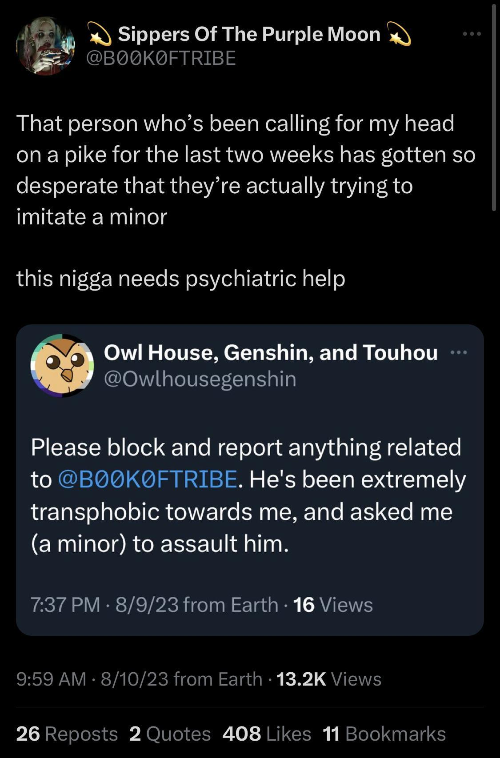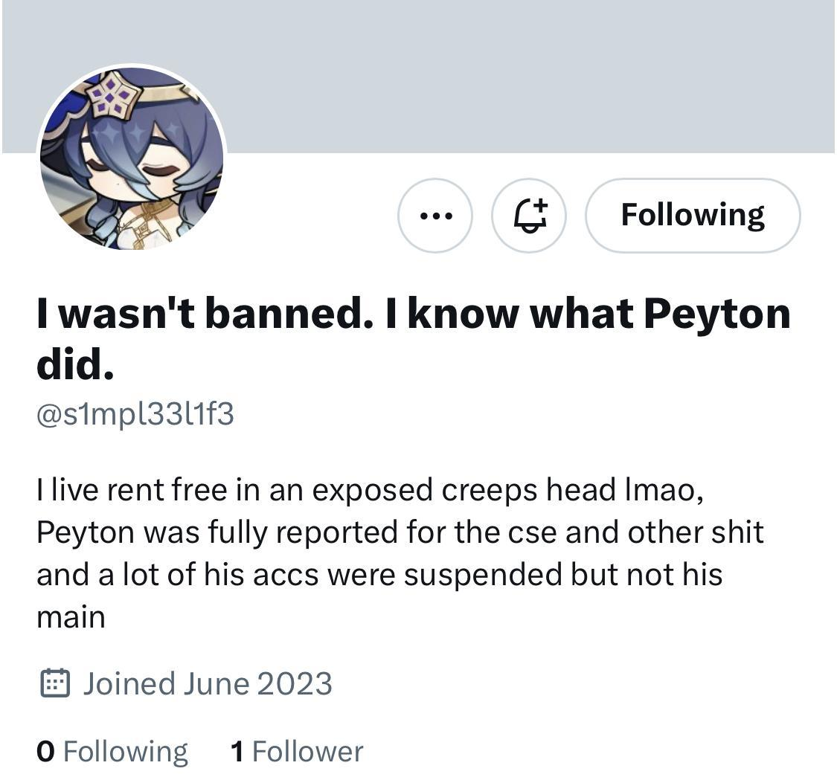

Her original discord account was even terminated for harassment as well. 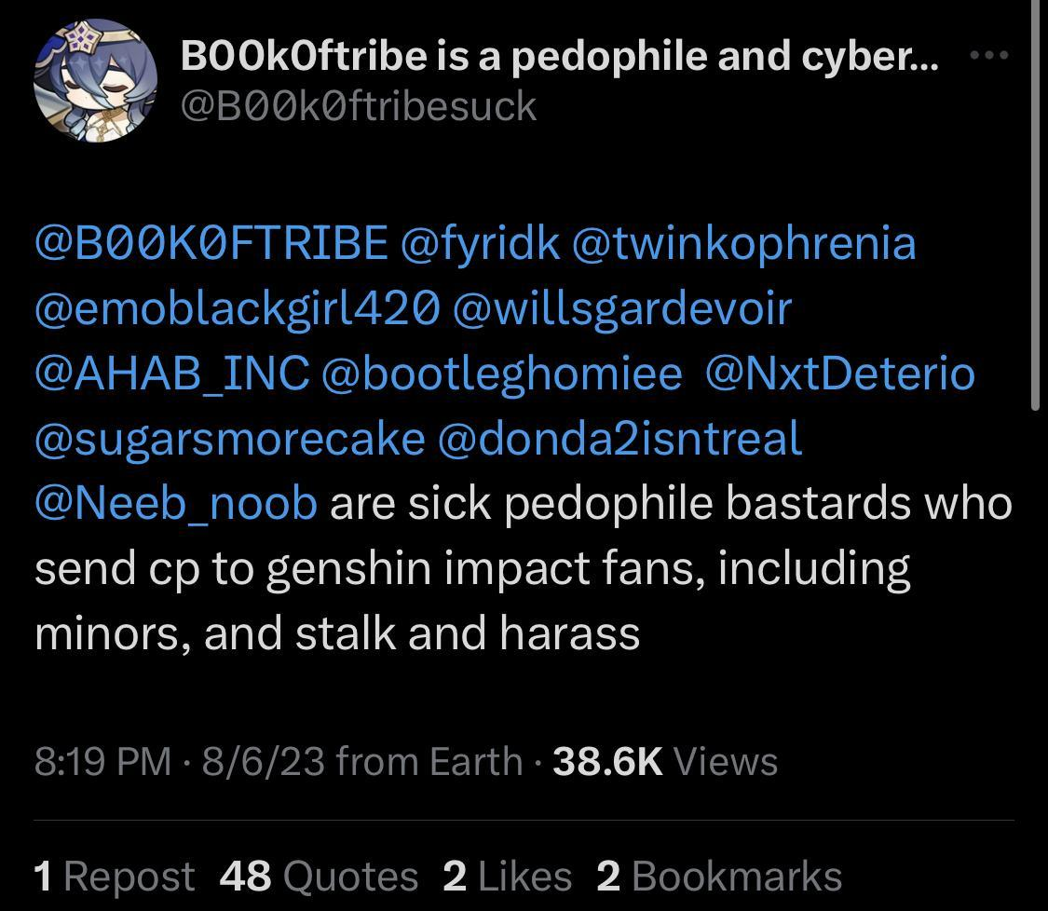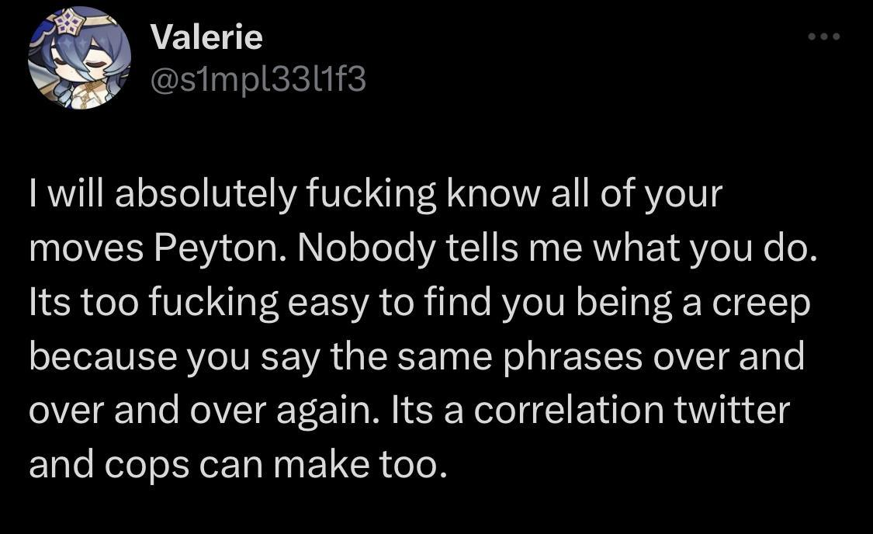She loves to say that people are cyberstalkers and such as well, when she does the exact same thing herself, and has admitted to it. On her main Twitter account at one point, she had about 270 tweets all about the same person. She finds new random twitter users to harass about every month or so, and her list of victims grows larger and larger. Despite her labeling of people as pedophiles and such, she’s also made some threats herself to underage people. She’s also attempted to get minors involved in her schemes against those she targets.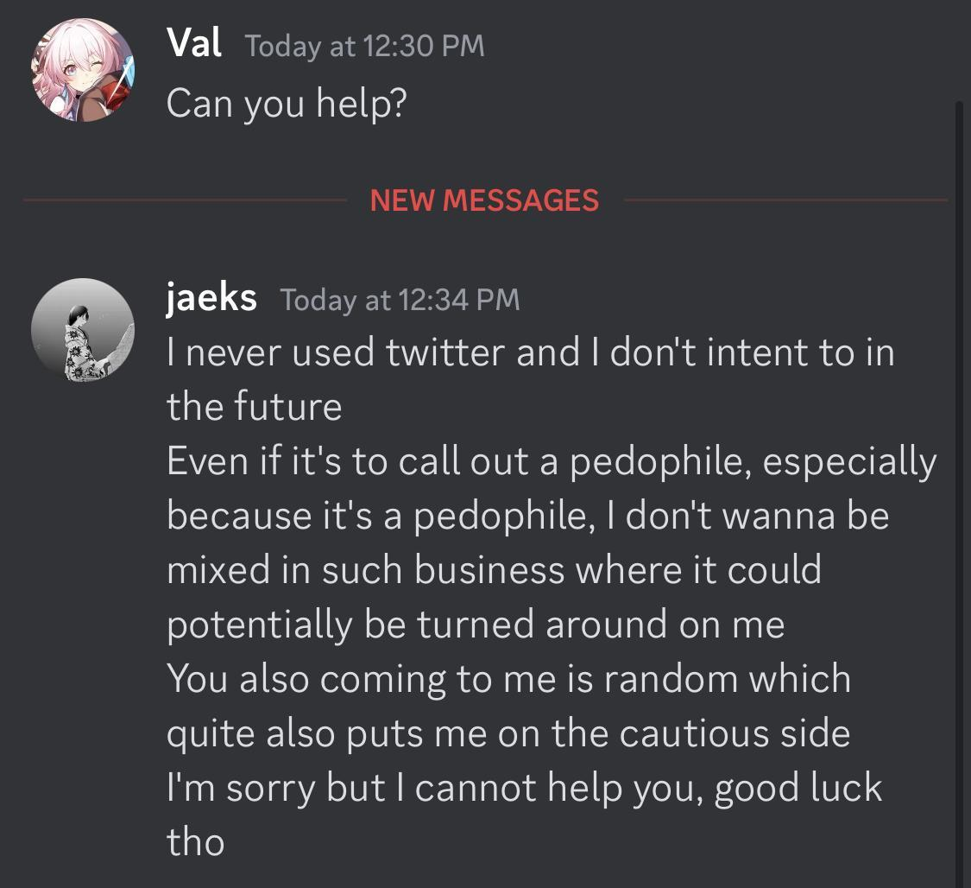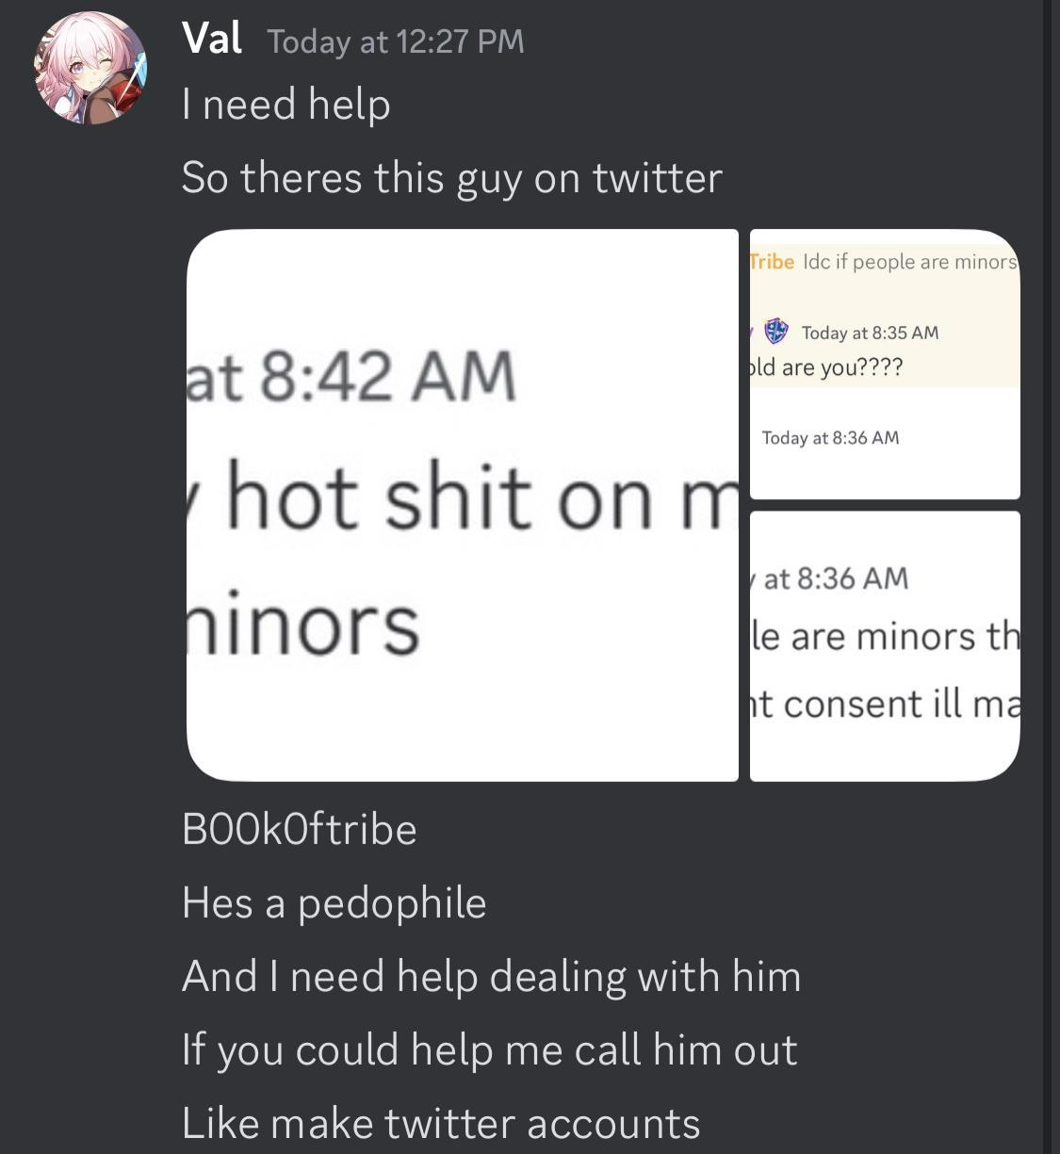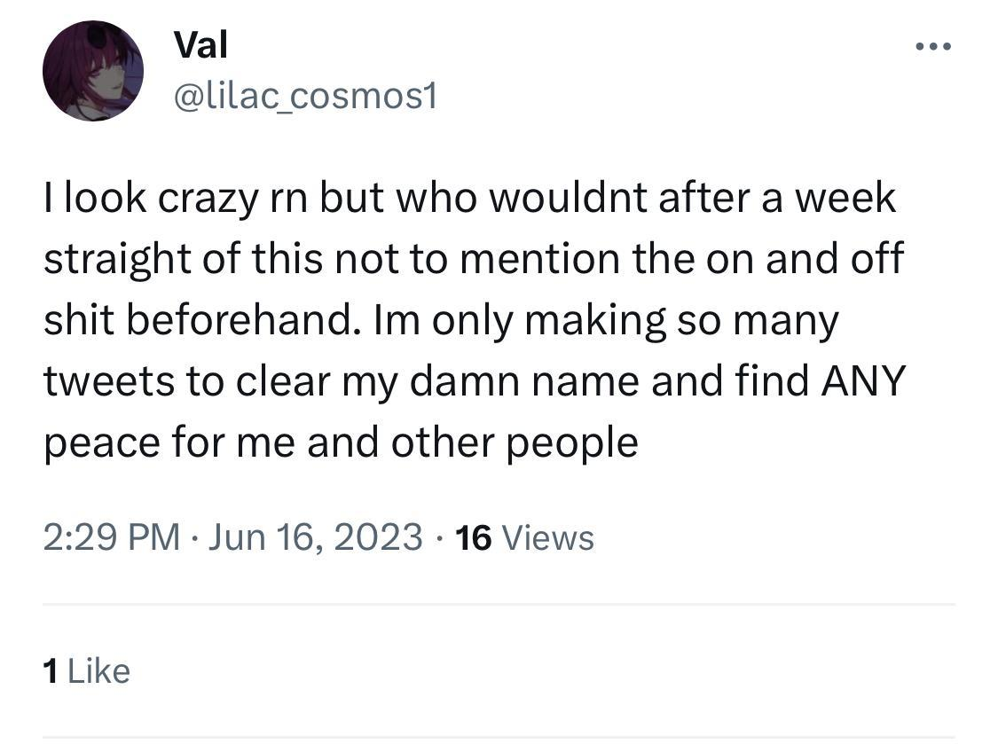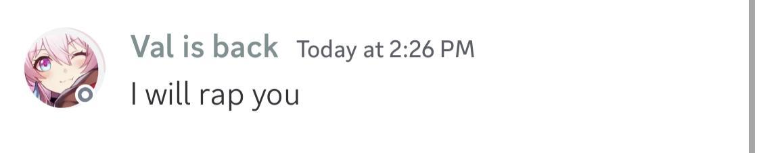 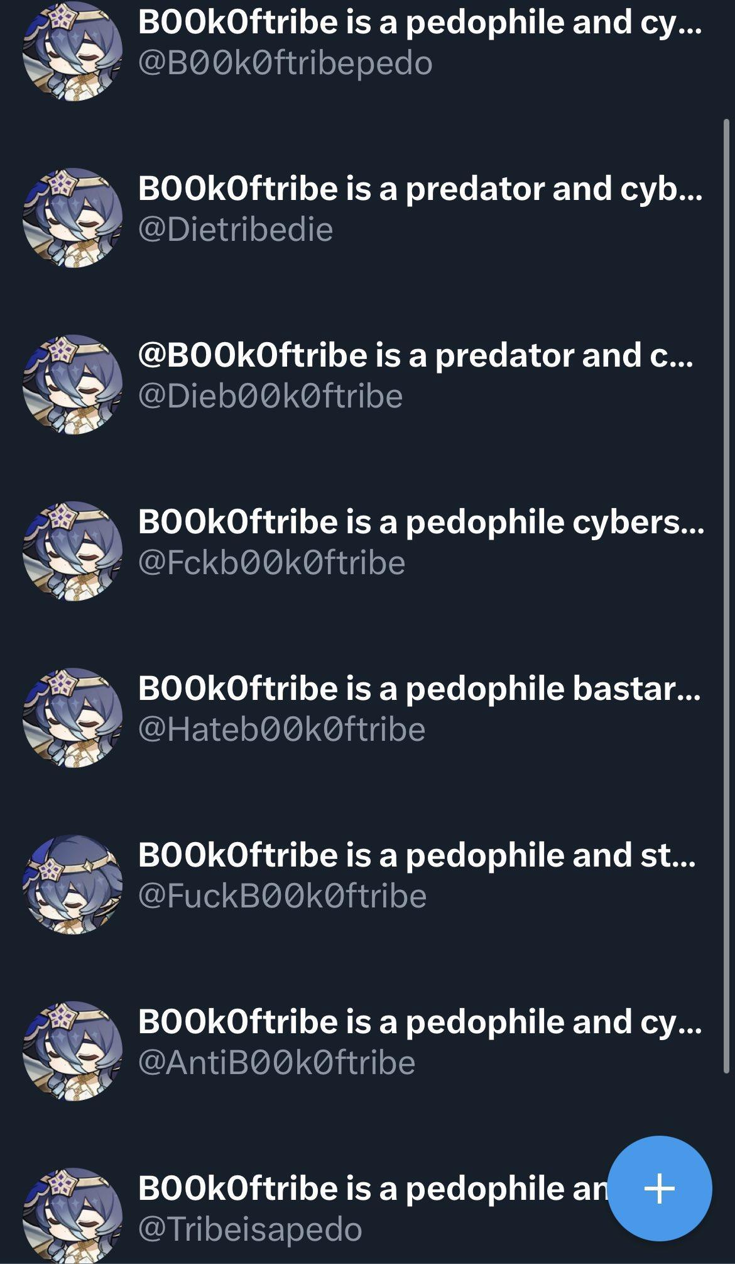she has a new discord: poppytea, so feel free to report and block it. It’s easy to tell when an alt of hers shows up in your mentions, so report and block her anytime she does.
She’s also attempted to dox people as well, and has admitted to having pictures of their faces saved onto her devices in addition. She’s even shared several of her faked nsfw screenshots with minors. Every accusation valerie throws at you is simply something that she is herself. Her main account is s1mpl33l1f3, and she has many, many alt accounts that she instead makes. She’ll also send death threats to people she’s targeting on these alts as well, and has said pro-nazi shit on them as well. Most of her claims against people she’s harassing are baseless, and when she does show proof, she shows clearly faked discord screenshots of her impersonating one of the twitter users she’s targeting. As mentioned before, her behavior has caused her original discord account to be terminated, and one of her alts is her screaming at a minor who happened to be a moderator on one of the discord servers she was banned from. It’s also worth mentioning that she brings up the genshin discord servers a lot, one of which she's in has a moderator who is 20 years old, and has been caught flirting with people who are 17. As stated before, block and report any social media you see belonging to valerie. She’s not just extremely mentally unwell, but is actively malicious and has been doing this for well over a year now. 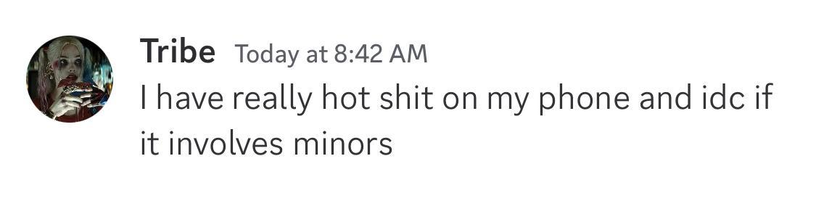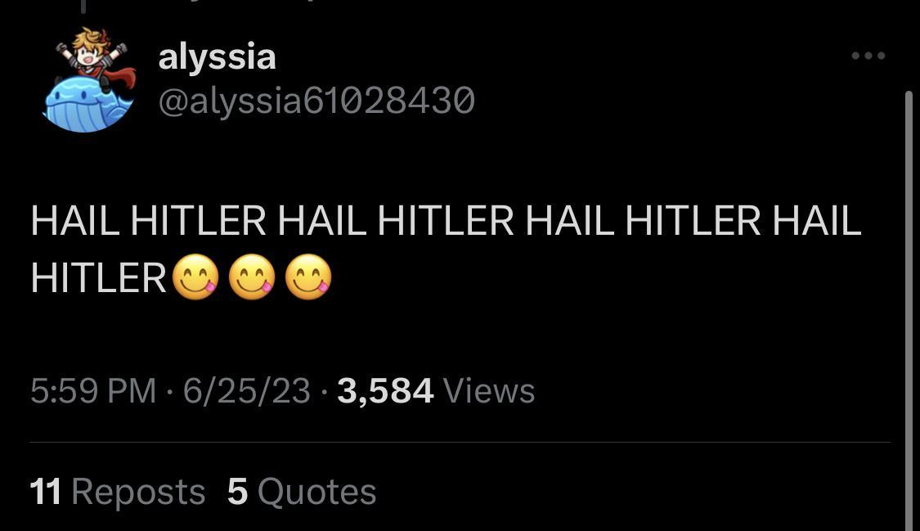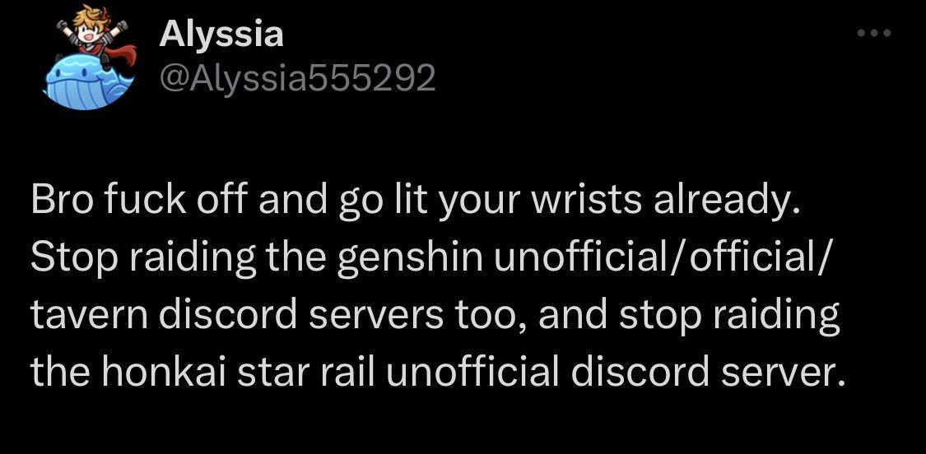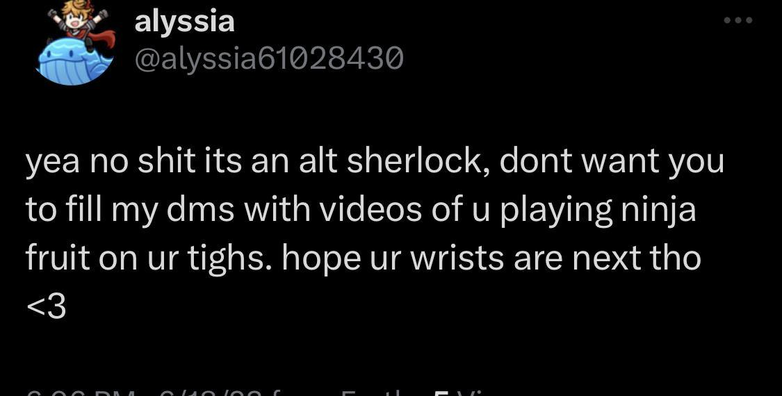 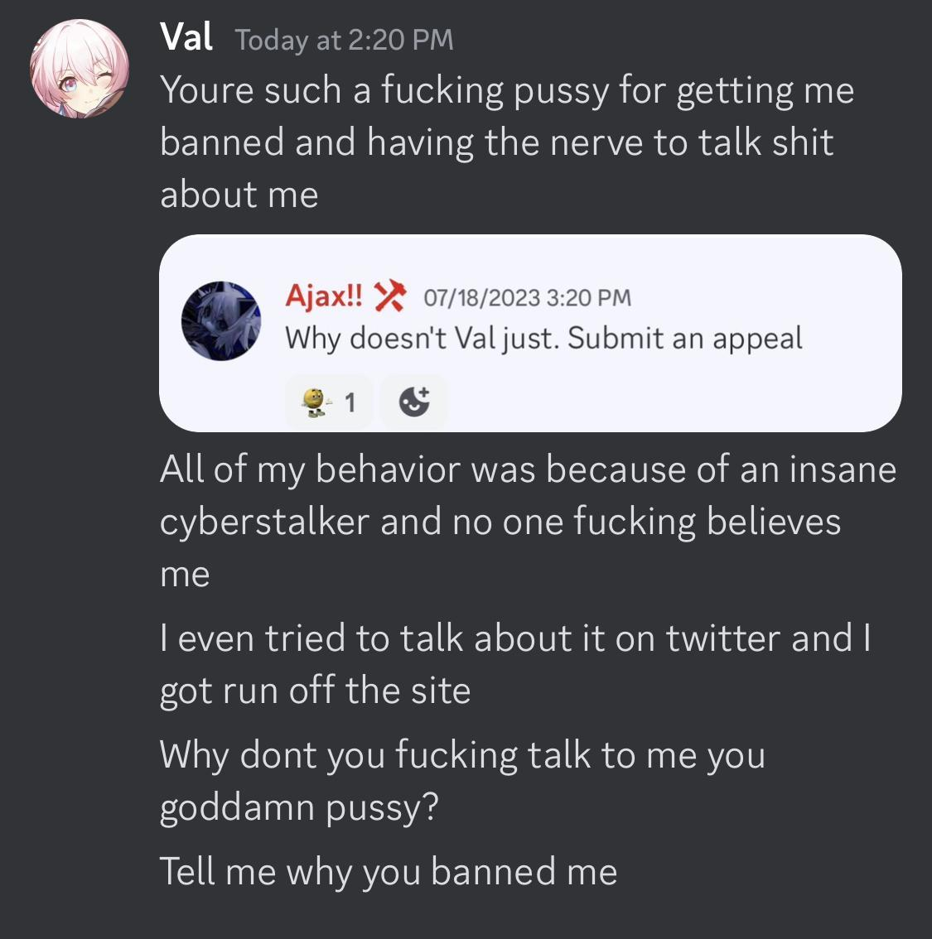
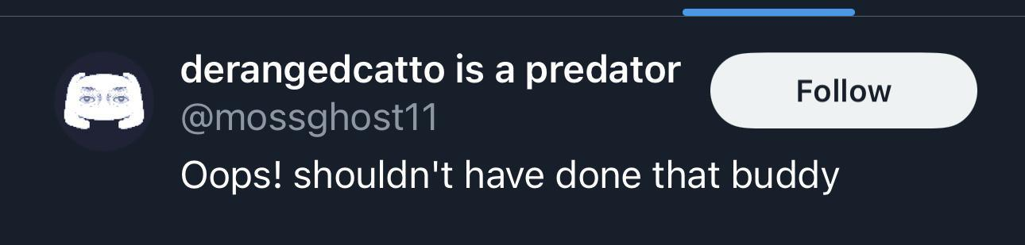 Val, despite accusing others of being zoophiles, has also shown signs that she happens to be one herself. She’s made some pretty gross comments about stuff she does with her dog. 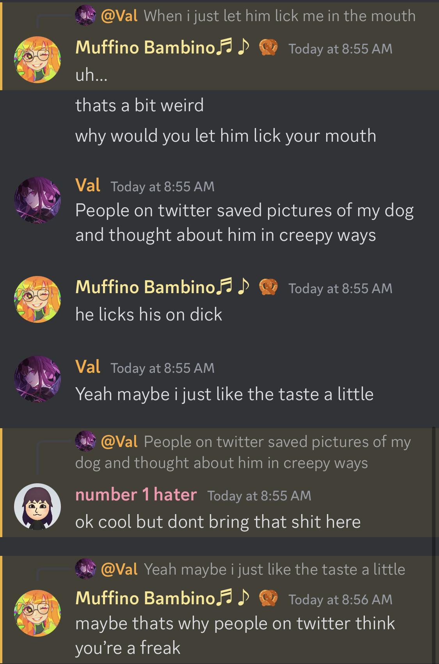
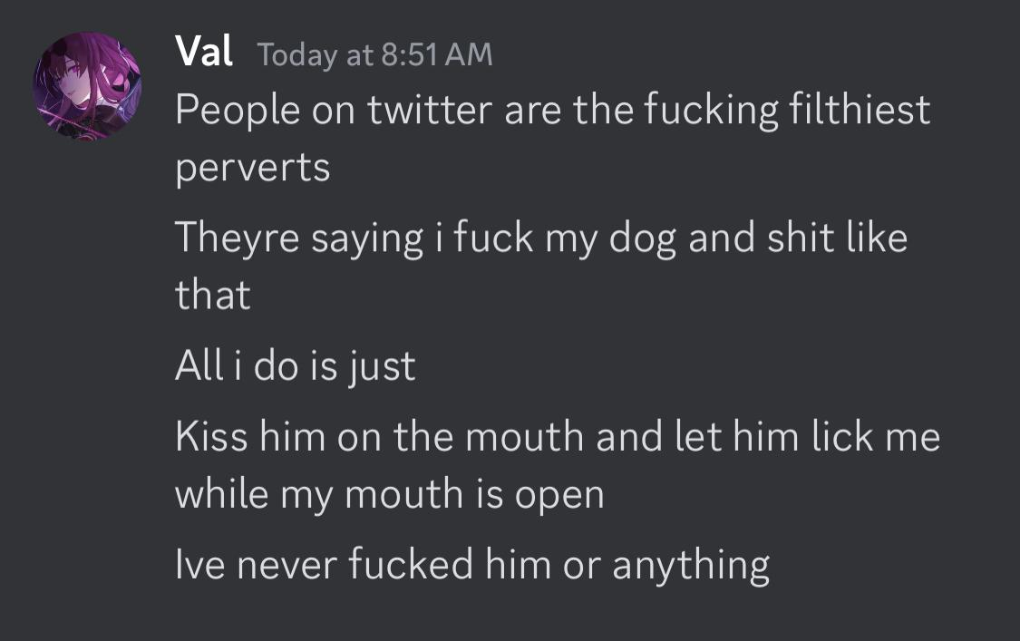Here’s Valerie’s social media so you can block and report
Twitter: Main account is s1mpl33l1f3, but she uses a ton of alts that are easy to spot, some alts include anything with any form of the username mossghost, alyssia, s1mpl33l1f, peachesdaisyi, poppyteasages, and poppycosmos1
Discord: Poppytea
Youtube: ValerieTheQueen-ql3zc

A few of Valerie’s friends are:@/ Itsnatsutalbott (who has been extremely transphobic and posted rape threats towards people)
@/Plumtheking (who runs a harassment Discord) and @/neurons. 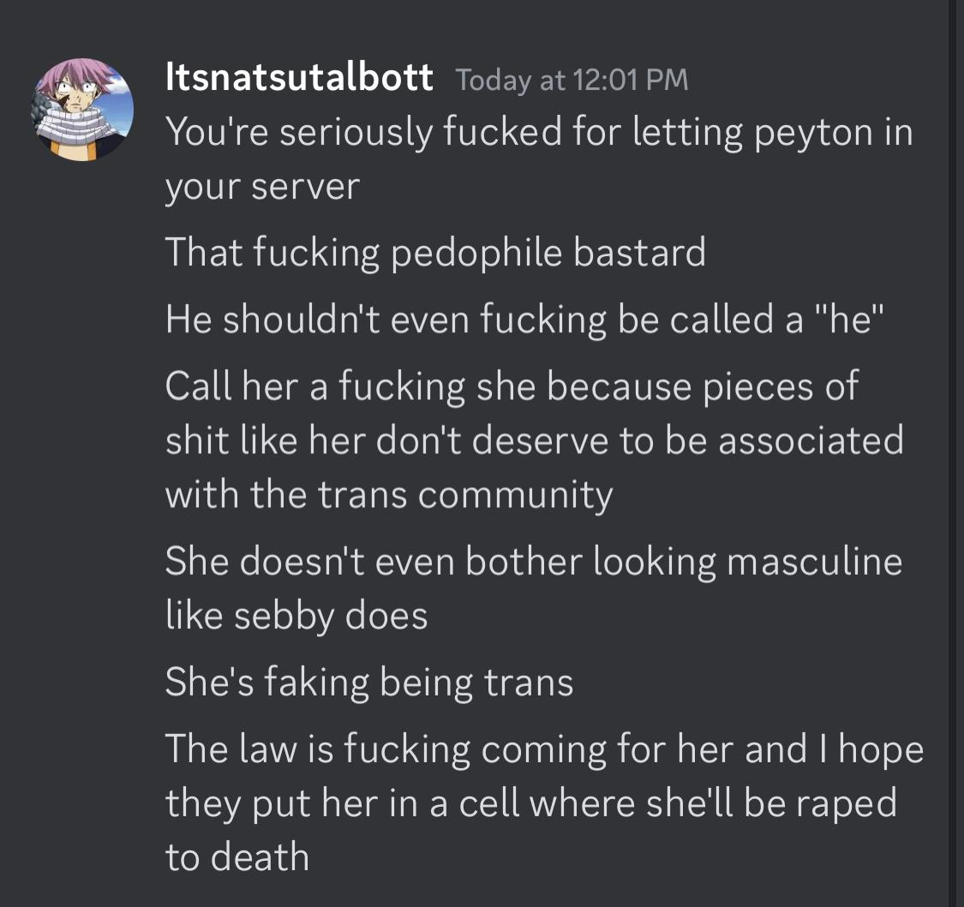
Please block and report all of these people too
Update: There’s more. Valerie has also accused people of being transphobic, yet is incredibly transphobic herself. She’s intentionally misgendered people, has made fun of people’s pronouns, and has said that people aren’t trans because they don’t “pass well enough”. She and one of her friends neurons have also made accounts impersonating said trans people, and have used their faces in them. One of my accounts below /chunkspree is impersonating me, and several of the photos they’ve posted were taken when I was a minor, including their pfp and banner.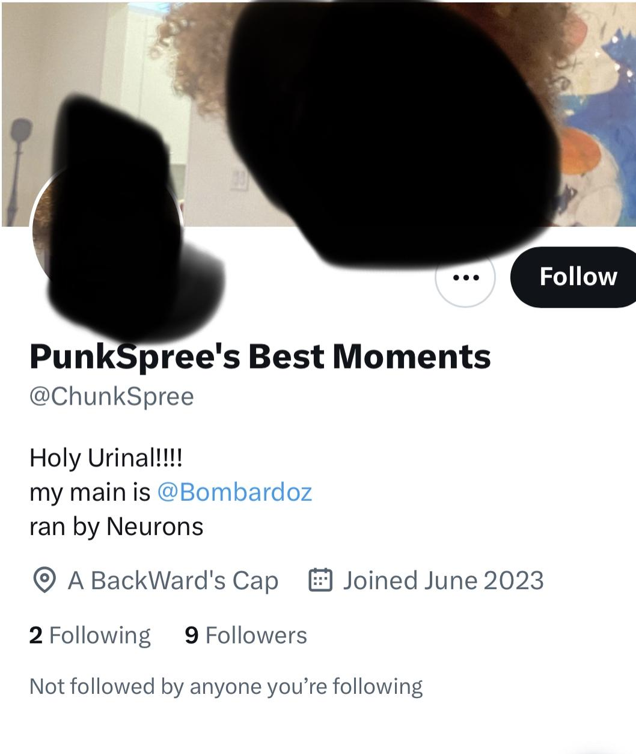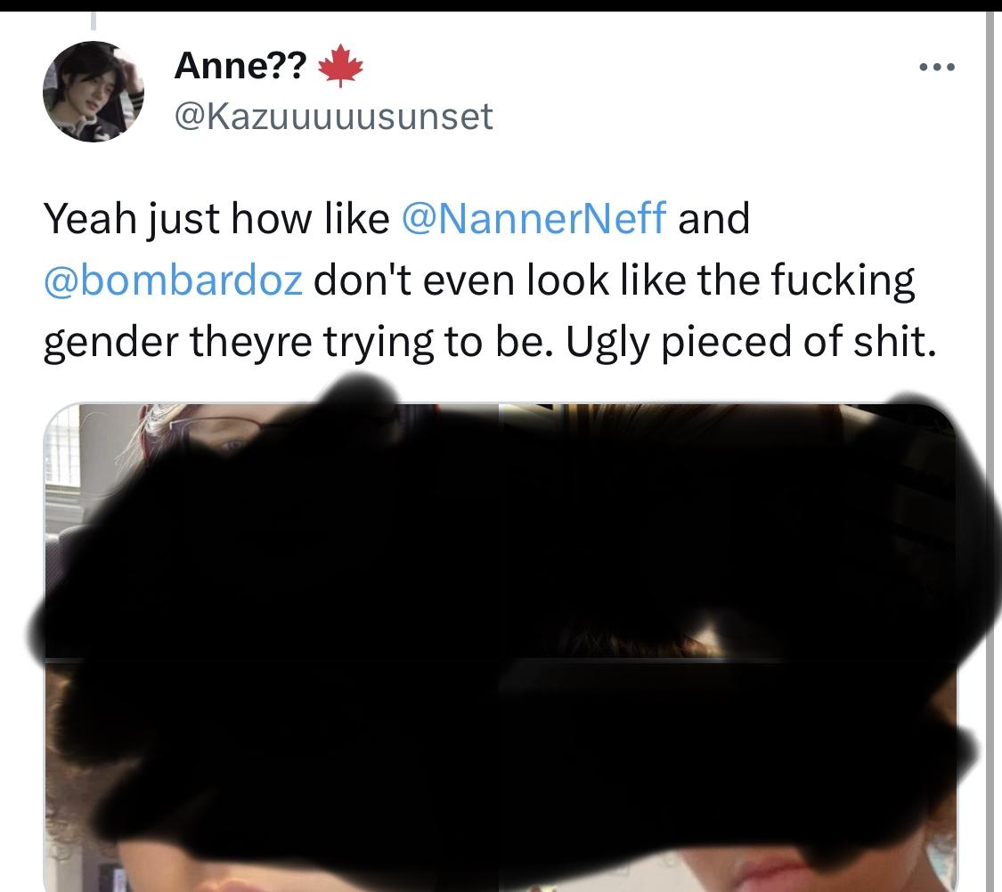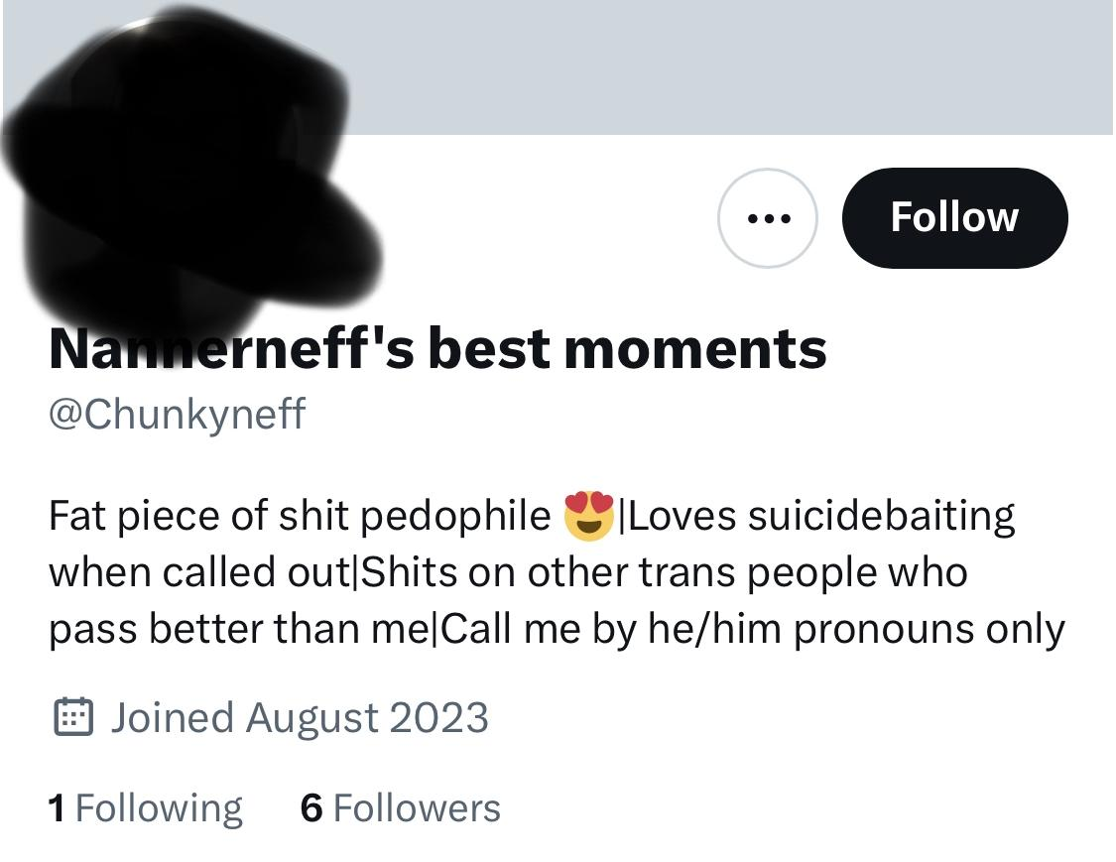
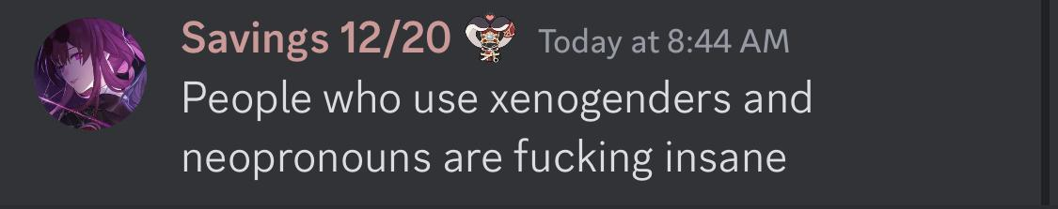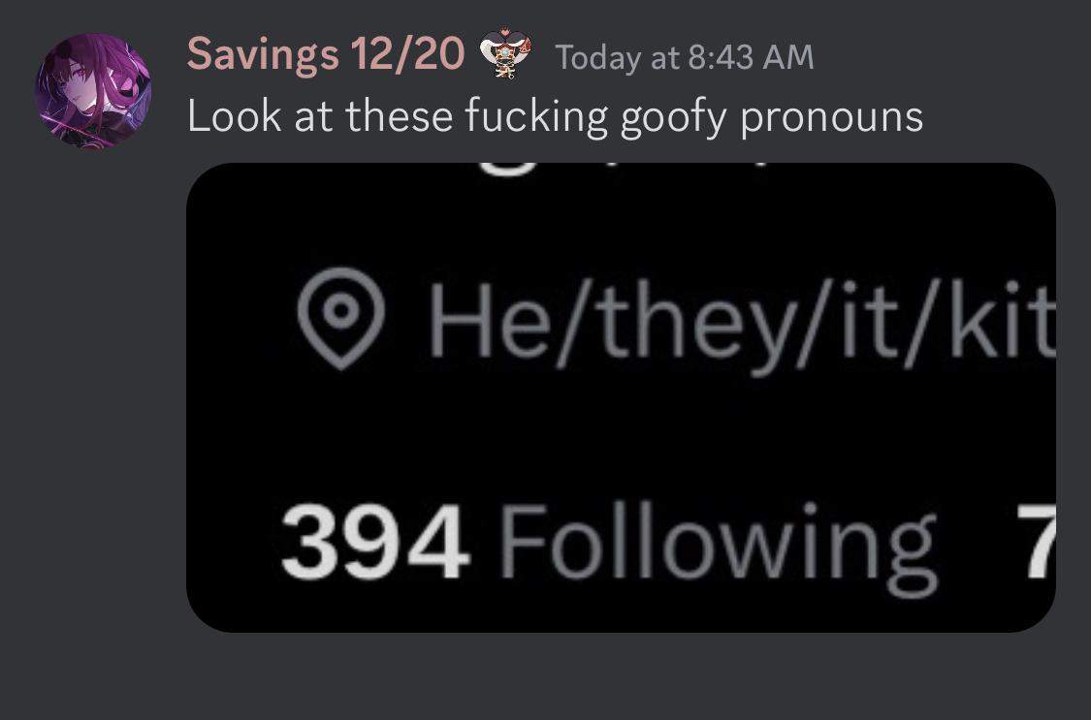

Please also block and report @/neurons. who is one of valerie’s friends and joins her in making accounts to impersonate people, along with @yanarock.
Neurons, valerie’s friend, who’s 19 has also made violent threats against animals as a “joke”. 

