TW/CW - Grooming of a minor
Hey. I’m gonna keep my identity anonymous, though I’m sure that Jenn will be able to piece together who created this.

I’ve known her for around 2-3 years now and supported her both as a creator and a friend. I’ve helped her at her lowest, as she’s helped me. However, these recent events have changed my opinion of her.

I know you know what’s going to be in this, Jenn. I don’t want to hear your excuse that “it’s legal” in this state. It’s morally wrong and disgusting. I don’t care if they consented, or if you say that age is a number, or that they were close to 18. You know what acting more mature than your age entails? You’re traumatized.

Allow me to begin, though.

Backstory
Sometime around the spring, Mars2030 was looking for a place to stay, as her parents would not allow her to return home after starting HRT and her apartment would not allow her to stay over the summer. Three people offered a vacant space in their apartment, as one tenant would be leaving in the summer. Around the beginning of May, she moved into the apartment, where some of the previous tenant’s belongings (particularly posters), would still be present. As such, here is proof of this person owning the posters.

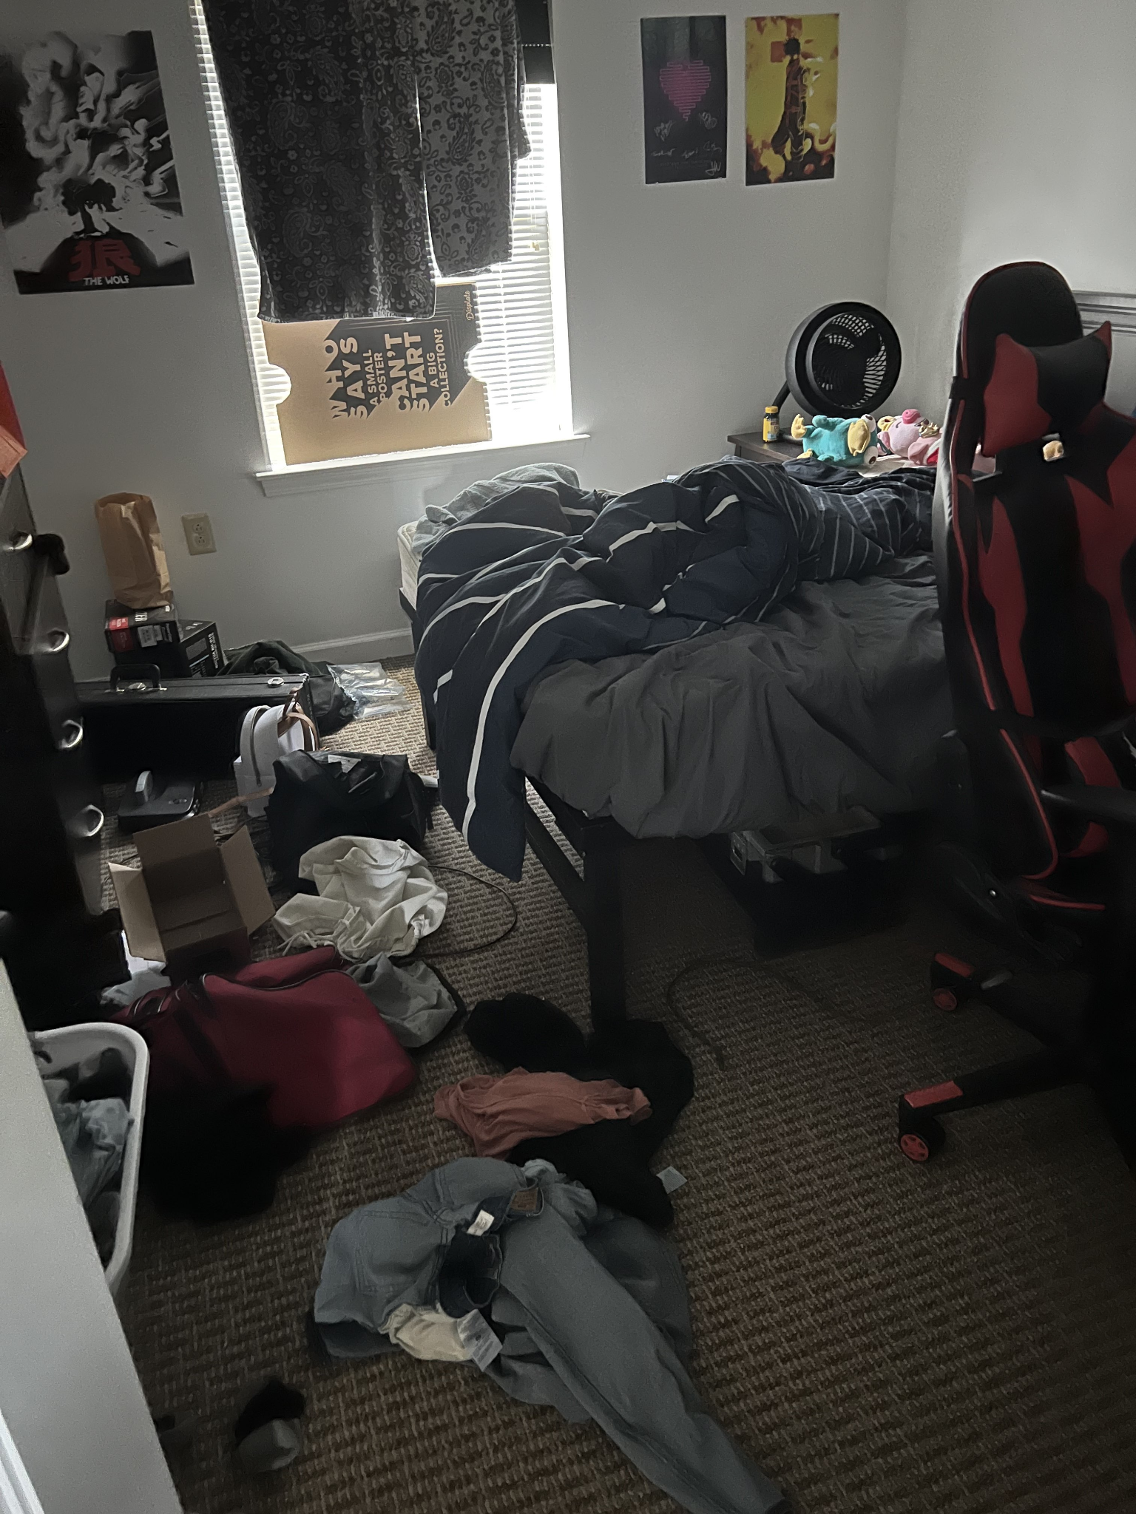





Note the Fitz and the Tantrums poster has gray signatures on it from the band members..
See the clip here for more posters in the background, which can be seen here in the next photo. These posters belong to ‘S,’ the tenant that was gone for the summer.

Around July of 2022, one roommate, who I’ll refer to as ‘Z,’ returned to the apartment. She is 20 and informed Jenn and myself, who was staying over the summer working, of a relationship that she was hoping to enter. They met this person, who will be referred to as ‘N,’ and their age was 17.



Z and N would enter into a polyamorous relationship and would invite Jenn into sexual incursions, unbeknownst to myself living in the apartment.

In the state of New York, it is possible that a prosecutor can charge a 20 year old of sexual misdemeanors if they are having sex with a 17 year old -

Sexual Misconduct
Sexual misconduct charges generally apply to consensual sexual activity (intercourse or oral or anal sexual conduct) with a person younger than 17 and the parties are close in age (basically, they're not within the age ranges applicable to rape or criminal sexual acts). For instance, a prosecutor could charge the following individuals with sexual misconduct:
- a victim is 15, 16, or 17 years old and the defendant is younger than 21 (for example, a 16- and 18-year old), or
- a victim is 11 to 15 years of age and the defendant (a minor) is less than four years older (for example, a 14- and 16-year old).
Sexual misconduct constitutes a class A misdemeanor, which carries penalties of up to 364 days in jail.
I notified our server owner of the incident that was happening, as other server members who were aware of this underage crime were rightfully disgusted and appalled that a ‘friend’ would do something like this. One member had even left our server (The Bunker), which was supposed to be a safe space. Jenn had a position of power in this server - this rank was quickly taken away from her while some of the staff team and members continued to discuss what next steps to take.

Jenn noticed the rank was taken away, and dm’ed the member that would eventually leave because of its actions.

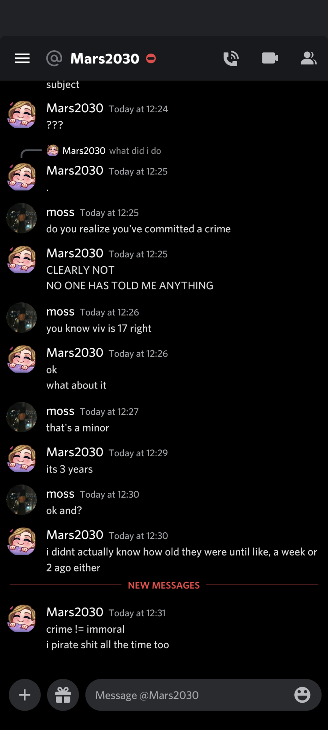

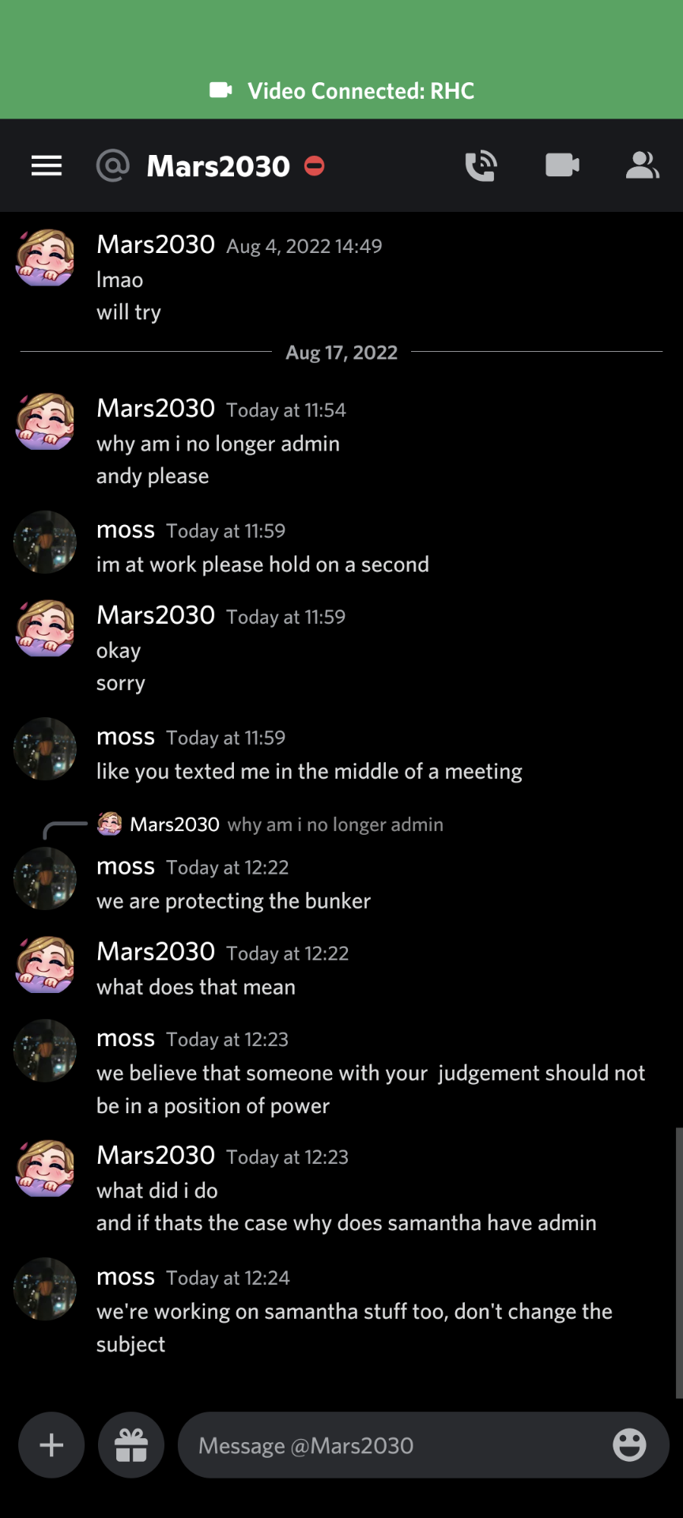



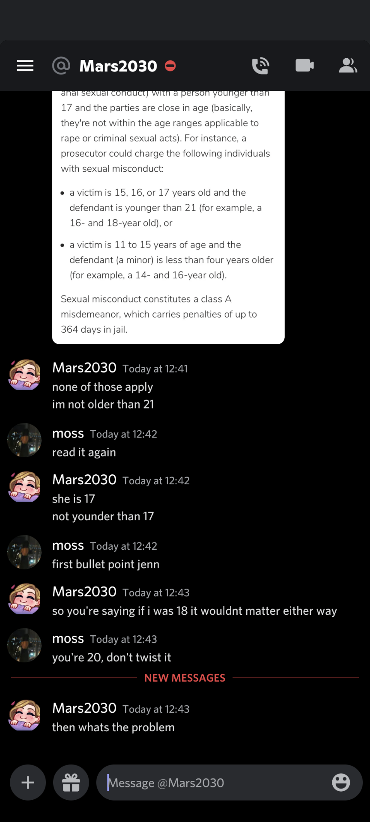

Upon being confronted, Jenn tried to compare what it had done to pirating a movie or game - a form of deflection and reduction of victims of grooming. She, in fact, DID know that ‘N’ was 17. For context, Viv and ‘N’ are the same person.



Even if Jenn tried to use the defense ‘I didn’t know about their age,’ it was well established that ‘N’ was a freshman entering into a local college and made it their personality that they were ‘the baby’ of the group. Even if Jenn tried to use this defense, in New York State, where the crime was committed, mistake of age is NOT a defense. Additionally, it was her responsibility to ask for N’s age before engaging in sexual intercourse.

Mistake of Age Is Not a Defense
Another common defense in rape prosecutions is mistake of age. Defendants accused of statutory rape often claim that they had no reason to know their partner was underage. They may argue the child said they were of age, and that a reasonable person would have believed it. But even if this is true, a defendant cannot rely on a mistake of age—even a reasonable one—to avoid conviction. Mistake of age is not a defense in New York.

I reached out to Amethyst about this situation to notify her, as any person would want to know if their partner was having sexual intercourse with a minor. However, Amethyst brushed this off, despite it being a crime, and said that she would take the side of Jenn.
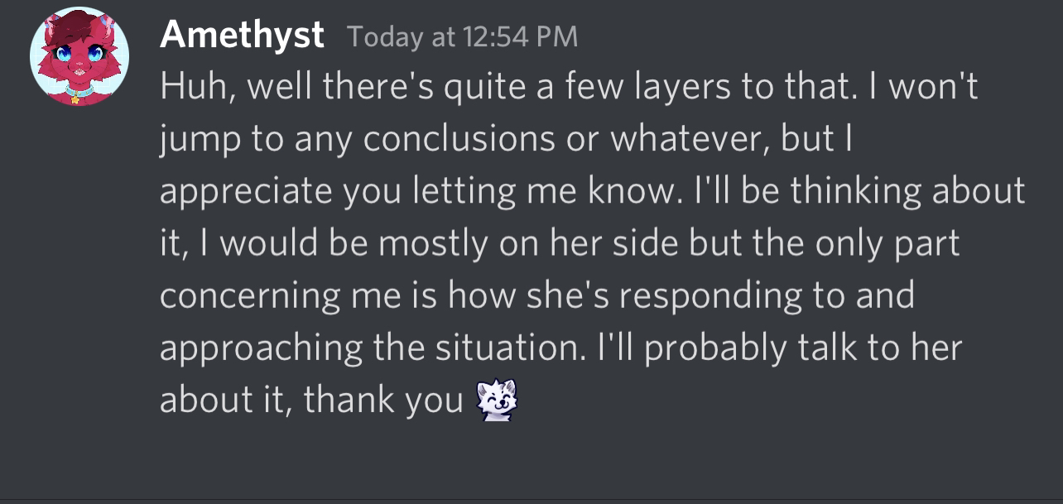

This was one of the responses that Jenn had given an admin of the server. Jenn had knowingly had sex with this minor and tried to brush it off as if it wasn’t. Having sex with a minor IS.

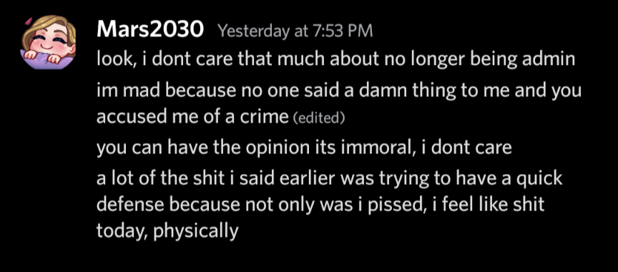

4/7/24 edit - Jenn, if you’re reading this, again, fuck you <3 I hope you enjoyed the preliminaries, it’s time for the main event :)

