TW // Mentions of Rape, Incest, NSFW

I’m writing this doc to come forward with my abuse that my disgusting piece of shit brother, James Bear, has done to me. Yes, I’m unfortunately his sister and I despise that fuck greatly.

Before any of you guys thinks this is another Cassette Girl situation, no it’s not. Unlike Lex, I actually have proof and everything lines up.

Okay here’s a picture of James desk
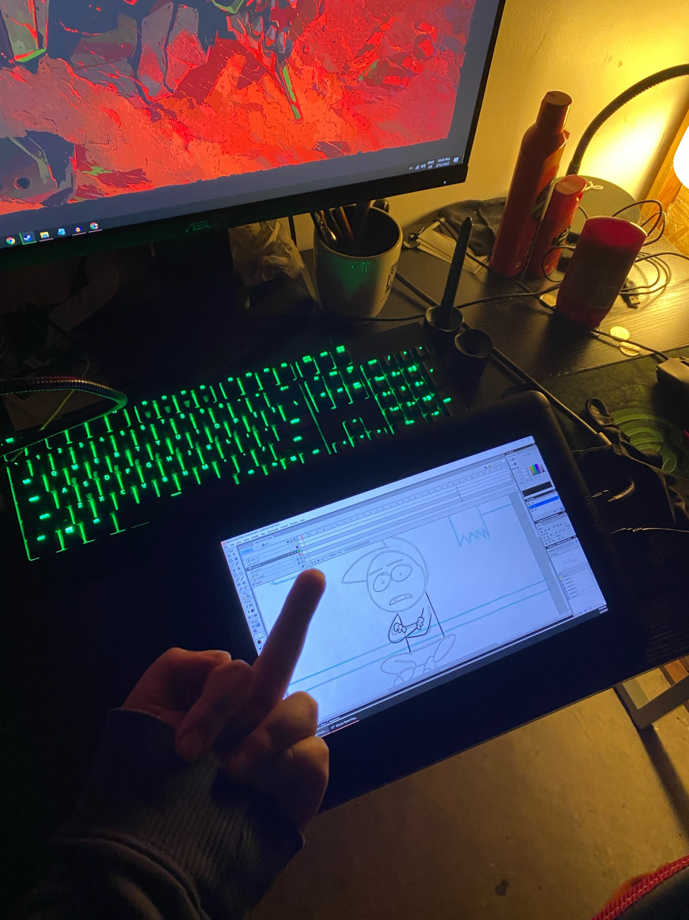
And here’s a picture of his silver play button.
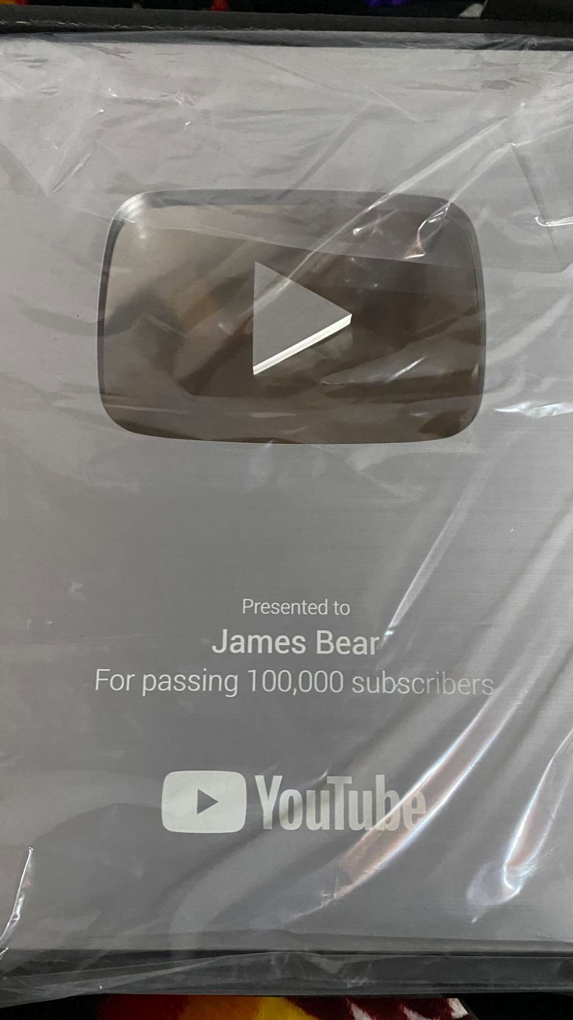
That’s it for the proof.

At the age of 9, I was raped by James. I don’t remember much about it but that’s when it started. It continued for a long time, especially past 2016. James lied about that part when he addressed this shit.

I wish I had done something to stop him but I couldn’t fight back, I was a weak young girl who’s innocence was stolen by a sick bastard of a sibling, no one was there to protect me, I had no one to trust or get support from, and if I had said something to my parents, they probably would’ve gotten mad at me and not put James faraway from me.

One time in 2019 when I was lashing out at my mom, I told her what James did to me and she was like “forget about it and move on” or some shit. Don’t you know how damaging that was for me? To have my own mom say that to my face? (This wasn’t even the first time where she didn’t punish my sibling harshly)

(When I was 11, I told my mom that my second oldest brother was being weird to me and she got mad at me when she noticed I was only wearing my bra and panties and when she confronted him, she didn’t call the police. She just left him off with a slap on his wrist and started taking me on trips whenever we would visit my oldest brother at a University dormitory)

Not looking good for my mom, she should’ve protected me and been there for me.

Anyways back to James, he’s done some disgusting acts to me like lick my breasts and my vaginal area, kissed me, vaginal penetration, anal, and oral. (I want to cover my mouth and other areas just thinking about it.) and he did of course, hurt me while doing some those acts and made me feel disgusted.

(Maybe I do have PTSD after all)

Sometime in 2015, I went on his iPod Touch and checked the photo gallery only to see porn of characters from Adventure Time, Star vs The Forces of Evil, Samus Aran, and Hatsune Miku. It was filled with mostly tentacle rape and futanari.
(Unfortunately for me, that’s how I got exposed to Vocaloid and which is why I despise the turquoise haired bitch.) because of me being exposed to porn at a young age, I became hypersexual and started looking at porn and hentai. Hell, I even started masturbating after James did something specific to me and I haven’t stopped doing it ever since.

Remember when I said James continued SA’ing me for years? Well it was still happening at the height of his popularity when he released his No Nut November animation in late 2019, while you were watching it, I was being SA’d.

The last attempt of James SA’ing me was in September 2020 when he asked me to come near his bed but I declined and so I went to another room.

I always felt pressured into letting James do those horrible acts to me, even if I consented to it. No one taught me that shit was wrong, nor could I avoid him. There were even some times where James said he would give me something in favour of letting him SA me, most of those times he wouldn’t live up to his promise. I felt like a fucking prostitute for even doing it in the first place.

Closing thoughts: I want to stay as far away from James and to never look back at his abuse. I’ll be leaving this kofi link down below if anyone would like to help fund my escape.

https://ko-fi.com/aliciainnevada

