LAST UPDATED: THURS: SEP 5, 2024: 12:30 AM EST

INTRODUCTION

Sup boys, Daddy Burt here. Welcome to my profile.

Based in Union County, New Jersey, USA.

DADDY BURT | Black Dom Top | BlackDomTop

@BurtObeng | BurtObeng.com

HEADSHOT: DADDY BURT

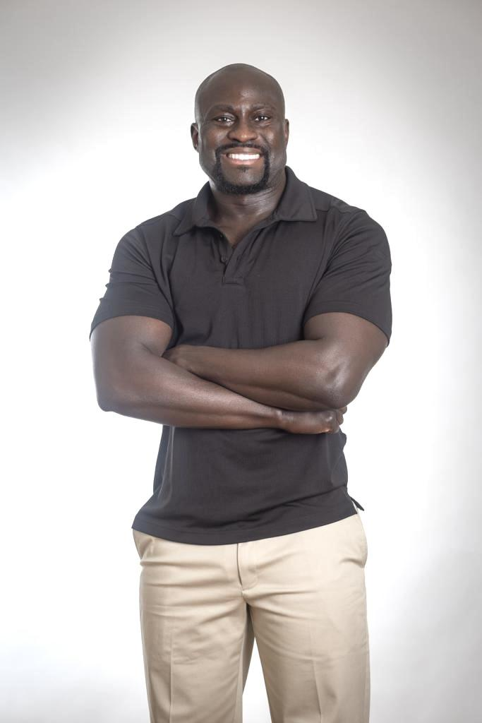

HOW TO CONTACT DADDY BURT

1. Click the link below.

2. Scroll all the way down to "Create New Contact."

3. Press "Done."

https://BurtObeng.com/contact

SOCIAL MEDIA

I always appreciate sweet boys who like, comment, share, repost, subscribe & follow me on my Twitter (X), OnlyFans, JustForFans, PornHub, Instagram, Threads, Facebook, YouTube, TikTok, Reddit, Backstage, & other social media for NSFW content at:

@BurtObeng

NSFW XXX PHOTOS & VIDEOS

My NSFW photo gallery of over 100 Nude X-Rated photos & videos are available on the following websites and apps:

RentMen, RentMasseur, Mintboys, TheBestFlex, Adam4Adam, Squirt, Sniffies, Seeking, Grindr, Growlr, Scruff, Jack’d, BLK, Bro, Archer, Hornet, Taimi, Surge, DaddyHunt, Tinder

Under the following profile names:

• Black Dom Top | BlackDomTop

• Burt Obeng | Burt O.

• Daddy Burt | Big Bro Burt

• Big Black Bull

BUSINESS CARD

Click here to view & download Daddy Burt’s current business card.

APPEARANCE

• 35 y/o, 6 ft, 200+ lb, US Size-12🦶🏿
• 100% West African: Ghana 🇬🇭
• Bald Bearded Burly Bodybuilder💪🏿
• Barefoot, Bareback, Bubble Butt🍑
• Hairy & Musky Pits, Nips, Pubes💦
• Beefy Arms, Thicc Thighs & Lips🦵🏿
• Hollywood Movie Star Smile 😁
• Seven Inches of Black Bull Cock 🍆

STATS & MEASUREMENTS

• Biceps, Neck, Calves: 17 inches
• Shoulders: 53 inches
• Chest: 43 inches
• Waist: 34 inches
• Hips: 42.5 inches
• Thighs: 26 inches
• Ankles: 8 inches
• Foot Length: 11 inches
• Foot Width: 4 inches
• Foot Circumference: 9.5 inches
• Arm Sleeve Length: 37 inches
• Penis: Seven (7) Inches

• Shoe Size: US-12 Feet
• Pant Size: 34x32

• Suit Blazer Size: 42L (Long)
• T-Shirt Size: Medium
• Tank Top Size: Medium

• Brief Size: Large
• Boxer Brief Size: Large
• Thong Size: Large / Extra Large
• G-String Size: Large / Extra Large

TRAITS

• Bisexual BNWO BBC Black Bull🤴🏿
• Dom Daddy Breeder Top🔝
• Nudist Exhibitionist Bator 👀
• On PrEP, Fully Vaxxed, DoxyPEP💉
• No Drugs 420 Alcohol Cigarettes 🛑

CAREERS

• Firefighter, Bodyguard, Bouncer 🔥
• Boxer, Wrestler, Sports Coach 🥊
• Math Professor: Mensa 160 IQ 📚
• Actor Bodybuilder Performer Speaker 🎬
• Bi Male Adult Film Porn Star ⭐️
• Landlord, CEO, Millionaire

AVAILABILITY

• Date, Plus-One, Travel Buddy 👨🏿‍❤️‍👨🏿
• Can Host in NJ NY PA CT DE🇺🇸
• Passport for USA & Global Travel✈️
• Contact for Services, Collab & Appts

KINKS

• Nude, Flash, Peep, Show-Off 🙈
• Kiss, Cuddle, Snuggle 🖤
• Musk, Muscle, Massage 💪🏿
• Tease, Tickle, Torture 😈
• Cum, Piss, Spit, Sweat💧
• Lips, Nips, Pits, Pubes 🪮
• Toes, Soles, Socks, Shoes🧦
• Leather, Cigar, Gloves, Boots👞
• Suit, Tie, Watch, Glasses 👔
• Scruff, Stubble, Beard💈
• Role Play, Race Play, Pup Play🦴
• Group, Orgy, Threesome 🧑‍🧒‍🧒
• MMM, MMF, MFM, FMF, FFM Ⓜ️
• Cuckold, Bull, Hotwife🤵🏿‍♂️🤰🏼
• BNWO, BBC, JOS, QOS ♠️
• BDSM CNC D/s M/s DD SPH ⛓️

ROLE-PLAY

• Daddy-Son | Brotherly Bromance
• Boss-Employee | Landlord-Tenant
• Cop-Criminal | Guard-Prisoner
• Coach-Athlete | Professor-Student
• Doctor-Patient | Masseur-Client

KINK TITLES

Ass Adonis. Backdoor Breeder. Bareback Beast. Barefoot Boss. Bate Bro. Big Black Bull. Bisexual Bandit. Blazer Suit Brute.

Body Hair Bear. Body Rub Rogue. Bondage Bossman. Chub Fuck Chad. Cuckold Commander.Cuddle Casanova. Cumshot King.

Deep Stroke Stallion. Dom Daddy. Edge Lust Lord. Gangbang Gladiator. Gooning Gangster. Grind Frot Freak.

Group Sex Stud. Gym Sweat Jock. Jungle Jockstrap. King Kong Thong. Leather Lieutenant. Man Musk Hunk.
Muscle Flex Flirt. Nipple Knight.

O-Face Overlord. Peeping Dom. Piss-N-Pits Perv. Public Playboy. Race Play Pimp. Rock Hard Hulk. Sadist Sergeant. Show-Off Shark.

Sir Spank-a-Lot. Sock-N-Sole Brother. Spartan Scholar. Tease-N-Tickle Titan. Thicc Thigh Thug. Tongue Tyrant.
Whiteboy Warden.

SERVICES & OFFERINGS

• BLACK BULL THREESOMES: For those interracial fantasies with white couples, I’ll take charge, own your wife while you watch, and get you in on the action. Expect some serious domination and raw, primal heat.

• MMF THREESOMES: Ready to team up and tag that chick together, from double penetration to tongue-tied oral action. We’ll make her feel it deep while we ride the wave.

• ADULT FILMS: Open to getting wild on camera in a range of scenes—interracial, cuckold, foot worship, and more. I’m an openly bisexual stud who craves the spotlight and loves showing off.

• ENTERTAINER/PERFORMER: Get ready for a high-energy show that’ll leave you and your guests buzzing with excitement.

• PHOTO & VIDEO SHOOTS: Capture your best angles with high-quality, professional shots that highlight every inch of your glory.

• CUSTOM CONTENT: Let’s create something unique—whether it’s photos, videos, or interactive sessions, I’ll bring your fantasies to life.

• VOICEOVER WORK: My deep, versatile voice is available for commercials, audiobooks, and more. I’ll bring the intensity you need.

• BODYBUILDING MODEL: My professional, compelling presence is perfect for art modeling or themed events that demand a powerful figure.

• MUSCLE WORSHIP: Get your hands on this ripped physique. Whether you’re a guy or a girl, I love being admired, touched, and appreciated, especially on my sculpted ass and broad shoulders.

• EROTIC WRESTLING: Let’s strip down and grapple. I’m all about dominating with a mix of strength and dirty talk that’ll leave you breathless.

• 1-ON-1 CUDDLING: I’m your go-to for some manly, therapeutic cuddling. Let’s get close, share some heat, and talk through whatever’s on your mind.

• UNIQUE SESSIONS: From strength training to motivational talks, I offer a range of experiences tailored to fire you up.

• FOOT FETISH: My Size-12 Feet are ready for your worship—rub, lick, and indulge in some hot roleplay. White guys, get ready to serve and pleasure.

• USED CLOTHING: After an intense workout, I’ll meet you with my sweat-soaked socks and underwear, fresh off my body and ready for you to savor.

• PLUS-ONE: Need a sexy, dominant presence at your next event? I’ll be your polished date, turning heads with my smooth style and sharp looks.

• GUEST APPEARANCES: Make your event unforgettable with my magnetic presence, keeping everyone entertained and engaged.

• PUBLIC SPEAKING: I deliver powerful, engaging talks that’ll motivate and inspire any crowd.

• BOUNCER/SECURITY: I’ll keep your venue safe and secure with my imposing strength and no-nonsense attitude.

• BARBACK/WAITER: Whether it’s keeping the drinks flowing or serving with a smile, I’ll keep your event running smooth.

• BARTENDER: Watch me mix up the perfect drink with expert skill and flair, making any event a hit.

• JOIN MY WORKOUTS: Train with me and push your limits with personalized sessions designed to sculpt your body to perfection.

• WELLNESS CONSULTING: Get personalized advice on how to stay strong, healthy, and full of life.

• PROFILE BOOSTING: I’ll elevate your social and hookup app profiles, turning you into a magnet for attention.

• COLLEGE MATH TUTORING: Sharpen your skills with expert tutoring in college math—let’s ace those classes together.

MEET DADDY BURT IN PERSON
Step into the world of Daddy Burt, the ultimate Black Dom Top. I’m here to fulfill your wildest kinks, fetishes, and desires.
From muscle worship to intense race play, wrestling, roleplay, and even some bro-style cuddling, I’ll dominate and thrill every sub punk chump who dares to meet me.

LOCATION & TRAVEL

I can travel & host for incall appointments in upscale hotels and Airbnbs near you across NJ, NY, PA, CT, and DE.

My preferred hotel locations for incall appointments are:

• Linden, New Jersey, USA
• Elizabeth, New Jersey, USA

I’m available almost any time with 3 hours’ notice, even after midnight. I can also travel worldwide if travel and lodging are covered.

INCALL AMENITIES

The hotels I host for incall contain the following amenities for free:

1. Free Parking
2. Free WiFi
3. Bed (Queen Size)
4. Television (High-Definition)
5. Shower, Sink, Toilet
6. Toothbrush, Toothpaste, Mouthwash, Floss
7. Deodorant, Soap, Sponge, Towel
8. Face Cleanser & Body Wash
9. Face Moisturizer, Body Lotion, Foot Lotion
10. Bottled Water

INCALL & OUTCALL AMENITIES

For both incall and outcall appointments, I always bring the following amenities for clients to use for free:

1. Condoms
2. Lube (Water-Based)
3. Poppers
4. Cock Ring
5. Prostate Massager
6. Meditative Music
7. Phone Chargers, Batteries, Cables, Outlets
8. Antibacterial Sanitary Wipes
9. Hand Sanitizer
10. Aromatherapeutic Fragrances
11. Filming Equipment: Lighting Stand
12. Discreet Face Mask (For Filming)

COMPLIMENTARY SUPPLEMENTS

My in-person services include the complimentary supplements:

1. DoxyPEP: Taken immediately after our session to prevent contacting: chlamydia, gonorrhea, syphilis, pneumonia, bronchitis, UTI, malaria, Lyme Disease, and acne.

2. Cilias: Taken at least 30 mins before our session to help maintain consistent erections for those with Erectile Dysfunction (ED). Effects can last up to 24-72 hours.

3. Viagra: More powerful than Cilias. Taken at least 30 mins before our session to help maintain consistent erections for those with Erectile Dysfunction (ED). Effects can last up to 4-6 hours.

4. Multivitamins, Omega 3 Fatty Acids

5. Creatine HCL

6. Tylenol / Advil

PReP & PEP

Daddy Burt has access to the following supplements upon request:

1. PReP (Truvada): Taken daily to prevent HIV infection

2. PEP (Truvada & Isentress): Taken twice daily after sex for 28 days straight to prevent HIV infection

CURRENT IN-PERSON RATES: SUMMER 2024

• 30 Minutes: $290
• 60 Minutes: $350
• 90 Minutes: $390
• 120 Minutes: $450

Rates already include hotel cost, travel expenses, plus all the included amenities.

DADDY BURT’S CUSTOM CONTENT

• Custom Photo: $45 per photo
• Custom Audio: $45 per minute
• Custom Video: $95 per minute

DADDY BURT’S LIVE SERVICES

• Erotic Text Chat: $45 per 8 messages
• Erotic Phone Call: $45 per 5 minutes
• Erotic FaceTime: $75 per 5 minutes

DADDY BURT’S WORN CLOTHING

All items are worn for at least 12 hours with no deodorant or scented creams, given directly in person.

• Socks: $75 each
• Underwear: $95
• Thong: $95
• G-String: $95
• Gym Shorts: $95
• Tank Tops: $95
• Sweatpants: $95

PAYMENT METHODS

I accept: Zelle, Venmo, Cash App, PayPal, Apple Cash, Credit Cards & Debit Cards.

ON-CAMERA HOOKUPS

Seeking local guys, chicks & couples who are willing to be filmed for my adult film portfolio. Consent forms required.

DIGITAL ID BADGE & BUSINESS CARD



