Collaborator Netherlands Facelift
Collaborator Netherlands Facelift
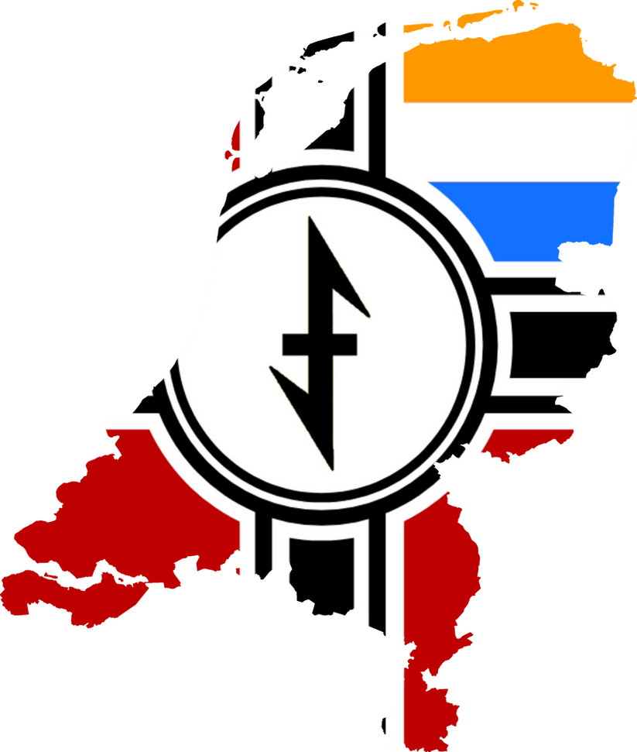

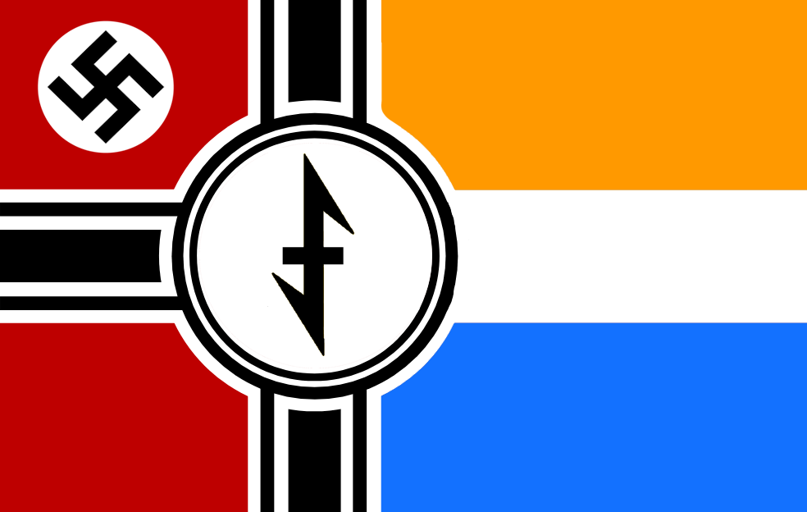

Summary
Immediate:
- Cut Biesheuvel restores democracy / van Geelkerken declares war on Germany paths (both are insane)
- Make all major RK Niederlande leaders natsoc but give them subideologies, the Netherlands is a mini Germany
- Add 1962-1963 event where Seyss-Inquart retires and one of the 4 main guys succeeds him
- Another event where the Netherlands becomes (Reichsgau) Westland and turns Germany's color before Hitler dies to illustrate the completion of Germanisation
Later:
- Change all Führer interactions with RKN to just be about putting their guy in charge, remove all invasion outcomes because why invade your core land

Introduction
The current Netherlands skeleton content is a relic from the ancient days of pre-release TNO and is largely still based on assumptions about the Netherlands that make no sense. Requiem can do without a mass suicide epidemic among the Dutch and a national power outage because the German Civil War is happening and the entire power grid is in Germania.

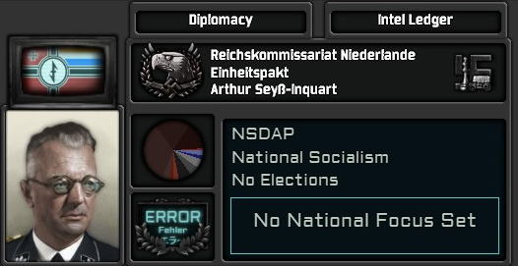

By 1962 the Netherlands will be in the final stages of its complete Germanisation; while Dutch is recognised as a local dialect of the greater German language family, most people speak German as a second language and due to the process of Gleichshaltung (the enforced national socialisation of all institutions like in Germany itself) practically all social mobility is tied to membership in the NSDAP, with it being the sole legal party.

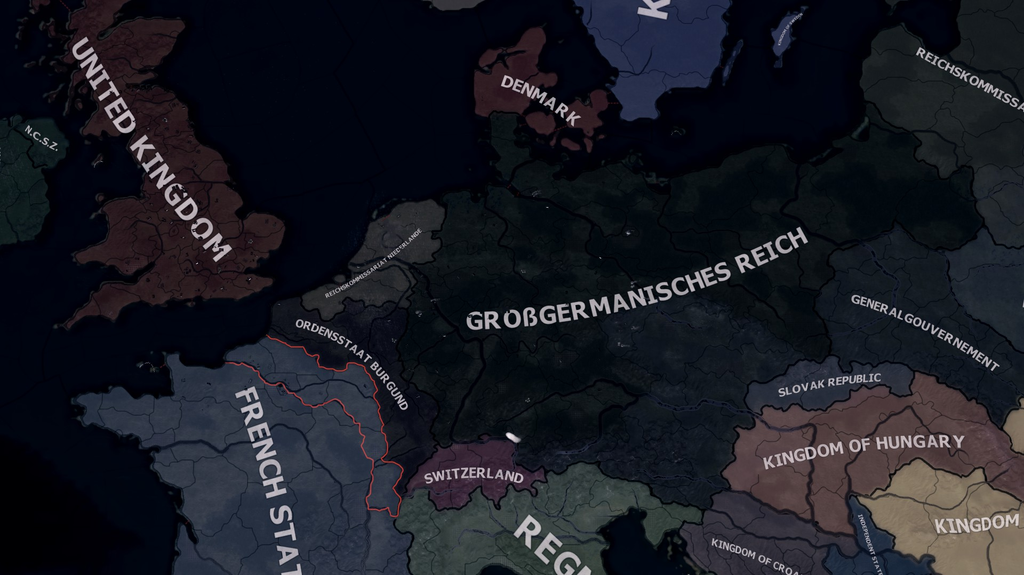
(borders not final since Kortrijk / Courtrai should be in the Calais state instead of Flanders)

Midway through the year, Reichskommissar Arthur Seyss-Inquart will hold official celebrations to declare the Germanisation of the Netherlands complete.
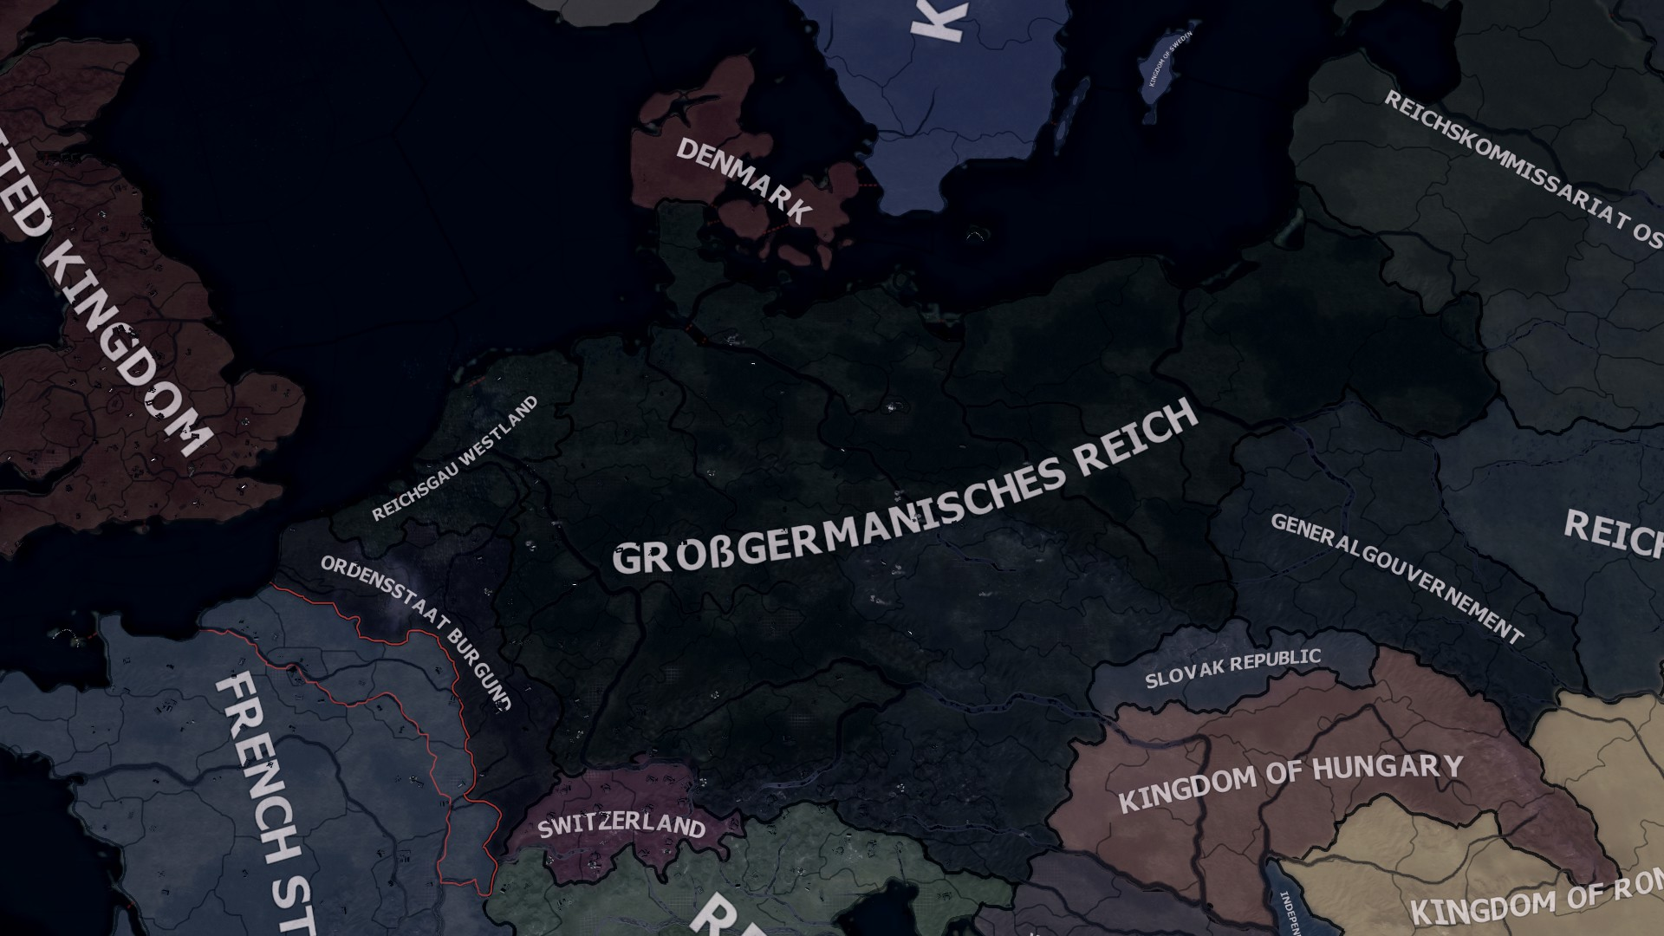

At this point the Dutch nation-state is formally annexed into the Reich and Arthur Seyss-Inquart retires to be replaced by one of 4 Gauleiter successors, which will be outlined in detail below. This event will be heralded in the world news as spread around by the Pakt press as the first instance of a successful Germanisation of a greater German territory and serves narratively speaking as a final triumph for Hitler right before his death and the civil war.

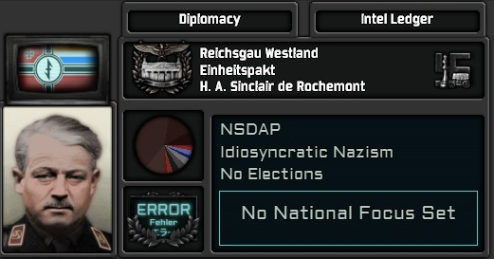
(An example of a successor to Seyss-Inquart; the Völkisch and Idiosyncratic H.A. Sinclair de Rochemont)

Following this even the Netherlands will remain a passive observer of the goings-on in the Reich to keep the scope of this proposal as small as possible. The basic interactions the Führers now have with them will be overhauled to let Bormann or Speer enforce their subideology onto whoever succeeds Seyss-Inquart rather than outright replacing them with another candidate.

The Successors (1960s)
These are the people who will become Gauleiter of Westland immediately after Seyss-Inquart’s retirement.
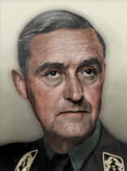
Cornelis van Geelkerken (1901-1976)
Ideology: National Socialist Orthodoxy
Alignment: Bormann

One of the original founders of the National Socialist Movement (NSB), van Geelkerken’s very public split with Anton Mussert led to the former’s fall from grace and the dismissal of Dutch particularism among the collaborator movement in favour of a union with Germany.

His tenure as Gauleiter will be about deciding to embrace the Flemish elements inherited from the Aansluiting of Flanders to the Netherlands or to continue the status quo and align himself with the Bormannite faction in Germania.

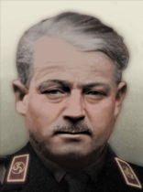
Hugues Alexandre Sinclair de Rochemont (1901-1942[IRL])
Ideology: Idiosyncratic Nazism
Alignment: Oberländer

A real Renaissance man of Nazism, the Huguenot Sinclair de Rochemont veered on the fringes of the prewar fascist movement and joined many Dutch ultranationalist movements such as Jan Baars’ ANFB before founding his own national solidarist movement in the Netherlands aligned with the Flemish version.

In real life, he joined the SS and died fighting the Soviets during Operation Barbarossa. In TNO, he spent the wartime years building connections with the Dutch East Company and Heerema’s group.

His tenure as Gauleiter will be mainly about expanding Dutch influence in Eastern Europe and espousing the beliefs of Theodor Oberländer and Alfred Rosenberg that the Slavs who fought with Germany against Soviet Bolshevism should be included in Aryan race theory on par with Germans themselves.

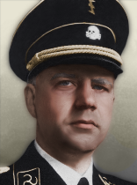
Henk Feldmeijer (1910-1945[IRL])
Ideology: Stratocratic Nazism
Alignment: Heydrich

Foreman of the SS-inspired Mussert-garde within the NSB, Feldmeijer was the man most likely positioned to actually succeed Arthur Seyss-Inquart in real life. Unlike his contemporaries Feldmeijer had deep connections to the SS even before the German invasion of the Netherlands and maintained close contact with Hanns Albin Rauter, the chief representative of the SS in the Netherlands, during the initial occupation. Feldmeijer died in a skirmish during the closing stages of the liberation of the Netherlands and his death was heavily propagandised.

His tenure as Gauleiter will be the most hardline out of all 4 potential successors. The new Reichsgau Westland will be turned into a model province of Germany where dissent and reformism is completely unthinkable. Instead of potentially aligning with Flemish solidarists, Feldmeijer will attempt to root out these particularist sympathies by allying himself with the most radically pro-German elements within Flanders.

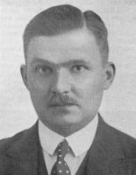

Hans Linthorst Homan (1903-1986)
Ideology: Reformist Nazism / Transitioning Democracy
Alignment: Speer

Alternate option for Biesheuvel. Linthorst Homan was one of the three founders of the anti-Nazi but pro-collaboration corporatist association called the Nederlandsche Unie and was described as being the most-pro German out of the 3. His tenure as Gauleiter will be about a grand, sweeping depolitisation of the NSDAP in the new German province of Westland. Radicals and ideologues will be replaced with apolitical bureaucrats and Westlander society will slowly be opened up to non-party members in compliance with the reforms Speer’s Gang of 4 is passing in Germania in the meanwhile.

The Successors’ successors (1970s)
After the first generation of Gauleiters becomes too old, they will themselves retire by the mid 70s just before the Second West Russian war. The new administrators will be an illustration of the effects of the policies of their predecessors.
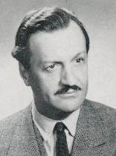

Willem Sassen (1918-2001)
Ideology: National Socialist Orthodoxy
Alignment: Bormann (Feldmeijer / van Geelkerken)

Willem Sassen’s whole family enthusiastically collaborated with the Germans and ingratiated themselves with the various organisations that came to the Netherlands following the occupation. Willem himself would fight for Germany to the very end in real life, even being recruited into the Wehrwolf program, then after his capture and arrest by the Allies he spent the rest of his life in South America as a special advisor to the likes of Juan Peron and Augusto Pinochet.

In the context of TNO, Willem Sassen is simply the idealised collaborator; loyal to a fault and entirely ideologically aligned with national socialism. Consequently, he is the orthodox choice as the second generation to inherit the Gauleiter position of the Netherlands.
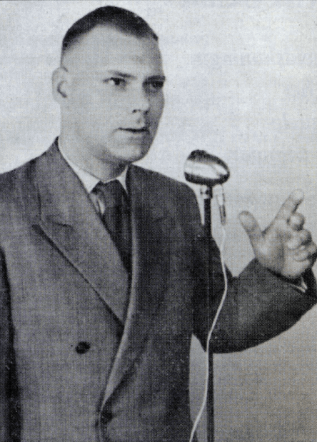
Paul van Tienen (1921-1991)
Ideology: Idiosyncratic Nazism
Alignment: Oberländer (Feldmeijer / Sinclair de Rm.)

Paul van Tienen served as a propagandist in the SS on the Eastern Front during WW2 and spent most of the 50s and 60s IRL advocating for the rights of European SS collaborators as part of the European Social Movement (ESM) led by the Swedish Per Engdahl.

He could potentially succeed either Feldmeijer or Sinclair de Rochemont and as Gauleiter he would espouse the same kind of Pan-European nationalism and pro-SS sentiment as either of these figures.

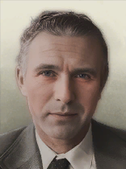
Joop Glimmerveen (1928-2022)
Ideology: Stratocratic Nazism
Alignment: Speidel / Schörner (Feldmeijer / Sinclair de Rm.)

Joop Glimmerveen was a rather unflattering neonazi populist in real life who founded the National People’s Union (NVU) and rallied against immigration, all of which had little to do with ideological national socialism. However, he formed his views during the OTL Korean War through his NCO who was apparently also a national socialist.

This means Glimmerveen could represent a generation of Second West Russian War veterans who grew up in the Reich’s military that exert a type of hawkishness not seen in their older contemporaries,
a Nazi neoconservatism if you will.

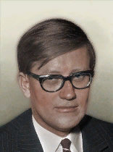
Hans Wiegel (1941-2025)
Ideology: Reformist Nazism / Transitioning Democracy
Alignment: Speer (Linthorst Homan)

Similarly to Joop Glimmerveen, outside of the army a new generation of Party bureaucrats also emerges in the civilian administration. Like Linthorst Homan before them, they believe more in Pan-European unity and corporatism than they do in Nazism (if the latter is very relevant in their day-to-day lives at all) so a successor from this emerging class of Eurocrats could be any OTL 1970s politician with similar technocratic views.

Interactions with Germania

The reason I want to have the ceremonial annexation of the Netherlands and the abolition of the Reichskommisariat happen before Hitler’s death is to do away with the issue of there being friction between the Dutch administration and the Führer who succeeds Hitler after the civil war. Bormann’s interactions with the Netherlands currently can be especially strange as before he annexes and cores the RK now he has the opportunity to just depose the Dutch Reichskommisar and reinstall a German guy in the intervening years. Van Geelkerken and Biesheuvel in turn both have paths where they can attempt to declare war on Germany to preserve Dutch sovereignty which turns into a conflict that lasts about a week which makes no sense.

To streamline all of this, I propose the following; no matter who becomes Gauleiter after Seyss-Inquart’s retirement, Bormann or Speer will get the option to “course-correct” them to their own subideology shortly after the end of the civil war. If for example Feldmeijer is the Gauleiter, Speer can make him adopt Reformist Nazism or force him to step down to be replaced with Linthorst Homan / Biesheuvel. There will no longer be the option for the government in the Hague to refuse.

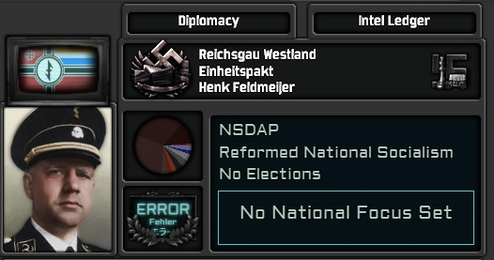
(An example of Feldmeijer forced to accept Reformed Nazism by Speer.)

The Second West Russian War

In the event of a total Russian victory during the 2WRW (instead of immediately when Moscow falls) an event similar to Mad Tuesday (Dolle Dinsdag) occurs; mass demonstrations against the government lead to a state of emergency being declared by the Gauleiter and reprisals against the Dutch people simultaneously with the departure of many important Germans in the local administration cause serious instability, which can lead to a number of outcomes.
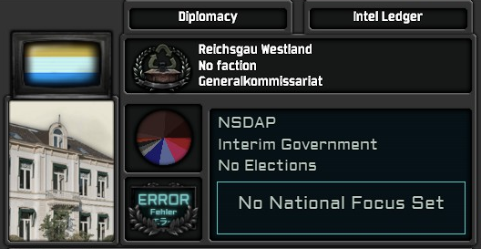
(An example of the emergency NSDAP administration.)
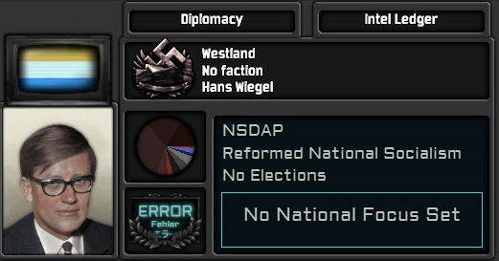
Young Bureaucrats Seize Control (No 2GCW)
If the disturbances of Mad Tuesday are successfully dealt with, young reformist-minded apparatchiks within the NSDAP will re-establish control of the now temporarily autonomous province of Westland to continue their peaceful integration into the Greater German Reich, even in the face of their recent total defeat to the Russians.

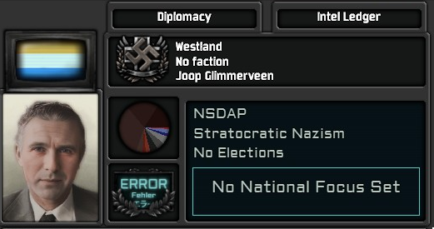
Heer Steps In (No 2GCW)
If instead of either of the two options above, Germany decided to intervene directly, they will place the province of Westland under a temporary military administration led by Generalmajor Joop Glimmerveen (fresh from his adventures fighting the Russians).

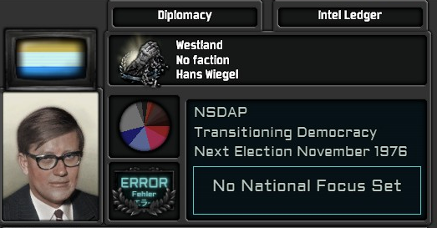
“Do not dismay, do not disrespect your enemies, there is nothing in the world that can hinder us.” (2GCW Exclusive Outcome)
The outbreak of the German Civil War has exacerbated the fallout of Mad Tuesday to such an extent that the NSDAP can no longer maintain its sole grip on the Dutch people. Elections are scheduled and secret negotiations with the government in Suriname and the OFN will begin.

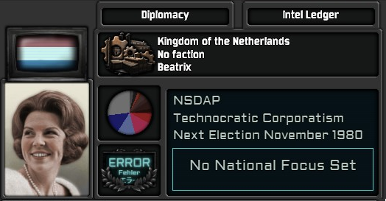
Should these negotiations succeed and should the NSDAP win the elections of 1976 before the German Civil War is over, the exiled regime of the Kingdom of the Netherlands will be reinvited and Princess Beatrix will be made the head of state. Suriname will be granted immediate independence and the NSDAP, now rebranded the National Socialist Dutch Workers’ Party, will remain legal with full amnesty for all collaborators.

Starting Situation (Politics & Parties)

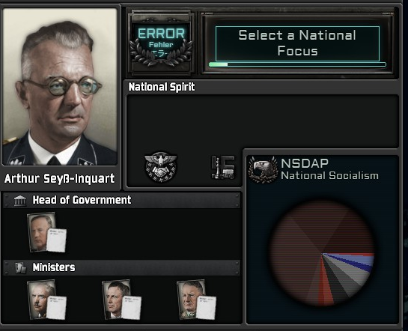
(The Reichskommisariat of the Netherlands in 1962.)

Parties & Popularities (Overview)

Parties | Popularities
HOL_paternalism_party:0 "NSDAP - Bureaucraten" | paternalism = 5
HOL_conservatism_party:0 "Kerkgemeenschappen" | conservatism = 2
HOL_despotism_party:0 "NU - Duitsgezinden" | despotism = 5
HOL_ultranationalism_party:0 "DMO" | ultranationalism = 5
HOL_fascism_party:0 "NSB - Kleinstaaters" | fascism = 2
HOL_fascism_1_party:0 "Eenheidsbeweging-VNV" | fascism_1 = 3
HOL_national_socialism_party:0 "NSDAP" | national_socialism = 34
HOL_national_socialism_1_party:0 "NSDAP - Partijgetrouwen" | national_socialism_1 = 16
HOL_national_socialism_2_party:0 "NSDAP - Hervormers" | national_socialism_2 = 20
HOL_national_socialism_3_party:0 "NSDAP - Völkische" | national_socialism_3 = 4
HOL_liberalism_party:0 "Provo's" | liberalism = 3
HOL_socialist_party:0 "Antifa" | socialist = 1
Parties & Popularities Context
Glossary
- NSDAP = Nationaal Socialistische Dietsche Arbeiderspartij
- NSB = Nationaal Socialistische Beweging
- NU = Nederlandsche Unie
- DMO = Dietsche Militanten Orde

Parties (and organisations) existing in 1962
NSDAP (National Socialism: various subideologies)

With Gleichschaltung completed some time in the 50s the collaborators in the NSB were forced to either get with the program or lose all political influence in the new order, which leads to a starting situation where the NSDAP has a formal Dutch branch in the Netherlands as the only legal political party.

Even a party-state has factionalism however and as the years went on a power struggle similar to the one unfolding in Germania started to occur in the Netherlands as well. Consequently the NSDAP now has 4 distinct camps; a group of reactionary orthodox apparatchiks who side with Bormann, a young and opportunistic group of reformists aligned with Speer, a group of radicals who advocate for closer Pan-European cooperation aligned with Oberländer (and loosely aligned with Heydrich) and in the background a small subsection of hawkish populists aligned with Göring.

The figure of Arthur Seyss-Inquart holds these factions in balance, as for all his attempts to endear himself to the Dutch population he is still seen as an impartial outsider and loyal to Hitler over the upstarts below the Führer.

NSDAP Bureaucrats (Paternalism: Paternalistic Developmentalism)

The banality of evil is a concept where people working for a totalitarian regime commit so many crimes against humanity that the abnormal becomes normal and the normal becomes mundane.

What happens though when such a totalitarian society genuinely becomes responsible for absolutely everything? If to get even the most basic permit of license you have to go through the NSDAP’s byzantine bureaucracy? This is when you get the bureaucrats in the Reichskommisariat Niederlande; people with almost no interest in the actual ideology of the Party their state is composed of but who do their jobs with efficiency nonetheless.

NSB Remnants (Fascism: National Solidarism, Corporate Statism)

While never outright banned, the NSB has lost almost all of its influence in the regime and is reduced to a cultural association for the most diehard ‘Kleinstaater’ holdouts still remaining.

Anton Mussert, age 68, still leads the NSB in fiery Hagenpreken where he rallies the people against van Geelkerken the sellout, Feldmeijer the fraud, Homan the comprador and Sinclair the Rochemont the homosexual. Fewer and fewer people turn up to listen every time.

NU Germanophiles (Despotism: Managerial State)

In the first few months of the German occupation of the Netherlands a competing organisation to the NSB was founded by the triumvirate of consisting of Louis Einthoven (Chief Commissioner of Police in Rotterdam), Johannes Linthorst Homan (Commissioner of the Province of Groningen) and Jan de Quay (Government Commissioner for Labour).

In real life this organisation, despite attracting mass membership in the millions, never fully committed to everything expected with collaboration such as active antisemitism. In my opinion this development coincided with the turn of events of WW2 and mainly Operation Barbarossa, so with TNO being a German maximalist alternate history the case could be made that at the very least the new Dutch NSDAP is constructed from equal parts of the NU and NSB without either organisation being able to turn too much against the occupiers.

In practice ingame, this means a small fraction of the NU still exists as the same kind of cultural association as the NSB is now. Its remaining members advocate for apolitical Pan-European unity but most prominent figures such as Johannes Linthorst Homan have since joined the NSDAP proper. It should also be noted that while our Heldenvolk content currently uses the NVB as its party-state for the Dutch exile regime and it historically emerged from the infrastructure laid by the NU, I want to make it clear in the lore that an ideological split occurred within the NU which led to the Germanophiles remaining in the mainland and the Dutch ultranationalists fleeing to Suriname. As a result, two organisations exist with the same origin.

Kerkgemeenschappen (Conservatism: Christian Conservatism)

Even with the Kirchenkampf being as successful in the Netherlands as it had been in Germany proper, some holdouts of Christian communities still exist. They are scattered across the country with no real central leadership (other than the Pope for the Catholic communities) and are slowly being made irrelevant in Dutch society at large.

DMO (Ultranationalism: Reactionary Nationalism)

At the rightmost fringes of the Reichskommisariat’s political scene, even further right than the regime itself, exist a number of paramilitary organisations not subordinate to the Party structure or the broader SS. Many of these originate in Flanders, such as the Order of Dutch Militants.

They parade around and their leaders make grand statements about Pan-European unity in the face of ossified particratic structures but otherwise have little to no influence on the government’s decision making. Instead, some intrepid bureaucrats sometimes use these organisations to get rid of their political rivals.

Provo’s (Liberalism: Social Liberalism)

Just like the Stubi’s in Germania, the Dutch student movements still have a fringe of libertine radicals who care little about the Party politics of their parents and just want to spend their days kicking against the shins of the system in careless hedonism.

Antifa (Socialism: Anarcho-Communism)

The Dutch far left utterly collapsed in the intervening decades between WW2 due to the downfall of the Soviet Union and Operation Sealion forcing the Royalist government in exile out of Europe entirely, so in its place the German Antifascistische Aktion recently emerged in the Netherlands as an import of an extremely small amount of German dissidents who emigrated to the major Dutch cities for work as the only remaining socialist resistance force left in the country.

Banned Parties
CPN (Communism: National Communism)

The Dutch Communist Party is banned, dead and buried in 1962. In the unlikely event that Germany undergoes an apocalyptic reversal of its society and itself becomes communist in the late 70s due to their total defeat to the Russians in the 2WRW, the party could be brought back. By that point leadership of the CPN would be passed on to Marcus Bakker, a close confidant of the prewar CPN leader Paul de Groot who IRL was responsible for publishing the ‘little red book’ which accused many party members who were not loyal to de Groot of collaborating with the Germans.

Various liberal parties in exile (N/A)

Gleichschaltung banned all prewar political parties in the Netherlands, so the royalist establishment in Suriname is the only place where parties such as the SDAP, ARP etc. still exist.

Starting Situation (National Spirits)

Currently I have 5 distinct national spirits in mind:

Name | Effect | Desc. | Notes
Pan-European Vanguard | drift_defence_factor = 0.3  party_popularity_stability_factor = 0.3 | WIP | The Netherlands is propagandised abroad as the shining example of the success of the Pan-European project and the seeds of a European identity that goes beyond just being Dutch or even German are taking root there
Last Stages of Germanisation | master_ideology_drift = 0.05  overlord_trade_cost_factor = -0.15 | WIP | (This is a timed national spirit that expires in mid 1963 a few weeks before Hitler dies)  The Seyss-Inquart administration considers the Germanisation of the Netherlands almost complete, to the point where they can celebrate its handover to a native Gauleiter soon
Downfall of the NSB | fascism_drift = -0.01  fascism_acceptance = -10  stability_factor = 0.05 | WIP | Gleichschaltung transformed all existing national socialist and fascist organisations into a Dutch NSDAP which forced the local collaborators to get with the program or be swept aside, Mussert could not stomach this and gave up on collaboration while van Geelkerken led the NSB Germanophiles into the new Party
Second Pillarisation | political_power_factor = 0.1  national_socialism_1_drift = 0.01  national_socialism_2_drift = 0.01  national_socialism_3_drift = 0.01 | WIP | The traditional Protestant, Catholic, socialist and liberal pillars are replaced with which Hitler successor you support
Pakt-centric Economy | industrial_capacity_factory = 0.3 | WIP | The majority of Dutch economic assets are tied up in the Nederlandsche Oost Compagnie and are therefore in the eastern RKs, would be a shame if those suddenly collapsed

The names and descriptions as well as the tone are all up for discussion and feedback, but generally I want to refer to these 5 things.

The Netherlands is by virtue of its proximity to Germany the most ‘successful’ RK, one that is almost ready to be abolished and integrated. The particularists in the NSB and other fringe organisations have largely been absorbed, forced to comply or left to the wayside. Dutch society, which was already highly stratified in the 1930s, has been unified only to stratify itself again along national socialist campist lines. Its economy mainly operates through the Einheitspakt as major Dutch corporations expand in Ukraine and the Caucasus or German investment develops the RK itself.

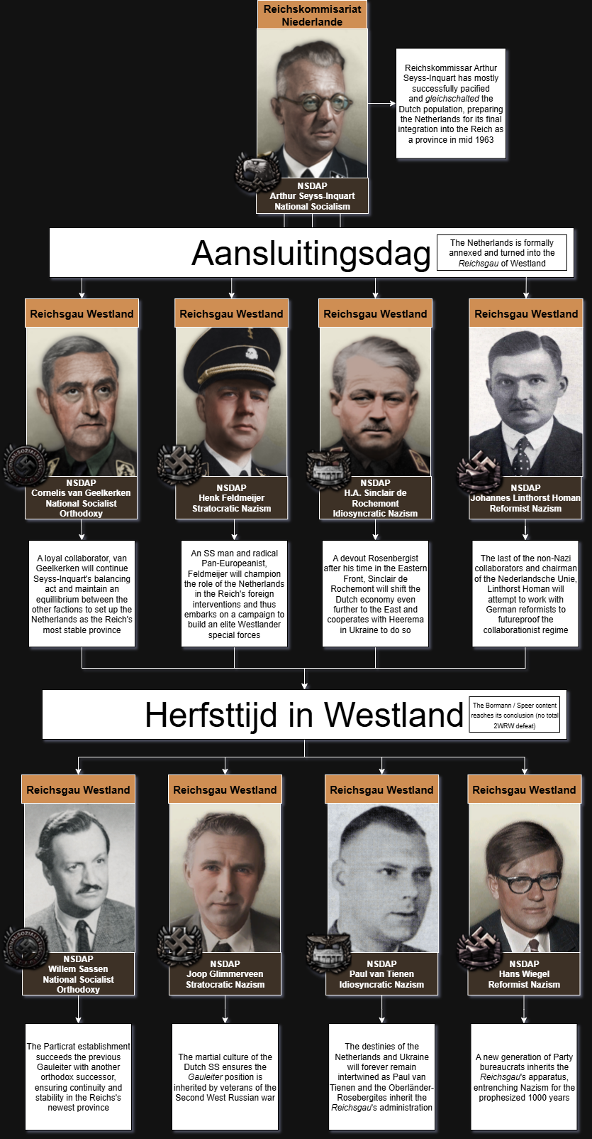
Flowchart

Lore Timeline (1940-1962)

In the interest of time and efficiency most of this will be an approximation of my personal beliefs as to how the Netherlands would endure 22 years of occupation but if necessary I will be able to back my claims up with historical sources in so far as they directly apply to the Netherlands itself (some Germany pre TNO lore is poorly documented so I have to guess what happens there regardless)

- 1939: German invasion of Poland, start of WW2 in Europe
- 1940: German invasion of the Netherlands, installment of Arthur Seyss-Inquart as Reichskommissar, Nederlandsche Unie founded by triumvirate to compete with NSB, royalists flee to London to set up Free Netherlands
- 1941: Seyss-Inquart’s administration concludes that wholly erasing Dutch culture and the Dutch language is counterproductive to the Germanisation process (Dutch people are already Germans), dual language approach and hearts and minds campaign is opted for instead
The February Strike still happens but none of the subsequent OTL strikes do, instead this first major strike is used as a pretext to endear the administration to the masses by beginning the process of decoupling the NSB from the new government
- 1942: Operation Barbarossa begins, Gleichschaltung forces all Nazi and fascist (but also all liberal) parties into the NSB in preparation for the creation of the Dutch chapter of the NSDAP, NOC is founded
- 1943-1945(?): Soviets are defeated, Sealion happens, royalist Dutch government flees Europe completely, resistance activities in the mainland slowly die out
- 1945-±1950: Dutch NSDAP party-state is constructed by the Seyss-Inquart administration, sovereign Dutch statist collaborators are expelled, NSB largely dismissed
- ±1950-±1961: OTL depillarisation happens except everyone is made a Hitlerite so over time new pillars form around the big names in the NSDAP (more generally around Nazi orthodoxy, reformism, hawkishness and Pan-Europeanism through the SS), the Dutch economy is completely integrated into the Reich, major corporations form to exploit the resources of the eastern RKs as spearheaded by Heerema and Rost van Tonningen
- 1962: The Netherlands is on the brink of total annexation into the Greater German Reich, an event that will be celebrated as the first completed goal of Nazism on Earth just as the man in orbit is a German goal in space

Gameplay Timeline (1962-1974)

While this proposal is intended as a facelift at first, it could potentially be expanded into a full 12 years of gameplay. This would roughly look like the following:

- 1963: Aansluitingsdag is here, the Reichskommissariat Niederlande is abolished and turned into the Reichsgau Westland (colour changes to match Germany but it remains playable on the map), a new Gauleiter is appointed from the pool of leaders listed in the doc
In this year the German Civil War also happens, during which the new Gauleiter will declare “loyalty to Hitler” and therefore neutrality
- ±1964-±1973: With stability returned to Germany, the Gauleiter sets out to enact their agenda
If an unfriendly Gauleiter was appointed before the GCW (i.e. a reformist if Bormann wins or a hardliner if Speer wins) the Reich will get to ideologically course-correct them so they comply with the stance of the new regime
By 1973 the Second West Russian War happens, the Netherlands will participate in it alongside the Reich and unless Germany is totally defeated the normal epilogues happen
- 1974: The second generation of Gauleiters succeeds the first, the Netherlands will forever remain a province of the Reich

