So I’m not sure how much of my own story I’m comfortable with sharing, I just wanted to add my voice and experiences as back up to the others, to collaborate what I can and to provide more evidence that what they’re saying is the truth. There will be pieces of my experience, but not the full picture.

I want to make something clear from the start: I’m not here to gain sympathy for myself, I simply want to validate and back up what others have said (and what others will say if they choose to come forward.) I initiated my contact with Ryan after he appeared on Off Topic and talked about how he had a snapchat now, but he’d never received anything explicit. I (like Leigh in her story, which I’ll tie in more with her later) sent it thinking “what the hell” he probably won’t open it, but if he does it’ll probably make him smile and then he can say he has received something explicit. But I was wrong, and he was instantly so responsive. And I went along with it because I wanted to, I liked him, and I wanted him to like me.

First here is our friendship page and the date of our first saved chat:
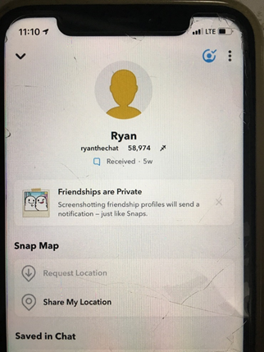
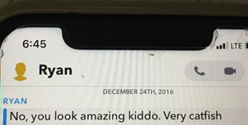

I’m not one of the ones he dropped sexual innuendos to that he could claim were innocent if they weren’t receptive. I’m never going to claim that I was. I started it and I kept it going until we first met up because I wanted to. After that first meeting, shit changed. (I now know why, but it gets too personal about things I’m not sure the others are comfortable with sharing.) After that, I no longer liked the sexting aspect of it, it started making me feel like shit.

But I would continue because I thought I had to in order for him to like me. Others have said that he gets you hooked on his attention and then it’s like a roller coaster, always up and down so you’re constantly unsure, constantly feeling like you’re not good enough, and constantly trying to get him to like you again. That’s true. I liked him as a person so much (never as anything more, never romantically, which I made clear to him multiple times) that I would do it even though I no longer wanted to, because he made it pretty clear this was how to make him give a shit about you. And when you like someone so much and you’ve liked them for years, you’ll do pretty much anything to get them to like you or find you appealing. You won’t say no to things you normally would, you won’t speak up when you don’t like something. Especially when you feel so damn insignificant compared to them. They’re this huge deal that has so much power and influence over you, and you’re just…you. You feel so small in comparison.
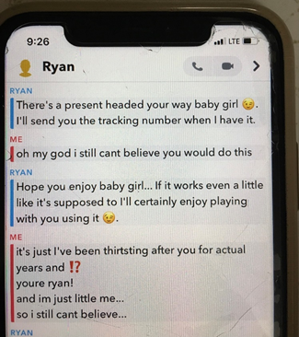
(The “present” is explained later down.)
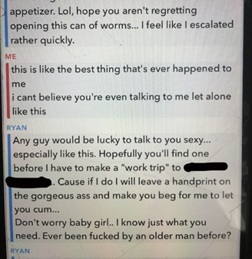

So you do things you don’t really want to get him to like you, and then he pulls the roller coaster crap and you feel shitty about yourself for doing these things you don’t like when they don’t even seem to work. But then when they do work, you feel good under his praise and attention. Rinse and repeat.

It took me about a year after the first time we met up in person (April 2017 to March 2018) to break out of that cycle and start ignoring him gradually. I wouldn’t answer for days, then weeks, then months, and when I did it was casual conversation. I talked to him normally (like friends) again in Aug 2020 because it took that long for me to build my self esteem and self worth back up, and to unlearn everything this experience taught me, in order to not feel sick when actually interacting with him.

(It was here that he told me there was one other fan, but it started “at least a month after I abandoned him”. Here he is describing how it started with her. Sounds familiar:
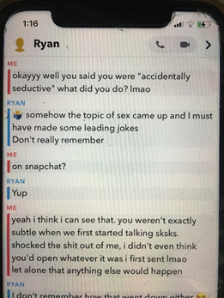

And here, he admits he couldn’t tell if I was submissive or just nervous in person, and me admitting I was intimidated:
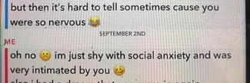
)

I spent all that time feeling so fucking stupid for everything that happened, and so fucking confused for how it affected me (I was always nervous, shaking and practically paralyzed). I didn’t understand why the power imbalance had to be so tilted. I wanted to see him, I wanted him to like me, but (after the first meet up) I hated sending him explicit stuff and I hated the sex part of meeting up with him. Talking to him like normal friends was nice though, so I sucked it up and did the stuff I hated so I could keep getting to do that.

And I guess this is a good segue into the sex part. One of the things I wanted to back up was the claim about how many virgins there were: this is true. I was one of them. And my first time experience is not different from most of the others’. A lot of them said the first time was different. Without getting into their experiences, I’ll say for me the first time was different and I did enjoy it. It didn’t even hurt that bad. But every other time it fucking hurt.

Others have said how rough he was, this is true. Others have said they couldn’t sit or walk afterwards, this is also true. I met up with him 11 times total over 1 year, and every single time he would make me bleed. I would wonder if that was normal. I would blame myself for being “broken”. One of the worst things he ever said to me was about this. It was in person, one of the later meetings, when he was trying to shove it in forcefully. I had a visceral reaction to hearing what he said because it made me feel like shit, like it was definitely my fault. That has been burned in my brain ever since, word for word, I’ve never forgotten. I can still hear his tone of voice, how loud and mad he sounded. I won’t repeat it, but it just implied I was to blame for how much it hurt.

This is what I mean when I say I didn’t like it, but was too scared to say anything. Which is my fault I know, but I didn’t feel like I could. There are times it was brought up (he actually tore me on two separate occasions, and I told him about one of them) and he said he’d go slower but nothing changed. I’ve also included times he acknowledged he should go slow, even though that never happened:
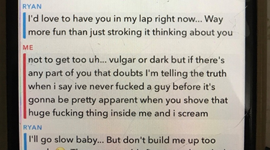
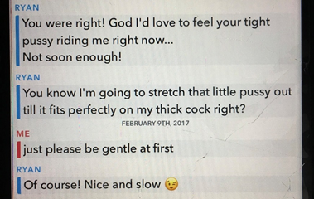
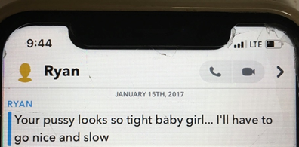
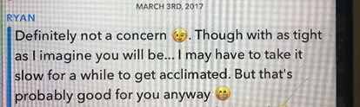
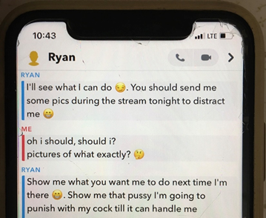
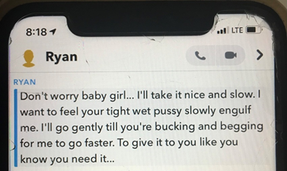
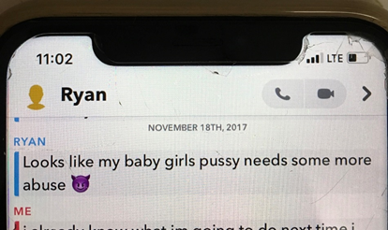
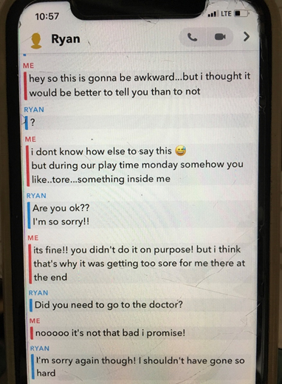
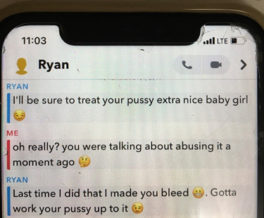
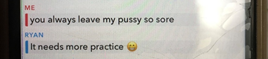
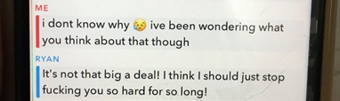

Yet nothing ever changed, it was always painful.

It was midway through 2017 that I started thinking it wasn’t worth it anymore. I still liked him as a person, but the bad started outweighing the good. I gradually got less and less involved, but it took until March 2018 for me to actually start pulling away completely.

I’ve felt really guilty about how I initiated it, and continued it despite not liking it, being responsible for my own unhappiness. So I didn’t feel like I could really be a victim, or compare to the other girls’ stories.

But that was before I realized I wouldn’t have continued it if I had known the truth. The truth I explicitly, point blank asked him, and he lied straight to my face about (multiple times, not just in the 4th screenshot posted below). I was already gradually pulling away, knowing the truth would have made me break it off completely and could have prevented so much more from happening, so much more I had to work through and heal from.

If you’ve made it this far, I’m glad, because THIS is the part that compelled me more than anything to say something and back the others up. This is the part that made me rage cry when I found out. This is the part that still disgusts me beyond belief.

Earlier I mentioned that until Aug 2020 I thought I was the only one. This is true, but Aug 5th 2017 he mentioned the possibility of meeting up with someone else (later he said it fell through). I was honest and said it didn’t bother me as long as he didn’t “replace me”, and that “it was better to know than be kept in the dark”.

These are four separate times of me saying such:
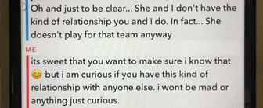
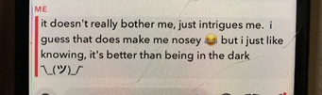
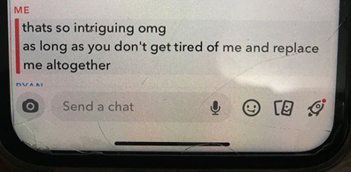

Towards the end, after he told me to tell him if I hooked up with anyone else:
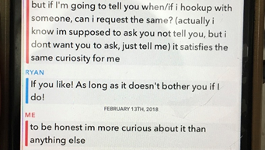

He had multiple times to tell me the truth about this part but didn’t.

But after he said he might meet up with someone else, I brought up something that I wasn’t comfortable with. As I said earlier, it’s hard to speak out about things you don’t like when someone has that much influence over you. Before we met up, we video chatted a couple times. The first time he asked me out of nowhere if I was on birth control. I said no because 1) I was a virgin and he knew that, but 2) something he didn’t know was that I have an ovarian problem that causes infertility, so there was no reason to be. He said that because of those two reasons and the fact he never has sex except for maybe once a year (he gave me the same story that he gave the others about that by the way) so he didn’t want to use a condom. That thought made me uneasy, but it made sense and I stupidly 100% trusted him, so I agreed. If you’re unaware, not using a condom is one way all our experiences are linked. There’s a pretty good number of us that have found each other, and so far only one he used a condom with.

Fast forward to Aug 5th 2017, when he’s telling me he might see someone else for the first time. Although it was hard to speak out against things I knew he wanted for fear he’d stop liking me, I immediately brought how uneasy this made me to his attention. And he immediately lied to my fucking face:
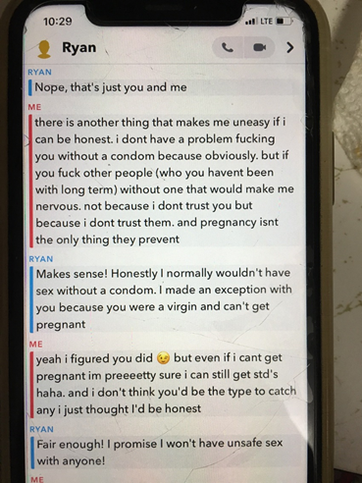

I now know how stupid it was of me to trust him, but I honestly did. I also now know me saying he’s not “the type to catch” STDs was stupid considering he is literally exactly that type (that’s not my story to tell though). He was already having unprotected sex with multiple girls by the time this conversation happened, and he would continue to do so up until 2020.

If I had known this was a lie, back in the beginning of Aug 2017, I would have stopped seeing him right then with no hesitation. It would have prevented the last 7 times I met up with him. It would have prevented the time he said the thing that’s burned into my brain. It would have prevented him ruining so many things for me (and I’m not the only one he ruined things for. But that’s also not my business to tell). When I found out how many people he fucked without a condom, I kicked things, screamed, and cried. This was an absolute deal breaker for me.

I wanted to include this so if you heard Michelle mention him having unprotected sex with so many fans in her video, there would be something to back that up. This is one of the worst aspects of it to me, and it’s incredibly frustrating to see people downplay the seriousness of the situation. I thought if I could share this part, people might understand a little better.

People can say “you initiated it”, “you weren’t forced to go there”, and “you didn’t speak up so it’s your fault” all they want, and yeah that shit is true in my case. But I did not consent to unprotected sex like that, many of us didn’t. He knew the conditions I consented to sex without a condom under, and he lied to my fucking face about following them. That’s inexcusable.

Now about Leigh…
I said I’d connect our experiences later. Well, her post is here if you haven’t seen it: https://twitter.com/leigh__sucks/status/1315034283870957568?s=20

It proves she was absolutely in the hotel room with him RTX 2019. Two years earlier RTX 2017 I was in the exact same hotel.

I’ve censored her picture in his jacket because I’m focusing on the background. She did not censor it on her post, but I am. And I’m censoring my face because I still want to be anonymous.
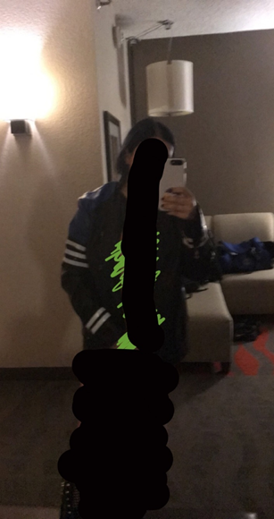

Here’s mine:
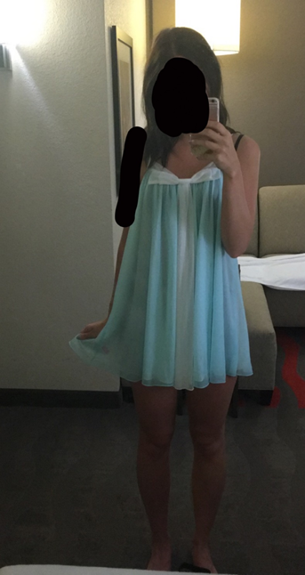
Same background and you can see the top of what I’m wearing in this picture with him:
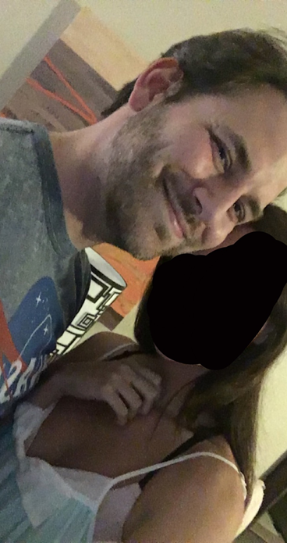
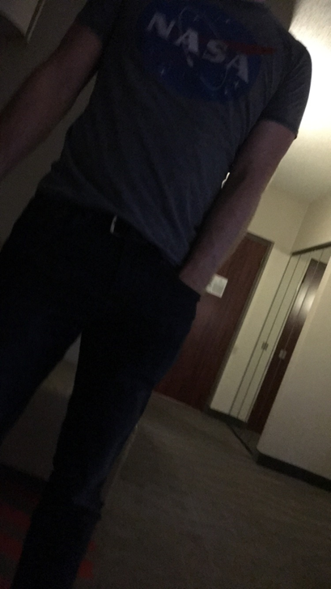


The rest will be random pieces of information that’s already been hinted at that I can vouch for:

• The general patterns of all our experiences: using work travel to meet up, the age difference, the innocent or pure virgin thing, Michelle says in her video that he told her he’d “teach her how to really please a man”, that type of thing is mentioned as well:

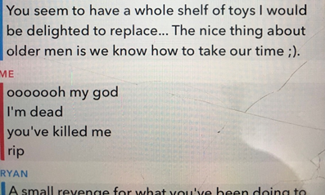
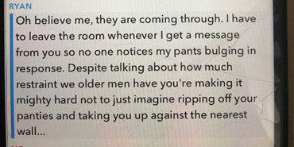
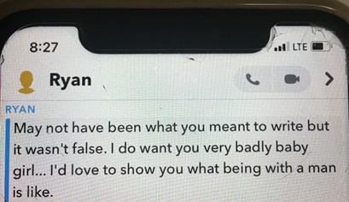
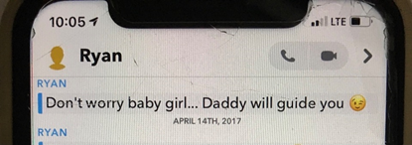
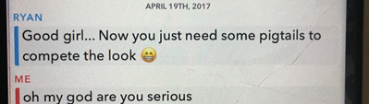
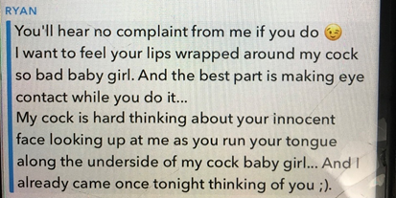
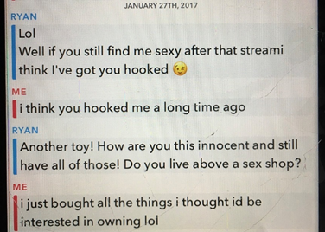

Right before we met up for the first time:
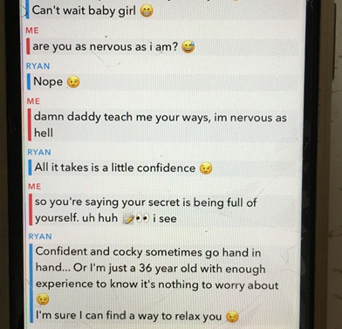
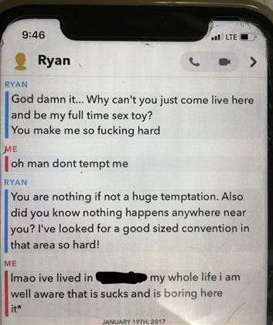
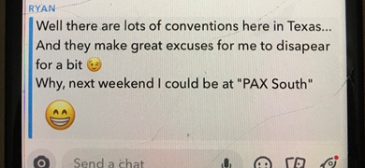
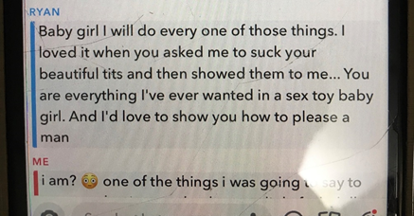
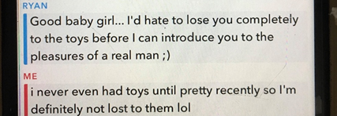
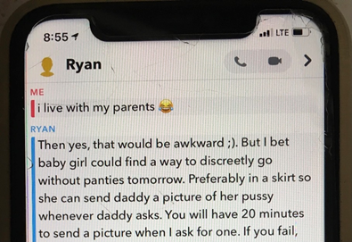
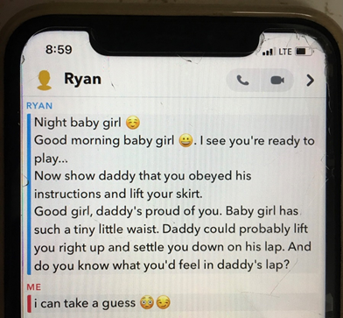
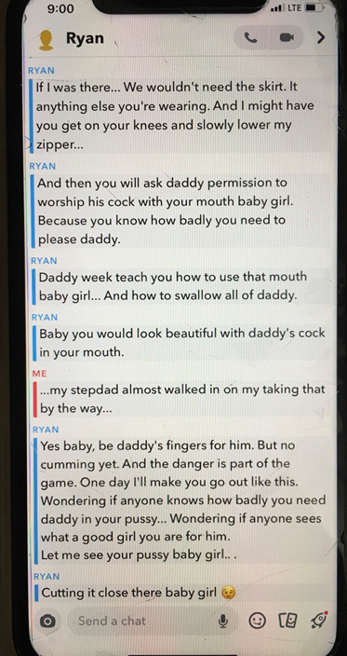
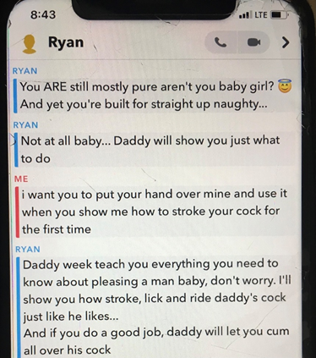
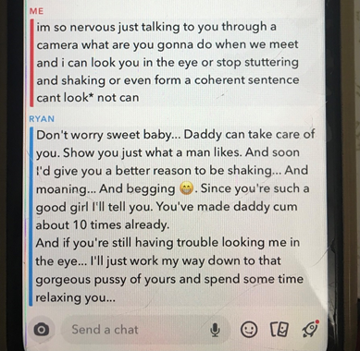

• Leigh posted this in her twitter thread from June 2020:
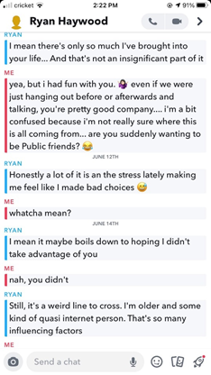
And I had said this to him May 2020, when I was still ignoring him for long periods of time:
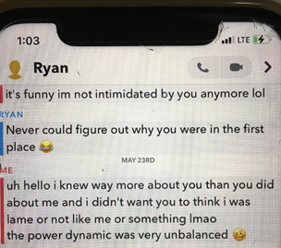

• I’ve seen people say shit like, “ThEy AcTeD LiKe PrOsTiTuTeS wHo ToOk HiS mOnEy.” Well here I am declining something he offered me for the second time (the first being he offered to pay for my trip which I was uncomfortable with) proving that it was always him who offered, we didn’t ask:
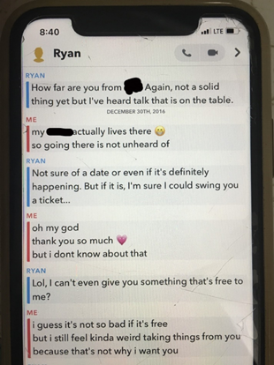
The third picture I posted in this doc (the one about a “present”) is referencing a wifi controlled vibrator he sent me, the only thing he ever bought or paid for. This was before and after that:
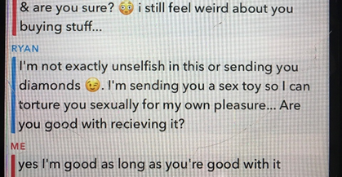
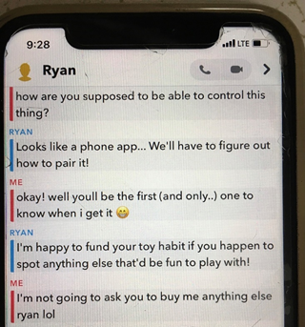
This is when he first mentioned it, and he also says “plausible deniability” which another girl had mentioned him saying in her story:
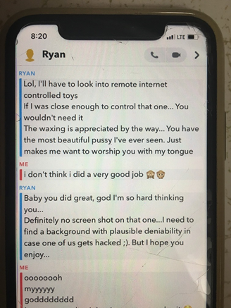

• Miscellaneous:
“Hot young women”:
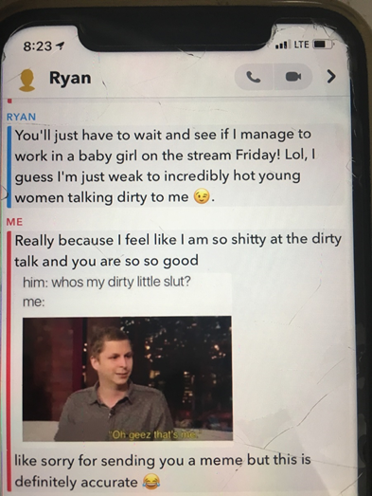

Off Topic episode 87 timestamp 8:27 - 9:30:
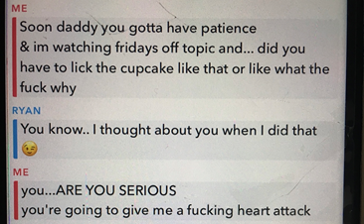

Sexting people while he streamed which I now know he did a lot:
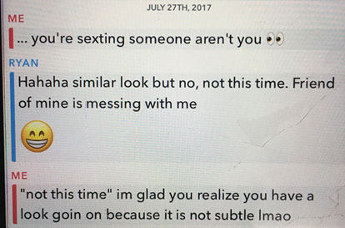

I hadn’t talked to him for a while and he denied having someone else (sidenote: snapchat dates are for the messages underneath them):
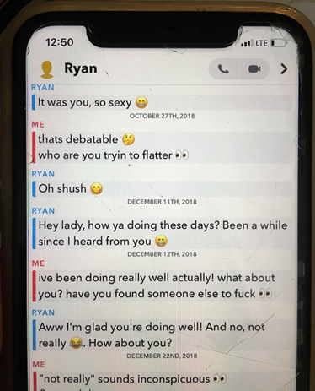

I don’t even know what the fuck this is supposed to mean but it’s sus:
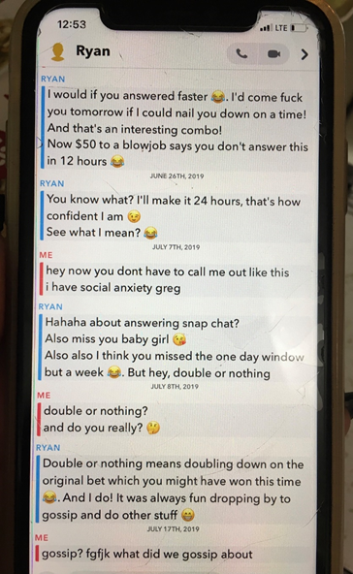

Others have mentioned him doing things without permission/without asking first. Here he admits that when he choked me really hard without warning, that it was undiscussed beforehand (sidenote: the choking wasn’t what I was referring to in my message and yes he spelled it wrong):
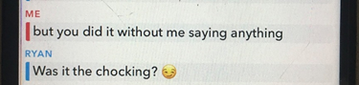

And then there was the time I said this clown shit:


Hilarious.

This week I’ve felt sick, nauseated, had panic attacks, cried, felt like the dumbest bitch on the planet, hated myself more than ever, had my self esteem and self worth (that was badgered by this in the first place) drastically shoot back down because the experience I worked through and healed from wasn’t actually the true experience I had, so now I have to start from scratch. But I’ve also felt so seen and supported and heard from the rest of the girls. I’m so thankful to have met them, even if I hate the reason why.

I wanted to make this to support their statements of their experiences with pieces of my own. While it’s not my whole story and I’m still hiding behind anonymity, typing this out has helped, too. I know it’s probably a mess, my brain is fried. But thanks for reading.

